# Deploy

1. Right click on solution -> publish

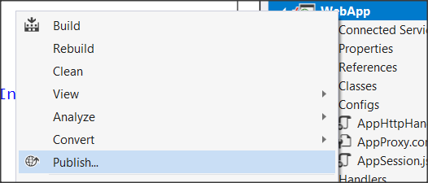

1. setup your publish profile to set deploy location on your server

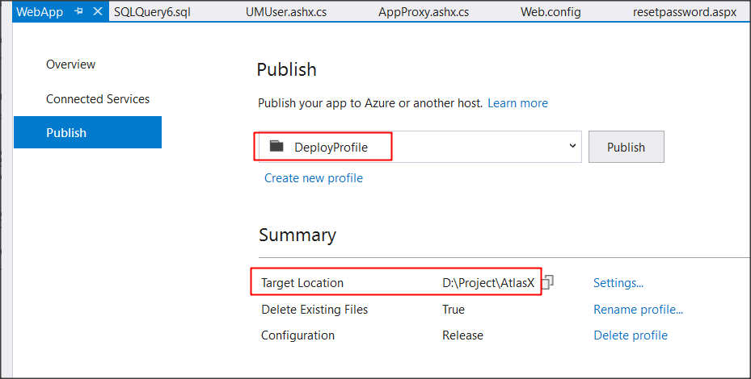

1. click publish. If successful, it will build code to folder in step (2)

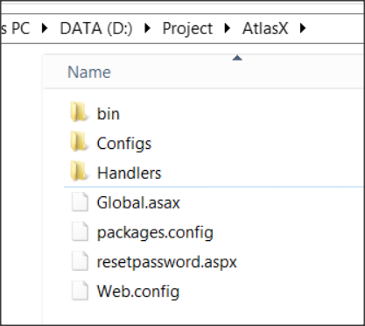

1. Open <root folder>/Angular in Visual Studio Code

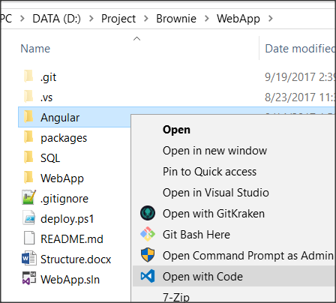

and type command

|  |
| --- |
| ng build --prod --aot=false |

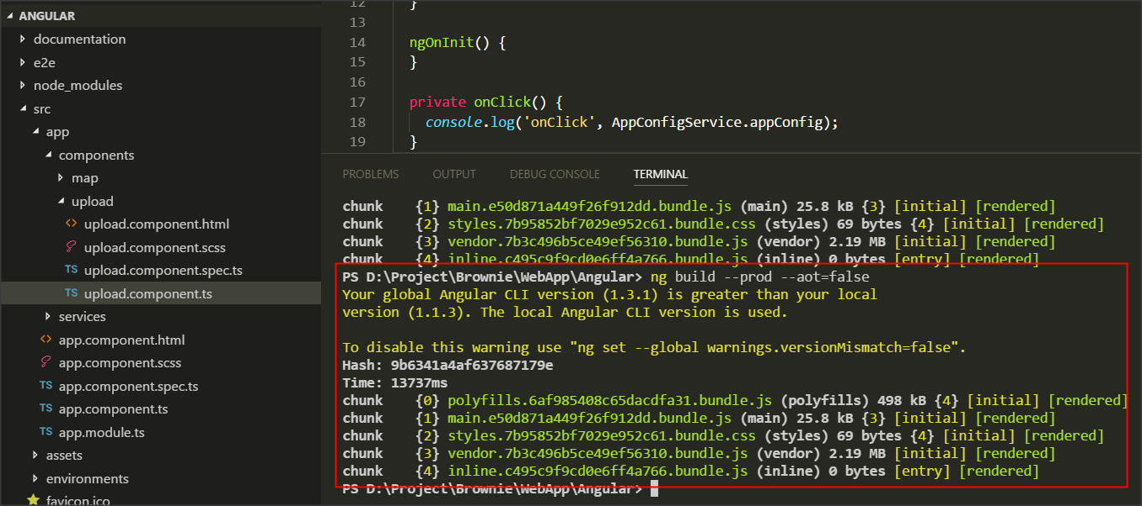

you will see output in <root folder>/WebApp/client

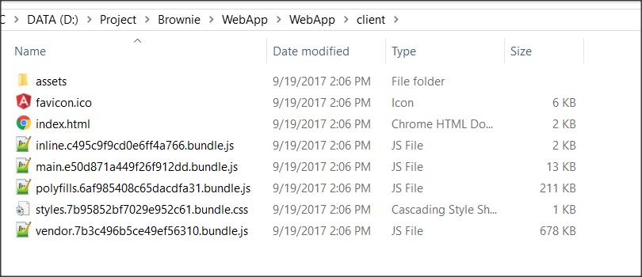

1. copy folder <root folder>/WebApp/client into deployment folder in step (2)

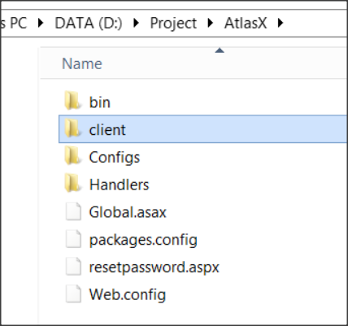

1. zip everything

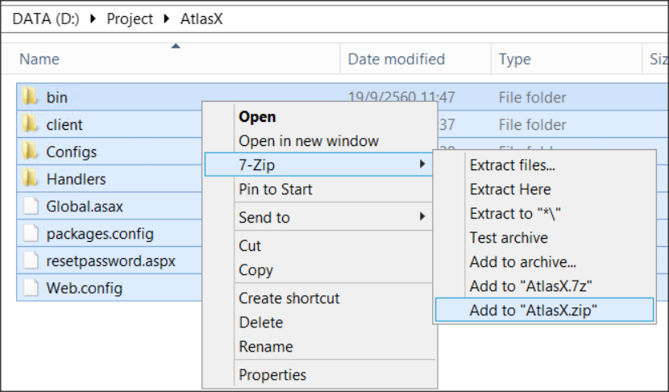

1. Copy zip file to server you want to deploy. Then, setup IIS and test website.

**Note:** On Server, ASP.NET State Service must be set to 'Automatic' and start service like this

