**Java Web Programming - PRJ321**

**Workshop Requirement**

You are requested to create a small part of a web application similar to socrative, kahoot, cms… In those application, student will login to a quiz session by providing their identity (user name) and the quiz session code (or room).

Assume that there was a backend app, which provides features for teacher to generate and manage quiz sessions. You are requested to a frontend app for student to join and perform a given quiz session.

Base on the given script, you have to create following page: Login Page for Student, Input Quiz Session Code, and Perform Quiz Page.

The Script file: PRJ321_Workshop1_DB_Script.sql is put in the same folder with this requirement

The database schema diagram as follow:



You are requested to do this workshop individually and you have to complete following tasks:

1. Create a Login Page for student as following:

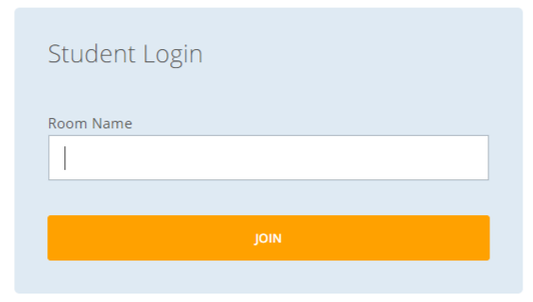

In the Room Name, Student will input the QuizSession Code there, and then they have to register their identity in the next screen

1. Create a Register Page as follow:

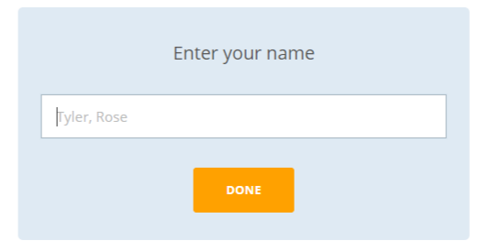

Then a Quiz Session will be started and Student can do their work by answering questions here.

1. Create Showing Questions in a Quiz Session as follow:



1. Update the work of student to the database when they submitted the answer