# Peat Depth Model: Model Evaluation

| **area** | **run** |
| --- | --- |
| England (eng) | run_20200823-1202 |

### Import model and data

Model specification

| Table 1a. Model Specification | | | |
| --- | --- | --- | --- |
| model_name | model | psill | range |
| eng_run_20200823-1202 | Nug | 0.7713418 | 0.00 |
| eng_run_20200823-1202 | Sph | 1.7405983 | 21104.41 |

Input and predictor summary

| Table 1b. Summary statistics for input and prediction data | | | | | | | | |
| --- | --- | --- | --- | --- | --- | --- | --- | --- |
| dataset | n_points | depth_med | depth_min | depth_max | elev_min | elev_max | slope_min | slope_max |
| predictors | 14712087272 | NA | NA | NA | -26.81 | 962.96 | 0 | 84.68 |
| observations extract | 10000 | 195.939 | 0 | 560 | -2.00 | 782.24 | 0 | 41.98 |
| England run_20200823-1202 | | | | | | | | |

### Ten-fold cross validation

This analysis uses the gstat function krige.cv() to perform ten-fold cross validation

#### Cross validation of spatial model

## [1] "cross validation using 10 clusters"

## Spatial model cross-validation metrics (not back-transformed, eng_run_20200823-1202):

## mean error = -0.001, MSPE = 0.413, mean square norm. error = 0.468,

## cor obs&pred = 0.909, cor pred&resid = 0.058, R2 = 0.827, R2 adj = 0.827

## Spatial model cross-validation metrics (back-transformed, eng_run_20200823-1202):

## mean error = -5.07, MSPE = 22337.71,

## cor obs&pred = 0.959, cor pred&resid = 0.697, R2 = 0.919, R2 adj = 0.919

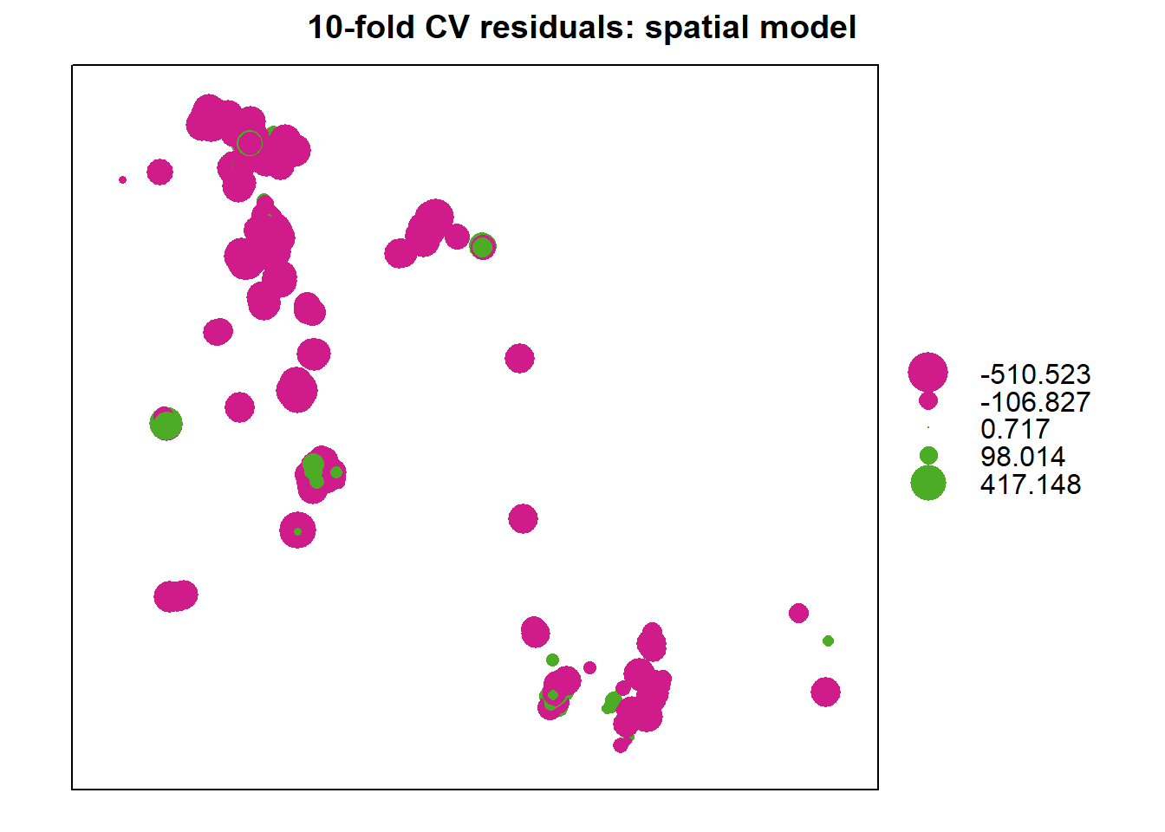

#### Cross validation of linear model

## Linear model cross-validation metrics (not back-transformed, eng_run_20200823-1202):

## mean error = 0, MSPE = 1.625, mean square norm. error = 1.001,

## cor obs&pred = 0.562, cor pred&resid = -0.001, R2 = 0.315, R2 adj = 0.315

## Linear model cross-validation metrics (back-transformed, eng_run_20200823-1202):

## mean error = -21.973, MSPE = 7970.987,

## cor obs&pred = 0.59, cor pred&resid = -0.032, R2 = 0.348, R2 adj = 0.347

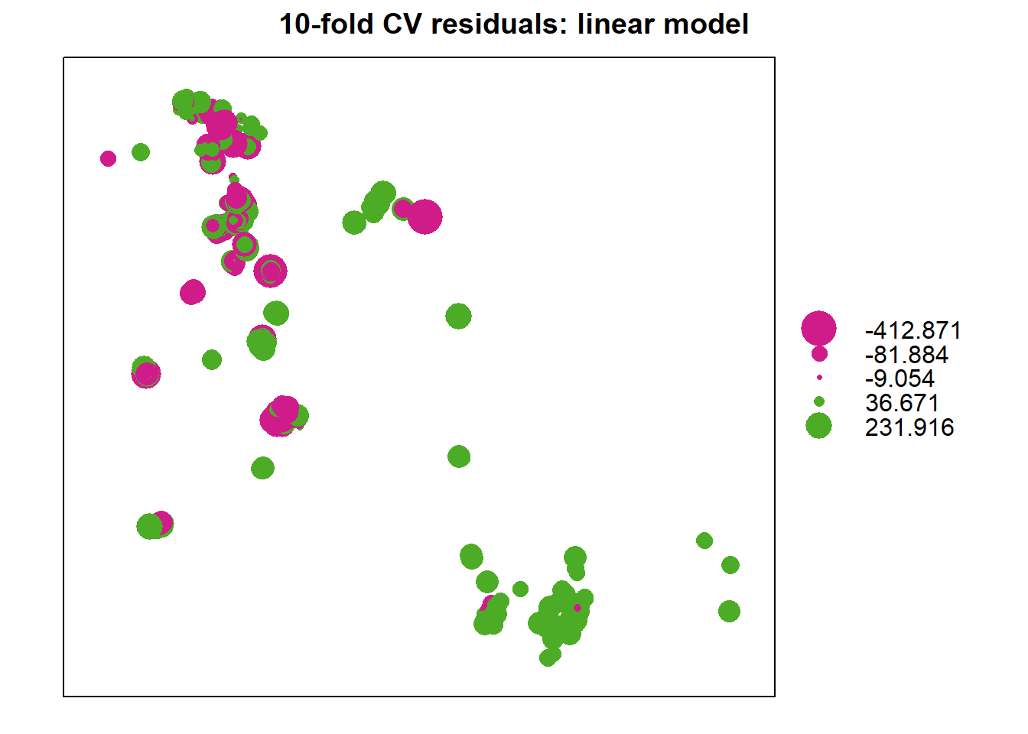

#### Estimate null model

Linear regression with no spatial component

##

## Call:

## lm(formula = depth ~ elev + slope, data = dat_sp)

##

## Residuals:

## Min 1Q Median 3Q Max

## -247.59 -58.96 -11.95 61.44 706.45

##

## Coefficients:

## Estimate Std. Error t value Pr(>|t|)

## (Intercept) 247.543008 1.512902 163.62 <2e-16 ***

## elev -0.049745 0.003228 -15.41 <2e-16 ***

## slope -18.870578 0.330246 -57.14 <2e-16 ***

## ---

## Signif. codes: 0 '***' 0.001 '**' 0.01 '*' 0.05 '.' 0.1 ' ' 1

##

## Residual standard error: 89.18 on 9997 degrees of freedom

## Multiple R-squared: 0.3066, Adjusted R-squared: 0.3065

## F-statistic: 2210 on 2 and 9997 DF, p-value: < 2.2e-16

## Linear null-model metrics (eng_run_20200823-1202):

## R2 = 0.307, R2 adj = 0.306, RMSE = 89.169 cm

##

##

## Model equation

## depth = 247.54300762 - 0.04974453 * elev - 18.87057779 * slope

#### Estimate best linear model from the literature

## Exponential model by Parry, metrics (eng_run_20200823-1202):

## R2 = 0, R2 adj = 0, RMSE = 223.279 cm

##

##

## Model equation

## exp(0.875 + 0.00758 * elev - 0.0903 * slope) - 25 + (0.5 * exp(0.875 + 0.00758 * elev - 0.0903 * slope))

##

##

### Results summary

| Table 2. Performance metrics for spatial and linear models | | | | | | | |
| --- | --- | --- | --- | --- | --- | --- | --- |
| modeltype | rmse | r2 | r2adj | cc | coverage | bias | interv |
| sm | 31.06 | 0.919 | 0.919 | 0.96 | 0.97 | -5.07 | 43.09 |
| lm | 89.28 | 0.348 | 0.347 | 0.59 | 0.95 | -21.97 | 124.72 |
| null | 89.17 | 0.307 | 0.306 | 0.55 | NA | 0.00 | NA |
| parry | 223.28 | 0.000 | 0.000 | 0.01 | NA | -7.09 | NA |
| England run_20200823-1202 | | | | | | | |

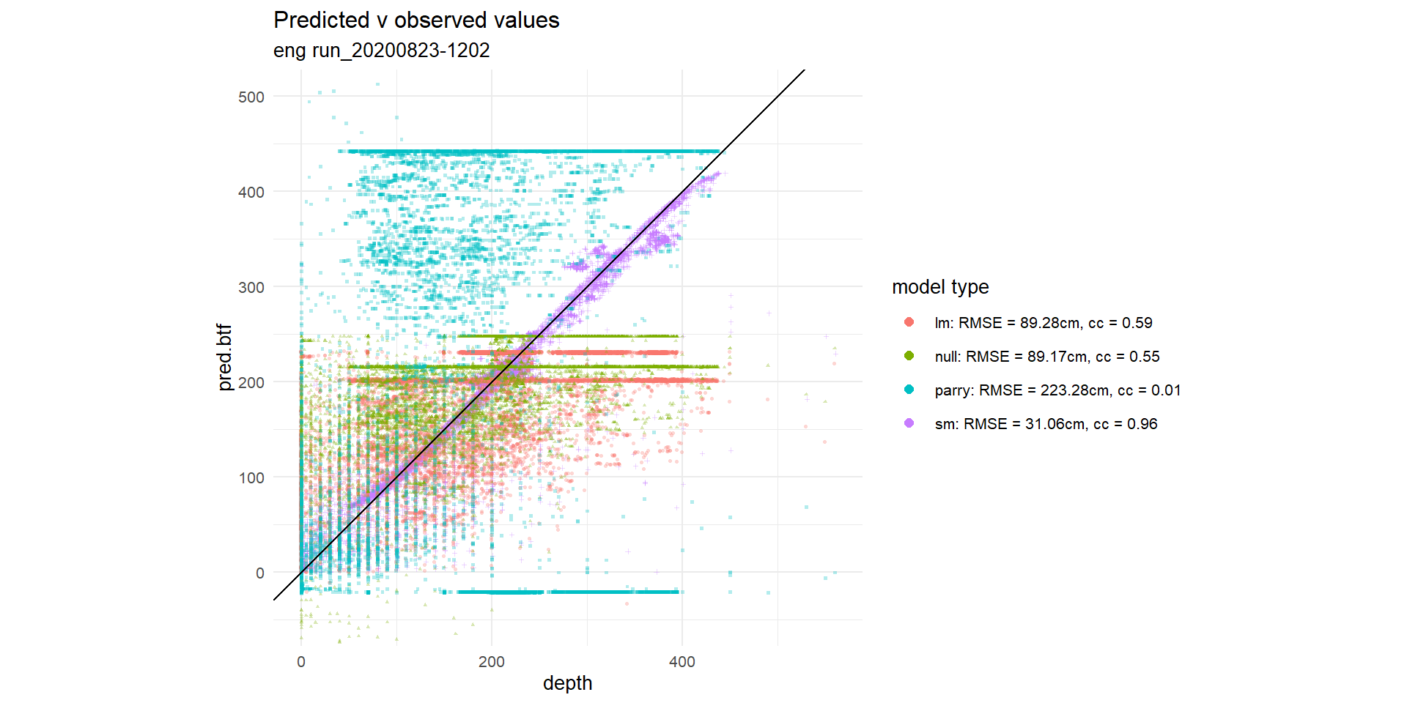

### Parameters and environment

Run at 2020-08-26 13:27:05 for **** (**) with the following parameters:

## $area_name

## [1] "England"

##

## $area_abbr

## [1] "eng"

##

## $pred_bound

## [1] "../data/peaty_soils/Peaty_Soils_buff_200m.shp"

##

## $NP

## [1] "NA"

##

## $raster_source

## [1] "TerrainTiles"

##

## $terrain_raster_file

## [1] "../data/terr_eng_12.tif"

##

## $cell_size

## [1] 5

##

## $obs_path

## [1] "../data/peat_depth_data/Combined_Peat_Depth_Survey_Data_NOV2012_ALLDATA.shp"

##

## $projection

## [1] "+proj=tmerc +lat_0=49 +lon_0=-2 +k=0.9996012717 +x_0=400000 +y_0=-100000 +ellps=airy +datum=OSGB36 +units=m +no_defs"

##

## $field_depth

## [1] "PEAT_DEPTH"

##

## $input_data.sp.fn

## [1] "../data/input.data_eng_5m.rds"

##

## $elev_raster_fn

## [1] "../data/elev_eng_5m.tif"

##

## $slope_raster_fn

## [1] "../data/slope_eng_5m.tif"

##

## $input_data_prep.sp.fn

## [1] "../data/input.data_eng_5m.rds"

##

## $rundate

## [1] "run_20200823-1202"

##

## $tf

## [1] "cbrt"

##

## $params_fn

## [1] "../data/parameters_eng.rds"

##

## $model_fn

## [1] "../outputs/model.geo_eng_run_20200823-1202.rds"

##

## $inputs_fn

## [1] "../outputs/input.data.gs_eng_run_20200823-1202.rds"

##

## $parallel

## [1] TRUE

##

## $subset

## [1] TRUE

## R version 3.6.1 (2019-07-05)

## Platform: x86_64-w64-mingw32/x64 (64-bit)

## Running under: Windows 10 x64 (build 19041)

##

## Matrix products: default

## locale:

## [1] LC_COLLATE=English_United Kingdom.1252

## [2] LC_CTYPE=English_United Kingdom.1252

## [3] LC_MONETARY=English_United Kingdom.1252

## [4] LC_NUMERIC=C

## [5] LC_TIME=English_United Kingdom.1252

## attached base packages:

## [1] parallel stats graphics grDevices utils datasets methods

## [8] base

##

## other attached packages:

## [1] doParallel_1.0.15 iterators_1.0.12 foreach_1.4.7 flextable_0.5.10

## [5] stars_0.4-1 abind_1.4-5 gstat_2.0-5 geoR_1.8-1

## [9] elevatr_0.2.0 sf_0.9-3 rgdal_1.4-7 raster_3.1-5

## [13] sp_1.4-2 forcats_0.4.0 stringr_1.4.0 dplyr_0.8.3

## [17] purrr_0.3.3 readr_1.3.1 tidyr_1.0.0 tibble_3.0.1

## [21] ggplot2_3.3.2 tidyverse_1.3.0

##

## loaded via a namespace (and not attached):

## [1] RandomFieldsUtils_0.5.3 nlme_3.1-140 fs_1.4.1

## [4] xts_0.12-0 lubridate_1.7.8 httr_1.4.1

## [7] tools_3.6.1 backports_1.1.5 R6_2.4.1

## [10] KernSmooth_2.23-15 DBI_1.1.0 colorspace_1.4-1

## [13] withr_2.1.2 tidyselect_1.1.0 splancs_2.01-40

## [16] compiler_3.6.1 RandomFields_3.3.8 cli_2.0.2

## [19] rvest_0.3.5 xml2_1.3.1 officer_0.3.12

## [22] labeling_0.3 scales_1.1.0 classInt_0.4-3

## [25] systemfonts_0.2.3 digest_0.6.25 rmarkdown_2.1

## [28] base64enc_0.1-3 pkgconfig_2.0.3 htmltools_0.4.0

## [31] dbplyr_1.4.3 rlang_0.4.7 readxl_1.3.1

## [34] rstudioapi_0.11 FNN_1.1.3 farver_2.0.1

## [37] generics_0.0.2 zoo_1.8-6 jsonlite_1.6.1

## [40] zip_2.0.4 magrittr_1.5 Rcpp_1.0.4.6

## [43] munsell_0.5.0 fansi_0.4.0 gdtools_0.2.2

## [46] lifecycle_0.2.0 stringi_1.4.3 yaml_2.2.0

## [49] MASS_7.3-51.4 grid_3.6.1 crayon_1.3.4

## [52] lattice_0.20-38 haven_2.2.0 hms_0.5.2

## [55] knitr_1.26 pillar_1.4.4 uuid_0.1-4

## [58] tcltk_3.6.1 spacetime_1.2-3 codetools_0.2-16

## [61] reprex_0.3.0 glue_1.4.0 evaluate_0.14

## [64] data.table_1.12.6 modelr_0.1.8 vctrs_0.3.0

## [67] cellranger_1.1.0 gtable_0.3.0 assertthat_0.2.1

## [70] xfun_0.11 lwgeom_0.2-4 broom_0.5.6

## [73] e1071_1.7-3 class_7.3-15 intervals_0.15.2

## [76] units_0.6-6 ellipsis_0.3.1