Mapping benthic habitat sensitivity to marine activities

Natural England report XXX-draft

Philip Haupt and Duncan Vaughan

29 March 2019

# Introduction

The United Kingdom’s (UK) marine environment is of significant economic value, in which the exploitative activities and infrastructure development is constantly weighed up against their impact on the environment (Walport and Boyd 2017). The UK’s marine environment is subject to a vast array of pressures, such as fishing operations, marine aggregate dredging, development of renewable energy and risks of pollution from oil spills among many others. Overfishing and habitat loss are regarded as two of the main contributors to the degradation of the UK’s marine environment (Walport and Boyd 2017).

Commercial fishing operations are widespread throughout the United Kingdom, and is fished by both national and international fleets within the remits of the London Fisheries Convention (1964) and the Common Fishery Policy (CFP 1970s). Many of the existing regulations and laws are therefore enshrined in EU maritime law. The withdrawal of the UK from the European Union (EU exit), which is scheduled for the 29 March 2019,[European Union (Withdrawal) Act 2018, section 20](http://www.legislation.gov.uk/ukpga/2018/16/section/20); [Article 50](https://eur-lex.europa.eu/legal-content/EN/TXT/HTML/?uri=CELEX:12016M/TXT&from=EN), is likely to lead to change in fisheries regulations (Phillipson and Symes 2018). Leaving the EU may change how fish stocks are shared across political borders, quota allocation to EU-member states in the UK, and Total Allowable Catch (TAC) for different stocks among many other aspects related to managing the UK fishing grounds (Phillipson and Symes 2018). A change in fishing regulations and management may have substantial ramifications fishing operations in the UK. The spatial distribution of fishing effort among various fishing metiers is a key element is likely to be influenced by a change in regulations (Vaughan 2017). Previous research has shown that a displacement of fishing effort could lead to detrimental environmental and socio-economic effects (e.g. **???**). It is therefore important that the impact on the marine environment brought about by a displacement of fishing effort be considered prior to adopting new regulations or change in management practices (Vaughan 2017; Chollett, Box, and Mumby 2016).

Natural England provides statuary conservation Advice on Operations in English territorial waters (from the shore to 12 NM offshore) to the Defra, regulators and developers. Natural England also provides advice out to 200 NM offshore for renewable energy through the delegation of responsibility from the Joint nature Conservation Council (JNCC). Previous studies have developed tools to predict the impacts of fishing effort displacement, which forecast a change in fishing effort displacement (Bastardie, Nielsen, and Miethe 2013). This project did not attempt to predict a change in fishing activity given the significant uncertainty and complexity in how Brexit would affect fishing opportunities and regulations in the UK. Delineating the geographical distribution of habitat sensitivity has been identified as critical dataset for managing human activities on the marine environment (Bax and Williams 2001). The sensitivity of marine habitats have previously been defined as sensitivity as: *“The intolerance of a species or habitat to damage from an external factor and the time taken for its subsequent recovery”*,[Laffoley et al. (2000); Tyler-Walters & Hiscock (2005)](https://www.marlin.ac.uk/sensitivity/sensitivity_rationale)), *, or, “the degree to which marine features respond to stresses, which are deviations of environmental conditions beyond the expected range”* (Zacharias and Gregr 2005). In this study habitat sensitivity to standardised pressures from various activities in the marine environment were mapped. The sensitivity mapping is a precautionary approach which could then be used to assess impacts from change in marine activities as they happen. This response, as opposed to predictive approach was preferred due to the multitude of uncertainties associated with fishing displacement, and other activities in the marine environment arising from EU exit.

Natural England uses sensitivity assessments of protected benthic habitats and species to inform its Advice on Operations. The habitat sensitivity assessments are comprised of three principal components, namely 1) habitat, 2) pressure, and 3) activity (which may be attributed to an operation).

#### Habitat

This study was limited to the marine benthic habitat, comprised from the substratum and the community of organisms adhered to or living in close contact to the seabed. The definition of the multitude of benthic habitat categories used by Natural England is based on the pan-European adopted habitat classification system, known as the European Nature Information System (EUNIS). The EUNIS benthic habitat categories is a hierarchical system within which fine-scale habitat categories are nested within broader-scale habitat categories, referred to as EUNIS levels. At the top of the hierarchical classification system, the broadest definition of habitat corresponds, e.g. “Marine”, to EUNIS level 1. At higher EUNIS values, the amount of thematic detail about the habitat increases progressively, for example, EUNIS level 2: A1 : Littoral rock and other hard substrata, EUNIS level 3: A1.1 : High energy littoral rock, EUNIS level 4: A1.11 : Mussel and/or barnacle communities, EUNIS level 5: A1.113 : *Semibalanus balanoides* on exposed to moderately exposed or vertical sheltered eulittoral rock, EUNIS level 6: A1.1132 : *Semibalanus balanoides*, *Fucus vesiculosus* and red seaweeds on exposed to moderately exposed eulittoral rock.

*See the* [EUNIS-webpage](https://eunis.eea.europa.eu/habitats-code-browser.jsp) *for more examples on the hierarchical view of the EUNIS habitat classification system.*

#### Pressure

Pressure is the force of stress exerted by an activity on marine benthic habitats. Every activity may be associated with numerous pressures which act simultaneously on these habitats. The nature of the pressure is determined by the activity type, intensity and distribution [Robinson et al. (2008)](https://www.marlin.ac.uk/sensitivity/sensitivity_rationale). Pressures are standardised according to a benchmark. A benchmark is a set level at which there are known effect and habitats or species. See the MarESA methods *(MarESA reference to be included - also check with James Highfield taht indeed we are using MarESA, or MarLIN -a s there are differences!)*.

#### Activity

Standardized categories of human activities and natural events, to which pressures on the environment are associated. Activities can be grouped within operations.

#### Natural England’s role

Natural England’s benthic habitat sensitivity assessments include 39 pressures associated with a 100 activities stemming from 18 operations in the marine environment. Other common concepts include the Vulnerability and Exposure. Vulnerability is the measure of the degree of exposure of a receptor to a pressure to which it is sensitive [Based on Hiscock et al. 1999; Oakwood Environmental Ltd (2002)](https://www.marlin.ac.uk/sensitivity/sensitivity_rationale). Exposure is the action of a pressure on a receptor, with regard to the extent, magnitude and duration of the pressure [Robinson et al. (2008)](https://www.marlin.ac.uk/sensitivity/sensitivity_rationale).

Natural England’s statutory remit is restricted to protected habitats and species within English marine protected areas (MPAs), known as designated features. The designated habitat features are represented at a intermediate scale of detail, equivalent to EUNIS level 3. Natural England’s conservation advice is therefore limited to a subset of the area of English territorial waters, and provided at a coarser scale of habitat detail than is available for the UK seabed. In recognition that impacts from a displacement of fishing effort occurring outside of MPAs can have an impact on features within MPAs, a “wider-seas” and “whole-sites” approach was used to assess the sensitivity of benthic habitats to fishing activities for the UK’s EEZ (Exclusive Economic Zone). The whole-sites and wider-seas approach means that currently protected features were not considered in isolation, but that the connectivity between benthic habitats were considered to provide a holistic overview the spatial distributions of fishing related impacts on the benthic habitat. Natural England holds a bespoke dataset which details potential fine-scale habitats (EUNIS level 4 - 6) which occur within the broader habitat categories (EUNIS level 1 - 3) within the subbiogeographical sea regions around England from 0 to 12 NM offshore. The bespoke dataset was informed through expert consultation with Dr Keith Hiscock (Hiscock, K. 2016). A case study was developed to explore the potential use of benthic habitat sensitivity models to help inform NE of potential impacts on the marine environment.

#### Previous sensitvity mapping work

Previous attempts to use quantitative methods to delineate benthic habitat sensitivity were limited by the level of detail about the underlying benthic habitat upon which fishing activities impact. These studies have assumed that benthic habitat were comprised of four broad-scale categories, such as mud, muddy sand, sand and gravel. Current quantitative models therefore do not consider differences in living structures occurring within these habitats. These models are therefore likely to over- or under-estimate the sensitivity of fine-scale habitats within these very broad definitions of habitat. Alternative methods using score based or expert judged systems to map out geographical distribution of habitat sensitivity e.g. (H. Tillin and Tyler-Walters 2014; Zacharias and Gregr 2005) have been criticized for not being quantitative, and therefore not repeatable (D. E. Duplisea et al. 2002; J. G. Hiddink, Jennings, and Kaiser 2007). Despite this limitation, both quantitative and scored based systems of habitat sensitivity have commonly been based upon the same central tenet of resilience to pressures, and standardization of the pressures [See Roberts et al 2010](https://www.marlin.ac.uk/sensitivity/sensitivity_rationale).

#### Sensitivity assessments used by Natural England

Sensitivity assessments are often comprised of two components, namely 1) resistance and 2) resilience. The resistance is the ability of the substrate and the benthic community of organisms to withstand damage caused by a particular pressures associated with an activity. In other words, it is the likelihood of damage due to a pressure. The second component, resilience, is the time that it takes for the benthic community to regenerate and restore the productivity and/or biomass (J. G. Hiddink, Jennings, and Kaiser 2007) to its former level prior to the impact. In the qualitative methods used by NE, resistance and resilience is and resilience are based on assigning a resistance and resilience category to each habitat category based on literature reviews or expert judgement *(insert MAResa methods and reference)*. Cross-tabulation of the categorical scores of resistance and resilience are then used to determine the sensitivity category in the MAResa methods. A confidence score is then associated with each of the assessments, resistance, resilience and overall sensitivity, based on the quality of the evidence and and its applicability to the assessment of the likely effects of a pressure on a given feature (species or habitat). The quality of the evidence is based on the reputability of the source, e.g. journal article, grey literature or expert opinion, and the level of agreement between the different sets of evidence [Tillin and Tyler-Walters, 2014, d’Avack et al. 2014](https://www.marlin.ac.uk/sensitivity/sensitivity_rationale).

#### Aim

The overarching **aim (1.1)** of this project was to map the spatial distribution of sensitivity of fine-scale benthic habitats (EUNIS level 4 - 6) in relation to 39 pressures caused by all , with an emphasis on fishing activities, on which NE provides conservation advice in the UK’s Exclusive Economic Zone (EEZ). The study area includes the wider seas (outside of MPAs) to provide evidence of sensitive habitats which may be affected by a displacement of fishing pressures arising from different scenarios of EU Exit.

In this report a case study was developed to inspect the application of the habitat sensitivity mapping in relation to spatial maps of fishing activity. The **aim 1.2** of the case study was to identify a) sensitive and not-fished, and b) not-sensitive and not-fished areas, as a potential source to inform management of options which identifies the spatial distribution of fishing effort which would minimise the their impact on the benthic habitat.

Fishing activities have had profound effects on the UK’s marine ecosystem, of which bottom towed fishing gears is one of the most damaging activities which altered benthic habitats, composition and trophic structure of fish and invertebrate communities over the last century of industrial fishing (Kaiser et al. 1998; Jennings et al. 2001; J G Hiddink et al. 2006; H. M. Tillin et al. 2006; Thurstan, Brockington, and Roberts 2010). Bottom towed fishing gears impact the habitat through penetration of the seabed, abrasion as the gear is being towed, and sedimentation caused in the wake of the towed gear **[NEEDS A REFERENCE]**. For these reasons, the sensitivity of benthic habitat to bottom towed gears were used in the case study. The objective of the case study was to quantify the proportion of low, medium and highly sensitive habitat currently under three pressures, including, i) penetration, ii) abrasion and iii) sedimentation, from three bottom towed fishing gears, namely, a) dredging, b) demersal otter trawling, and c) beam trawl activities in the English seabed 0 - 220 NM offshore.

# Methods

## Study Area

Marine habitat sensitivity maps were generated for the United Kingdom’s Exclusive Economic Zone (EEZ), from the shoreline to 200 NM offshore. The sensitivity maps were generated in two steps, first for 0 - 12 NM offshore for English territorial waters (area in light blue in Figure 1), and second, comprising both the 12 - 200 NM English offshore and 0 - 200 NM for devolved administrations [Figure 1](!english_waters). The habitat sensitivity maps were therefore generated independently for these adjacent geographical areas.

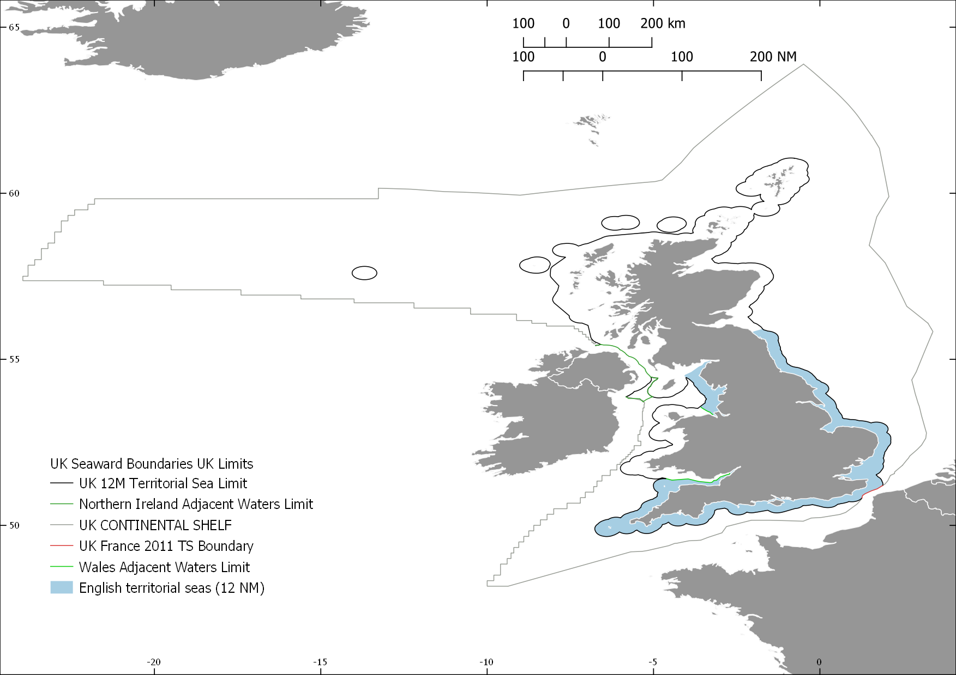

The United Kingdom’s boundaries, showing English territorial waters (inshore) and offshore areas used in this study.

The areas were treated independently as Natural England holds fine-scale data on the composition of the benthic habitat in 0 - 12 NM in England which was not available for the offshore (12 - 200 NM) English waters and 0 - 200 NM for Devolved Administrations at the time of writing. The fine-scale information on habitat composition was utilised in an additional step within the R modelling routines, which allowed biotope prediction within mapped broader scale habitats. The biotope level habitat information was obtained from additional data and expert validation which describes the likely biotopes within subbiogeoregions regions within English waters. (This fine-scale habitat information when NE provides statutory advice, and is therefore well established within the organisations day to day working.)

### Data sources

Two main data sets were used to map the sensitivities for the marine benthic habitats within the UK’s EEZ, including 1) habitat sensitivity assessments, and 2) a marine habitat map for the UK. The two data sources share a common key in the datasets and could therefore be joined to associate the sensitivity of habitat categories to the mapped habitat categories.

#### 1. Sensitivity assessments

Sensitivity assessments of each benthic habitat categories has been carried out for most EUNIS habitats using the MarESA methods (H. Tillin and Tyler-Walters 2014) as part of Natural England’s ongoing advice on operations programme. The sensitivity of the EUNIS habitats levels 4 to 6 were assessed against 39 standardised pressures for each activity. The ten fishing activities in the Advice on Operations database were included in this project (Table 1). The pressures are standardised according to benchmarks, for which the benchmark value is defined at which point an effect caused by the pressure is expected (H. Tillin and Tyler-Walters 2014). The 39 pressures include the 36 OSPAR standardised pressures and an additional three which allow specifying direction of a pressure rather than one parameter stating non-directional change (Table 2). For example instead of one pressure stating a change of 0.5&deg C, two separate pressures are included stating an increase of 0.5° C and another a decrease of 0.5° C. For details about the benchmarks please see Tillin et al (2014). One of six levels of sensitivity are assigned to each habitat category in response to each of the 39 pressures, each with their own defined benchmark (Table 3). The sensitivity score is based on the resistance and resilience of the habitat. See (H. Tillin and Tyler-Walters 2014) for details.

Table 1: Fishing activities in Advice on Operations (AoO) database

ActivityName

Description

Anchored nets/lines

Sub-activity includes gill nets, trammel nets & tangle nets, and long lines, that are fixed/anchored to, or come into contact with, the seabed. Also includes handlines and rod & line angling (*where anchoring of the vessel occurs*).

Electrofishing

Sub-activity that includes trawls that interact with the seabed and use electric fields to fish for shellfish e.g. razor shells, shrimp or fish e.g. plaice, sole.

Traps

Sub-activity includes pots, creels & traps, as well as fyke nets and other similar gear.

Pelagic fishing (or fishing activities that do not interact with sea bed)

Sub-activity includes gears that do not interact with the seabed e.g. pelagic/mid water trawls, drift nets, pelagic seines and pelagic long lines. Also includes handlines and rod & line angling (vessel-based) (*where no anchoring occurs*).

Hydraulic dredges

Sub-activity includes hydraulic/suction dredging e.g. clams, cockles, razor shells.

Dredges

Sub-activity includes dredging (non-hydraulic) for shellfish e.g. scallops, oysters, mussels (including seed), clams & cockles. Includes dredges towed by vessels and tractors.

Demersal trawl

Sub-activity includes beam trawls, demersal otter trawls, demersal pair trawls (excludes electronic pulse fishing).

Demersal seines

Sub-activity includes demersal anchor/Danish seines and Scottish seines, as well as beach seines that come into contact with the seabed.

Shore-based activities

Sub-activity includes crab tiling, bait digging, shellfish collection (including seed mussel) e.g. by hand (with or without digging apparatus), rake or through the use of ‘tiles’. Also includes rod & line angling. The setting of pots and nets from the shore is also included. Vehicles or vessels may be used to access the shoreline.

Diving

Collection of target species by divers, snorkelers. Includes recreational diving.

Table 2: Standardised 39 ppressures in Operations (AoO) database

PressureCode

PressureName

B1

Visual disturbance

B2

Genetic modification & translocation of indigenous species

B3

Introduction or spread of invasive non-indigenous species (INIS)

B4

Introduction of microbial pathogens

B5

Removal of target species

B6

Removal of non-target species

D1

Habitat structure changes - removal of substratum (extraction)

D2

Penetration and/or disturbance of the substratum below the surface of the seabed, including abrasion

D3

Changes in suspended solids (water clarity)

D4

Smothering and siltation rate changes (Heavy)

D5

Smothering and siltation rate changes (Light)

D6

Abrasion/disturbance of the substrate on the surface of the seabed

H1d

Temperature decrease

H1i

Temperature increase

H2d

Salinity decrease

H2i

Salinity increase

H3

Water flow (tidal current) changes, including sediment transport considerations

H4

Emergence regime changes, including tidal level change considerations

H5

Wave exposure changes

L1

Physical loss (to land or freshwater habitat)

L2sb

Physical change (to another seabed type)

L2sed

Physical change (to another sediment type)

O1

Litter

O2

Electromagnetic changes

O3

Underwater noise changes

O4

Introduction of light

O5

Barrier to species movement

O6a

Collision ABOVE water with static or moving objects not naturally found in the marine environment (e.g., boats, machinery, and structures)

O6b

Collision BELOW water with static or moving objects not naturally found in the marine environment

O7

Above water noise

O8

Vibration

P1

Transition elements & organo-metal (e.g. TBT) contamination

P2

Hydrocarbon & PAH contamination

P3

Synthetic compound contamination (incl. pesticides, antifoulants, pharmaceuticals)

P4

Introduction of other substances (solid, liquid or gas)

P5

Radionuclide contamination

P6

Nutrient enrichment

P7

Organic enrichment

P8

Deoxygenation

Table 3. The six sensitivity levels which were assigned to habitats in relation to the 39 standardised pressures.

Rank

Description

1

Not sensitive

2

Insufficient evidence

3

Not assessed

4

Low

5

Medium

6

High

Table 4. Assessment scale for resistance (tolerance) to a defined intensity of pressure.

Resistance

Description

None

Key functional, structural, characterizing species severely decline and/or physicochemical parameters are also affected e.g. removal of habitats causing a change in habitats type. A severe decline/reduction relates to the loss of 75% of the extent, density or abundance of the selected species or habitat component e.g. loss of 75% substratum (where this can be sensibly applied).

Low

Significant mortality of key and characterizing species with some effects on the physicochemical character of habitat. A significant decline/reduction relates to the loss of 25-75% of the extent, density, or abundance of the selected species or habitat component e.g. loss of 25-75% of the substratum.

Medium

Some mortality of species (can be significant where these are not structural/functional and characterizing species) without change to habitats relates to the loss <25% of the species or habitat component.

High

No significant effects on the physicochemical character of habitat and no effect on population viability of key/characterizing species but may affect feeding, respiration and reproduction rates.

Table 5. Assessment scale for resilience (recovery)

Resilience

Description

Very Low

Negligible or prolonged recovery possible; at least 25 years to recover structure and function.

Low

Full recovery within 10-25 years.

Medium

Full recovery within 2-10 years.

High

Full recovery within 2 years.

## [1] " Resisistence"

Table 6. The combination of resistance and resilience scores to categorize sensitivity.

Resilience

None

Low

Medium

High

Very Low

High

High

Medium

Low

Low

High

High

Medium

Low

Medium

Medium

Medium

Medium

Low

High

Medium

Low

Low

Not sensitive

##### 1.1 Sensitvity assessments database

The sensitivity data is also stored internally at Natural England in a Microsoft Access database, namely, PD_AoO.accdb. The Microsoft Access database, PD_AoO.accdb, was used as the source for the sensitivity assessments of the EUNIS habitats in relation to the activities and pressures in this project. The sensitivity assessments are used to inform NE’s Advice on Operations (AoO), available as conservation advice packages to the public on the [Designated Sites View](https://designatedsites.naturalengland.org.uk/Marine/MarineSiteDetail.aspx?SiteCode=UKMCZ0045&SiteName=aln&countyCode=&responsiblePerson=&SeaArea=&IFCAArea=).

#### 2. Marine habitat map

The benthic habitat map used by NE (Marine_Evidence_Base_Internal.gdb, layer = BSH), was used as the basis to inform the spatial distribution of benthic habitats around within the UK’s EEZ for this project. The habitat categories contained within NE’s habitat map are based on the EUNIS classification developed in conjunction with the JNCC (**???**; **???**). The habitat map is continuously updated as new information on habitat becomes available following a well defined process between NE and JNCC.

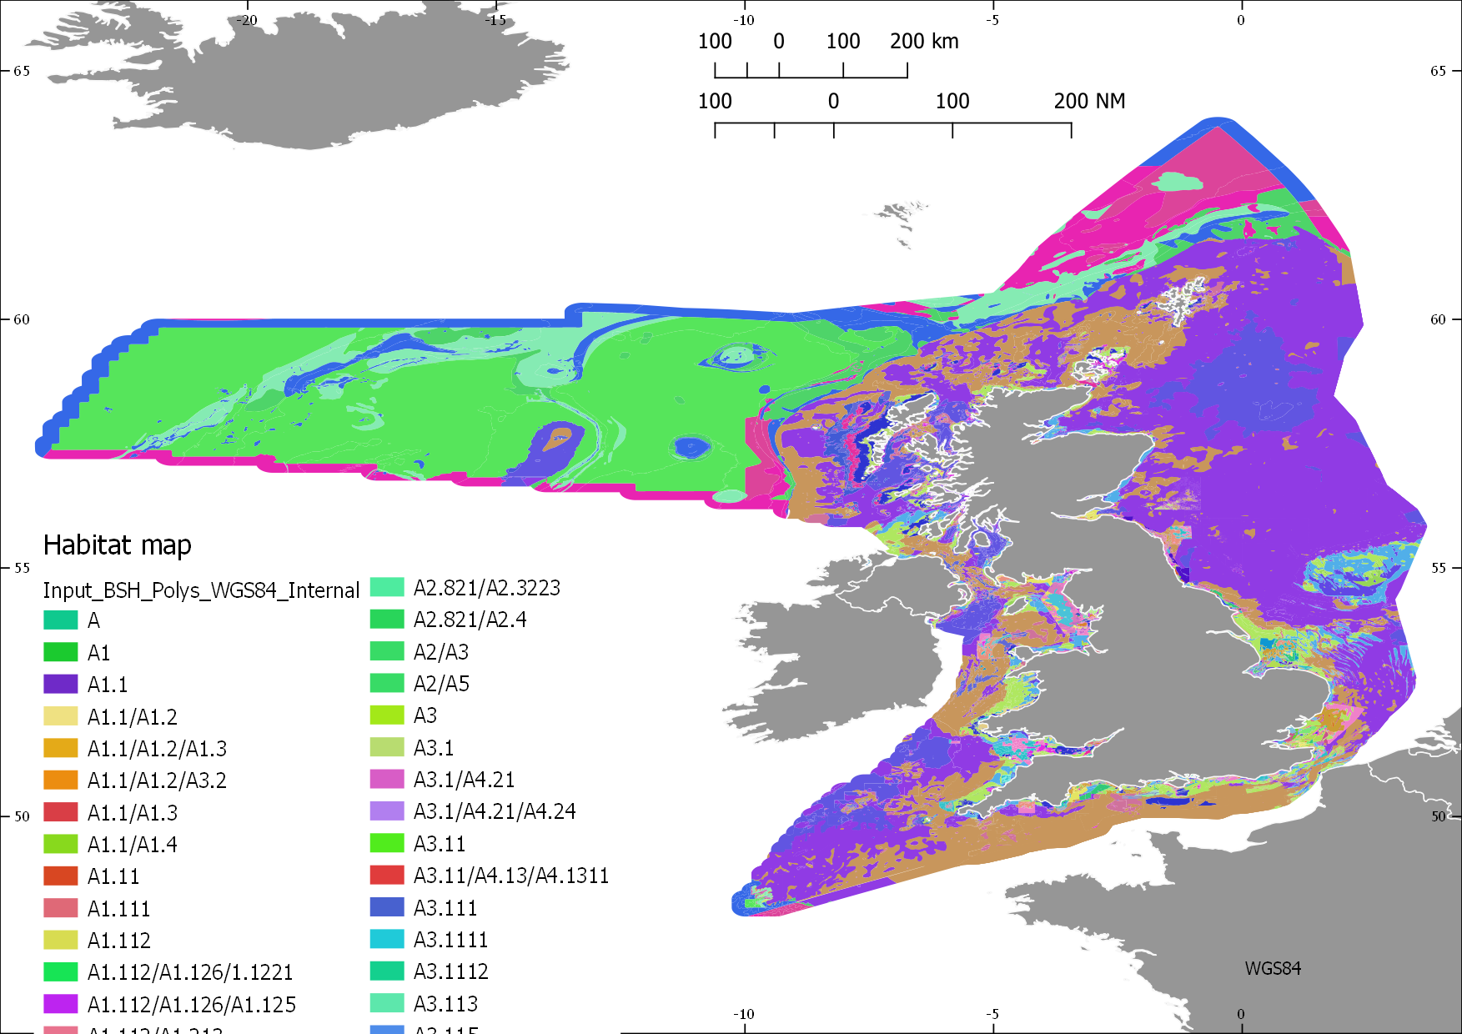

The benthic habitat map for the United Kingdom from 0 to 200 NM offshore, showing a small sample of the EUNIS habitat codes.

The habitat map was comprised habitat categories which were of different EUNIS levels (2 - 6) @ref. The differences in the habitat categories (EUNIS levels) is a result of different amounts of data available for the different areas across the EEZ. The development of the habitat is an ongoing process which updates the habitat maps and habitat classification system as new information becomes available. As such, there is variability in the amount of detail about the habitat (substrate and benthos), as well as variability in confidence between the mapped areas (referred to as polygons hereafter). The habitat map is therefore comprised of a patchwork of polygons which may differ in their shape, area and the habitat category (and EUNIS level) which they represent, as well as the level of confidence with which the habitat was category was assigned to it. The confidence associated with habitat classification of each polygon is represented by a MESH (Mapping European Seabed Habitats) score (*Annex MESH confidence*). MESH scores are derived from the confidence associated with different data sources used to inform the classification of the habitat category assigned to a polygon. The data sources used to generate the benthic habitat map are based on a variety of methods and data sources, such as remote sensing, side-scan sonar, sediment grabs and SCUBA-diver surveys.

### 3. Addressing the mismatch in EUNIS habitat assessments and the habitat map.

A significant proportion (70 %) of the mapped area of inshore and offshore habitats corresponded to EUNIS habitat categories which have been assessed for sensitivity, but about 30% of the area included habitat categories which have not had not been assessed. The main reason for this was the mismatch in the habitat categories included in the habitat map and those that have been assessed for sensitivity to pressures. The habitat map includes EUNIS level 2 - 6, while the assessments only cover EUNIS level 4 - 6.

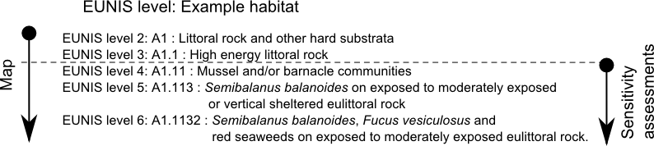 In order to remedy this mismatch, an approach was adopted in which the sensitivities of fine-scale habitats which are known to occur within broad-scale habitats were assigned to the polygons where a mismatch of EUNIS levels occurs, as follows.

#### 3.1 Integration of expert fine-scale benthic habitats within inshore sub-biogeoregions

Fine-scale benthic habitats (EUNIS level 4 - 6) which are known to occur within sub-biogeoregions within (0 - 12 NM) were identified by Dr Keith Hiscock in project (Hiscock, K. 2016). These fine scale habitats were then associated with their parent broad-scale habitats for each sub-biogeoregion.

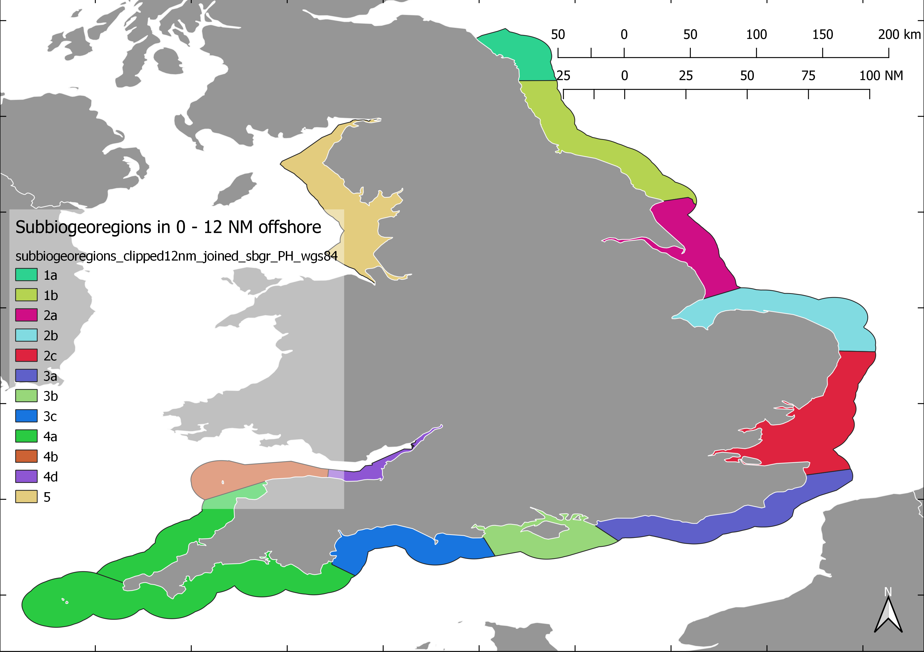

Figure 3: The subbiogeoregions within which fine-scale habitats (EUNIS level 4 - 6) are known, and were assocaited with broad-scale habitats from which fine scale habitat on the habitat map.

The EUNIS benthic habitat categories which appear on the habitat map were associated with habitat categories contained within the sensitivity assessment database. By joining these datasets sensitivity maps for benthic habitat to the various pressures and activities were generated. The following steps were taken to produce the habitat sensitivity maps from the aforementioned data sources.

### 4. Data processing

GIS steps were required to split the original habitat map into an inshore (0 - 12 NM) and offshore component (12 - 200 NM). All other technical data manipulation was carried out using the R statistical environment in effort to make the work repeatable and provide instant results following updates to the sensitivity assessment database (PD_AoO.accdb) or updates to the benthic habitat map.

#### 4.1 GIS steps:

Geoprocessing tools in QGIS was used for the production of the inshore (0 - 12 NM) and offshore (12 - 200 NM) areas. The habitat map (master copy - Marine_Evidence_Base_Internal.gdb) was copied, and clipped (using the DIFFERENCE geoprocessing tool in QGIS) keeping the area inside the English 12 NM boundary to create the basis for the inshore habitat map. The sub-bioregional shapefile was used to associate the subbiogeoregions (subbiogeoregions_clipped12nm_joined_sbgr_PH_wgs84.shp) to the individual polygons comprising the inshore habitat map, using INTERSECT geoprocessing tool in QGIS.

The files used are specified below.

## [1] "Inshore (inside 12NM) habitat map\nF:/copy_data/Marine_Evidence_Base_Internal.gdb --> DIFFERENCE with D:/projects/fishing_displacement/2_subprojects_and_data/2_GIS_DATA/masks/mask_minus_12nm_and_land_WGS84.shp\nNAME: D:/projects/fishing_displacement/2_subprojects_and_data/2_GIS_DATA/Marine habitat/Input_Polys_WGS84_Internal_BGR_inside_12nm.gpkg"

## [1] "Associate subbiogeoregions to Inshore habitat map\nInput_Polys_WGS84_Internal_BGR_inside_12nm.gpkg --> INTERSECT with subbiogeoregions_clipped12nm_joined_sbgr_PH_wgs84.shp"

The GIS process for the inshore map can be depicted in flow diagram as follows, where the files shown above were the input to the GI geoprocessing tools shown below. 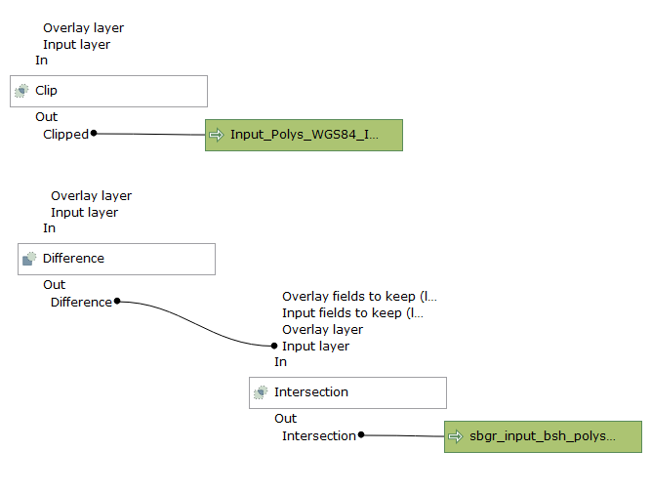 The offshore habitat map was prepared by clipping (DIFFERENCE geoprocessing tool in QGIS) with the English 12 NM boundary, keeping the area outside of the 12 NM boundary. A column was added to the offshore dataset (built into the R script described below), equivalent to the subbiogeoregion column added to the inshore habitat map, but here labeling all polygons as “offshore”, to allow merging of the end products.

The files used for the offshore data layer are specified below

## [1] "Offshore (outside 12 NM) habitat map\nF:/copy_data/Marine_Evidence_Base_Internal.gdb <U+2192> CLIP with D:/projects/fishing_displacement/2_subprojects_and_data/2_GIS_DATA/masks/mask_minus_12nm_and_land.shp"

#### 3.2 R-code steps

All programming to generate habitat sensitivity layers was carried out in R. the files are stored on Natural England’s GitHub [webpage](https://github.com/naturalengland/marine_biotope_sensitivity). Here only the high-level overview of how the code works is described, Details about what each section of code does is described within each file. The inshore and offshore are two separate sets of code, and run indecently, after they were split using the GIS described above. The R scripts of r the inshore and offshore follow largely the same steps, described below.

The code is structured as a main script which calls sixteen helper functions to run the separate processes sequentially over 11 steps. In the main script, the user provides input, such as the locality of the input data sources, e.g. Microsoft Access database, and habitat maps. Furthermore, the location of outputs generated, and the choice of file names. Once the user enters these inputs, the main body of the code can be run, where upon the user will be prompted to select one of the 18 Operations for which to generate habitat sensitivity maps. Once the user has entered their selection, the code runs without further user input requirements.

##### The eleven steps follow:

The main script now starts calling the helper functions, one at a time, and passes on output from a previous step for further processing. It starts by (1) reading the desired section of data from the MS Access database, which it runs through a query to obtain a list of EUNIS habitat types and their sensitivity assessments. (2) It then ranks the possible combinations of sensitivity scores from 1 - 6 based on the degree of their sensitivity, to allow selecting the greatest (maximum) sensitivity associated with a fine-scale habitat occurring within a broad-scale habitat, further down the process (see step 10). The ranks are then associated to the appropriate sensitivity category in the list of EUNIS-sensitivity assessments. A lists of unique combinations of sensitivities to each pressure (39) is then generated for each of the assessed EUNIS habitats, separately for each activity within the operation. (“act.press.list”) (3) The GIS file (geodatabase) is read in either from a new location supplied by the user, or from a back-up copy to avoid future changes to the map preventing the code from running should there be a mistake in the new map. (4) The GIS attributes are then separated from the polygons to allow for efficient data handling. In this step the data are cleaned, e.g. white space and inconsistent data separators were corrected. The “HAB_TYPE” column in the GIS habitat map is the main source of information which describes the EUNIS habitats associated with each polygon on the habitat map. Where more than one habitat were associated with a polygon, only the first instance was kept, as this is understood to be the dominant habitat in that polygon. (5) Step five associates the EUNIS levels to the data set, based on the number of characters in the EUNIS code provided. This step allows for splitting the assessed data according to levels further down the process. (6) Step six is the critical step in the code. In step 6, the GIS data set is also attributed with habitat levels. This dataset is then split to according the subbiogeoregions (sbgr), and only a unique set of EUNIS codes per sbgr is retained in parameter called “bgr.dfs.lst”. The database-sourced habitat sensitivity assessments are then split into matrices according to their EUNIS levels, called “x.dfs.lst”. The two data sets (two lists containing matrices) are then matched in a cross tabulation exercise, such that where character coding of a fine-scale habitat matches that of a broad-scale habitat, the fine-scale habitat is recorded as a new value in the cross tabulation. The matrices of unique habitats per sbgr (“bgr.dfs.lst”) were therefore sequentially matched assessment data matrices (“bgr.dfs.lst”). The process is therefore done for separately for of the subbiogeoregions, within a EUNIS level, and repeated until all subbiogeoregions are complete, before it moves onto the next EUNIS level. The result is a set of data matrices in which per EUNIS level and where the fine-scale habitats which correspond to broad-scale habitat (EUNIS level 2 - 3) are stored as values in cross tabulated data matrices. (7) In step seven, the data matrices of the same according to subbiogeoregion, were then merged into a single data matrix (“sbgr.matched.btpt.w.rpl”) for each sbgr, as follows: the data matrix representing EUNIS level 4 was overlaid on the the data matrix representing EUNIS level 5, replacing only values in this matrix where there was not already a value in the EUNIS level 5 data matrix.i.e. replace missing values. This new dataset was then overlaid onto the EUNIS level 6 data matrix,again replacing only missing values. The result was a single data matrix for each sbgr, in which the fine-scale habitat was retained per matching broad-scale habitat. Note that multiple fine-scale habitats may be associated with a broad-scale habitat within its sbgr. (8) In step eight, the unique combinations of fine-scale habitats in broad-scale habitats is joined to the list of habitat sensitivities per pressure, for each per sbgr within each activity (“act.press.list”). This generated a new list of data matrices data matrices (“xap.ls”). In this new list of data matrices **all** unique fine-scale-habitats-within-broad-scale habitats were associated with the habitat assessments, with one data matrix per pressure-sensitivity combination. (9) Step nine compares and keeps only maximum values for each biotope-pressure-activity-sub-biogeographic region combination. maximum is retained in a R list “act.sbgr.bps.gis”. (10) the outputs from step nine are used in step ten, where it retains only the habitat-sensitivity assessment of the assessed habitats which had the highest sensitivity score, per GIS polygon ID value. This set of data matrices are stored in an R object “sbgr.BAP.max.sens”. (11) The sbgr.BAP.max.sens is then associated (joined) to the GIS habitat map layer, and saved as a new geopackage (gpkg) file outside of R, in the directory specified at the start by the user.

The process was the same for the offshore, but he database was not split into subbiogeoregions.

## Case Study

### Fishing activity data investigation

The spatial match of scallop dredging activity was compared to the distribution of sensitive habitats. The habitat sensitivity map to abrasion (Pressure code D6) from dredging (activity code Z5) in the UK’s EEZ was used. The aggregated dredging activity between 2013-2014, “Fishermap_JNCC_NE_UK_VMS_Fishing_Activity.gdb“, in the English EEZ was used to assess the spatial overlap between dredging activity and sensitive benthic habitats. The fishing activity data set contains all scallop dredging, tractor drawn dredging, and rake dredging data, but the latter two only apply to the shoreline-area, and can therefore the layer can largely be regarded as an indication of scallop dredging. In future this layer may be replaced by another, but here it is meant to be proof of concept.

*Requires further infomration on background of Fishermap_JNCC_NE_UK_VMS_Fishing_Activity.gdb data to spell out details around the layer; and describe the values on the table*

was overlaid onto the habitat sensitivity map to investigate 1.) the overlap of dredging activities on habitats which are sensitive thereto, 2. ) the placement of MPAs in relation to the impacts on sensitive benthic habitats.

## Sensitivity confidence assessments (MarESA methods)

1. Quality of evidence (QoE) e.g. Peer review, grey literature etc. Displayed as a map, all others in table format in the Annex.
2. Applicability of Evidence (AoO) How realistic is it for a given pressure to impact upon a habitat
3. Degree of concordance between evidence (DoE) Agreement between different evidence sources.

Single confidence index: Mean high (all high) (lowest common denominator) everything else majority rule

## GIS data

### Fishing pressure layer

A fishing activity layer for dredging and the current Marine Conservation Zone (MCZ) layer shows the placement of MCZs in relation to the fishing activity. 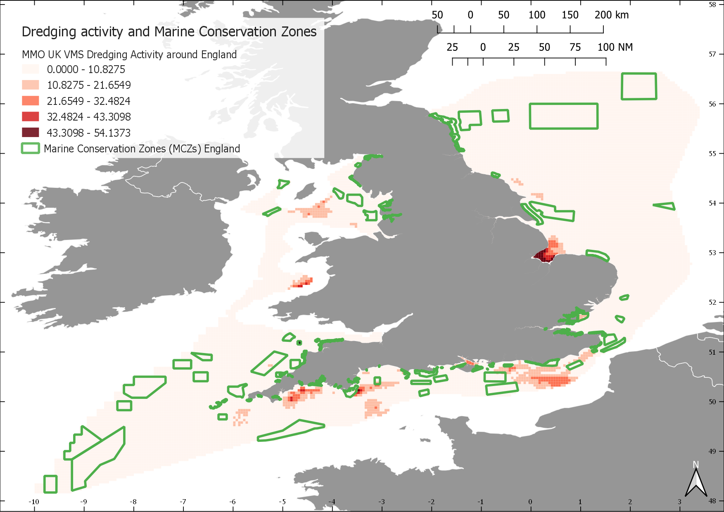 Marine protected area layer (Provide metadata description) The Marine Conservation Zone data layer for England was overlaid to provide insight into the overlap of dredging activities and protected areas.

# Results

In total 390 benthic habitat sensitivity maps were produced for 39 pressures from the ten fishing activities. Output maps were vector based, and mirror the spatial resolution and habitat detail of the benthic habitat map.

## Case study results

1. The spatial distribution of benthic habitat sensitivity to abrasion from dredging is shown in Figure @ref(fig:insh_drdg). (or merge the inshore and offshore into 1 figure perhaps?)

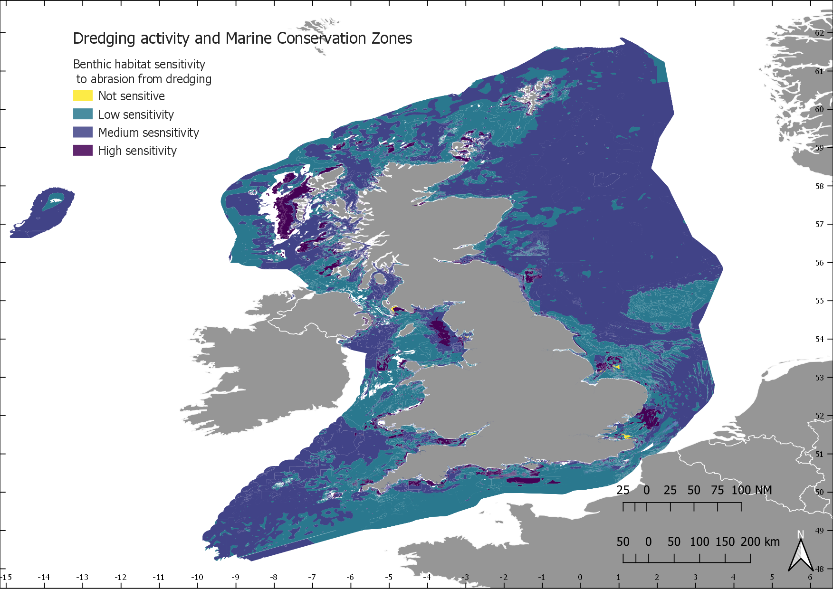

Figure : The benthic habitat sensitivity to abrsation from dredging activities in the UK’s Exclusive Economic Zone (EEZ)

1. Overlay fishing activity And provide some analysis of the proportion of sensitivity categories which overlap with dredging activity (which may need to be categorised into high/medium/low?)
2. Overlay the MPAs, and repeat the above?

# Discussion

The sensitivity maps

## Future development of the research

In a second phase essential fish habitat which are currently only lightly impacted, or not impacted will be identified.

A follow up project will consider: A third project objective is the development of maps of the sensitivity distribution for 30 fish and shellfish species within UK waters to fishing related activities. These models are underpinned by sensitivity assessments carried out at set benchmarks, and coupled with species distribution models.

## Compare with quantitaive methods

This is fundamentally different from how recovery time is estimated using quantitative methods. Recovery as used in quantitative models follows a mathematical formula such as a modified Lotka–Volterra to estimate the based on the assumption that the recovery rate of organisms is uniform according to size and being soft or hard bodied organisms [dupliseaSizebasedModelImpacts2002].

# Annex

**Table.** EUNIS MESH confidence scores

|  |  |  |
| --- | --- | --- |
| Confidence Range (%) | Confidence Level | Explanation |
| 0 < x ≤ 20 | Very low confidence | - |
| 20 < x ≤ 37 | Low confidence | Upper limit is the highest possible score for maps that use only physical ground truthing data |
| 37 < x ≤ 58 | Moderate confidence | Upper limit is the highest possible score for maps that use only physical and biological ground truthing data. |
| 58 < x ≤ 79 | High confidence | Upper limit is the highest possible score for maps that use only physical ground truthing and remote sensing data. |
| 79 < x ≤ 100 | Very high confidence | Maps with confidence scores higher than 79 % definitely include biological ground truthing and remote sensing data. |

# Refs to add

Tyler‐Walters, H., and Jackson, A. 1999. Assessing seabed species and ecosystems sensitivities; rationale and user guide. Report to English Nature, Scottish Natural Heritage and the Department of the Environment Transport, and the Regions from the Marine Life Information Network (MarLIN report 4). Marine Biological Association of the United Kingdom , Plymouth .

# References

Bastardie, Francois, J Rasmus Nielsen, and Tanja Miethe. 2013. “DISPLACE: A Dynamic, Individual-Based Model for Spatial Fishing Planning and Effort DisplacementIntegrating Underlying Fish Population Models.” *Canadian Journal of Fisheries and Aquatic Sciences* 71 (3): 366–86.

Bax, Nicholas J., and Alan Williams. 2001. “Seabed Habitat on the South-Eastern Australian Continental Shelf: Context, Vulnerability and Monitoring.” *Marine and Freshwater Research* 52 (4): 491–512. doi:[10.1071/mf00003](https://doi.org/10.1071/mf00003).

Chollett, Iliana, Stephen J. Box, and Peter J. Mumby. 2016. “Quantifying the squeezing or stretching of fisheries as they adapt to displacement by marine reserves.” *Conservation Biology* 30 (1): 166–75. doi:[10.1111/cobi.12573](https://doi.org/10.1111/cobi.12573).

Duplisea, Daniel E, Simon Jennings, Karema J Warr, and Tracy A Dinmore. 2002. “A Size-Based Model of the Impacts of Bottom Trawling on Benthic Community Structure.” *Canadian Journal of Fisheries and Aquatic Sciences* 59 (11): 1785–95. doi:[10.1139/f02-148](https://doi.org/10.1139/f02-148).

Hiddink, J G, S Jennings, M J Kaiser, A M Queirós, D E Duplisea, and G J Piet. 2006. “Cumulative Impacts of Seabed Trawl Disturbance on Benthic Biomass, Production, and Species Richness in Different Habitats.” *Canadian Journal of Fisheries and Aquatic Sciences* 63 (4): 721–36. doi:[10.1139/f05-266](https://doi.org/10.1139/f05-266).

Hiddink, J. G., S. Jennings, and M. J. Kaiser. 2007. “Assessing and Predicting the Relative Ecological Impacts of Disturbance on Habitats with Different Sensitivities.” *Journal of Applied Ecology* 44 (2): 405–13. doi:[10.1111/j.1365-2664.2007.01274.x](https://doi.org/10.1111/j.1365-2664.2007.01274.x).

Jennings, Simon, John K. Pinnegar, Nicholas V. C. Polunin, and Karema J. Warr. 2001. “Impacts of Trawling Disturbance on the Trophic Structure of Benthic Invertebrate Communities.” *Marine Ecology Progress Series* 213 (April): 127–42. doi:[10.3354/meps213127](https://doi.org/10.3354/meps213127).

Kaiser, M. J., D. B. Edwards, P. J. Armstrong, K. Radford, N. E. L. Lough, R. P. Flatt, and H. D. Jones. 1998. “Changes in Megafaunal Benthic Communities in Different Habitats After Trawling Disturbance.” *ICES Journal of Marine Science* 55 (3): 353–61. doi:[10.1006/jmsc.1997.0322](https://doi.org/10.1006/jmsc.1997.0322).

Phillipson, Jeremy, and David Symes. 2018. “’A Sea of Troubles’: Brexit and the Fisheries Question.” *Marine Policy* 90 (April): 168–73. doi:[10.1016/j.marpol.2017.12.016](https://doi.org/10.1016/j.marpol.2017.12.016).

Thurstan, Ruth H., Simon Brockington, and Callum M. Roberts. 2010. “The Effects of 118 Years of Industrial Fishing on UK Bottom Trawl Fisheries.” *Nature Communications* 1 (May): 15. doi:[10.1038/ncomms1013](https://doi.org/10.1038/ncomms1013).

Tillin, H. M., J. G. Hiddink, S. Jennings, and M. J. Kaiser. 2006. “Chronic Bottom Trawling Alters the Functional Composition of Benthic Invertebrate Communities on a Sea-Basin Scale.” *Marine Ecology Progress Series* 318 (August): 31–45. doi:[10.3354/meps318031](https://doi.org/10.3354/meps318031).

Tillin, HM, and H. Tyler-Walters. 2014. “Assessing the Sensitivity of Subtidal Sedimentary Habitats to Pressures Associated with Marine Activities. Phase 1 Report: Rationale and Proposed Ecological Groupings for Level 5 Biotopes Against Which Sensitivity Assessments Would Be Best Undertaken.” 512A. Peterborough, UK: Joint Nature Conservation Committee.

Vaughan, Duncan. 2017. “Fishing Effort Displacement and the Consequences of Implementing Marine Protected Area Management Perspective.” *Marine Policy* 84: 228–34. doi:[10.1016/j.marpol.2017.07.007](https://doi.org/10.1016/j.marpol.2017.07.007).

Walport, Mark, and Ian Boyd. 2017. “Foresight Future of the Sea: A Report from the Government Chief Scientific Adviser.” Government Chief Scientific Advisor.

Zacharias, Mark A., and Edward J. Gregr. 2005. “Sensitivity and Vulnerability in Marine Environments: An Approach to Identifying Vulnerable Marine Areas.” *Conservation Biology* 19 (1): 86–97. doi:[10.1111/j.1523-1739.2005.00148.x](https://doi.org/10.1111/j.1523-1739.2005.00148.x).