ripInverts - paper content

## 3 Methods

### 3.2 Comparison between pit falling and timed hand searches.

We explored effect of sampling type on the the composition of the communities we recorded. The similarity of the presence/absence data between each two replicates was quantified using the Jaccard index. Permutational Multivariate Analysis of Variance (PERMANOVA) was carried out on the resulting similarity matrix to establish the contribution of event, river and sample type to the variance of similarity. All this was carried out in one step using the R function vegan::adonis2. [citations to be added]

### 3.4. To what extent do sampling events adequately represent the full diversity of riparian beetles present along any given stretch?

We examined the completeness of the riparian beetle inventory by creating species accumulation curves which plot the number of species against sampling effort. In most cases, we used number of replicates as the measure of sampling effort, although we also considered events and event/sample-type. Species accumulation curves were fitted using the R function vegan::specaccum. As the probability of finding a new species with an additional sample approaches zero, species accumulation curves reach an asymptote. We considered it sufficient to judge this by eye using graphs of the relevant curves. [citations to be added]

## 4 Results and Conclusions

### 4.2 Comparison between pit falling and timed hand searches.

Accross all sampling events, 551 species were found. Of these, 178 species were found by handsearch only, 107 by pitfall only and 266 by both handsearch and pitfall methods (see fig x).

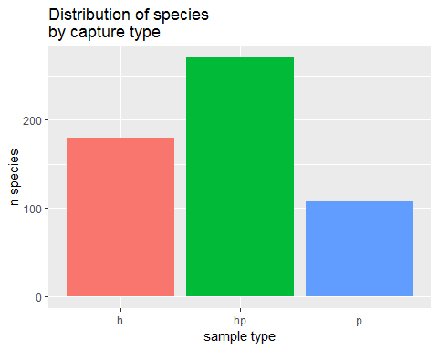

Of these, 300 are wetland species, and 225 are not. Wetland species were caught by pitfall only in significantly lower proportions to non-wetland species, but significantly higher proportion of species was caught by both handfall and pitfall methods (Pearson’s Chi-squared test, X-squared = 39.0950277, df = 2, p = 0)

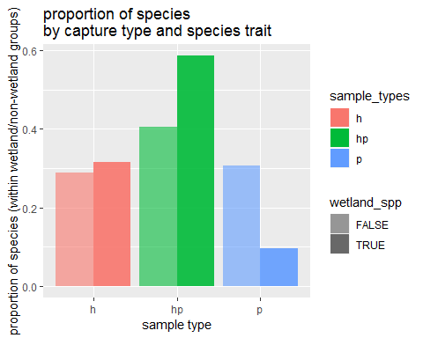

It was expected that the physical dimensions of a species would be predictive of whether they were more likely to be caught in a pitfall trap or not. However, no such effect was found when looking at minimum length (maximum length showed an even smaller difference). *[need to add in statistical test for difference, but it’s not going to be significant as you can see from the boxplots]*

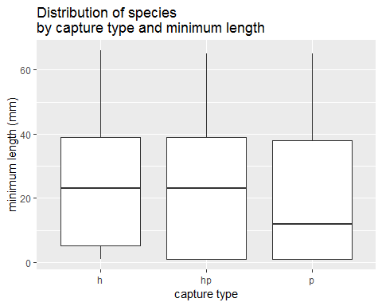

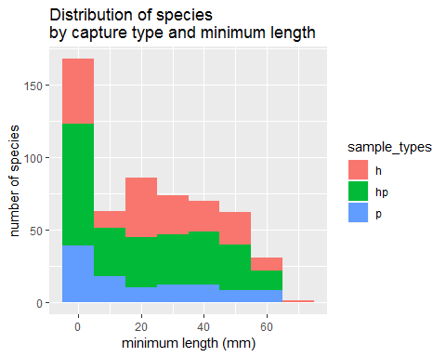

After controlling for river and event, sample type makes a significant contribution to the dissimilarity between samples (1 Df, F = 8.11, p = 0.0083)

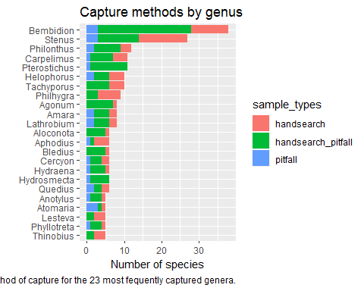

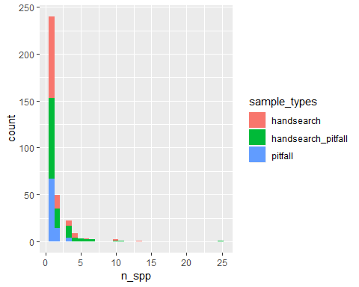

### 4.4 To what extent do sampling events adequately represent the full diversity of riparian beetles present along any given stretch?

If a survey has found all species present, the species accumulation curve should flatten and reach an asymptote as it approaches the total number of species found. When plotting the observations of all species on an accumulation curve, there is still an appreciable gradient in the curve as it approaches the total nubmer of species (551n). We can therefore conclude that the data does not comprise an exhaustive inventory of all wetland invertebrates in all the rivers sampled. This should not be surprising as the surveys in question cover a range of rivers and geographical locations.

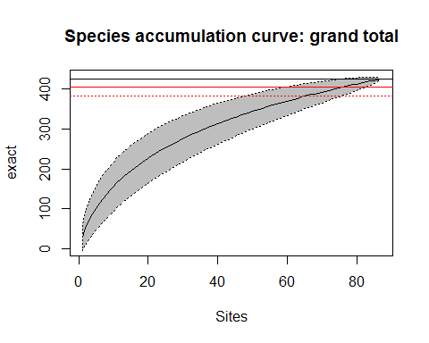

Of more interest is whether there is sufficient sampling of each river. Most of the rivers have very low levels of replication and it is clear from the steepness of the accumulation curves that they are not close to leveling out. In the case of the Wye (41 replicates) and the Lugg (28 replicates) there is some levelling out but still no asymptote is reached.

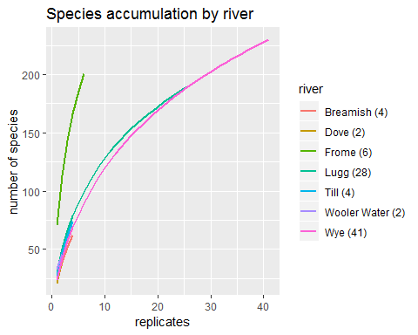

It may be that this is due to the heterogeneity of species compositions along rivers - this should be reduced at the event level. Unfortunately, at the level of events the greatest level of replication is n = 9 samples. It can be seen that this is insufficient replication for the species accumulation curve to reach an asymptote.

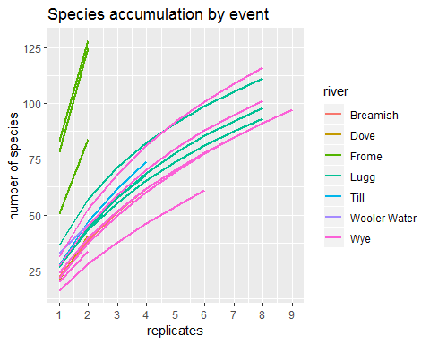

The last remaining source of sampling variability is is the type of sample (hand search or pitfall) and we looked at whether splitting by these results in a sample reaching an asymptote within an event. Here we have even less replication (max is n = 5, the majority are n = 4 or lower) and it is clear that no asymptote is reached.

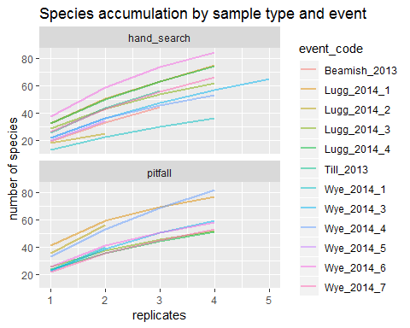

We therefore conclude that the proposed method is not capable of sampling the full abundance of species even at replication of 40 samples for a single river. It is not known what level of replication would be sufficient.