Plan of Action
Differences in software performance for analyses of
High Throughput Ion Torrent DNA barcode data.
Bio-informatics, Year 3 2012-2013, 1st and 2nd term, BPDSA, 8EC.

Authors: Alex Hoogkamer, Thomas Bolderink and Roeben vink.
Supervisors: Dr. Sigrid Beiboer, Dr. Barbara Gravendeel and Dr. Rutger Vos
Content
Introduction 3
Research questions 3
Problem 1.......................................................................................................................................3
Hypothesis 1 3
Problem 2 3
Hypothesis 2 3
Goals 3
Products 3
Project boundaries 3
Quality 3
Project organization 3
Project agreements 3
Planning 3
Software Testing Flowchart 3
Project flowchart 3
Pipeline flowchart………………………………………………………………………………………………………………………3
Risk analysis 3

Introduction
In recent years, Traditional Chinese Medicines (TCMs) have become increasingly popular in western countries. These TCMs make use of endangered species of plants or animals and may contain potentially dangerous components. This is a serious danger to the continued existence of certain plants and animals in the wild. In order to better protect these organisms and to prevent harm to humans, it is necessary to identify which species and components are present in TCMs. Since TCMs contain a mix of species they are currently analyzed with DNA barcoding using a high‐throughput technique: Ion Torrent sequencing. This saves a lot of time and money.
Careful information of the DNA barcoding regions present in these medicines is necessary.
However, without good software, it might prove very hard to make correct observations of the DNA barcodes found in TCM samples. To do this, three different packages will be compared: Geneious, CLC Bio and Life Technologies Ion Torrent software. This will be done by comparing a dataset from a single TCM sample on all three packages, so that decent assumptions can be
made about each package's unique set of features and methods in relation to their function of
properly identifying (illegally‐used) plant species.
Important functions to compare include the way data is imported, the workload necessary
to gain proper results, how much options there are in modifying BLAST settings and how accurate the results are. Other important factors are user friendliness of the program and visual representation of the results. A program with clear, color‐coded results will rank higher than a program that only displays names in a single list of names and scores. Additionally, this project will include the creation of a pipeline, the steps of which will initially be decided upon via an ad‐hoc basis. Following review of these steps, a streamlined version will be decided upon and created.

Research questions

Problem 1
Why do different software packages give different blast results?

Hypothesis 1
Different programs use different settings, perform more or less accurate BLASTs, trim the reads differently or not at all, and/or do not use the same reference databases.

Problem 2
What would be the added value of a newly designed pipeline next to already existing software?

Hypothesis 2
The newly designed pipeline would be for free (licenses for other software are expensive), offers more flexibility for data handling, and/or produces more accurate results.

Goals
This project will have several goals. Because this is a educational project most of the goals will be about educating ourselves and gaining new skills.
- Writing reports in English.
- Gain experience in a 20 weeks project.
- Examining software.
- Learn how to recommend software based on own research.
- Programming a pipeline.
- Learning to work with Microsoft Word.
- Communication with teachers and clients.
- Project management.
- Learning to write a Plan of Action showing insight in assignment.

Products
At the end of the project the following products will we handed over:
- Preliminary report consisting of our findings concerning the examined software packages and
an advice on the program that performed the best during the testing.
- A pipeline that can automatically trim the Ion Torrent dataset, BLAST (P) the trimmed dataset,
reliably identify organisms in the dataset and show the results in a clear and simple format.
- Manual of the pipeline, explaining how to use the program and containing further information (e.g. formats, options etc).
- Final report, this will give a detailed explanation about the methods, findings of the project and the code of the pipeline program (well documented for further use).

Furthermore, several presentations will be given. For school 2 presentations will be held and a 3rd (final) presentation will be held for Naturalis.

Project boundaries

For the first part of the project the main focus lies on discovering why three software-packages get different results while the input remains the same.
The second part of the project consists of building a pipeline to make analyzing the data generated by the sequencer easier and more user friendly(only display less complicated options, fixed parameters, etc).
It is important not to stray too far from these set tasks, if such a thing might occur we will plan a additional meeting to confess this problem.
The duration of the project according to the modulewijzer for each member will be 224 hours distributed over a time period of 20 weeks.

Quality
In order to maintain a high quality report the following points will be monitored :
- Correct grammar.
- Substantive level of information.
- Style.
- Lay-out.
- Correct Image subscripts.
- Relevance.
- The source of the information.
The final report is read by all members prior to submission and checked again for any mistakes.

project organization
Chair:
Alex Hoogkamer
Email: aqhoogkamer@outlook.com
Email: S1047388@student.hsleiden.nl
Tel: 06-54797996
Secretaries:
Roeben Vink
Email: roeben@zonnet.nl
Email: S1047911@student.hsleiden.nl
Tel: 06 55533002
Thomas Bolderink
Email: Thomas_bolderink@hotmail.com
Email: s1047798@student.hsleiden.nl
Tel: 06 11283106
Project supervisors:
Sigrid Beiboer
Email: beiboer.s@hsleiden.nl
Dr. Barbara Gravendeel
Email: barbara.gravendeel@naturalis.nl
Dr. Rutger Vos
Email: Rutgeraldo@gmail.com
Clients:
Dr. Barbara Gravendeel
Email: barbara.gravendeel@naturalis.nl
Dr. Rutger Vos
Email:Rutgeraldo@gmail.com

Project agreements
The role of secretary is exchanged weekly where Roeben will be the first to do so. The presidency is fixed and thus will not be exchanged by the members. During the meetings, the progress of the overall planning be reviewed (and modified if necessary) and any irregularities and/or problems of the previous week are discussed. The records of the meeting will be mailed within 24 hours to the project members and project supervisor.
The project supervisor and clients will be available via email and personal contact for questions and/or uncertainties. Each week there will be a meeting with the project supervisor as scheduled on the school planning. The client will be kept informed via a weekly email containing results and what progress is made. It is expected that mails are answered as soon as possible and that appropriate help will be offered if needed.
For this project we will use Github. All members of the project group will have access to the Github folder used for the project. Everyone will put data, script components and parts of the Plan of Action and report in the shared Github folder when done. Every time a member makes changes to a document a version number is added to the document name. Each member will have its own part to work on the script so comments in the script will be added containing the date and time and the changes made/work done. A new document will be made containing the version number and the changes made in that version.
In the occasion that any member in not able to join the weekly meetings he is expected to inform the other members of his absence as soon as possible
Both the module supervisor and clients will receive a copy of the final products by e-mail.

Planning
What | Person | Who | Start | End | Deliverables
Plan of action | Alex | Alex,Roeben,Thomas | 24-9-2012 | 1-10-2012 | Plan of Action .docx/.pdf
Software Testing (data input, time, number of actions) | Roeben |  | 28-9-2012 | 9-10-2012 | Put data on Github
Software Testing(output, settings, validity) | Thomas |  | 9-10-2012 | 17-10-2012 | Put results on Github
Software Testing with incense data | Alex |  | 17-10-2012 | 30-10-2012 | Put results on Github
Clc bio |  | Roeben
Geneious |  | Thomas
Torrent Suite |  | Alex
Preliminary report | Thomas | Alex,Roeben,Thomas | 2-11-2012 | 9-11-2012 | Report
Pipeline Script(research) | Thomas | Alex,Roeben,Thomas | 31-10-2012 | 7-11-2012 | Put challenge on Github
Pipeline Script (programming) | Roeben | Alex,Roeben,Thomas | 7-11-2012 | 27-12-2012 | Put scripts on Github
Pipeline Script(validation) | Alex | Alex,Roeben,Thomas | 18-12-2012 | 11-1-2013 | Script, validation report
Presentation | Roeben | Alex,Roeben,Thomas | 16-1-2013 | 21-1-2013 | Presentation
Final report | Alex | Alex,Roeben,Thomas | 14-1-2013 | 28-1-2013 | Report

Incense data: Naturalis is currently working on an new Ion Torrent data set acquired from incense with fully known ingredients. When the data set is ready it will be passed to us. Earlier testing’s will be done with data provided of TCMs with unknown ingredients and contamination.

Software Testing Flowchart

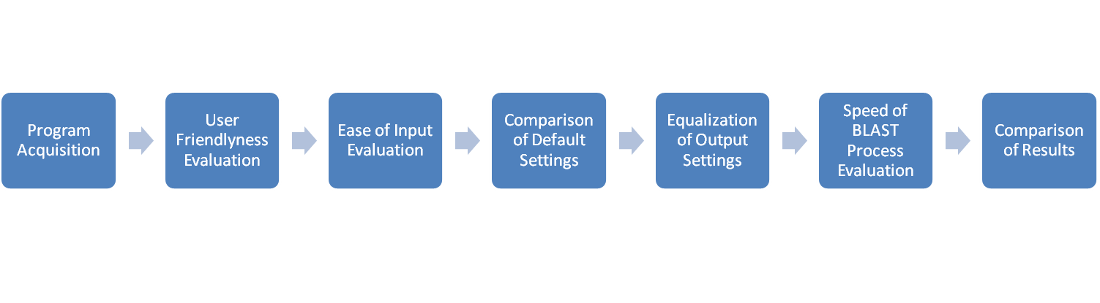

Project flowchart

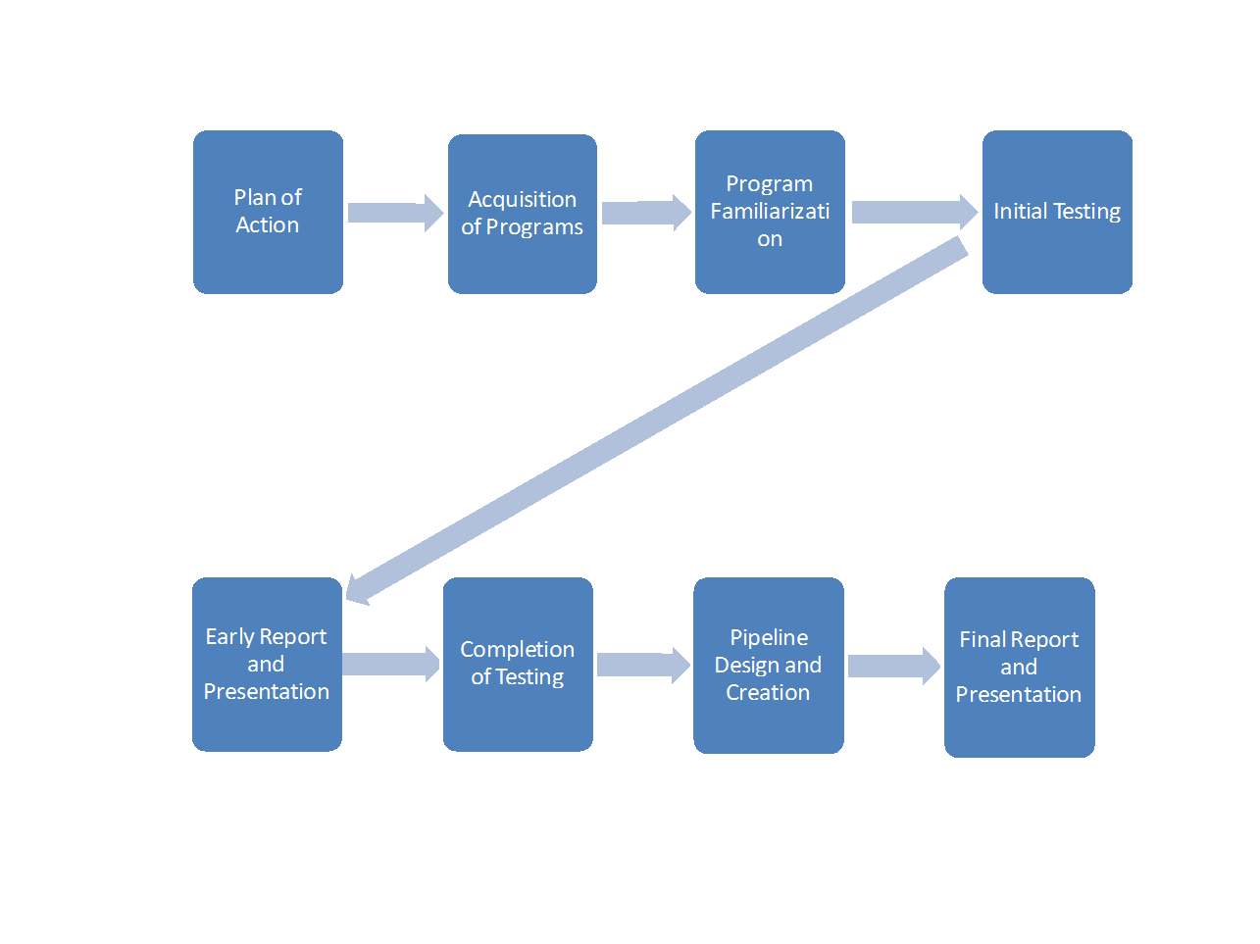

Pipeline flowchart

Risk analysis
Main probable causes of project failure include the unavailability of licenses or the sudden incorporation of a large update halfway through the project, which would in theory require a complete redo of that part of the research process.
Smaller concerns include hardware failure (e.g. computers don’t have enough memory for some of the tasks of the software) and other mechanical failures. Personal injury during the project might also result in loss of knowledge and results.
Risk | Description | Chance of appearance | Impact | Chance of discovery | Risk factor
1 | Inadequate programming experience | 3 | 2 | 1 | 6
2 | Problems due to hardware failure | 3 | 3 | 1 | 9
3 | Bad communication/communication error | 3 | 3 | 2 | 18
4 | Not following up on agreements | 2 | 3 | 2 | 12
5 | Missing deadline | 3 | 5 | 4 | 60
6 | Project members quitting the project | 2 | 4 | 2 | 16
7 | Low quality products | 2 | 4 | 2 | 16

For all risk factors 1 is low and 5 is high. Three factors are taken into account : chance of appearance , impact and chance of discovery. The risk factor is calculated by multiplying the three individual value’s . Anything under 10 constitutes a minor risk. A score between 11 and 29 is considered a risk that warrants small preventive measures. Scores above 30 are serious risks that need to be contained as much as possible (see Appendix 1).

