**DATA TEST 1**

Default:

*Forward*

errF <- learnErrors(cutFs, multithread = TRUE)

102643734 total bases in 411085 reads from 42 samples will be used for learning the error rates.

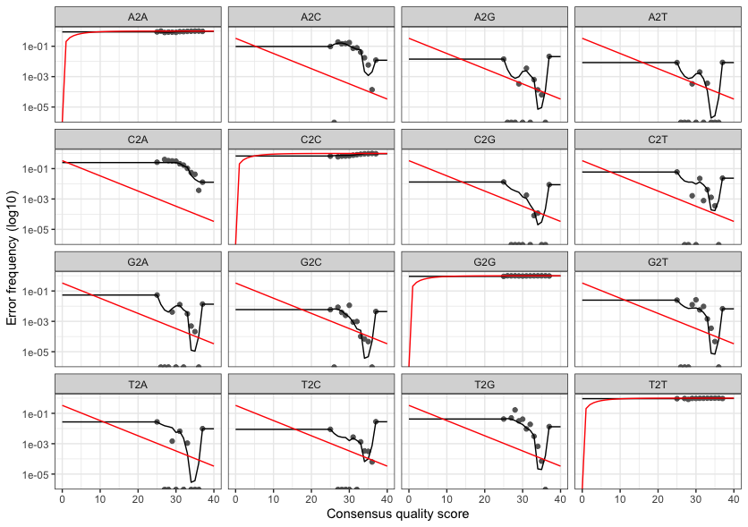

*Reversed*

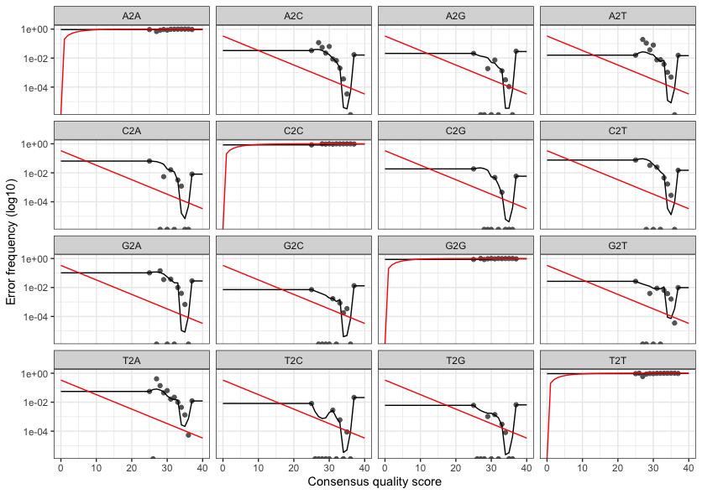

Option 1

*Forward*

120745010 total bases in 481074 reads from 50 samples will be used for learning the error rates.

Initializing error rates to maximum possible estimate.

Error rates could not be estimated (this is usually because of very few reads).

Error in getErrors(err, enforce = TRUE) : Error matrix is NULL.

*Reversed*

119832639 total bases in 481074 reads from 50 samples will be used for learning the error rates.

Initializing error rates to maximum possible estimate.

Error rates could not be estimated (this is usually because of very few reads).

Error in getErrors(err, enforce = TRUE) : Error matrix is NULL.

**DATA TEST 2:**

**Default**:

*Forward*