The potential current and future (2050) distribution of the common squirrel monkey (Saimiri sciureus).

Name: Fabio Sweet
Student number: 1943987

Species introduction
Saimiri sciureus is a common New World monkey native to the Amazon rainforest. According to GBIF’s database, it can be found almost everywhere in the northern half of South-America; according to the IUCN red list, it can be found in protected areas in Brazil, Guyana, French Guyana, Suriname, Colombia, Equador and Peru (Boubli et al. 2008)⁠. It has also been introduced into Florida in the 1969’s to attract tourists, and according to the ‘Florida Fish and Wildlife Conservation Commission’, there are three reported breeding populations in the state (Florida Fish and Wildlife Conservation Commission n.d.)⁠. It is currently listed as a species of least concern due to its adaptability, wide distribution and the apparent lack of big threats. Its adaptability in disturbed areas is part of this assessment, and it is also commonly found close to human settlements. They are not actively hunted, but they are in some places trapped for pet trade (Boubli et al. 2008)⁠. Information on the habitat and ecology can be found in the same assessment by Boubli et al..

Methods
The potential distribution was estimated with the use of data from GBIF and MaxEnt. On MaxEnt, the linear and quadratic features were selected, as organisms have the tendency to have either a linear or parabolic response to environmental pressures. The settings proposed in the handout were used for building the models. The output format was set to logistic, as probability of presence values from the response curve output can then be interpreted as the probability of occurrence. For this analysis, bio2, bio8, bio9, bio16 and bio17 were used; these bioclimatic values stand for ‘mean diurnal range’, ‘mean temperature of wettest quarter’, ‘mean temperature of driest quarter’, ‘precipitation in wettest quarter’, and ‘precipitation in driest quarter’, respectively. This was deemed to be a probable combination of non-correlated effectors for tropical rainforest animals.

Present and future potential distribution
The AUC of the model is 0.796, which would put it in the ‘useful’ class of distribution models (contested). The mean temperature in the driest quarter and the precipitation in the driest quarter influence the model most.
Based on these climatic (abiotic) variables, the current potential distribution of Saimiri sciureus is much wider than its current distribution in South-America. The species could potentially, if it had a means of transportation to those regions, expand to the Atlantic rainforest, the southeastern states of the USA, the Caribbean, Central Africa, Japan, New-Zealand and Malesia (Figure 1). This map also shows that there is a possibility that the monkeys could expand their range in the USA, as they already have a stable foothold in small part of that region (Florida). MaxEnt reported no variables being far outside their training range.

The future potential global distribution, with respect to future climate estimates for 2050, does, on first glance, not seem to differ very much from the current potential distribution (Figure 2). When thresholded maps are used to compare habitat suitability between the two timeframes, thought, globally, the picture is very different. On the verges of suitable areas, suitability becomes much less (Figure 3). What is apparent, is that the amount of suitable area in South-America becomes slightly less, albeit outside of its native range (Figure 4).

Biological interpretation
The distribution of Saimiri sciureus within these its home range is not expected to change much due to a change in climatic conditions. Only on some places on the verges, near the cost, climatic conditions become unfavorable. It is improbable that Saimiri sciureus will colonize regions outside of its current range, as it is on the CITES list and will thus not be traded for pet trade(Boubli et al. 2008)⁠.

There will probably not be many climatic effects on the species. Its adaptability and wide rang, and the fact that it’s relatively well off close to human settlements, contribute to a strong resistance to disturbances.
This model, although interesting, is not very useful. The environmental variables chosen for the model were chosen with to logical thinking (guessing), and are not backed by empirical data. The validity of the model could also not be tested due to the lack of time to compare it with a null model. These models are built on only bioclimatic data. Ideally, the distribution of possible prey taxa and human influences would be included, but this would also dramatically increase the model complexity.

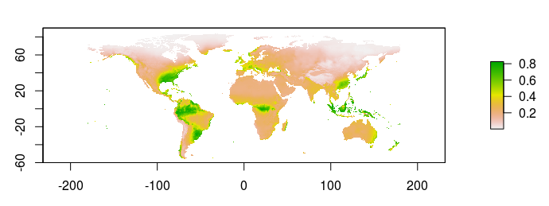Figure 1. The current potential global distribution of Saimiri sciureus.

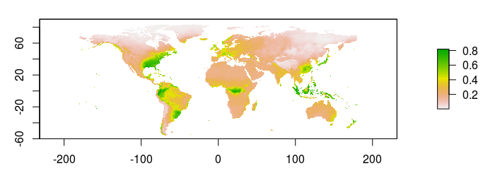Figure 2. The potential global distribution of Saimiri sciureus in 2050, with respect to changing climatic conditions.

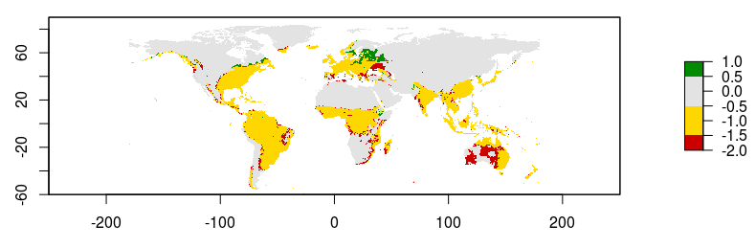
Figure 3. Increase (green), conservation (yellow), and decline (red) of suitable climatic conditions for Saimiri sciureus between the current time and 2050. Most of the decrease in suitable habitat is at the borders of the current suitable habitat, with the exception of middle-Australia. In north-earstern Europe and the northern border of the USA, there is an increase in suitable habitat.

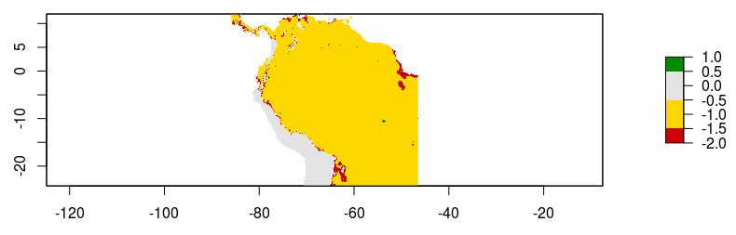
Figure 4. Increase (green), conservation (yellow), and decline (red) of suitable climatic conditions for Saimiri sciureus in its home range between the current time and 2050. There are relatively small decreases.

Table 1. Maxent Analysis of Variable Contribution. Bio9 contributes most to the model, followed by bio17.
Variable | Percent contribution | Permutation importance
bio9 | 67 | 58.8
bio17 | 20.4 | 19.4
bio2 | 6.4 | 12.4
bio8 | 5.6 | 0.6
bio16 | 0.6 | 8.8

References
Boubli, J.-P, A B Rylands, S Torre, and P Stevenson. 2008. “Saimiri Sciureus, Common Squirrel Monkey.” The IUCN Red List of Threatened Species. https://doi.org/10.2305/IUCN.UK.2008.RLTS.T41537A10494364.en.
Florida Fish and Wildlife Conservation Commission. n.d. “Squirrel Monkey - Saimiri Sciureus.” Accessed December 10, 2017. http://myfwc.com/wildlifehabitats/nonnatives/mammals/squirrel-monkey/.

