

DOCUMENT

Documents are structured presentations of Text. Text is a string of characters. By definition, the string is 1 dimensional. But by using some special symbols, it can be made two dimensional. However, it tends to have two defined axes of expansion. It can only go left to right (ignoring RTL languages) per line, and lines can go underneath one another.

Usually, no one writes diagonally. Defining what a standard diagonal should be is also a problem and so on.

Additionally, we can have Images or diagrams (or even interactive applets) in a document, which in our current technology can also be encompassed as a 2D objects. However, Corundum is designed in such a way, that we can also extend to other dimensions.

A Corundum document is a presentation of Information in a certain container, with certain formatting.

Document subsystems

The document can be assumed as made of the following tangible subsystems. At this point, we are not even considering the Text or Images or anything. Conceptually it makes sense to imagine the document as a finite manifold in a mathematical sense. For now, all discussion will assume it to be a 2D topological space.

Let the elements of this topological space be letters that make up strings and lines of text, images, diagrams, etc.

In this manner, a document can have the following element-independent structures inside it

- Page
- Section
- Region
- Hole
- Bridge

Note that element-independent here means that in order to find or define these subsystems, we do not have to rely on any specific element (such as text of image) of the page as defined above.

We consider the structures in detail now.

PAGE

The page is the superstructure that contains everything, including other structures as well as the elements. To create a page the following commands are used.
..
CREATE ;
OTHER COMMENTS GO HERE
..

The minimum command is:

..
CREATE ;
ID PAGEID;
..

The commands must appear after a NEW LINE. They begin with a pair of periods followed by a NEW LINE, and also end in a NEW LINE, followed by pair of periods.

This set of commands can be used anywhere in the document. While this is written as text like all the text elements of the document, the renderer recognizes this as a page command. The renderer, once encountering this instruction, executes this immediately, and redraws everything else as needed. The actual drawing of the page (and subsequent elements) may be dependent on the hardware and/or drawing APIs, but that is handled by a separate abstraction layer. The pseudocode is:

if pageCommand found
API.DrawPage();
info = API.decide_how_toUpdateOtherDrawings();
API.redraw(info);

The API handles the optimization routines of page drawing, and avoids unnecessary redrawings. The renderer does not have to worry about that.

If only CREATE; is specified then the default page is created. Even then, an unique page ID need to be specified. The Page on a traditional computer screen has the following attributes and methods:

SHAPE

The shape of the page. Supported values are:

- POLY
- CLOSEDCURVE
- SEGMENTS

Each of these are discussed in detail later

The default is : SHAPE POLY 2D 4;

The shape command needs to be explicitely equipped with argument 2D, even though in this document we assumed the page to be a 2D manifold. Everything from this point onwards is based on the same assumption.

SHAPEPARAMS

This is used to declare where the initial shape should be, how big the shape should be etc. The defaults depend on the exact shape as we will see later. The units can be:

- PX
- mm
- % <parent>

The % <parent> can be used to specify values in % of a parent object. This parent object can be the canvas, or any other section or region of unique ID. In case of a circular dependency, an error is thrown.

TRANSLATION

The page is not tightly coupled to the render area. It is possible to render a page anywhere in the canvas (canvas is specified at the time the renderer is initialized). While SHAPEPARAMS can be used to supply the initial location, the final location can be a translation from it. This translation is set by the TRANSLATION keyword. The required values can be supplied in various ways:

- COM : supplies the position of the center of MASS of the page in the canvas coordinates. Example:

TRANSLATION COM PX X_COORD Y_COORD;

- TL : supplies the position of the top most and left most point of the page.
- TR : Topmost, Rightmost point.
- BL : Bottom-most, Left-most
- BR : Bottom-most, Right-most
- INTERSECTION : supplies the position of a marked intersection point TBD

OTHER METHODS TBD.

The defaults are:

TRANSLATION TL PX 0 0;

Again, the same units are supported.

ORIENTATION

The orientation of a page on the canvas is specified as an angle measured counter clockwise. This also depends on shape. The details are discussed with shape details below. Example:

ORIENTATION DEGREE 0;

This is again the default for 2D shapes. For a 2D shape, the renderer automatically understands this. For a 3D shape, the renderer expects three params, and thus the default is:

ORIENTATION DEGREE 0 0 0;

The supported angle units are:

- RADIAN
- DEGREE

Angles are specified as a singular noun. Example:

ORIENTATION DEGREE 60;

Notice that DEGREE is singular, even tho the value is 60.

If multiple angles are specified, then all angles must be in same units.

BACKGROUND

The document background color, supplied as a color scheme, and associated numbers. Currently supported color schemes are:

- RGBA

It takes 4 numbers, for R, G, B and A channel. The R, G, and B values can vary between 0 and 255, the A (alpha) value between 0 and 100.

Example:

BACKGROUND RGBA 20 200 180 100;

The default is:

BACKGROUND RGBA 255 255 255 100;

This will make the background color white.

FOREGROUND

The color of the text, or parametric drawing elements in the document. The text plays a central role in many documents as we know. But simple parametric drawings, such as a line or a circle should also be considered as integral parts of the document. The color affects all these. Locally the color can be changed as well - as we will see later.

Example:

FOREGROUND RGBA 0 0 0 100;

This will make text and drawings black. This is also the default. Also here only RGBA is supported for now.

FONT

Font could either be specified as a named font, or a family. Currently only named fonts are supported. A default doesn’t exist. Example:

FONT NAMED "Inria Serif";

Construction of a page

The constructors are discussed in detail :

POLY Constructs a page which is polytopal in shape.

For 2D convex polygon pages, the POLY command must be followed by the declaration 2D, and then the type of polygon (polytopes in 2D are called polygons). Example :

SHAPE POLY 2D <number of sides>;

If we are to make a concave polygon, then the command will be

SHAPE POLY -2D <number of sides>;

Currently only convex polygons are supported. Methods to construct concave polygon is TBD. As stated, the default is a four sided regular polygon. The default side length is the canvas width or canvas height, whichever is smaller. We may want a page that extends in size with increasing text, or content – which we will see in a moment.

We consider a few shape cases (all commands are `;` terminated).

Command | SHAPE POLY 2D <number>
NOTE | The number of sides is specified in <number>
SHAPE PARAMS | SHAPEPARAMS 1 <initial x coordinate of COM> <initial y coordinate of COM> <distance to the rightmost vertex from COM> etc
NOTE | At this point we are generating regular polygons. The 1 immediately followed by SHAPEPARAMS indicates that we have a regular polygon. The rightmost vertex and the COM has the same y coordinate. The Y coordinate is measured traditionally, bottom to top.
SHAPE PARAMS | SHAPEPARAMS -1 <initial x coordinate of COM> <initial y coordinate of COM> <distance to the rightmost vertex from COM> etc
NOTE | The -1 indicates that we have a regular polygon here as well. The rightmost vertex and the COM has the same y coordinate. The Y coordinate is measured like on a computer screen, top to bottom – the minus 1 designates the flip of the y-coordinate
SHAPE PARAMS | SHAPEPARAMS 2 <initial x coordinate of COM> <initial x coordinate of COM>  <difference of x coordinate of first vertex from COM> <difference of y coordinate of first vertex from COM> <difference of x coordinate of second vertex from COM> <difference of y coordinate of second vertex from COM> etc
NOTE | This is an irregular polygon. The 2 immediately followed by SHAPEPARAMS indicate that we have an irregular polygon. The dx and dy values of all vertices from the COM is given. Y is measured like in the case of 1.  Exception: in case of a 4 sided tetragon, we could get away by only specifying width and height instead of the dx and dy values.
SHAPE PARAMS | SHAPEPARAMS -2 <initial x coordinate of COM> <initial x coordinate of COM>  <difference of x coordinate of first vertex from COM> <difference of y coordinate of first vertex from COM> <difference of x coordinate of second vertex from COM> <difference of y coordinate of second vertex from COM> etc
NOTE | Same as 2, but y is measured like in the case of -1

In all cases, the units are specified together with the coordinates.

CLOSEDCURVE

At this time, various closed curves can also be taken as pages.

Command | SHAPE CONICSECTION 2D <number>
NOTE | The type of conic section is specified in <number>.  1 : Circle  2 : Ellipse  Currently only these are recognized, and only circle is fully implemented. But many other curves in 2D is planned.
SHAPE PARAMS | SHAPEPARAMS 1 <initial x coordinate of COM> <initial y coordinate of COM> <other params>
NOTE | The 1 immediately followed by SHAPEPARAMS indicates that Y coordinate is measured traditionally, bottom to top. Depending on whether we supplied circle or ellipse, we need to supply additional parameters in <other>. For circle, we only supply radius. For ellipse TBD
SHAPE PARAMS | SHAPEPARAMS -1 <initial x coordinate of COM> <initial y coordinate of COM> <other params>
NOTE | Same as 1, but y is measured as on a computer screen.

In case of a conic section, the circle and ellipses are always closed. Other conic sections TBD.

SEGMENTS

Segments make a page from straight and curved line segments. TBD

An Example command to create a rectangular page can be:

.. | START page command
CREATE ; | CREATE page
ID SOMEID ; | ID is specified.
SHAPE POLY 2D 4; | 4 sided polygon
SHAPEPARAMS -2 CANVASW/2 CANVASH/2 | -2 : Irregular with COM center of canvas.  Note that this row did not end in a `;`  CANVASH and CANVASW are already known to the renderer
CANVASW/2 CANVASH/2 | dx and dy of the bottom right vertex
CANVASW/2 -CANVASH/2 | dx and dy of the top right vertex
-CANVASW/2 -CANVASH/2 | dx and dy of the top left vertex
-CANVASW/2 CANVASH/2; | dx and dy of the bottom left vertex  (here, the shapeparams declaration ends with a `;`)
.. | End of page command
Altogether:

..
CREATE ;
ID SOMEID;
SHAPE POLY 2D 4;
SHAPEPARAMS -2 CANVASW/2 CANVASH/2
CANVASW/2 CANVASH/2
CANVASW/2 -CANVASH/2
-CANVASW/2 -CANVASH/2
-CANVASW/2 CANVASH/2;
..

This makes a page with a strict size. Here, we don’t need the units, because the renderer can directly recognize the constants. If it were to contain more text (or anything else) that can fit in it, and we wanted the size to increase to accommodate for the additional text then we need to specify the grow/shrink behavior. That is done by:

GROW <axis>;

For example, to enable the page to grow in y-direction (as measured on a computer screen), we write:

GROW -y;

The minus sign indicates that we use the y axis as on a computer screen, which is the opposite of a standard 2D Cartesian coordinate on paper. This makes the full code as follows:

..
CREATE ;
ID PAGEID;
SHAPE POLY 2D 4;
SHAPEPARAMS -2 CANVASW/2 CANVASH/2
CANVASW/2 CANVASH/2
CANVASW/2 -CANVASH/2
-CANVASW/2 -CANVASH/2
-CANVASW/2 CANVASH/2;
GROW -y;
..

To create a page with specific pixel size, mixed with % measures we can do:

..
CREATE ;
ID PAGEID;
SHAPE POLY 2D 4;
SHAPEPARAMS -2 PX 400 400
PX 200 200
% CANVAS 50 -50
PX -200 -200
PX -200 -200 ;
GROW -y;
..

SECTION

A page is made out of sections, which contain various text, glyphs, etc that flow like text flow on an usual page. Images and diagrams can be anchored in specific place, but text is usually fed in a way, where each character is “just after the previous” one – which avoids having to provide a specific location to every character of text.

All Text and such must be placed in a section or a region. All pages must contain at least one section. The sections are described as follows:

.|

CREATE;
ID < UNIQUE ID >;
IN < PARENT >;
COORDINATES < COORDINATES > ;
SHAPE <values>;
SHAPEPARAMS <values>;
TRANSLATION <values>;
ORIENTATION <values>;
BACKGROUND <values>;
FOREGROUND <values>;
FONT <values>;
GROW <value>;

|.

Sections are started with the character group .| and end in |., and follow the same NEW LINE rules as with a page definition.
Sections must be somehow congruent to the shape of the page. The exact nature needs to be properly defined. For now, we will define them as subspace of the the page – recall that the page is a 2D topological space – such that the boundaries of a section are parallel to the edges of the page. This agrees with the sections of a rectangular page. By drawing lines parallel to the edges of a rectangular page, we can create the conventional “sections” thereof.
The first section may be placed in the page using its position, orientation etc declarations. However, if these are not declared, then by default the section is aligned to the top left of the page, with the top left of the section. The top coordinate has a higher priority than the left in case of ambiguity. Subsequent sections are filled by aligning their top left with the previous ones top right. In case of ambiguity, the left (resp. right) will take precedence.
Alternatively, a filling algorithm may be specified in the page itself, using the optional SECTIONFILLALGORITHM command. The exact commands and their meanings are TBD.
Applying this concept on Hexagon may lead to various different things. Figure 1 shows some examples. There needs to be a library or standards for sections of hexagon – TBD.

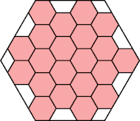 | 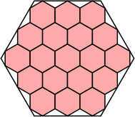 | 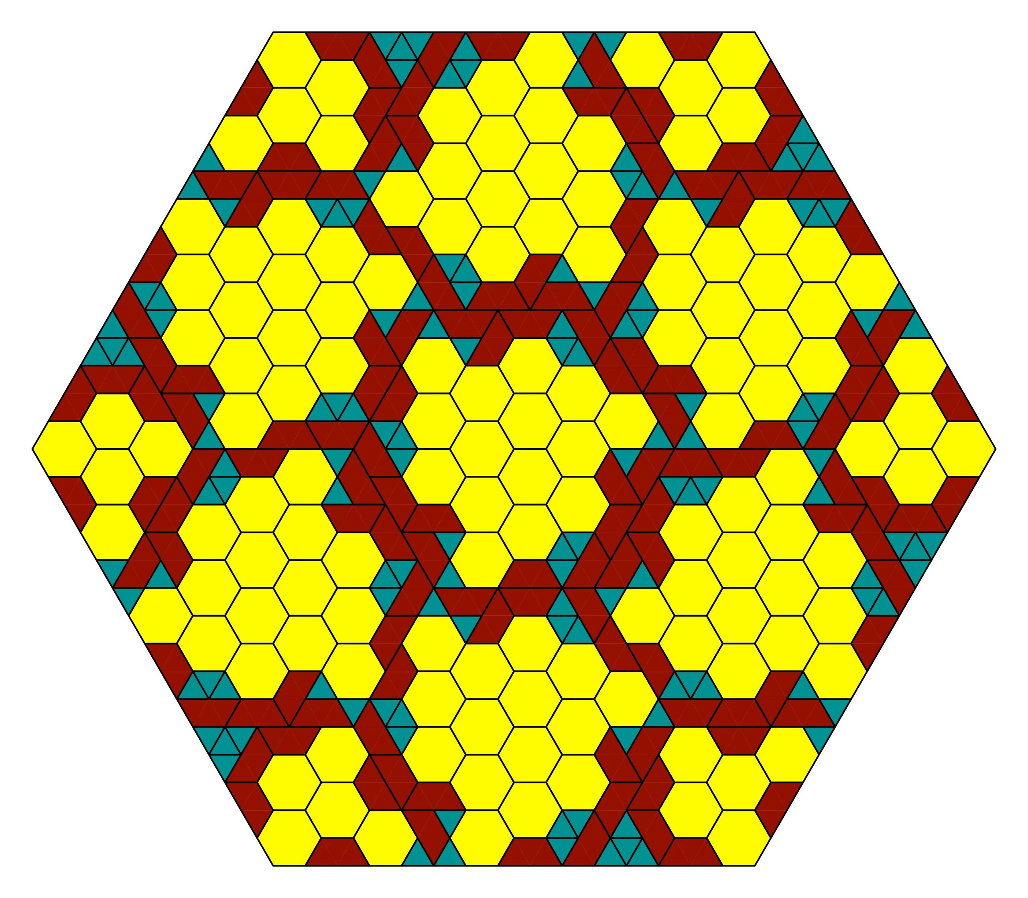
Figure 1. Packing Hexagons in Hexagons, note the various shapes generated by the process. Credit: Left and Middle: Maurizio Morandi (https://erich-friedman.github.io/packing/hexinhex/) Right: H. Murray (https://twitter.com/MurrayH83/status/1637161163950800897/photo/2)

Picture serves only as a general idea of what to expect. No algorithm is made based on these.

Each section must have an unique ID, specified by the ID keyword. The ID must be unique throughout the document. Even if the document has different pages in it, sections in different pages can’t share the same ID.
Each section must also have a parent specified by the IN keyword. The parent can be the Page, or another section. Regions can’t act as parents of sections for now. This can change in future. The argument to the IN keyword is the ID of the parent.
Each section must specify a coordinate system. The arguments are either PAGE or SECTION. This specifies whether the sub-elements of the section should use a coordinate system anchored on the page, or the current section itself respectively.
The remaining commands behave in the same way as in the context of a page.
The intersection of two sections can either be their common boundary (a geometric line) or null.

To fill up a section with contents, we may use the following command :

.|| <unique id>;
CONTENT goes here
||.

The first line must start with the character group .|| followed by a blank space, followed by the ID of the section we are trying to fill up. The opening symbols and the ID must be in the same line. It must be terminated via a semicolon and a NEW LINE. The last line must be the character group ||.
Again, the same rules of NEW LINE apply here as well. This command is used, if the section is being filled up after it is defined. If we wish to fill up a section at the same time it is being defined, we could use:

.|
CREATE;
ID <unique ID>;
IN <parent>;
< other create commands >
.||
CONTENT GOES HERE
||.
|.

Note the NEW LINE -s in the code.
Sections aren’t intended to contain Images or such things. This will be discussed in detail in the “Text and Glyphs” section.

REGION

A region is any generic subspace of a page. It does not have to be congruent to the page. Intersection of regions may be anything. Regions have to be defined within a section.

After a region is defined, it should be attempted to split the remaining area of the parent section into further sections so that no overlap is created. This may leave some space in between. See Figure 2. It would be ideal to fill up the remaining region with Text or Glyphs. This is trivial if the regions and sections are all rectangular. However, it may not be as simple for Hexagonal regions. Details TBD.

The command to create a region is

.:
CREATE;
ID <UNIQUE ID>;
IN <PARENT>;
<OTHER COMMANDS>;
:.

PAGE
Section in the
remaining area
Section
Region
Figure 2: In the blue page, a magenta section is created. In the magenta section, the yellow (sub-)section is placed, in which the orange region is added. The remaining magenta area (original magenta excluding orange) is split so that another section can be added. For illustration purposes, the green section is added with visible margin. These margins can be adjusted to maximize the area of the green section in the left side of the orange region. On the right side of the region, there is still space in the magenta section. Altough another region could be added here, none is added. Note that the yellow (sub-)section must be empty besides for the region.

Here, the character group is .: - and the same rules of NEW LINE apply here as well. The remaining commands are just like the ones in section, including ID and IN.

Inside a region, at this point other regions or sections are not supported. It may change in future.

To fill a region with contents, the following commands may be used:

.:: <unique id>;
CONTENT goes here
::.

To fill up a region with its content immediately, the following may be used:

.:
CREATE;
ID <unique ID>;
IN <parent>;
< other create commands >
.::
CONTENT GOES HERE
::.
:.
The exact behavior of intersecting regions is TBD.

HOLE

The document may contain an area where no content should be added. This can be achieved by creating a region and then keeping it empty. This is called a hole. Currently, there is no special method of creating a hole . In future the following command MAY be used.

./
HOLE
/.

PATCH
A patch is a sub-page that can be overlaid anywhere on a page. The parent of a patch can be either the page, a region, or a section. Like before, there is no requirement of congruence, or constrained intersection. While a region is always placed in an empty section, a Patch can be placed anywhere, overwriting the contents behind it. The patches will be rendered by a second pass of the renderer after everything else is rendered. The command to create a patch is:

.\
PATCH Definition goes here.
\.

The creation commands of a patch is same as a page, with the addition of an one additional item: z-index. The z-index dictates which patch should be rendered on top of which other patch.
Filling a patch with contents is done by the surrounding the contents by .\\ and \\. similar to a region and section.

The patches must be supplied with a position command.

BRIDGE

._
BRIDGE commands
_.

Bridge is used for joining multiple pages. TBD.

COMBINATION

TBD

Text and Glyphs

A document is a topological space, in which there can be (potentially infinitely) many points, which can be enumerated in an ordered list. Regardless of how these points are distributed in a 2D space, that can be mapped bijectively to a string of numbers. In turn, a string of characters or other objects could be mapped also bijectively to the same string of numbers. Therefore, the string of characters (or other objects) could be mapped backed to the 2D space.

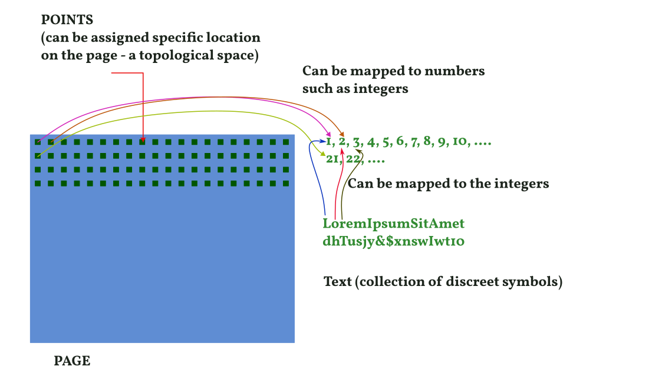
This map in general dictates how we write text or other objects on the document. For example, in an LTR language, we can enumerate the points on the document from left to right using the positive real numbers. The integers can appear at a regular distance, and once the right edge is arrived, we go back to the left edge, at a point below the last point that we considered in the left edge. Again we can choose to set the vertical distance as we need to enumerate a particular point with an integer (there are infinitely many reals between any two other reals that we can use to enumerate other points).

Then, we can map the characters of a string to the same point which is enumerated with the same integer as the index of the character in the string.

In the example above, the first letter of the example Text L is mapped to the first point, which in turn is mapped to the first integer, and so on. Similarly, besides text, we can also fill up the document using symbols, or diagrams etc.

This mapping is controlled by a set of parameters that we will discuss here. An example would be:

.|

CREATE;
ID < UNIQUE ID >;
IN < PARENT >;
COORDINATES < COORDINATES > ;
SHAPE <values>;
SHAPEPARAMS <values>;
TRANSLATION <values>;
ORIENTATION <values>;
BACKGROUND <values>;
FOREGROUND <values>;
FONT <values>;
GROW <value>;
ENUMERATIONALGORITHM < NAME >;
ENUMERATIONPARAMS <values>;
GLYPHMAPALGORITHM < NAME > < ANCHORSET >;
GLYPHMAPPARAMS <values>;

|.

Here we have introduced several new commands. These will be discussed below.

Writing text

The process of writing text involves two distinct steps, as elaborated upon earlier. The initial phase entails mapping the points within the sections (constituting a topological space) onto a numerical space. Typically, a mapping to the 1D number line suffices, although in subsequent iterations, there's potential to explore mappings onto a 2D Argand plane or other more unconventional structures.

Subsequently, our glyphs are correlated with the numerical values derived from the initial topological mapping, establishing a one-to-one relationship between our symbols and the section space.

Enumeration of points

The enumeration of points is facilitated through the ENUMERATIONALGORITHM, which may accept a name or a function. Predefined names for this purpose include:

LEFTtoRIGHTandTOPtoBOTTOM | Glyphs are filled like a Standard Latin text, starting at the left, then moving to the right, and then wrapping in the next horizontal line below the previous
RIGHTtoLEFTandTOPtoBOTTOM | Same as above, but right to left like Arabic
TOPtoBOTTOMandLEFTtoRIGHT | Glyphs go from top to bottom first, then wrap around in the next vertical line right of the previous, like ancient Manchurian
TOPtoBOTTOMandRIGHTtoLEFT | Same as before, but right to left.

Each of these algorithms can be invoked by their respective names. However, it is imperative to provide specific parameters for their execution. When dealing with predefined names, these parameters are supplied in the following manner:

ENUMERATIONPARAMS ANCHORTYPE EXTRAPOLATION STARTX STARTY FIRSTAXISDIST SECONDAXISDIST ;

ANCHORTYPE | The task of mapping an infinite set of points from the topological space to a 1D number line (itself comprising an infinite array) requires a deliberate selection of specific elements from each. This selection process is vital to enable subsequent mapping, with the remaining points in between being extrapolated using a suitable methodology.  In such scenarios, we opt for particular points within the topological space and map them to well-defined numbers characterized as elements of a totally-ordered set with infinite count. As an illustration, employing the anchortype INTEGER involves mapping the initial position to the number zero, followed by successive points in the topological space (determined through linear displacement, as detailed below) being mapped to consecutive integers.  Similarly, with the anchortype PRIMES, the starting position is mapped to the number two, and subsequent points in the topological space (chosen with a linear displacement method described below) are mapped to consecutive prime numbers. The utilization of prime numbers introduces a distinct scaling, impacting the mapping of intermediate points between specified anchors, necessitating adjustments as more points are incorporated into the mapping process.
EXTRAPOLATION | In case we are using a custom enumeration, and the extrapolation needs to be specified, then it is specified here. In the above mentioned cases, the extrapolation is linear.
STARTX | X coordinate of the point in the topological space that will be mapped first element in the number line (as chosen above)
STARTY | Y coordinate of the point in the topological space that will be mapped first element in the number line (as chosen above)
FIRSTAXISDIST | Distance between two consecutive points in the topological space along the first axis. Example: In case of LEFTtoRIGHTandTOPtoBOTTOM it is the horizontal axis, and in case of TOPtoBOTTOMandLEFTtoRIGHT it is the vertical axis
SECONDAXISDIST | Distance between two consecutive points in the topological space along the second axis. Example: In case of LEFTtoRIGHTandTOPtoBOTTOM it is the vertical axis, and in case of TOPtoBOTTOMandLEFTtoRIGHT it is the horizontal axis

All coordinates are interpreted in the immediate parents coordinate system.

Besides these, it is also possible to specify a custom function for enumeration algorithm. The parameters need to be adjusted accordingly. TBD.

Mapping of glyphs

The glyphs, essentially symbols characterized by finite but non-zero dimensions, pose a challenge when it comes to mapping them onto points with zero dimensions. To address this, we can designate a specific point within the spatial representation of the glyph to serve as the representative anchor for the entire glyph. This approach allows us to effectively map a glyph with non-zero dimensions onto a singular point in the space.

This mapping is controlled by the commands GLYPHMAPALGORITHM and GLYPHMAPPARAMS. Like the ENUMERATIONALGORITHM discussed before, GLYPHALGORITHM can be specified in terms of predefined names, followed . Currently the following names are defined

CENTERofMASS | Map the center of mass of the Glyph’s external-most boundary to the target point.  Consider the Glyph „A“. The letter A has the COM somewhere below the horizontal bar in the shape of A. However, a font Glyph may come packed in a bounding rectangle. In this case, the COM of bounding rectangle will be mapped to the target point.
CENTERofMASSofCORE | Map the center of mass of the Glyph’s core to the target point.  Consider the Glyph „A“. The letter A has the COM somewhere below the horizontal bar in the shape of A. In this case, that COM below the horizontal bar will be mapped to the target point.
TOPLEFT | The top left of the external boundary is mapped to the target.
TOPRIGHT | The top right of the external boundary is mapped to the target.
BOTTOMLEFT | The bottom left of the external boundary is mapped to the target.
BOTTOMRIGHT | The bottom right of the external boundary is mapped to the target.
LOCATION | A specific location in the bounding rectangule interpreted as ratios of height and width. This will require specifying additional parameters

Now that we have determined the specific point within the non-zero dimensional glyph that will be mapped to the target point, the next crucial step is to define the selection criteria for these target points. Should we exclusively anchor the glyphs to integer-valued points within the topological space, or is it permissible to map them to points with non-integer values? These questions form the basis for further exploration and demand careful consideration in our approach. Clarifying these aspects will contribute significantly to the coherence and precision of our mapping process.

This is resolved by supplying a value to the ANCHORSET parameter. For now the supported values are:

INTEGER | Map the glyphs only to points of integer values.
HARMONIC N | Map the glyphs to points at 1/Nth distance from the previous point, starting at 0, with N an Integer

Two values are supplied to the ANCHORSET parameter, each one for an axis for a typical 2D page section. For more exotic shapes, this can change in future.

Therefore the full command looks like:

GLYPHMAPALGORITHM CENTERofMASS INTEGER INTEGER

This command will cause each glyph to be mapped to a integer valued point, and in case it needs to wrap, the first glyph of the wrapped string will fall on a point with integer value in the next line.

Self intersecting lines and others

Mapping finer controls

Automatic adjustment of glyphs

Formatting text

Images and multimedia

Images

Interactive elements I (such as sound : controls on page, output is elsewhere)

Interactive elements II (video without sound and 3D : controls and display are both on the page)

Interactive elements III (video : control on page, output on page and elsewhere)
Page controlls

automatic repaging

..
CREATE;
PAGE;
SHAPE POLY 2D 4;
SHAPEPARAMS -2 CANVASW/2 CANVASH/2
CANVASW/2 CANVASH/2
CANVASW/2 -CANVASH/2
-CANVASW/2 -CANVASH/2
-CANVASW/2 CANVASH/2;
GROW -Y;
BACKGROUND RGBA 220 250 230 100;
FOREGROUND RGBA 20 140 90 100;
FONT NAMED “INRIA SERIF”;
..

.|
CREATE;
ID CODECONTAINER;
IN PAGE;
SHAPE POLY 2D 4;
SHAPEPARAMS -2 CANVASW/2 CANVASH/2
PX CANVASW/2 - 10 CANVASH/2 - 10
PX CANVASW/2 - 10 -CANVASH/2 + 10
PX -CANVASW/2 + 10 -CANVASH/2 + 10
PX -CANVASW/2 + 10 CANVASH/2 + 10;
|.

.|| CODECONTAINER

!USE siunits;
~ this will load SI UNITS;

Earth : {
mass : 3283 ;
radius : 4000 ;
};

shape1 : 467834;
shape2 : 4000 ;

||.

.#
{
1 : EX : \! : ||||;;
&& 2 : ER : {{ {REPEAT 0+ }{ 1: EC : \w : ||||;;} }} : ||;;
&& 3 : EX : USE : |||| ;;
}

3
FOREGROUND RGBA 120 120 220 100;

#.

.#
{
1 : EX {}{ANCHOR 0}: SHAPE : ||||;;
&& 2 : ER : {{ { REPEAT 1+}{1 : EV : * : ||||;;}: }} ||||;;
&& 3 : EX : \; : ||||;;
}

1
FOREGROUND RGBA 220 120 120 100;

#.
{
1 : ER : {{
REPEAT 1+ [@ind01 _count01] // if no { then fail
{
1 : EX : \{ : || ||;;
2 : ER : {{ REPEAT 0+ {
1 : EV : * : ||||;;
} }} : || || ;; // between two {
// anything may be
// found with any
// number
}
}} : || || ;; // save where the
// first { was found
// and the number of
// { s
2 : ER {} {OFFSET #ind01} : {{
REPEAT [#count01] // if any other number
// of } then fail
{
1 : EX : \} || ||;;
2 : ER : {{ REPEAT 0+ {
1 : EV : * : ||||;;
} }} : || || ;;
}
}} : || || ;; // first } must be
// after the first {
} // Also, “and”
// relation, where
// the string of
// } may not be
// strictly after
// the last }
0 : EY : NULL : ||
#cnt01 := 0;
#cnt02 := 0;
||;;

{
1 : ER : {{

REPEAT 0+
{

(
1 : ER : REPEAT 1 {1:EX:\{:||||;;} :
|| #cnt01 := #cnt01+1; ||;;
/
2 : ER : REPEAT 1 {1:EX:\}:||||;;} :
|| #cnt02 := #cnt02+1; ||;;

)

3 : EY : NULL : ||
if (#cnt02 > #cnt01) {FAIL;} ||;;

}

}} : || || ;;

2 : EY : NULL : || if (#cnt02 <> #cnt01) {FAIL;} ||;;

}

