14/03/2022
Darwin
Export data into Tab-delimited
Note: made from RBINS version (direct export into Tab-Delmited)
- Log and connect to the backend interface :
https://darwin.naturalsciences.be/

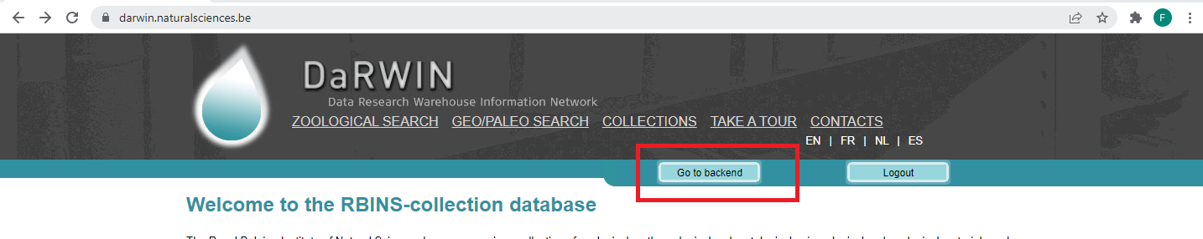
- Go to “Searches=> specimens”
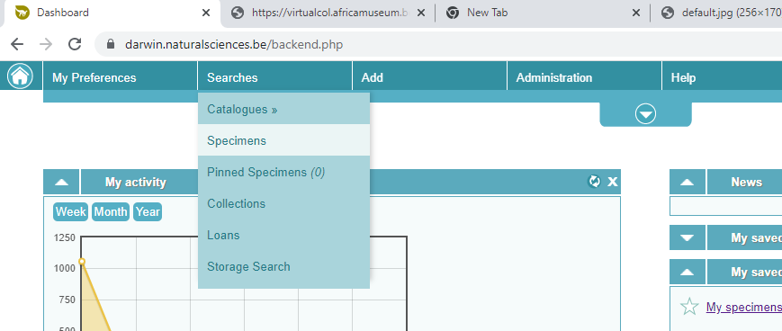

- Carry out a search (e.g data from Cameroon)
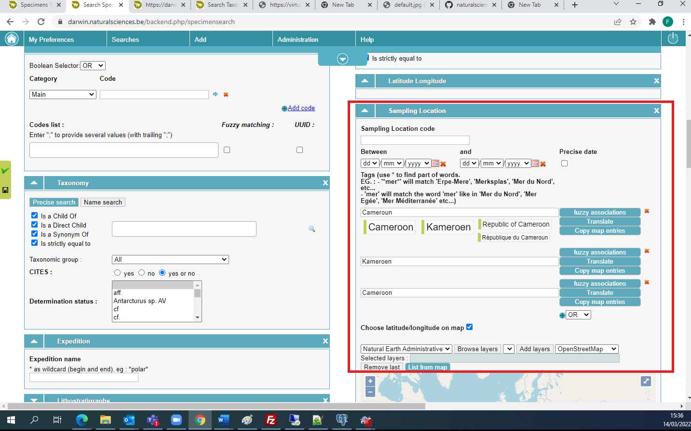

4. run the search…

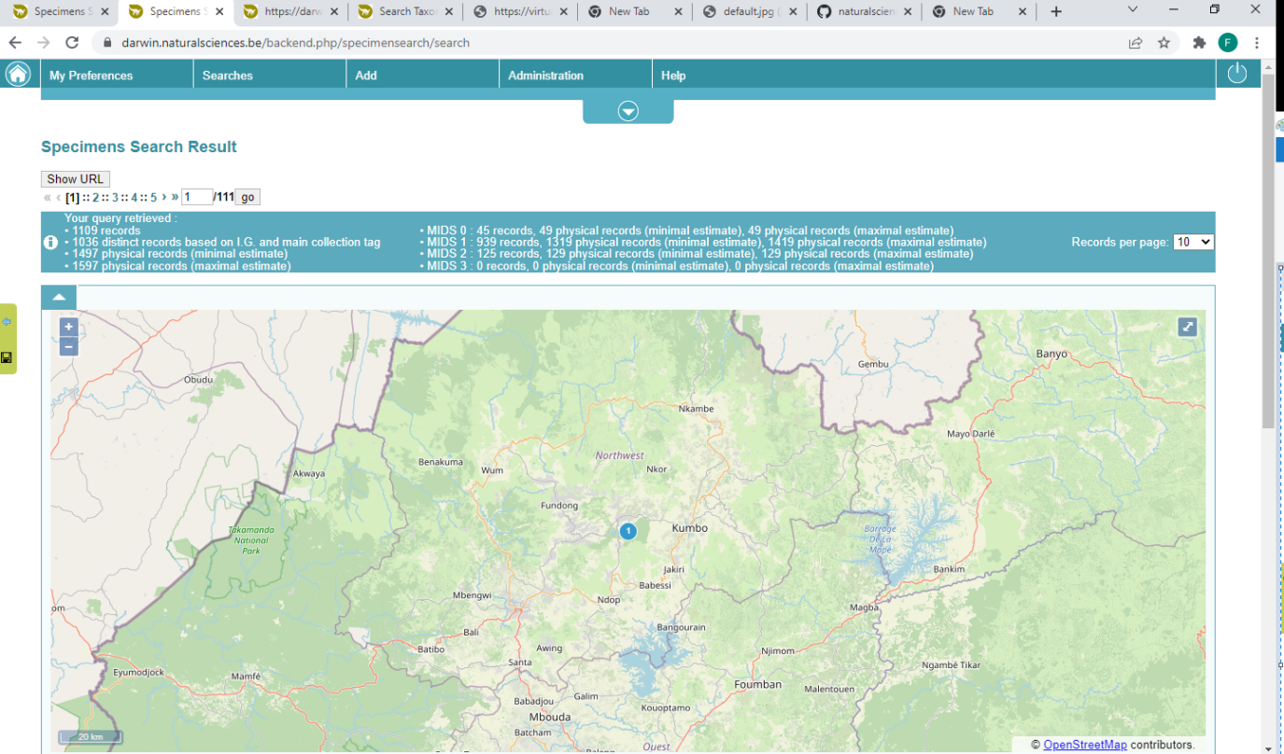

5. clic on “Save this search” (bottom right)

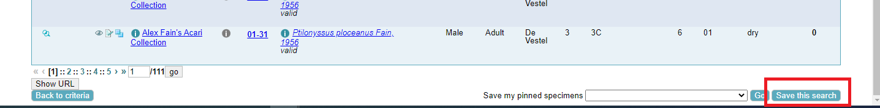

6. Give a recognizable name to your query and save..

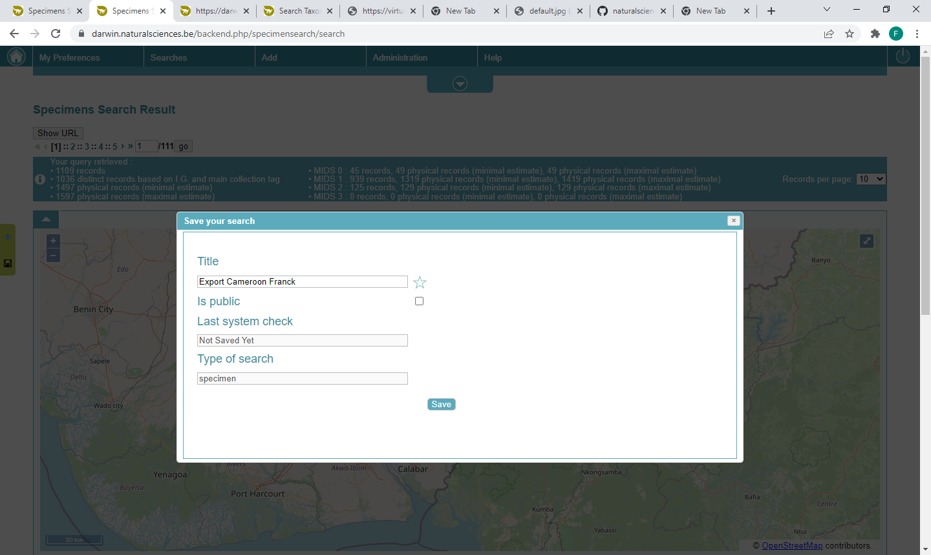

7. Go to “Saved search” in the upper left menu
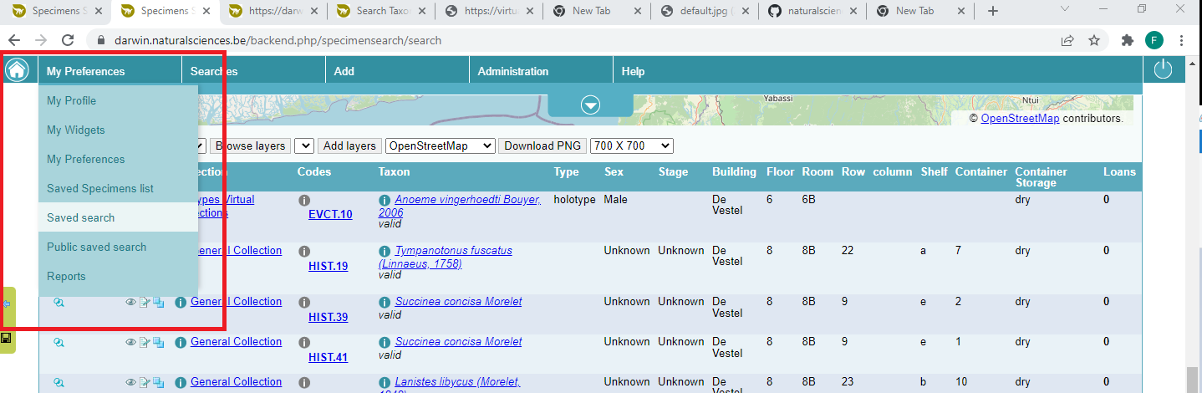
8. push on Get report next to the search data to export

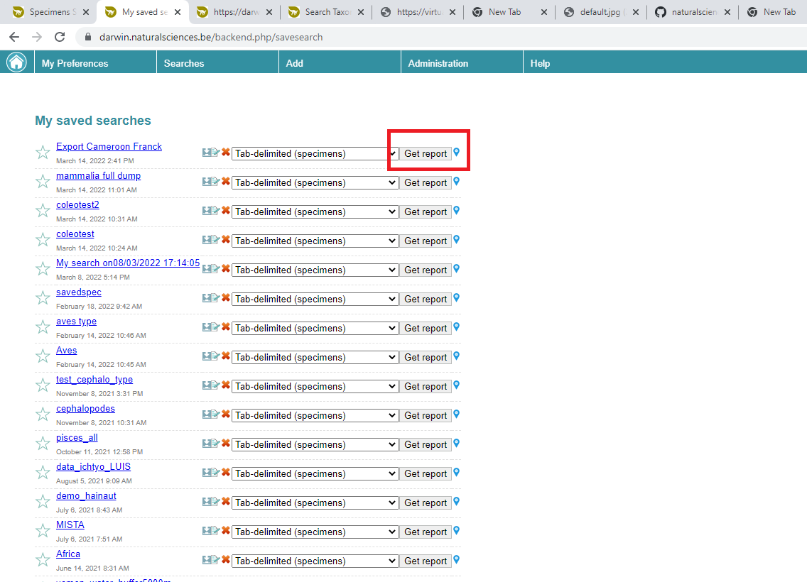

9. a new tab should open to your browser, looping through the dataset (about 20 seconds for each batch of 10 000 records). When ready, a green Download button will be displayed.

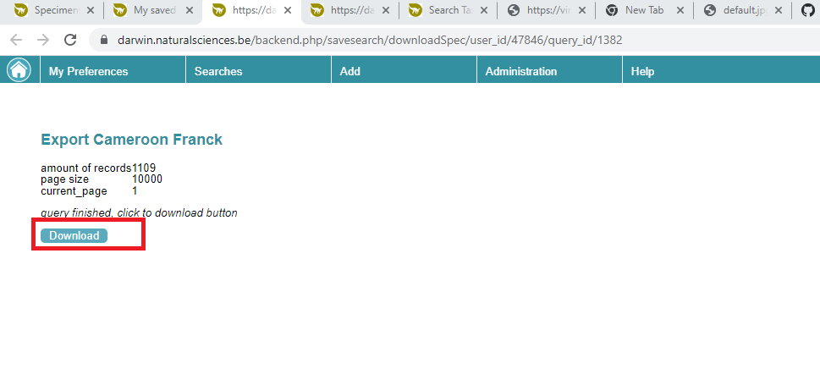

10. By clicking on download, you will received your data as a tab-delimited file. Its name is the technical database ID of the query (e.g. report_1382.txt)

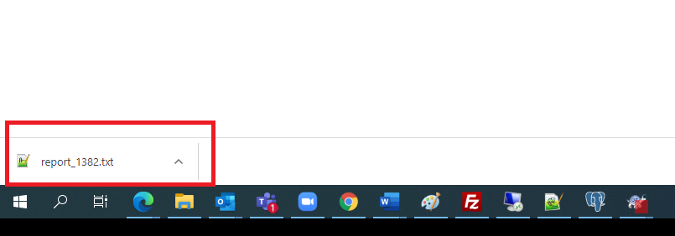

Data in Notepad++
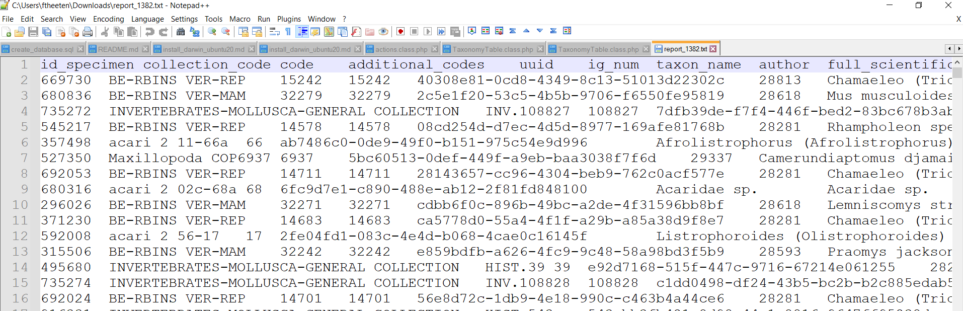

11. You can use Excel (e.g. Data => From CSV) to convert the data
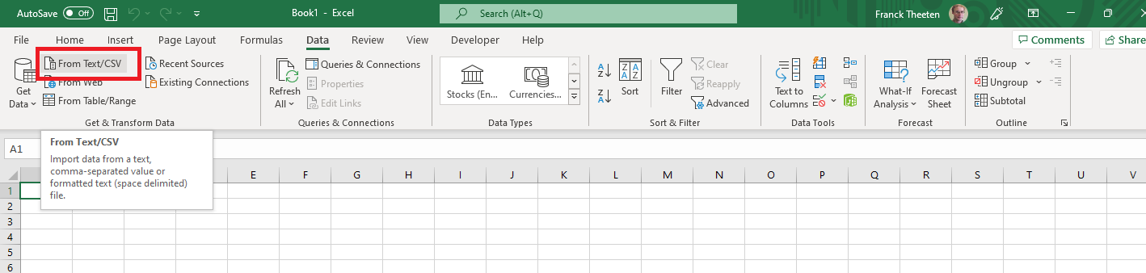

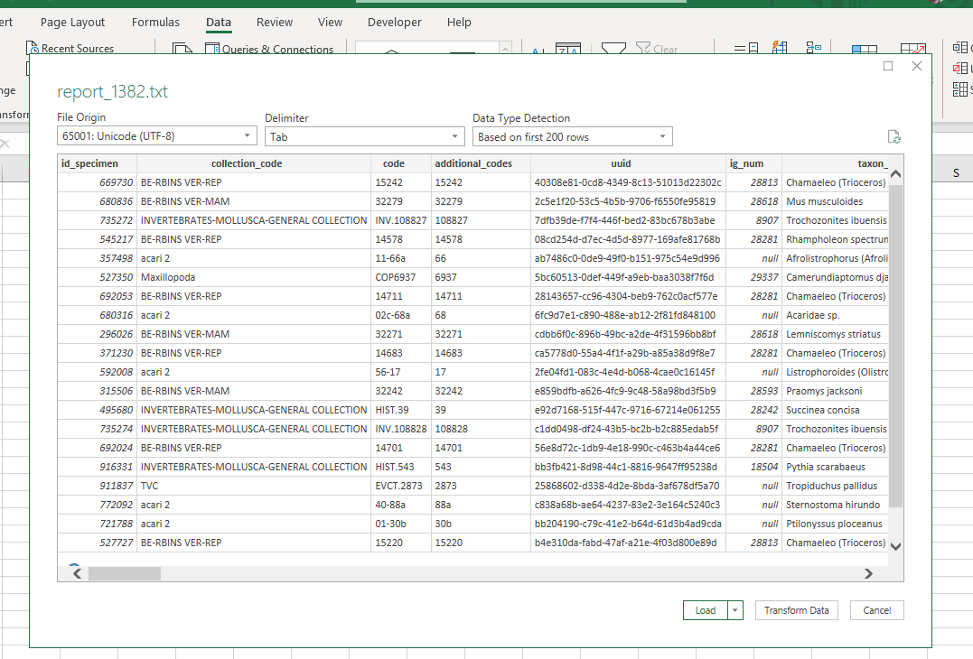

Notes :
  - Choose the appropriate Delimiter
  - Beware, source encoding is Unicode /UTF-8 (not the standard encoding of Excel which is Latin1). Check this option, otherwise you risk to alter data and loose those with diacritic or accented characters (e.g. “België” can become “Belgi□” “10 mètres” becomes 10 “m□tres”)
  - Using LibreOffice or OpenOffice works often better than Excel to convert the data into Excel, especially if the source data contains line breaks (several lines)

