14/03/2022

Darwin

Export data into Tab-delimited

Note: made from RBINS version (direct export into Tab-Delmited)

1. Log and connect to the backend interface :

<https://darwin.naturalsciences.be/>

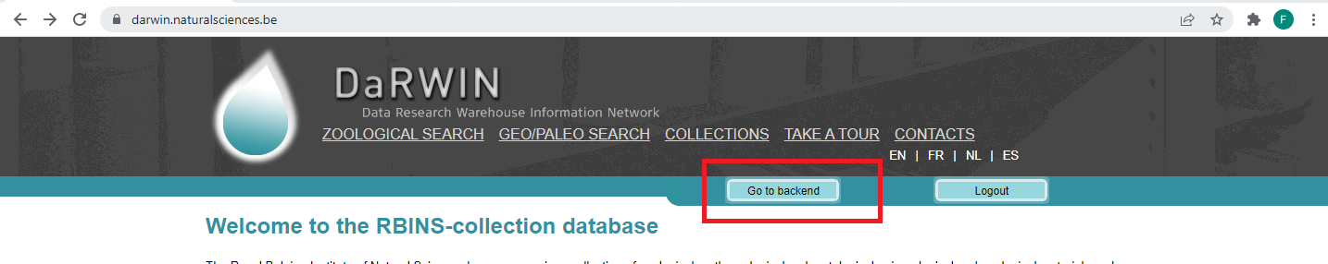

1. Go to “Searches=> specimens”

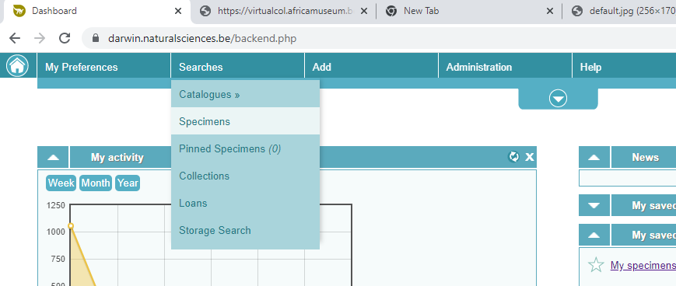

1. Carry out a search (e.g data from Cameroon)

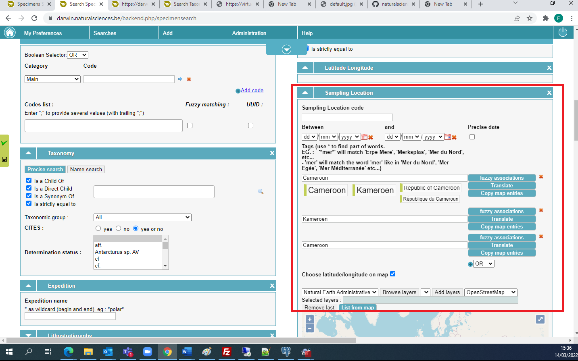

4. run the search…

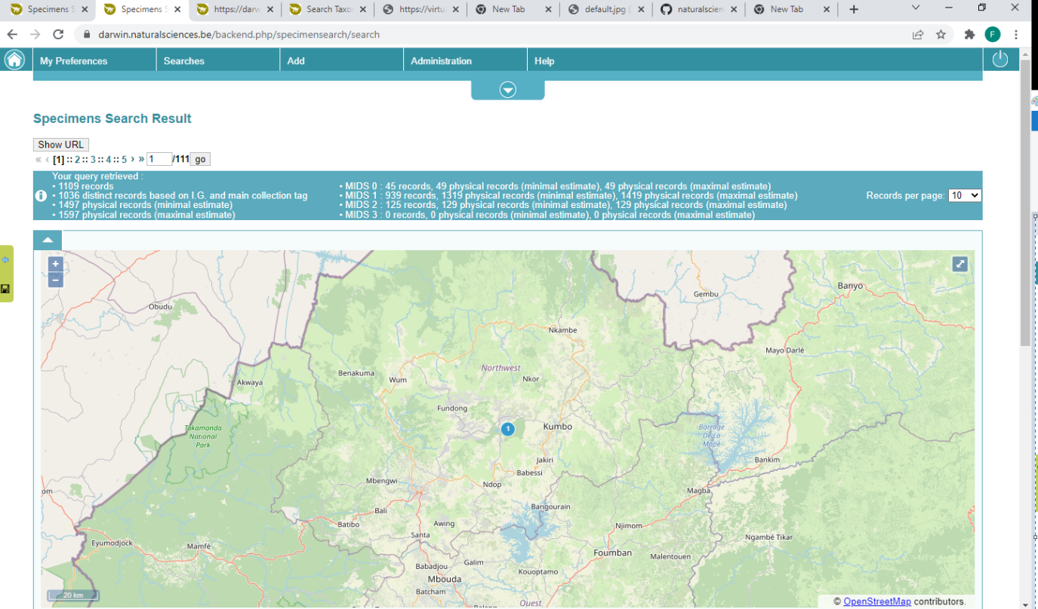

5. clic on *“Save this search”* (bottom right)

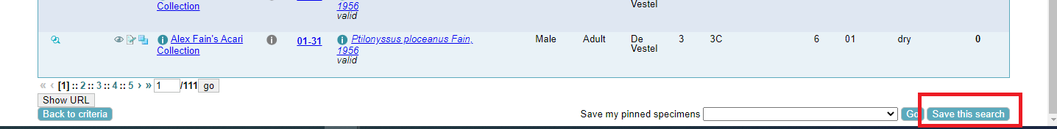

6. Give a recognizable name to your query and save..

7. Go to “*Saved search”* in the upper left menu

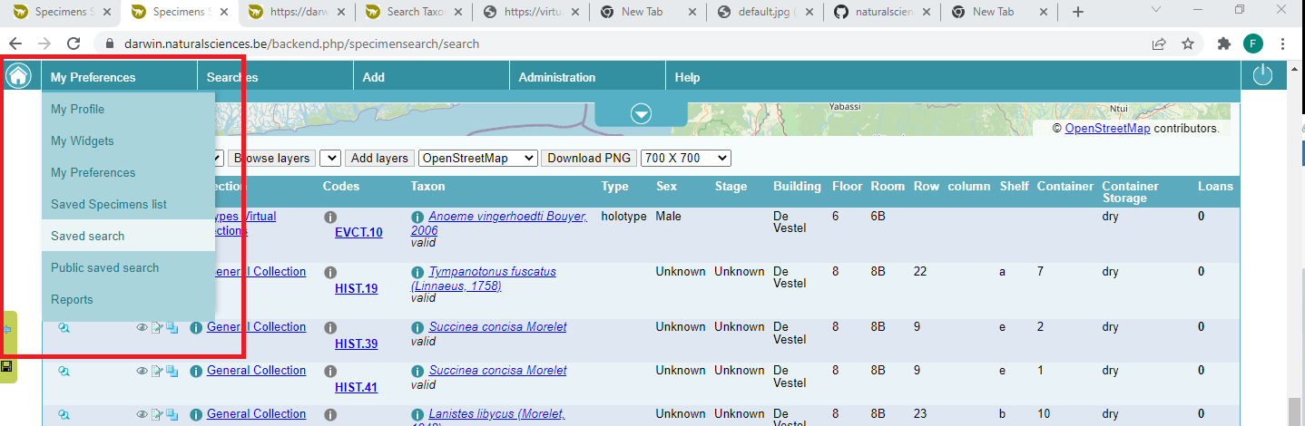

8. push on *Get report* next to the search data to export

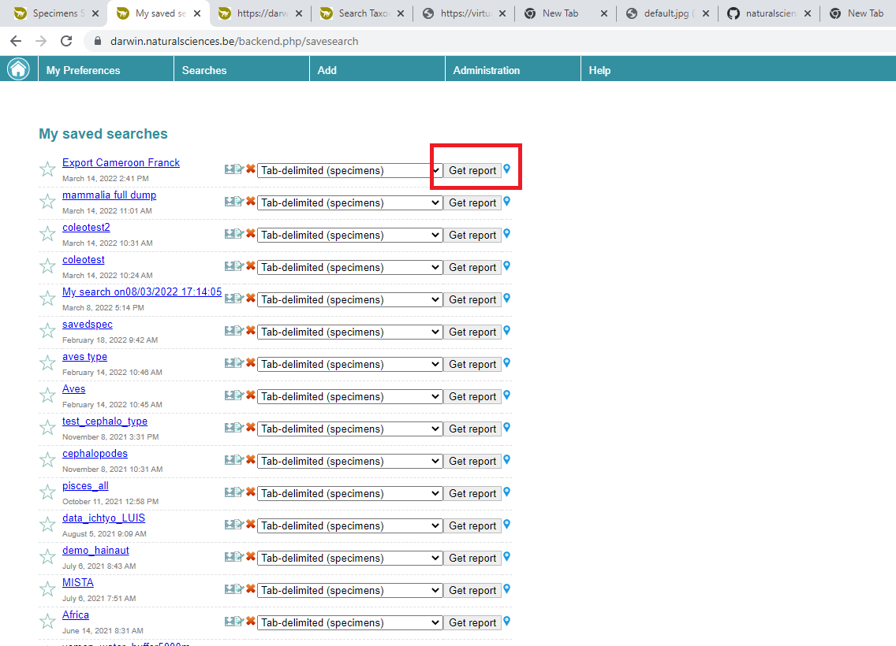

9. a new tab should open to your browser, looping through the dataset (about 20 seconds for each batch of 10 000 records). When ready, a green *Download* button will be displayed.

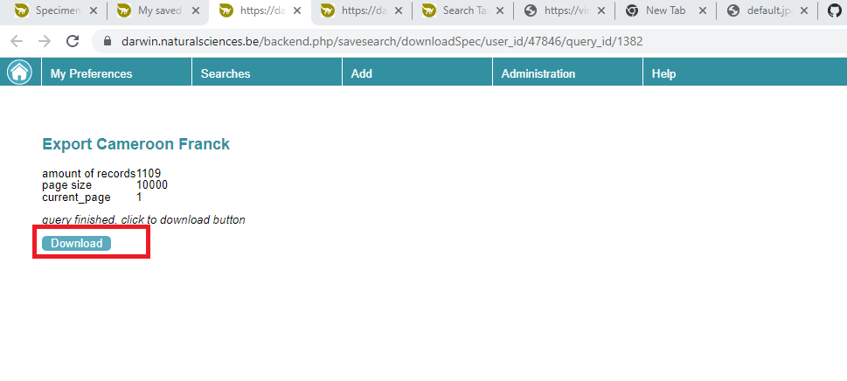

10. By clicking on download, you will received your data as a tab-delimited file. Its name is the technical database ID of the query (e.g. *report_1382.txt*)

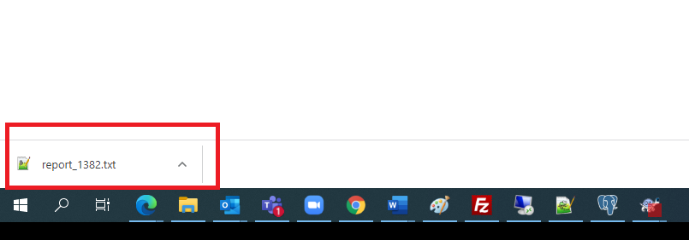

Data in Notepad++

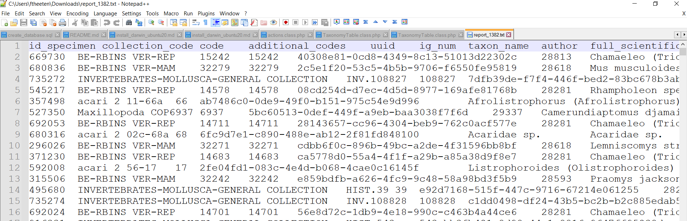

11. You can use Excel (e.g. Data => From CSV) to convert the data

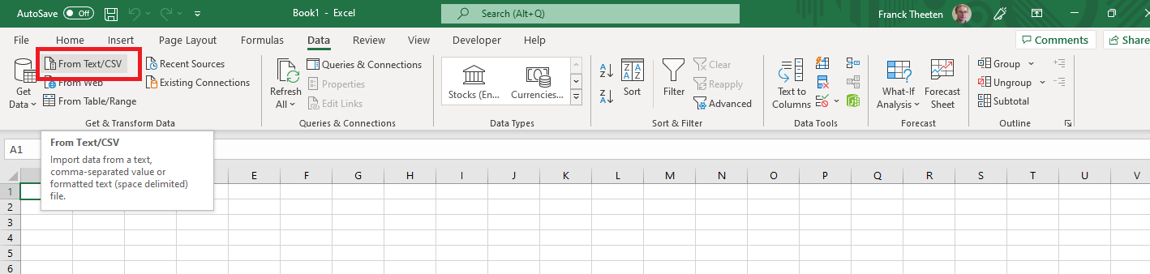

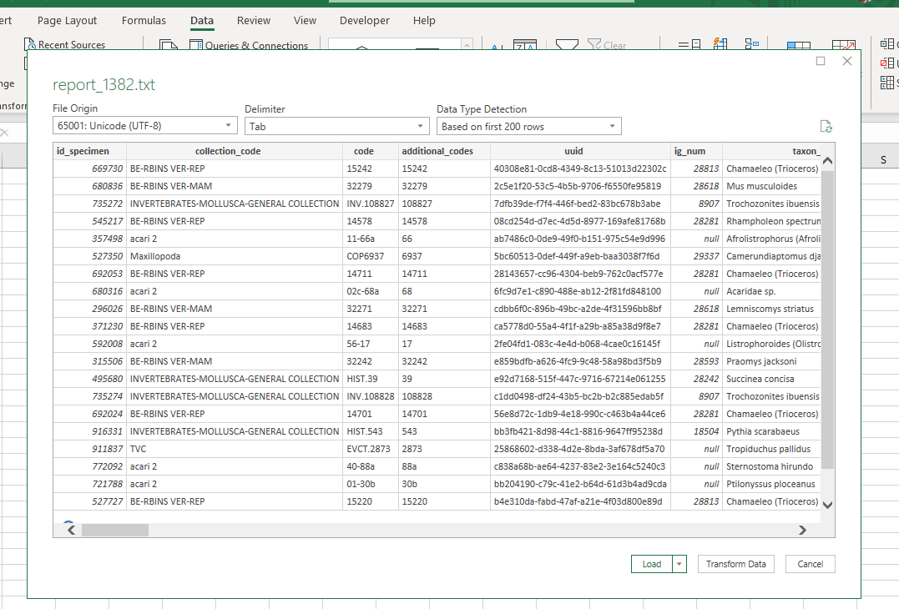

Notes :

* 1. Choose the appropriate Delimiter
  2. Beware, source encoding is Unicode /UTF-8 (not the standard encoding of Excel which is Latin1). Check this option, otherwise you risk to alter data and loose those with diacritic or accented characters (e.g. *“België”* canbecome *“Belgi□” “10 mètres”* becomes *10 “m□tres”*)
  3. Using LibreOffice or OpenOffice works often better than Excel to convert the data into Excel, especially if the source data contains line breaks (several lines)