We’re really happy to accept contributions from the community, that’s the main reason why we open-sourced it! There are many ways to contribute, even if you’re not a technical person.
We’re using the simplified Github workflow to accept modifications (even internally), basically you’ll have to:
- Create an issue related to the problem you want to fix (good for traceability and cross-reference). To do that, click on the link (1) and create a new issue (2).
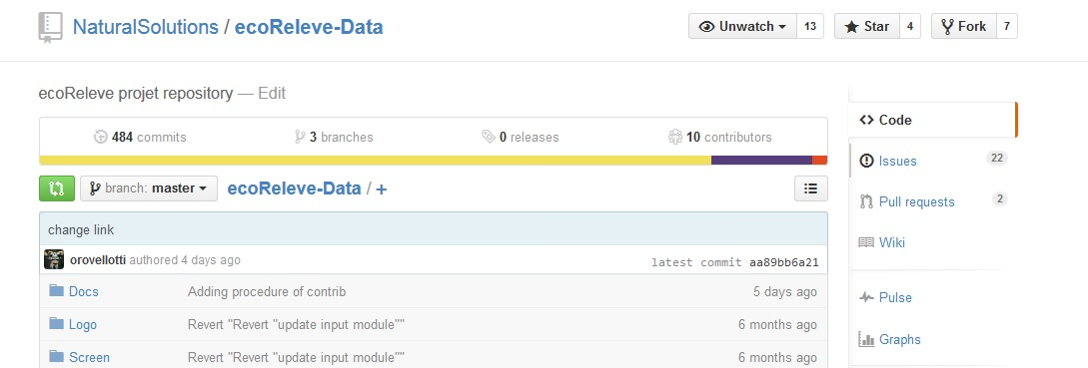
1

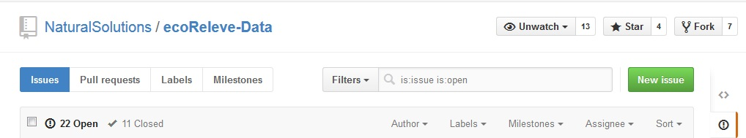
2

- Fork the repository. It allows you to have your own copy to your account. You need to login and simply click on “fork” button on the top right of the project home page.
- Create your local copy by cloning repository from your account (forked repository). On GitHub, navigate to your fork. In the right sidebar of your fork's repository page, click to copy the clone URL for your fork.
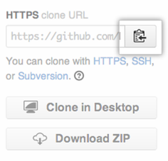
- Open Terminal (for Mac users) or the command prompt (for Windows and Linux users).
- Type git clone, and then paste the URL you copied in previous step.

- Create a branch (optionally with the reference to the issue in the name)

- hack hack hack

- commit incrementally with readable and detailed commit messages

- submit a pull-request against the master branch of this repository

We’ll take care of tagging your issue with the appropriated labels and answer within a week (hopefully less!) to the problem you encounter.
If you’re not familiar with open-source workflows or our set of technologies, do not hesitate to ask for help! We can mentor you or propose good first bugs (as labeled in our issues).

- fork
- Clone to desktop
- Create a branch

- Faire la modification
- Exécuter les tests
- Commit & push forked depôt
- Création d’une PR
- Attendre le retour (code review effectué à ce moment là)
- Si OK, supprimer la branche (optionel)

Procdeure merge pull request :
- Code review
- Ajouter commentaire dans le code.
- Approuver ou refuser (commentaire obligatoire)

