# Carnatic Music Lessons, Notes Generator and Synthesizer

# PyCarnatic – Carnatic Music Guru ©

**Version 1.2.1**

**Copyright © Dr. Sundaram Sundaresan**

**website:** <https://github.com/naturalstupid/pycarnatic/>

# Features:

The “PyCarnatic” Carnatic Music Guru is a python based software inspired by Jraagam developed by this author. For details about java based JRaaga – see <https://sourceforge.net/projects/carnaticmusicguru/>

Pycarnatic has (or will have) same features as follows:

* Typically carnatic music lesson books give lessons such as saraLi varisai only for maaya maaLava GowLai raagam.
* This software can generate music lessons at any raaga, thaalam and jaathi combination.
* V0.7.5 onwards: You can generate kalpana swaram for any raaga, thaalam and jaathi combination using either a notation file or using lessons.
* Plays the music notes (can be either generated lessons, or manually entered notes, or even notes from a file)
* You can search for a raaga and play the lessons in that raaga
* You can change the thaaLa and jaathi for the lessons.
* It supports the following instruments: Veena (two types), Flute, Violin, Piano, Sitar, Sarod, Guitar.
* You can include percussion to accompany the playing – percussion will be played per selected thaala, jaathi, nadai combination
* It supports following percussion instruments: Mridangam and Thavil.
* It supports playing solkattu for mridangam **(Please use Thaalam Menu for the same)**
* **TODO:** Provides a tool to “Check your Shruthi” and set it to the instruments.
* Provides a krithi player which will show krithis for the selected raga (if available from <http://www.shivkumar.org/music/index.html>). It can also be used to play MP3 files from the computer.
* **TODO:** The notations can be saved as a PDF, Text File, or even as Music Sheets (for this feature you should have LilyPond installed in your computer)
* The notes can be Equal Tempered scale or just intonation Carnatic scales of 12, 16 and 22 notes.
* It also supports microtones in all the above scales. Between each notes you can have up to microtones.
* The user interface is available in English and Tamil (as of V1.2.1)

## Generation of music lessons in carnatic music notation

PyCarnatic can generate following music lessons in carnatic music notations:

ஸ்வராவளி வரிசை swaravaaLi varisai

ஜண்டை வரிசை jantai varisai

தாட்டு வரிசை dhaattu varisai

மேல் ஸ்தாயி வரிசை mEl sthaayi varisai (Upper Sthaayi)

கீழ் ஸ்தாயி வரிசை mEl sthaayi varisai (Lower / Manthra Sthaayi)

அலங்காரம் alankaara varisai

NOTE: As far as alankaaram is concerned – there are two menus – one to generate as per the Gaanamritha Bodhini book or to generate them using this software using an up-down algorithm.

The Basic Lessons (SwaraavaLi to KeezhSthaayi) are currently available for only for the following raaga/thaala combinations:

Sampoorna Raagas – that have all the 8 notes (S to S^) and for janya ragas that have 6 notes (e.g. Mohanam S R G P D S’).

Thaala/Jaathi combinations that lead to total of 12 or 16 akshasaras or its factors (e.g. 4|2|2|| is a factor of 16, 3|1|2|| is a factor of 12)

Other combinations are not available yet.

### Version 0.7.5: Kalpana Swaram Generation

PyCarnatic is first of its kind to be able to generate kalpana swaram using Markov Chain model. Other s/w use midi files where PyCarnatic uses the notations itself. Kalpana swaram can be generated either using your own notation file for the raaga, or using Varnam file for the raaga. Second option is to be able generate the kalpana swaram from the carnatic music lessons for the raaga (from SaraLi to Alankaaram). For raagas with 6 or 7 notes in their arogana/avarogana – all lessons may not be available still the kalpana swaram is possible.

To generate the Kalpana Swarams do the following steps:

* Select the raaga for which you want to kalpana swaram. You can use Search menu to find your raaga.
* Select the thaaLa and Jaathi
* Select the song speed (swaras per akshara). Typically kalpana swaram are done with third speed (four swaras per akshara).
* From Tools>Options menu – Select number of avarthana of kalpana swaram to be generated.
* Then use the menu Raaga>Generate> “Kalpana Swaram from Corpus” or “Kalpana Swaram from Lessons”

## Commands:

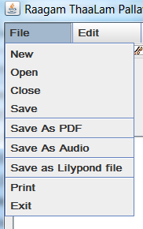

File

New... Write your own notes in the notes window and play it by pressing the PLAY Button above the notes window

Open... Open a notation file. The contents of the notation file will be automatically played

Close Close the note file and clear the notes window

Save Save the notation file as a text file.

Save As Not implemented

Save As PDF To save the lyrics as a PDF file. Each speed from 2nd speed onwards will have a overline on top of swaras. The output is stored by default in the pdf folder.

Save As LilyPond File To Save as LilyPond File. You need LilyPond software to convert the LilyPond file into a Music Sheet PDF.

If you have LilyPond installed in your computer – then change /Config/vbfugue.inp file and set the value of

*is_LilyPond_Installed=1*

*and LilyPond_Executable="D:\\LaptopBackup\\Local\\Program Files\\LilyPond\\usr\\bin\\lilypond.exe"* **<< Use LilyPond executable path like this. Note “\\”**

Print Not implemented

Exit Exit the Application.

### Generate Menu Items

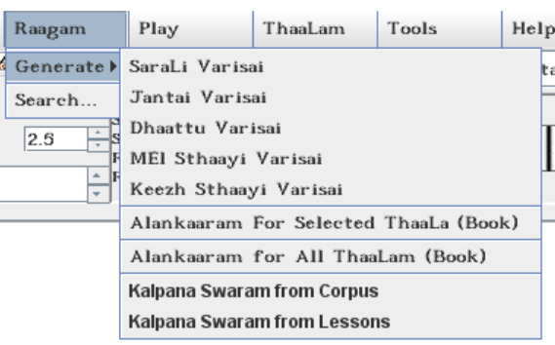

Raaga

Generate

SaraLi Varisai Generate the SaraLi varisai notations of the selected raaga in a file

Jantai Varisai Generate the Jantai varisai notations of the selected raaga in a file

Dhattu Varisai Generate the Dhaattu varisai notations of the selected raaga in a file

mEl Sthaayi Varisai Generate the mEl Sthaayi varisai notations of the selected raaga in a file

Keezh Sthaayi Varisai Generate the Keezh Sthaayi varisai notations of the selected raaga in a file

Alankaaram Selected ThaaLam (Book) Generate the Alankaara varisai of the selected raga and selected ThaaLam (based on the Ganaamritha Bodhini Book)

Alankaaram All ThaaLam (Book) Generate the Alankaara varisai of the selected raga for All 35 ThaaLams (based on the Ganaamritha Bodhini Book)

Kalpana Swara from Corpus Generate Kalpana Swaram for the selected raga for All 35 ThaaLams using the note sequences from a notation file such as Varnam.

Kalpana Swara from Lessons Generate Kalpana Swaram for the selected raga for All 35 ThaaLams using the using the lessons of the raaga.

Search... Search for a raga – you can enter part of the raga name in the search window. A List box will show – raga names that contains the search text. You can select a raga from that list by Clicking the “Accept the Selected Raaga”

The Raaga Search also be performed by clicking the  (Binocular like button between the Raaga List and Thaala List).

For more details see Raaga Search Window section.

### Play Menu items

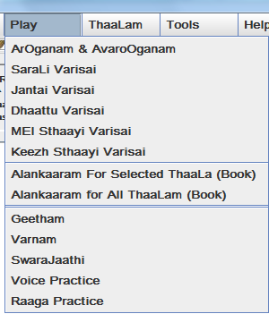

Play

ArOGanam & avarOGanam Play the ArOganam and avarOganam of the selected raaga

SaraLi Varisai Play the SaraLi varisai of the selected raaga

Jantai Varisai Play the Jantai varisai of the selected raaga

Dhattu Varisai Play the Dhaattu varisai of the selected raaga

mEl Sthaayi Varisai Play the mEl Sthaayi varisai of the selected raaga

Keezh Sthaayi Varisai Play the Keezh Sthaayi varisai of the selected raaga

Alankaaram Selected ThaaLam (Book) Play the Alankaara varisai of the selected raga and selected ThaaLam (based on the Ganaamritha Bodhini Book)

Alankaaram All ThaaLam (Book) Play the Alankaara varisai of the selected raga for All 35 ThaaLams (based on the Ganaamritha Bodhini Book)

Geetham Play Selected Geetham Notes file

Varnam Play Selected Varnam Notes file

SwaraJaathi Play Selected SwaraJaathi Notes file

Voice Practice It provides the voice practice lessons from Carnatica brother – Shri Shashikiran’s “Funtastik” book.

Raaga Practice Play and Practice some raga sanchaara notes (Courtesy – Perfecting Carnatic Music – Shri. Ravi Kiran’s book).

### ThaaLam Menu Items

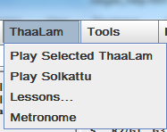

* Play Selected ThaaLam: Clicking this menu – will generate two Aavarthanam solkattu for the selected ThaaLam/Jaathi/Nadai combinations and play them.
* Play Solkattu: You can enter your own solkattu using the syllables:  
  *tha ri ki ta ka jo nu dhi mi chap thom num ta na thom*chap dhin ta*thom num*thom dhin*thom chap*thom dhin*tha gu gi nam thi.* Use comma (“,”) for *kaarvai*
* Lessons: 9 basic mridangam lessons can be accessed from this menu.
* Metronome: Clicking this menu – A Solkattu with about 10 aavarthanam for the selected thaaLam/Jaathi/Nadai combination is generated and played.

### Tools Menu Items

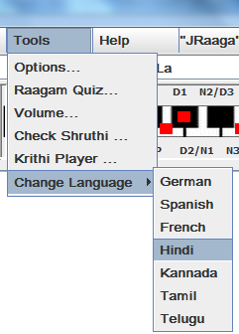

Tools

Options.... Select Instruments, Configure whether to include thaala with lessons.

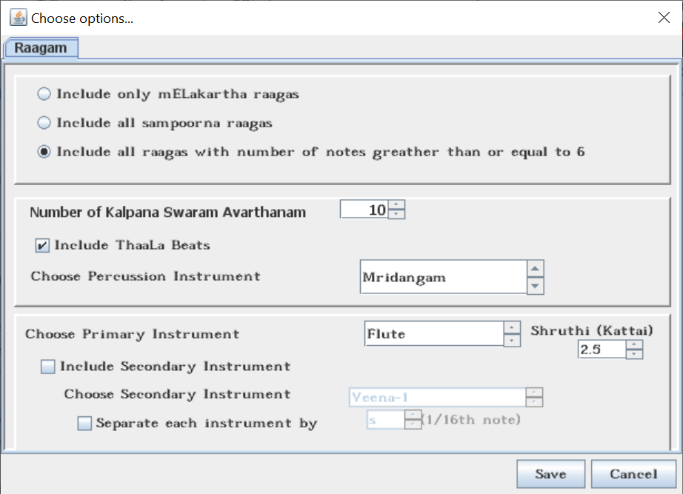

**Raaga List Selection:**

You can select either

only 72 mELakartha ragas (default)

All ragas that have all the 8 notes (both mELaKartha and Janya)

Raagas with number of notes >= 6

For the List of Raagas – Click here => RAAGA TABLE  
**NOTE: Only raagas of same number of swaras in aagrogana and avarOgana are selected in each option. Raagas with different number of swaras in aarogana and avarOgana will be ignored.**

**Number of Kalpana Swaram Avarthanam:** To select number thaala cycle (avarathanam) of kalpana swaram to be generated. (**V2.2 Feature)**

**Select Percussion Instrument:**

If the *Include ThaaLaa Beats* is checked – then there will be percussion beat for each note played as per thaala/jaathi/nadai selected in the main screen.

You can also select Mrdiangam, Tabla (2 variations) as the percussion instrument

You can also use this window to include one additional instrument to play the notes, lessons. Select how much (lag) duration each instrument be separated so that they can be heard distinctly playing the notes.

**Check Shruthi...** You can sing the notes. The application will detect the shruthi and display.   
 If you are happy with the detected note – you can select it.  
 You also can select Shruthi directly from Shruthi List   
 (List next to Duration, below instrument icons)

**Krithi Player…** It will show krithis available for the selected raaga (from the website of <http://www.shivkumar.org/music.html>)

You can change raaga, search for a raaga, rewind, pause, play etc.

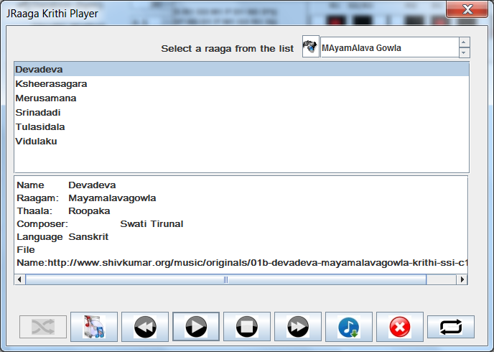

**Change Language>** You can change the user interface language to one of the following available languages:

**English, Spanish, German, French, Tamil, Hindi, Kannada and Telugu.**

**Help**

**Features...** Shows this page

**About...** Shows the revision History and Author of this software

## Selecting Note Scale

JRaaga provides 4 scales for notes:

### Equal Tempered Western Scale

Equal Tempered Western Scale is where S R1 R2 G2 G3 M1 M2 P D1 D2 N2 N3 S’ are aligned with piano keys. For example when the kattai is chosen to be 4.0:

S => C

R1 => C#

R2 => D

G2 => D#

G3 => E

M1 => F

M2 => F#

P => G

D1 => G#

D2 => A

N2 = A#

N3 => B

S‘ => C

If the kattai is 4.5 then the aligned keys are shifted to the right. For example S => C#. Similarly, when the kattai 3.0 (Note: There is no 3.5 kattai), the S => B. In this notation, G1=R2, G2=R3, N1=D2, N2=D3.

### Just Intonation Carnatic Scale of 12 notes

This scale can be selected using “#N1” in the notation.

In the case of “Carnatic Scale of 12 notes”, only “S”, “P” are aligned to the piano keys whereas the other pitches of other notes are determined by the ratios: 16/15, 9/8, 6/5, 5/4, 4/3, 45/32, 3/2, 8/5, 27/16, 9/5, 15/8 respectively for R1, R2, G2, G3, M1, M2, P, D1, D2, N2 and N3. In this notation, G1=R2, G2=R3, N1=D2, N2=D3. These factors can be changed in the configuration file.

### Just Intonation Carnatic Scale of 16 notes

This scale can be selected using “#N2” in the notation.

In the case of “Carnatic Scale of 16 notes”, only “S”, “P” are aligned to the piano keys whereas the other pitches of other notes are determined by the ratios: 32/31, 16/15, 10/9, 32/27, 6/5, 5/4, 4/3, 17/12, 3/2, 128/81, 8/5, 5/3, 16/9, 9/5, 15/8 respectively for R1,R2,R3, G1,G2, G3, M1, M2, P, D1, D2, D3, N1, N2 and N3. Note that we have 3 separate notes for R, G, D, and N. These factors can be changed in the configuration file.

### Just Intonation Carnatic Scale of 22 notes

This scale can be selected using “#N3” in the notation.

In the case of “Carnatic Scale of 22 notes”, only “S”, “P” are aligned to the piano keys whereas the other pitches of other notes are determined by the ratios: 32/31, 16/15, 10/9, 9/8, 32/27, 6/5, 5/4, 81/64, 4/3, 27/20, 45/32, 64/45, 3/2, 128/81, 8/5, 5/3, 27/16, 16/9, 9/5, 15/8, 31/16 respectively for R1,R2,R3, R4, G1,G2, G3, G4, M1, M2, M3, M4, P, D1, D2, D3, D4, N1, N2, N3 and D4. Note that we have 4 separate notes for R, G, M, D, and N. These factors can be changed in the configuration file.

## Microtones

In addition to basic 12 or 16 or 22 notes, JRaaga also provides notations for additional 10 microtones between each major note.

For example a notation S<1 provides a micro-note that has pitch 10% lower pitch than the “S” of the selected scale. S<2, S<3, S<4, S<5 are micro-notes with 20%, 30%, 40% and 50% lower pitches of S. For other notes similarly R1<1 to R1<5 can be used as notations.

Using a “>” symbol can have micro-notes of 10% to 50% higher pitches for the corresponding major note. Example: M1>5, S’<4 etc.

## Gamakams – Ornamentation

### *Jaaru - Sliding*

In this version, JRaaga provides some experimental gamakam notations that to some extent represent “*jaaru”.*

For example, you can use “/” for ascending slide (“aetra jaaru”) as follows

S/1 – you can slide from “S” to “R1”.

S/2 – you can slide from “S” to “R2”.

S/3 – you can slide from “S” to “G2”.

S/4 – you can slide from “S” to “G3”.

S/5 – you can slide from “S” to “M1”.

Note: S/2 to S/5 – you might hear some jumps though.

Similarly, you can use “!” for descending slide (“irakka jaaru”) as follows

M1!1 – you can slide from M1 to G3.

M1!2 – you can slide from “M1” to “G2”.

M1!3 – you can slide from “M1” to “R2”.

M1!4 – you can slide from “M1” to “R1”.

M1!5 – you can slide from “M1” to “S”.

Note: M1!2 to M1!5 – you might hear some jumps though.

### *Orikai (switch to next tone before/after the duration)*

You can also adjust note durations for adjacent notes.

For example:

S_1 R => S will be played for 110% of its duration whereas R will be played only 90% of its duration.

S_2 R => S will be played for 120% of its duration whereas R will be played only 80% of its duration.

S_3 R => S will be played for 130% of its duration whereas R will be played only 70% of its duration.

S_4 R => S will be played for 140% of its duration whereas R will be played only 60% of its duration.

S_5 R => S will be played for 150% of its duration whereas R will be played only 50% of its duration.

## Notations for Swara Notes:

Basic Swaras: S   
 R1 R2=G1 R3=G2

G1=R2 G2=R3 G3

M1 M2

P

D1 D2=N1 D3=N2

N1=D2 N2=D3 N3

S^

You can also use plain S R G M P D N for the notes without numbers. The swara notation is also case insensitive which means “s” or “S” implies Shadjama of middle octave.

* ^ (carrot symbol) or ‘ (single quote symbol) Following a swara = upper octave of the swara
* . (period) following a swara = Lower octave of the swara
* - (hyphen) is a emphasis note. Also used to denote the beginning of silence if , or ; follow the hyphen.
* , (comma) can be used to prolong a note to double its duration (example : S , means S is prolonged to double its duration. Comma will also be a silence if it does not follow a note or after end of a thaala.
* ; (semicolon) can be used to prolong a note to triple its duration (example : S ; is equivalent to S , , and means S is prolonged to triple its duration. Semicolon will also be a silence if it does not follow a note or after end of a thaala.   
    
  NOTE: Specifying a note twice will not sound the same as prolonging the note – due to decaying effect added to notes.
* : (colon) can be used for ½ note silence or prolongation as above.
* | or || can be used to denote division or end of thaala. The program will ignore it and generate its own – if it does not match thaala/jaathi specified
* / (forward slash) –this can be used to glide from one to its next note for S/R is to be used to Glide from S to R. Number of slashes will determine when the slide happens.
* _ (underscore). For example S_1 R means 110% S and 90% R (S will be played for 110% of its duration and R and will be played for 90% of its duration). Similarly - “S_2 R” means 120% S- and 80% R, “S///R” means 130% - 70% etc
* \ (backward slash) – same meaning as above – but for readability purpose you can use this when you want to slide down a note. Both symbols (“/” or “\”) would mean the same though.
* >n (greater than symbol) –to increase the frequency of a note by “n” times a fraction
* <n (less than symbol) – In future this symbol will be used to decrease the frequency of a note by “n” times a fraction

## Screen Shots

### Main Window

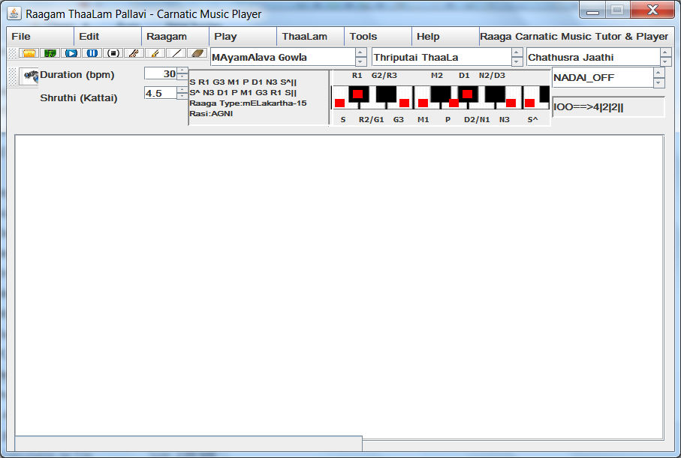

The Shadjama (S) Frequency for middle octave – is by default 166 Hz – and can be changed. The duration of each swara / note is 1 second (1000 milli seconds) – by default and can be changed.

The short-duration (notation is to use a hyphen symbol following a note: E.g. S- or N1-) is to emphasize a specific note while playing and hence the duration of its note is shortened by 90% (0.9) and this factor can be changed. Similarly the a note is prolonged by using a symbol “comma” (“,”). By default it is prolonged double in its duration (hence the factor 1.0)

You can select a raga from the raga list – and use keyboard UP or ARROW keys to scroll through the list. As you scroll through the list, the ArOganam, avarOganam, mELakartha number and the Rasi it belongs to and whether it is mELakartha or Janya – is displayed in adjacent fields.

You can select the Base Shruthi (KATTAI) from any of the values from 0.5 to 7.0 (ARAI KATTAI to EZHU KATTAI)

You can select Veena, Violin or Flute by clicking the respective icons. You can also switch off/on the percussion by clicking the mridangam icon.

You can play/resume/stop the music by pressing corresponding buttons.

### Raaga Search Window

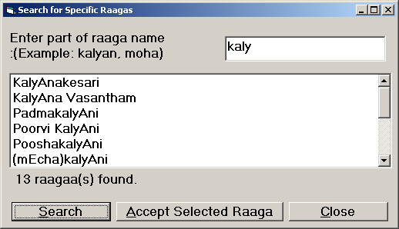

You can open the Raaga Search Window – from the menu Raaga>Search... or directly by pressing the CTRL+F key (Pressing CTRL and F together).

The search text – is Case-Insensitive – meaning “KALY”, “kalY” , “kaly” – are all same.

Enter the search text and press “Search” button. **Please note that the raga names use “transliteration words”. For example – KalyAni – Upper Case “A” implies “long A” equivalent to “aa”. Therefore avoid using “aa” instead use “A”. When in doubt – try entering less number of characters.**

Then select the raaga you want from the list and click “Accept Selected Raaga” – to be used for playing or generating lessons.

For the List of Raagas – Click here => RAAGA TABLE

### Shruthi Detection Window

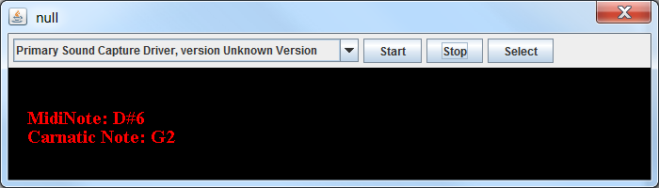

You can invoke the Pitch Detection (Shruthi Detection) From Tools > Check Shruthi Menu.

Select your microphone device (Default: “Primary Sound Capture Driver…” works most of the time.

Click Start button

Sing the “Shadjam” – “Sa” – sustain it for a few seconds. You should see the detected Shruthi in English Note Scale C or C# … etc.

Click Select – once you are satisfied about your shruthi.

The Selected Shruthi will be chosen as the base for your Shadjam (Sa).

Click Stop and Close the window. And Reopen – if you want to try again.

## Raagam Quiz

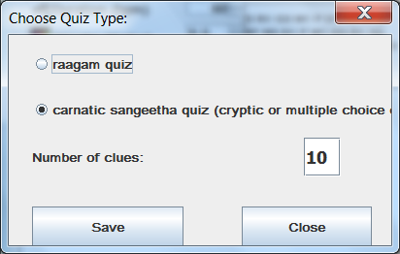

Select one of the quiz types:

Raagam Quiz will show a quiz dialog where it will randomly choose one of the 750+ raaga and show the aroganam and avaroganam. Guess the raaga or click the answer. It will show the raaga details and will speak out the raaga name (provided you are connected to internet without any corporate firewall)

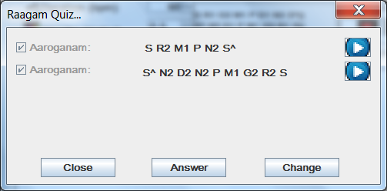

Or Select option for Carnatic music related questions quiz . Enter number of quiz questions you would prefer.

In this case, it will provide the number of questions (either cryptic with clues, or multiple choice answers). Click on Answer to find out the answer. It will show the correct answer with check mark, and if your selection is incorrect it will show cross mark. It will also speak out the answer in the language of the selection. Click Next or Previous to move to the next/previous questions. Click Close to end the dialog and return to main screen.

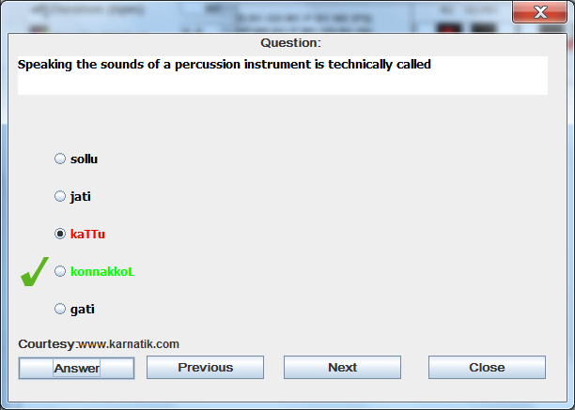

## Change the volume of the instruments

To change the volume of the instruments – click Tools>Volume… menu

Select the instrument. You can adjust the volume slider listening to the instrument sound. The slider volume is relative to the selected system volume from your computer. If more volume is needed adjust the system volume (and not here),

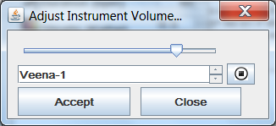

## Notation Directives to Control Music

Program uses the following notations and tokens (commands):

Any line that starts with { will be treated as comments and be ignored for playing but will be displayed

Any line that starts with # will be treated as a token line and the token (command) will be processed as follows:

### #Nx

#N1 stands for Just Intonation Carnatic scale of 12 notes

#N2 stands for Just Intonation Carnatic scale of 16 notes

#N3 stands for Just Intonation Carnatic scale of 22 notes

If this notation is missing, Equal Tempered Western scale will be used.

### #Dnnn

#D stands for DURATION (TEMPO) followed by a number up to 999. Where nnn is the tempo number (duration of a note) in terms of beats per minute. For #D120 means the tempo is 120 beats per minute which means the duration of a note is equal to ½ second (500 milli seconds) – default is #D60 (duration is 1 second). #D30 means each note is 2 seconds long

### #Sn

#S Stands for SPEED (Kaalam) and n stands for the speed = 1, 2 , 3 or 4. Default is first speed   
 #S1 means First Speed,   
 #S2 means Second Speed and   
 #S3 means Third Speed.   
 Up to Five Speeds are allowed and more than that will default to third speed.

**( .. )** If you want to increase or decrease the speed of a few notes inside the lyrics – you can use parenthesis “(“ (to increase) or “)” (to decrease). For example S (RG) ((MPDN)) S’. In this S will be first speed, RG will be second speed and MPDN will be in third speed.

### #Mnn

#M stands for mELakarthaa number nn ( 1 to 72)

### #In or #Ix;y;z

#I stands for Instrument Selection

#I0 => Veena

#I1 => Veena (This was a simulated veena using mathematical waveforms)

#I2 => Flute

#I3 => Sarod

#I4 => Violin

#I5 => Sitar

#I6 => Shenai

#I7 => Guitar

#I8 => Piano

Using #In... You can select different instruments at different places of the song.

**Selecting multiple Instruments:**

You can also use #Ia;b;c (SEPARATE USING SEMICOLON) directive to select two instruments to play at a time

For example #I0;2

will select Veena and Flute to be played at the same time.

You can use this notation anywhere in the lyrics. For example one line of the lyrics can have instrument, another line can have another instrument and a third line can have multiple instruments.

### #Tn

Used to specify the ThaaLa

#T1 => EKA_THAALA  
 #T2 => ROOPAKA_THAALA

#T3 => JAMPA_THAALA  
 #T4 => THRIPUTAI_THAALA  
 #T5 => MATHYA_THAALA  
 #T6 => ATA_THAALA  
 #T7 => DHURVA_THAALA

### #Jn

Used to specify Jaathi of the thaaLa

#J1 => THISRA_JAATHI  
 #J2 => CHATHUSRA_JAATHI  
 #J3 => KHANDA_JAATHI  
 #J4 => MISRA_JAATHI  
 #J5 => SANKEERNA_JAATHI

For the complete list of 35 thaalas – click the THAALA TABLE

**{** Any line starting with curly braces will be treated as a comment.   
 Only exception is a line { Ragam: ssssssss where the program will attempt to match the string following “{ Ragam:” and set the notes for the same

## Configuration

The software can be configured by editing the configuration file Config\vbfugue.inp – sample set of fields and values are shown below:.

#Supported Languages: ta=Tamil, te=Telugu, ka=Kannada, hi=Hindi

#en=English, es=Espianol (Spanish), de=Deutsch (German), fr=French

language=en

# Choose JRaaga Configuration

# 1 = Lite Version - no Indian Instrument or Percussion soundbank supported

# 0 = Full version - Include path of Indian Sound Font file name

is_jraaga_lite=0

# Specify Indian Sound Font file name in the LIB Folder

#sound_font_file=file_name.sf2

sound_font_file=SIWF8.sf2

# Specify Raaga Selection:

#1 = Load Only MeLakartha Raagas 2= Load All SampoorNa Raagas (Raagas with all 8 notes)

#3 = Load all raagas that have at least 6 notes

raaga_selection=3

# Specify whether percussion should be played by default

#1 = Include ThaaLa 0= Do not inlcude ThaaLa

include_thaala=1

# Specify default duration of a note

#0=full note, 1=1/2, 2=1/4, 3=1/8, 4=>1/16, 5=>1/32, 5=>1/64, 6=>1/128

note_duration=2

# Specify Attack Decay Pattern

#Format: a<xxx>d<yyy>: a120d30 means attack=120 and decay=30. Range: 0 to 127

#Leave it empty if you do not want attack/decay

attack_decay_pattern=a120d30

# Specify Default Instrument Index

#If soundfont loaded 0=Veena, 1=Veena-2, 2=Flute, 3=Sarod, 4=Violin, 5=Sitar, 6=Shenai, 7=Guitar, 8=Piano

#Otherwise 0=Violin, 1=Sitar, 2=Shenai, 3=Guitar, 4=Piano

default_instrument=0

# Specify Each Instrument Kattai

#(Values: 0 => 0.5, 1 => 1.0, 2 => 1.5, 3 => 2.0, 4 => 2.5, 5 => 3.0, 6 => 4.0, 7 => 4.5, 8 => 5.0, 9 => 5.5, 10 => 6.0, 11 => 6.5 )

#Array element 0=Veena, 8=Piano Example: #instrument_kattai_0=4.0

instrument_kattai_0=6

instrument_kattai_1=6

instrument_kattai_2=6

instrument_kattai_3=6

instrument_kattai_4=6

instrument_kattai_5=6

instrument_kattai_6=6

instrument_kattai_7=6

instrument_kattai_8=6

# Specify Each Instrument Volume (Value between 0 and 127=Max)

#Array element 0=Veena, 7=Piano

instrument_volume_0=40

instrument_volume_1=40

instrument_volume_2=40

instrument_volume_3=40

instrument_volume_4=30

instrument_volume_5=20

instrument_volume_6=40

instrument_volume_7=40

instrument_volume_8=40

instrument_volume_9=0

percussion_volume_0=80

percussion_volume_1=80

# Specify Default Percussion Instrument Index

#If soundfont loaded 0=Mridangam, 1=Tabla

percussion_instrument=0

# Specify whether by default two instruments are played always

#1=two instruments played by default, 0=only one instrument played by default

extra_instrument=0

# Specify whether to stagger playing two instruments (to be able to listen them)

#0=No 1=Yes

stagger_instrument=1

# Specify how much interval between two instruments

#0=full note, 1=1/2 note 2=1/4 note, 3=1/8 note and so on

stagger_note_index=4

# Specify whether LilyPond software is installed in your computer

#LilyPond is a software to create Music Sheets

#0 = No and 1= Yes. You can also save notation as LilyPond File.

is_LilyPond_Installed=0

# Specify Path where LilyPond software is installed in your computer

# In Windows use \ to separate folder names. Others use /

#LilyPond_Executable=path_of_lilypond.exe_file

LilyPond_Executable=path_of_lilypond.exe_file

#Speak the raagas: 0 => Do not speak, 1 => Speak only in Quiz 2 => Speak always.

speak_the_raaga=0

#Quiz Type 1 => Quiz on random raagas showing Aaroganam/Avaroganam and playing them

#Quiz Type 2 => Quiz on random cryptic/multiple choice questions on carnatic music

quiz_type=2

# Specify whether to check for software updates

# 1 => Check for updates 0 => Do not check for updates

check_for_updates=1

# Specify how ThaaLa Patterns to be generated sequential or random

# 1 => Random 0=> Sequenctial

thaaLa_pattern_random=1

# Scale of Notes: 0=> Equal Tempered Notes (Western), 1=> Carnatic Scale of Notes

# 2 => Carnatic Scale of 15 notes, 3=> Carnatic scale of 22 notes.

scale_of_notes=0

# specify Just Intonation ration of carnatic 12 notes separated by comma

# S R1 R2 G2 G3 M1 M2 P D1 D2 N2 N3 S^

carnatic_12_freq=1, 16/15, 9/8, 6/5, 5/4, 4/3, 45/32, 3/2, 8/5, 27/16, 9/5, 15/8 ,2

# specify Just Intonation ration of carnatic 16 notes separated by comma

# S R1 R2 R3 G1 G2 G3 M1 M2 P D1 D2 D3 N1 N2 N3 S^

carnatic_16_freq=1, 32/31, 16/15, 10/9, 32/27, 6/5, 5/4, 4/3, 17/12, 3/2, 128/81, 8/5, 5/3, 16/9, 9/5, 15/8, 2

# specify Just Intonation ration of carnatic 22 notes separated by comma

# S R1 R2 R3 R4 G1 G2 G3 G4 M1 M2 M3 M4 P D1 D2 D3 D4 N1 N2 N3 N4 S^

carnatic_22_freq=1, 32/31, 16/15, 10/9, 9/8, 32/27, 6/5, 5/4, 81/64, 4/3, 27/20, 45/32, 64/45, 3/2, 128/81, 8/5, 5/3, 27/16, 16/9, 9/5, 15/8, 31/16, 2

## Program Credits

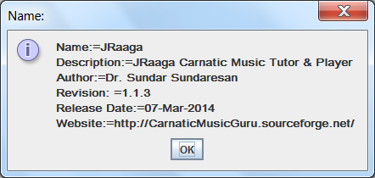

**Special Thanks to my daughters Raji and Bhuvana in fixing the frequency of the swaras based the real feel of the raagas.**

### Third Party Open Source Credits

### JFugue – Carnatic Music String to MIDI Conversion and Playing soundfonts - <http://www.jfugue.org/>

### Gervill – Soundbank Support to JFugue - https://java.net/projects/gervill/pages/Home

### Viena – soundfont creation – http://www.synthfont.com/

### iText – PDF Creation – http:// <http://itextpdf.com/>

### Tarsos – Pitch Detection – <https://github.com/JorenSix/TarsosDSP>

### Jaco MP3 Player – <http://jacomp3player.sourceforge.net/>

### MP3 Tagging: MP3Agic: <https://github.com/mpatric/mp3agic>

### Krithi Archive: Shri Shivkumar Kalyanaraman: <http://www.shivkumar.org/music/index.html>

### In addition I would like to thank Shri. M Subramanian – the author of Rasika V2 (<http://carnatic2000.tripod.com>) which was the inspiration in the development of this software. Rasika V2 has fine quality of Veena and Flute and in addition supports microtones (gamakams) – which is lacking in JRaaga. Then why did I still venture this? Reason: I wanted this software be able to generate the lessons for any raga/thaaLa combination and be able to support multiple instruments (including percussion) be played like in a concert.

## Disclaimers

The program is still at infancy. It has been written by a person who has limited theoretical knowledge and has no practical experience with “Carnatic Music” and therefore should be used with caution.

**Any Suggestions to improve this is always welcome. Please email your comments to Sundaram.Sundaresan@gmail.com**

## Example Songs (to demonstrate all notations supported)

{ Following line is processed to gather the raagam name

{ Ragam: MAyamAlava Gowla

{ Since the Ragam is picked up from above line – following line is ignored, Otherwise will be used to gather MELakartha number

#M15

{ Duration = 90 beats per minute => Each note is 2/3 seconds long

#D90

{ following is notation for Eka ThaaLam

#T1

{ Following is notation for Thisra Jaathi

#J1

{ Play First speed in Veena

#I0

{ Select first Speed

#S1

{ you can use upper case or lower case for notes. You can use suffix 1,2,3 to differential notes

S r1 g2 M P d n S’

{ Select Flute

#I2

{ Use comma for double duration, ; to triple and : to half the duration

s, R; g: M2

{ following notation selects violin and piano and notes following that will be played by these at the same time

#I3;4

S R G M P D N S^

{ use ( to increase and ) to decrease speed

{S played full note, r, g, m played ½ note, p, d, n and S’ ¼ note each.

S (rg) (m (pdnS’) (S’ndp) m )

{ More examples are in Geetham, Varnam, Swarajaathi folders