**Computer Vision Homework 1 Report**

R05922064 謝天然

OS: Ubuntu 16.04 64bits

Language: **python**

I use **opencv** library to read and write an image.

How to use:

|  |  |
| --- | --- |
| usage: | **python ./hw1.py [task_id]** |
| task_id | **1~3** |

I have already read “lena.bmp” for default. So just choose the task id.

Task 1: upside-down

Task 2: right-side-left

Task 3: diagonally mirrored

Please install opencv library first before running the program.

|  |  |
| --- | --- |
| Step1: install pip |  |
|  | $ sudo apt-get install python-pip python-dev |
|  | $ sudo pip install --upgrade pip |
| Step2: install opencv2 |  |
|  | $ pip install opencv-python |

**Original image (512*512) Task 1: Upside-down image**

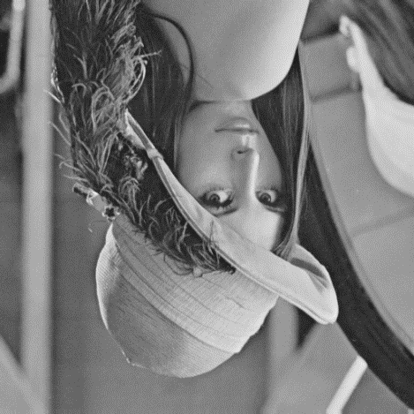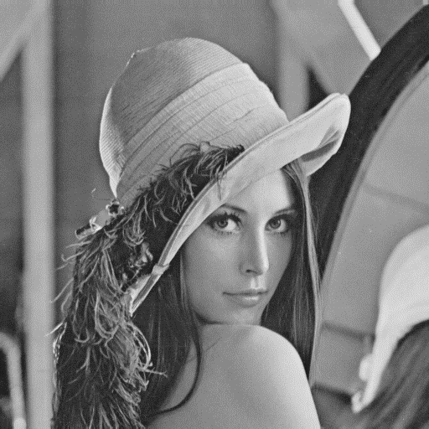

Task:

* **Part A: Coding**

1. Upside-down image: Define in function “**upside_down(img)**”. Reverse the rows of the image by reading the last row to the first row.
2. Right-side-left image: Define in function “**right_side_left (img)**”. Reverse the pixels of each row of by reading the last pixel to the first pixel.
3. Diagonally mirrored image: Define in function “**dia_mirror (img)**”. I mirror the image according to the diagonal from left-top corner to right-bottom corner. Reserve the values between two pixels P[x,y] and Q[y,x]. For instance: new_img[x,y] = img[y,x].

**Task 2: Right-side-left image Task 3: Diagonally mirrored image**

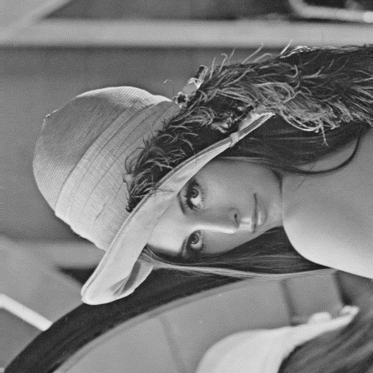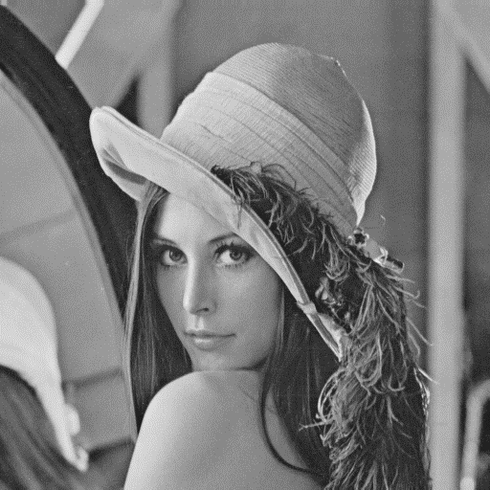

* **Part B: Use Gimp (version 2.8.16)**:

1. Clockwise 45 degree: Go to menu bar-> “Layer” -> “Transform” -> “Arbitrary Rotation”-> Input **45** at the column “Angle”

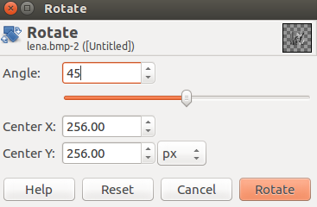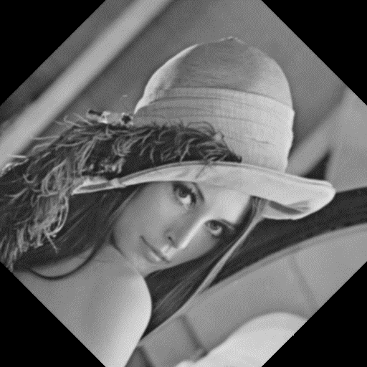 **Task 4: Clockwise 45 degree image**

1. 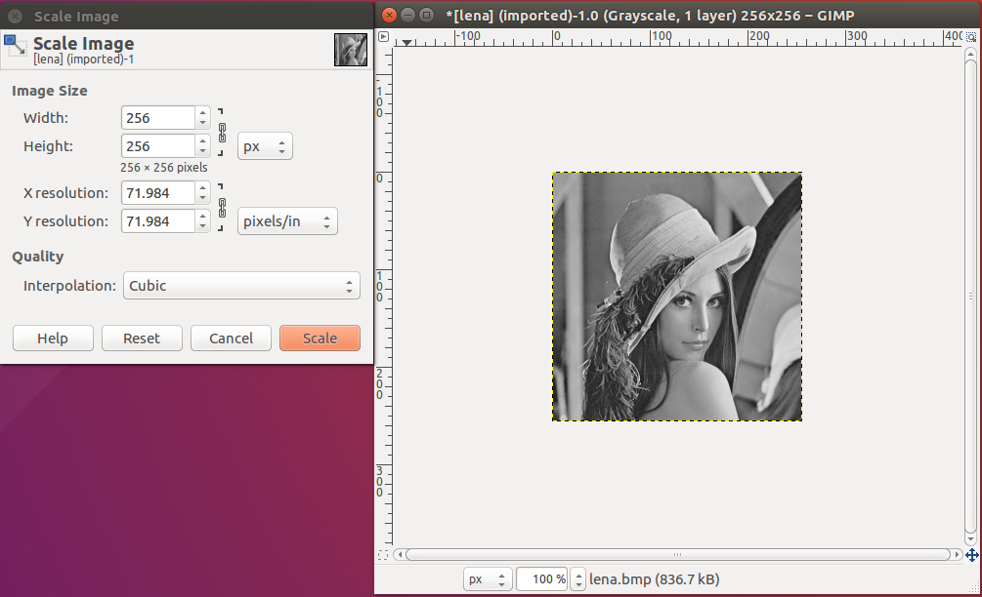Shrink half in width and height: Go to menu bar-> “Image” -> “Scale Image…” -> Change width and Height columns into “**256**”

**Task 5: Shrink image (256*256) Task 6: binarize at 128 image**

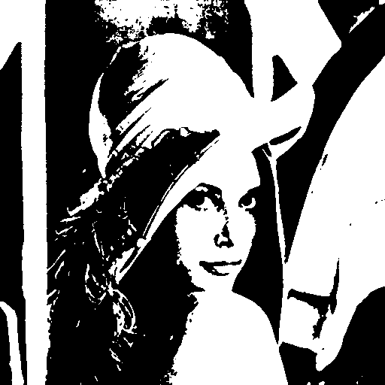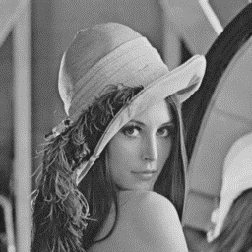

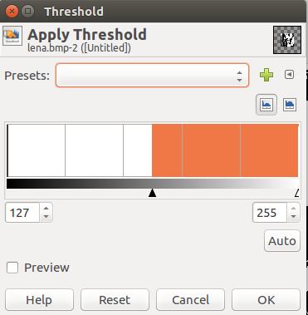3. Binarize at 128: Go to menu bar-> “Colors” -> “Threshold…” -> change the threshold at **128**.