Step 1: Configure GRADLE_USER_HOME in environment variables and give the path where it can be replicated in destination system.

For **windows**

GRADLE_USER_HOME : c:\gradle_cache

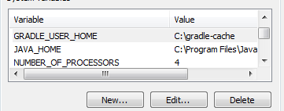

For **Linux**

Set the path in /etc/profile



Step 2: download the dependent JAR files by giving the command

**Windows/Linux**

Navigate to JPOS folder where gradlew.bat / gradlew is available

Open the command prompt and enter gradlew installApp. The dependent JAR files will download in the directory given in GRADLE_USER_HOME path.

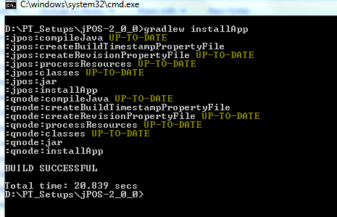

Step 3: In the destination system configure the GRADLE_USER_HOME variable and copy the downloaded jar files to that directory

Step 4: download gradle-4.3.1-bin.zip (get the latest version)

Step 5: Navigate to ..\jPOS-2_0_0\gradle\wrapper and edit gradle-wrapper.properties file

Default : 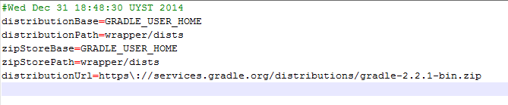

Change distributionURL to

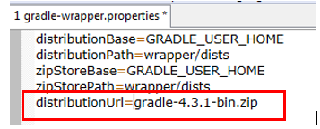

Copy the downloaded gradle-4.31.bin-zip to ..\jPOS-2_0_0\gradle\wrapper folder

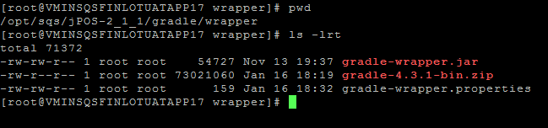

Step 6 :

Navigate to JPOS folder where gradlew.bat / gradlew is available

Open the command prompt and enter gradlew installApp, source will compile with build successful result.