A Hybrid DistilBERT-Logistic Regression Model for Taglish Misleading Information Detection Using Contextual and Linguistic Features.

A Capstone Project Presented to the Faculty of College of Computing Studies of Eulogio "Amang" Rodriguez Institute of Science and Technology

In Partial Fulfillment of the Requirements for the Degree of Bachelor of Science in Information Technology.

The system was developed by the following:
Kamilan, Diana F.
Naty, Ashley B.
Gagarin, Matt Dwayne S.
Villanueva, Aaron Zeke R.

This document is respectfully submitted to:
Prof. Hazel C. Anuncio

BSINFOTECH 3C
September 2026

TABLE OF CONTENTS
THE PROBLEM AND ITS BACKGROUND 1
Introduction 1
Background of the Study 6
Project Context 8
Purpose and Description 9
Conceptual Framework 11
Objectives of the Study 15
General Objective 15
Specific Objectives 15
Significance of the Study 20
Scope and Limitations of the Study 21
Definition of Terms 24
REVIEW OF RELATED LITERATURE AND STUDIES 30
Review of Related Literature 30
Foreign Literature 30
Local Literature 35
Review of Related Studies 39
Foreign Studies 39
Local Studies 44
Synthesis of Related Works 48
METHODOLOGY AND DESIGN 49
Technical Background 49
Approaches and Techniques 51
Supervised Binary Text Classification 51
Dataset Preparation and Evidence Validation 51
Text Acquisition and Extraction 55
Text Preprocessing 56
Contextual Feature Extraction 57
Linguistic and Stylistic Feature Extraction 58
Feature Fusion and Logistic Regression 59
Baseline Model Comparison 60
Credible-Source Retrieval 62
Controlled Dataset and Model Maintenance 62
Methodology 64
Phase 1 Requirements and Planning 65
Phase 2 Dataset Preparation 65
Phase 3 Model Development 66
Phase 4 System Development Sprints 66
Phase 5 Integration and Testing 66
Phase 6 Evaluation 66
Phase 7 Refinement and Deployment Preparation 67
Requirement Analysis 67
Population, Sample Size and Sampling Techniques 72
Population 72
Sample Size 72
Sampling Techniques 73
Description of Respondents 73
Research Instrument 74
Dataset Annotation and Evidence Validation Form 74
Model Evaluation Record 75
Multimedia Extraction Evaluation Form 75
Functional and Integration Test Cases 76
Software Quality Evaluation Questionnaire 77
Data Gathering Procedures 78
Step 1 Approval and coordination 78
Step 2 Candidate data preparation 78
Step 3 Evidence retrieval and human validation 79
Step 4 Partitioning and model development 79
Step 5 Held-out model evaluation 79
Step 6 Multimedia extraction testing 80
Step 7 Functional and integration testing 80
Step 8 Technical and general-user evaluation 80
Step 9 Compilation and protection of data 81
Statistical Treatment of Data 81
Percentage 82
Fleiss’ Kappa 82
Accuracy 83
Precision 83
Recall 83
F1-Score 84
Macro F1 84
False Positive Rate 84
Weighted Mean, if approved 85
Word Error Rate 85
Character Error Rate 86
McNemar’s Test 86
95% Bootstrap Confidence Interval 87
System Requirements 88
Hardware 88
Software and Technology Stack 89
Peopleware 93
Network 96
Dataware 97
References 103

LIST OF FIGURES
Figure 1. Conceptual Framework of SuriPH 14
Figure 2. Dataset Screening and Evidence Validation Flow 54
Figure 3. Hybrid DistilBERT-Logistic Regression Model Pipeline 60
Figure 4. Controlled Model Retraining and Activation Flow 64
Figure 5. Hybrid Agile Methodology of SuriPH 65
Figure 6. System Architecture of SuriPH 92
Figure 7. Use Case Diagram of SuriPH 95
Figure 8. Network Architecture of SuriPH 97
Figure 9. Entity Relationship Diagram of SuriPH 100
Figure 10. Data Flow Diagram Level 1 of SuriPH 101

LIST OF TABLES
Table 1. Functional Requirements of SuriPH 67
Table 2. Non-Functional Requirements of SuriPH 70
Table 3. Proposed Agreement Scale 77
Table 4. Hardware Requirements 88
Table 5. Planned Software and Technology Stack 90
Table 6. Peopleware Requirements 93
Table 7. Planned Dataware Entities 98

CHAPTER 1

THE PROBLEM AND ITS BACKGROUND
This chapter establishes the foundation of the study by presenting the problem addressed by the research, the setting in which the proposed system will operate, its purpose and objectives, the conceptual framework, the significance of the project, its boundaries, and the operational meaning of the terms used throughout the manuscript.

Introduction
Social-media users encounter public claims through posts, captions, comments, screenshots, and videos. These formats make information easy to share, but reposting can detach a claim from its source, date, or explanation. A short statement may therefore reach a reader without the material needed to judge it fairly.
The Organisation for Economic Co-operation and Development explains that false and misleading information can create confusion, intensify polarization, weaken trust, and interfere with informed public discussion. Responses to this problem must also preserve freedom of expression and access to diverse sources. An automated screening system should therefore assist users in examining information rather than present itself as an unquestionable authority over legitimate speech (OECD, 2024).
In the Philippines country chapter of the Digital News Report 2026, Chua (2026) reported overall news trust of 28 percent among the online respondents surveyed. Social media remained the dominant news source. These survey findings describe news use and trust in the surveyed population; they do not measure the proportion of misleading posts or provide labels for this study.
The Philippine setting also presents a linguistic challenge. Filipino online communication often moves between English and Filipino within the same sentence or exchange. Herrera, Aich, and Parde (2022) describe Tagalog-English code-switching as a common form of Philippine discourse and note that it remains underrepresented in natural language processing research. Their TweetTaglish dataset contains more than 20,000 instances collected to support research on this language pattern.
Taglish content can contain informal spelling, abbreviations, borrowed vocabulary, local expressions, and platform-specific writing styles. A model trained mainly on standard English may not adequately represent this mixture. The meaning of a statement may depend not only on the words it contains, but also on how English and Filipino expressions interact within the surrounding context.
Cruz, Tan, and Cheng (2020) demonstrated the value of local language resources by constructing the Fake News Filipino benchmark dataset for Filipino fake-news detection. Their work showed that transfer learning can support classification in a low-resource setting, while also highlighting the limited availability of carefully labeled Philippine language data.
This study focuses on misleading information in checkable textual claims. It does not infer whether an author intended to deceive. Candidate records will be reviewed against evidence before receiving a final Misleading or Non-Misleading label. This operational distinction follows the need for clear definitions identified in the literature (Broda & Strömbäck, 2024).
The proposed model combines contextual representations from multilingual DistilBERT with measurable linguistic and stylistic features, then classifies the combined representation through Logistic Regression. Sanh et al. (2019) introduced DistilBERT through knowledge distillation. Their reported size and speed advantages concern their evaluated models and are not hardware benchmarks for SuriPH.
The selected checkpoint, distilbert-base-multilingual-cased, was distilled from multilingual BERT using Wikipedia in 104 languages (Hugging Face, n.d.). Its multilingual pretraining provides a starting representation, not evidence of Taglish screening accuracy. The study will establish that performance through controlled experiments and separate language-group reporting.
The study will compare four configurations using the same underlying dataset partitions: TF-IDF with Logistic Regression; multilingual DistilBERT representations with Logistic Regression; linguistic and stylistic features with Logistic Regression; and the proposed hybrid representation with Logistic Regression. This comparison will determine whether the combined feature design provides measurable value over simpler alternatives.
Live screening will focus on selected supported social-media post content encountered through supported webpages. The browser extension will obtain directly accessible post text and captions, including selected comments when context is sufficient. EasyOCR will extract visible words from supported images or screenshots. For supported webpage videos associated with a post, Whisper will transcribe speech and EasyOCR will extract on-screen text from sampled frames. Only the resulting textual content will enter the classifier.
Image and video support does not extend to visual-semantic judgments. SuriPH will not determine whether a face is genuine, an image is manipulated, or a scene is deceptive. OCR and speech transcription are acquisition methods for the same text-classification task.
A separate Serper.dev retrieval process will locate related sources under the approved credible-source policy. The interface will distinguish these links from the classifier prediction and confidence. Retrieval will neither recalculate the prediction nor invalidate a completed result when related sources are unavailable.
The speed of online circulation also changes the practical conditions under which people evaluate a claim. A user may encounter a headline, screenshot, caption, or video excerpt after it has been detached from the original article, date, speaker, or qualifying statement. Repetition across several accounts can make the claim appear independently confirmed even when the posts trace back to one source. For this reason, an assistive screening system must consider the text presented to the user while clearly communicating that a model prediction is not equivalent to factual verification.
The Philippine information environment makes this problem especially relevant because users move across languages and content formats within the same browsing session. A public claim may first appear in English, be summarized in Filipino, and later circulate as a Taglish caption or spoken commentary. The wording may change while the factual claim remains substantially the same. A locally responsive system must therefore recognize mixed-language expression and must prevent equivalent versions of one claim from being separated across training and testing partitions.
Taglish cannot be treated as English text with a few Filipino words added. It may combine English content words with Filipino particles, affixes, pronouns, discourse markers, and sentence structures. Informal users also alter spelling, repeat characters, omit punctuation, or use capitalization to represent emphasis. These patterns carry useful information about language use and writing style, but they cannot independently establish that a statement is misleading. The proposed hybrid design evaluates whether contextual representations and explicitly measured linguistic features contribute complementary information under controlled experiments.
The extension is intended for the point at which a user encounters a selected social-media post. Processing will begin only after an explicit screening request. It will not automatically scan an entire feed, crawl websites, or continuously monitor browsing. This user-directed interaction keeps the prototype aligned with its assistive purpose.
The research problem therefore has three connected dimensions. The first concerns the limited availability of validated Taglish data for evidence-grounded classification. The second concerns whether a hybrid multilingual DistilBERT and linguistic-feature representation improves performance over simpler configurations. The third concerns whether the resulting model can be integrated into a usable academic prototype with responsible presentation, independent credible-source retrieval, privacy controls, and controlled model maintenance.

Background of the Study
Misleading information is not only a problem of information availability. Users encounter claims from sources with different levels of editorial control, expertise, transparency, and accountability. Reposting can also separate a claim from its original date, author, or qualifying context, which makes verification more difficult.
A social-media claim may appear as post text, a caption, a context-dependent comment, words embedded in an image, spoken commentary, or on-screen text in an associated video. SuriPH will combine relevant accessible text from these supported inputs before classification, while preserving the distinction between an extraction error and a classification error.
False positive classifications also require careful treatment. A screening tool should not tell a user that legitimate content is definitively false merely because a model assigns it to the positive class. SuriPH will translate the internal Misleading prediction into the public label Potentially Misleading and will display confidence and supporting context separately.
The project addresses the development and controlled evaluation of a Taglish-centered hybrid classifier and its integration into a browser-based prototype for screening selected supported social-media post content. Independent credible-source retrieval will help users examine related information without turning the prediction into a factual verdict.
External corpora differ in language, source, and purpose. Formal Filipino news articles, code-switched comments, and natural-language inference pairs cannot be treated as interchangeable examples of the same task. SuriPH will retain their original labels as provenance rather than ground truth and will apply one evidence-validation guide to candidate claims. Formal-news and social-media records will also be distinguished in the source inventory and evaluation: good performance on articles alone cannot establish performance on posts.
Evaluation will report Taglish results separately from supplementary Filipino and English results. This reporting rule prevents a larger or easier language group from concealing weak performance on the main domain of the study. It also allows the researchers to examine whether the multilingual checkpoint transfers consistently across the supported language groups and whether code-switched input introduces error patterns that require further data preparation or feature revision.
The project remains an academic prototype. It is intended to demonstrate a complete and defensible research workflow rather than to operate as a public authority on truth. The AFP IT Department will assess applicable technical and software quality characteristics, while eligible fourth-year BSIT students from the selected class block will assess the clarity and usability of the public-facing interaction. These evaluation groups have different roles, so their instruments and results will remain separate.

Project Context
SuriPH will be developed as a browser-based screening prototype for selected supported social-media post content, with Taglish as its primary language domain and Filipino and English as supplementary groups. SuriPH is a proper system name, not an acronym.
The public-facing component will operate through a React-based browser extension. Browser-side content scripts and WebExtensions-compatible APIs will inspect supported regular Document Object Model elements and accessible or open Shadow DOM structures, subject to granted permissions and the technical design of the webpage. The backend will not inspect the webpage DOM directly.
The extension will send only the resulting textual content or approved media-processing request to the backend. The Python and FastAPI backend will coordinate text preparation, EasyOCR processing, Whisper transcription, contextual representation, linguistic and stylistic feature extraction, Logistic Regression inference, independent credible-source retrieval, database operations, file handling, and model-version management. This separation keeps model artifacts, database credentials, and third-party service keys outside browser-side code.
Content scripts will inspect only supported page elements that the browser extension can access with the required permissions. This may include regular DOM elements and accessible or open Shadow DOM. Closed shadow roots, protected media, cross-origin restrictions, and platform changes may prevent acquisition. These conditions will produce an appropriate status or failure record instead of an unsupported compatibility claim.
Image and screenshot support will rely on EasyOCR to convert visible words into machine-readable text. The OCR result may contain recognition errors caused by small fonts, decorative type, low contrast, compression, rotation, mixed scripts, or cluttered backgrounds. The prototype will therefore treat OCR as a text-acquisition stage and will measure extraction quality independently from classifier quality. A wrong model prediction and an incorrect OCR transcript represent different failure sources and must be evaluated separately.
For supported webpage videos, Whisper will obtain spoken transcripts from accessible audio, while EasyOCR will process selected frames for visible on-screen text. The transcript and relevant frame text will be combined after normalization and deduplication. The system will not examine facial identity, object authenticity, editing patterns, scene semantics, or manipulated media. Its video capability is limited to obtaining textual information for the same classifier used by the other supported inputs.

Purpose and Description
The purpose of this study is to develop and evaluate SuriPH as a Taglish-centered browser-based screening system for misleading information. The research will examine whether combining multilingual contextual representations with explicit linguistic and stylistic features improves classification when compared with simpler model configurations.
The intended user interaction is an initial screening of selected social-media post text, captions, contextual comments, and textual material extracted from associated supported images or videos. The prototype will not screen every arbitrary webpage. Broader references to webpages describe the browser-access mechanism, not an expansion of the live screening unit.
The study will evaluate the machine-learning component, the media-to-text extraction procedures, the functional integration of the prototype, and selected software quality characteristics. The resulting project will remain an academic prototype and will not be presented as a replacement for professional fact-checking or human judgment.
The minimum target of 4,000 validated Taglish records addresses the need for a substantial and defensible main-language dataset. The final number may exceed the target if additional records satisfy the evidence and quality criteria. Filipino and English records will remain supplementary. Their inclusion can support multilingual experiments and subgroup evaluation, but they will not replace or dilute the Taglish requirement.
Evidence retrieval has two distinct roles. The Google Fact Check Tools API supports dataset reviewers in locating published fact checks; a reviewer must confirm that the evidence concerns the same claim before using it to support a label. Serper.dev supports live retrieval of related credible-source context. It is not a second classifier and cannot overwrite the Logistic Regression prediction.
The project will also document failure behavior. Unsupported webpage structures, OCR failure, inaudible speech, unavailable video, backend errors, missing retrieval results, and model-service interruption must produce understandable status messages. Functional evaluation will examine whether the system recovers safely and communicates what happened. This is necessary because a screening tool that provides no explanation when processing fails may encourage users to misinterpret the absence of a result.
The completed study is expected to clarify where the system performs adequately and where caution remains necessary. Performance differences across language groups, topics, sources, and content-acquisition methods will be reported when sample sizes allow meaningful interpretation. False positive analysis will receive particular attention because labeling legitimate content as potentially misleading can reduce user trust and may cause unnecessary concern.

Conceptual Framework
The conceptual framework contains three connected areas: Dataset and Model Development, Live System Processing, and Controlled Dataset and Model Maintenance. The separation clarifies which activities occur before deployment, which occur during a user's screening request, and which require administrative authorization.
The conceptual framework begins with Dataset and Model Development. Candidate sources are inventoried with their provenance and original purpose. Records then pass through language screening, claim identification, evidence retrieval, human validation, duplicate review, claim grouping, and dataset-version approval. Only approved records move to partitioning and model development. This sequence treats dataset construction as a documented research activity rather than a preliminary technical task.
Every model configuration will use the same approved claim-group-aware partitions. Vocabulary construction, scaling, and other fitted transformations will use training data only. Training and validation data will support model selection; the held-out test set will be reserved for the final evaluation. Where Figure 1 abbreviates this sequence, partitioning takes precedence over fitting any data-dependent transformation.
An explicit user request starts live processing of selected supported social-media post content. The extension will inspect permitted page structures and send the accessible text or approved media-processing request to the backend. OCR and transcription will supply textual input where required. After text preparation, contextual and linguistic features will be fused and Logistic Regression will return the internal class and model probability.
The presentation stage combines information without merging its evidentiary meaning. The prediction, confidence value, disclaimer, system status, and related sources appear in one interface, but the classifier and retrieval service remain independent. This separation allows the user to compare the automated screening result with external context and avoids the misleading impression that a retrieved link mathematically determined the prediction.
The restricted Admin Dashboard will support candidate and evidence review, Approve, Revise, or Exclude decisions, approved dataset versioning, authorized retraining, and candidate-model evaluation. Manual approval or rejection is separate from activation: only an approved model version may become active. Public submissions remain candidates, and the model does not change merely because new requests or submissions arrive.
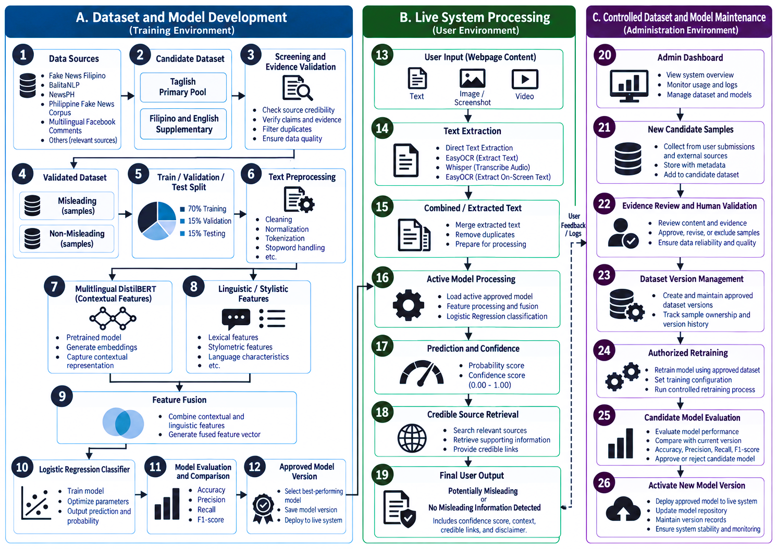
The three areas are linked by governance rules. Public inference does not create approved training data. Retrieval does not assign labels. Candidate models do not replace the active model without evaluation. Temporary media is not retained beyond the approved period. These controls define how data and decisions move through SuriPH and provide a basis for system requirements, test cases, and evaluation instruments in Chapter 3.

Figure 1. Conceptual Framework of SuriPH

Objectives of the Study

General Objective
The general objective of this study is to develop and evaluate SuriPH, a browser-based screening system for selected supported social-media post content centered on Taglish. The system will combine multilingual DistilBERT contextual representations and selected linguistic and stylistic features with Logistic Regression, obtain text from supported post-associated media, provide independent credible-source retrieval, and support controlled dataset and model maintenance.

Specific Objectives
1. To develop an evidence-grounded, Taglish-centered dataset for misleading-information classification.
1.1 To collect candidate records from documented Philippine and multilingual data sources relevant to Taglish, Filipino, and English content.
1.2 To screen candidate records according to language, claim checkability, contextual completeness, source provenance, text quality, topic, duplication, and evidence availability.
1.3 To validate candidate records through human review supported by professional fact-check records and other approved credible or authoritative sources.
1.4 To document and examine dataset composition according to class, language, topic, source, provenance, exclusion reason, and other relevant characteristics in order to identify potential dataset bias and source-related shortcuts.
1.5 To produce a minimum of 4,000 validated Taglish samples, supplemented by validated Filipino and English records that satisfy the same evidence and quality criteria.
1.6 To prevent information leakage by identifying exact duplicates, near-duplicates, and substantially equivalent claims and ensuring that records belonging to the same claim group remain within a single dataset partition.
2. To develop and compare machine-learning configurations for the classification of misleading information.
2.1 To develop a TF-IDF with Logistic Regression baseline configuration.
2.2 To develop a multilingual DistilBERT contextual-representation with Logistic Regression configuration.
2.3 To develop a linguistic and stylistic feature with Logistic Regression configuration using only features implemented and consistently measurable in the study.
2.4 To develop the proposed hybrid multilingual DistilBERT and linguistic-feature model, in which the contextual and explicit feature representations are fused before Logistic Regression classification.
2.5 To train, validate, and test the four configurations using the same approximately 70% training, 15% validation, and 15% testing partitions while preserving claim-group separation.
3. To develop a browser-based mechanism for obtaining textual information from selected supported social-media post content encountered through supported webpages.
3.1 To inspect supported regular Document Object Model elements and accessible Shadow DOM structures within the permissions and technical limits of the implemented browser extension.
3.2 To obtain directly accessible post text, captions, and selected contextual comments from supported webpage elements.
3.3 To extract visible text from supported images and screenshots using EasyOCR.
3.4 To obtain spoken transcripts from supported webpage videos using Whisper and visible on-screen text from sampled video frames using EasyOCR.
3.5 To combine and prepare extracted textual information from supported content before submitting it to the same text-classification pipeline.
4. To provide assistive misleading-information screening and credible-source context to general users.
4.1 To classify processed textual content internally as Misleading or Non-Misleading.
4.2 To present the corresponding public-facing result as Potentially Misleading or No Misleading Information Detected.
4.3 To present the model confidence value separately from factual verification or external evidence.
4.4 To retrieve related contextual information and credible-source links through Serper.dev independently from the classifier.
4.5 To ensure that retrieved information does not automatically modify or overwrite the classifier prediction.
4.6 To provide an assistive disclaimer that communicates the limitations of the system and clarifies that its output does not replace professional fact-checking or human judgment.
4.7 To allow a General User to optionally submit selected content as a candidate record for dataset review without assigning a final label, triggering retraining, or changing the active model.
5. To develop a restricted Admin Dashboard for controlled dataset and model maintenance.
5.1 To allow authorized administrators to review candidate samples, provenance information, annotations, and supporting evidence.
5.2 To allow authorized administrators to approve, revise, or exclude candidate records according to the established validation procedure.
5.3 To create and maintain traceable approved dataset versions.
5.4 To allow authorized initiation of controlled model retraining when an approved dataset version has been intentionally updated, sufficient newly validated data are available, or documented model-performance concerns justify another training cycle.
5.5 To present candidate-model evaluation results before model replacement.
5.6 To allow an authorized administrator to approve or reject a candidate model and activate only an approved model version for live inference.
6. To evaluate the reliability and predictive performance of the dataset and machine-learning models.
6.1 To measure agreement among multiple reviewers on the overlapping annotation subset using Fleiss’ Kappa under the final approved reviewer design.
6.2 To evaluate classifier performance using Macro F1 as the primary performance measure, supported by Accuracy, Precision, Recall, False Positive Rate, class-level scores, and confusion-matrix analysis.
6.3 To examine model performance by language, particularly Taglish, and by topic and other relevant subgroups where the number of held-out records supports meaningful analysis.
6.4 To estimate uncertainty around the primary model-performance result using a 95% bootstrap confidence interval.
6.5 To compare the paired held-out predictions of the proposed hybrid model with each comparison configuration using McNemar’s test under the statistician-approved significance procedure.
7. To evaluate the multimedia text-extraction components used by the prototype.
7.1 To evaluate EasyOCR extraction from supported images, screenshots, and sampled video frames using an appropriate text-recognition error measure, such as Character Error Rate, when verified reference text is available.
7.2 To evaluate Whisper transcription of supported webpage video speech using Word Error Rate when verified reference transcripts are available.
7.3 To examine end-to-end processing of media-derived text separately from the predictive performance of the misleading-information classifier.
8. To evaluate the completed SuriPH prototype through functional, technical, and general-user assessment.
8.1 To conduct functional and integration testing of the browser extension, backend, media-to-text extraction, machine-learning inference, retrieval component, structured data storage, and Admin Dashboard.
8.2 To evaluate selected applicable software-quality characteristics based on ISO/IEC 25010:2023 using an approved evaluation instrument.
8.3 To obtain a separate technical assessment from qualified and authorized AFP Information Technology Department personnel.
8.4 To obtain a separate general-user assessment from eligible fourth-year BSIT students in the selected class block who interact with the supported public-facing functions of SuriPH.
8.5 To assess browser compatibility, processing behavior, error handling, and system performance only within the environments and workload conditions actually tested.
8.6 To analyze AFP IT technical-evaluation results separately from fourth-year BSIT general-user evaluation results.

Significance of the Study
Filipino internet users may benefit from an optional screening step for selected social-media claims, particularly those written in Taglish. A cautious label and accessible related sources can point the user toward further examination. Users will still need to read the source, check its date and context, and consult appropriate expertise; the model probability cannot do those tasks for them.
The AFP IT Department will serve as the designated institutional beneficiary and technical evaluator within an approved academic setting. Qualified personnel can assess observable prototype behavior without connecting to operational or classified infrastructure. Their assessment will provide technical feedback, not evidence of institutional deployment or endorsement of the classifier’s predictions.
Fact-checkers and media-literacy practitioners may find the dataset procedure useful as a documented example of screening Taglish claims, matching evidence, preserving independent judgments, and controlling claim overlap across partitions. Error analysis may also identify cases in which automated screening is unreliable and human review remains necessary.
Researchers and developers will be able to examine the contribution of contextual and explicit linguistic representations under the same experimental conditions. An improvement would need to be supported by class-level results, uncertainty estimates, and false-positive analysis. A null or unfavorable result would still show whether the additional feature branch is justified under the tested conditions.
Academic institutions and future researchers may use the documented methods, limitations, and evaluation records as a reference for related Philippine-language projects. The contribution will be bounded by the validated dataset and tested prototype rather than presented as a complete fact-checking service.

Scope and Limitations of the Study
The study covers the development and evaluation of SuriPH as an academic browser-based prototype. Its primary language focus is Taglish, supported by supplementary Filipino and English records. The final model-development dataset will target at least 4,000 validated Taglish samples. The number of supplementary records will depend on the samples that satisfy the approved evidence and screening criteria.
The machine-learning task is supervised binary text classification. Approved records will use Misleading and Non-Misleading labels. Exclude, Revise, and Approve are dataset-management decisions rather than model classes. The study does not infer the intention of a content creator.
The public component will screen selected supported social-media post content only after user activation. Direct post text and captions, selected contextual comments, visible words in supported images or screenshots, and spoken or on-screen text in supported webpage videos are in scope. The extension will not crawl sites, automatically scan feeds, or monitor continuous browsing. Access to these inputs remains subject to permissions, page implementation, cross-origin restrictions, protected media, and platform changes.
For images and screenshots, the system will process only OCR-extracted visible text. For supported webpage videos, the system will process only accessible spoken transcripts and visible on-screen text obtained from sampled frames. The prototype will not detect manipulated images, deepfakes, faces, objects, scenes, or other visual semantics.
Video-related support concerns text extraction, not detection based on total video duration. Evaluation may use a bounded processing window or selected segment for reproducibility and measured resource constraints. The final timestamps and settings will be recorded. Protected streams, unavailable audio, poor recording quality, and unreadable frame text may prevent extraction.
The classifier's confidence value is a model probability and not proof of factual certainty. SuriPH may produce false positives and false negatives. The public interface will therefore use assistive wording and will encourage users to inspect related evidence.
Serper.dev retrieval will remain independent of classification. Source selection, relevance filtering, query wording, indexing, API availability, and publisher access may affect which links appear. A retrieval failure may reduce contextual support but will not change or invalidate a completed classifier result. The Google Fact Check Tools API is reserved for evidence retrieval during human dataset validation.
The Admin Dashboard will be limited to authorized administrative functions required by the study. It will not serve as a full enterprise MLOps platform. Retraining will be initiated intentionally, evaluated, and approved before activation. Raw public-user activity will not directly become training data.
The AFP IT Department will evaluate the prototype only within the approved academic scope. SuriPH will not connect to classified networks, restricted communications, private institutional databases, intelligence systems, or operational AFP infrastructure. It will not perform surveillance or censorship.
The scope includes the complete path from candidate-data preparation to approved model activation. It covers the browser extension, FastAPI backend, OCR and transcription services, feature-generation pipeline, Logistic Regression classifier, retrieval integration, structured database, file-based model storage, and Admin Dashboard. Evaluation covers the model, media-to-text stages, functional integration, and applicable software quality characteristics.
The study also excludes automated moderation actions. SuriPH will not remove posts, report accounts, suppress search results, restrict user access, or send decisions to a platform operator. It will not perform surveillance of continuous browsing activity. Processing begins only through the approved user interaction, and any stored request information will follow the final research design and privacy controls.
The model is limited by the data and the operational definitions used in the study. New slang, changing political references, sarcasm, satire, incomplete quotations, and claims that depend on specialized knowledge may produce errors. Confidence values may also be poorly calibrated for unfamiliar material. The interface and conclusions will therefore avoid presenting a high probability as factual certainty.
Final model settings, implemented feature measurements, respondent counts, reviewer design, compatibility results, processing settings, hardware requirements, and performance limits will be documented after the relevant implementation, testing, or approval. Formal-news records and social-media posts will not be assumed equivalent; source-domain composition and subgroup results will qualify the study’s conclusions.

Definition of Terms
Admin Dashboard. The restricted SuriPH interface used for candidate-sample review, evidence validation, dataset versioning, controlled retraining, model evaluation, and approved model activation.
Candidate Sample. A record considered for inclusion in the study dataset but not yet approved as final ground truth.
Claim Group. A set of records that express the same or substantially equivalent factual claim and must remain within one data partition to reduce leakage.
Confidence Value. The probability produced by the classifier for its predicted class. It does not represent verified factual certainty.
Contextual Features. Text representations generated from the surrounding sequence by multilingual DistilBERT.
Controlled Retraining. An authorized process in which an approved dataset version is used to train a candidate model that must be evaluated and approved before activation.
Data Leakage. The unintended transfer of information from evaluation data into model training or feature construction, which can produce overly optimistic results.
Document Object Model. The structured representation of a webpage that scripts can inspect or manipulate within the limits of browser permissions.
EasyOCR. The OCR library selected to obtain visible text from supported images, screenshots, and sampled video frames.
Evidence Validation. The human review process used to determine whether available sources support the proposed label for a candidate record.
Feature Fusion. The combination of contextual and linguistic feature representations before classification.
Linguistic and Stylistic Features. Measurable text characteristics such as length, lexical diversity, capitalization, punctuation, repeated characters, digits, URLs, mentions, or hashtags, limited to features actually implemented.
Logistic Regression. The regularized linear classifier used to assign Misleading or Non-Misleading probabilities from the selected feature representation.
Misleading Information. The study's operational category for validated textual content whose checkable claim conflicts with the evidence criteria applied during annotation, without inferring deceptive intent.
Multilingual DistilBERT. The distilbert-base-multilingual-cased transformer checkpoint intended to generate contextual text representations for Taglish, Filipino, and English input.
Non-Misleading. The study label assigned to validated textual content that meets the approved evidence criteria for the negative class.
Optical Character Recognition. The process of converting visible words in an image into machine-readable text.
Potentially Misleading. The public-facing wording used when the internal classifier predicts the Misleading class.
Shadow DOM. An encapsulated webpage structure used by web components. Access depends on the browser, extension APIs, permissions, and how the shadow root is implemented.
SuriPH. The official name of the proposed browser-based misleading-information screening system. It is used as a proper name rather than as an acronym.
Taglish. Code-switched or mixed use of Tagalog or Filipino and English within a statement, exchange, or document.
TF-IDF. Term Frequency-Inverse Document Frequency, the weighted term representation used for the traditional baseline configuration.
Whisper. The speech-recognition model selected to convert accessible spoken video content into text.
Annotation Agreement. Consistency among independent reviewer judgments on the designated overlapping annotation subset before adjudication. The approved Fleiss’ Kappa procedure will specify the rating target and reviewer design.
Candidate Model. A newly trained model version that has completed training but has not yet been approved for live inference. Its metrics and error cases must be reviewed before activation.
Claim Correspondence. The documented determination that a retrieved fact check or evidence source addresses the same factual claim as the candidate record rather than a merely similar topic.
Credible-Source Retrieval. The separate live Serper.dev search process that presents related material under the approved source policy without changing the classifier prediction.
Dataset Version. An approved, traceable collection of validated records with documented membership, label distribution, provenance, and partition assignments used for a specific model-development cycle.
Evidence Record. The stored source information, link, claim-match decision, rating where applicable, reviewer notes, and validation metadata used to support a candidate decision.
False Negative. A held-out record labeled Misleading that the model predicts as Non-Misleading.
False Positive. A held-out record labeled Non-Misleading that the model predicts as Misleading. The study gives this error specific attention because it may incorrectly warn users about legitimate content.
Held-Out Test Set. The approved evaluation partition that is not used for fitting preprocessing, training the model, or selecting hyperparameters and is opened only for final model comparison.
Inference. The process of applying the active model to prepared input in order to produce a predicted class and confidence value.
Model Activation. The authorized administrative action that designates an approved candidate model as the version used for live inference.
Model Version. A stored combination of model configuration, dataset version, metrics, artifact location, approval state, and activation state.
OCR Confidence. The recognition score returned by the OCR component for detected text. It measures recognition certainty and is not the classifier's misleading-information confidence.
Provenance. Information that records where a candidate sample originated, how it was collected, and which transformations or reviews it underwent.
Retrieval Failure. A condition in which related-source search is unavailable or returns no useful result. It does not change or invalidate the classifier output.
Taglish-Centered Dataset. A dataset in which validated Taglish records form the primary language group and Filipino and English records serve only as supplementary groups.
Temporary Media. An image, audio stream, video segment, or derived file held only for the period required by approved processing or research testing.
Validation Decision. The recorded Approve, Revise, or Exclude outcome assigned by a reviewer during candidate preparation. It is an administrative dataset decision rather than a model class.
CHAPTER 2

REVIEW OF RELATED LITERATURE AND STUDIES
This chapter reviews literature and studies that support the conceptual, linguistic, technical, and methodological foundations of SuriPH. The discussion is organized into foreign and local literature, followed by foreign and local related studies, and concludes with a synthesis of the research gap addressed by the proposed system.

Review of Related Literature

Foreign Literature

Misleading Information and the Digital Information Environment
Broda and Strömbäck (2024) reviewed 1,261 journal articles published from 2010 to 2021 and found substantial variation in how misinformation, disinformation, and fake news are defined. Studies differ in whether they emphasize truthfulness, intent, source, deception, or content characteristics. This inconsistency supports the need for an explicit operational definition in an automated classification study.
The OECD (2024) treats false and misleading information as a challenge to information integrity because it can distort public discussion and weaken trust. It also argues that policy and technical responses must protect access to diverse information and freedom of expression. SuriPH follows this assistive approach by presenting a screening result rather than censoring or reporting content.
Aïmeur, Amri, and Brassard (2023) review the spread and detection of questionable information on social networks and explain why automated content assessment remains difficult. SuriPH addresses only a bounded part of that problem: textual screening of a selected supported post and presentation of related sources. It will not infer an author’s motives or reconstruct a coordinated sharing network.
The terminology used by researchers also varies according to discipline and research objective. Some studies classify fabricated news articles, others detect rumors or deceptive writing, and others focus on individual factual claims. A label may describe the truth status of the content, the reliability of a source, or the intention of the producer. The present study addresses this inconsistency by defining the unit of analysis and by using a common validation guide across candidate sources.
The growth of generative and easily edited media further complicates online verification, but it does not remove the need for careful text evaluation. Many misleading posts still depend on captions, quotations, overlaid text, or spoken claims. Extracting these words can make them available to a text classifier and to evidence search. At the same time, the limitation must remain explicit: a textual statement can be processed even when the system cannot determine whether the accompanying image or video has been manipulated.

Human Judgment and the Spread of Misinformation
Human susceptibility to questionable claims cannot be reduced to a list of stylistic markers. Urgent language, emotional wording, capitalization, or repeated punctuation may occur in satire, personal expression, emergency announcements, and legitimate advocacy. If a model learns that these forms directly imply a misleading label, it may produce systematic false positives. The explicit feature branch must therefore be evaluated empirically and interpreted as one source of predictive information rather than a rule-based proof system.
Repeated claims also create a methodological risk. Reposts and paraphrases may allow a classifier to recognize a claim already encountered during training. Claim-group separation addresses this evaluation problem; it should not be confused with measuring how familiarity affects human belief. Geirhos et al. (2020) provide the broader warning that predictive success can depend on unintended dataset cues.
The interface design must account for these limits in human judgment. A user may treat a confident automated label as an authoritative verdict, especially when the tool appears inside the browsing environment. SuriPH will use assistive wording, show confidence separately, and provide a disclaimer that encourages evidence review. Related sources are included to support the user's next step, not to create the impression that the model has completed professional verification.

Transformer Based Contextual Representation
Contextual representations depend on the surrounding token sequence. For Taglish, this offers a way to represent mixed-language wording without treating each word as independent. The multilingual checkpoint nevertheless comes from a different pretraining domain, so its usefulness for informal posts must be measured rather than inferred from multilingual coverage (Hugging Face, n.d.; Sanh et al., 2019).
The study uses DistilBERT as a representation component rather than assuming that end-to-end fine-tuning is the only valid design. Contextual vectors can be passed to a separate Logistic Regression classifier, allowing the same final classifier family to be used across contextual, linguistic, and hybrid experiments. This controlled arrangement makes the contribution of each representation easier to compare.

Dataset Quality and Shortcut Learning
Machine-learning systems can obtain high test scores while depending on unintended dataset signals. Geirhos et al. (2020) describe shortcut learning as the use of easy predictive cues that work in a particular dataset but do not represent the intended reasoning process.
For misleading-information classification, publisher names, source-specific wording, duplicated claims, topic imbalance, and formatting can act as shortcuts. SuriPH therefore retains provenance for audit, prevents claim-group overlap across partitions, and compares performance across language and source-related subsets.
Dataset quality includes more than the total number of records. Label definitions, class balance, topic coverage, language distribution, duplicate rate, evidence traceability, and reviewer consistency all influence what a reported score means. A large collection with inherited or inconsistent labels may produce less defensible conclusions than a smaller collection with clear evidence and documented exclusions.
Shortcut learning is especially likely when source identity correlates with the label. If most misleading samples come from one publisher or one social-media page, the model may learn names, formatting conventions, or repeated slogans rather than properties that transfer to unseen claims. Removing publisher names from the predictive input does not fully solve the problem if other source-specific wording remains. Subgroup analysis and claim-group separation help reveal these effects.
Temporal and topical concentration can create similar shortcuts. A dataset dominated by one election, public-health event, or conflict may reward topic recognition. The present study will retain topic and collection metadata so that the researchers can describe the data and examine error concentration. These fields support analysis and audit but will not be treated as evidence that a topic itself is misleading.

Evidence Supported Verification
Professional fact checks offer valuable evidence because they normally identify the claim, provide a rating or conclusion, cite sources, and explain the reasoning. Automated access through the Google Fact Check Tools API can reduce search time by returning published claims and associated reviews. The API result still requires interpretation because a similar phrase or topic may refer to a different date, person, place, or factual proposition.
Structured annotation studies such as RUN-AS emphasize that news reliability contains several observable dimensions and that reviewer guidance affects dataset validity. Bonet-Jover et al. (2024) support the broader principle that annotation decisions should be explicit and traceable. SuriPH applies this principle through candidate status, evidence records, claim-match decisions, reviewer notes, and dataset-version approval.
Uncertain cases are an expected part of evidence-based preparation. A record may contain a checkable claim but lack sufficient evidence, combine several claims with different truth status, omit necessary context, or depend on an interpretation that reviewers cannot resolve. These cases may be revised or excluded rather than forced into one of the two model classes. Exclusion protects the meaning of the approved binary labels.

Local Literature

The Philippine Digital News Environment
Chua’s (2026) Philippines report identifies social media as the dominant news source and reports 28 percent overall news trust among online survey respondents. For SuriPH, the relevant implication is the setting of use: a selected post encountered through a platform may need examination alongside its original source. The survey does not establish a misinformation prevalence rate or justify labeling unfamiliar sources as misleading.
Pulse Asia Research (2022) reported that 86 percent of surveyed Filipino adults considered false or fake news a problem in the country. This describes public concern, not the factual status of individual posts. It supports the social context of the project but will not be used as a training label or as a measure of SuriPH’s effectiveness.
The Philippine setting includes risks associated with political polarization, coordinated communication, and rapid recirculation of old material. A post may be technically authentic while becoming misleading after its date or context is removed. For this reason, dataset reviewers must examine the complete factual proposition and available context rather than label a record only from emotional tone or source reputation.
The study also recognizes that information integrity must coexist with freedom of expression. SuriPH does not block, remove, report, or rank public content. It provides an optional screening result and related sources after user activation. This boundary is consistent with an assistive academic prototype and reduces the risk of presenting a probabilistic classifier as a censorship mechanism.

Taglish and Low Resource Natural Language Processing
TweetTaglish contains more than 20,000 instances for investigating Tagalog-English code-switching (Herrera et al., 2022). Its contribution is linguistic: it documents mixed-language discourse and methods for collecting it. Those language annotations do not establish whether a checkable claim is misleading, so any candidate considered for SuriPH still requires evidence review.
Imperial and Ong (2021) examined linguistic measurements for reading-difficulty assessment in Filipino educational text. This is evidence that explicit language measurements can be studied computationally, not a validation of readability or sentiment as SuriPH features. The present project will retain only its own implemented and consistently measurable candidate feature families.
Code-switching identification also presents boundary problems. A proper noun, borrowed technical term, or short English phrase inside Filipino text does not always establish the same degree of mixed-language structure as a sentence that changes grammatical frame. The annotation and preprocessing procedures must therefore document the practical rule used to identify Taglish records and should not rely on one isolated token.
Because language use changes quickly, the dataset should retain provenance and time-related metadata when available. Emerging slang and event-specific vocabulary may later reveal performance drift. Controlled dataset versioning allows the research team to add newly validated records and train a candidate model without silently altering the evidence base of the active version.

Philippine Fact Checking and Human Oversight
Philippine collaborative fact-checking demonstrates the importance of documented evidence and transparent corrections. Tsek.ph has brought together academic, media, and civil-society organizations to check public and election-related claims. Its practice illustrates why SuriPH should help users reach source material and why a classifier output must remain open to human review (Tsek.ph, n.d.).
Professional fact-checking also exposes the limits of automated labels. A reviewer may need to consult official records, archived pages, subject specialists, original speeches, or data tables. SuriPH cannot reproduce this investigative process through a probability score. Its contribution is to assist initial screening and organize related material, while the responsibility for final verification remains with qualified human reviewers.
Human oversight applies to both the research dataset and the deployed prototype. Dataset reviewers control which evidence supports a label, administrators control which dataset version may be used for retraining, and authorized evaluators assess system quality. Public users control when the extension screens supported content. These points of control are part of the design rather than optional safeguards added after model development.

Local Language and News Resources
Philippine resources offer different kinds of candidate material. BalitaNLP links Filipino news articles with images; NewsPH-NLI supports natural-language inference; and Cruz’s multilingual Facebook-comment collection records language use around Moro identity and armed conflict (Buñag & Esquivel, 2023; Cruz, Resabal, et al., 2020; Cruz, 2024). Their source roles must remain explicit: none is automatically a validated Taglish misleading-information dataset.
Fake News Filipino provides a local classification benchmark developed by Cruz, Tan, and Cheng (2020). Its formal news articles and inherited labels may inform candidate discovery, but records must satisfy SuriPH’s language, checkability, context, and evidence rules before use. A derived subset may differ substantially from the original benchmark after these checks.
NewsPH-NLI contributes a different type of resource. Cruz, Resabal, et al. (2020) used the structure of published news articles to generate Filipino natural-language inference data. The project shows how Philippine news can support language understanding research, yet entailment pairs are not equivalent to labels of misleading information. SuriPH may use such material for language coverage or candidate discovery only when records satisfy the common validation procedure.

Review of Related Studies

Foreign Studies

Hybrid Transformer and Machine Learning Classification
Hybrid research combines representation methods in several ways. Some systems join convolutional or recurrent networks, others combine transformers with traditional classifiers, and others add social or source context. The label hybrid therefore does not identify one standard architecture. SuriPH uses the term specifically for the fusion of multilingual DistilBERT contextual representations with an explicit linguistic and stylistic feature vector before Logistic Regression.
Essa, Omar, and Alqahtani (2023) combined BERT representations with LightGBM for fake-news detection. This supports the feasibility of separating the representation stage from a conventional classifier, but it is not an experiment with Logistic Regression and does not prove that SuriPH’s fusion will improve Taglish performance. SuriPH will test that question through its own controlled configurations.
Other hybrid studies report gains from combining semantic and manually derived features, but reported scores cannot be transferred directly across datasets. Label definitions, language, source distribution, sample size, and partition strategy differ. The present research therefore treats the literature as design evidence and evaluates its own four configurations under identical partitions.
Logistic Regression provides a suitable common classifier because it supports probabilistic binary classification and can operate on dense contextual vectors, sparse TF-IDF input, or a fused representation after compatible transformation. Regularization can limit overfitting, and coefficients for explicit features can be inspected. The contextual dimensions remain latent, so the study will not describe the entire hybrid model as fully interpretable.

Structured Annotation and Evidence
Bonet-Jover et al. (2024) show that annotation design is part of the research contribution. Clear categories, reviewer instructions, and recorded disagreements allow readers to understand what a model learned. SuriPH similarly separates preliminary inherited labels from final study labels and records Approve, Revise, or Exclude decisions before dataset membership is established.
Reviewer agreement can indicate whether an annotation guide supports consistent decisions, but agreement alone cannot establish factual validity. Fleiss’ Kappa will be applied to the approved nominal-rating design using independent judgments before adjudication (Fleiss, 1971). The number of reviewers and records, rating categories, and missing-rating treatment will be documented with the result.
Disagreement resolution must preserve the original decisions. Reviewers should first record independent judgments, after which conflicting cases may be discussed or escalated according to the approved procedure. The final record should distinguish the initial annotations from the resolved label so that the dataset does not conceal the uncertainty encountered during preparation.

Multilingual Fact Checked Data
Nielsen and McConville (2022) introduced MuMiN as a multilingual and multimodal dataset connected to professionally fact-checked claims. MuMiN demonstrates the value of linking multilingual content to professional fact checks, publishers, users, and social context. Its scale and graph structure are beyond the scope of the present capstone, but its traceability principle is directly relevant. SuriPH will preserve source and evidence links for approved samples and will keep dataset and model versions connected.
Multilingual surveys such as Wang, Zhang, and Rajtmajer (2024) describe persistent challenges for low-resource misinformation detection, including limited annotated data, cross-lingual transfer, domain shift, and unequal performance across languages. These challenges support separate reporting for Taglish, Filipino, and English rather than relying only on one aggregate score.
Language balance also affects model selection. A model may achieve a strong overall Macro F1 while performing poorly on a smaller subgroup, or it may improve Taglish recall at the cost of more false positives. The study will therefore examine confusion matrices and subgroup results alongside the primary measure. Any conclusion about the hybrid design will be limited to the validated data and tested conditions.

Generalization and Uncertain Cases
Pelrine et al. (2023) emphasize uncertainty, insufficient context, and generalization in misinformation mitigation. Their findings support the decision not to force every candidate into a binary label. A missing source, incomplete quotation, or unresolved claim should lead to revision or exclusion during dataset preparation rather than a speculative final class.
Uncertain live inputs present a related but different problem. The classifier will still return a probability for model-compatible text, yet the value may be unreliable when the input is very short, corrupted by OCR, dominated by names, or outside the training distribution. The interface can communicate extraction problems and limited input without inventing an evidence judgment that the system did not perform.
Confidence calibration and error review are therefore important to presentation. A probability near one does not guarantee that the claim is false, and a value near one-half may reflect genuine ambiguity or unfamiliar language. The study will document how confidence is produced and will avoid converting it into unsupported verbal categories unless a validated interpretation rule is approved.

Video Based Misinformation Research
Video-focused research illustrates how much information a fully multimodal system would need to consider. Bu et al. (2024) combine semantic, sentimental, spatial, and temporal signals for short-video fake-news detection. Jadhav et al. (2025) likewise discuss multilingual and multimodal approaches for trustworthy detection. These studies show that scene and temporal reasoning require methods beyond text extraction.
SuriPH adopts a narrower and testable boundary. Whisper provides a transcript of accessible speech, while EasyOCR obtains visible words from selected frames. The resulting text can capture spoken allegations, subtitles, captions, or displayed statistics. It cannot determine whether the images support the narration, whether a clip was edited deceptively, or whether a person shown is authentic.
Separating extraction from classification also improves evaluation. Word Error Rate can measure differences between a verified transcript and Whisper output. Character Error Rate can measure OCR differences. Classifier metrics then describe predictions from the text supplied to the model. Without this separation, a transcription error could be incorrectly interpreted as a weakness in the classification architecture.
The study does not restrict its conceptual video support to short-form media. Practical testing may use bounded durations or selected segments because processing cost increases with audio length and frame count. The final limit will be based on implemented behavior and approved testing conditions rather than on an unsupported claim that all webpage videos can be processed in full.

Local Studies

Fake News Filipino and Transfer Learning
Cruz, Tan, and Cheng (2020) established Fake News Filipino as a local benchmark and demonstrated that transfer learning can improve classification in Filipino. SuriPH builds on that contribution but changes the unit of emphasis from formal Filipino news articles to validated Taglish claims and mixed online text. The new task therefore requires additional language screening, evidence review, and subgroup analysis.
The balanced design of the original corpus does not guarantee that a derived SuriPH subset will remain balanced after validation. Taglish filtering, evidence availability, claim duplication, and exclusion of ambiguous records may affect class counts. Final distributions will be reported after validation, and any class weighting or sampling method will be fitted only on training data and documented.
Transfer learning also creates a risk of overestimating performance when related articles or repeated claims cross partitions. Claim-group-aware splitting is stricter than a simple random article split because it attempts to keep equivalent factual content together. This procedure may reduce scores, but it provides a more meaningful test of performance on unseen claims.

Philippine News Corpus and Linguistic Features
Jamen and Reyes (2023) evaluated TF-IDF combined with VADER sentiment ratios and Linear Discriminant Analysis on a Philippine news corpus. Their experiment provides a local reason to include a conventional feature-based comparison rather than assume a transformer is superior. Their use of sentiment does not add sentiment to SuriPH’s hybrid feature list; feature choices remain specific to each study.
Fernandez and Devaraj (2019) examined linguistic cues in Philippine fake-news detection. This line of work provides a relevant local comparison for explicit language measurements. Its feature inventory and experimental findings must not be transferred to SuriPH without implementation and evaluation under the present dataset and partition design.
The candidate feature families are word or token count, sentence count, average words per sentence, type-token ratio, uppercase ratio, punctuation rates or intensity, repeated-character ratio, digit ratio, and URL, mention, and hashtag counts where applicable. These are candidate measurements, not a confirmed implementation inventory. The final experiment record will identify only the measurements actually computed.

NewsPH and Filipino Language Resources
Cruz, Resabal, et al. (2020) used news-article structure to construct Filipino entailment data and evaluate language understanding. That published experiment concerns inference rather than fake-news detection. Its resource contribution is relevant to the scarcity of Filipino data, but an entailment label cannot be converted directly into a SuriPH label.
The distinction between resource suitability and label suitability is important. A corpus may be useful for vocabulary coverage, tokenization analysis, OCR testing, or retrieval experiments even when its labels do not match the model task. The candidate-source inventory will document the intended use of each dataset and prevent an unrelated label from being silently converted into Misleading or Non-Misleading.
Montalan et al. (2025) introduced Batayan, a Filipino benchmark with tasks spanning understanding, reasoning, and generation in Tagalog and Taglish. Their experiments identify gaps in multilingual model performance and emphasize native-speaker review. Batayan is not a misleading-information detection benchmark; its relevance is the need to evaluate Filipino and code-switched capability directly rather than infer it from a model’s general multilingual claim.

BalitaNLP Multimodal News Data
Buñag and Esquivel’s (2023) published work concerns transformer-based conditional generation of Filipino news articles, while the associated BalitaNLP resource supplies article text and images. Neither the repository nor the presence of an image makes a record a fake-news detection study. For SuriPH, these materials may support candidate discovery and extraction testing after access and suitability checks.
Images in news and social-media environments present different OCR conditions. News images may contain headlines, captions, charts, or watermarks, while social posts may use screenshots, stylized fonts, and compressed text. The extraction test set should represent the supported cases and should use verified reference text so that recognition quality is measured objectively.
The source also supports the need to record the relationship between text and media. When an article image contains a caption already present in the page, repeated OCR segments should be deduplicated before classification. Otherwise, duplicated words may distort linguistic counts or give the classifier an unintended weighting of repeated content.

Multilingual Philippine Social Media Data
Cruz’s (2024) multilingual Facebook-comment collection reflects Philippine social-media language around Moro identity and armed conflict. It offers a different input domain from edited news articles. The collection may support language analysis or candidate discovery, but its language categories and topic do not supply misleading-information labels.
Public comments also create privacy and contextual concerns. Usernames, profile identifiers, and unrelated personal details should not become model features. A short comment may respond to an earlier message that is unavailable, making the claim incomplete. The screening procedure will therefore consider checkability and contextual sufficiency before a public comment can enter the validated dataset.
The dataset's focus on Moro identity and armed conflict also illustrates topic concentration. If many records from one source share one topic, the model may learn event vocabulary instead of general misleading-information patterns. Topic metadata and source-aware analysis will help the researchers interpret performance and avoid generalizing beyond the evidence.

Synthesis of Related Works
The literature supports optional, carefully qualified assistance with online claims rather than an automated authority over speech. Philippine resources document Filipino and Taglish language use, but their units and labels differ. SuriPH therefore needs evidence-grounded validation and an explicit distinction between formal-news candidates and the social-media posts screened during live use.
Contextual representations and explicit text measurements offer complementary possibilities, not guaranteed gains. A common Logistic Regression classifier across TF-IDF, contextual-only, linguistic-only, and hybrid representations will make the comparison more informative. Claim grouping, training-only transformations, and source/topic review are necessary because apparent gains may otherwise reflect repeated claims or source-specific shortcuts.
The combined gap addressed here is a Taglish-centered evaluation of that hybrid design within an assistive browser prototype. OCR and speech transcription extend access to text without extending the task to visual semantics. Separate extraction metrics, cautious public labels, independent source retrieval, and human-controlled maintenance connect the experimental model to a defensible system use. The study will claim contribution within this defined combination, not that no related system or study exists.
CHAPTER 3

METHODOLOGY AND DESIGN
This chapter presents the methodology and design used to develop and evaluate SuriPH. It covers the technical background, approaches and techniques, Hybrid Agile methodology, requirement analysis, respondents and sampling, research instruments, data gathering, statistical treatment, and the hardware, software, peopleware, network, and dataware requirements of the prototype.

Technical Background
The Armed Forces of the Philippines Information Technology Department at Camp Aguinaldo, Quezon City will serve as the institutional beneficiary and primary technical evaluator of this study. Qualified and authorized personnel can provide a professional assessment of the implemented academic prototype in areas such as functional suitability, performance efficiency, compatibility, interaction capability, reliability, security, maintainability, and flexibility where those characteristics are applicable and observable.
The department’s participation will remain within an approved academic evaluation. SuriPH will not connect to AFP classified networks, intelligence systems, restricted communications, private institutional databases, or operational infrastructure. Any demonstration, temporary administrative access, or turnover will use only the approved prototype, approved test materials, and the environment authorized for the study.
The technical instrument will draw from selected applicable characteristics of ISO/IEC 25010:2023 (International Organization for Standardization, 2023). The standard is a product-quality model, not a ready-made questionnaire or a certification awarded by this study. Each item must refer to implemented, observable behavior and pass adviser or expert review before use.
The intended public-facing users remain Filipino internet users who encounter English, Filipino, or Taglish online content. For formal general-user evaluation, the accessible population will consist of eligible fourth-year BSIT students from the selected class block who are at least 18 years old and can interact with online content in at least one of those languages. Their assessment will remain separate from the AFP IT technical evaluation.
SuriPH consists of a React-based browser extension, a restricted Admin Dashboard, a Python and FastAPI backend, media-to-text processing, machine-learning inference, independent credible-source retrieval, structured data storage, file and model storage, and controlled administrative maintenance. The following approaches describe how these components support the research objectives without extending the prototype beyond its approved academic scope.

Approaches and Techniques

Supervised Binary Text Classification
The study will use supervised binary text classification. Records accepted into an approved dataset version will carry the final study label Misleading or Non-Misleading. Records with inadequate context, insufficient evidence, unresolved disagreement, or non-checkable content may be excluded during dataset preparation. Exclude is a management status and not a prediction class.
Binary classification requires a clear relationship between the operational labels and the evidence used during validation. A record assigned Misleading must contain a checkable claim that conflicts with the approved evidence criteria. A record assigned Non-Misleading must satisfy the approved criteria for the negative class. The procedure does not transform lack of evidence into proof that a claim is misleading, and it does not infer deceptive intent.
Records that cannot support a defensible binary decision will remain outside the approved model dataset. Exclude may be used for non-checkable opinion, missing context, insufficient evidence, duplicate material, unsupported language, unusable extraction, or unresolved reviewer disagreement. Revise may be used when the record can be corrected, segmented, or supplemented before another review. These statuses belong to dataset management and are not additional prediction classes.

Dataset Preparation and Evidence Validation
The Google Fact Check Tools API may assist reviewers by searching published fact-checked claims. A returned result will not assign the SuriPH label automatically. The reviewer must determine that the review addresses the same underlying claim and must record the evidence used (Google for Developers, 2024).
The approved dataset will be divided approximately into 70 percent training, 15 percent validation, and 15 percent testing data. Class stratification will be applied where compatible with claim grouping. The same partitions will be used for every experimental model configuration.
Candidate acquisition will begin with a source inventory identifying the resource, original purpose, content unit, language coverage, original label meaning, collection period where available, access conditions, and intended use. Documented candidates include Fake News Filipino, BalitaNLP, NewsPH, the Philippine Fake News Corpus referred to by Jamen and Reyes (2023), and Cruz’s (2024) Facebook-comment collection. The exact release and provenance of each imported resource must be confirmed. Formal news and social-media records will remain distinguishable for domain review. Public availability alone will not be treated as permission for unrestricted reuse, and unnecessary personal identifiers will be removed or protected.
Candidates will be screened for language, checkability, contextual completeness, text quality, provenance, topic, duplication, and evidence availability. Reviewers will check whether the evidence concerns the same date, subject, location, and factual proposition. Google Fact Check Tools API results may locate published reviews, while approved credible or authoritative sources may support cases without a matching fact check. Evidence publisher, rating where applicable, URL, claim-match decision, independent reviewer judgment, validation decision, notes, and final resolved label will be recorded. A multi-claim record may be revised, segmented, or excluded under the annotation guide when one label would conceal conflicting evidence.
Exact and near duplicates will be removed or reviewed before partitioning. Text comparison and human claim review will identify substantially equivalent statements, which will share claim_group_id and remain in a single split. Source, publisher, topic, language, and provenance metadata will support validation, leakage checks, and subgroup analysis but will not be direct classifier features. These controls reduce leakage without proving that all source cues embedded in the text have disappeared.
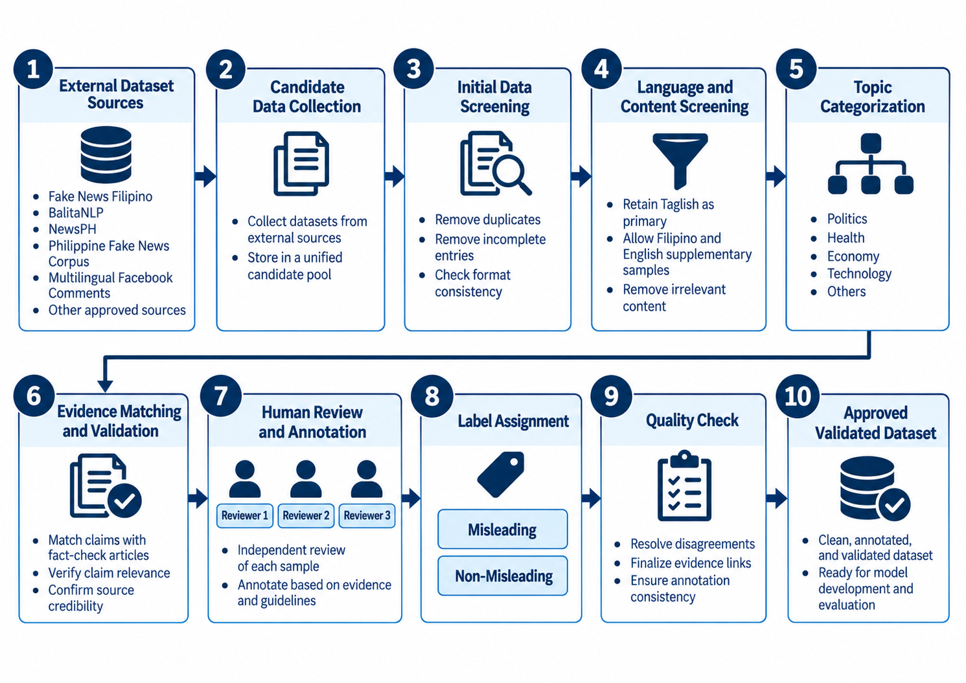
The target is a minimum of 4,000 validated Taglish samples. The final approved dataset will report language counts, class distribution, candidate-source contribution, exclusion reasons, and claim-group counts. Supplementary Filipino and English records will be documented separately. No fixed balance will be claimed before validation because evidence availability and exclusion decisions may change the usable distribution.
Figure 2. Dataset Screening and Evidence Validation Flow
Figure 2 illustrates multiple independent reviewers. Its three reviewer icons do not establish the final reviewer count, which will follow the approved annotation design. Proposed binary labels and management decisions will be recorded separately before adjudication.

Text Acquisition and Extraction
Browser content scripts will obtain selected supported social-media post content when extension permissions and URL-matching conditions allow access. They will inspect the webpage DOM and send the resulting text or approved media-processing request to the backend. The backend will not inspect the DOM directly (Mozilla, n.d.-a).
Regular DOM and accessible or open Shadow DOM may be inspected where permitted. SuriPH will not claim access to closed shadow roots or every visible page structure. Shadow-root mode, browser and extension permissions, cross-origin restrictions, protected media, and webpage changes determine what can be obtained (Mozilla, n.d.-b).
Direct post text, captions, and selected contextual comments will be obtained from supported page elements. EasyOCR will extract visible text from supported images or screenshots, and its recognition output will be treated as acquisition data rather than factual evidence (JaidedAI, n.d.).
For supported webpage videos, accessible audio will be transcribed by Whisper and visible text will be obtained from sampled frames through EasyOCR. Whisper was developed using large-scale multilingual and multitask speech supervision (Radford et al., 2023). The transcript and relevant frame text will be combined as textual input.
The request will identify selected supported post content rather than the entire feed or page. Compatibility testing will record the actual browser and extension version, platform or page type, permissions, supported structures, input type, expected behavior, and observed outcome. A successful test on one page structure will not establish support for every page on the same platform.
For images and screenshots, the backend will receive the supported file or captured region according to the implemented workflow. EasyOCR will detect text regions, recognized strings, and confidence information. Post-processing may order segments, remove duplicated detections, and discard unusable output. The original image will not be treated as a visual class input, and temporary media will be removed after the approved processing or testing period.
Video processing will obtain accessible audio and sample frames according to the implemented duration and resource limits. Whisper will transcribe speech, while EasyOCR will process visible text in selected frames. Repeated subtitles or captions may appear across several frames, so the media pipeline will deduplicate substantially identical segments before joining them with the transcript. The resulting text will enter the same preparation and classification pipeline as other inputs.
Acquisition errors will be recorded separately. Unsupported elements, protected media, unavailable audio, low-resolution images, unreadable text, and service failures may prevent processing. Functional tests will verify that the system returns a clear status and does not submit incomplete data silently. Media-extraction tests will compare output with verified reference text when feasible.

Text Preprocessing
Text preparation may require encoding repair, whitespace normalization, removal of unusable extraction artifacts, and deduplication of repeated OCR segments. Punctuation, capitalization, repeated characters, digits, URLs, mentions, and hashtags will be preserved until the features that need them are computed. The final sequence and text version used by each branch will be recorded after implementation, rather than assumed in advance.
The contextual branch and TF-IDF baseline may require different transformations. The transformer tokenizer will apply its own subword segmentation and model-specific input construction. The TF-IDF configuration will build its vocabulary from training data only. The linguistic branch will compute features from a defined version of the prepared text. Each configuration will document the exact sequence so that validation and test records undergo the same fitted operations without learning from held-out data.
Input length is another practical constraint. Transformer models have a maximum sequence length, while webpage text or transcripts may exceed it. The implemented system will specify whether long text is truncated, segmented, pooled across chunks, or handled through another approved method. This decision will be evaluated because it affects both response time and the amount of claim context available to the classifier.

Contextual Feature Extraction
The contextual branch will use the distilbert-base-multilingual-cased checkpoint and its corresponding tokenizer. The model will generate a contextual representation from the prepared input sequence.
A documented pooling procedure will convert contextual hidden states into the classifier’s input representation. Frozen versus fine-tuned use, pooling, long-text handling, and final dimensionality remain implementation-dependent. The checkpoint’s hidden size alone does not establish the dimensionality of the final representation (Hugging Face, n.d.).
The contextual branch may be used as a frozen representation generator or may undergo controlled training depending on the final experiment. The decision affects computing cost, risk of overfitting, and reproducibility. Hyperparameters, random seeds, model checkpoints, tokenizer version, pooling method, and any fine-tuning procedure will be recorded in the model-evaluation record.
All contextual experiments will use the same approved partitions. If representations are cached to reduce repeated computation, the cache will remain linked to the dataset version and preprocessing configuration. This prevents embeddings produced from one version of the data from being combined silently with another version during later experiments.

Linguistic and Stylistic Feature Extraction
The second branch will compute selected measurable properties from the same text. The exact list will be limited to implemented and consistently measurable features. Candidate measurements include:
- word or token count
- sentence count, average words per sentence, and type-token ratio
- uppercase ratio and punctuation rates or intensity
- repeated-character and digit ratios
- URL, mention, and hashtag counts where applicable
No feature will be described as proof that a statement is misleading. Its contribution will be assessed through the linguistic-only and hybrid experiments.
Counts and ratios can have different numerical scales. Any required scaling will be fitted only on training data and reused unchanged for validation, testing, and live screening. The feature inventory will document each implemented definition, denominator, text-normalization stage, and handling of empty input. Sentiment, emotion, urgency, readability, code-switching scores, and TF-IDF or N-gram indicators will not be implied as hybrid features merely because related studies use them.
The linguistic-only experiment will establish whether the explicit measurements carry useful signal without contextual embeddings. It also provides a direct way to inspect coefficients and error patterns. The hybrid experiment will show whether those measurements add value after contextual representation is already present. If the hybrid does not improve held-out performance or increases false positives, the study will report that result rather than assume the added branch is beneficial.

Feature Fusion and Logistic Regression
The fused vector will enter a regularized Logistic Regression classifier implemented through scikit-learn. Logistic Regression supports dense and sparse input and can return class probability estimates (scikit-learn developers, n.d.).
Feature fusion requires the contextual and explicit vectors to be aligned by record and converted into compatible numerical structures. The process will verify that every row in the contextual matrix corresponds to the same approved sample as the linguistic row. Missing or failed representations will be handled through an approved rule rather than silently shifting row order.
Logistic Regression settings, including solver, regularization strength, class weighting, iteration limit, and decision threshold, will be selected using training and validation data and then recorded with the final configuration. No value is assumed here. The threshold and probability mapping will be frozen before held-out testing, and the same mapping will be used for the reported model and its public labels.

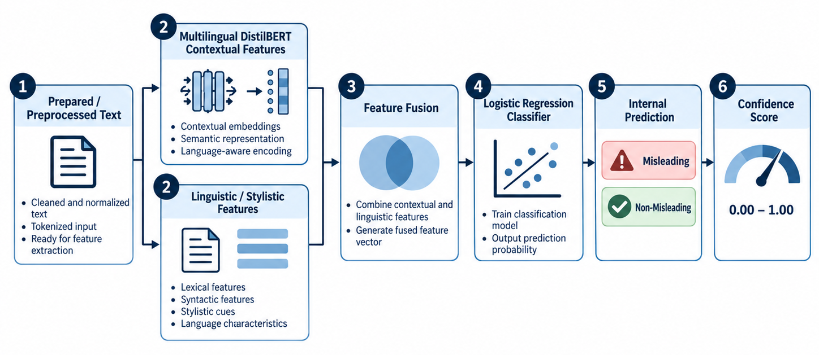
Figure 3. Hybrid DistilBERT-Logistic Regression Model Pipeline

Baseline Model Comparison
1. TF-IDF with Logistic Regression
2. Multilingual DistilBERT contextual representation with Logistic Regression
3. Linguistic and stylistic features with Logistic Regression
4. Proposed hybrid multilingual DistilBERT and linguistic-feature representation with Logistic Regression
The four configurations answer different questions. TF-IDF with Logistic Regression measures the strength of a conventional lexical baseline. Multilingual DistilBERT representations with Logistic Regression measure contextual information without explicit features. Linguistic and stylistic features with Logistic Regression measure the selected explicit branch. The hybrid configuration measures whether fusion provides additional value over these controlled alternatives.
Macro F1 will be the primary overall measure because it gives equal weight to the class-level F1 values and reduces the ability of a larger class to dominate the summary. Accuracy, precision, recall, false positive rate, class-level scores, and confusion matrices will provide complementary interpretation. Taglish results and other required subgroups will be reported separately when the available sample size supports a meaningful comparison.
Paired held-out predictions will support uncertainty estimation and comparison. Macro F1 will have a 95% bootstrap confidence interval, with repetition count and resampling details taken from the approved final analysis script. McNemar’s test will compare the hybrid with each other configuration at α = 0.05 unless the statistician approves a change. No multiple-comparison adjustment is presumed; the final report will state the procedure actually used and qualify interpretation of the separate comparisons.

Credible-Source Retrieval
Serper.dev will provide the live search interface for related-source retrieval (Serper.dev, n.d.). The backend will apply the approved source and relevance policy to returned links; search ranking itself is not a credibility judgment. Query formation, source eligibility, and the handling of irrelevant, missing, or unavailable results will be documented and tested. The user will see contextual support separately from the prediction, confidence, and disclaimer.
Retrieval and classification will remain independent processes. A retrieval failure will not convert a prediction, and a strong retrieval match will not silently overwrite the model's class. The user may compare the result with the cited material and decide whether further verification is needed. This arrangement keeps the statistical evaluation of the classifier separate from the coverage of the search service.
Administrative evidence search follows the same principle with a different purpose. Reviewers may use the Google Fact Check Tools API to locate professional fact checks during dataset validation, but a returned rating is not copied automatically into the SuriPH label. The reviewer must confirm claim correspondence and record the source, match decision, notes, and final validation outcome.

Controlled Dataset and Model Maintenance
The Admin Dashboard will distinguish candidate records from approved dataset items. Authorized users can examine provenance, language, claim group, evidence, annotations, and status before approving membership in a dataset version. Bulk import will not bypass validation. Audit records will identify important administrative actions and their outcomes.
Retraining creates a candidate model rather than replacing the active model immediately. The system will record the dataset version, configuration, metrics, artifact location, and approval state. An authorized evaluator or administrator can review the candidate and approve or reject activation. If rejected, the active version remains unchanged.
This controlled workflow protects the research from unreviewed feedback loops. Public submissions, browsing activity, prediction logs, or retrieved sources will not automatically become labeled training data. Any later use of public material would require the same approved screening and evidence process as other candidates, together with the required privacy and ethics controls.

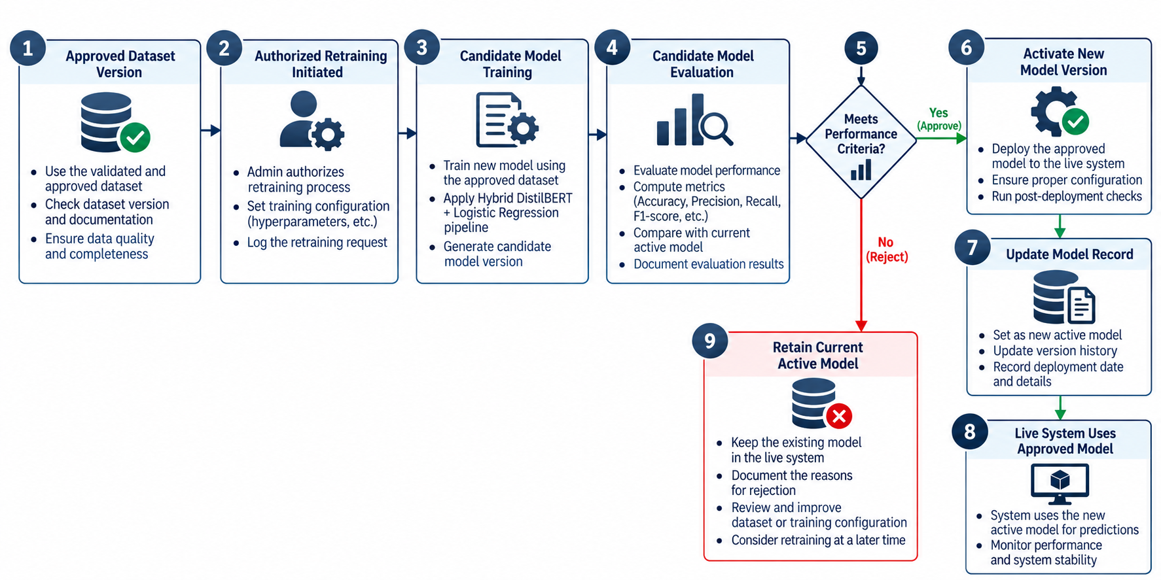

Figure 4. Controlled Model Retraining and Activation Flow

Methodology
The study will use a Hybrid Agile methodology that combines documented research decisions with iterative software development. Dataset approval, claim-group-aware partitioning, held-out evaluation, and model activation require controlled decisions. The software iteration is Scrum-inspired, drawing on planning, review, and retrospective practices described by Schwaber and Sutherland (2020); the entire research methodology is not claimed to be Scrum. Figure 5 shows the seven phases and the repeated development cycle.

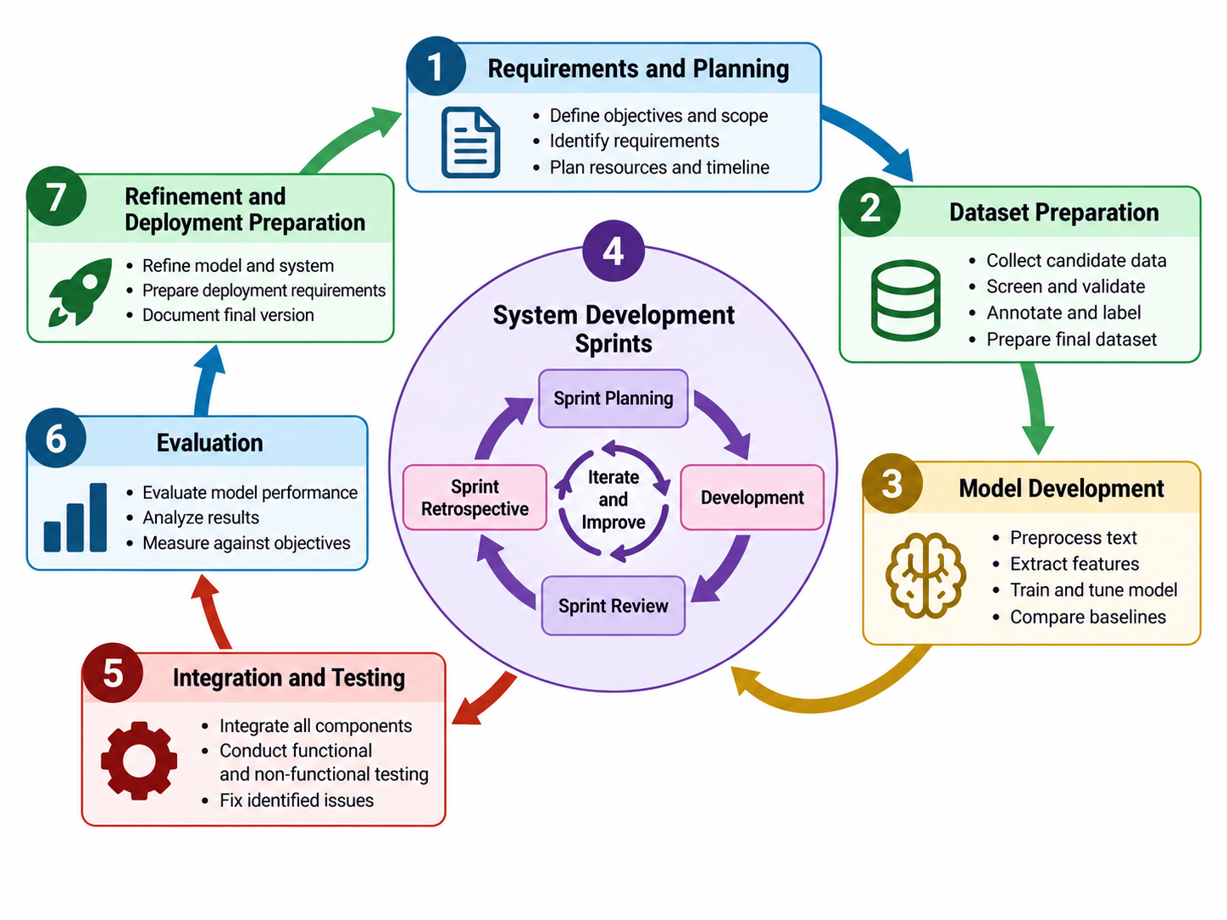
Figure 5. Hybrid Agile Methodology of SuriPH

Phase 1 Requirements and Planning
The researchers will confirm the finalized scope, users, functional and non-functional requirements, data-governance boundaries, evaluation design, and implementation-dependent decisions. AFP IT coordination and the separate general-user respondent plan will be documented before formal evaluation activities begin.

Phase 2 Dataset Preparation
Candidate records will be inventoried, screened, grouped by claim, and reviewed with evidence under the approved annotation guide. Only validated records will enter a traceable dataset version, with Taglish as the primary language and Filipino and English as supplementary groups.

Phase 3 Model Development
The four approved configurations will use the same approximately 70% training, 15% validation, and 15% testing partitions with claim-group separation. Training-data-only fitting, validation-based selection, and final held-out evaluation will preserve comparability and reduce leakage.

Phase 4 System Development Sprints
The browser extension, restricted Admin Dashboard, backend services, media-to-text pipeline, classifier, retrieval component, dataware, and model-version controls will be implemented iteratively. Each cycle will follow this exact sequence: Sprint Planning → Development → Sprint Review → Sprint Retrospective → Repeat.

Phase 5 Integration and Testing
The researchers will connect browser-side acquisition to backend processing and verify functional requirements across direct text, OCR, transcription, inference, retrieval, storage, authorization, controlled retraining, candidate-model review, and error handling.

Phase 6 Evaluation
Evaluation will comprise dataset composition and independent annotation agreement; held-out model performance and paired comparison; OCR and transcription quality against verified references; functional and integration test outcomes; AFP IT technical assessment; and separate fourth-year BSIT general-user assessment. The dataset and models are evaluated objects, not research instruments. Annotation forms, experiment records, extraction forms, test cases, and approved questionnaires will capture the relevant evidence. Macro F1 will remain the primary classifier measure.

Phase 7 Refinement and Deployment Preparation
Documented defects, evaluator findings, and panel recommendations will guide final refinement. Deployment preparation will identify only the browsers, hardware, workload behavior, response times, and processing limits demonstrated by the completed prototype, and activation will remain restricted to an approved model version.

Requirement Analysis
Requirement analysis defines what SuriPH must do and the conditions under which it should operate. Functional requirements describe system behavior. Non-functional requirements describe quality, security, privacy, compatibility, performance, and maintenance constraints.
Table 1. Functional Requirements of SuriPH
ID | Requirement Description | Priority
FR1 | Allow a user to initiate a screening request for selected supported social-media post content encountered through a supported webpage. | High
FR2 | Inspect supported regular DOM and accessible/open Shadow DOM through browser-extension content scripts within granted permissions. | High
FR3 | Obtain directly accessible post text, captions, and selected contextual comments from supported webpage elements. | High
FR4 | Extract visible text from supported images or screenshots through OCR. | High
FR5 | Obtain spoken transcripts and sampled-frame visible text from supported webpage videos. | High
FR6 | Allow optional submission of selected content to CandidateSamples for human review only, without assigning a final label or triggering retraining. | High
FR7 | Combine relevant extracted textual content, including video transcript and on-screen OCR text where applicable, normalize/deduplicate it as required, and prepare it for feature extraction and classification. | High
FR8 | Generate contextual representations using multilingual DistilBERT. | High
FR9 | Calculate the finalized linguistic and stylistic features. | High
FR10 | Fuse contextual and linguistic representations. | High
FR11 | Classify the fused representation through Logistic Regression. | High
FR12 | Produce an internal class prediction and confidence value. | High
FR13 | Present Potentially Misleading or No Misleading Information Detected with the model confidence value and an assistive disclaimer. | High
FR14 | Use Serper.dev to retrieve related information under the approved credible-source policy independently of classification, without recalculating or overwriting the prediction. | High
FR15 | Display related context and credible-source links when available. | High
FR16 | Communicate between the extension and backend through the implemented API. | High
FR17 | Provide understandable errors for extraction, communication, inference, and retrieval failures. | Medium
FR18 | Restrict the Admin Dashboard to authorized users. | High
FR19 | Allow authorized candidate and evidence review, with Google Fact Check Tools API assisting dataset evidence retrieval only and human confirmation of claim correspondence. | High
FR20 | Allow administrators to approve, revise, or exclude candidate records. | High
FR21 | Maintain approved dataset versions and membership records. | High
FR22 | Allow authorized administrators to initiate controlled retraining. | High
FR23 | Display candidate-model evaluation results before activation. | High
FR24 | Allow an authorized decision to approve or reject a candidate model. | High
FR25 | Activate only an approved model version for live inference. | High
FR26 | Maintain audit and version records for significant dataset review, retraining, candidate-model approval/rejection, and activation actions; a dedicated record-viewing screen is not assumed. | Medium

Table 2. Non-Functional Requirements of SuriPH
ID | Requirement Description | Priority
NFR1 | Produce results within response times established by actual prototype benchmarking. | High
NFR2 | Use HTTPS for deployed client-to-backend communication. | High
NFR3 | Keep API keys, database credentials, and administrative secrets out of browser-side code. | High
NFR4 | Minimize unnecessary collection and retention of browsing information. | High
NFR5 | Remove temporary media after processing unless retained for approved research testing. | High
NFR6 | Handle unavailable media, OCR failure, transcription failure, retrieval failure, and backend errors without uncontrolled failure. | High
NFR7 | Use modular backend and machine-learning components to support testing and maintenance. | Medium
NFR8 | Keep dataset and model versions traceable for reproducibility and controlled retraining. | High
NFR9 | Present public results in language understandable to non-technical users. | High
NFR10 | Restrict administrative functions to authorized personnel. | High
NFR11 | Claim browser compatibility only for tested extension environments. | High
NFR12 | Support expansion of validated records without redesigning the classification pipeline. | Medium
NFR13 | Maintain stable operation during repeated requests within tested capacity. | High
NFR14 | Keep retrieval failure from changing or invalidating the model prediction. | High
NFR15 | Prevent raw public submissions from automatically becoming training data or triggering retraining. | High

Requirement analysis connects the objectives to observable system behavior. Each functional requirement identifies an action or result that can be demonstrated through an approved test case. Non-functional requirements identify conditions such as security, privacy, compatibility, reliability, maintainability, and performance that influence how the function operates. Priority labels support planning but do not replace acceptance criteria.
The public workflow begins with user activation and selection of supported social-media post content. It includes text acquisition, requested media-to-text processing, prediction and confidence, independent Serper.dev retrieval, cautious labels, and a disclaimer. Optional submission creates a candidate record only. Test cases will distinguish incomplete extraction, failed screening, and completed classification with unavailable retrieval.
The administrative workflow requires stronger controls. Only authorized users may review candidates, record evidence, manage validation decisions, create dataset versions, initiate retraining, inspect candidate-model metrics, approve or reject a model, and activate an approved version. Important actions must remain traceable so that the team can determine which dataset and model produced a result.
The requirements will be updated only through the approved development process. If implementation testing shows that a media type, browser structure, or performance threshold is not feasible, the change will be documented in the scope and test plan. The final manuscript will describe the system actually evaluated rather than an earlier design that was not completed.

Population, Sample Size and Sampling Techniques

Population
The study will use two distinct evaluator populations. The general-user evaluation population will consist of eligible fourth-year Bachelor of Science in Information Technology students from the selected class block. Each eligible student must be at least 18 years old and able to interact with English, Filipino, or Taglish online content. The separate technical-evaluator population will consist of qualified and authorized AFP Information Technology Department personnel whose work or training is relevant to software, networking, security, databases, system administration, maintenance, or related information-technology functions.

Sample Size
The official number of eligible fourth-year BSIT students in the selected class block remains unconfirmed. If the full eligible block is invited, the method will be total enumeration within that block, and the report will state the eligible, invited, and responding counts separately. Slovin’s formula is retained only as a contingency if sampling later becomes necessary and the adviser and statistician approve its use. No final N, n, or response count is assumed.
$$n = \frac{N}{1 + Ne²}$$
Here n denotes the proposed sample size, N the confirmed eligible block population, and e the approved margin of error. A value of e = 0.05 and any rounding rule will be used only if approved for the contingency sampling design. The formula is not applied to AFP IT personnel and does not make a selected class block representative of the general public.

Sampling Techniques
If all eligible students in the selected class block are invited as the intended respondent group, the procedure will be described as total enumeration or a census within that block, and Slovin’s formula will not be presented as necessary. If only a sample is selected, the final sampling procedure will match the adviser- and statistician-approved design. AFP IT technical evaluators will be selected separately through the approved purposive procedure because participation requires relevant expertise and institutional authorization. Their number will not be combined with the general-user population or sample-size computation.
Results from AFP IT personnel and fourth-year BSIT general-user respondents will be analyzed and reported separately because the groups perform different tasks and evaluate different aspects of the prototype.

Description of Respondents
AFP IT respondents will evaluate the completed prototype through tasks that expose the implemented technical behavior. Depending on authorization and final scope, they may examine extension-to-backend communication, error handling, authentication, administrative access, model-version information, performance, compatibility, or maintenance documentation. Their questionnaire will include only quality characteristics that can be assessed from the system and provided materials.
Eligible fourth-year BSIT respondents will use the extension through a guided set of representative tasks. They will evaluate whether activation is understandable, whether system status is visible, whether results and confidence are explained clearly, whether credible links are accessible, and whether the disclaimer communicates the limits of the prediction. Technical jargon will be avoided in items intended for this group.
Both groups will receive consistent instructions and an opportunity to report problems or observations. Demographic or profile information will be limited to variables required by the approved research design. Participation records and responses will be protected according to institutional and privacy requirements.

Research Instrument

Dataset Annotation and Evidence Validation Form
The Dataset Annotation and Evidence Validation Form will record sample identifier, text, language, topic, provenance, original or preliminary label, claim_group_id, evidence source and publisher, URL, rating where applicable, claim-match decision, reviewer identifier, independent judgment, validation date, notes, and Approve, Revise, or Exclude status. Independent judgments and the final resolved Misleading or Non-Misleading label will occupy separate fields. Insufficient evidence is not equivalent to evidence that contradicts a claim; unresolved cases may be revised or excluded.
The annotation guide will accompany the form with inclusion, exclusion, segmentation, and disagreement rules. Reviewers will receive examples of checkable and non-checkable content, sufficient and insufficient context, duplicate claims, and acceptable evidence. A pilot annotation round will identify ambiguous instructions before the full validation process begins.

Model Evaluation Record
Each model experiment will have a record linked to its dataset version and fixed partition identifiers. Once implementation is frozen, the record will specify the actual checkpoint and tokenizer revision, frozen or fine-tuned mode, pooling, long-text handling, contextual dimensions, feature definitions and scaling, Logistic Regression settings, threshold, software versions, seeds, and artifact location. It will then capture observed confusion matrices, class-level metrics, Macro F1, False Positive Rate, subgroup results, bootstrap settings and intervals, and paired comparisons. Unimplemented choices will not be filled with assumed values.
Candidate-model review will use the experiment record and documented acceptance procedure. Reviewers will distinguish validation evidence used for selection from held-out evidence used for final reporting. Repeated maintenance cycles must not tune a candidate against the same final test outcomes. Approval and activation will be recorded separately, and an increase in one aggregate score alone will not establish acceptable false-positive behavior.

Multimedia Extraction Evaluation Form
The Multimedia Extraction Evaluation Form will record the media identifier and type, selected segment or timestamps, audio duration where applicable, frame-sampling procedure, normalization settings, OCR or transcription output, verified reference text, and failure type. Character Error Rate will assess supported image and frame OCR; Word Error Rate will assess speech transcription. The form will preserve substitutions, deletions, insertions, reference lengths, and complete failures so extraction quality can be evaluated separately from downstream classification.
Extraction cases will represent the media conditions supported by the prototype. The researchers will avoid using only clean laboratory examples if the public system is intended to process screenshots or webpage media. At the same time, unsupported or deliberately adversarial cases will be identified as such so that the reported evaluation matches the implemented scope.

Functional and Integration Test Cases
Each functional and integration test case will include its Requirement ID and corresponding Objective reference, prerequisites, input or action, expected result, actual result, status, and version tested. Failed cases will include reproducible notes and a linked retest instead of replacing the failure record. The suite will cover FR1–FR26 and applicable NFR1–NFR15, including candidate-only submission, failure handling, authorization, and retrieval independence.
Integration tests will verify data flow across component boundaries. Examples include sending extracted webpage text to the backend, connecting OCR or transcription output to preprocessing, returning active-model information with a prediction, keeping retrieval results separate, applying authentication to administrative endpoints, and preserving dataset-to-model traceability during retraining.

Software Quality Evaluation Questionnaire
Table 3. Proposed Agreement Scale
Scale | Response
5 | Strongly Agree
4 | Agree
3 | Neutral
2 | Disagree
1 | Strongly Disagree

Separate technical and general-user questionnaires will use a proposed five-point agreement scale. Items will be developed from the applicable, observable characteristics of ISO/IEC 25010:2023 and reviewed for relevance and clarity before use (International Organization for Standardization, 2023). The standard supplies a quality model, not a ready-made questionnaire. Characteristics that cannot be assessed through the approved procedure will not be included merely for completeness.
A five-point agreement scale provides a consistent response format, but numerical interpretation ranges will be approved with the statistician. Results will be summarized by item and applicable characteristic. Open comments may supplement the scale by explaining a defect or usability concern that a mean score cannot describe.
Technical and general-user questionnaires will share only items that genuinely apply to both groups. Security configuration, maintainability, or administrative traceability may be appropriate for technical personnel, while ease of requesting screening and understanding the result belong to general-user assessment. Separate instruments reduce the pressure to ask respondents about matters outside their experience.

Data Gathering Procedures

Step 1 Approval and coordination
Before collection or evaluation, the researchers will seek the required adviser, institutional, ethics-related, and statistical approvals for the instruments, respondent plan, data handling, and testing procedures. Coordination with AFP IT will confirm authorized participants, environment, and demonstration access. Academic evaluation will not imply permission to connect the prototype to protected institutional resources.

Step 2 Candidate data preparation
Candidate sources will be inventoried with their release, purpose, permitted use, original label meaning, language, topic, and provenance. The team will screen contextual completeness and checkability and document repairs, anonymization, duplicates, and exclusions. Formal-news and social-media records will remain distinguishable. This step produces candidate records, not final ground truth.

Step 3 Evidence retrieval and human validation
Following a pilot annotation round, reviewers will apply the approved guide and preserve independent judgments on the designated overlap subset. Google Fact Check Tools API may locate published reviews, but reviewers must confirm claim correspondence and document evidence, publisher, rating where applicable, URL, decision, and notes. Approved credible or authoritative sources may be used when no suitable fact check exists. Disagreements will be resolved only after the independent records needed for Fleiss’ Kappa have been retained; uncertain records may be revised or excluded.

Step 4 Partitioning and model development
Validated records will receive claim_group_id before approximately 70% training, 15% validation, and 15% testing assignment. Equivalent claims will remain together, with stratification where compatible with grouping. All four configurations will use the same partitions. Data-dependent preprocessing and transformations will be fitted only on training data, while validation data will support configuration and threshold selection before final testing.

Step 5 Held-out model evaluation
After configuration selection is frozen, the four models will predict the same untouched held-out records. The researchers will compute Macro F1, supporting class-level metrics and confusion matrices, False Positive Rate, language and feasible source/topic/domain subgroup summaries, a 95% bootstrap interval, and paired McNemar comparisons. Test-set error analysis will describe limitations; it will not tune or reselect the model whose final held-out score is reported. Any later correction or development cycle will be documented separately and will not be reported as an untouched repeat of the same test.

Step 6 Multimedia extraction testing
Supported images, screenshots, and selected webpage video segments will be processed against verified reference text or transcripts. Records will identify media, segment timestamps, audio duration, sampled-frame procedure, normalization settings, output, and failures. WER and CER will describe extraction error under those conditions, while separate end-to-end cases will examine the effect of extracted text on screening without conflating the two evaluation stages.

Step 7 Functional and integration testing
The researchers will execute the approved functional and integration suite, linking each case to its Requirement ID and Objective reference. Evidence will record outcomes, failure details, and corrected retests for both public and administrative workflows. Tests will include retrieval failure after completed classification, candidate-only submission, administrative access, controlled retraining, manual approval, and approved-model activation without exposing real credentials or protected data.

Step 8 Technical and general-user evaluation
Qualified and authorized AFP IT personnel and eligible fourth-year BSIT general-user respondents will receive consent information, orientation, approved tasks, and the questionnaire appropriate to their role. A consistent prototype version and documented environment will be used where feasible. Eligible, invited, and participating counts will be recorded without assuming full participation. Responses will be checked for completeness without pressure to change judgments, and the two groups will be analyzed separately.

Step 9 Compilation and protection of data
Research records will be stored under controlled identifiers with access restricted to authorized research roles. Collection will be limited to data needed for the approved purpose; unrelated browsing and personal information will not be retained. Temporary media and derivatives will be deleted after processing unless specifically retained for approved research testing, in which case an approved retention and deletion schedule will apply. Respondent information will be separated from analysis summaries. Public submissions, inference records, and retrieved links will never become approved labels or training data automatically.
The final analysis will keep raw observations separate from interpreted summaries. Corrections to data or coding will be documented. Tables and manuscript statements will use the same approved counts and version identifiers so that a reader can trace reported results to the underlying evaluation records.

Statistical Treatment of Data
The study will apply descriptive, agreement, predictive-performance, extraction-quality, uncertainty, and paired-comparison procedures according to the finalized research design. Technical-evaluator and general-user questionnaire results will remain separate. Model measures will be calculated from held-out predictions, while OCR and transcription error measures will use verified reference text when available. Macro F1 will serve as the primary model-performance measure.

Percentage
Percentage will summarize frequencies such as class, language, topic, provenance, exclusion reason, respondent profile, and test-case outcome. Every percentage for a subgroup will be reported with its denominator.
$$P = \frac{f}{N} × 100$$
P is the percentage, f is the frequency of the category, and N is the total number of observations in the relevant group.

Fleiss’ Kappa
Fleiss’ Kappa will assess independent nominal judgments on the approved overlapping annotation subset before adjudication (Fleiss, 1971). The statistician will approve the reviewer count, common rating target, categories, coverage, and handling of missing judgments. Approve, Revise, and Exclude decisions will not be mixed with binary proposed-label ratings in one calculation. Agreement based on already reconciled labels would not measure independent agreement.
$$κ = \frac{\overline{P} - {\overline{P}}_{e}}{1 - {\overline{P}}_{e}}$$
Here κ is agreement beyond chance, P̄ is mean observed pairwise agreement, and P̄e is chance agreement from the overall category proportions. For M independently rated records, r ratings per record, and k approved nominal categories, nᵢⱼ is the number of ratings in category j for record i. Then Pᵢ = [Σⱼ nᵢⱼ(nᵢⱼ − 1)]/[r(r − 1)], P̄ = ΣᵢPᵢ/M, pⱼ = Σᵢnᵢⱼ/(Mr), and P̄e = Σⱼpⱼ². The displayed coefficient requires r > 1 and P̄e < 1; any incompatible or incomplete rating pattern will be resolved through the approved analysis procedure rather than silently treated as agreement.

Accuracy
Accuracy will describe the overall proportion of held-out records classified correctly (Rainio, Teuho, & Klén, 2024).
$$Accuracy = \frac{TP + TN}{TP + TN + FP + FN}$$
TP and TN are correctly predicted Misleading and Non-Misleading records; FP and FN are the corresponding errors. All counts refer to the same held-out subset. Undefined denominators and absent classes will be disclosed and handled through a documented metric convention rather than an assumed perfect score. Rates will be distinguished from percentages throughout the results.

Precision
Precision will indicate the proportion of records predicted as Misleading that are labeled Misleading in the held-out data.
$$Precision = \frac{TP}{TP + FP}$$
TP is the number of true-positive Misleading predictions, and FP is the number of Non-Misleading records incorrectly predicted as Misleading.

Recall
Recall will indicate the proportion of held-out Misleading records detected by the classifier.
$$Recall = \frac{TP}{TP + FN}$$
TP is the number of true-positive Misleading predictions, and FN is the number of Misleading records incorrectly predicted as Non-Misleading.

F1-Score
The class-level F1-Score will combine precision and recall through their harmonic mean (Rainio et al., 2024).
$$F1 = \frac{2 × Precision × Recall}{Precision + Recall}$$
Precision is the positive predictive value for the class, and Recall is the sensitivity for that class.

Macro F1
Macro F1 will average the class-level F1 values without allowing the larger class to dominate and will serve as the primary measure for comparing the four configurations.
$$Macro F1 = \frac{{F1}_{Misleading} + {F1}_{Non-Misleading}}{2}$$
F1Misleading is the F1-Score for the Misleading class, and F1Non-Misleading is the F1-Score for the Non-Misleading class.

False Positive Rate
False Positive Rate will be examined separately because an incorrect warning about legitimate material may reduce trust and cause unnecessary concern.
$$FPR = \frac{FP}{FP + TN}$$
FPR is the False Positive Rate, FP is the number of Non-Misleading records predicted as Misleading, and TN is the number of Non-Misleading records classified correctly.

Weighted Mean, if approved
A weighted mean may summarize responses to approved five-point questionnaire items only if the adviser and statistician approve this treatment and its interpretation ranges. Technical and general-user results will not be pooled.
$$x̄ = \frac{Σfx}{N}$$
x̄ is the weighted mean, Σfx is the sum of each response frequency multiplied by its assigned weight, and N is the total number of valid responses in the relevant evaluator group.

Word Error Rate
Word Error Rate will compare Whisper output with a verified reference transcript using a documented common normalization and tokenization procedure. The measure counts minimum-edit substitutions, deletions, and insertions relative to the reference word count (Radford et al., 2023; JiWER contributors, n.d.). This citation supports the metric definition and does not assert that JiWER is an implemented system dependency.
$$WER = \frac{S + D + I}{N}$$
WER is the Word Error Rate, S is the number of word substitutions, D is the number of word deletions, I is the number of word insertions, and N is the number of words in the reference transcript.

Character Error Rate
Character Error Rate will compare EasyOCR output with verified reference text for supported images, screenshots, and sampled video frames. A common documented normalization procedure will define the characters compared (JiWER contributors, n.d.). Empty references will be handled explicitly; WER and CER may exceed 1 when insertions are numerous and will not be capped to improve the reported score.
$$CER = \frac{S_{c} + D_{c} + I_{c}}{N_{c}}$$
CER is the Character Error Rate; Sc, Dc, and Ic are character substitutions, deletions, and insertions; and Nc is the number of characters in the reference text.

McNemar’s Test
McNemar’s test will compare the paired held-out predictions of the proposed hybrid model with each comparison configuration. The planned significance level is α = 0.05 unless the statistician approves a change. An exact procedure will be used if the approximation is inappropriate, and no multiple-comparison correction will be claimed unless later approved (McNemar, 1947).
$$χ² = \frac{(|b - c| - 1)²}{b + c}$$
Here b counts cases correctly classified by the first model and incorrectly by the second, and c counts the reverse. The statistic is the continuity-corrected form for an adequate number of discordant pairs. If b + c = 0, there are no discordant predictions to compare and the expression must not be evaluated by division by zero. McNemar’s test concerns paired correctness, not a direct test of a Macro-F1 difference. Dependence among variants within held-out claim groups must be reviewed with the statistician before inferential claims are made.

95% Bootstrap Confidence Interval
A 95% bootstrap interval will estimate uncertainty around held-out Macro F1 by resampling labels together with their corresponding predictions (Efron & Tibshirani, 1986). Under the percentile procedure, the bounds are the 2.5th and 97.5th percentiles of the resampled scores. The final script will document repetition count, seed, resampling unit, subgroup handling, and undefined-score handling. Because records may share claim groups, the statistician must approve how within-group dependence is handled; independent row resampling will not be assumed valid merely because the split is group-aware.
$${CI}_{95\%} = [Q_{0.025}(Macro F1*), Q_{0.975}(Macro F1*)]$$
CI95% is the 95% confidence interval, Macro F1* is a bootstrap Macro-F1 value from a paired resample, and Q0.025 and Q0.975 are the 2.5th and 97.5th percentiles of the resulting distribution.

System Requirements

Hardware
Table 4. Hardware Requirements
Component | Requirement
Development and training workstation | CPU, RAM, storage, and optional GPU acceleration sufficient for transformer experiments, OCR, Whisper, local integration, and dataset preparation. Final specifications will match the equipment actually used.
Backend server | Resources sufficient for FastAPI, active-model inference, OCR, transcription, retrieval coordination, temporary processing, database access, and the tested request capacity.
End-user device | A computer capable of running a supported browser and extension. Heavy model processing is expected to occur on the backend.
Administrator device | A secured computer with a supported browser and authorized access to the Admin Dashboard.

Hardware requirements will be based on the completed implementation and measured workloads. The development and training workstation must support dataset preparation, repeated transformer representation generation, OCR, transcription, and model evaluation. GPU acceleration may reduce experiment time, but the final specification will distinguish a convenience for development from a true minimum requirement.
The backend server must support active-model inference, request coordination, temporary media processing, retrieval, structured database access, and the tested level of concurrent use. Storage planning must account for model artifacts, approved dataset exports, logs permitted by the research design, and temporary files. Capacity claims will be tied to the workload used during benchmarking.
End-user and administrator devices require a supported browser and network access to the backend. Heavy model work is expected to occur on the server rather than on the user's computer. The final browser and operating-system combinations will be named only after actual compatibility testing.

Software and Technology Stack
The SuriPH technology stack separates browser-side presentation and webpage inspection from backend orchestration, machine learning, media processing, retrieval, database operations, and model storage. The React-based browser extension will use content scripts and WebExtensions-compatible APIs to inspect regular DOM and accessible or open Shadow DOM structures within granted permissions. The backend will not inspect the webpage DOM directly. It will receive the resulting text or media-processing request and coordinate heavy or security-sensitive processing.
Table 5 identifies the core planned stack, not a claim that every dependency has already been deployed. Optional icon and server-runner choices are omitted because the supplied manuscript does not confirm their use. Before implementation testing, this inventory will be reconciled with the actual dependency files and build records; unused tools will be removed and retained versions documented.
Table 5. Planned Software and Technology Stack
System Layer | Technology | Role in SuriPH
Frontend Framework | React | Main user-interface framework for the browser extension and restricted Admin Dashboard.
Frontend Build Tool | Vite | Development server and production build tooling for the React frontend.
Frontend Styling | Tailwind CSS | Layout, responsive styling, and consistent interface presentation.
Browser Extension Integration | WebExtensions-compatible APIs | Content scripts, permissions, messaging, regular DOM inspection, and accessible/open Shadow DOM inspection.
Backend Language | Python | Primary server-side and machine-learning programming language.
Backend Framework | FastAPI | REST/API endpoints and orchestration of backend processing.
Transformer Framework | Hugging Face Transformers | Loads the tokenizer and multilingual DistilBERT model.
Contextual Model | distilbert-base-multilingual-cased | Produces contextual text representations for Taglish, Filipino, and English inputs.
Deep-Learning Runtime | PyTorch | Executes transformer-model operations.
Traditional Machine Learning | scikit-learn | TF-IDF baseline, Logistic Regression, transformations, and evaluation utilities.
Data and Feature Processing | pandas and NumPy | Dataset preparation, numerical operations, and implemented linguistic/stylistic feature processing.
Optical Character Recognition | EasyOCR | Extracts visible text from supported images, screenshots, and sampled video frames.
Speech-to-Text | Whisper | Transcribes spoken content from supported webpage videos.
Media Processing | FFmpeg | Audio extraction, media conversion, and video-frame sampling.
Structured Database | MySQL / MariaDB | Stores administrative, dataset, evidence, annotation, dataset-version, model-version, and audit metadata.
File and Model Storage | Server filesystem | Stores trained model artifacts, tokenizer resources, approved dataset exports, and temporary media.
Dataset Evidence Retrieval | Google Fact Check Tools API | Assists human reviewers in locating published fact-check records during dataset validation.
Live Credible-Source Retrieval | Serper.dev | Retrieves related credible-source results independently from the classifier.
Version Control | Git / GitHub | Tracks source-code revisions and project versions.
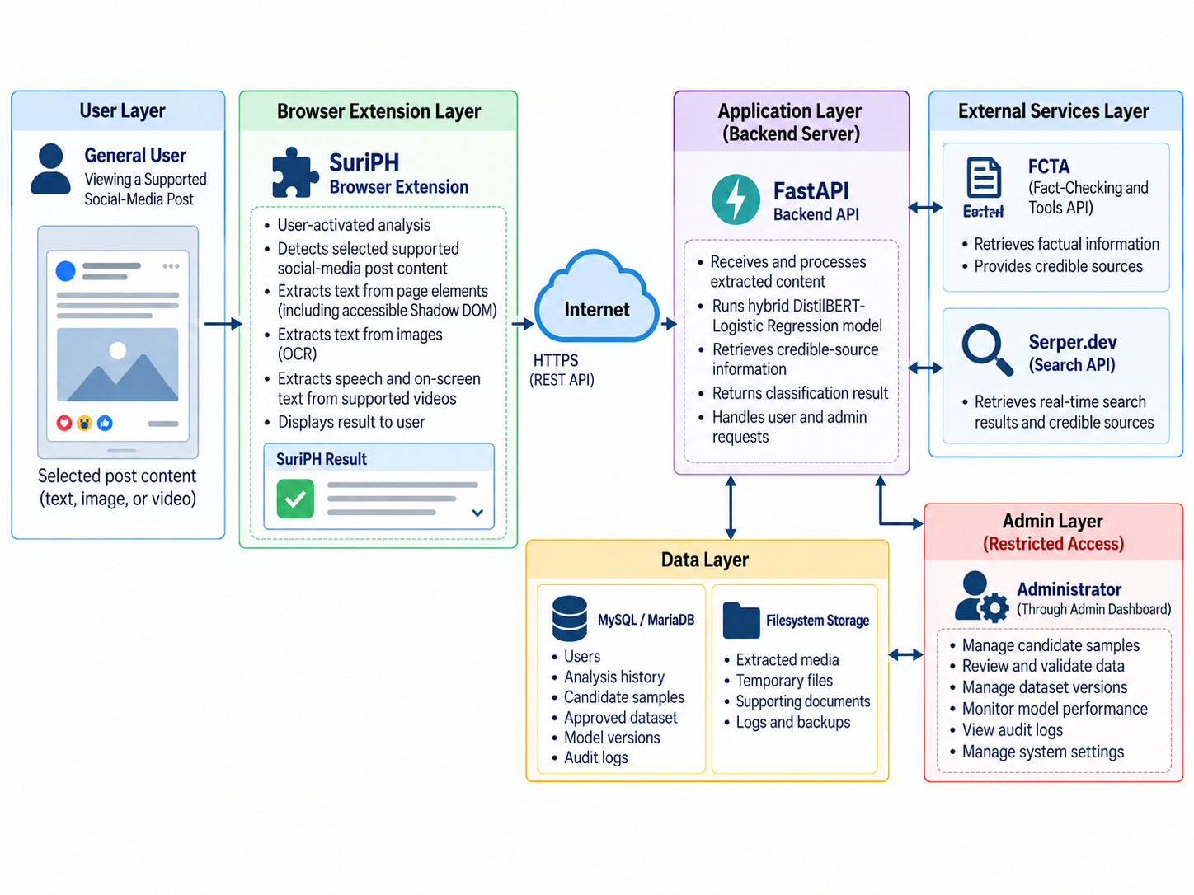
Figure 6. System Architecture of SuriPH
In Figure 6, the extension is responsible for selecting and obtaining supported social-media post content; the backend receives text or approved media-processing requests. FCTA denotes Google Fact Check Tools API and is used only for dataset evidence retrieval under human review. Serper.dev supplies independent live source retrieval. Generic Users in the storage layer means restricted AdminUsers, while any analysis history is optional InferenceLogs under the approved privacy design, not a public-account or compulsory browsing-history service. Model and media artifacts remain on the protected filesystem. The diagram’s broad labels do not authorize functions beyond the requirements.

Peopleware
Table 6. Peopleware Requirements
Role | Responsibility
Researchers and developers | Prepare data, implement and test the model and system, maintain documentation, and conduct the approved evaluation.
Research adviser | Guides the research design, scope, manuscript, and approval process.
Statistician | Reviews sampling, instruments, metrics, statistical tests, and interpretation procedures.
Dataset reviewers or annotators | Review claims and evidence, record decisions, and participate in disagreement resolution.
AFP IT technical evaluators | Assess applicable technical and software quality characteristics of the prototype.
Eligible fourth-year BSIT general-user evaluators | Assess public-facing interaction, result presentation, credible links, disclaimer clarity, and error feedback.
Authorized administrator | Uses restricted dataset and model-management functions within the approved scope.

Peopleware includes the researchers and developers who prepare data, implement the system, run experiments, test functions, and maintain the manuscript. The research adviser guides scope and academic decisions, while the statistician reviews sampling, instruments, measures, statistical procedures, and interpretation. These roles help keep the research method aligned with approved academic and statistical requirements.
Dataset reviewers or annotators examine claims and evidence, record independent decisions, and participate in the approved disagreement process. AFP IT technical evaluators assess applicable quality characteristics and technical operation. Eligible fourth-year BSIT general-user evaluators assess the public interaction. Authorized administrators manage only the restricted dataset and model functions allowed by the approved prototype.
Role separation will be enforced where practical. Public users will not gain administrative privileges, and evaluator participation will not automatically authorize model activation or dataset approval. The final documentation will identify which actions require authentication, which require an approval decision, and which are automated backend processes.
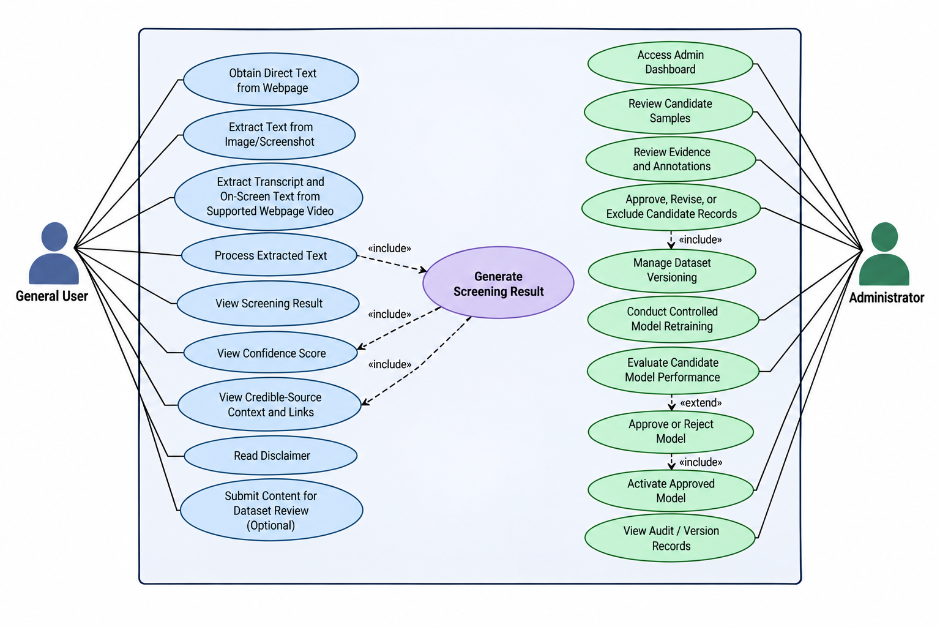
Figure 7. Use Case Diagram of SuriPH
Figure 7 shows the General User requesting screening of selected supported social-media post content. The extension can obtain direct text or request supported image OCR, video transcription, and frame OCR. Relevant text is prepared for the same classifier. Results comprise the exact public label, model confidence, separate Serper.dev context and links when available, and a disclaimer. Optional submission creates CandidateSamples for human review; it does not assign a final label or trigger training.
The Administrator uses the restricted Admin Dashboard for candidate and evidence review, Approve, Revise, or Exclude decisions, approved dataset versions, authorized retraining, candidate-model evaluation, manual approval or rejection, and activation of an approved version. Google Fact Check Tools API assists evidence retrieval only during validation. Audit and version records support traceability; the diagram’s View Audit / Version Records label is not a claim of a dedicated viewing screen unless that screen is implemented and tested.

Network
The deployed academic prototype will require a network connection between the browser extension or restricted Admin Dashboard and the backend. Application traffic will use HTTPS in the tested deployment environment. Browser-side code will not contain database credentials, administrative secrets, model artifacts, or third-party API keys.
The backend will coordinate inference, OCR, transcription, retrieval, database access, temporary file handling, and model-version selection. Server-side integrations will contact the structured database, server filesystem, Google Fact Check Tools API during human-supported dataset validation, and Serper.dev for planned live credible-source retrieval. Retrieval availability will not determine or modify the classifier output.
Administrative endpoints will require authentication and authorization. Database and model-management services will not be exposed directly to the public extension. If retrieval fails after classification, the prediction may still be presented with a clear notice that related sources are unavailable.
Exact network performance, timeouts, rate limits, browser compatibility, workload capacity, and response behavior will be reported only for the environments and conditions actually tested.
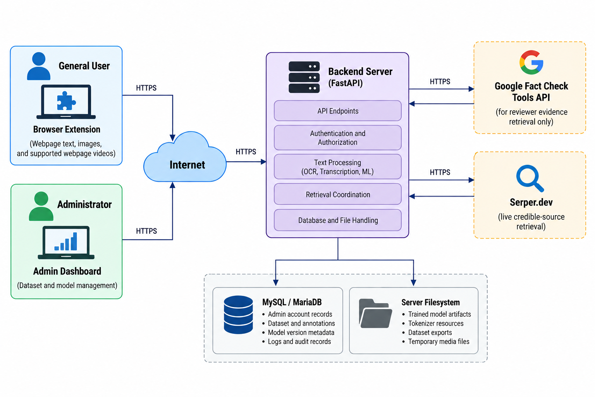

Figure 8. Network Architecture of SuriPH

Dataware
SuriPH will separate structured administrative and research metadata from file-based artifacts. MySQL or MariaDB will store structured records, while the protected server filesystem will store trained model artifacts, tokenizer resources, approved dataset exports, and temporary media required for approved processing or testing.
The main logical entities are AdminUsers, CandidateSamples, EvidenceRecords, Annotations, DatasetVersions, DatasetItems, ModelVersions, and AuditLogs. AdminUsers represent only authorized administrative accounts; the design does not assume public user accounts. CandidateSamples preserve text, provenance, language, topic, claim_group_id, a preliminary or proposed label, and validation status. EvidenceRecords preserve claim-match status, source or URL, rating where applicable, reviewer or verification metadata, and notes. Annotations use the reviewer identifier established by the approved reviewer design and do not require every annotator to be an AdminUser.
DatasetVersions and DatasetItems will identify approved record membership, final labels, and partition assignments for each research cycle. ModelVersions will link each candidate or active model to the dataset version, actual configuration, measured metrics, approval and activation states, and filesystem artifact location. AuditLogs will record significant authorized actions. Figure 9 is a logical design: physical field names, key constraints, credential protection, and the method for resolving artifact paths will be documented from the implemented schema rather than inferred as finished functionality.
InferenceLogs and RetrievedSources will be optional and will be enabled only if the completed implementation and approved privacy design require them. Raw public-user activity will not automatically become approved training data, and temporary media will not be retained beyond the approved processing or testing period. Physical field names, retention periods, backup procedures, and storage limits remain implementation-dependent until the completed prototype is verified.
Table 7. Planned Dataware Entities
Entity | Purpose
AdminUsers | Authorized administrative identities and access-control information.
CandidateSamples | Candidate text, language, topic, provenance, claim group, proposed label, and review status.
EvidenceRecords | Evidence sources, links, professional fact-check information where applicable, and human claim-match decisions.
Annotations | Independent reviewer decisions, notes, dates, and approved disagreement-resolution information.
DatasetVersions | Traceable approved dataset releases and their composition metadata.
DatasetItems | Membership and claim-group-aware partition assignment of approved records within a dataset version.
ModelVersions | Model configuration, dataset version, evaluation results, artifact location, approval state, and activation state.
AuditLogs | Traceable records of significant authorized administrative actions and outcomes.

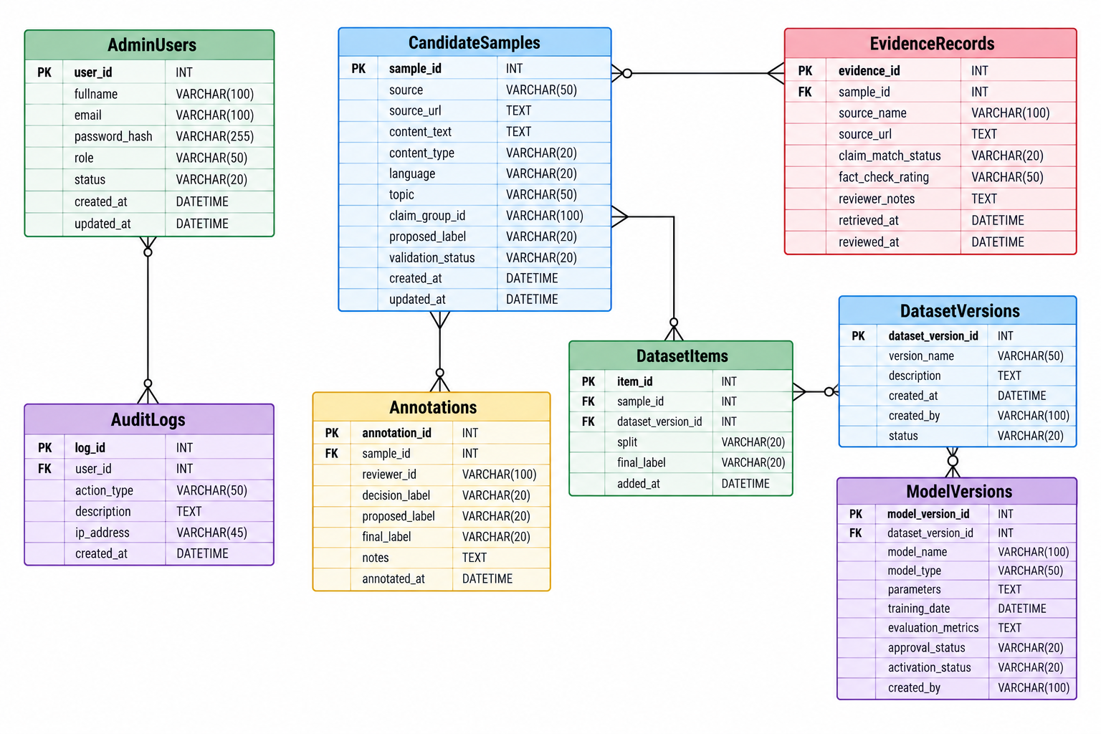

Figure 9. Entity Relationship Diagram of SuriPH

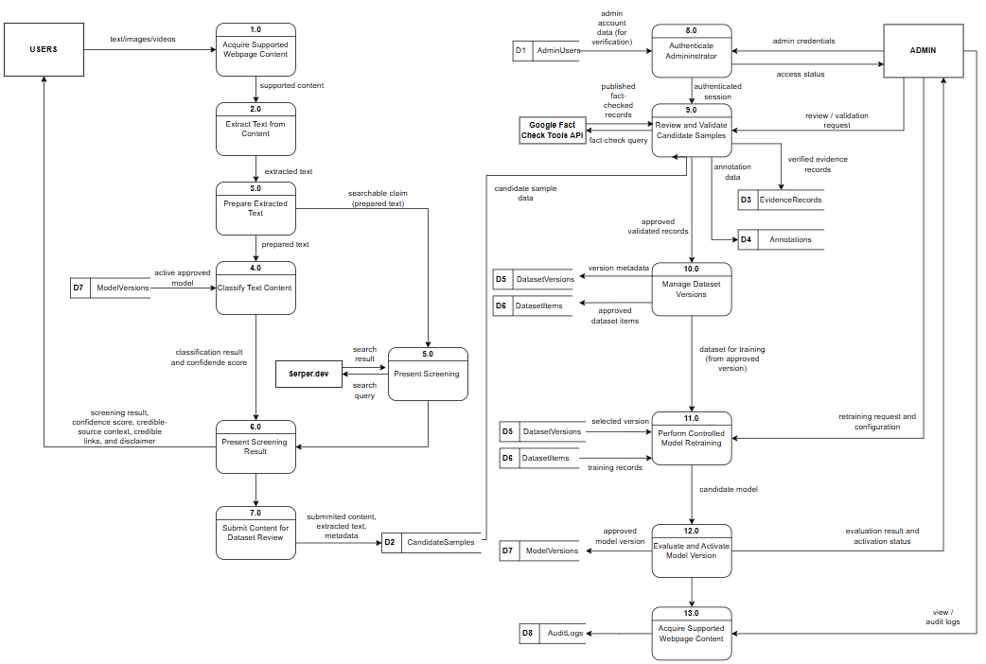
Figure 10. Data Flow Diagram Level 1 of SuriPH

Figure 10 represents the public and administrative data flows. The General User initiates screening of selected supported social-media post content. The extension obtains accessible post text or requests EasyOCR extraction from supported images and video frames and Whisper transcription from accessible video speech. Relevant transcript and OCR text are normalized and deduplicated before the active text classifier returns its prediction and confidence. The live retrieval branch uses Serper.dev to obtain related credible-source context; it does not modify, overwrite, or recalculate the prediction. A retrieval failure may leave the completed screening result available with an appropriate notice.
Optional submission is a separate action that creates candidate data for review, not approved training data. Authorized administrators review candidates and evidence, with Google Fact Check Tools API used only to locate published fact checks for human claim matching and validation. Approved records may enter a controlled dataset version. Retraining is manually initiated; candidate evaluation, manual approval or rejection, and activation of an approved model are distinct decisions even where the diagram compresses them into one process box. The lower audit-related branch represents administrative and version traceability, not a second public-content acquisition service. Public requests and submissions cannot automatically alter dataset labels or the active model.

References
Aïmeur, E., Amri, S., & Brassard, G. (2023). Fake news, disinformation and misinformation in social media: A review. Social Network Analysis and Mining, 13(1), Article 30. https://doi.org/10.1007/s13278-023-01028-5
Bonet-Jover, A., Sepúlveda-Torres, R., Saquete, E., Martínez-Barco, P., & Nieto-Pérez, M. (2024). RUN-AS: A novel approach to annotate news reliability for disinformation detection. Language Resources and Evaluation, 58, 609-639. https://doi.org/10.1007/s10579-023-09678-9
Broda, E., & Strömbäck, J. (2024). Misinformation, disinformation, and fake news: Lessons from an interdisciplinary, systematic literature review. Annals of the International Communication Association, 48(2), 139-166. https://doi.org/10.1080/23808985.2024.2323736
Bu, Y., Sheng, Q., Cao, J., Qi, P., Wang, D., & Li, J. (2024). FakingRecipe: Detecting fake news on short video platforms from the perspective of creative process [Preprint]. arXiv. https://doi.org/10.48550/arXiv.2407.16670
Buñag, K. L. T., & Esquivel, R. A. (2023). Transformer-based conditional language models to generate Filipino news articles. In Proceedings of the International Conference on Industrial Engineering and Operations Management (pp. 2231–2237). IEOM Society International. https://ieomsociety.org/proceedings/2023manila/595.pdf
Chua, Y. T. (2026, June 16). Philippines. In Digital News Report 2026. Reuters Institute for the Study of Journalism. https://reutersinstitute.politics.ox.ac.uk/digital-news-report/2026/philippines
Cruz, F. A. (2024). A multilingual collection of Facebook comments on the Moro identity and armed conflict in the southern Philippines. Journal of Open Humanities Data, 10(1), 41. https://doi.org/10.5334/johd.219
Cruz, J. C. B., Resabal, J. K., Lin, J., Velasco, D. J., & Cheng, C. (2020). Exploiting news article structure for automatic corpus generation of entailment datasets. arXiv. https://arxiv.org/abs/2010.11574
Cruz, J. C. B., Tan, J. A., & Cheng, C. (2020). Localization of fake news detection via multitask transfer learning. Proceedings of LREC 2020, 2596-2604. https://aclanthology.org/2020.lrec-1.316/
Efron, B., & Tibshirani, R. (1986). Bootstrap methods for standard errors, confidence intervals, and other measures of statistical accuracy. Statistical Science, 1(1), 54-75. https://doi.org/10.1214/ss/1177013815
Essa, E., Omar, K., & Alqahtani, A. (2023). Fake news detection based on a hybrid BERT and LightGBM models. Complex & Intelligent Systems, 9, 6581-6592. https://doi.org/10.1007/s40747-023-01098-0
Fernandez, A. C. T., & Devaraj, M. (2019). Computing the linguistic-based cues of fake news in the Philippines towards its detection. In Proceedings of the 9th International Conference on Web Intelligence, Mining and Semantics (pp. 1–9). Association for Computing Machinery. https://doi.org/10.1145/3326467.3326490
Fleiss, J. L. (1971). Measuring nominal scale agreement among many raters. Psychological Bulletin, 76(5), 378-382. https://doi.org/10.1037/h0031619
Geirhos, R., Jacobsen, J.-H., Michaelis, C., Zemel, R., Brendel, W., Bethge, M., & Wichmann, F. A. (2020). Shortcut learning in deep neural networks. Nature Machine Intelligence, 2, 665–673. https://doi.org/10.1038/s42256-020-00257-z
Google for Developers. (2024). Fact Check Tools API: Method claims.search. https://developers.google.com/fact-check/tools/api/reference/rest/v1alpha1/claims/search
Herrera, M., Aich, A., & Parde, N. (2022). TweetTaglish: A dataset for investigating Tagalog-English code-switching. Proceedings of LREC 2022, 2090-2097. https://aclanthology.org/2022.lrec-1.225/
Hugging Face. (n.d.). Model card for DistilBERT base multilingual (cased). Retrieved September 8, 2026, from https://huggingface.co/distilbert/distilbert-base-multilingual-cased
Imperial, J. M., & Ong, E. (2021). Diverse linguistic features for assessing reading difficulty of educational Filipino texts [Preprint accepted at ICCE 2021]. arXiv. https://doi.org/10.48550/arXiv.2108.00241
International Organization for Standardization. (2023). Systems and software engineering—Systems and software Quality Requirements and Evaluation (SQuaRE)—Product quality model (ISO/IEC Standard No. 25010:2023). https://www.iso.org/standard/78176.html
Jadhav, R., Meshram, V., Bhosle, A., Patil, K., Dash, S., & Jadhav, S. (2025). Explainable multilingual and multimodal fake-news detection: Toward robust and trustworthy AI for combating misinformation. Frontiers in Artificial Intelligence, 8, Article 1690616. https://doi.org/10.3389/frai.2025.1690616
JaidedAI. (n.d.). EasyOCR [Computer software]. GitHub. Retrieved September 8, 2026, from https://github.com/JaidedAI/EasyOCR
Jamen, R. J. B., & Reyes, R. C. (2023). Fake news detection in Philippine news corpus using LDA and sentiment analysis with machine learning. In Proceedings of the 41st Samahang Pisika ng Pilipinas Physics Conference, SPP-2023-PB-40. https://proceedings.spp-online.org/article/view/SPP-2023-PB-40
JiWER contributors. (n.d.). JiWER documentation. Retrieved September 8, 2026, from https://jitsi.github.io/jiwer/
McNemar, Q. (1947). Note on the sampling error of the difference between correlated proportions or percentages. Psychometrika, 12(2), 153-157. https://doi.org/10.1007/BF02295996
Montalan, J. R., Layacan, J. P., Africa, D. D., Flores, R. I., Lopez, M. T., II, Magsajo, T. D., Cayabyab, A., & Tjhi, W. C. (2025). Batayan: A Filipino NLP benchmark for evaluating large language models [Preprint]. arXiv. https://doi.org/10.48550/arXiv.2502.14911
Mozilla. (n.d.-a). Content scripts. MDN Web Docs. Retrieved September 8, 2026, from https://developer.mozilla.org/en-US/docs/Mozilla/Add-ons/WebExtensions/Content_scripts
Mozilla. (n.d.-b). Using shadow DOM. MDN Web Docs. Retrieved September 8, 2026, from https://developer.mozilla.org/en-US/docs/Web/API/Web_components/Using_shadow_DOM
Nielsen, D. S., & McConville, R. (2022). MuMiN: A large-scale multilingual multimodal fact-checked misinformation social network dataset. Proceedings of SIGIR 2022. https://doi.org/10.1145/3477495.3531744
OECD. (2024). Facts not fakes: Tackling disinformation, strengthening information integrity. OECD Publishing. https://doi.org/10.1787/d909ff7a-en
Pelrine, K., Imouza, A., Thibault, C., Reksoprodjo, M., Gupta, C., Christoph, J., Godbout, J.-F., & Rabbany, R. (2023). Towards reliable misinformation mitigation: Generalization, uncertainty, and GPT-4. In Proceedings of the 2023 Conference on Empirical Methods in Natural Language Processing (pp. 6399–6429). Association for Computational Linguistics. https://doi.org/10.18653/v1/2023.emnlp-main.395
Pulse Asia Research. (2022). September 2022 Ulat ng Bayan survey general report. https://pulseasia.ph/wp-content/uploads/2025/05/UB-September-2022-General-Report.pdf
Radford, A., Kim, J. W., Xu, T., Brockman, G., McLeavey, C., & Sutskever, I. (2023). Robust speech recognition via large-scale weak supervision. Proceedings of the 40th International Conference on Machine Learning, 28492-28518. https://proceedings.mlr.press/v202/radford23a.html
Rainio, O., Teuho, J., & Klén, R. (2024). Evaluation metrics and statistical tests for machine learning. Scientific Reports, 14(1), Article 6086. https://doi.org/10.1038/s41598-024-56706-x
Sanh, V., Debut, L., Chaumond, J., & Wolf, T. (2019). DistilBERT, a distilled version of BERT: Smaller, faster, cheaper and lighter. arXiv. https://arxiv.org/abs/1910.01108
Schwaber, K., & Sutherland, J. (2020). The Scrum guide: The definitive guide to Scrum. https://scrumguides.org/scrum-guide.html
scikit-learn developers. (n.d.). LogisticRegression. Retrieved September 8, 2026, from https://scikit-learn.org/stable/modules/generated/sklearn.linear_model.LogisticRegression.html
Serper.dev. (n.d.). Serper Google Search API. Retrieved September 8, 2026, from https://serper.dev/
Tsek.ph. (n.d.). About Tsek.ph. Retrieved September 8, 2026, from https://www.tsek.ph/about/
Wang, X., Zhang, W., & Rajtmajer, S. (2024). Monolingual and multilingual misinformation detection for low-resource languages: A comprehensive survey. arXiv. https://doi.org/10.48550/arXiv.2410.18390

