
PennyPal
Fresh All Along
Project Documentation
A cross-platform personal finance app for students

Item | Details
Project name | PennyPal
Theme | NextGen BudgetBee
Category | Multi-Platform App Computing
Platforms | Android phones, iPhone / iPad, tablets, web browsers
Technology | Flutter 3.27.4, Dart 3.6, SQLite, Firebase (optional), Google Gemini (optional)
Document version | 1.0
Date | 24 September 2026
Prepared by | ______________________________

Table of Contents
1. Problem Definition 3
1.1 Background 3
1.2 Problem Statement 3
1.3 Objectives 3
1.4 Scope 3
1.5 User Roles and Permissions 4
1.6 Constraints 4
2. Design Specifications 6
2.1 Technology Stack 6
2.2 System Architecture 6
2.3 Module Design 8
2.4 Site Map 9
2.5 User Interface Design 9
2.6 Key Business Rules and Algorithms 9
2.7 Security and Privacy Design 10
2.8 Non-Functional Requirements 11
2.9 Requirements Traceability 11
3. Diagrams 13
3.1 Data Flow Diagram – Level 0 (Context) 13
3.2 Data Flow Diagram – Level 1 13
3.3 Flowcharts 13
3.4 Entity Relationship Diagram 20
4. Database Design 21
4.1 Overview 21
4.2 Table Definitions 21
4.3 Relationships 25
4.4 Cloud Firestore Structure (optional) 25
4.5 SQL Scripts Submitted 25
5. Test Data and Testing 27
5.1 Test Data 27
5.2 Test Cases 28
5.3 Automated Tests 29
6. Project Installation Instructions 31
6.1 Prerequisites 31
6.2 Install the APK on an Android phone 31
6.3 Run from the source code 31
6.4 Optional: enable the Gemini chatbot 31
6.5 Optional: enable Firebase cloud sync 31
6.6 Load the database scripts (optional) 31
7. User Credentials 32
8. Assumptions 33
9. Acknowledgements 34
9.1 Third-party libraries and resources 34
9.2 AI tools used 34
Appendix A. Screenshots 35
A.1 Student app 35
A.2 Admin portal 38
A.3 Tablet / web layout 39

1. Problem Definition

1.1 Background
Many students start receiving money for the first time through allowances, scholarships, internships or part-time jobs, usually without any habit of recording what they spend. Small daily costs such as food, transport, subscriptions, entertainment and study materials add up quickly and leave little for necessities or savings. Notebooks and spreadsheets are slow to maintain on the go, so most students stop tracking after a few days and only notice a problem when the money has already run out.

1.2 Problem Statement
Students need a quick, simple and trustworthy way to:
- record income and expenses in a few taps, even without an internet connection;
- plan how much they can spend each month and in each category;
- be warned before, not after, they overspend;
- save steadily towards personal goals and see their progress;
- understand their spending habits and learn basic money-management skills.
Existing banking or investment apps are too complex for beginners, are often tied to a particular bank, and are not designed to teach. PennyPal addresses this gap with a focused, beginner-friendly tool that works the same on Android, iOS, tablets and the web.

1.3 Objectives
Table 1: Project objectives
# | Objective | How PennyPal meets it
O1 | Make expense tracking fast | Add income/expense from any screen with a floating Add button; smart category suggestion fills the category automatically.
O2 | Support budgeting | Monthly overall budget plus category limits with a configurable alert threshold (default 80%).
O3 | Prevent overspending | Real-time alerts the moment a threshold or limit is crossed, shown on screen, stored in Notifications and sent as a device notification.
O4 | Encourage saving | Savings goals with progress rings, milestones (25/50/75/100%), estimated completion date and a behind-schedule warning.
O5 | Build financial literacy | Learning hub with short lessons and the "Ask Penny" chatbot for budgeting questions.
O6 | Give insight | Dashboard summary, personalised tips, category charts, 6-month trend and exportable reports.
O7 | Work anywhere | One Flutter codebase for Android, iOS, tablets and web; offline-first local database with cloud sync.
O8 | Allow administration | Admin portal for students, learning content, support queries, feedback, settings and analytics.

1.4 Scope

In scope
- Student registration, login and logout; pre-configured administrator login.
- Income and expense management with categories, search and filters, receipt photos.
- Monthly and category budgets, real-time alerts and notifications.
- Savings goals with contributions, milestones and goal history.
- Dashboard, spending reports, charts and CSV export.
- Learning hub, About, Feedback, Contact Support and the AI chatbot.
- Optional AI features: automatic expense categorisation and the Gemini-powered chatbot.
- Offline data entry with automatic synchronisation to the cloud when available.
- Admin portal: manage students, monitor activity, analytics report, learning content, support and settings.

Out of scope (intentionally excluded)
PennyPal is a finance-learning and expense-management tool. As required by the specification it does not:
- connect to bank accounts, store card details or perform payments or transfers;
- act as a bank, digital wallet, payment gateway or investment platform;
- give investment, loan or professional financial advice. The chatbot declines such questions and every lesson and AI answer is labelled as educational guidance only.

1.5 User Roles and Permissions
Table 2: Role-based permissions
Permission | Student | Administrator
Register a new account | Yes | No (account is pre-configured)
Log in / log out | Yes | Yes
Manage own income, expenses, budgets, goals, categories | Yes | No
View own dashboard, reports, notifications | Yes | No
Use chatbot and learning hub | Yes | No
Submit feedback and support queries | Yes | No
View all students, activate / deactivate / delete accounts | No | Yes
View platform statistics and export analytics report | No | Yes
Create, edit, hide and delete learning content | No | Yes
Reply to support queries and read feedback | No | Yes
Change app settings (chatbot on/off, default alert threshold, support email) | No | Yes

1.6 Constraints
Table 3: Constraints from the specification
Constraint | How it is handled
Real-time processing | Budget usage is recalculated in memory each time an expense is saved; alerts appear immediately without a server round-trip.
Cross-platform compatibility | Single Flutter codebase; responsive layouts switch from a bottom navigation bar (phones) to a navigation rail (tablets and web, width 840 px or more).
Security and privacy | PBKDF2-hashed passwords, per-user data access, HTTPS for cloud and AI calls, Firestore security rules, no bank or card data collected.
Offline support | All data is written to a local SQLite database first and queued for synchronisation when the device is back online.
AI response latency | The chatbot shows a "Penny is thinking..." indicator and gives up after 10 seconds, falling back to the built-in rule-based advisor.

2. Design Specifications

2.1 Technology Stack
Table 4: Technology stack
Layer | Technology | Purpose
Framework | Flutter 3.27.4, Dart 3.6 | One codebase for Android, iOS, tablets and web
State management | provider | Session state and per-student finance state shared across screens
Local database | SQLite via sqflite (mobile) and sqflite_common_ffi_web (web) | Offline storage and sync queue
Cloud (optional) | Firebase Authentication, Cloud Firestore | Account sign-in and cloud backup of records
AI chatbot | Google Gemini API (key from Google AI Studio) over HTTPS | Budgeting answers; offline rule-based fallback
AI categorisation | string_similarity (Dice coefficient) | On-device category suggestion that tolerates typos
Charts | fl_chart | Donut and bar charts
Device features | image_picker, flutter_local_notifications, connectivity_plus, share_plus, path_provider | Receipt photos, notifications, connectivity detection, CSV export
Security | crypto (PBKDF2-HMAC-SHA256), uuid | Password hashing, collision-free record IDs
Formatting | intl | Currency and date formatting
Build / CI | GitHub Actions | Runs analysis and tests, builds APK and web app on each push

2.2 System Architecture
PennyPal follows a layered, offline-first architecture. The user interface never talks to the database directly: screens read and update state objects, state objects call services and repositories, and repositories are the only code that reads or writes SQLite. Every write also records an entry in a sync queue, which a background service pushes to Cloud Firestore when the student is signed in and online.
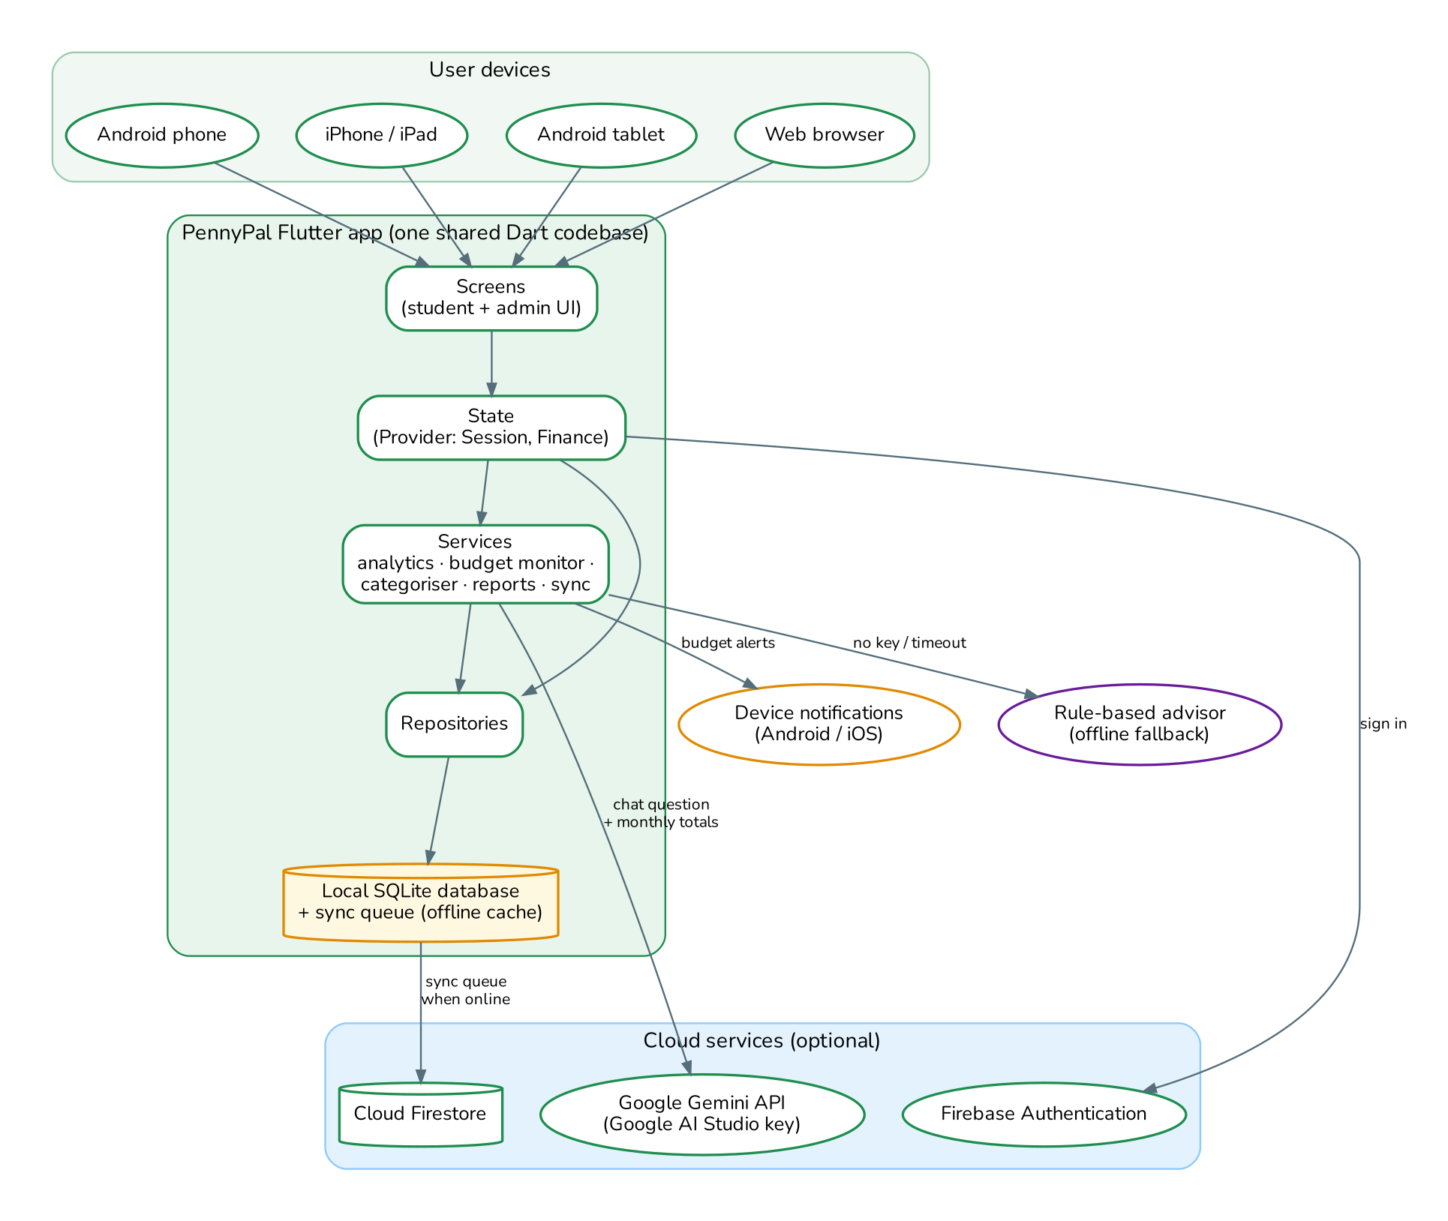
Figure 1: PennyPal system architecture
Table 5: Architecture layers
Layer | Responsibility
Screens | Student screens (dashboard, history, budget, goals, reports, chatbot, learning, feedback, support, profile) and admin screens (overview, students, content, support, settings).
State | SessionState keeps the logged-in user and profile; FinanceState keeps the student's transactions, budgets, goals and notifications in memory for fast screens.
Services | Analytics (totals, trends, insights), budget monitor (alerts), expense categoriser, chatbot, report builder, notification and sync services.
Repositories | Auth, finance, engagement (lessons, support, feedback, notifications, settings) and admin queries against SQLite.
Local database | SQLite schema created from the submitted SQL script; seeded with default categories, admin account, lessons and demo data.
Cloud (optional) | Firebase Auth for sign-in, Firestore for backup, Gemini for AI answers. The app remains fully usable without them.

2.3 Module Design
Table 6: Modules
Module | Main functions | Screens
Authentication | Register with validation and duplicate check, login, persistent session, logout, change password, account deactivation check | Login, Register, Profile
Dashboard | Available balance, total income/expenses, saved in goals, budget status, quick actions, budget progress, tips, spending chart, recent transactions, empty-state messages | Home
Income & expenses | Add, view, edit, delete; income source; expense category; payment mode; receipt photo; smart category suggestion | Transaction form, details sheet
Transaction history | Search text; filter by type, category and date range; daily grouping; swipe to delete | History
Categories | 8 default categories plus custom categories with icons | Categories
Budget management | Monthly budget, category limits, alert threshold, remaining / overspent, copy last month, month navigation | Budget
Alerts & notifications | Threshold and limit alerts, goal milestones, support replies; in-app list and device notifications | Notifications
Savings goals | Create/edit/delete, contributions, progress %, remaining, estimated completion, milestones, archive to history | Goals, Goal form
Reports | Period presets and custom range, totals, daily average, category breakdown, 6-month trend, CSV export, report history | Spending reports
Learning hub | Topic filter, lesson cards, lesson detail with disclaimer | Learning hub, Lesson
Chatbot | Gemini answers with student context, 10 s timeout, rule-based fallback, suggestion chips | Ask Penny
Feedback & support | Feedback with rating; support query with status and admin reply | Feedback, Contact support
About & privacy | Purpose, disclaimer, privacy notice, acknowledgements | About & privacy
Admin portal | Statistics, student management, content management, support replies, feedback, settings, analytics export | Overview, Students, Content, Support, Settings
Sync | Offline queue, connectivity detection, retry, per-user scoping | Sync indicator, Profile

2.4 Site Map
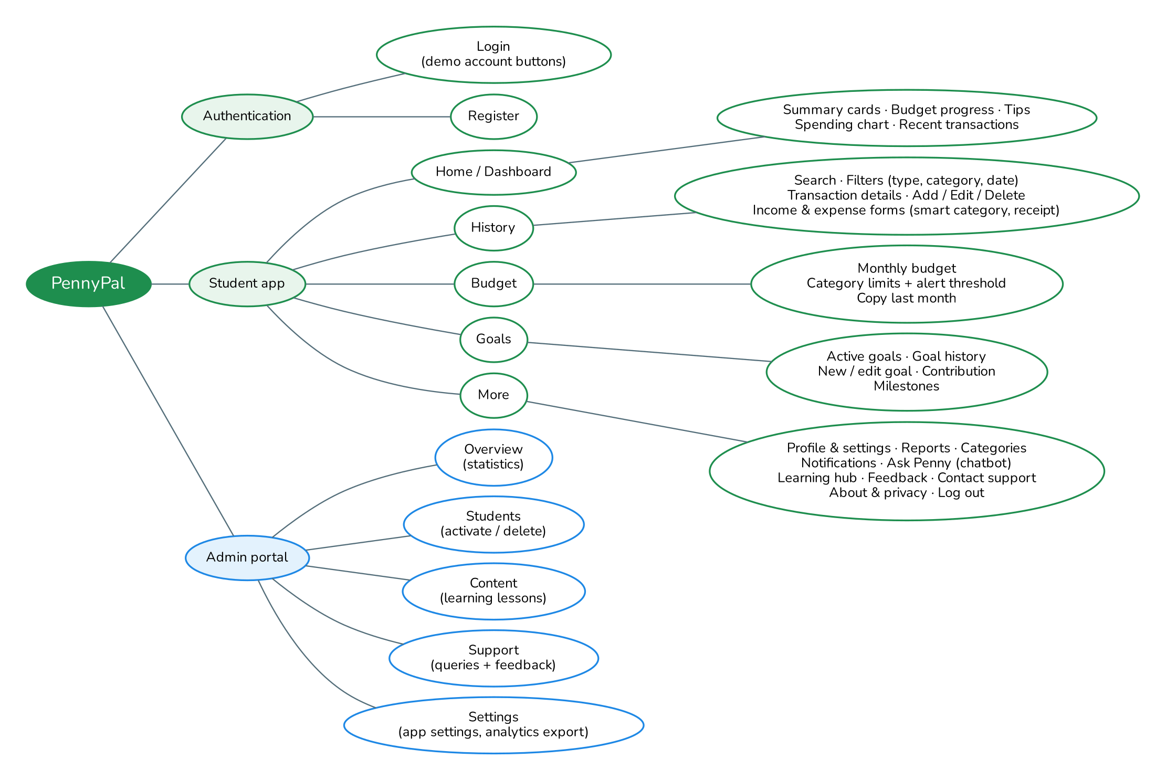
Figure 2: PennyPal site map

2.5 User Interface Design
- Visual identity: fresh green brand colour (#1E8E4E) matching the tagline "Fresh All Along", rounded cards, clear icons and the bundled Nunito font so the app looks the same on every platform and works offline.
- Colour meaning: green for income and healthy budgets, amber when a budget reaches its alert threshold, red for expenses and overspending.
- Responsive layout: bottom navigation on phones; navigation rail and wider grids on tablets and web; content width capped so text stays readable.
- Beginner-friendly language: simple labels ("Where your money went this month"), helpful validation messages and friendly empty states that say what to do next.
- Accessibility: screen-reader labels on charts, progress bars, icons and logo; tooltips on icon buttons; 48 px touch targets; sufficient colour contrast; light and dark themes follow the system setting.
Screenshots of the main screens are included in Appendix A.

2.6 Key Business Rules and Algorithms

Budget alerts
When an expense is saved, the app calculates, for the expense's month, the spending against the overall budget and against the budget of the expense's category, both before and after the change. An alert is raised only when this particular expense crosses a line: usage moves from below the alert threshold to at or above it ("Approaching your limit"), or from at most 100% to above 100% ("Budget exceeded"). This means the student is warned once instead of on every later purchase. Alerts are shown immediately, saved to Notifications and sent as a device notification if the student has notifications turned on.

Smart expense categorisation
While the student types a description the categoriser suggests a category in three steps: (1) if a previous expense has a very similar description (similarity 0.72 or higher), reuse its category, so the app learns from the student's own corrections; (2) look for known keywords for each category, such as "bus", "netflix" or "textbook"; (3) otherwise compare each word with the keywords and custom category names using the Dice coefficient, accepting matches of 0.6 or higher, so typos like "piza" still map to Food. The suggestion is only pre-selected until the student picks a category themselves.

Savings goal calculations
- Progress = current amount ÷ target amount; remaining = target − current.
- Months to go = remaining ÷ monthly contribution (rounded up); estimated completion = today + months to go.
- A goal is "behind schedule" when the estimated completion is after the target date; the app then shows the monthly amount needed to finish on time.
- Milestones at 25, 50, 75 and 100% are marked automatically (and can be marked manually). At 100% the goal is completed and moved to Goal history.

Personalised tips
The dashboard shows rule-based recommendations: budgets over or near their limit, spending more than income, a strong savings rate (20% or more), a category taking over 35% of spending, spending faster than at the same point last month, no budget set, and goals behind schedule.

Chatbot
The chatbot sends the question, recent conversation and a summary of the month (income, expenses, top categories, budget usage and goals) to Gemini with instructions to give short, educational budgeting advice and to decline investment or loan questions. No names, emails or phone numbers are sent. If no API key is configured, the request fails, or no answer arrives within 10 seconds, the offline rule-based advisor answers using the same summary.

Offline synchronisation
Every create, update or delete writes to SQLite and adds an entry to the SyncQueue table. Older queue entries for the same record are replaced, so repeated edits made offline are sent only once. When the student is signed in to Firebase and the device is online, queued entries for that student are pushed to Firestore using the record's ID as the document ID, which makes retries safe and prevents duplicates. Failed entries are retried later and skipped after five attempts so that one bad record never blocks the others.

2.7 Security and Privacy Design
Table 7: Security and privacy measures
Area | Design decision
Passwords | Never stored in plain text. PBKDF2-HMAC-SHA256 with 10,000 iterations and a random 16-byte salt per user; verification uses a constant-time comparison.
Password policy | At least 8 characters with upper case, lower case, a number and a symbol.
Access control | Every query is filtered by the logged-in user's ID; admin screens are only reachable with the admin role; deactivated accounts cannot log in.
Cloud rules | Firestore rules allow students to read and write only documents they own; only the administrator can change shared content and settings.
Transmission | Firebase and Gemini are called over HTTPS. The password hash is removed before any record is uploaded.
Secrets | API keys are passed at build time and are not stored in the source code.
Data minimisation | Only name, email, mobile number and the records the student enters are collected. No bank, card or location data.
Safety | No external links, downloads or redirects; destructive actions (delete, deactivate, log out) always ask for confirmation.

2.8 Non-Functional Requirements
Table 8: Non-functional requirements
Requirement | How PennyPal satisfies it
Safety | No downloads or redirects to external sites; confirmation dialogs before destructive actions.
Accessibility | Semantic labels for charts, images and progress bars, tooltips, large touch targets, readable contrast, system dark mode, text that scales.
User-friendliness | Plain language, clear menus, one-tap demo logins, inline validation messages, empty-state guidance.
Performance | Data kept in memory after the first load; charts and totals computed locally; no network needed for normal use.
Reliability | Input validation on every form, database constraints, try/catch around camera, notifications, sync and AI calls; duplicate-safe sync.
Security | Hashed passwords, per-user access, HTTPS, Firestore rules (see 2.7).
Privacy | Privacy notice shown at registration and in About; chatbot receives only totals.
Scalability | Layered design, UUID keys, custom categories, admin-managed content, and cloud storage allow more users, categories and modules without redesign.
Compatibility | Android 6.0+, iOS, tablets and modern browsers from one codebase.
Maintainability | Code organised by layer and module, commented, analysed with lints and covered by automated tests; the database schema lives in one SQL file used by both the app and the submission.

2.9 Requirements Traceability
Table 9: Traceability to the specification
Requirement (SRS 1.6) | Implemented in
Register with name, email, mobile, password | Register screen
Secure login with email and password; logout | Login screen; More / Profile / Admin settings → Log out
Validate required fields, email, password rules, duplicates | Register form validation; duplicate email check
Dashboard: income, expenses, balance, budget status | Home: balance card and summary tiles
Quick navigation to Add Income/Expense, Budget, History, Learning, Feedback, Support | Home: Quick actions
Visual indicators and empty-data messages | Home: cards, progress bars, donut chart, empty states
Add income (source, amount, date, description) | Add income form
Add expense (category, amount, date, description) | Add expense form
View, edit, delete income and expenses | History, transaction details sheet
Default expense categories | Food, Transport, Education, Shopping, Entertainment, Bills, Savings, Miscellaneous
Search and filter by date, category, type | History: search box, type buttons, category and date-range filters
Monthly budget, comparison, remaining, overspending, update/delete | Budget screen
Learning section with topics and readable lessons | Learning hub and lesson screen
About, Feedback (name, email, rating, comments), Support (subject, message), confirmations | About & privacy, Feedback, Contact support
Chatbot for budgeting questions | Ask Penny
Savings goals with target, current, date, monthly contribution | Goal form
Remaining amount, progress %, estimated completion | Goal card
Update contributions, mark milestones | Add contribution dialog; milestone chips
Progress charts, badges, motivational messages | Progress ring, milestone badges, messages on goal card
Completed goals archived in history | Goals → History tab
Instant notifications near thresholds | Budget monitor alerts and notifications
Camera images on transactions (optional) | Attach receipt photo
AI categorisation (optional) | Smart category suggestion
Reports and spending trends | Spending reports
Admin: manage users, monitor activity, analytics, content | Admin portal

3. Diagrams

3.1 Data Flow Diagram – Level 0 (Context)
The context diagram shows PennyPal as a single process and the external entities that exchange data with it.
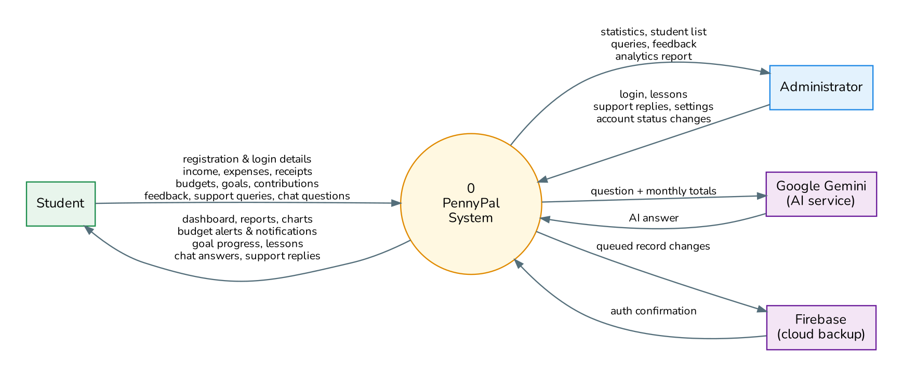
Figure 3: DFD Level 0

3.2 Data Flow Diagram – Level 1
Level 1 breaks the system into nine processes and shows the data stores (D1–D9) each one reads or writes.
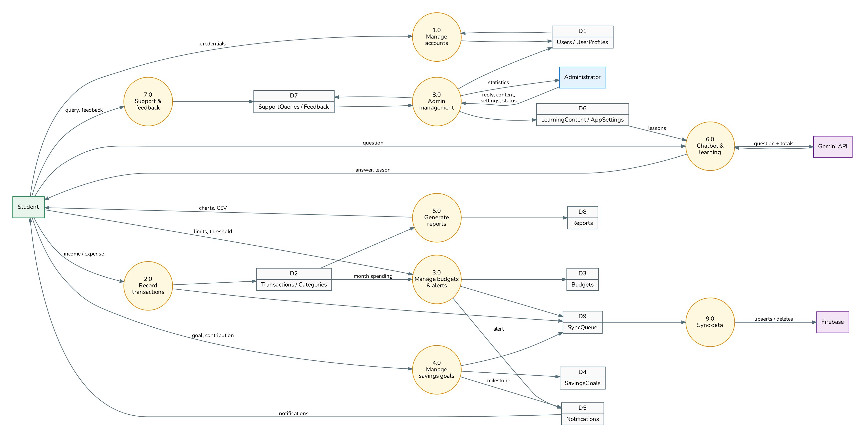
Figure 4: DFD Level 1

3.3 Flowcharts
Legend: green ovals are start/end points, white boxes are processing steps, blue parallelograms are user input or output, and amber diamonds are decisions.

3.3.1 Registration and login
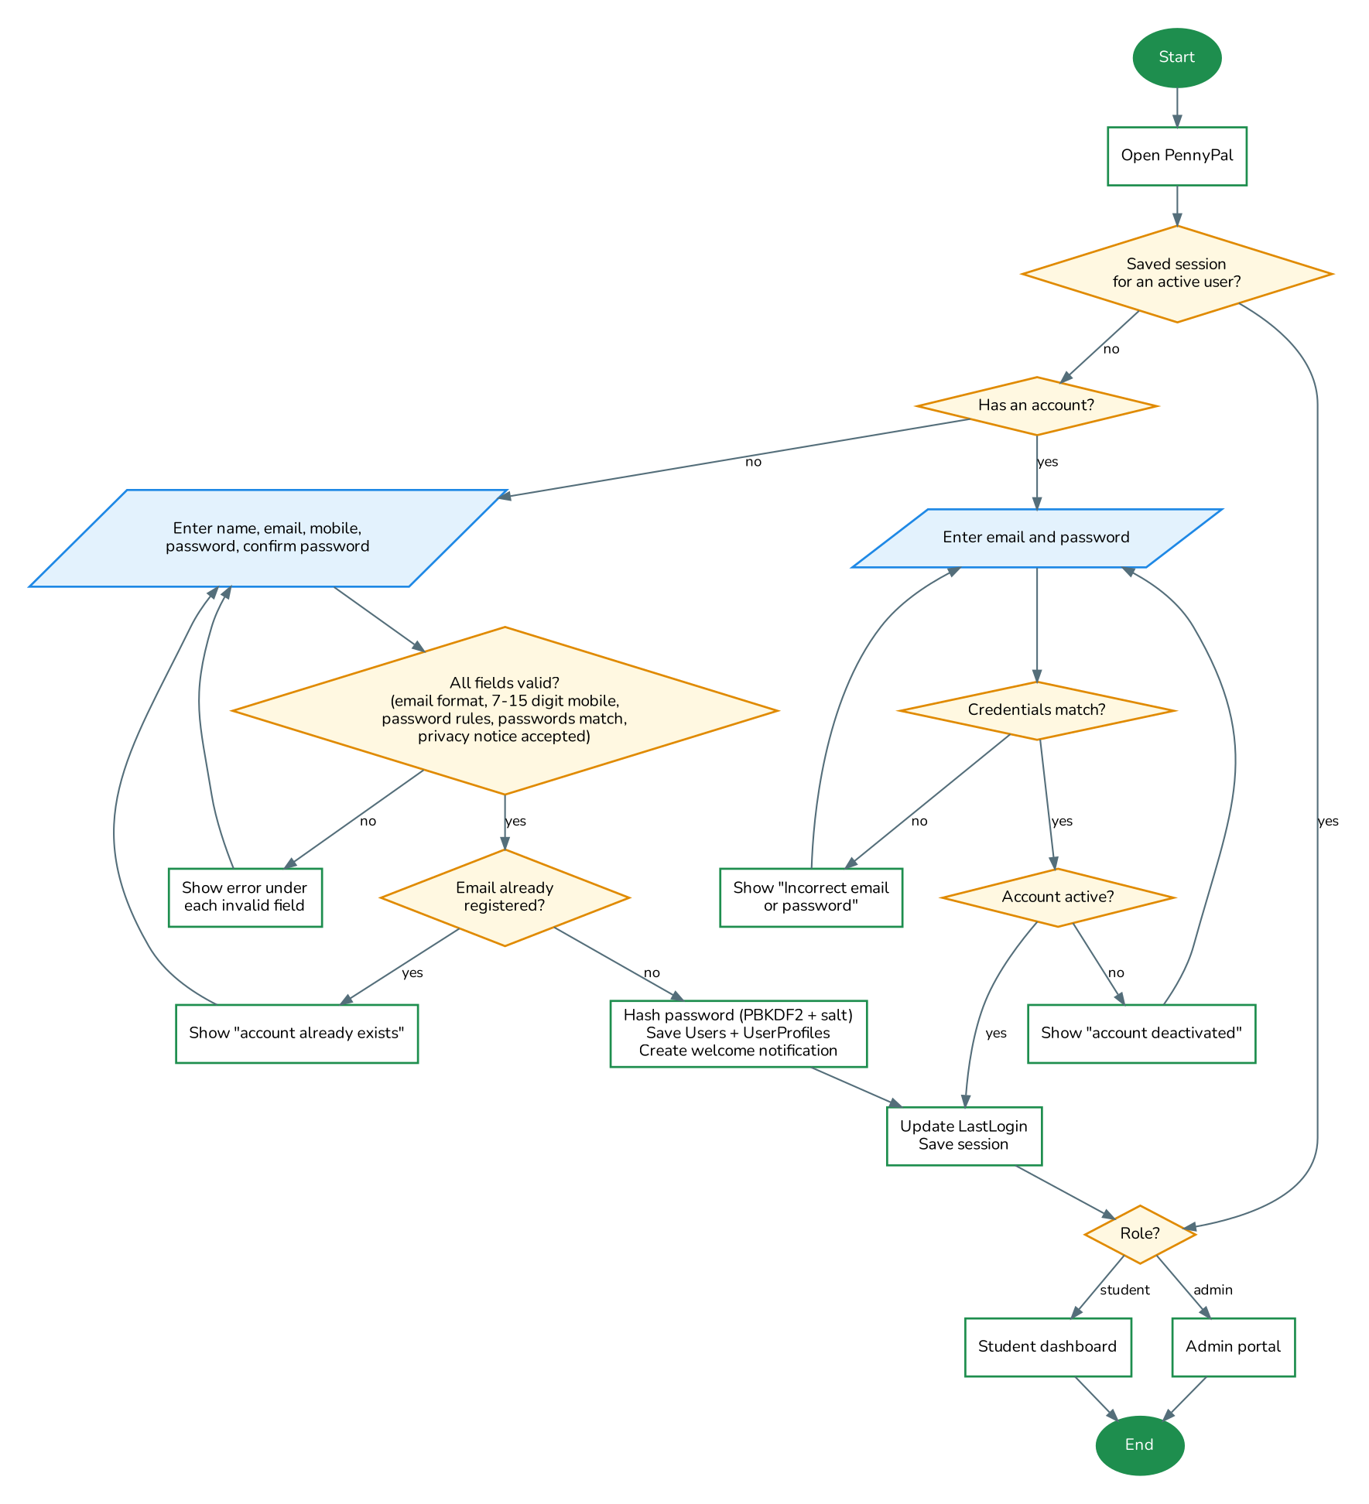
Figure 5: Registration and login flow

3.3.2 Adding an expense with real-time budget alert
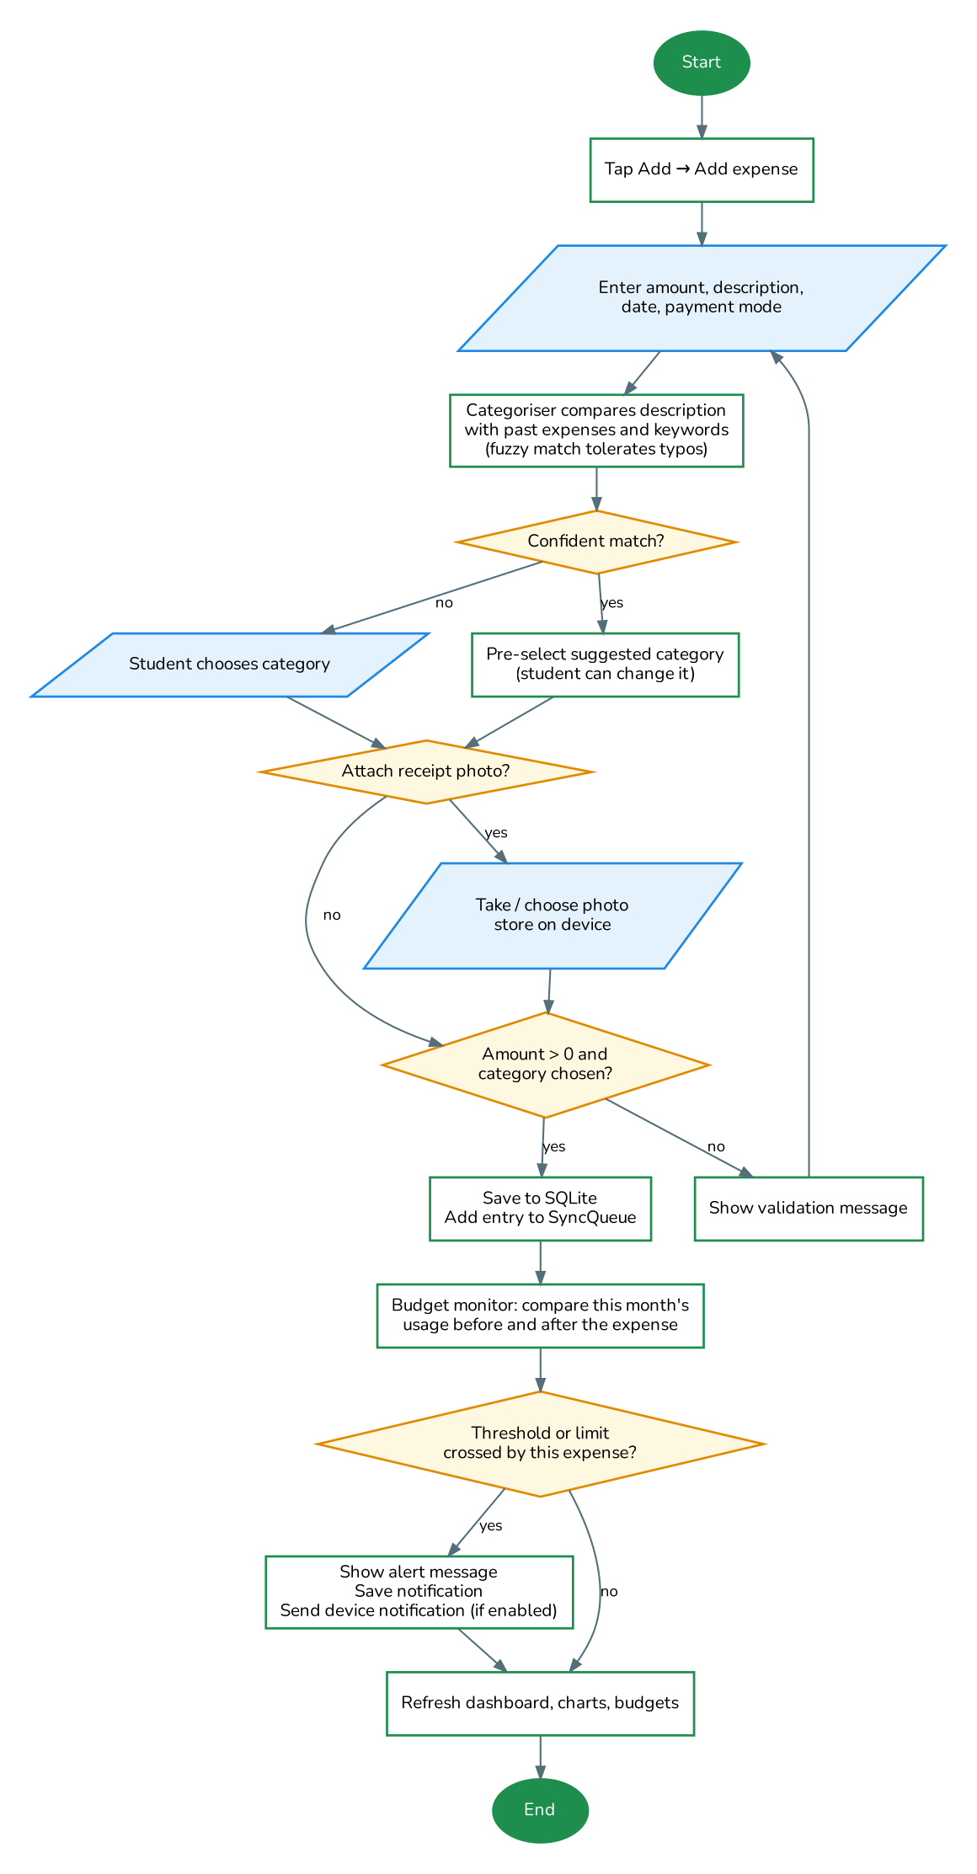
Figure 6: Add expense and budget alert flow

3.3.3 Savings goal contribution
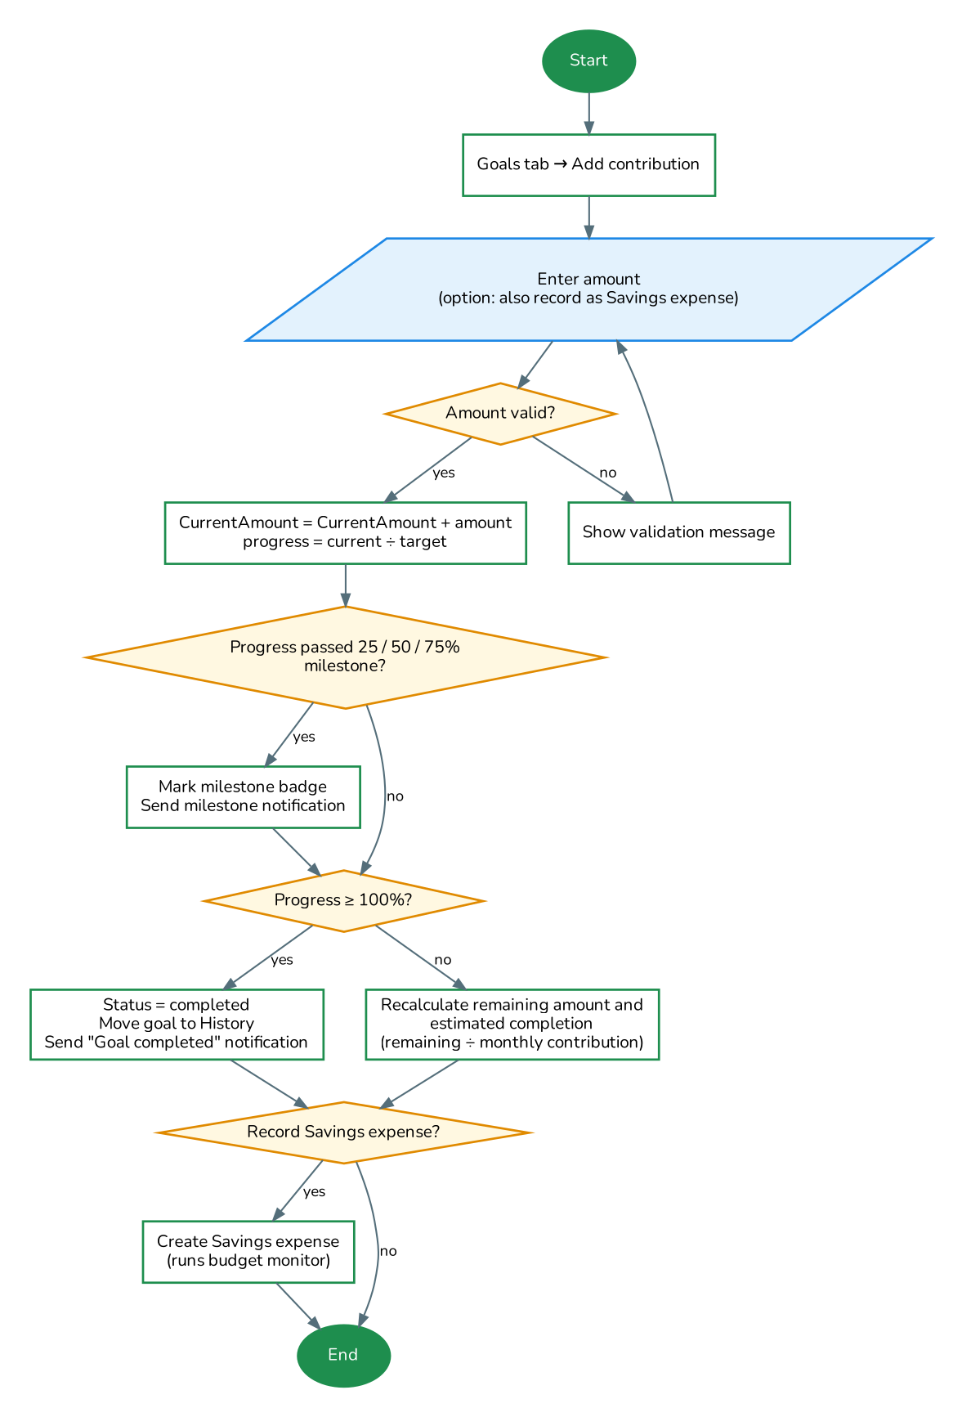
Figure 7: Savings contribution flow

3.3.4 Chatbot question
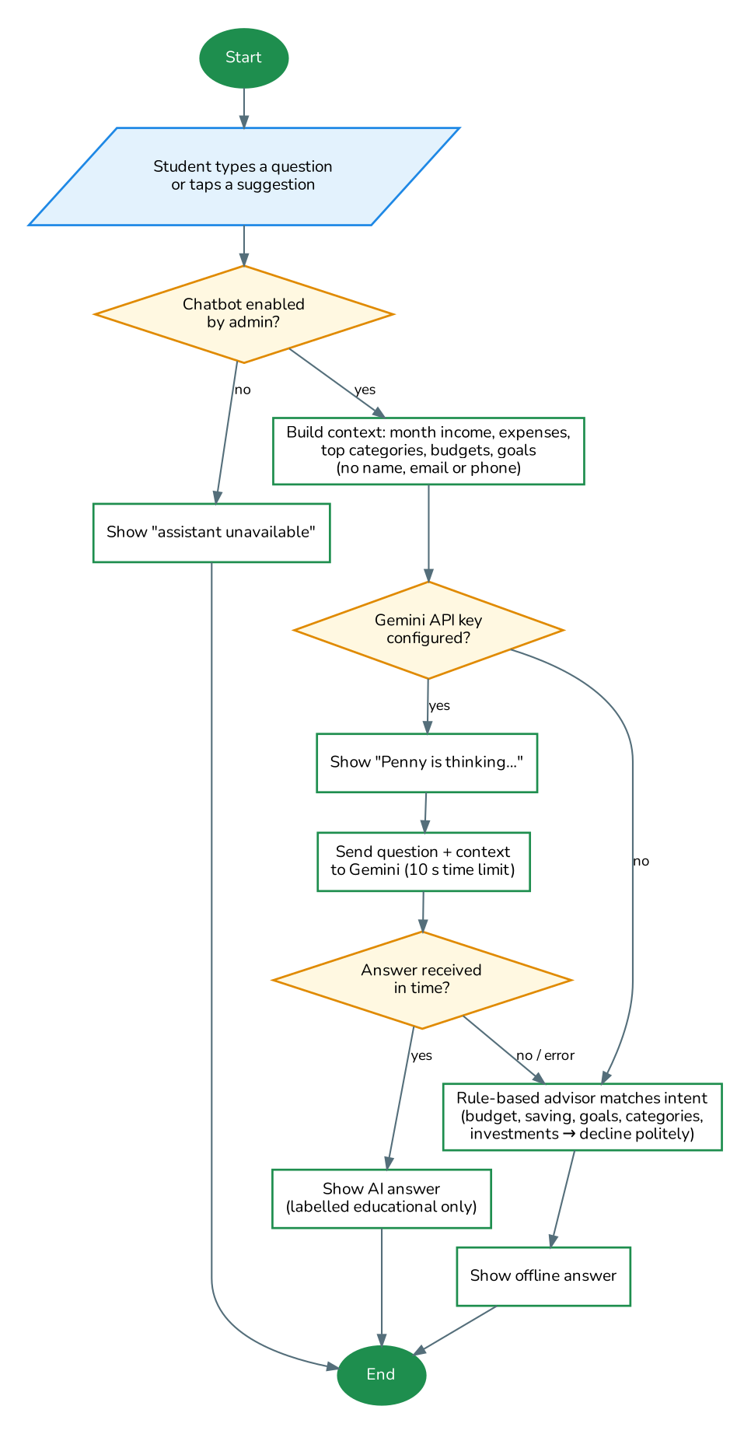
Figure 8: Chatbot flow with offline fallback

3.3.5 Offline synchronisation
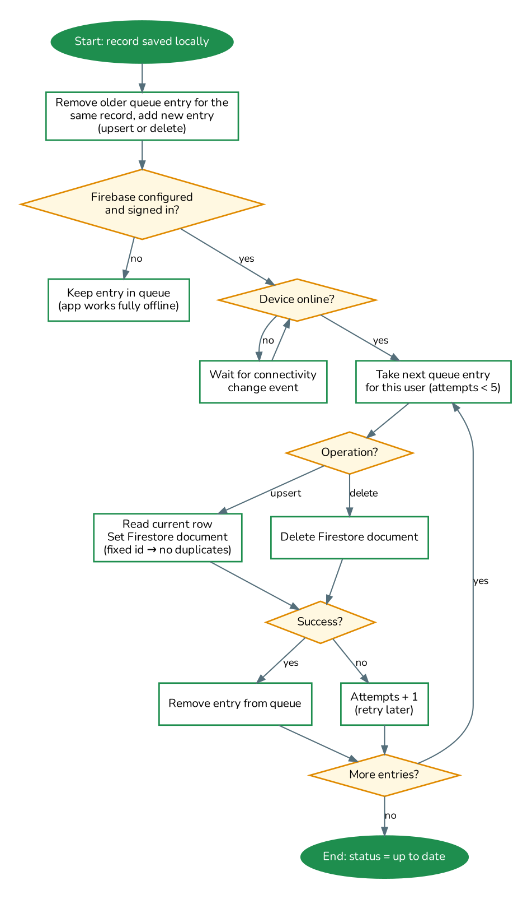
Figure 9: Offline sync flow

3.3.6 Administrator tasks
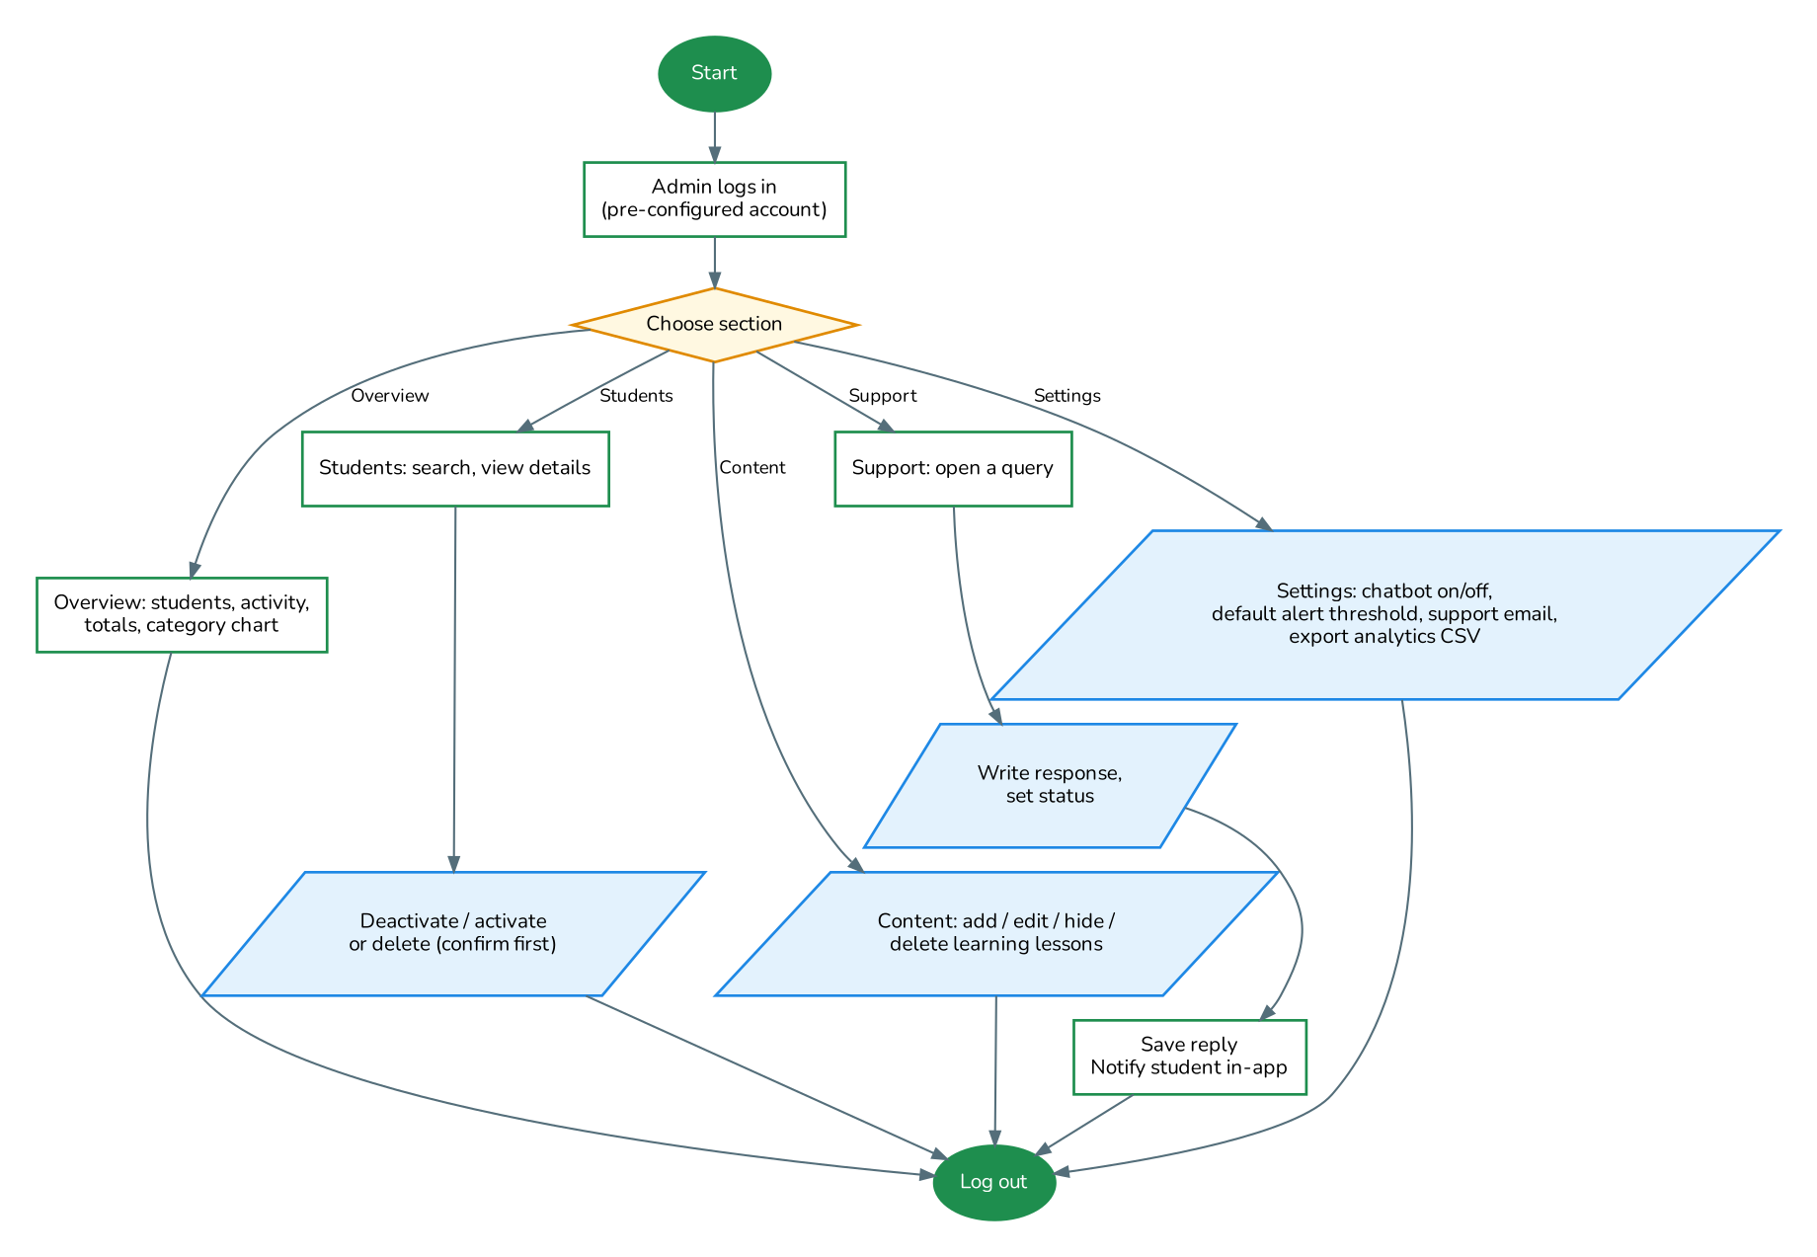
Figure 10: Administrator flow

3.4 Entity Relationship Diagram
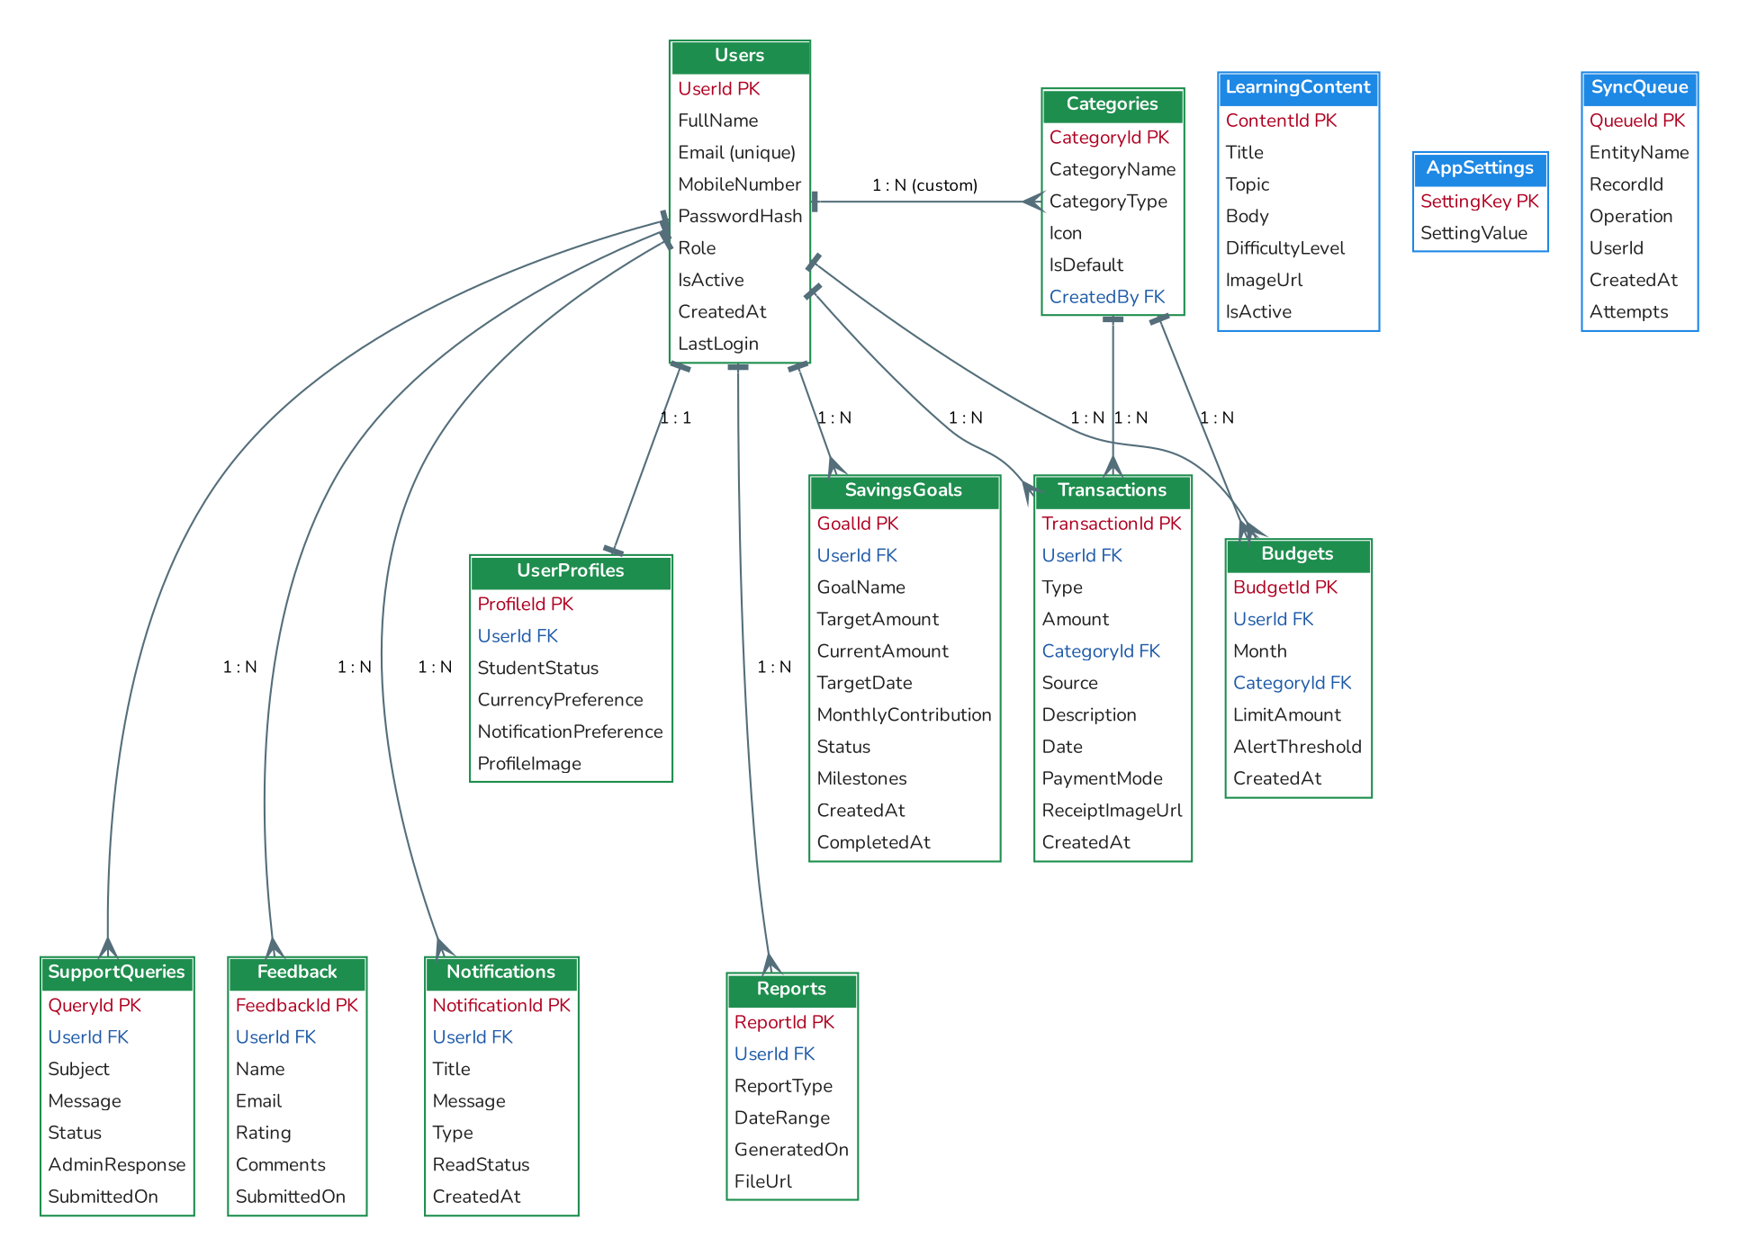
Figure 11: Entity relationship diagram (PK = primary key, FK = foreign key)

4. Database Design

4.1 Overview
- The on-device database is SQLite. It is created on first launch from the same script that is submitted (pennypal_schema.sql), so the documented design and the running app always match.
- Primary keys are text UUIDs, generated on the device, so records created offline on different devices never collide when synced.
- Dates are stored as ISO-8601 text (YYYY-MM-DD for transaction dates, full timestamps elsewhere); months are stored as YYYY-MM.
- Foreign keys are enforced. Deleting a user removes that user's profile, transactions, budgets, goals, reports, notifications and support queries (ON DELETE CASCADE).
- When cloud sync is enabled, the same records are mirrored in Cloud Firestore (see 4.4).

4.2 Table Definitions

Users
One row per account (students and the administrator).
Column | Type | Constraints | Description
UserId | TEXT | PK | UUID of the user
FullName | TEXT | NOT NULL | Name entered at registration
Email | TEXT | NOT NULL, UNIQUE (case-insensitive) | Login ID
MobileNumber | TEXT | NOT NULL | 7–15 digits, optional +
PasswordHash | TEXT | NOT NULL | PBKDF2 hash with salt
Role | TEXT | student | admin | Access level
IsActive | INTEGER | Default 1 | 0 = deactivated by admin
CreatedAt | TEXT | NOT NULL | Registration time
LastLogin | TEXT |  | Last successful login

UserProfiles
Preferences for each user (one-to-one with Users).
Column | Type | Constraints | Description
ProfileId | TEXT | PK | UUID
UserId | TEXT | FK → Users, UNIQUE | Owner
StudentStatus | TEXT |  | e.g. Undergraduate
CurrencyPreference | TEXT | Default USD | Display currency
NotificationPreference | INTEGER | Default 1 | Device notifications on/off
ProfileImage | TEXT |  | Reserved for a profile picture

Categories
Expense categories: 8 defaults plus custom categories created by students.
Column | Type | Constraints | Description
CategoryId | TEXT | PK | e.g. cat-food
CategoryName | TEXT | NOT NULL | Display name
CategoryType | TEXT | expense | income | Kind of category
Icon | TEXT |  | Icon/colour key
IsDefault | INTEGER | Default 0 | 1 for built-in categories
CreatedBy | TEXT | FK → Users | Owner of a custom category

Transactions
Income and expense records.
Column | Type | Constraints | Description
TransactionId | TEXT | PK | UUID
UserId | TEXT | FK → Users | Owner
Type | TEXT | income | expense
Amount | REAL | NOT NULL, > 0 | Amount in the student's currency
CategoryId | TEXT | FK → Categories | Expenses only
Source | TEXT |  | Income only, e.g. Monthly allowance
Description | TEXT |  | Free text (max 120 characters in the app)
Date | TEXT | NOT NULL | YYYY-MM-DD
PaymentMode | TEXT |  | Cash, Card, Bank transfer, Mobile money, ...
ReceiptImageUrl | TEXT |  | File path (mobile) or embedded image (web)
CreatedAt | TEXT | NOT NULL | Entry time

Budgets
Monthly overall budget (CategoryId empty) and category limits. A unique index allows one budget per user, month and category.
Column | Type | Constraints | Description
BudgetId | TEXT | PK | UUID
UserId | TEXT | FK → Users | Owner
Month | TEXT | NOT NULL | YYYY-MM
CategoryId | TEXT | FK → Categories, nullable | Empty = overall monthly budget
LimitAmount | REAL | NOT NULL, > 0 | Budget or limit
AlertThreshold | INTEGER | 1–100, default 80 | Percentage that triggers a warning
CreatedAt | TEXT | NOT NULL

SavingsGoals
Savings goals and their progress.
Column | Type | Constraints | Description
GoalId | TEXT | PK | UUID
UserId | TEXT | FK → Users | Owner
GoalName | TEXT | NOT NULL | e.g. New laptop
TargetAmount | REAL | NOT NULL, > 0
CurrentAmount | REAL | Default 0 | Saved so far
TargetDate | TEXT | NOT NULL | YYYY-MM-DD
MonthlyContribution | REAL | Default 0 | Planned monthly saving
Status | TEXT | active | completed | Completed goals appear in history
Milestones | TEXT |  | Reached percentages, e.g. "25,50"
CreatedAt | TEXT | NOT NULL
CompletedAt | TEXT |  | Completion time

Reports
History of generated/exported reports.
Column | Type | Constraints | Description
ReportId | TEXT | PK | UUID
UserId | TEXT | FK → Users | Owner
ReportType | TEXT | NOT NULL | monthly | custom
DateRange | TEXT | NOT NULL | "from..to"
GeneratedOn | TEXT | NOT NULL
FileUrl | TEXT |  | Exported file name

LearningContent
Lessons shown in the learning hub, managed by the administrator.
Column | Type | Constraints | Description
ContentId | TEXT | PK
Title | TEXT | NOT NULL
Topic | TEXT | NOT NULL | Budgeting, Saving, Income, Expenses, Requirements
Body | TEXT | NOT NULL | Lesson text
DifficultyLevel | TEXT | Default Beginner
ImageUrl | TEXT |  | Illustration key
IsActive | INTEGER | Default 1 | 0 = hidden from students

Notifications
In-app notifications (budget alerts, goal milestones, support replies, welcome message).
Column | Type | Constraints | Description
NotificationId | TEXT | PK
UserId | TEXT | FK → Users | Recipient
Title | TEXT | NOT NULL
Message | TEXT | NOT NULL
Type | TEXT | NOT NULL | budget | goal | system
ReadStatus | INTEGER | Default 0 | 1 = read
CreatedAt | TEXT | NOT NULL

SupportQueries
Contact-support requests and admin replies.
Column | Type | Constraints | Description
QueryId | TEXT | PK
UserId | TEXT | FK → Users | Student
Subject | TEXT | NOT NULL
Message | TEXT | NOT NULL
Status | TEXT | open | in_progress | resolved
AdminResponse | TEXT |  | Reply shown to the student
SubmittedOn | TEXT | NOT NULL

Feedback (added)
Feedback form submissions. Added to the reference design because the Feedback screen stores name, email, rating and comments.
Column | Type | Constraints | Description
FeedbackId | TEXT | PK
UserId | TEXT | FK → Users, nullable | Student who sent it
Name | TEXT | NOT NULL
Email | TEXT | NOT NULL
Rating | INTEGER | 1–5 | Star rating
Comments | TEXT | NOT NULL
SubmittedOn | TEXT | NOT NULL

AppSettings (added)
Key/value settings changed by the administrator (chatbot_enabled, default_alert_threshold, support_email).
Column | Type | Constraints | Description
SettingKey | TEXT | PK | Setting name
SettingValue | TEXT | NOT NULL | Setting value

SyncQueue (added)
Local changes waiting to be uploaded to the cloud.
Column | Type | Constraints | Description
QueueId | INTEGER | PK, auto-increment | Order of changes
EntityName | TEXT | NOT NULL | Table name
RecordId | TEXT | NOT NULL | Changed record
Operation | TEXT | upsert | delete
UserId | TEXT |  | Owner, used to sync only the signed-in user's changes
CreatedAt | TEXT | NOT NULL
Attempts | INTEGER | Default 0 | Failed upload attempts

4.3 Relationships
Table 10: Relationships and integrity rules
Relationship | Type | Rule on delete
Users → UserProfiles | 1 : 1 | Cascade
Users → Transactions, Budgets, SavingsGoals, Reports, Notifications, SupportQueries | 1 : N | Cascade
Users → Feedback | 1 : N | Set null (feedback is kept)
Users → Categories (custom) | 1 : N | Set null
Categories → Transactions | 1 : N | Deleting a custom category moves its expenses to Miscellaneous
Categories → Budgets | 1 : N | Budgets for a deleted custom category are removed

4.4 Cloud Firestore Structure (optional)
- students/{UserId}/{TableName}/{RecordId} – each student's records, with an ownerUid field linking them to the Firebase account.
- LearningContent/{ContentId} and AppSettings/{SettingKey} – shared content, readable by signed-in users and writable only by the administrator.
- Security rules are provided in firestore.rules.

4.5 SQL Scripts Submitted
Table 11: Database scripts
File | Contents
database/pennypal_schema.sql | CREATE TABLE and index statements for all 13 tables.
database/pennypal_seed_data.sql | INSERT statements for the seed and test data (admin account, demo student, categories, 38 transactions, budgets, goals, lessons, settings, sample support query, feedback and notification).

5. Test Data and Testing

5.1 Test Data
On first launch the app loads the following data. The same data is provided in pennypal_seed_data.sql. Demo transactions are dated relative to the current month so the dashboard always has data; the figures below are for the current month at the time of testing (September 2026).
Table 12: Seed and test data
Data set | Records
Accounts | Administrator (admin@pennypal.app) and demo student Ada Student (student@pennypal.app, Undergraduate, USD)
Categories | Food, Transport, Education, Shopping, Entertainment, Bills, Savings, Miscellaneous
Transactions | 38 records over three months: 11 expenses per month plus a monthly allowance of $500.00 and part-time tutoring income of $180.00 (in two of the three months)
Budgets (current month) | Overall $450.00; Food $100.00; Entertainment $30.00; Shopping $60.00 (all alert at 80%)
Savings goals | New laptop $320.00 of $900.00 ($75.00/month); Emergency fund $150.00 of $500.00 ($50.00/month); Concert ticket $120.00 of $120.00 (completed)
Learning content | 9 lessons across Budgeting, Saving, Income, Expenses and Requirements
Engagement | 1 resolved support query, 1 five-star feedback, 1 welcome notification
App settings | Chatbot enabled; default alert threshold 80%; support email support@pennypal.app

Table 13: Monthly demo transactions (amounts shown as current / last / two months ago where they differ)
Day | Description | Category | Payment | Amount
1 | Monthly allowance | Income | Bank transfer | +500.00
2 | Groceries at supermarket | Food | Card | 42.50
3 | Monthly bus pass | Transport | Card | 25.00
5 | Netflix subscription | Entertainment | Card | 12.99
7 | Pizza with friends | Food | Cash | 18.40
9 | Phone data plan | Bills | Mobile money | 35.00
11 | Textbooks and printing | Education | Card | 60.00 / 75.00 / 90.00
13 | Cafeteria lunches | Food | Cash | 22.75
15 | Part-time tutoring | Income | Bank transfer | +180.00
16 | New t-shirt | Shopping | Card | 45.00 / 40.00 / 35.00
20 | Transfer to savings | Savings | Cash | 50.00
22 | Uber ride home | Transport | Card | 9.50
25 | Cinema tickets | Entertainment | Cash | 15.00

Expected current-month totals with this data: income $680.00, expenses $336.14, overall budget 75% used ($113.86 left), Entertainment 93% used and Food 84% used (both above the 80% alert threshold).

5.2 Test Cases
The test cases below were run on the web build of the app (phone and desktop screen sizes) and through the automated tests. Items that depend on phone hardware are marked for verification on a physical device.
Table 14: Test cases
ID | Module | Test / input | Expected result | Result
TC01 | Login | Demo student: student@pennypal.app / Student@123 | Student dashboard opens | Pass
TC02 | Login | admin@pennypal.app / wrong password | "Incorrect email or password." | Pass
TC03 | Login | Admin: admin@pennypal.app / Admin@123 | Admin portal opens | Pass
TC04 | Register | Name "A", email "not-an-email", mobile "12", empty password | Error under each field: name too short, invalid email, 7–15 digits, password required | Pass
TC05 | Register | Password "alllowercase1!" | Message asks for an upper-case letter | Pass
TC06 | Register | Valid details with an email that already exists (different case) | "An account with this email already exists." | Pass
TC07 | Register | Grace Hopper, grace@uni.edu, +1 555 010 0300, Compiler#1 | Account created, mobile saved as +15550100300, welcome notification | Pass
TC08 | Login | Student deactivated by admin tries to log in | "This account has been deactivated..." | Pass
TC09 | Dashboard | Log in as demo student | Income $1,860.00 total ($680.00 this month), expenses $1,038.42 ($336.14), balance $821.58, budget 75% used | Pass
TC10 | Dashboard | Register Grace Hopper (grace@uni.edu, +15550100300, Compiler#1) and open the dashboard | All totals $0.00, budget "Not set", "No budget for this month" and "No expenses this month" messages, "Start tracking" tip | Pass
TC11 | Expense | Amount 20, description "piza with friends" | Smart category suggests Food (similar to "Pizza with friends") | Pass
TC12 | Budget alert | Save TC11 expense (Food at $83.65 of $100) | "Budget exceeded ... Food budget ... by $3.65" message and notification | Pass
TC13 | Budget alert | Food at $70 of $100, add $15 | One "Approaching your limit" alert; a further $5 expense gives no repeat alert | Pass
TC14 | Expense | Amount 0 or "abc" | "Amount must be greater than zero" / "Enter a number" | Pass
TC15 | Expense | Edit "Uber ride home" from 9.50 to 12; then delete it and confirm | "Changes saved" and amount shows −$12.00; after delete the record disappears and totals update | Pass
TC16 | History | Search "uber" | 3 results, total −$28.50 | Pass
TC17 | Budget | Save Transport limit twice for the same month | Second save updates the first (no duplicate) | Pass
TC18 | Budget | Open next month (no budget) → Copy last month | "Copied 4 budget(s) from last month"; overall $450 and 3 category limits at $0.00 used | Pass
TC19 | Goals | Contribute remaining $350.00 to Emergency fund | Milestones 50/75/100% reached, goal completed and moved to History | Pass
TC20 | Goals | Goal $1,000, saved $400, $100/month | Remaining $600, 40%, 6 months to go | Pass
TC21 | Categories | Add custom "Gym", add expense, delete "Gym" | Expense moves to Miscellaneous | Pass
TC22 | Reports | This month | Income $680.00, expenses $336.14, net $343.86, donut chart and 6-month bars | Pass
TC23 | Reports | Export CSV | CSV file shared/downloaded and listed under Generated reports | Verify on device
TC24 | Chatbot | "How am I doing this month?" (no API key) | Offline answer with income, spending and budget usage | Pass
TC25 | Chatbot | "Should I buy bitcoin?" | Polite refusal recommending a qualified adviser | Pass
TC26 | Chatbot | With a Gemini key | AI answer labelled "AI-generated · educational only" within 10 s | Verify on device
TC27 | Support | Submit subject + message; admin replies "Use Reports > Export." | Student sees reply and a "Support replied" notification | Pass
TC28 | Feedback | Comment "Budget alerts are really helpful." without a rating, then with 4 stars | "Please choose a rating"; then "Thank you!" confirmation dialog | Pass
TC29 | Admin | Delete demo student (confirm) | Student and all their records removed | Pass
TC30 | Admin | Hide "The 50/30/20 rule", log out, log in as the student, open Learning hub | Lesson marked hidden in admin list and not shown to the student | Pass
TC31 | Logout | More → Log out → confirm; log in as admin | Returns to login; admin portal opens with no student data | Pass
TC32 | Offline | Edit the same record three times offline | Only one queue entry kept for that record | Pass
TC33 | Receipt | Attach photo with the camera on an Android phone | Photo shown on the form and in transaction details | Verify on device
TC34 | Notifications | Cross a budget threshold on an Android phone | System notification appears | Verify on device
TC35 | Layout | Open on a 1280 px wide screen | Navigation rail and 4-column summary tiles | Pass

5.3 Automated Tests
The project includes 33 automated tests that run on every push (GitHub Actions) together with static analysis. They use an in-memory copy of the real database schema.
Table 15: Automated test coverage
Group | What is checked
Validators | Email, password rules, mobile number, amount parsing
Password hashing | Correct password accepted, wrong password rejected, random salt
Categoriser | Keyword match, typo tolerance, learning from history, no suggestion for gibberish
Analytics | Monthly totals, category totals, overall and category budget usage
Budget monitor | Single alert on crossing threshold, alert on exceeding limit, other categories ignored
Savings goals | Remaining, progress, months to go, behind-schedule logic; contributions complete goals
Offline advisor | Answers with student figures, declines investment questions
Database | Seeded accounts, registration and duplicates, deactivation, unique budgets, sync-queue de-duplication, category deletion, admin statistics, support replies, cascade delete

6. Project Installation Instructions

6.1 Prerequisites
- Flutter SDK 3.27.4 with Dart 3.6 (https://docs.flutter.dev/get-started/install)
- Android Studio with Android SDK API 35, an Android emulator or an Android phone running Android 6.0 or later
- JDK 17
- For iOS: a Mac with Xcode 15 or later and CocoaPods
- Development PC: Intel Core i5/i7 or equivalent, 8 GB RAM or more, internet connection for the first build

6.2 Install the APK on an Android phone
- Copy PennyPal.apk (from the submission, or from the "PennyPal-apk" artifact of the GitHub Actions build) to the phone.
- Open the file on the phone. If asked, allow installing apps from this source.
- Tap Install, then Open. The app creates its database and demo data on first launch.
- Log in with one of the accounts in section 7.

6.3 Run from the source code
- Unzip the source code (or clone the repository) and open the folder in Android Studio or VS Code.
- In a terminal in the project folder run: flutter pub get
- Start an emulator or connect a phone with USB debugging enabled, then run: flutter run
- To run in a browser: flutter run -d chrome
- To build the APK: flutter build apk --release (output: build/app/outputs/flutter-apk/app-release.apk)
- To build the web version: flutter build web --release --no-web-resources-cdn (output: build/web)

6.4 Optional: enable the Gemini chatbot
- Create an API key in Google AI Studio (https://aistudio.google.com/app/apikey).
- Run or build with the key, for example: flutter run --dart-define=GEMINI_API_KEY=<your key>
- Without a key the chatbot uses its built-in offline answers.

6.5 Optional: enable Firebase cloud sync
- Create a Firebase project; enable Email/Password sign-in and Cloud Firestore.
- Add a Web app in the Firebase console and note its API key, App ID, Project ID and Sender ID.
- Publish the security rules from firestore.rules (Firebase console → Firestore → Rules, or firebase deploy --only firestore:rules).
- Build with --dart-define=FIREBASE_API_KEY=..., FIREBASE_APP_ID=..., FIREBASE_PROJECT_ID=... and FIREBASE_SENDER_ID=...

6.6 Load the database scripts (optional)
The app creates its database automatically. To inspect the design separately, open a terminal in the database folder and run the two scripts with the SQLite command-line tool: first pennypal_schema.sql, then pennypal_seed_data.sql, for example: sqlite3 pennypal.db < pennypal_schema.sql, followed by sqlite3 pennypal.db < pennypal_seed_data.sql

7. User Credentials
Table 16: Login credentials
Role | Login ID (email) | Password | Notes
Administrator | admin@pennypal.app | Admin@123 | Pre-configured; cannot be created by registration
Student (demo) | student@pennypal.app | Student@123 | Has three months of sample data

New student accounts can be created from the login screen using "Create an account". The login screen also has "Student" and "Administrator" buttons that fill in the demo credentials.

8. Assumptions
- Each device keeps its own local database. Without Firebase, the admin portal manages the accounts and data stored on that device; with Firebase, data is also backed up to the cloud.
- Each student uses one currency, chosen in Profile & settings. There is no currency conversion.
- Available balance = all income recorded − all expenses recorded. Savings contributions can optionally be recorded as a Savings expense.
- Budgets are per calendar month: one overall budget and at most one limit per category per month.
- New budgets start with the administrator's default alert threshold (80%), which the student can change per budget.
- A goal is completed when the saved amount reaches the target; it re-opens if the target is later increased.
- Receipt photos stay on the device (embedded in the record on the web) and are not uploaded to the cloud.
- Feedback, AppSettings and SyncQueue tables were added to the reference database design to support the Feedback screen, admin settings and offline sync.
- The administrator account is pre-configured and cannot be registered through the app.

9. Acknowledgements

9.1 Third-party libraries and resources
Table 17: Libraries and resources
Resource | Used for
Flutter and Dart (Google) | Cross-platform framework
provider | State management
sqflite, sqflite_common_ffi_web | SQLite on mobile and web
fl_chart | Charts
intl | Currency and date formatting
http | Gemini API calls
crypto | Password hashing
uuid | Record IDs
string_similarity | Smart categorisation
image_picker | Receipt photos
share_plus | CSV export
connectivity_plus | Online/offline detection
path_provider, shared_preferences | File locations and saved session
flutter_local_notifications | Device notifications
firebase_core, firebase_auth, cloud_firestore | Optional cloud sync
Google Gemini API / Google AI Studio | Chatbot answers (when configured)
Nunito font (SIL Open Font License) | App typography
Graphviz | Diagrams in this document

9.2 AI tools used
Claude Code (Anthropic) was used as an AI coding assistant during development and to help prepare this documentation. No AI-generated images are used in the app; the app icon is drawn by a script in the project (tool/generate_icons.py).

Appendix A. Screenshots

A.1 Student app
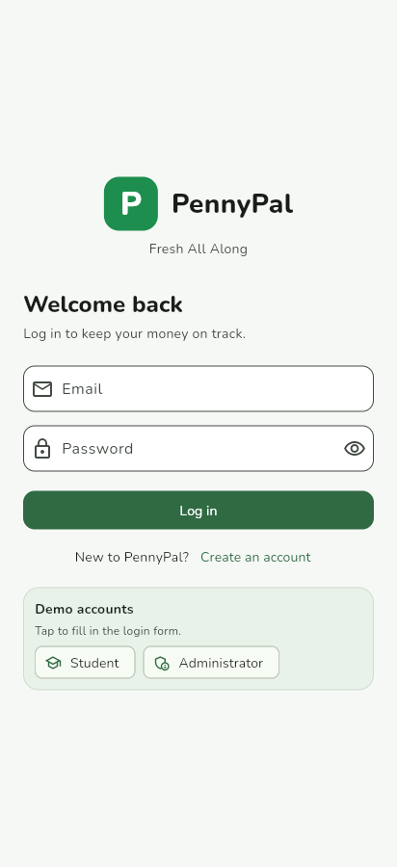  Figure 12: Login | 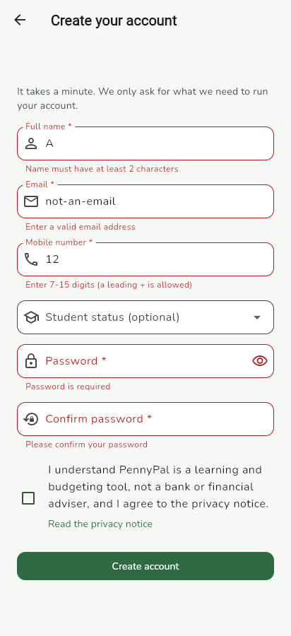  Figure 13: Registration validation | 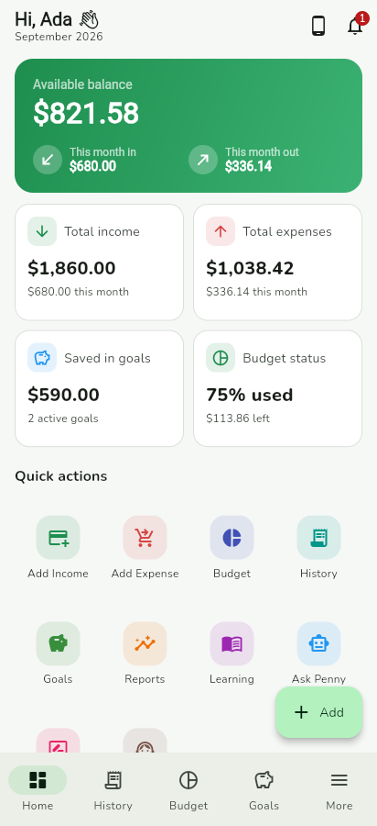  Figure 14: Dashboard
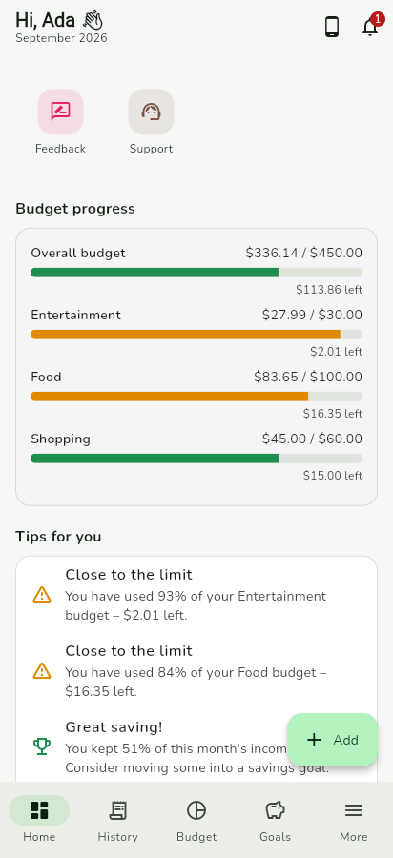  Figure 15: Budget progress and tips | 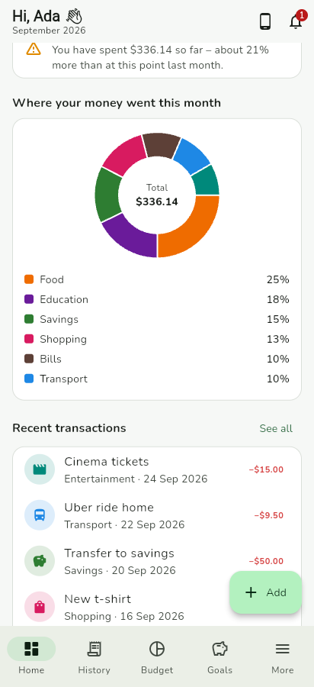  Figure 16: Spending chart | 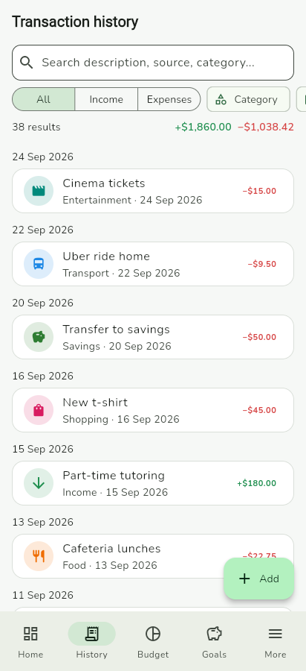  Figure 17: Transaction history
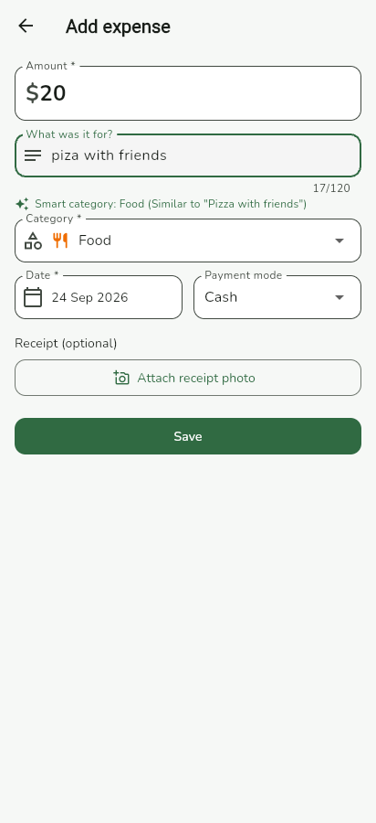  Figure 18: Add expense with smart category | 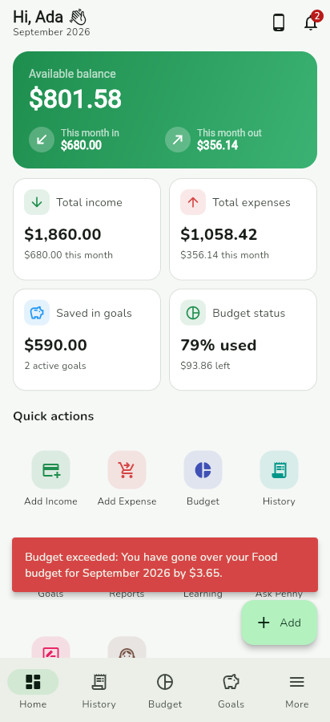  Figure 19: Real-time budget alert | 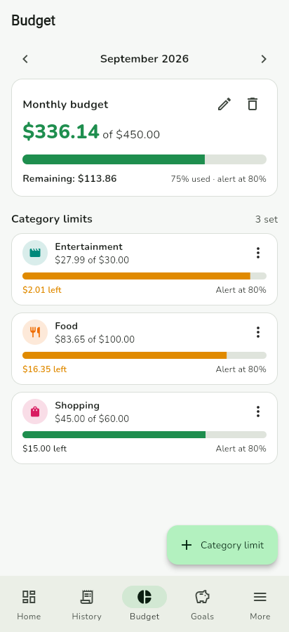  Figure 20: Budget
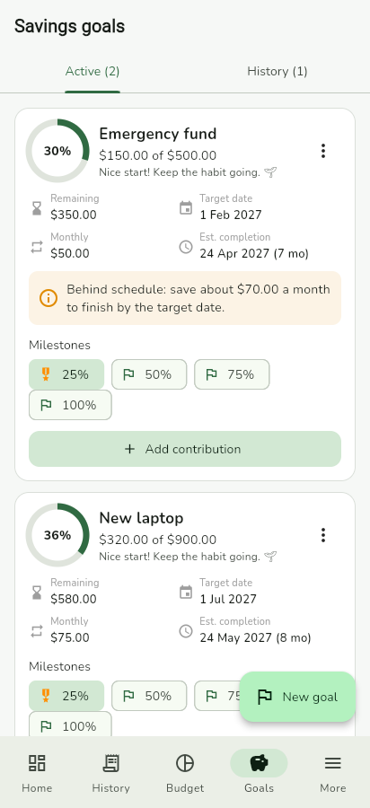  Figure 21: Savings goals | 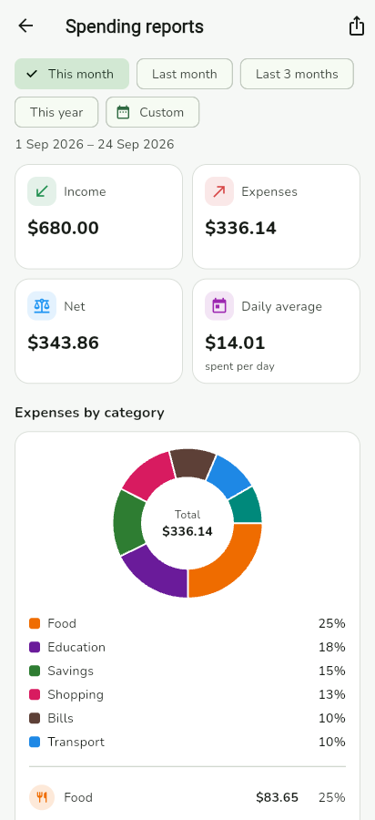  Figure 22: Spending report | 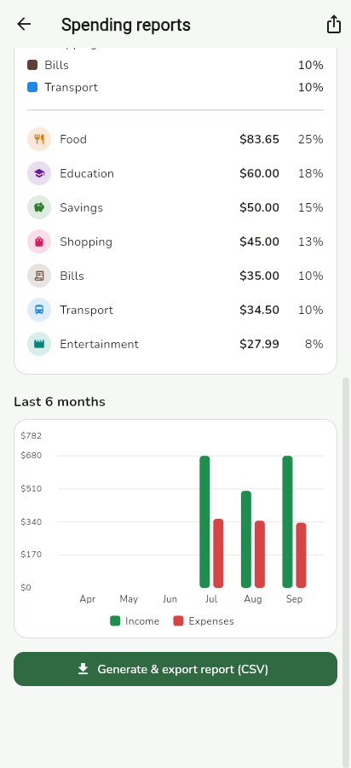  Figure 23: Category breakdown and trend
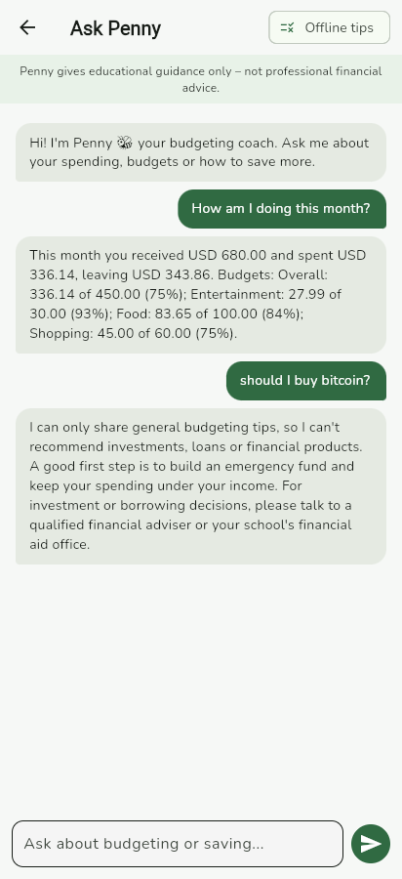  Figure 24: Ask Penny chatbot | 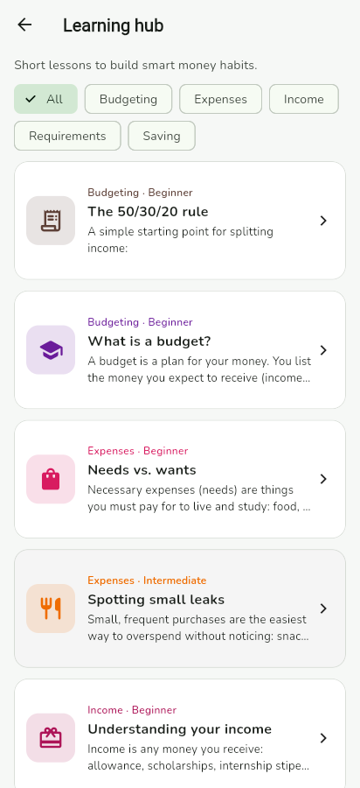  Figure 25: Learning hub | 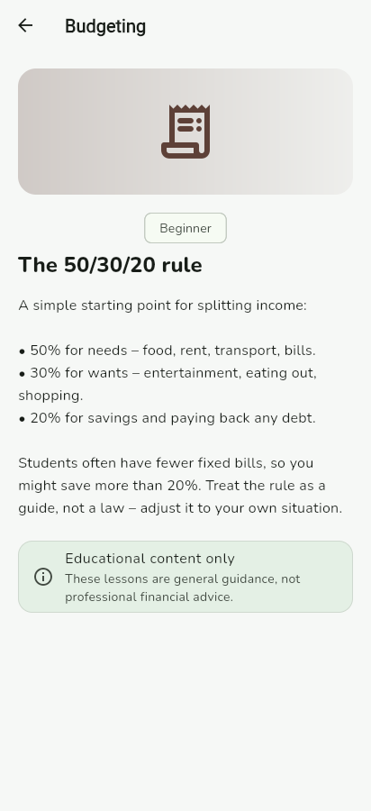  Figure 26: Lesson
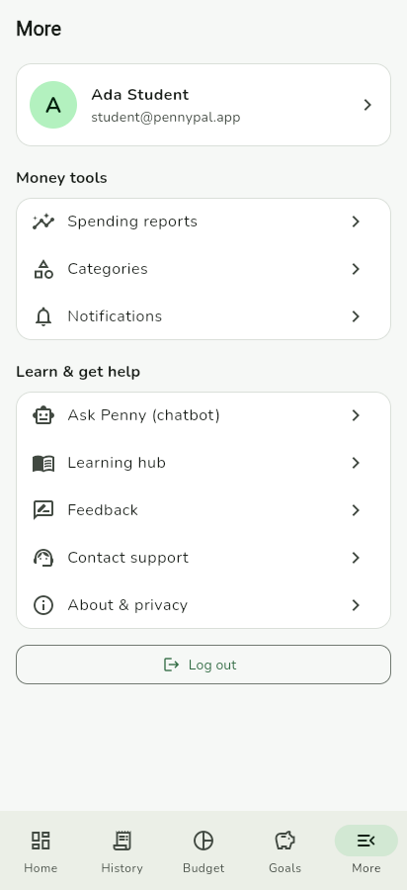
Figure 27: More menu

A.2 Admin portal
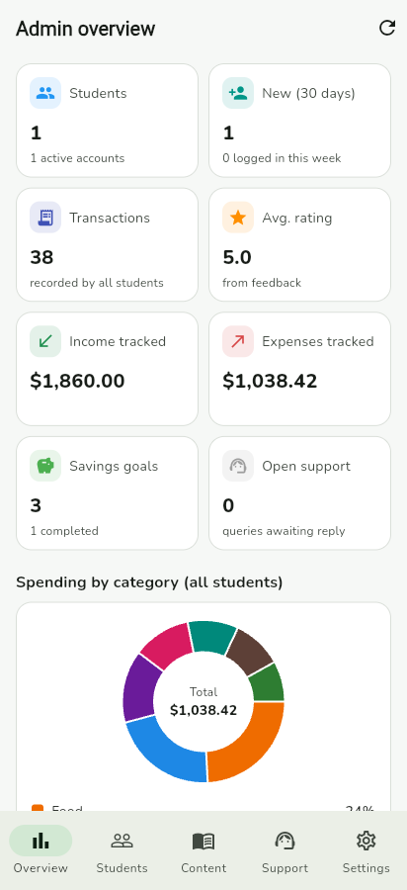  Figure 28: Admin overview | 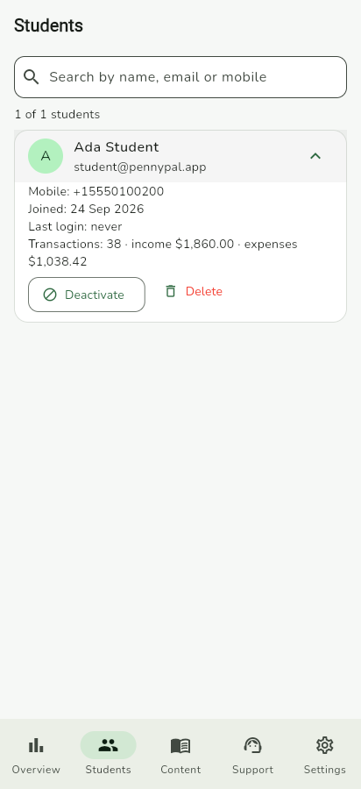  Figure 29: Student management | 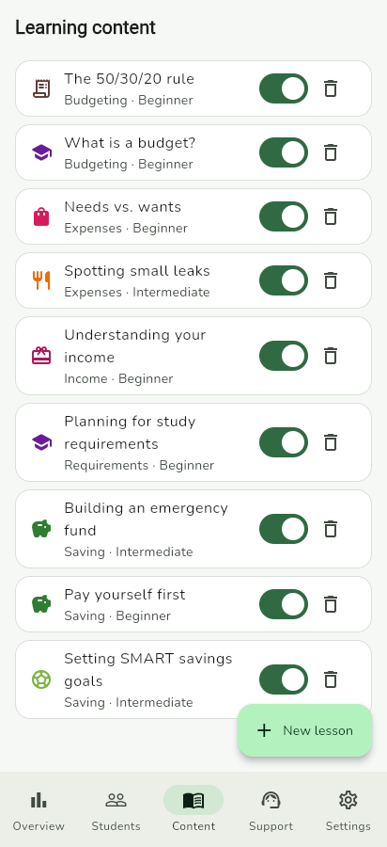  Figure 30: Learning content
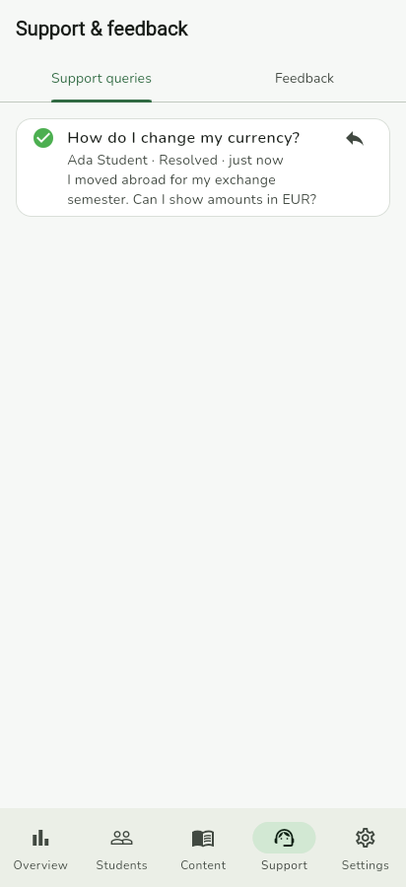  Figure 31: Support queries | 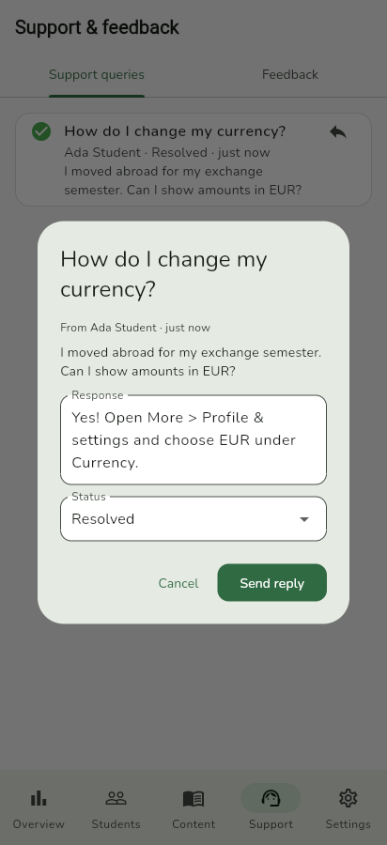  Figure 32: Replying to a query

A.3 Tablet / web layout
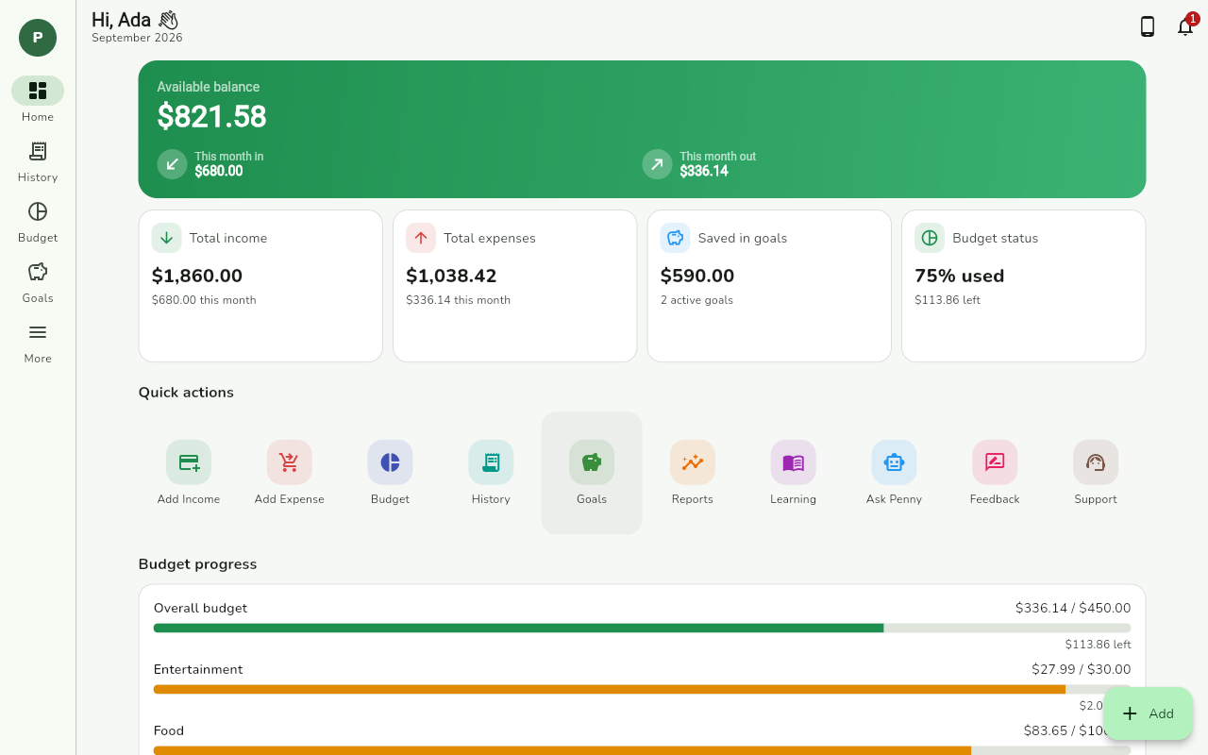
Figure 33: Dashboard on a wide screen with navigation rail

