Instruction Manual

**MODEL VNA1-40MC**

**Vector Network Analyzer Booster Pack**

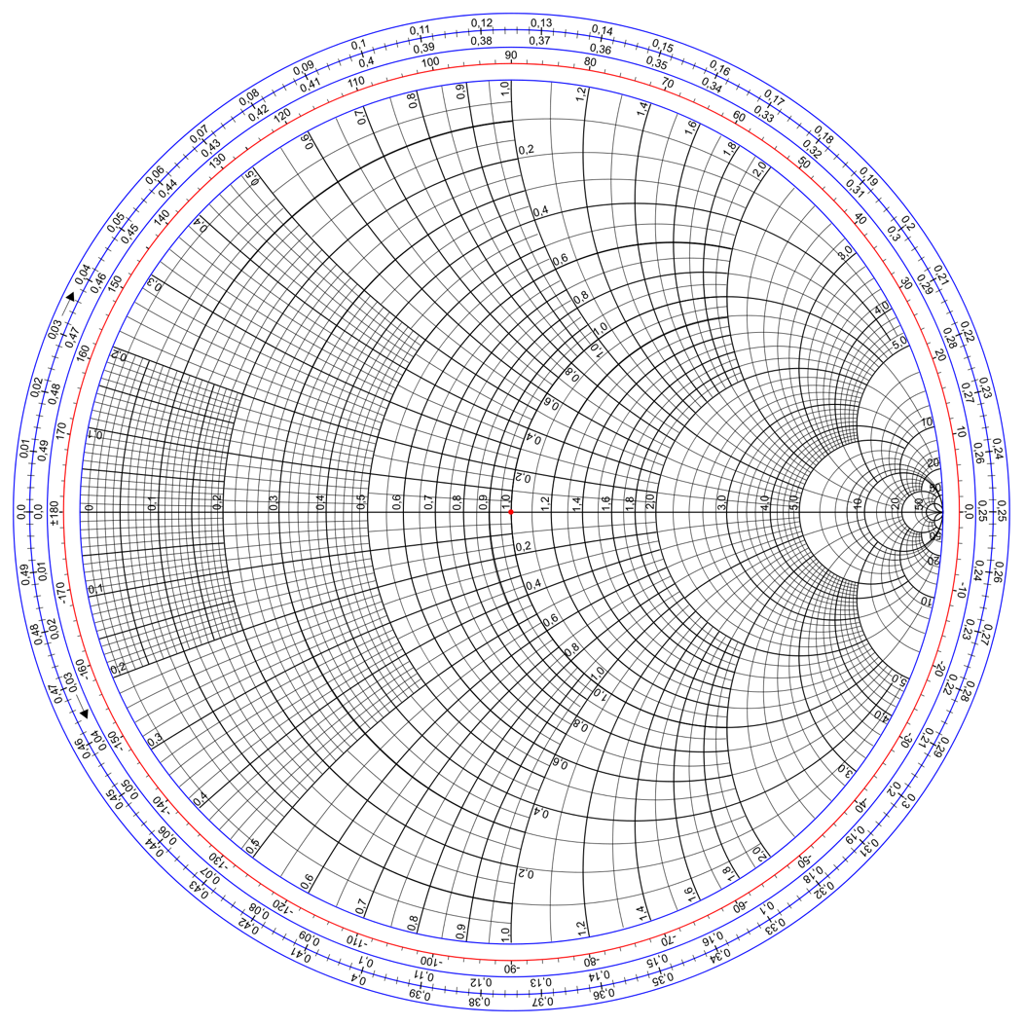

**GAZI-TEK**

**Jeremy Gaines and  
 Nathan Zimmerly**

**NO WARRANTY**

THE HARDWARE AND SOFTWARE IS DISTRIBUTED IN THE HOPE THAT IT WILL BE USEFUL, BUT WITHOUT ANY WARRANTY. IT IS PROVIDED "AS IS" WITHOUT WARRANTY OF ANY KIND, EITHER EXPRESSED OR IMPLIED, INCLUDING, BUT NOT LIMITED TO, THE IMPLIED WARRANTIES OF MERCHANTABILITY AND FITNESS FOR A PARTICULAR PURPOSE. THE ENTIRE RISK AS TO THE QUALITY AND PERFORMANCE OF THE PROGRAM IS WITH YOU. SHOULD THE PROGRAM PROVE DEFECTIVE, YOU ASSUME THE COST OF ALL NECESSARY SERVICING, REPAIR OR CORRECTION.

IN NO EVENT UNLESS REQUIRED BY APPLICABLE LAW THE AUTHOR WILL BE LIABLE TO YOU FOR DAMAGES, INCLUDING ANY GENERAL, SPECIAL, INCIDENTAL OR CONSEQUENTIAL DAMAGES ARISING OUT OF THE USE OR INABILITY TO USE THE PROGRAM (INCLUDING BUT NOT LIMITED TO LOSS OF DATA OR DATA BEING RENDERED INACCURATE OR LOSSES SUSTAINED BY YOU OR THIRD PARTIES OR A FAILURE OF THE PROGRAM TO OPERATE WITH ANY OTHER PROGRAMS), EVEN IF THE AUTHOR HAS BEEN ADVISED OF THE POSSIBILITY OF SUCH DAMAGES (“Open-Source Software License Agreement,” N.D.).

Table of Contents

Table of Contents 2

Section 1 General Description 3

1.1 The VNA1-40MC Booster Pack 3

1.1 Specifications 3

Section 2 Circuit Schematic and Description 4

2.1 Schematic Overview 4

2.2 Block Diagram 5

2.4 Schematic 7

3 Component Specifications 8

Mux 8

High Frequency Op-Amp 8

D-flipflops 8

PLL 8

DDS Module 8

Low Frequency Op-Amps 8

Future Work 8

# Section 1 General Description

## 1.1 The VNA1-40MC Booster Pack

The GAZI-TEK VNA1-40MC is a 40-pin VNA booster pack designed for the TI MSP series LaunchPads (currently only the MSP432P401R). Its primary function is calculating s-parameters of electrical networks and characterizing two-port networks. This provides users with cost-effective prototyping solutions and troubleshooting for a variety of signal applications. The VNA BoosterPack must be paired with an additional DDS BoosterPack for proper operation.

## Specifications

**Power**

Power is provided via the MSP series LaunchPads.

**Operating Frequencies**

The VNA1-40MC can measure networks ranging from 1-40 MHz. This is a theoretical range, it will be updated once we test it.

**Output**

The BoosterPack outputs a Smith chart of the device under test (DUT) via the GUI linked below under “Supported LaunchPads and Software.”

**Supported LaunchPads and Software**

The VNA1-40MC supported by the MSP series LaunchPads, specifically the MSP432P401R. Download [Code Composer Studio](http://www.ti.com/tool/ccstudio) (CCS) along with the MSP libraries in the CCS app store in order to use the software (“Code Composer Studio (CCS) Integrated Development Environment (IDE),” 2016). The corresponding VNA GUI for this BoosterPack is provided in the following GitHub repository: <https://github.com/frohro/qvna/tree/serial>

**Connecting the Boosterpack:**

The Boosterpack should be placed on the MSP432P401R with the BNC connectors facing away from the micro-USB port on the MSP432P401R as shown in Figure 1.

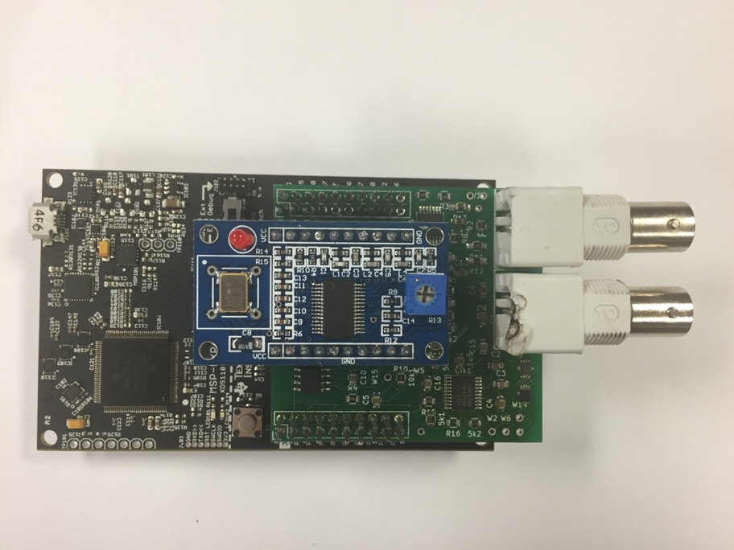

Figure 1

# Section 2 Circuit Schematic and Description

## 2.1 Schematic Overview

Figure 6 shows the components used in designing the VNA. The design follows direct conversion approach using a Tayloe mixer to measure the magnitude and phase of the single frequency responses of the device under test (DUT) (Tayloe, N.D.). The Direct digital synthesizer (DDS) module drives a sinusoidal and square wave at a specified frequency. The square wave goes into the phase-locked loop (PLL) IC that multiplies the frequency by four. This goes into the high-frequency flip-flops which provide the two clock signals (90 degrees out of phase) used for the Tayloe mixer. The two waveforms are then turned into DC signals proportional to the real and imaginary parts of the reflected and transmitted waves.

The DDS sinusoidal wave is first sent into a Wheatstone bridge, where the DUT is connected ("Bridge Circuits," N.D.). The reflected wave bounces off the DUT and is then measured using a differential amplifier. The output is then sent to the Tayloe mixer. The transmitted wave is measured after going through the DUT and is sent to the Tayloe mixer as well. The mixer takes both reflected and transmitted waves and samples them at 4x their frequency all 90° apart. Then it differentially amplifies the 0° and 180° together and also the 90° and the 270° together for each signal. These four values are then output directly into the MSP432P401R Launchpad.

## 2.2 Block Diagram

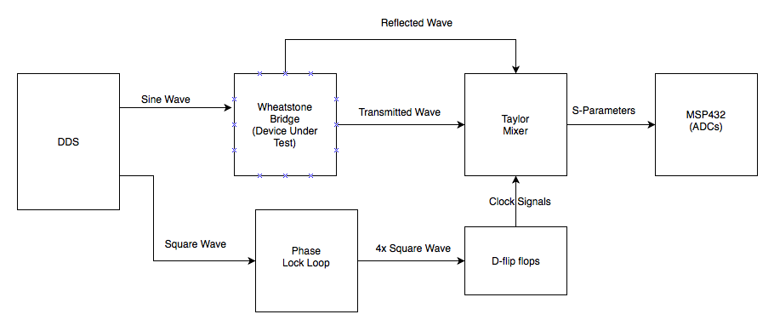

Figure 2

2.3 Printed Circuit Board (PCB)

BNC for DUT

(Tayloe Mixer)

Flip-Flops

PLL

High Frequency Op-Amp

Low Frequency Op-Ampss

DDS Pins

BNC for DUT

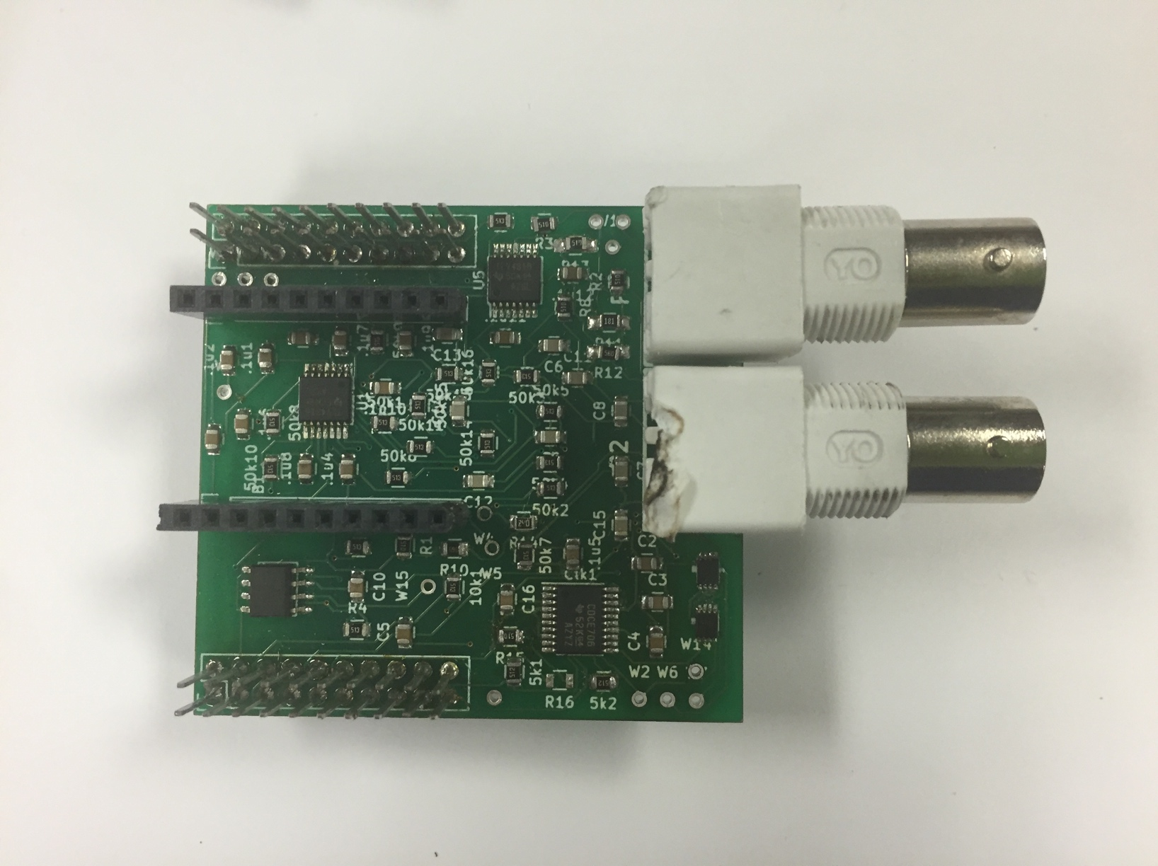

Figure 3: PCB top without DDS

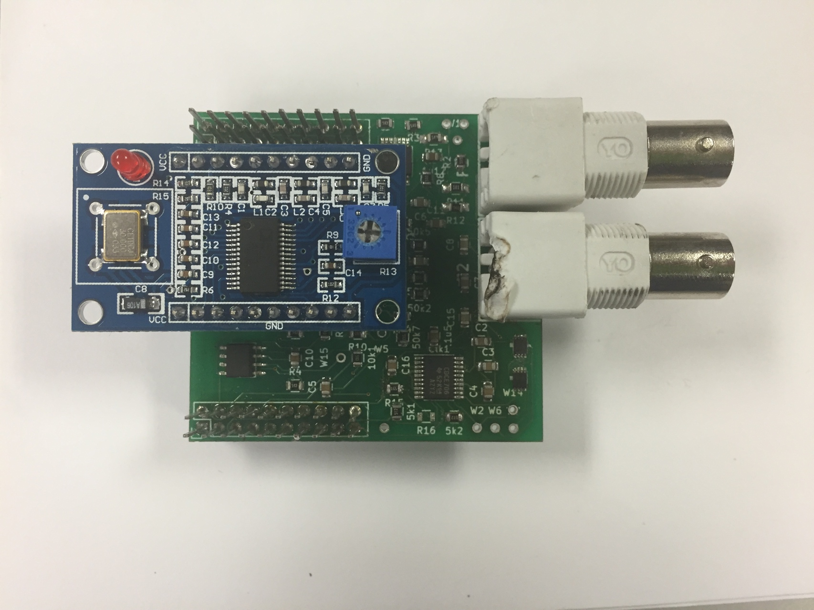

Figure 4: PCB top with DDS

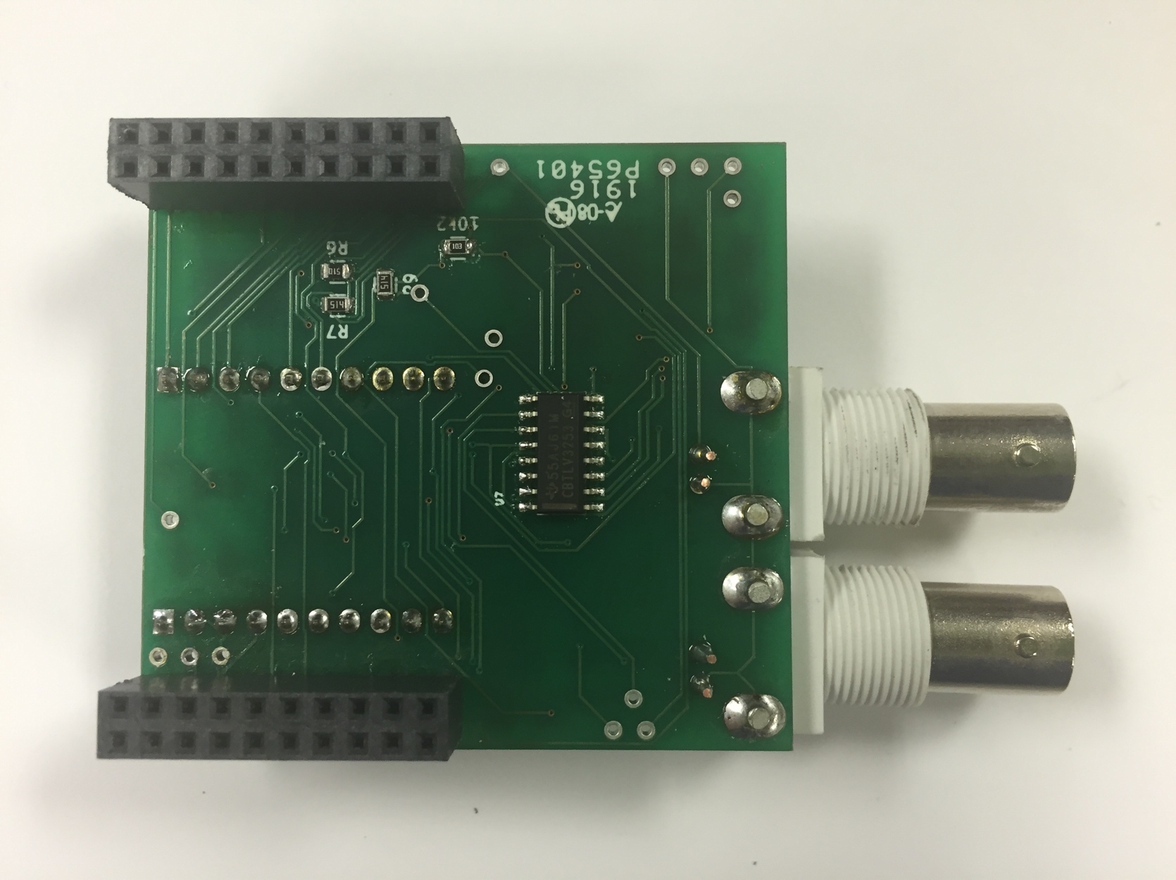

Pins to MSP432

52.9 mm

50.0 mm

Figure 5: PCB Bottom

Mux

## 2.4 Schematic



Figure 6: Schematic

# 3 Component Specifications

## Mux

Datasheet: <http://www.ti.com/lit/ds/symlink/sn74cbtlv3253.pdf>

Model: SN74CBTLV3253

Package: SIOC16

## High Frequency Op-Amp

Datasheet: <http://www.ti.com/lit/ds/symlink/opa830.pdf>

Model: OPA830

Package: SOIC8

## D-flipflops

Datasheet: <http://www.ti.com/lit/ds/symlink/sn74lvc1g74.pdf>

Model: SN74LVC1G74

Package: VSSOP 8

## PLL

Datasheet: <http://www.ti.com/lit/ds/symlink/cdce706.pdf>

Model: CDCE706

Package: TSSOP20

## DDS Module

Datasheet: <http://www.qrp-labs.com/images/ultimate3mod6m/ddsmodule.pdf>

DDS IC (AD9850) Datasheet: <http://www.analog.com/media/en/technical-documentation/data-sheets/AD9850.pdf>

[Model: AD9851](http://www.analog.com/media/en/technical-documentation/data-sheets/AD9850.pdf)

Package: Two 1x10 Pins placed 20mm apart

## Low Frequency Op-Amps

Datasheet: <http://www.ti.com/lit/ds/symlink/tlv4316.pdf>

Model: TLV4316

Package: TSSOP14

# Future Work

Currently, the CCS code is not yet functional for our VNA. We are having issues with writing directly to the registers of our PLL using the SMBus communication. As far as we know, there are no issues with the board’s functionality. Also, the GUI interface that creates the Smith chart from the VNA’s data is not fully developed. We are having problems with the analog to digital converter on the MSP432. We will update this document along with the rest of the files in the Github repository as soon as the software is fully developed.

# **References**

"Bridge Circuits." *All About Circuits*. N.p., n.d. Web. 07 June 2016. <http://www.allaboutcircuits.com/textbook/direct-current/chpt-8/bridge-circuits/>.

*Code Composer Studio (CCS) Integrated Development Environment (IDE)*. Computer software. *- CCSTUDIO*. Vers. 6.1.3. Texas Instruments, June 2016. Web. 06 June 2016. <http://www.ti.com/tool/ccstudio>.

*Open-Source Software License Agreement*. Rep. Foerster Group, n.d. Web. 06 June 2016. <http://www.foerstergroup.de/Software-License-Agreements.822.0.html?&no_ cache=1&L=1&cid=165463&did=760 5&sechash=0f369b69>.

Tayloe, Dan. *Ultra Low Noise, High Performance, Zero IF Quadrature Product Detector and Preamplifier*. Tech. N.p., n.d. Web. 6 June 2016. <http://www.foerstergroup.de/ Software-License-Agreements.822.0.html?&no_cache=1&L=1&cid=165463&did=7605 &sechash=0f369b69>.