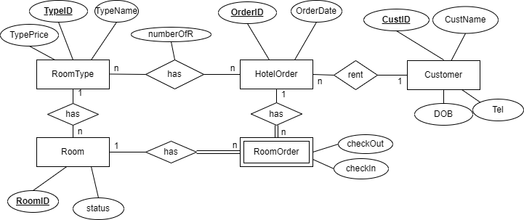
useDate
noOfUse
useServeceID
n
n
Services
use
ServiceID
serviceCharge
serviceName

