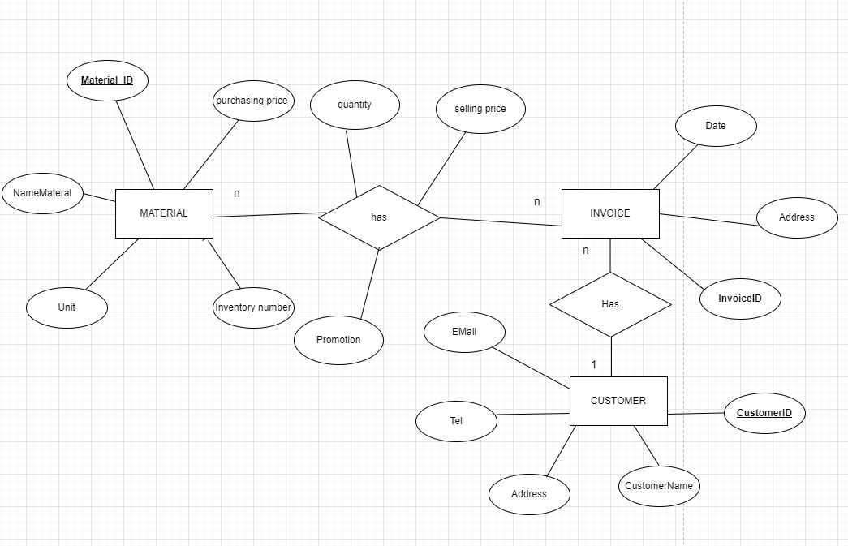
1
n
location
warehouseID
stored
phoneNo
WAREHOUSE
address

