Practical Examination
Subject code: DBI202
Duration : 85 minutes
Requirements:
+ Download the file PE_DBI202.sql, write the SQL statement to create the table in question 2 and execute it to create the database and tables.
+ Students complete the exams and submit the exam consisting of 2 files: PE_DBI202.sql and .docx file containing the ERD for question 1.
- (2 point) From the ERD diagram of the Material management system as shown in the figure, add entity and relationship/attributes to meet the following requirements:
Each material is stored in a warehouse in a certain location, each warehouse stores many types of materials, but materials are only stored in a certain warehouse. Warehouse information includes warehouseID, phone number and address.
Use the diagram below to complete question 1 (Draw it in MS Word).
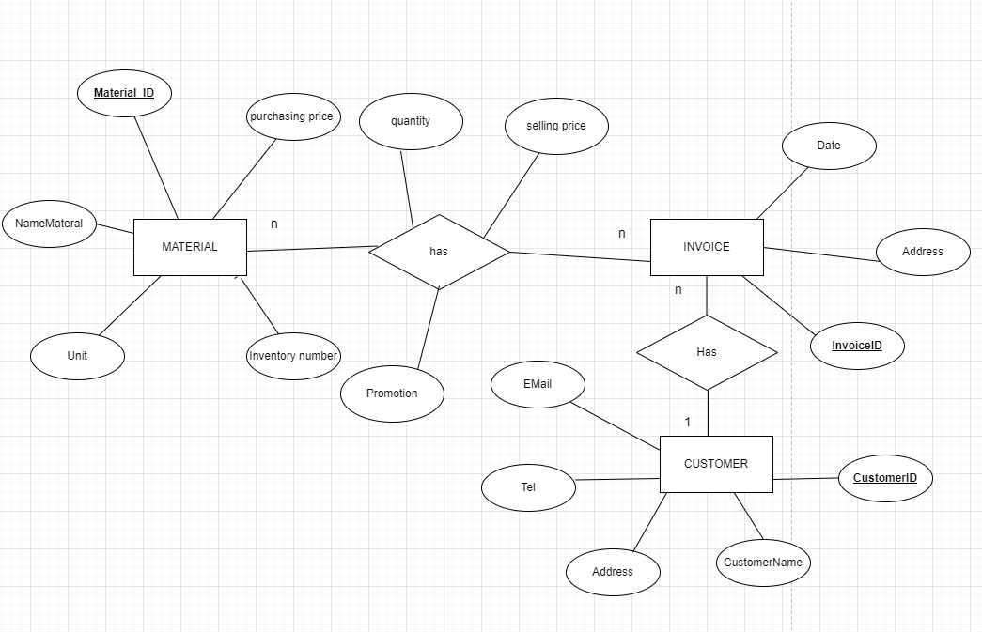
- (2 points)
From the diagram in question 1, write SQL statement to create table corresponding to the entity added in the diagram. The statement needs to show maximum data constraints on the table fields. Enter 5 appropriate rows of data for the table just created. Add attribute to related tables if needed (Other tables are already available).

- (2 points) Write a procedure to search for invoices by customer name, displaying information including: InvoiceID, Invoicedate, delivery address, total amount of each invoice. The total amount of an invoice is calculated by the total of quantity * selling price of all the items. Handling any error is required.

- (2 points) Write a trigger when inserted a record in DetailInvoice table, ensure that the quantity of Material must be greater than or equal to the sale quantity. In addition, update the quantity of the Material – substract by the sale quantity.

- (2 points) Write the statement to create a view named InvoicesInfo that display information on all invoices, includes:
InvoiceID, InvoiceDate, DeliveryAddress, Total, Tax
where:
Total is sum of selling price * quantity of all detailInvoice
Tax is calculated by following rules:
- If total is greater than 5000000, 10% of the total amount will be charged for tax
- If total is greater than 100000 and less than 5000000, tax is 5% of the total amount
- Otherwise tax is 0

