# Introduction

This guide details the main components of the printed circuit board (PCB) for the NAU OpenExo and provides instructions on how to order the PCB and its assembly from a manufacturer. Resources on PCB background and design can be found on websites such as [Sparkfun](https://learn.sparkfun.com/tutorials/pcb-basics/all#designing-your-own), [KiCad](https://www.kicad.org/), and [EasyEDA](https://easyeda.com/),

# PCB Background

This custom-designed PCB is a crucial part of the NAU OpenExo (exo) system. It communicates with the external control application, receives commands, and performs motor control based on predefined algorithms.

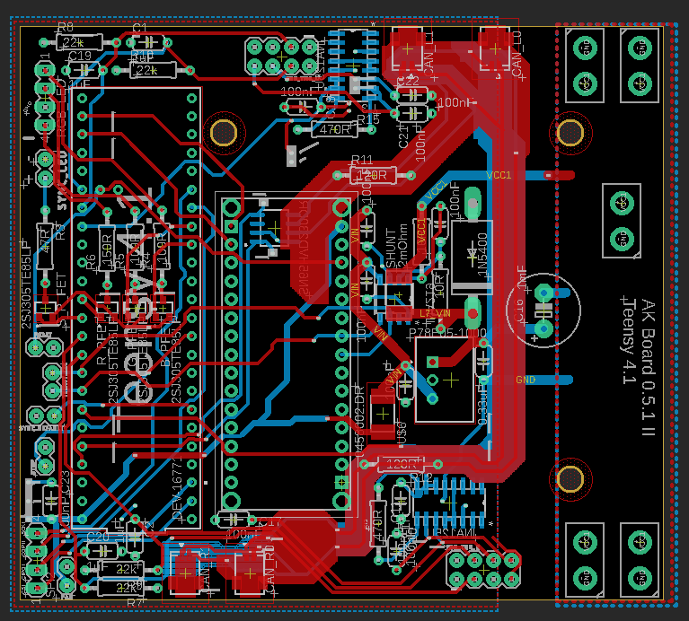

Figure 1: PCB - Top Layer (Red), Bottom Layer (Blue)

**Key Components**

* **DC-DC converter** (P78E05-1000): This component converts the battery voltage to 5V DC in order to properly power onboard components such as the Arduino Nano and Teensy 4.1.

Important Note: Capacitor C16 may need to be replaced if a battery with higher voltage output is used (Example Replacement: MAL217250471E3).

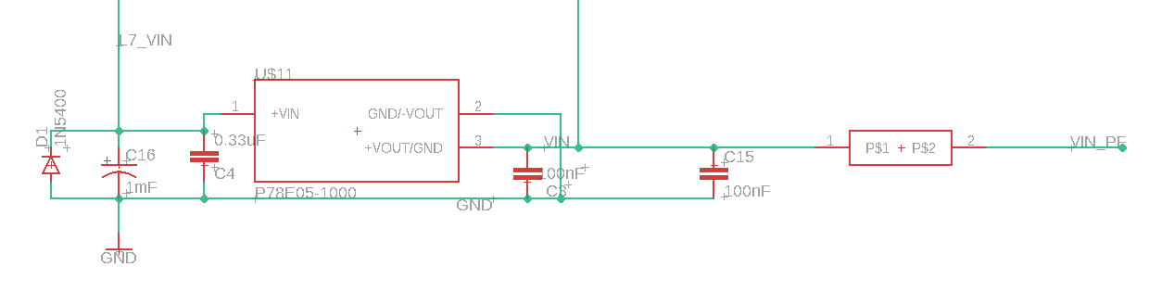

* **Development boards** (Arduino Nano 33 BLE and Teensy 4.1): These boards provide the main computing power for the PCB. The Arduino Nano handles communication between the exo and the external control application, while the Teensy 4.1 processes sensor data and controls the motors based on the high-level controller. All variations of Teensy 4.1 are compatible, but some libraries may need to be added depending on the version.

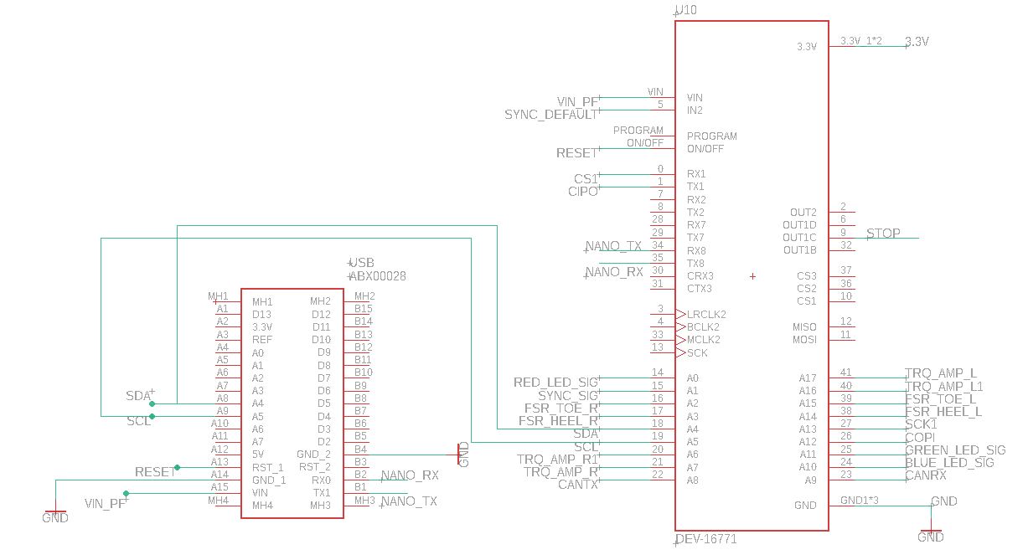

* **CAN interface** (SN65HVD230DR): This interface serves as the communication link between the CAN transceiver pins and the receiver pins on the Teensy 4.1, as well as the motors. A keep out area is created around the CAN interface traces to reduce the electromagnetic interference.

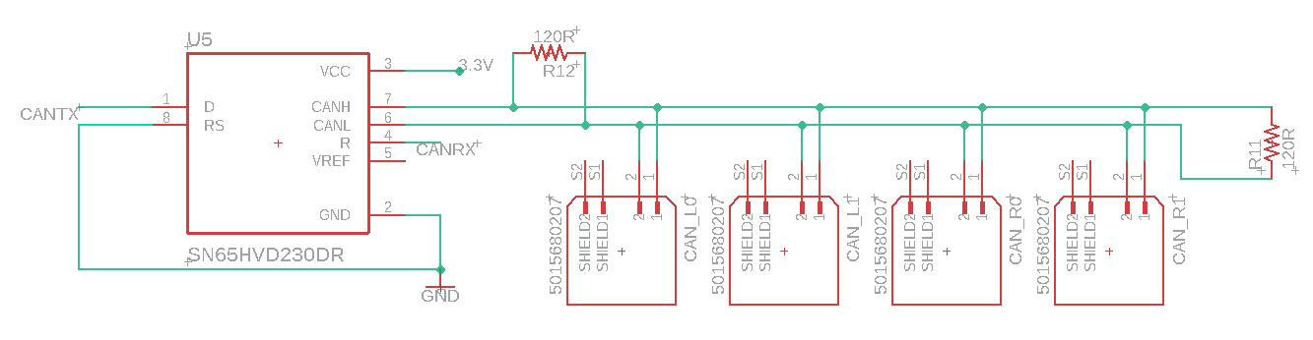

* **Strain gauge amplifier** (INA125U): This amplifier boosts the torque sensor signal output. The INA125UA is also compatible.

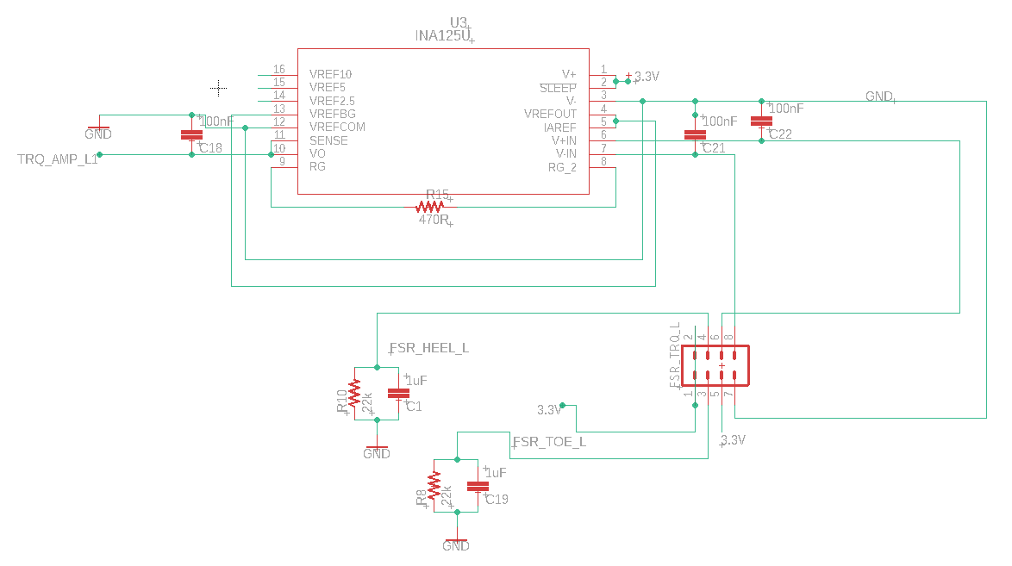

Other components/subsystems:

* Battery power monitor (INA219)
* RGB LEDs (2SJ305TE85LF)

While the OpenExo is fully functional without these subsystems, certain code changes may be required if they are omitted from the board.

# Ordering the PCB

All necessary resources to order the OpenExo PCB are provided (NAU_OpenExo_PCB_Files.zip). If modifications are needed, follow these instructions to generate the required files for a PCB manufacturer.

## Files needed:

* Gerber file (.zip)

This file contains the board design information necessary for PCB manufacturing and can be generated using PCB design software. The NAU OpenExo PCB was designed with Autodesk EAGLE 9.6.2. To generate the Gerber file in EAGLE, load the “.brd” file, switch to “board view”, select “File > Generate CAM data”, click on “OK”, and save the zip file.

* BOM file (.csv)

The Bill of Materials (BOM) lists all electronic components to be placed on the PCB, facilitating communication between the designer and manufacturer.

* CPL file (.csv)

The Component Placement List (CPL) describes the location and orientation of each surface-mount technology (SMT) component on the PCB, guiding the pick-and-place machine.

## PCB manufacturer:

The NAU OpenExo PCB was ordered from [JLCPCB](https://jlcpcb.com/), which provides component ordering services and optional PCB assembly (soldering). JLCPCB offers automated pipelines for easy BOM and CPL file generation. The required ULP pipeline can be found on [JLCPCB’s GitHub repository](https://github.com/JLCPCB/jlcpcb-eagle).

## Ordering the PCB from JLCPCB

1. Create an account at JLCPCB.com
2. Select “Order now”
3. Add the gerber file (.zip)

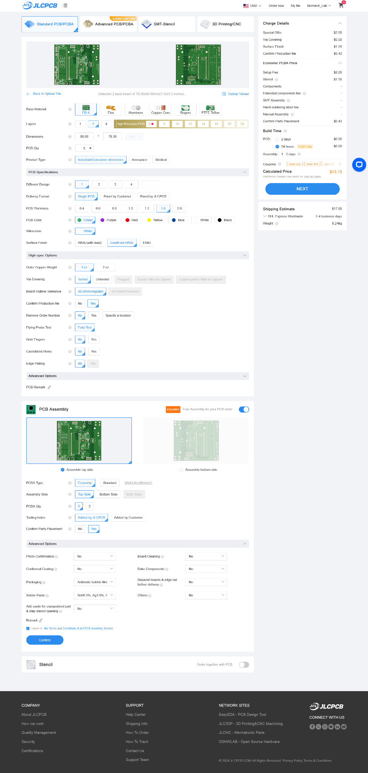

1. If “PCB Assembly Service” is needed, on the next pages please upload BOM (.csv) and CPL (.csv). Components not included in BOM and CPL will not be assembled onto the PCB by JLCPCB.
2. Review the order. JLCPCB may contact you to confirm the production file.

# Modifying the PCB for a Larger Battery

We currently utilize [22.2 V LiPo Batteries](https://www.amazon.com/HRB-1800mAh-Helicopter-Airplane-Multicopter/dp/B088QXJNJV/) to power our device. While perfectly functional, these batteries are the limiting factor for device operation time. If you wish to utilize a battery that would lead to a longer operation time, such as [Inspired Energy’s 28.8 V Li-Ion Battery](https://www.inspired-energy.com/products/details/3/209-ph3059hd29), you will need to swap out Capacitor C16 (red box) with one of a [higher capacitance](https://www.mouser.com/ProductDetail/Vishay-BC-Components/MAL217250471E3?qs=vvQtp7zwQdMjYJ1hQJzD0Q%3D%3D). If you do swap batteries, you may need to modify connectors and the design of the battery/PCB casing to accommodate this.

