**LAPORAN**

**PEMROGRAMAN BERORIENTASI OBJEK PRAKTIKUM**

**DATABASE**

**NAUFAL FIRMANSYAH**

**5210411166**

**PROGRAM STUDI INFORMATIKA**

**FAKULTAS SAINS & TEKNOLOGI**

**UNIVERSITAS TEKNOLOGI YOGYAKARTA**

# DAFTAR ISI

Contents

DAFTAR ISI 2

Latihan 1 2

**MySQL 2**

**Code 2**

**Hasil 2**

**Penjelasan 2**

**SQLite 2**

**Code 2**

**Hasil 2**

**Penjelasan 2**

**POSTGRE 2**

**Code 2**

**Hasil 2**

**Penjelasan 2**

**ORACLE 2**

**Code 2**

**Hasil 2**

**Penjelasan 2**

Latihan 2 2

Latihan 3 2

Tugas 2

# Latihan 1

## MySQL

### Code

#### Connector

#### Created

#### Insert

#### Update

#### Deleted

#### Print

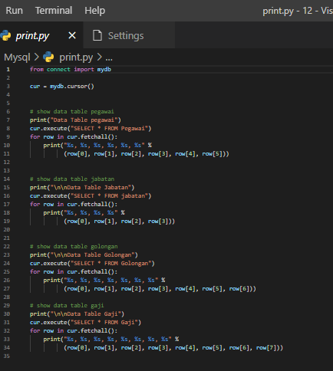

### Hasil

### Penjelasan

## SQLite

### Code

#### Connect

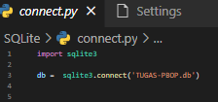

#### Created

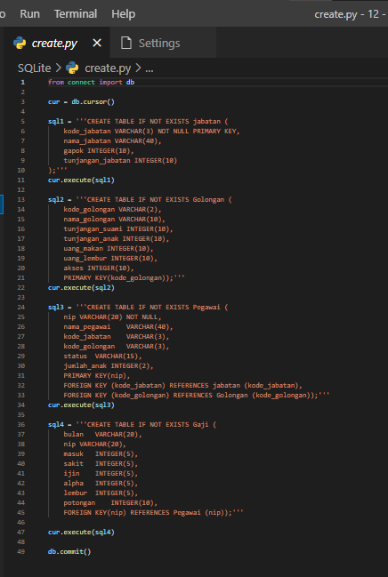

#### Insert

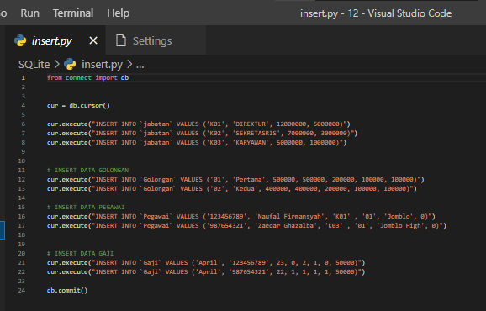

#### Update

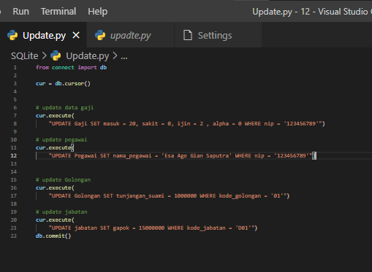

#### Deleted

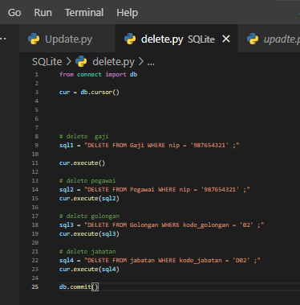

#### Print

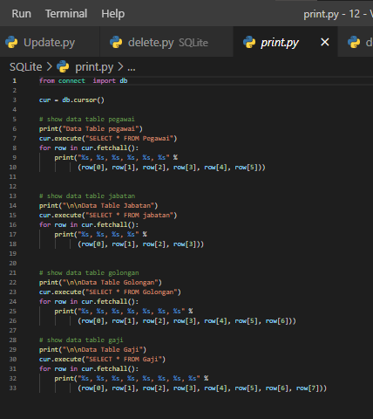

### Hasil

### Penjelasan

## POSTGRE

### Code

#### Connect

#### Created

#### Insert

#### Update

#### Deleted

#### Print

### Hasil

### Penjelasan

## ORACLE

### Code

#### Connect

#### Created

#### Insert

#### Update

#### Deleted

#### Print

### Hasil

### Penjelasan

# Latihan 2

# Latihan 3

# Tugas