Statement 🡪 while <kondisi> : <aksi>

Kondisi 🡪 <variabel> <comparator> <variabel> | True | False

Aksi 🡪 <variabel> = <variabel> <operator> <variabel>

Variabel 🡪 x | y

Comparator 🡪 is | in | == | > | >= | < | <= | !=

Operator 🡪 + | - | * | ** | / | //

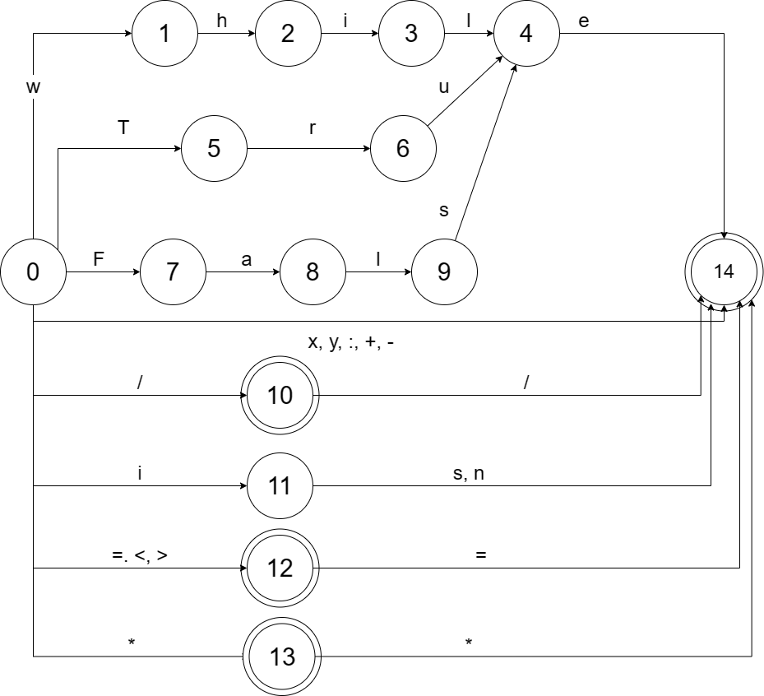

|  |  |  |  |  |  |  |  |  |  |
| --- | --- | --- | --- | --- | --- | --- | --- | --- | --- |
|  | while | : | True | False | = | x | y | is | in |
| statement | while <kondisi> : aksi | error | error | error | error | error | error | error | error |
| kondisi | error | error | True | False | error | <variabel> <comparator> <variabel> | <variabel> <comparator> <variabel> | error | error |
| aksi | error | error | error | error | error | <variabel> = <variabel> <operator> <variabel> | <variabel> = <variabel> <operator> <variabel> | error | error |
| variabel | error | error | error | error | error | x | y | error | error |
| comparator | error | error | error | error | error | error | error | is | in |
| operator | error | error | error | error | error | error | error | error | error |

|  |  |  |  |  |  |  |  |  |  |  |  |  |  |
| --- | --- | --- | --- | --- | --- | --- | --- | --- | --- | --- | --- | --- | --- |
|  | == | | != | > | >= | < | <= | + | - | / | // | * | ** |
| statement | error | | error | error | error | error | error | error | error | error | error | error | error |
| kondisi | | error | error | error | error | error | error | error | error | error | error | error | error |
| aksi | | error | error | error | error | error | error | error | error | error | error | error | error |
| variabel | | error | error | error | error | error | error | error | error | error | error | error | error |
| comparator | | == | != | > | >= | < | <= | error | error | error | error | error | error |
| operator | | error | error | error | error | error | error | + | - | / | error | * | ** |