

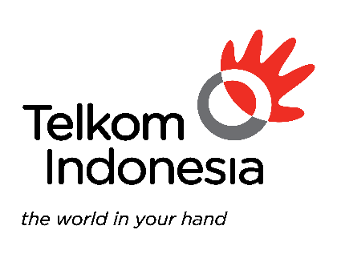
Silabus Kursus ini dibuat dengan bantuan Kecerdasan Artifisial (AI)
{{ course_category }}

Rancangan Silabus
Versi Dokumen [*]
Dokumen Konfidensial
Dikeluarkan Oleh PT. Telekomunikasi Indonesia, Tbk
[{{ date_stamp }}]

{{ client_company_name }}

{{ course_title }}

PT. Telekomunikasi Indonesia, Tbk.
Kawasan The Telkom Hub, Gedung Telkom Landmark Tower II, Lantai 39, Jl. Jendral Gatot Subroto Kav. 52, Kuningan Barat, Mampang Prapatan, Jakarta Selatan, Jakarta, indonesia 12710

1. | 1. PROFIL PERUSAHAAN

1.1. Profile Perusahaan
{{r company_profile_summary }}

1.2. Rangkuman Komersial Perusahaan
{{r commercial_overview }}

2. | 2. {{ course_name }}

Terminal Learning Objective
{{r tlo_result }}
Performance:
{{r performance_result }}
Condition:
{{r condition_result }}
Standard:
{{r standard_result }}

Enabling Learning Outcome
{{r elo_results }}
3. | 2. LEARNING JOURNEY

Pre-Learning
{{r pre_learning_results }}

Classroom
{{r classroom_results }}

After-Learning
{{r after_learning_results }}

