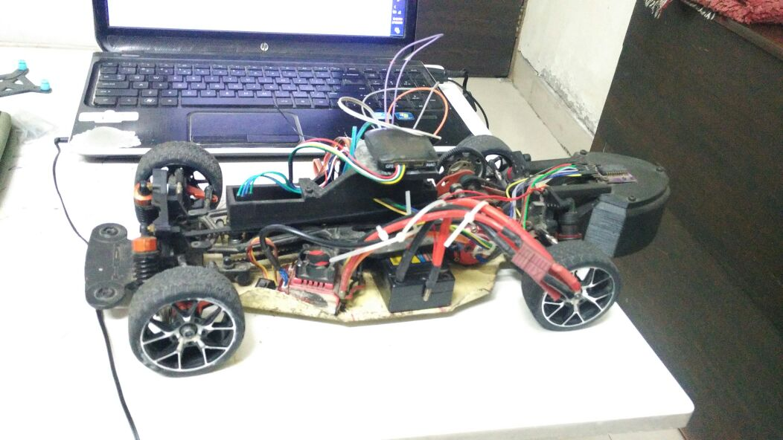

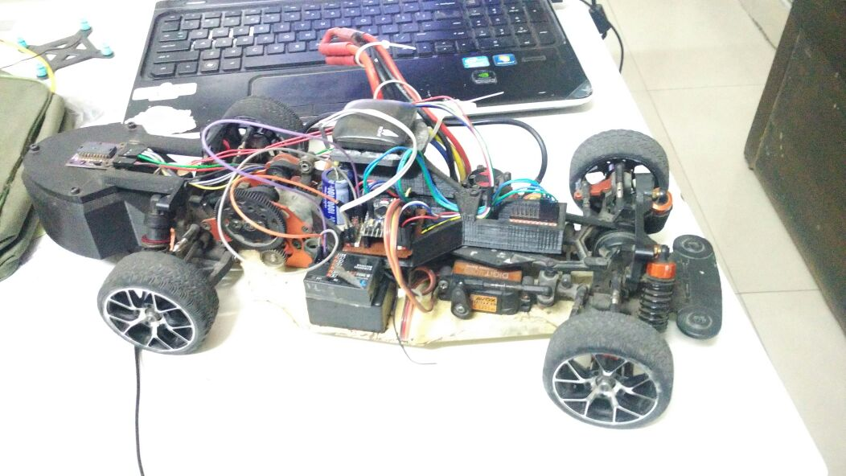

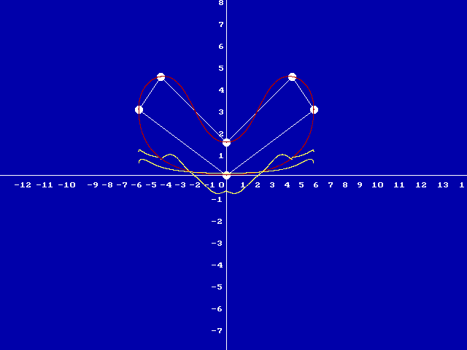

The white circles represent the waypoints that the user (me) provide to the arduino. The arduino then figures out the appropriate headings at each point. The appropriate heading at each point is (for now) the average of the angle made by the line joining that point to the last point and the line joining that point to the next point.

at the beginning of each cycle major cycle, the arduino calculates where the car will be by the end of the next major cycle. Using this we can back calculate the parameter 't' for the bezier curve(taken as the ratio of (distance to the point at the end of next major cycle)/total distance to next waypoint

The red curve is the calculated trajectory(the arduino doesn't exactly calculate the trajectory, it directly jumps to the ROC at each point, The red trajectory drawn here(done in c++) is just to help the reader understand what is going on inside the arduino). The yellow curves represent the corresponding steering angle at every point.  
  
To be clear, the arduino does not produce these images! This image was generated using a c++ program that ran on a laptop and is only for the sake of explanation.