|  |
| --- |
| Zayed University  Department of Computer Science  SWE-320 Software Engineering  1st Semester 2017-2018  Submission Date: 18 Nov 2017  Assignment 2 |

**Authors**

|  |  |  |
| --- | --- | --- |
| Name | ID | Section |
|  |  |  |
|  |  |  |
|  |  |  |
|  |  |  |

# Problem Description

This project involved Inheritance and Polymorphism. It was a good project to get grasp on basic OOP concepts. We used standard ways to assign and retrieve values of instance variables using getters and setters methods. We used standard naming conventions for classes and variables. We learned a lot from this project.

# Problem Analysis

**Attribute Names**

**Attribute Types**

|  |  |
| --- | --- |
| name | String |
| address | String |
| program | String |
| year | int |
| fees | double |
| school | String |
| pay | double |
| input | Scanner |
| person | Person |
| student | Student |
| staff | Staff |

# Solution Design

**UML Class diagram**

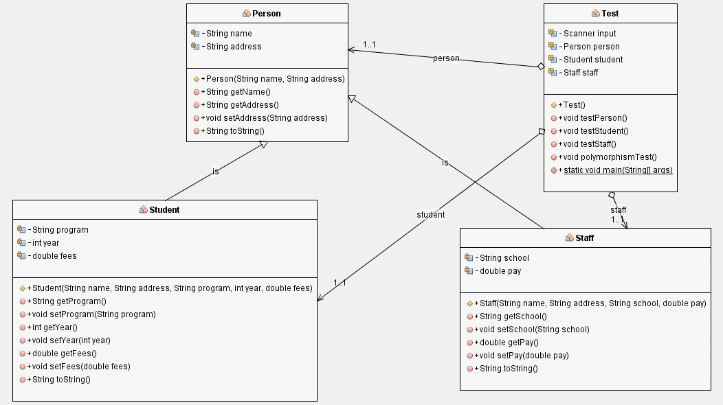

# Implementation

## Person

public class Person {

private String name;

private String address;

public Person(String name, String address){

this.name = name;

this.address = address;

}

public String getName() {

return name;

}

public String getAddress() {

return address;

}

public void setAddress(String address) {

this.address = address;

}

@Override

public String toString() {

return "Person[" + "name = " + name + ", address = " + address + "]";

}

}

## Student

public class Student extends Person {

private String program;

private int year;

private double fees;

public Student(String name, String address, String program, int year, double fees) {

super(name, address);

this.program = program;

this.year = year;

this.fees = fees;

}

public String getProgram() {

return program;

}

public void setProgram(String program) {

this.program = program;

}

public int getYear() {

return year;

}

public void setYear(int year) {

this.year = year;

}

public double getFees() {

return fees;

}

public void setFees(double fees) {

this.fees = fees;

}

@Override

public String toString() {

return "Student[Person[name=" + getName() + ", address=" + getAddress() + "], program=" + getProgram() + ", year=" + getYear() + ", fees=" + getFees() + ']';

}

}

## Staff

public class Staff extends Person {

private String school;

private double pay;

public Staff(String name, String address, String school, double pay) {

super(name, address);

this.school = school;

this.pay = pay;

}

public String getSchool() {

return school;

}

public void setSchool(String school) {

this.school = school;

}

public double getPay() {

return pay;

}

public void setPay(double pay) {

this.pay = pay;

}

@Override

public String toString() {

return "Staff[Person[name=" + getName() + ", address=" + getAddress() + "], school=" + school + ", pay=" + pay + "]";

}

}

## Test

import java.util.Scanner;

public class Test {

Scanner input = new Scanner(System.in);

Person person;//attribute person will store Person class reference

Student student;// attribute student will store Student class reference

Staff staff;//attribute staff will store Staff class reference

public Test() {

person = new Person("Ali Abdul Rahman", "UAE");

student = new Student("Ali Abdul Rahman", "UAE", "Computer Science", 2017, 2000.0);

staff = new Staff("Salman", "UAE", "ZU", 3500.0);

testPerson();

testStudent();

testStaff();

polymorphismTest();

}

//###############################################################################################//

//In this method we will do some communication with Person class

public void testPerson() {

System.out.println(person.toString());//printing String representation of the Person object

System.out.println("Lets change " + person.getName() + "'s address using setter");

System.out.print("Enter " + person.getName() + "'s address: ");

person.setAddress(input.nextLine());//setting Person's address to user entered address

System.out.println(person.toString() + "\n");//Printing updated values of the Person object

}

//###############################################################################################//

//In this method we will do some communication with Student class

public void testStudent() {

System.out.println("***************\n* Student *\n***************");

System.out.println(student.toString());//printing String representation of the Student object

System.out.println("Lets test Student class once again using setters");

System.out.print("Enter " + student.getName() + "'s address: ");

student.setAddress(input.nextLine()); //setting address to user entered address

System.out.print("Enter " + student.getName() + "'s program: ");

student.setProgram(input.nextLine()); //setting name to user entered name

try {

System.out.print("Enter " + student.getName() + "'s year: ");

student.setYear(input.nextInt()); //setting year to user entered year

System.out.print("Enter " + student.getName() + "'s fees: ");

student.setFees(input.nextDouble()); //setting fees to user entered fees

} catch (Exception inputMismatchException) { //If user enters String instead of int or double for year or fees then inputMismatchException will be thrown

System.out.println("Please enter valid values next time");

}

System.out.println(student.toString() + "\n");//printing new values of Student object, \n shifts cursor to new line.

}

//###############################################################################################//

//In this method we will do some communication with Staff class

public void testStaff() {

System.out.println("***************\n* Staff *\n***************");

System.out.println(staff.toString());//printing String representation of the Staff object

System.out.println("Lets test Staff class once again using setters");

System.out.print("Enter " + staff.getName() + "'s address: ");

staff.setAddress(input.nextLine()); //setting address to user entered address

System.out.print("Enter " + staff.getName() + "'s school: ");

staff.setSchool(input.nextLine()); //setting school to user entered school

try {

System.out.print("Enter " + staff.getName() + "'s pay: ");

staff.setPay(input.nextDouble()); //setting pay to user entered pay

} catch (Exception e) {//If user enters String instead of int or double for pay then inputMismatchException will be thrown

System.out.println("Please enter valid values next time");

}

System.out.println(staff.toString() + "\n");

}

//###############################################################################################//

//In this method we will update address of student and staff using Person reference

//The beauty of polymorphism is that an object can take many forms.

public void polymorphismTest() {

// Instantiating child_class(Student) using parent_class(Person) reference

System.out.println("****************\n* Polymorphism *\n****************");

Person stuPerson = new Student("Abdullah", "UAE", "Software Engineering", 2017, 1500.0);

System.out.println(stuPerson.toString());//printing String representation of the Student object

System.out.println("Lets update attribute 'address' of Student(Child class) using Person(Parent) class reference");

System.out.print("Enter " + stuPerson.getName() + "'s address: ");

input.nextLine();

stuPerson.setAddress(input.nextLine()); //setting address to user entered address

//Now lets see updated address in Student class

System.out.println(stuPerson.toString() + "\n");

//******************************************************************************************//

// Instantiating child_class(Staff) using parent_class(Person) reference

Person staPerson = new Staff("Nauman", "Sharjah", "SAIS", 1600.0);

System.out.println(staPerson.toString());//printing String representation of the Student object

System.out.println("Lets update attribute 'address' of Staff(Child class) using Person(Parent) class reference");

System.out.print("Enter " + staPerson.getName() + "'s address: ");

staPerson.setAddress(input.nextLine()); //setting address to user entered address

//Now lets see updated address in Staff class

System.out.println(staPerson.toString());

}

public static void main(String[] args) {

new Test(); //instantiating current class instance

}

}

# Evaluation

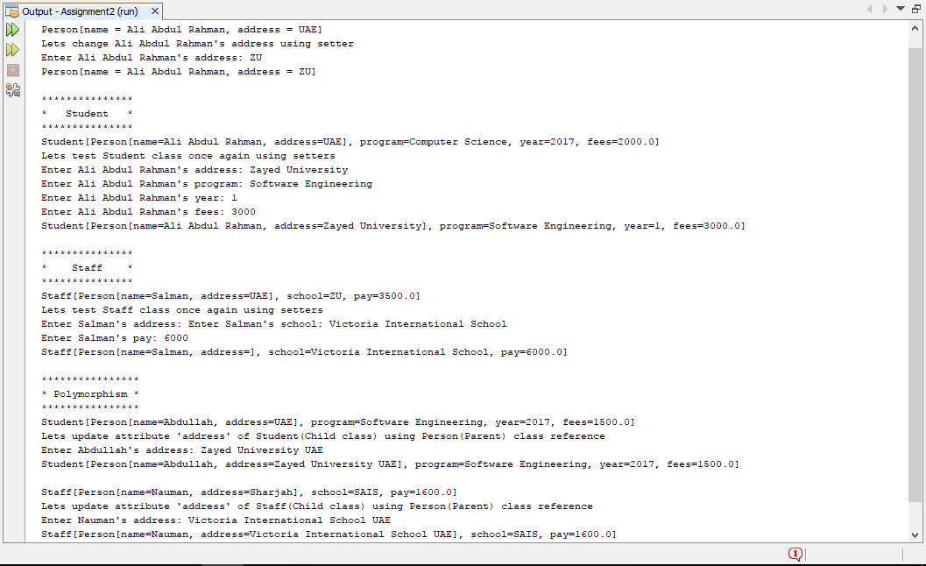

# Self Reflection

1. How did you work on the project?

**Answer:** First i draw class diagram then i implemented whole project from that class diagram.

1. What did you learn out of the project?

**Answer:** I learned about Inheritance and Polymorphism in this project.

1. How much time did you spend working on the project?

**Answer:** I spent 6 hours working on this project.

1. And what is your personal opinion about the project?

**Answer:** Overall this project was very helpful in understanding some of the basic concepts of java. It was awesome.