|  |
| --- |
| Zayed University  Department of Computer Science  SWE-320 Software Engineering  1st Semester 2017-2018  Submission Date: 23 Nov 2017  Final Group Project |

**Authors**

|  |  |  |
| --- | --- | --- |
| Name | ID | Section |
|  |  |  |
|  |  |  |
|  |  |  |
|  |  |  |

# **PROBLEM DESCRIPTION**

The problem was to create a University grading system which will assign grades to students on the basis of their credit hours and credit points. This problem was GUI based and it was very tuff job for us to design such a GUI which involves a lot of JLabels, JTestJields, JButtons etc but due to our hard work we managed to tackle this problem.

# **SOLUTION DESIGN**

**UML Class diagram**

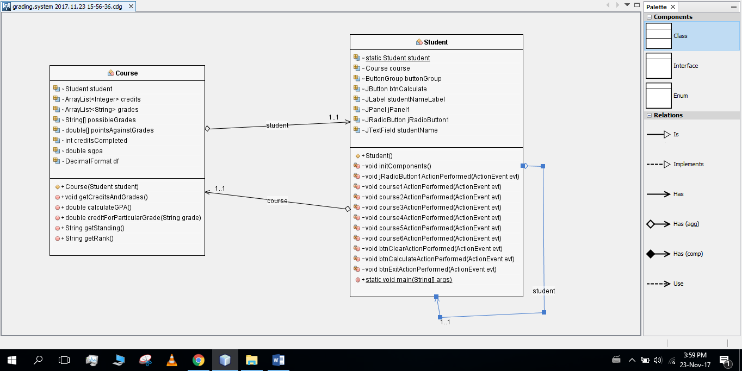

# **IMPLEMENTATION**

## Course.java

package grading.system;

import java.text.DecimalFormat;

import java.util.ArrayList;

public class Course {

Student student;

ArrayList<Integer> credits;

ArrayList<String> grades;

String[] possibleGrades;

double[] pointsAgainstGrades;

int creditsCompleted;

double sgpa;

DecimalFormat df;

public Course(Student student) {

this.student = student;

credits = new ArrayList<>();

grades = new ArrayList<>();

possibleGrades = new String[]{"A+", "A", "A-", "B+", "B", "B-", "C+", "C", "C-", "D+", "D", "D-", "F", "WF"};

pointsAgainstGrades = new double[]{4, 4, 3.7, 3.3, 3, 2.7, 2.3, 2, 1.7, 1.3, 1, 0.7, 0, 0};

creditsCompleted = Integer.valueOf(student.creditsCompleted.getText());

df = new DecimalFormat("#.00");

getCreditsAndGrades();

}

public void getCreditsAndGrades() {

for (int i = 0; i < 6; i++) {

switch (i) {

case 0:

credits.add(Integer.parseInt(student.credit1.getText()));

grades.add(student.grade1.getText());

break;

case 1:

credits.add(Integer.parseInt(student.credit2.getText()));

grades.add(student.grade2.getText());

break;

case 2:

credits.add(Integer.parseInt(student.credit3.getText()));

grades.add(student.grade3.getText());

break;

case 3:

credits.add(Integer.parseInt(student.credit4.getText()));

grades.add(student.grade4.getText());

break;

case 4:

credits.add(Integer.parseInt(student.credit5.getText()));

grades.add(student.grade5.getText());

break;

case 5:

credits.add(Integer.parseInt(student.credit6.getText()));

grades.add(student.grade6.getText());

break;

}

}

}

public double calculateGPA() {

double multiplicationPart = 0; // ((P1 * U1) + (P2 * U2)+ (P3 *U3) + (P4*U4) + (P5*U5))

int totalCreditUnits = 0;

for (int i = 0; i < 6; i++) {

multiplicationPart += (creditForParticularGrade(grades.get(i)) * credits.get(i));

totalCreditUnits += credits.get(i);

}

sgpa = Double.valueOf(df.format(multiplicationPart / totalCreditUnits)); //Semester GPA = ((P1 * U1) + (P2 * U2)+ (P3 *U3) + (P4*U4) + (P5*U5)) / Total credit units

return sgpa;

}

//Grade Points Table provided in project requirement document

public double creditForParticularGrade(String grade) {

for (int j = 0; j < possibleGrades.length; j++) {

if (grade.equals(possibleGrades[j])) {

return pointsAgainstGrades[j];

}

}

return 0;

}

public String getStanding() {

if (sgpa >= 0 && sgpa <= 0.9) {

return "Poor";

} else if (sgpa >= 1 && sgpa < 1) {

return "Satisfactory";

} else if (sgpa >= 2 && sgpa < 3) {

return "Good";

} else if (sgpa >= 3 && sgpa <= 4) {

return "Excellent";

}

return "";

}

public String getRank() {

if (creditsCompleted >= 0 && creditsCompleted <= 30) {

return "Freshman";

} else if (creditsCompleted >= 31 && creditsCompleted <= 60) {

return "Sophomore";

} else if (creditsCompleted >= 61 && creditsCompleted < 90) {

return "Junior";

} else if (creditsCompleted >= 90) {

return "Senior";

}

return "";

}

## Test.java

package grading.system;

import javax.swing.ButtonGroup;

import java.awt.event.ActionEvent;

import java.awt.event.ActionListener;

import java.awt.Color;

import java.awt.Font;

import java.awt.SystemColor;

import javax.swing.GroupLayout;

import javax.swing.JButton;

import javax.swing.JFrame;

import javax.swing.JLabel;

import javax.swing.JOptionPane;

import javax.swing.JPanel;

import javax.swing.JRadioButton;

import javax.swing.JTextField;

import javax.swing.LayoutStyle.ComponentPlacement;

import javax.swing.WindowConstants;

public class Student extends JFrame {

static Student student;//Student refernce

Course course;//Course reference to update results on runtime if user changes input after execution

ButtonGroup buttonGroup;//for grouping two radio buttons

JButton btnCalculate, btnClear, btnExit;

JLabel studentNameLabel, SGPALabel, sgpa, standingLabel, standing, rankLabel, rank, summary, summaryLine1, summaryLine2,

summaryLine3, studentIDLabel, summaryLine4, semesterLabel, campusLabel, creditsCompletedLabel, coursesLabel,

creditsLabel, gradesLabel, outputsLabel;

JPanel jPanel1, jPanel2;

JRadioButton jRadioButton1, jRadioButton2;

JTextField studentName, course6, credit1, credit2, credit3, credit4, credit5, credit6, grade1, grade2, grade3, id, grade4,

grade5, grade6, semester, creditsCompleted, course1, course2, course3, course4, course5;

public Student() {

initComponents();//initializing all components of JFrame

setVisible(true);//If false then JFrame wont be visible

}

//in this method we initialized the whole GUI

private void initComponents() {

buttonGroup = new ButtonGroup();

studentNameLabel = new JLabel();

studentName = new JTextField();

studentIDLabel = new JLabel();

id = new JTextField();

semesterLabel = new JLabel();

semester = new JTextField();

campusLabel = new JLabel();

jRadioButton1 = new JRadioButton();

jRadioButton2 = new JRadioButton();

creditsCompletedLabel = new JLabel();

creditsCompleted = new JTextField();

coursesLabel = new JLabel();

creditsLabel = new JLabel();

gradesLabel = new JLabel();

course1 = new JTextField();

course2 = new JTextField();

course3 = new JTextField();

course4 = new JTextField();

course5 = new JTextField();

course6 = new JTextField();

credit1 = new JTextField();

credit2 = new JTextField();

credit3 = new JTextField();

credit4 = new JTextField();

credit5 = new JTextField();

credit6 = new JTextField();

grade1 = new JTextField();

grade2 = new JTextField();

grade3 = new JTextField();

grade4 = new JTextField();

grade5 = new JTextField();

grade6 = new JTextField();

btnCalculate = new JButton();

btnClear = new JButton();

jPanel1 = new JPanel();

outputsLabel = new JLabel();

jPanel2 = new JPanel();

SGPALabel = new JLabel();

sgpa = new JLabel();

standingLabel = new JLabel();

standing = new JLabel();

rankLabel = new JLabel();

rank = new JLabel();

summary = new JLabel();

summaryLine1 = new JLabel();

summaryLine2 = new JLabel();

summaryLine3 = new JLabel();

summaryLine4 = new JLabel();

btnExit = new JButton();

setDefaultCloseOperation(WindowConstants.EXIT_ON_CLOSE);

setTitle("Zayed University SGPA Calculator");

studentNameLabel.setFont(new Font("Tahoma", 1, 14));

studentNameLabel.setText("Student name:");

studentName.setFont(new Font("Tahoma", 1, 14));

studentName.setForeground(new Color(51, 102, 255));

studentName.setBorder(new javax.swing.border.SoftBevelBorder(javax.swing.border.BevelBorder.RAISED));

studentIDLabel.setFont(new Font("Tahoma", 1, 14));

studentIDLabel.setText("ID:");

id.setFont(new Font("Tahoma", 1, 14));

id.setForeground(new Color(51, 102, 255));

id.setBorder(new javax.swing.border.SoftBevelBorder(javax.swing.border.BevelBorder.RAISED));

semesterLabel.setFont(new Font("Tahoma", 1, 14));

semesterLabel.setText("Semester:");

semesterLabel.setToolTipText("");

semester.setFont(new Font("Tahoma", 1, 14));

semester.setForeground(new Color(51, 102, 255));

semester.setBorder(new javax.swing.border.SoftBevelBorder(javax.swing.border.BevelBorder.RAISED));

campusLabel.setFont(new Font("Tahoma", 1, 14));

campusLabel.setText("Campus:");

jRadioButton1.setFont(new Font("Tahoma", 1, 14));

jRadioButton1.setText("Abu Dhabi");

jRadioButton1.addActionListener(new ActionListener() {

public void actionPerformed(ActionEvent evt) {

jRadioButton1ActionPerformed(evt);

}

});

jRadioButton2.setFont(new Font("Tahoma", 1, 14));

jRadioButton2.setText("Dubai");

buttonGroup.add(jRadioButton1);

buttonGroup.add(jRadioButton2);

creditsCompletedLabel.setFont(new Font("Tahoma", 1, 14));

creditsCompletedLabel.setText("Credits Completed:");

creditsCompleted.setBorder(new javax.swing.border.SoftBevelBorder(javax.swing.border.BevelBorder.RAISED));

coursesLabel.setFont(new Font("Tahoma", 1, 14));

coursesLabel.setForeground(new Color(51, 102, 255));

coursesLabel.setText("Courses");

creditsLabel.setFont(new Font("Tahoma", 1, 14));

creditsLabel.setForeground(new Color(51, 102, 255));

creditsLabel.setText("Credits");

gradesLabel.setFont(new Font("Tahoma", 1, 14));

gradesLabel.setForeground(new Color(51, 102, 255));

gradesLabel.setText("Grades");

course1.setFont(new Font("Tahoma", 1, 14));

course1.setForeground(new Color(51, 102, 255));

course1.setBorder(new javax.swing.border.SoftBevelBorder(javax.swing.border.BevelBorder.RAISED));

course1.addActionListener(new ActionListener() {

public void actionPerformed(ActionEvent evt) {

course1ActionPerformed(evt);

}

});

course2.setFont(new Font("Tahoma", 1, 14));

course2.setForeground(new Color(51, 102, 255));

course2.setBorder(new javax.swing.border.SoftBevelBorder(javax.swing.border.BevelBorder.RAISED));

course2.addActionListener(new ActionListener() {

public void actionPerformed(ActionEvent evt) {

course2ActionPerformed(evt);

}

});

course3.setFont(new Font("Tahoma", 1, 14));

course3.setForeground(new Color(51, 102, 255));

course3.setBorder(new javax.swing.border.SoftBevelBorder(javax.swing.border.BevelBorder.RAISED));

course3.addActionListener(new ActionListener() {

public void actionPerformed(ActionEvent evt) {

course3ActionPerformed(evt);

}

});

course4.setFont(new Font("Tahoma", 1, 14));

course4.setForeground(new Color(51, 102, 255));

course4.setBorder(new javax.swing.border.SoftBevelBorder(javax.swing.border.BevelBorder.RAISED));

course4.addActionListener(new ActionListener() {

public void actionPerformed(ActionEvent evt) {

course4ActionPerformed(evt);

}

});

course5.setFont(new Font("Tahoma", 1, 14));

course5.setForeground(new Color(51, 102, 255));

course5.setBorder(new javax.swing.border.SoftBevelBorder(javax.swing.border.BevelBorder.RAISED));

course5.addActionListener(new ActionListener() {

public void actionPerformed(ActionEvent evt) {

course5ActionPerformed(evt);

}

});

course6.setFont(new Font("Tahoma", 1, 14));

course6.setForeground(new Color(51, 102, 255));

course6.setBorder(new javax.swing.border.SoftBevelBorder(javax.swing.border.BevelBorder.RAISED));

course6.addActionListener(new ActionListener() {

public void actionPerformed(ActionEvent evt) {

course6ActionPerformed(evt);

}

});

credit1.setFont(new Font("Tahoma", 1, 14));

credit1.setForeground(new Color(51, 102, 255));

credit1.setBorder(new javax.swing.border.SoftBevelBorder(javax.swing.border.BevelBorder.RAISED));

credit2.setFont(new Font("Tahoma", 1, 14));

credit2.setForeground(new Color(51, 102, 255));

credit2.setBorder(new javax.swing.border.SoftBevelBorder(javax.swing.border.BevelBorder.RAISED));

credit3.setFont(new Font("Tahoma", 1, 14));

credit3.setForeground(new Color(51, 102, 255));

credit3.setBorder(new javax.swing.border.SoftBevelBorder(javax.swing.border.BevelBorder.RAISED));

credit4.setFont(new Font("Tahoma", 1, 14));

credit4.setForeground(new Color(51, 102, 255));

credit4.setBorder(new javax.swing.border.SoftBevelBorder(javax.swing.border.BevelBorder.RAISED));

credit5.setFont(new Font("Tahoma", 1, 14));

credit5.setForeground(new Color(51, 102, 255));

credit5.setBorder(new javax.swing.border.SoftBevelBorder(javax.swing.border.BevelBorder.RAISED));

credit6.setFont(new Font("Tahoma", 1, 14));

credit6.setForeground(new Color(51, 102, 255));

credit6.setBorder(new javax.swing.border.SoftBevelBorder(javax.swing.border.BevelBorder.RAISED));

grade1.setFont(new Font("Tahoma", 1, 14));

grade1.setForeground(new Color(51, 102, 255));

grade1.setBorder(new javax.swing.border.SoftBevelBorder(javax.swing.border.BevelBorder.RAISED));

grade2.setFont(new Font("Tahoma", 1, 14));

grade2.setForeground(new Color(51, 102, 255));

grade2.setBorder(new javax.swing.border.SoftBevelBorder(javax.swing.border.BevelBorder.RAISED));

grade3.setFont(new Font("Tahoma", 1, 14));

grade3.setForeground(new Color(51, 102, 255));

grade3.setBorder(new javax.swing.border.SoftBevelBorder(javax.swing.border.BevelBorder.RAISED));

grade4.setFont(new Font("Tahoma", 1, 14));

grade4.setForeground(new Color(51, 102, 255));

grade4.setBorder(new javax.swing.border.SoftBevelBorder(javax.swing.border.BevelBorder.RAISED));

grade5.setFont(new Font("Tahoma", 1, 14));

grade5.setForeground(new Color(51, 102, 255));

grade5.setBorder(new javax.swing.border.SoftBevelBorder(javax.swing.border.BevelBorder.RAISED));

grade6.setFont(new Font("Tahoma", 1, 14));

grade6.setForeground(new Color(51, 102, 255));

grade6.setBorder(new javax.swing.border.SoftBevelBorder(javax.swing.border.BevelBorder.RAISED));

btnCalculate.setFont(new Font("Tahoma", 1, 14));

btnCalculate.setForeground(new Color(51, 102, 255));

btnCalculate.setText("Calculate");

btnCalculate.setBorder(new javax.swing.border.LineBorder(new Color(102, 102, 102), 3, true));

btnCalculate.addActionListener(new ActionListener() {

public void actionPerformed(ActionEvent evt) {

btnCalculateActionPerformed(evt);

}

});

btnClear.setFont(new Font("Tahoma", 1, 14));

btnClear.setForeground(new Color(51, 102, 255));

btnClear.setText("Clear");

btnClear.setBorder(new javax.swing.border.LineBorder(new Color(102, 102, 102), 3, true));

btnClear.addActionListener(new ActionListener() {

public void actionPerformed(ActionEvent evt) {

btnClearActionPerformed(evt);

}

});

jPanel1.setBackground(new Color(220, 220, 220));

outputsLabel.setFont(new Font("Tahoma", 1, 14));

outputsLabel.setText("Outputs");

jPanel2.setBackground(SystemColor.controlHighlight);

jPanel2.setBorder(new javax.swing.border.LineBorder(new Color(153, 153, 153), 2, true));

SGPALabel.setFont(new Font("Tahoma", 1, 14));

SGPALabel.setText("SGPA:");

sgpa.setFont(new Font("Tahoma", 0, 14));

sgpa.setText("");

standingLabel.setFont(new Font("Tahoma", 1, 14));

standingLabel.setText("Standing:");

standing.setFont(new Font("Tahoma", 0, 14));

standing.setText("");

rankLabel.setFont(new Font("Tahoma", 1, 14));

rankLabel.setText("Rank:");

rank.setFont(new Font("Tahoma", 0, 14));

rank.setText("");

summary.setFont(new Font("Tahoma", 1, 14));

summary.setText("");

summaryLine1.setFont(new Font("Tahoma", 0, 14));

summaryLine1.setText("");

summaryLine2.setFont(new Font("Tahoma", 0, 14));

summaryLine2.setText("");

summaryLine3.setFont(new Font("Tahoma", 0, 14));

summaryLine3.setText("");

summaryLine4.setFont(new Font("Tahoma", 0, 14));

summaryLine4.setText("");

GroupLayout jPanel2Layout = new GroupLayout(jPanel2);

jPanel2.setLayout(jPanel2Layout);

jPanel2Layout.setHorizontalGroup(

jPanel2Layout.createParallelGroup(GroupLayout.Alignment.LEADING)

.addGroup(jPanel2Layout.createSequentialGroup()

.addContainerGap()

.addGroup(jPanel2Layout.createParallelGroup(GroupLayout.Alignment.LEADING)

.addGroup(jPanel2Layout.createSequentialGroup()

.addComponent(SGPALabel)

.addGap(18, 18, 18)

.addComponent(sgpa, GroupLayout.DEFAULT_SIZE, GroupLayout.DEFAULT_SIZE, Short.MAX_VALUE))

.addGroup(jPanel2Layout.createSequentialGroup()

.addComponent(rankLabel)

.addGap(18, 18, 18)

.addComponent(rank, GroupLayout.DEFAULT_SIZE, GroupLayout.DEFAULT_SIZE, Short.MAX_VALUE))

.addGroup(jPanel2Layout.createSequentialGroup()

.addComponent(standingLabel)

.addGap(18, 18, 18)

.addComponent(standing, GroupLayout.DEFAULT_SIZE, GroupLayout.DEFAULT_SIZE, Short.MAX_VALUE))

.addComponent(summaryLine1, GroupLayout.DEFAULT_SIZE, GroupLayout.DEFAULT_SIZE, Short.MAX_VALUE)

.addComponent(summaryLine2, GroupLayout.DEFAULT_SIZE, GroupLayout.DEFAULT_SIZE, Short.MAX_VALUE)

.addComponent(summaryLine3, GroupLayout.DEFAULT_SIZE, GroupLayout.DEFAULT_SIZE, Short.MAX_VALUE)

.addGroup(jPanel2Layout.createSequentialGroup()

.addComponent(summary)

.addGap(0, 0, Short.MAX_VALUE))

.addComponent(summaryLine4, GroupLayout.DEFAULT_SIZE, GroupLayout.DEFAULT_SIZE, Short.MAX_VALUE))

.addContainerGap())

);

jPanel2Layout.setVerticalGroup(

jPanel2Layout.createParallelGroup(GroupLayout.Alignment.LEADING)

.addGroup(jPanel2Layout.createSequentialGroup()

.addContainerGap()

.addGroup(jPanel2Layout.createParallelGroup(GroupLayout.Alignment.BASELINE)

.addComponent(SGPALabel)

.addComponent(sgpa))

.addPreferredGap(ComponentPlacement.UNRELATED)

.addGroup(jPanel2Layout.createParallelGroup(GroupLayout.Alignment.BASELINE)

.addComponent(standingLabel)

.addComponent(standing))

.addPreferredGap(ComponentPlacement.UNRELATED)

.addGroup(jPanel2Layout.createParallelGroup(GroupLayout.Alignment.BASELINE)

.addComponent(rankLabel)

.addComponent(rank))

.addPreferredGap(ComponentPlacement.UNRELATED)

.addComponent(summary)

.addPreferredGap(ComponentPlacement.UNRELATED)

.addComponent(summaryLine1)

.addPreferredGap(ComponentPlacement.UNRELATED)

.addComponent(summaryLine2)

.addPreferredGap(ComponentPlacement.UNRELATED)

.addComponent(summaryLine3)

.addPreferredGap(ComponentPlacement.UNRELATED)

.addComponent(summaryLine4)

.addContainerGap(61, Short.MAX_VALUE))

);

GroupLayout jPanel1Layout = new GroupLayout(jPanel1);

jPanel1.setLayout(jPanel1Layout);

jPanel1Layout.setHorizontalGroup(

jPanel1Layout.createParallelGroup(GroupLayout.Alignment.LEADING)

.addGroup(jPanel1Layout.createSequentialGroup()

.addContainerGap()

.addGroup(jPanel1Layout.createParallelGroup(GroupLayout.Alignment.LEADING)

.addGroup(jPanel1Layout.createSequentialGroup()

.addComponent(jPanel2, GroupLayout.DEFAULT_SIZE, GroupLayout.DEFAULT_SIZE, Short.MAX_VALUE)

.addContainerGap())

.addGroup(jPanel1Layout.createSequentialGroup()

.addComponent(outputsLabel)

.addGap(0, 0, Short.MAX_VALUE))))

);

jPanel1Layout.setVerticalGroup(

jPanel1Layout.createParallelGroup(GroupLayout.Alignment.LEADING)

.addGroup(jPanel1Layout.createSequentialGroup()

.addComponent(outputsLabel, GroupLayout.PREFERRED_SIZE, 17, GroupLayout.PREFERRED_SIZE)

.addPreferredGap(ComponentPlacement.RELATED)

.addComponent(jPanel2, GroupLayout.DEFAULT_SIZE, GroupLayout.DEFAULT_SIZE, Short.MAX_VALUE)

.addContainerGap())

);

btnExit.setFont(new Font("Tahoma", 1, 14));

btnExit.setForeground(new Color(51, 102, 255));

btnExit.setText("Exit");

btnExit.setBorder(new javax.swing.border.LineBorder(new Color(102, 102, 102), 3, true));

btnExit.addActionListener(new ActionListener() {

public void actionPerformed(ActionEvent evt) {

btnExitActionPerformed(evt);

}

});

GroupLayout layout = new GroupLayout(getContentPane());

getContentPane().setLayout(layout);

layout.setHorizontalGroup(

layout.createParallelGroup(GroupLayout.Alignment.LEADING)

.addGroup(layout.createSequentialGroup()

.addContainerGap()

.addGroup(layout.createParallelGroup(GroupLayout.Alignment.LEADING)

.addGroup(layout.createSequentialGroup()

.addGroup(layout.createParallelGroup(GroupLayout.Alignment.TRAILING)

.addGroup(layout.createSequentialGroup()

.addComponent(studentNameLabel)

.addPreferredGap(ComponentPlacement.RELATED, GroupLayout.DEFAULT_SIZE, Short.MAX_VALUE)

.addComponent(studentName, GroupLayout.PREFERRED_SIZE, 155, GroupLayout.PREFERRED_SIZE))

.addGroup(GroupLayout.Alignment.LEADING, layout.createSequentialGroup()

.addComponent(campusLabel, GroupLayout.PREFERRED_SIZE, 67, GroupLayout.PREFERRED_SIZE)

.addPreferredGap(ComponentPlacement.UNRELATED)

.addComponent(jRadioButton1)

.addPreferredGap(ComponentPlacement.UNRELATED)

.addComponent(jRadioButton2)))

.addGroup(layout.createParallelGroup(GroupLayout.Alignment.LEADING)

.addGroup(layout.createSequentialGroup()

.addGap(88, 88, 88)

.addComponent(creditsCompletedLabel)

.addGap(18, 18, 18)

.addComponent(creditsCompleted, GroupLayout.PREFERRED_SIZE, 70, GroupLayout.PREFERRED_SIZE)

.addContainerGap(GroupLayout.DEFAULT_SIZE, Short.MAX_VALUE))

.addGroup(layout.createSequentialGroup()

.addPreferredGap(ComponentPlacement.RELATED)

.addComponent(studentIDLabel, GroupLayout.PREFERRED_SIZE, 22, GroupLayout.PREFERRED_SIZE)

.addGroup(layout.createParallelGroup(GroupLayout.Alignment.LEADING)

.addGroup(layout.createSequentialGroup()

.addGap(278, 278, 278)

.addComponent(btnExit, GroupLayout.PREFERRED_SIZE, 90, GroupLayout.PREFERRED_SIZE))

.addGroup(layout.createSequentialGroup()

.addPreferredGap(ComponentPlacement.RELATED)

.addGroup(layout.createParallelGroup(GroupLayout.Alignment.LEADING)

.addComponent(jPanel1, GroupLayout.DEFAULT_SIZE, GroupLayout.DEFAULT_SIZE, Short.MAX_VALUE)

.addGroup(layout.createSequentialGroup()

.addComponent(id, GroupLayout.PREFERRED_SIZE, 120, GroupLayout.PREFERRED_SIZE)

.addPreferredGap(ComponentPlacement.UNRELATED)

.addComponent(semesterLabel)

.addPreferredGap(ComponentPlacement.UNRELATED)

.addComponent(semester)))))

.addContainerGap())))

.addGroup(layout.createSequentialGroup()

.addGroup(layout.createParallelGroup(GroupLayout.Alignment.LEADING)

.addGroup(GroupLayout.Alignment.TRAILING, layout.createSequentialGroup()

.addGroup(layout.createParallelGroup(GroupLayout.Alignment.LEADING, false)

.addComponent(course1, GroupLayout.DEFAULT_SIZE, 108, Short.MAX_VALUE)

.addComponent(course2)

.addComponent(course3)

.addComponent(course4)

.addComponent(course5)

.addComponent(course6))

.addGap(18, 18, 18))

.addGroup(layout.createSequentialGroup()

.addGap(19, 19, 19)

.addComponent(coursesLabel)

.addGap(51, 51, 51)))

.addGroup(layout.createParallelGroup(GroupLayout.Alignment.LEADING, false)

.addComponent(creditsLabel)

.addComponent(credit1, GroupLayout.DEFAULT_SIZE, 53, Short.MAX_VALUE)

.addComponent(credit2)

.addComponent(credit3)

.addComponent(credit4)

.addComponent(credit5)

.addComponent(credit6))

.addGap(18, 18, 18)

.addGroup(layout.createParallelGroup(GroupLayout.Alignment.LEADING, false)

.addComponent(gradesLabel, GroupLayout.DEFAULT_SIZE, GroupLayout.DEFAULT_SIZE, Short.MAX_VALUE)

.addComponent(grade1)

.addComponent(grade2)

.addComponent(grade3)

.addComponent(grade4)

.addComponent(grade5)

.addComponent(grade6))

.addGap(0, 0, Short.MAX_VALUE))

.addGroup(layout.createSequentialGroup()

.addComponent(btnCalculate, GroupLayout.PREFERRED_SIZE, 108, GroupLayout.PREFERRED_SIZE)

.addGap(18, 18, 18)

.addComponent(btnClear, GroupLayout.PREFERRED_SIZE, 90, GroupLayout.PREFERRED_SIZE)

.addContainerGap(GroupLayout.DEFAULT_SIZE, Short.MAX_VALUE))))

);

layout.setVerticalGroup(

layout.createParallelGroup(GroupLayout.Alignment.LEADING)

.addGroup(layout.createSequentialGroup()

.addContainerGap()

.addGroup(layout.createParallelGroup(GroupLayout.Alignment.BASELINE)

.addComponent(studentNameLabel)

.addComponent(studentName, GroupLayout.PREFERRED_SIZE, GroupLayout.DEFAULT_SIZE, GroupLayout.PREFERRED_SIZE)

.addComponent(studentIDLabel)

.addComponent(id, GroupLayout.PREFERRED_SIZE, GroupLayout.DEFAULT_SIZE, GroupLayout.PREFERRED_SIZE)

.addComponent(semesterLabel)

.addComponent(semester, GroupLayout.PREFERRED_SIZE, GroupLayout.DEFAULT_SIZE, GroupLayout.PREFERRED_SIZE))

.addGap(24, 24, 24)

.addGroup(layout.createParallelGroup(GroupLayout.Alignment.BASELINE)

.addComponent(campusLabel)

.addComponent(jRadioButton1)

.addComponent(jRadioButton2)

.addComponent(creditsCompletedLabel)

.addComponent(creditsCompleted, GroupLayout.PREFERRED_SIZE, GroupLayout.DEFAULT_SIZE, GroupLayout.PREFERRED_SIZE))

.addGroup(layout.createParallelGroup(GroupLayout.Alignment.LEADING)

.addGroup(layout.createSequentialGroup()

.addGap(35, 35, 35)

.addGroup(layout.createParallelGroup(GroupLayout.Alignment.BASELINE)

.addComponent(coursesLabel)

.addComponent(creditsLabel)

.addComponent(gradesLabel))

.addPreferredGap(ComponentPlacement.RELATED)

.addGroup(layout.createParallelGroup(GroupLayout.Alignment.LEADING, false)

.addComponent(course1)

.addComponent(grade1, GroupLayout.DEFAULT_SIZE, 29, Short.MAX_VALUE)

.addComponent(credit1))

.addPreferredGap(ComponentPlacement.RELATED)

.addGroup(layout.createParallelGroup(GroupLayout.Alignment.LEADING, false)

.addComponent(course2)

.addComponent(grade2, GroupLayout.DEFAULT_SIZE, 29, Short.MAX_VALUE)

.addComponent(credit2))

.addPreferredGap(ComponentPlacement.RELATED)

.addGroup(layout.createParallelGroup(GroupLayout.Alignment.LEADING, false)

.addComponent(course3)

.addComponent(grade3, GroupLayout.DEFAULT_SIZE, 29, Short.MAX_VALUE)

.addComponent(credit3))

.addPreferredGap(ComponentPlacement.RELATED)

.addGroup(layout.createParallelGroup(GroupLayout.Alignment.LEADING, false)

.addComponent(course4)

.addComponent(grade4, GroupLayout.DEFAULT_SIZE, 29, Short.MAX_VALUE)

.addComponent(credit4))

.addPreferredGap(ComponentPlacement.RELATED)

.addGroup(layout.createParallelGroup(GroupLayout.Alignment.LEADING, false)

.addComponent(course5)

.addComponent(grade5, GroupLayout.DEFAULT_SIZE, 29, Short.MAX_VALUE)

.addComponent(credit5))

.addPreferredGap(ComponentPlacement.RELATED)

.addGroup(layout.createParallelGroup(GroupLayout.Alignment.LEADING, false)

.addComponent(course6)

.addComponent(grade6, GroupLayout.DEFAULT_SIZE, 29, Short.MAX_VALUE)

.addComponent(credit6)))

.addGroup(layout.createSequentialGroup()

.addPreferredGap(ComponentPlacement.RELATED)

.addComponent(jPanel1, GroupLayout.PREFERRED_SIZE, GroupLayout.DEFAULT_SIZE, GroupLayout.PREFERRED_SIZE)))

.addPreferredGap(ComponentPlacement.RELATED, GroupLayout.DEFAULT_SIZE, Short.MAX_VALUE)

.addGroup(layout.createParallelGroup(GroupLayout.Alignment.BASELINE)

.addComponent(btnCalculate, GroupLayout.PREFERRED_SIZE, 35, GroupLayout.PREFERRED_SIZE)

.addComponent(btnClear, GroupLayout.PREFERRED_SIZE, 35, GroupLayout.PREFERRED_SIZE)

.addComponent(btnExit, GroupLayout.PREFERRED_SIZE, 35, GroupLayout.PREFERRED_SIZE))

.addContainerGap())

);

pack();

}

private void jRadioButton1ActionPerformed(ActionEvent evt) {

}

private void course1ActionPerformed(ActionEvent evt) {

}

private void course2ActionPerformed(ActionEvent evt) {

}

private void course3ActionPerformed(ActionEvent evt) {

}

private void course4ActionPerformed(ActionEvent evt) {

}

private void course5ActionPerformed(ActionEvent evt) {

}

private void course6ActionPerformed(ActionEvent evt) {

}

private void btnClearActionPerformed(ActionEvent evt) {

studentName.setText("");

id.setText("");

semester.setText("");

creditsCompleted.setText("");

sgpa.setText("");

standing.setText("");

rank.setText("");

summary.setText("");

summaryLine1.setText("");

summaryLine2.setText("");

summaryLine3.setText("");

summaryLine4.setText("");

course1.setText("");

course2.setText("");

course3.setText("");

course4.setText("");

course5.setText("");

course6.setText("");

credit1.setText("");

credit2.setText("");

credit3.setText("");

credit4.setText("");

credit5.setText("");

credit6.setText("");

grade1.setText("");

grade2.setText("");

grade3.setText("");

grade4.setText("");

grade5.setText("");

grade6.setText("");

}

private void btnCalculateActionPerformed(ActionEvent evt) {

try {

course = new Course(student);

sgpa.setText(String.valueOf(course.calculateGPA()));

standing.setText(course.getStanding());

rank.setText(course.getRank());

summary.setText("Summary:");

summaryLine1.setText("Dear " + studentName.getText() + " " + id.getText() + ",");

summaryLine2.setText("your semester GPA for " + semester.getText() + " is " + String.valueOf(course.calculateGPA()));

summaryLine3.setText("Your Academic Standing is " + course.getStanding());

summaryLine4.setText("and you are " + course.getRank());

} catch (Exception e) {

JOptionPane.showMessageDialog(rootPane, "Plz fill required fields with valid inputs", "Emplty fields or invalid inputs", JOptionPane.INFORMATION_MESSAGE);

}

}

private void btnExitActionPerformed(ActionEvent evt) {

System.exit(0);

}

public static void main(String[] args) {

try {

for (javax.swing.UIManager.LookAndFeelInfo info : javax.swing.UIManager.getInstalledLookAndFeels()) {

if ("Nimbus".equals(info.getName())) {

javax.swing.UIManager.setLookAndFeel(info.getClassName());

break;

}

}

} catch (Exception e) {

JOptionPane.showMessageDialog(new JFrame(), "Nimbus Look and Feel not Found", "Look and Feel", JOptionPane.INFORMATION_MESSAGE);

}

student = new Student();

}

}

# EVALUATION

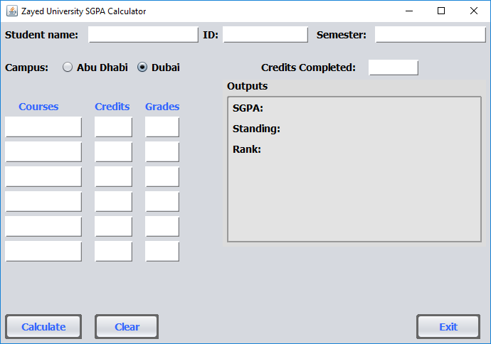

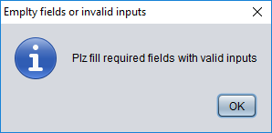

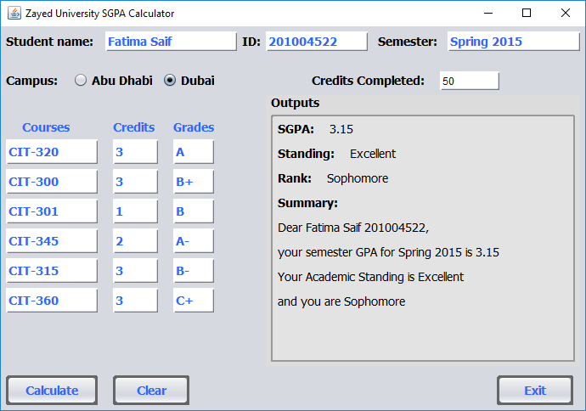

# Self Reflection

1. How did you work on the project?

**Answer:** First we draw class diagrams then we implemented whole project from those class diagrams.

1. What did you learn out of the project?

**Answer:** We learned about Java GUI’s and different Layouts. Some of those layouts can be seen in our project source code.

1. How much time did you spend working on the project?

**Answer:** We spent approximately 12 hours on this project.

1. And what is your personal opinion about the project?

**Answer:** Overall this project was very helpful in understanding some of the most used practices in java. It was a good learning experience.