**Final Project Report**

**Enhancing Learning Management System (LMS) User Experience A Human-Computer Interaction (HCI)**



**Project Supervisor**

Dr. Muhammad Salman Bashir

**Submitted By**

F2302F00DD

Nouman Ali BC220424776

**Software Projects & Research Section,**

**Department of Computer Sciences,**

**Virtual University of Pakistan**

|  |
| --- |
|  |



**CERTIFICATE**

This is to certify that Nouman Ali (BC220424776) have worked on and completed their Software Project at Software & Research Projects Section, Department of Computer Sciences, Virtual University of Pakistan in partial fulfillment of the requirement for the degree of BS in Computer Sciences under my guidance and supervision.

In our opinion, it is satisfactory and up to the mark and therefore fulfills the requirements of BS in Computer Sciences.

**Supervisor / Internal Examiner**

Dr. Muhammad Salman Bashir

Supervisor,

Software Projects & Research Section,

Department of Computer Sciences

Virtual University of Pakistan

___________________

(Signature)

**External Examiner/Subject Specialist**

<<External Supervisor Name>>

___________________

(Signature)

**Accepted By:**

**_____________**

(For office use)

**EXORDIUM**

**In the name of Allah, the Compassionate, the Merciful.**

**Praise be to Allah, Lord of Creation,**

**The Compassionate, the Merciful,**

**King of Judgment-day!**

**You alone we worship, and to You alone we pray for help,**

**Guide us to the straight path**

**The path of those who You have favored,**

**Not of those who have incurred Your wrath,**

**Nor of those who have gone astray.**

**DEDICATION**

Dedicating this project to the pursuit of knowledge and education's advancement, we acknowledge its profound impact on individuals and society. We honor students, educators, and institutions striving for excellence in education. This dedication extends to our families' support, the Virtual University of Pakistan's faculty, and all dedicated to education's noble cause. May this project inspire others toward a brighter future through the transformative power of education.

**ACKNOWLEDGEMENT**

We extend our sincere gratitude to the Virtual University of Pakistan for organizing this project for final year students of BS Computer Science. Special thanks to Dr. Muhammad Salman Bashir for his invaluable guidance and support throughout the project. We also acknowledge Nouman Ali, student ID BC220424776, for his dedication and contribution to the completion of this project.

**PREFACE**

The report provides a comprehensive overview of the project's objectives, methodologies, and outcomes aimed at enhancing the user experience of a Learning Management System (LMS) at the Virtual University of Pakistan. It encompasses detailed analyses of the project's gathering and analysis of information, planning, design, and development phases. Each chapter delves into specific aspects of the project, from defining its scope and requirements to outlining the chosen methodologies and strategies employed. Through a systematic approach, the report aims to elucidate the project's purpose, methodologies, and outcomes while providing valuable insights into the process of enhancing LMS usability. Ultimately, the report serves as a documentation of the project's journey, offering valuable lessons and recommendations for future endeavors in educational technology enhancement.

**TABLE OF CONTENTS**

|  |
| --- |
|  |

CHAPTER NO. 1

gathering & Analyzing info 10

1.1 Introduction

1.2 purpose

1.3 scope

1.4 definitions, acronyms and abbreviations

1.5 use cases and usage scenarios

1.5.1 Use Case Diagrams

1.5.2 Usage Scenarios

1.6 supplementary requirements

1.6.1 Usability

1.6.2 Reliability

1.6.3 Supportability

1.6.4 System Requirements

CHAPTER NO. 2

planning the project 11

2.1 Introduction

2.2 Methodology

* 1. Available Methodologies
  2. Chosen Methodology
  3. Reasons for Chosen Methodology
  4. Work Plan
  5. Project Structure
     1. Team Structure
     2. Project Schedule (Submission Calendar)

CHAPTER NO. 3

designing the project 12

3.1 Introduction

3.2 purpose

3.3 scope

* 1. definitions, acronyms and abbreviations
  2. Dynamic Model: Sequence Diagrams
  3. Object Model/Logical Model: Class Diagram
  4. Database Model (Database Diagram)
  5. Graphical User Interfaces

Chapter no.4

DEvelopment 13

4.1 Development plan (Architecture Diagram)

**CHAPTER 1**

Gathering & Analyzing Info

1.1 Introduction

This project aims to revolutionize the user experience (UX) of our Learning Management System (LMS) through the application of HCI principles.

By focusing on redesigning the interface and incorporating user-centric design strategies.

By this project we aim to gain a deep understanding of HCI principle relevant to LMS design and the specific needs of our diverse user base, including students, instructors, and administrators.

1.2 purpose

The purpose of this project is to revolutionize the user experience (UX) of our Learning Management System (LMS) by applying Human-Computer Interaction (HCI) principles. Through the redesign of the interface and the integration of user-centric design strategies, we aim to enhance usability and satisfaction for all users, including students, instructors, and administrators. By focusing on HCI principles relevant to LMS design, we seek to gain a deep understanding of the specific needs and preferences of our diverse user base. Ultimately, this project aims to create an LMS interface that is intuitive, efficient, and tailored to the unique requirements of each user group, thereby improving overall engagement and learning outcomes.

1.3 scope

|  |
| --- |
| The scope of this project encompasses the redesign and enhancement of the user experience (UX) for our Learning Management System (LMS) at the Virtual University of Pakistan. Specifically, the project will focus on the following areas:  1. Interface Redesign  2. HCI Principles Application  3. User-Centric Design Strategies:  4. Usability Testing and Iterative Design  5. Accessibility Considerations  6. Documentation and Reporting  Overall, the scope of this project is to significantly enhance the user experience of the LMS by applying HCI principles and user-centric design strategies, ultimately improving engagement and learning outcomes for students, instructors, and administrators. |

1.4 definitions, acronyms and abbreviations

Definitions, Acronyms, and Abbreviations

LMS: Learning Management System - A software application used for the administration, documentation, tracking, reporting, and delivery of educational courses or training programs.

UX: User Experience - The overall experience of a person using a product, system, or service, especially in terms of how easy or pleasing it is to use.

HCI: Human-Computer Interaction - A multidisciplinary field concerned with the design, evaluation, and implementation of interactive computing systems for human use and with the study of major phenomena surrounding them.

UI: User Interface - The point of human-computer interaction and communication in a device or computerized system that the user can manipulate and use to interact with the system.

SRS: Software Requirements Specification - A document that clearly and precisely describes the essential requirements for a software product.

GDB: Graded Discussion Board - An assessment tool in which students participate in an online discussion forum and are graded based on the quality of their contributions.

PPT: PowerPoint - A presentation program developed by Microsoft.

HTML: Hypertext Markup Language - The standard markup language for documents designed to be displayed in a web browser.

CSS: Cascading Style Sheets - A style sheet language used for describing the presentation of a document written in HTML or XML.

PHP: Hypertext Preprocessor - A server-side scripting language designed for web development but also used as a general-purpose programming language.

URL: Uniform Resource Locator - A reference to a web resource that specifies its location on a computer network and a mechanism for retrieving it, typically in the form of a web address.

GUI: Graphical User Interface - A type of user interface that allows users to interact with electronic devices through graphical icons and visual indicators.

URL: Uniform Resource Locator - A web address that specifies the location of a resource on the internet.

1.5 use cases and usage scenarios

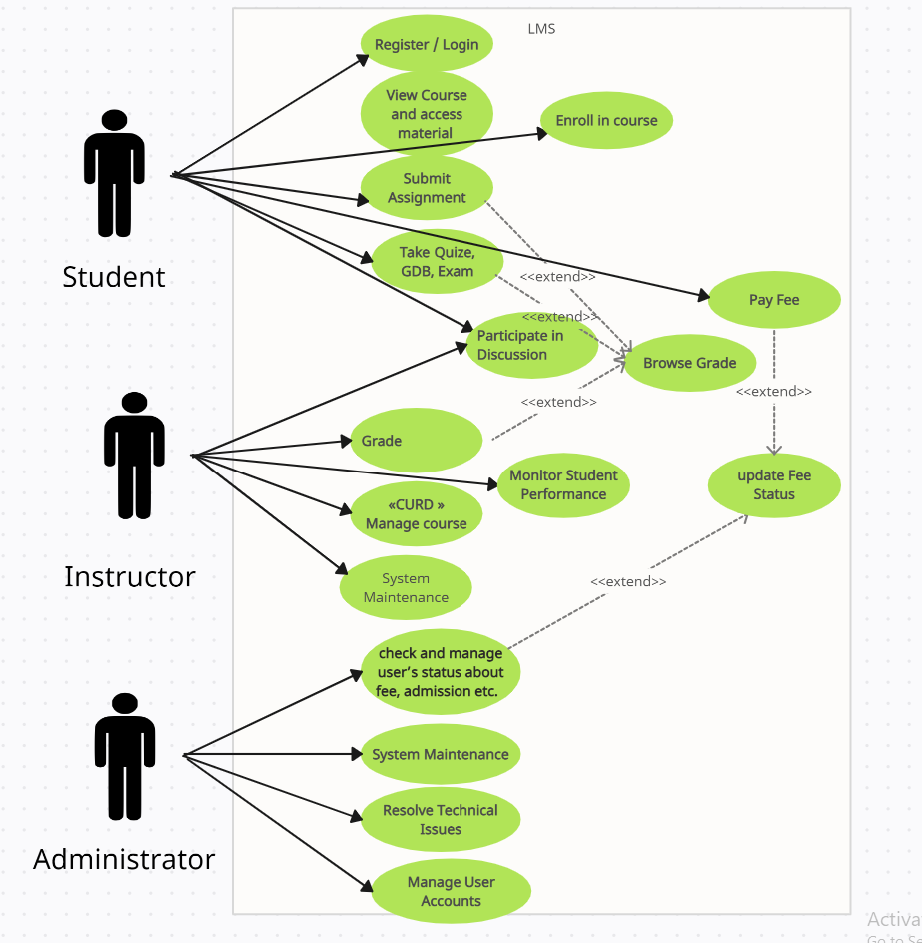

1.5.1 Use Case Diagrams

**1.5.2 Usage Scenarios**

Usage Scenarios for Students:

1. Accessing Course Materials:

As a student, I log into the LMS and navigate to my enrolled courses. I access the course materials, including lecture slides, readings, and supplementary resources, to prepare for upcoming classes and deepen my understanding of the subject matter.

2. Completing Assignments:

After reviewing the course materials, I access the assignments section on the LMS to view upcoming tasks. I complete assignments, essays, or projects as required by the course curriculum. Upon completion, I submit my work electronically through the LMS platform for evaluation by the instructor.

3. Taking Quizzes and Tests:

To assess my knowledge and understanding of the course material, I access the quick test section on the LMS. I take quizzes, tests, or assessments assigned by the instructor, answering questions and providing responses within the allocated time frame. I review my results and feedback provided by the system or instructor afterward.

4. Profile Information:

Scenario: As a student, I navigate to the profile section within the LMS to view personal information.

Usage Scenarios for Admin:

1. Managing Course:

As an admin, admin can navigate to the course management section to create, edit or remove course.

2. Enrolling Student’s:

Admin can navigate into the manage student's section to enroll new student and edit already registered student’s I.e there name, id, picture etc.

3. Providing support:

Admin has access to address technical issues and provides support.

1.6 Supplementary Requirements:

1.6.1 Usability:

* The system should prioritize usability, ensuring that the interface is intuitive and easy to navigate for all user roles, including students, instructors, and administrators.
* Usability testing should be conducted regularly to gather feedback and make iterative improvements to the user experience based on user interactions and preferences.

1.6.2 Reliability:

* The system should be reliable, ensuring consistent performance and availability to users at all times.
* Measures should be implemented to mitigate potential issues such as system crashes, data loss, or downtime, ensuring uninterrupted access to course materials and functionalities.

1.6.3 Supportability:

* Adequate support mechanisms should be in place to assist users in case of technical issues or difficulties navigating the system.
* A help desk or support ticket system should be established to provide timely assistance and troubleshooting guidance to users encountering problems with the LMS.

1.6.4 System Requirements:

* System requirements may include considerations for hardware specifications, operating systems, web browsers, and internet connectivity to ensure seamless access and functionality for all users.

**CHAPTER 2**

Planning the Project

planning the project 11

2.1 Introduction:

The planning phase of the project sets the groundwork for its successful execution, outlining key strategies and methodologies to achieve the desired outcomes. In this section, we provide an overview of the planning process and its significance in ensuring project success.

**2.2 Methodology:**

For this project, I has adopted a methodology that leverages a combination of HTML, CSS, JavaScript (including jQuery plugin DataTables), PHP for backend development, and Figma for designing. This approach ensures a comprehensive development and design process, catering to both frontend and backend requirements effectively.

**2.3 Available Methodologies:**

Several methodologies are available for web development and design, each with its own set of principles and practices. Some common methodologies include waterfall, agile, scrum, and iterative development. These methodologies offer different approaches to project management, emphasizing flexibility, collaboration, and iterative improvements.

**2.4 Chosen Methodology:**

The chosen methodology for this project revolves around core HTML, CSS, and JavaScript for frontend development, utilizing the DataTables jQuery plugin for enhanced data presentation. PHP is employed for backend development, leveraging its widespread usage and robust features. Additionally, Figma is selected as the design tool due to its beginner-friendly interface and popularity among web designers. This combination of technologies ensures a cohesive and efficient development process tailored to the project's requirements.

**2.5 Reasons for Chosen Methodology:**

The decision to utilize core HTML, CSS, and JavaScript for frontend development is driven by their versatility, compatibility, and extensive support across web browsers. PHP is chosen for backend development due to its widespread adoption, powering a significant portion of web servers globally. Furthermore, Figma's user-friendly interface and web-based platform make it an ideal choice for designing, enabling seamless collaboration and iteration. This methodology aligns with industry standards and best practices while ensuring efficiency and effectiveness in project implementation.

2.6 Work Plan

The work plan for this project involves a sequential approach, starting with understanding the project requirements and creating the Software Requirements Specification (SRS). Once the requirements are clear, the next step is to design the user interface using tools like Figma. Following the design phase, the frontend development will commence using HTML, CSS, and JavaScript to implement the interface design.

Subsequently, the database will be designed and implemented to store the necessary data for the application. Finally, the backend development will be undertaken using PHP to create the necessary server-side functionality to interact with the database and provide dynamic content to the frontend.

2.7 Project Structure

2.7.1 Team Structure

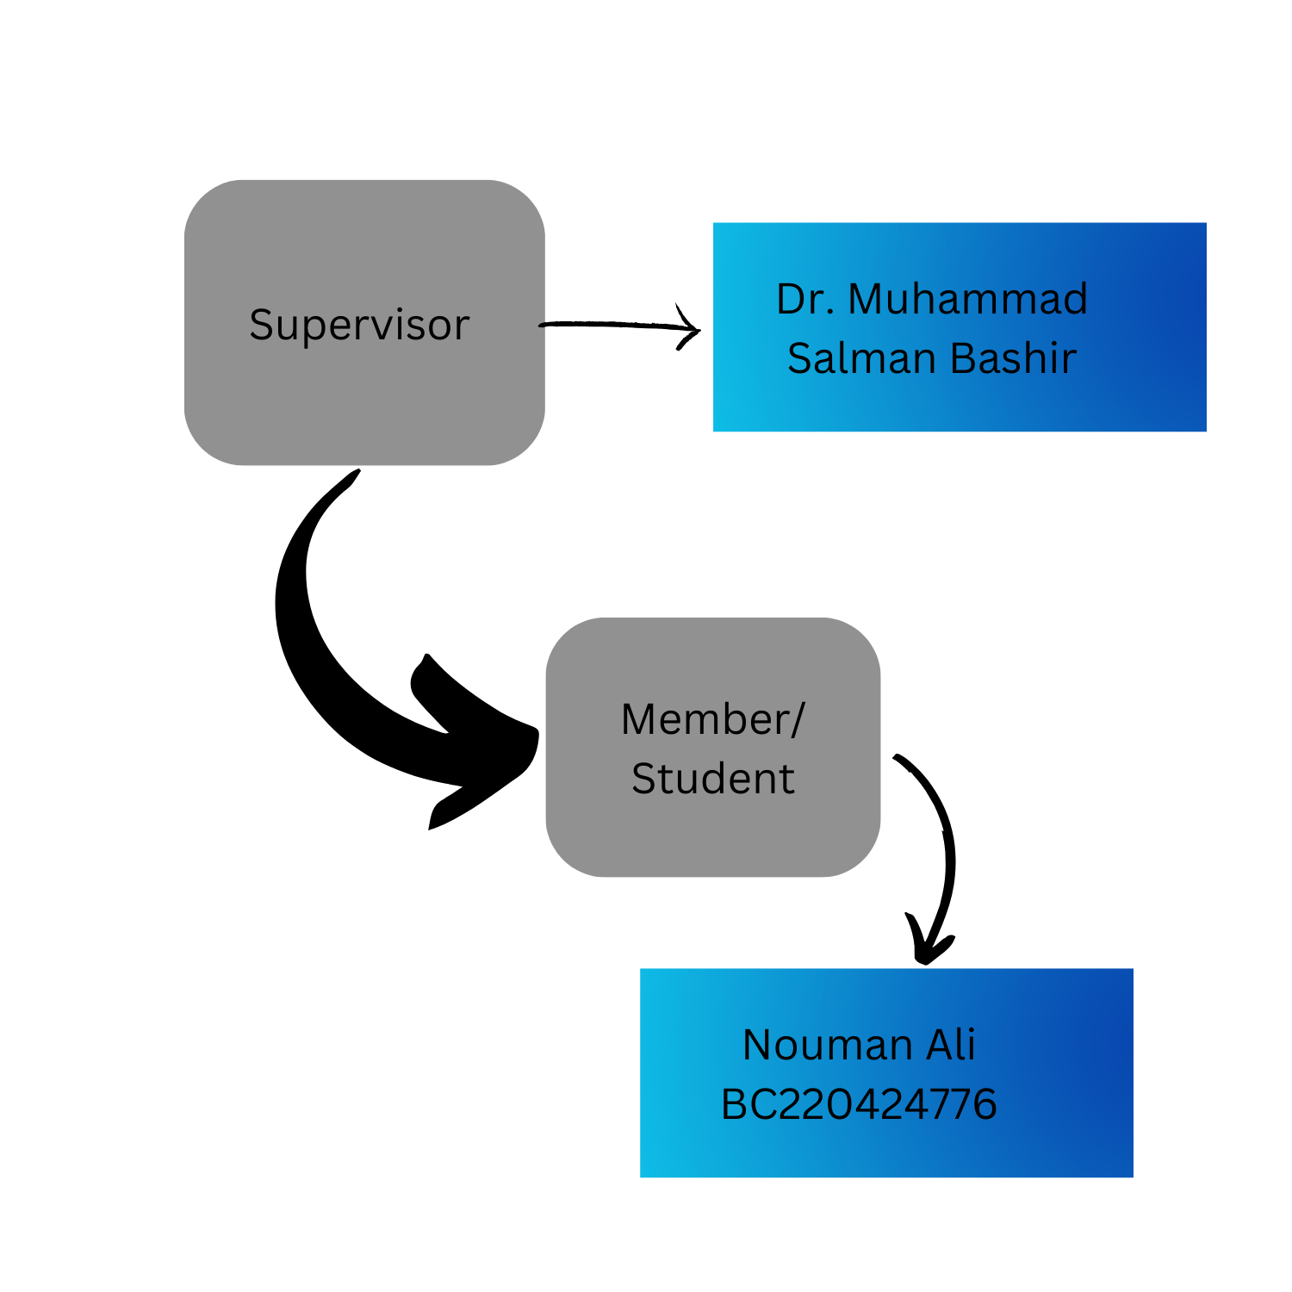

2.7.2 Project Schedule

1. Understanding Requirements:

Duration: 1 week

Tasks: Analyze project requirements and clarify scope.

2. Design and planning phase:

Duration: 2 weeks

Tasks: create SRS document, design database schema, plan system architecture.

3. User Interface Design:

Duration: 1 week

Tasks: Design wireframes and mock-ups using Figma.

4. FrontEnd Development:

Duration: 1 week

Tasks: Develop frontend using core HTML, CSS and JavaScript and ensure compatibility on different browsers.

5. Backend Development:

Duration: 1 week

Task: Develop backend functionalities using PHP, integrate with frontend, ensure data integrity and security.

6. QA, Testing and Debugging:

Duration: 2 weeks

Tasks: test project on different browsers, ensure security and privacy of users and fix bugs and issues (R_and_D).

**CHAPTER 3**

Designing the Project

3.1 Introduction

The designing phase of any software plays very crucial and important role in in shaping user experience (UX) and interface of the final product. We designed the interface ensuring the usability, functionality and good engagement between user and product.

3.2 purpose

The purpose of this phase is to translate the gathered requirements and user needs into a tangible design solution. By creating wireframes, mockups, and prototypes, we aim to visualize the structure, layout, and interactions of the system, ensuring alignment with user expectations and business objectives.

3.3 scope

The scope of the design phase encompasses the creation of user interfaces, navigation flows, and interactive elements that facilitate a seamless user experience. It involves defining design principles, patterns, and standards to guide the development process effectively.

* 1. definitions, acronyms and abbreviations

**Figma:** A cloud-based design tool used foro creating user interface, prototypes and collaborative design projects

**LMS:** Learning Management System, an application for the administration, documentation, tracking, reporting and delivery of educational courses or training programs.

**UI:** User interface, is the point of human-computer interaction and communication in devices.

**UX:** User Experience, the overall experience of a person using a product such as website or any application

**Login Panel:** The interface component where users enter their credentials to access the system or application.

**Home page:** The main/initial page of a website or any application that serves as the starting point for navigation and accessing various features and content.

* 1. Dynamic Model: Sequence Diagrams

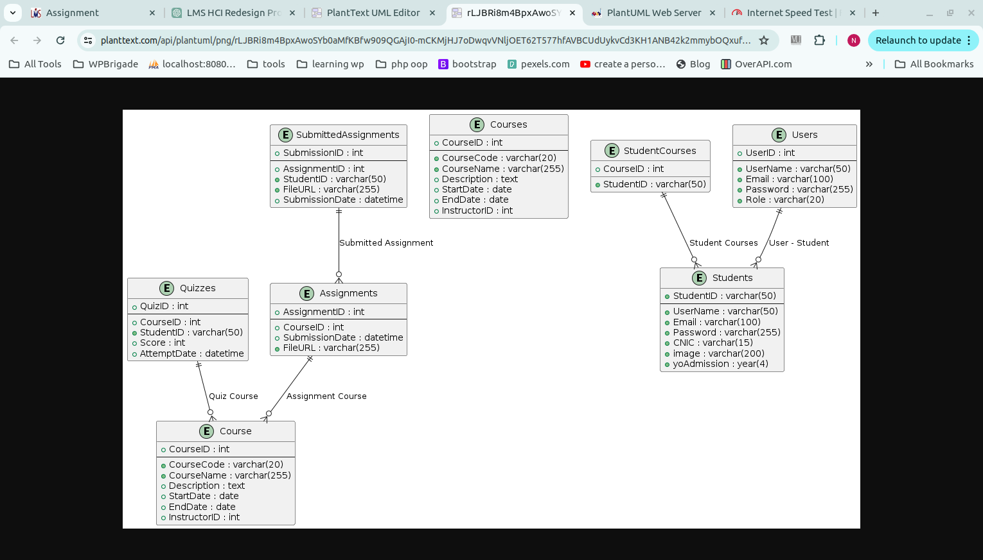

* 1. Object Model/Logical Model: Class Diagram

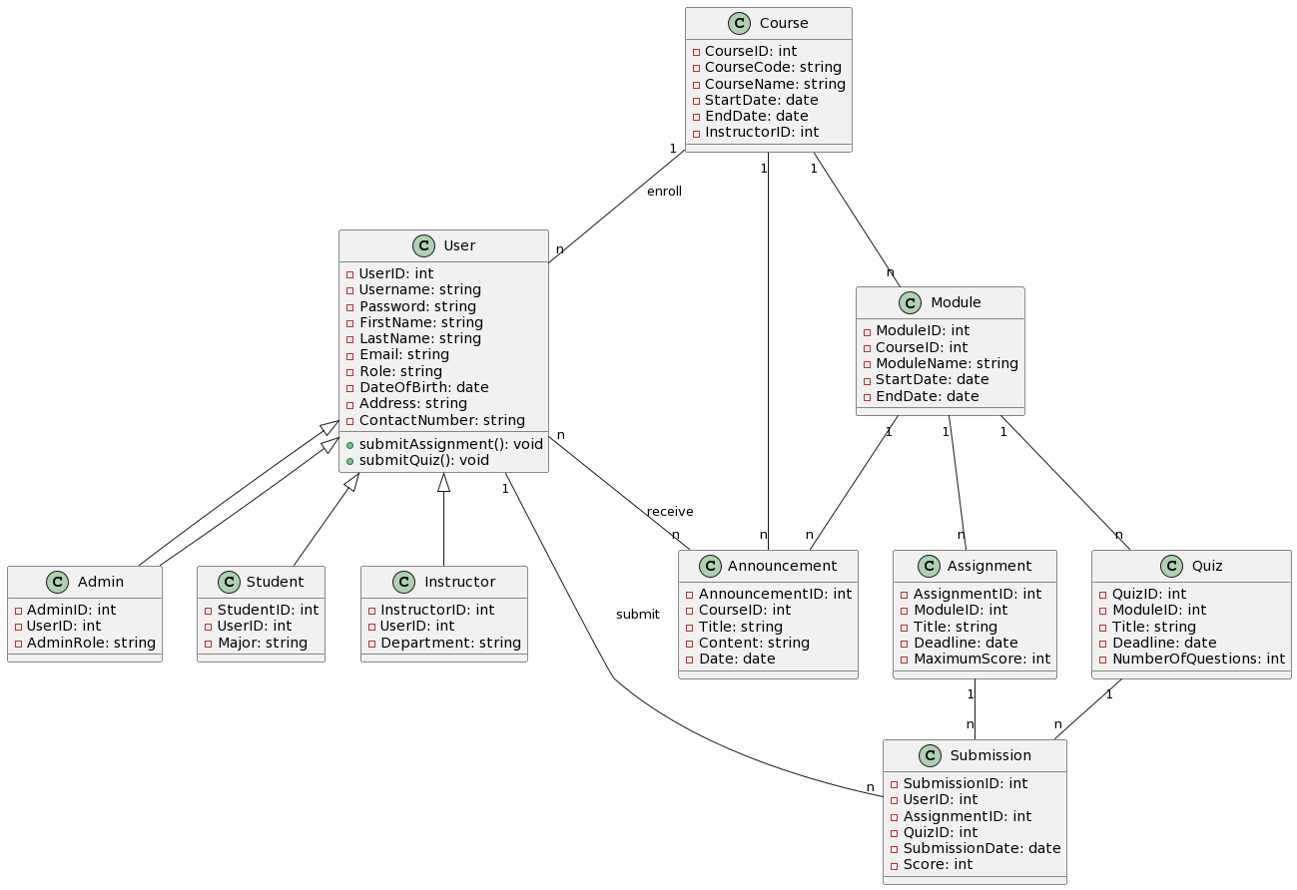

* 1. Database Model (Database Diagram)

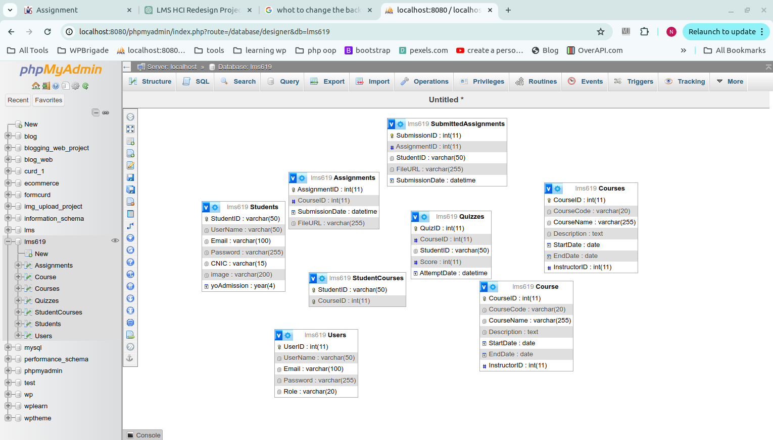

* 1. 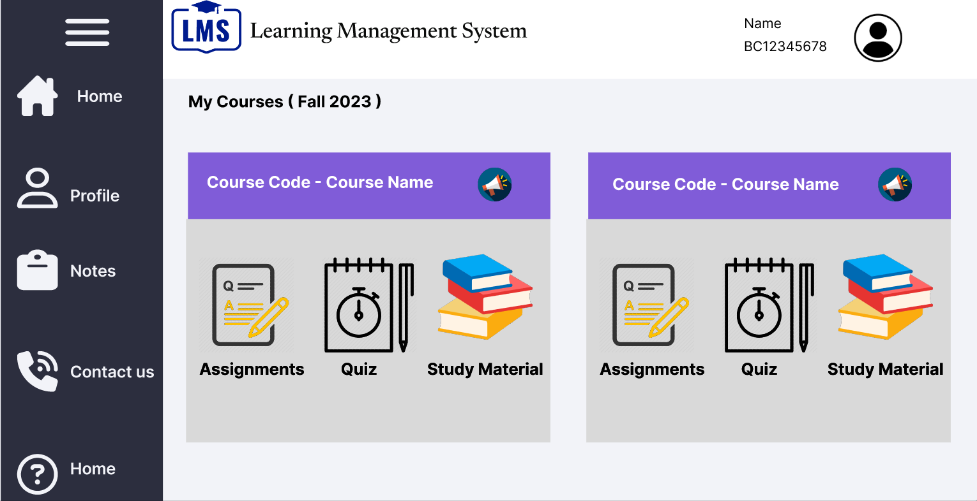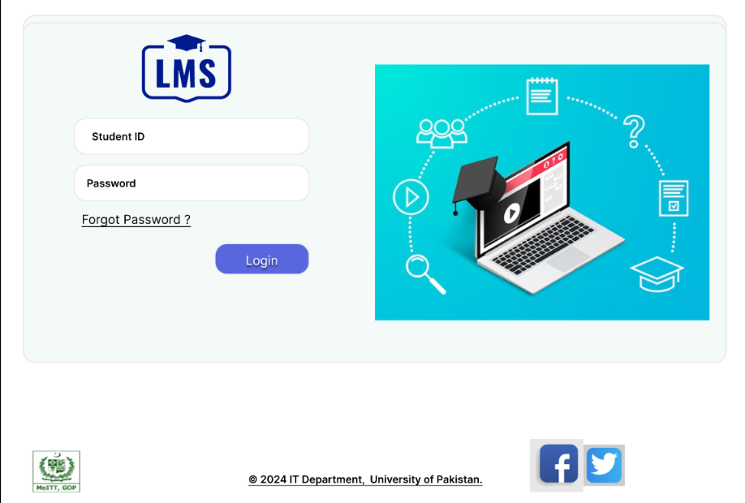Graphical User Interfaces

**CHAPTER 4**

Development

The development plan for this project encompasses a systematic approach to building the Learning Management System (LMS) with a focus on achieving the project's objectives efficiently and effectively. The plan consists of several key stages, each with specific tasks and milestones to ensure the successful completion of the project.

1. **Requirements Gathering and Analysis:** This initial phase involves thoroughly understanding the project requirements, including user needs, system functionalities, and technical specifications. It also includes analyzing existing LMS systems and identifying areas for improvement.

**2. Design and Prototyping:** Following the requirements analysis, the design phase begins, where wireframes and high-fidelity mockups are created using design tools like Figma. These designs serve as blueprints for the user interface and overall system architecture.

**3. Frontend Development:** With the design finalized, frontend development commences using HTML, CSS, and JavaScript. This stage focuses on implementing the user interface elements and ensuring a seamless and intuitive user experience.

**4. Backend Development:** Simultaneously, backend development takes place using PHP to build the server-side logic and database management functionalities. This includes user authentication, data storage, and interaction with the frontend interface.

**5. Integration and Testing:** Once both frontend and backend components are developed, they are integrated to form a cohesive system. Comprehensive testing is conducted at this stage to identify and resolve any bugs or issues, ensuring the system functions as intended.

**6. Deployment and Launch:** After thorough testing and quality assurance, the LMS is deployed to a production environment, making it accessible to users. This stage involves setting up servers, configuring databases, and deploying the application securely.

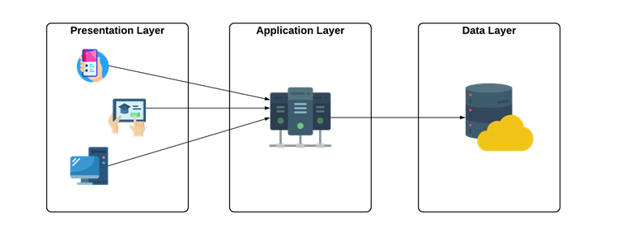

**REFERENCES**

1. Xampp: For local server environment

2. DataTables.net: Popular jQuery plugin for creating interactive tables.

3. javatpoint: online resource for PHP tutorial and documentation

(<https://www.javatpoint.com/php-tutorial>).

4. Figma: Online design tool used for creating wireframes and mockups

(<https://www.figma.com/file/Pba2VFrPTEyaSG4mAcgFGc/Figma-basics?type=design&node-id=4368%3A321189&mode=design&t=eZMjTgBHGyc0cCNQ-1>)

5. YouTube: video tutorial and guidance for various programming concepts and tools.

6. Self Study and Internet: r_and_d (research and development), online resources for learning and problem solving

7. W3Schools: online tutorial and reference for web development language and technologies.

8. PHP.net: offical documentation and resource for php programming language.

9. HCI Research Papers: Academic papers and research studies focused on Humand computer interaction.

**APPENDIX**

1. Sample Wireframes: Collection of wireframe designs created during the interface design phase.

2. Database Schema: Detailed schema of the database structure used in the project, including tables, relationships, and attributes.

3. Code Snippets: Relevant snippets of HTML, CSS, JavaScript, and PHP code used in the development phase.

4. Usability Test Results: Summary of usability test findings, including user feedback and suggestions for improvement.

5. Project Documentation: Comprehensive documentation outlining project requirements, design decisions, and implementation details.

6. Feedback Surveys: Results of feedback surveys conducted with users to gather insights and suggestions for enhancing the LMS user experience.

7. Project Presentation Slides: Slides used for presenting the project overview, methodology, and outcomes to stakeholders.