Screenshots of Postman responses
All API Endpoints:

Users
POST /api/users
GET /api/users
GET /api/users/:userId
PUT /api/users/:userId
DELETE /api/users/:userId

Games
POST /api/games
GET /api/games
GET /api/games/:gameId
PUT /api/games/:gameId
DELETE /api/games/:gameId

Rentals
POST /api/rentals
GET /api/rentals/:rentalId
GET /api/rentals/user/:userId
PUT /api/rentals/:rentalId
DELETE /api/rentals/:rentalId

Purchases
POST /api/purchases
GET /api/purchases/:purchaseId
GET /api/purchases/user/:userId

Reviews
POST /api/reviews
GET /api/reviews
GET /api/reviews/game/:gameId
GET /api/reviews/user/:userId
GET /api/reviews/review/:reviewId
GET /api/reviews/can-review/:userId/:gameId
PUT /api/reviews/review/:reviewId
DELETE /api/reviews/review/:reviewId

Categories
POST /api/categories
GET /api/categories
GET /api/categories/:categoryId
PUT /api/categories/:categoryId
DELETE /api/categories/:categoryId

Memberships
POST /api/memberships
GET /api/memberships
GET /api/memberships/:userId
PUT /api/memberships/:membershipId
DELETE /api/memberships/:membershipId

Context:
The above-mentioned list shows all the API endpoints which our backend supports. The screenshots below show the validity of the most fundamental routes which itself proves the working of all other extensions from that route.
Note:
- In Reviews POST, there is a middleware check where you can only add reviews on the games which you have been confirmed to play,so its not a connection issue
- If in any screenshot it says ID = Null, its not actually null, SSMS auto assigns a 6-digit key to that entry which can be fixed through identity but this deliverable is focusing on API connections.

USERS
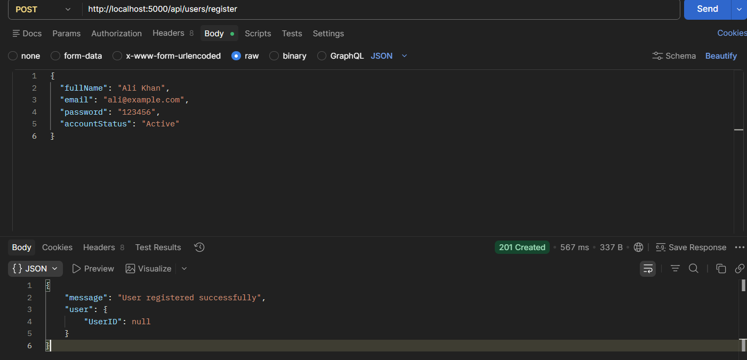
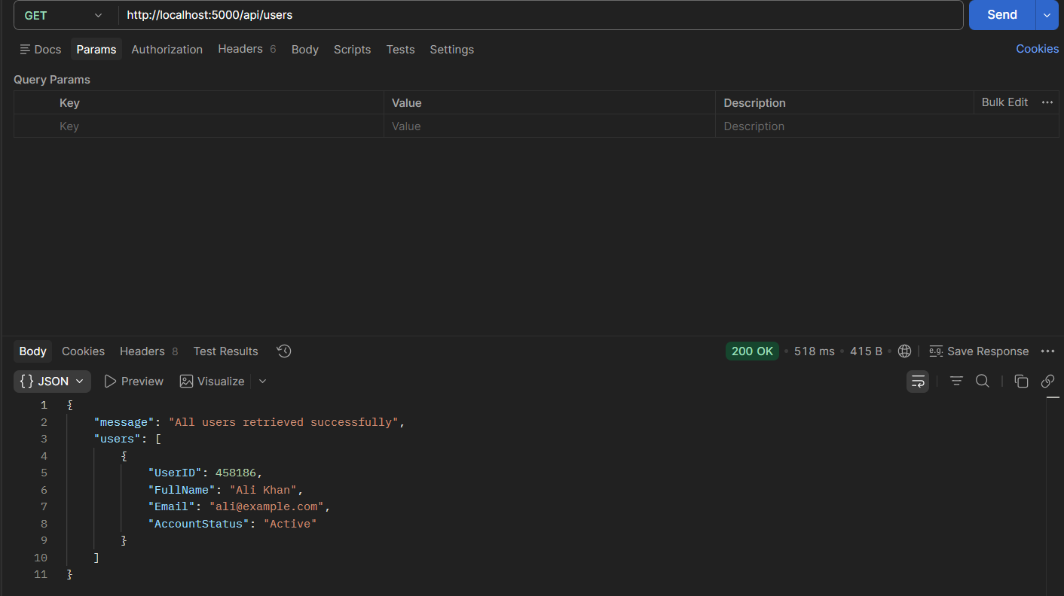
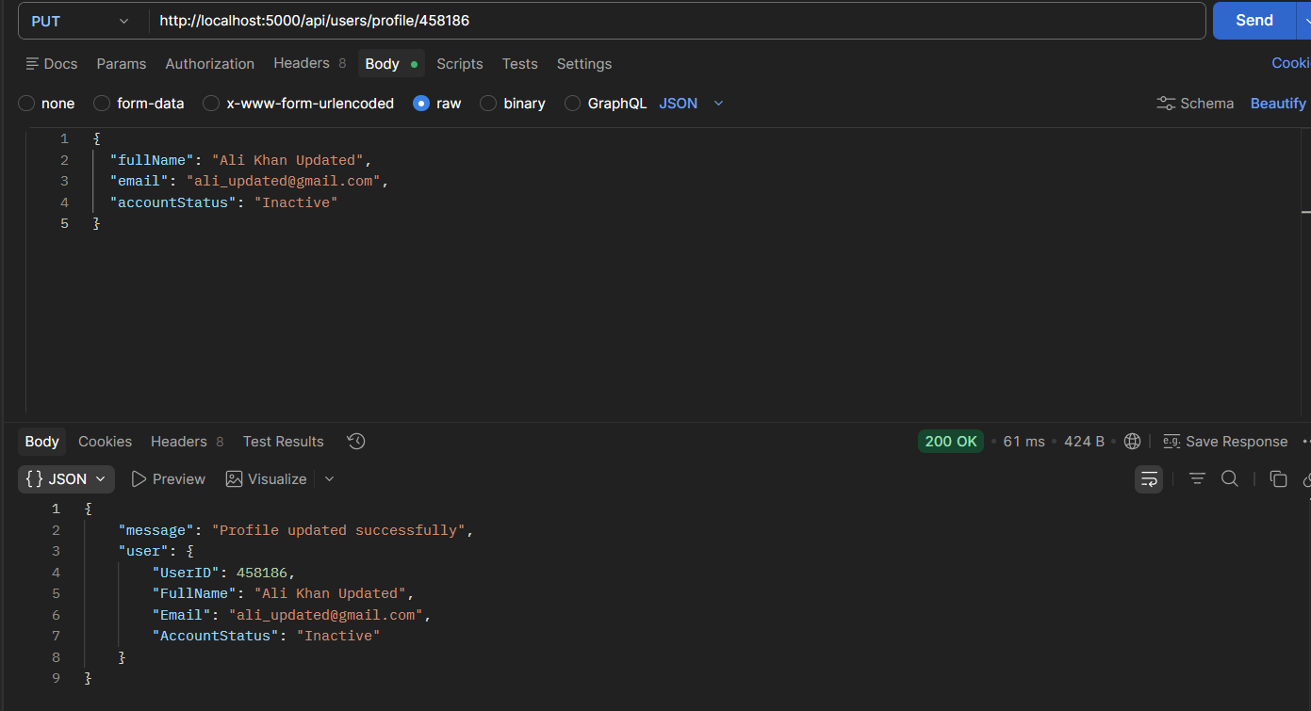
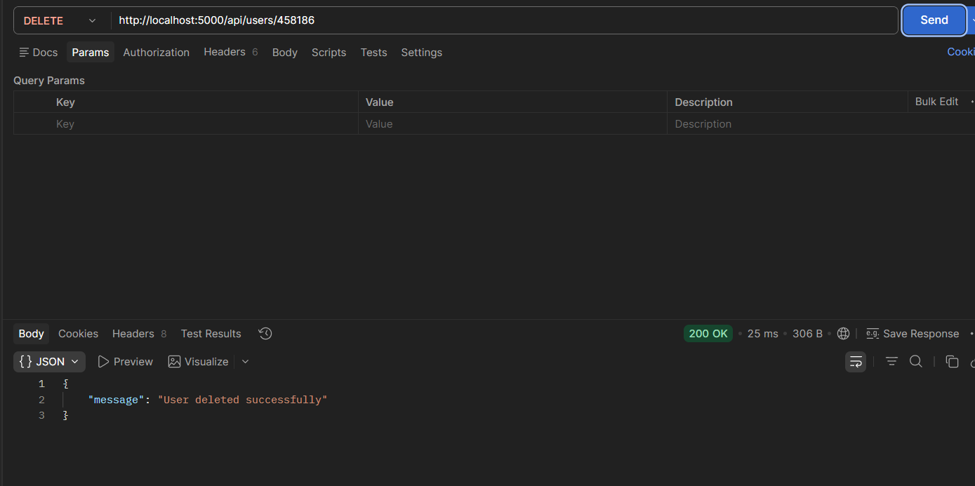

REVIEWS:
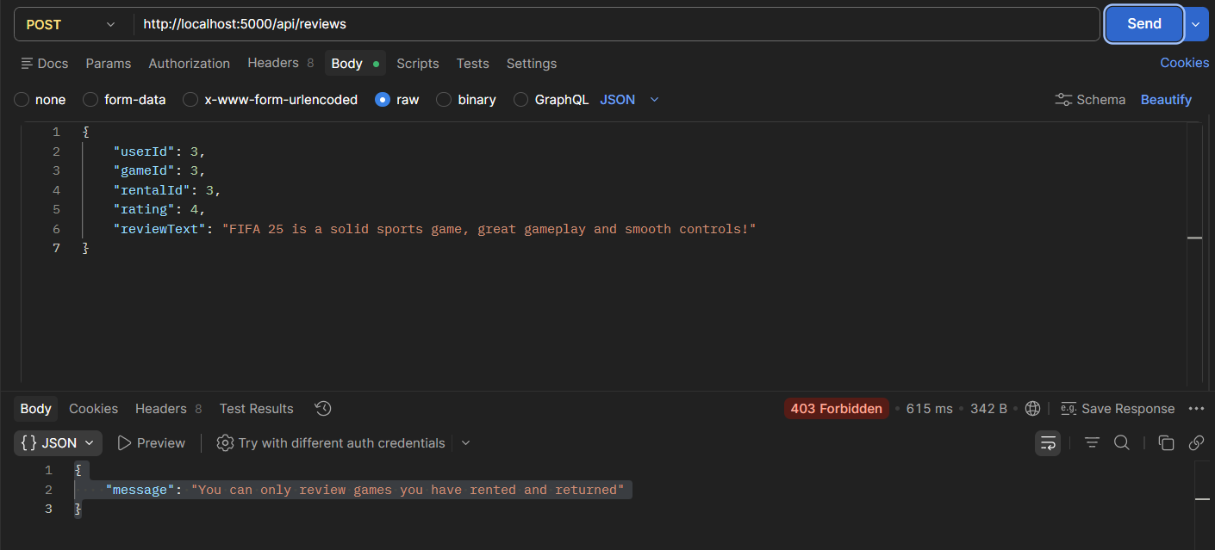
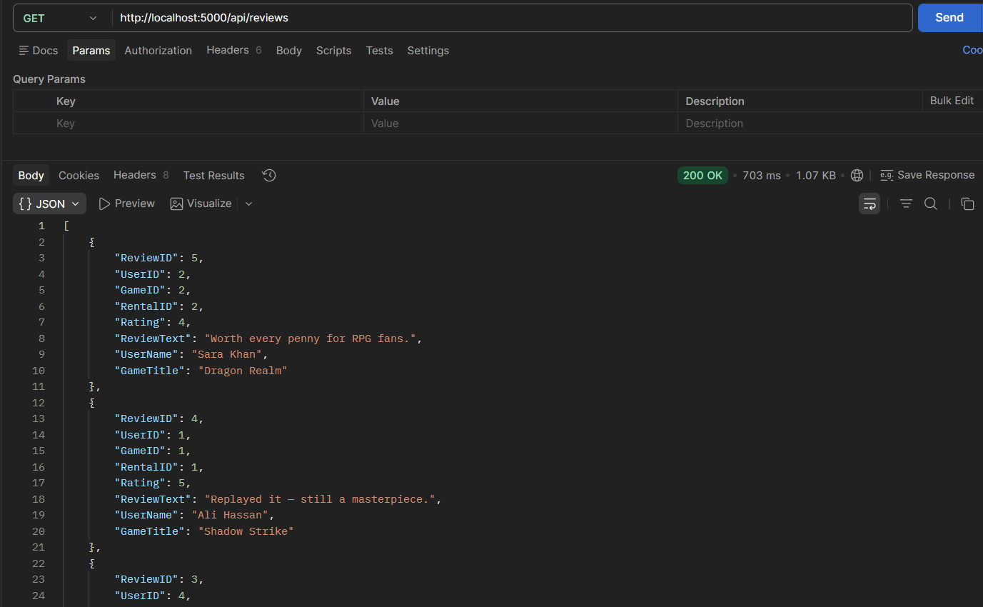
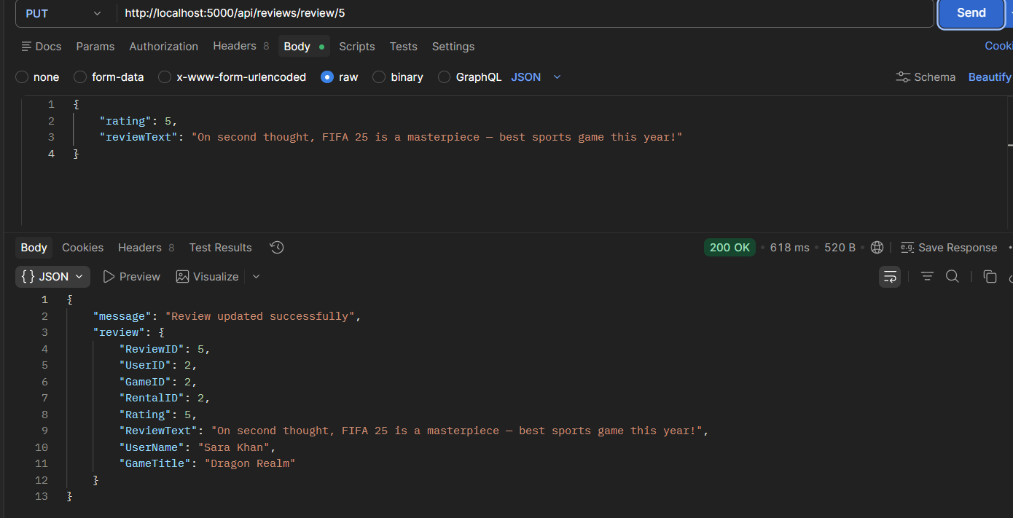
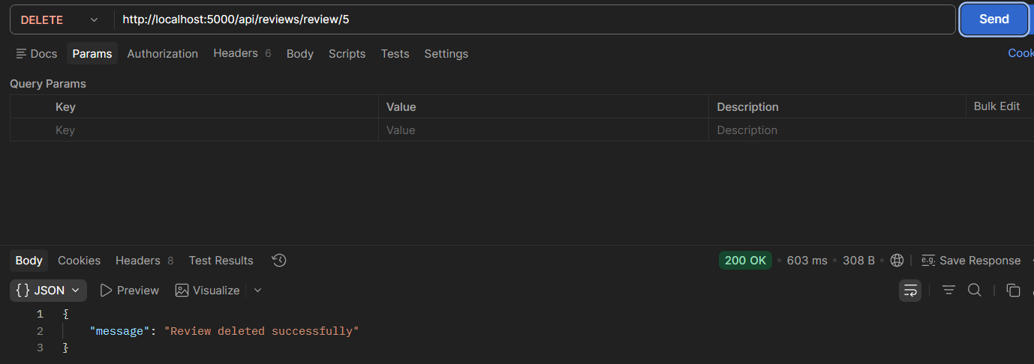

RENTAL
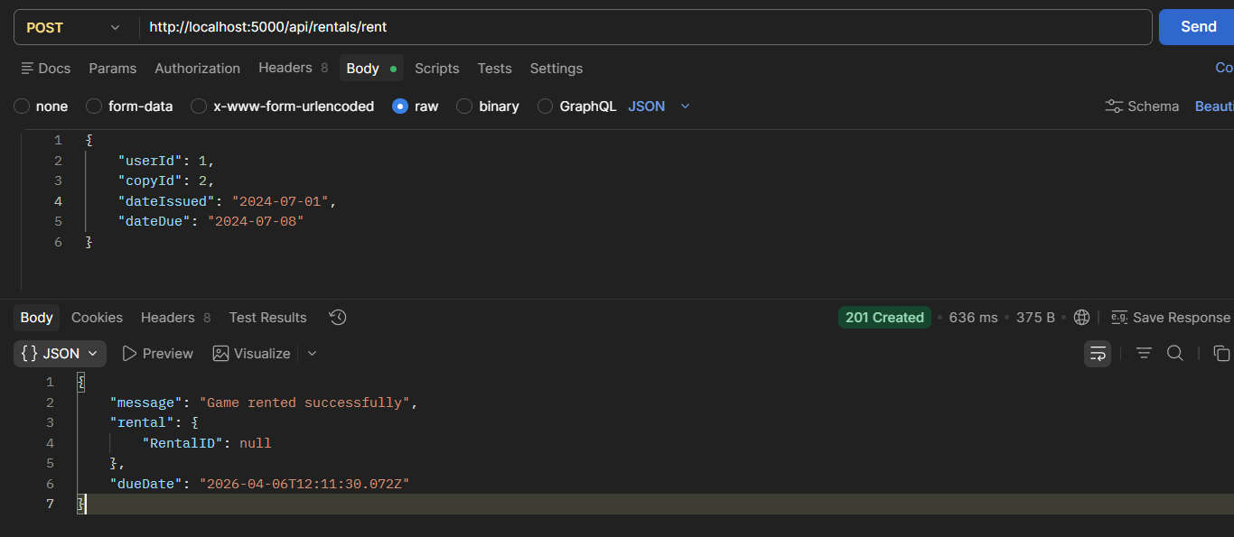
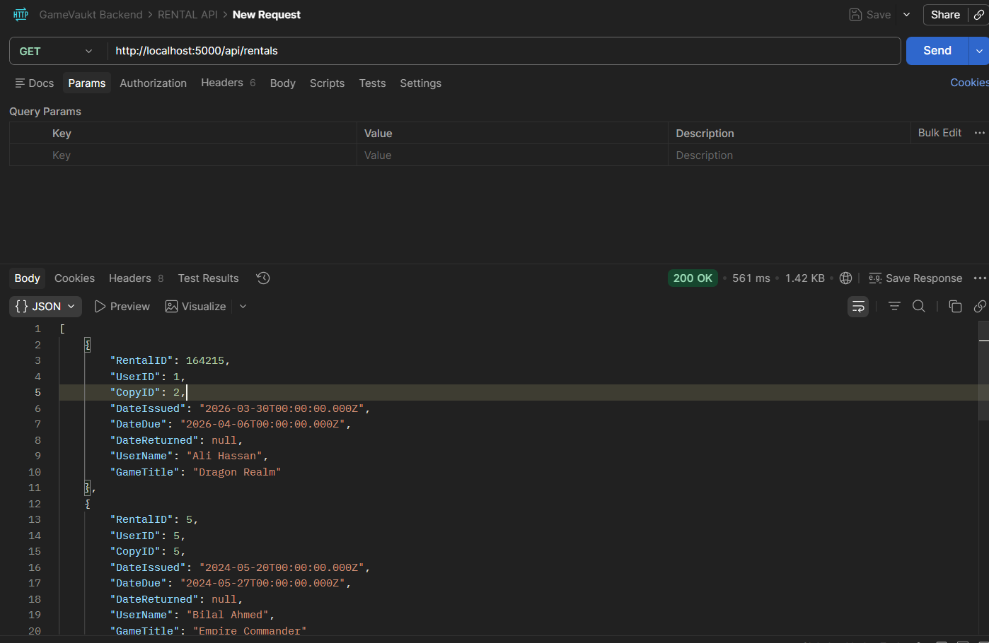
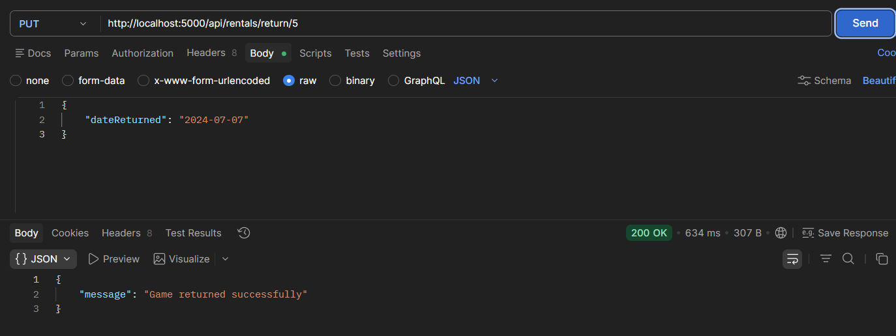
PURCHASE
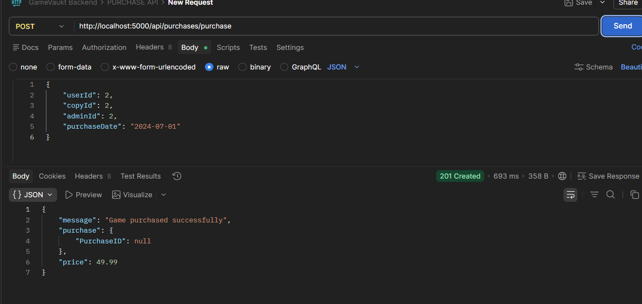
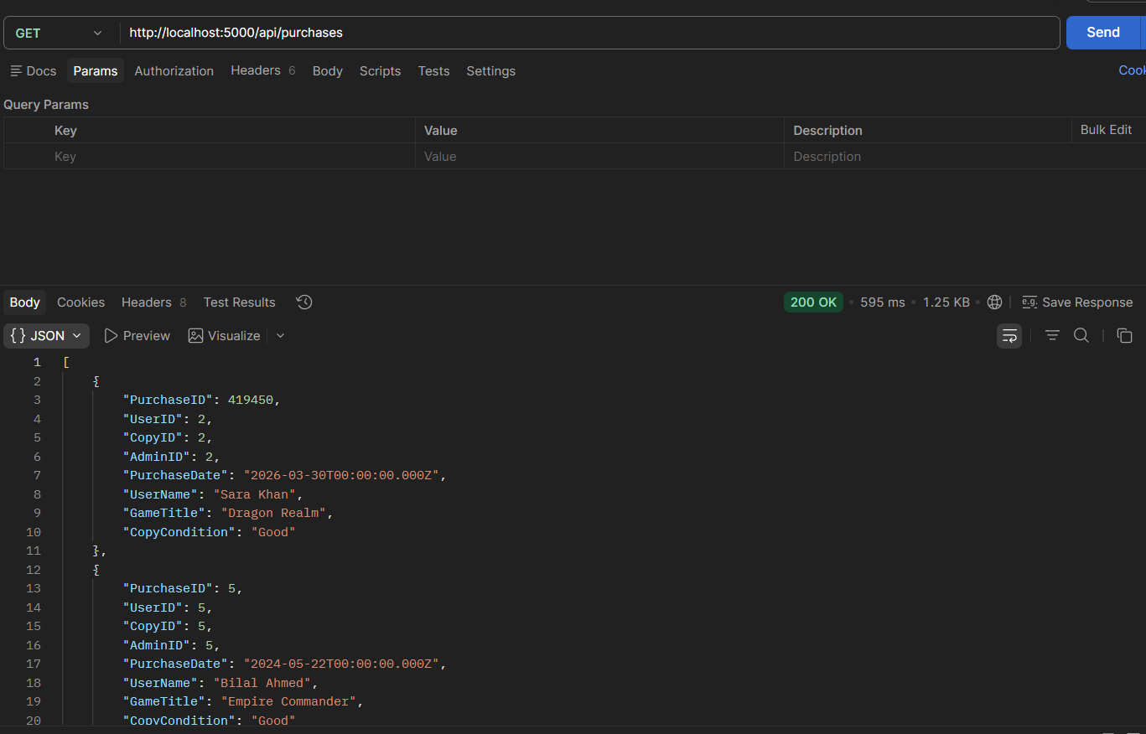

MEMBERSHIPS
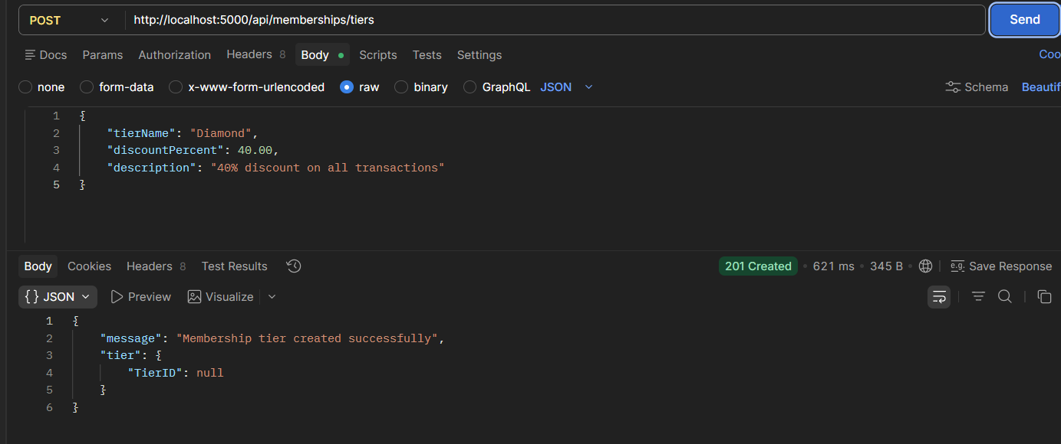
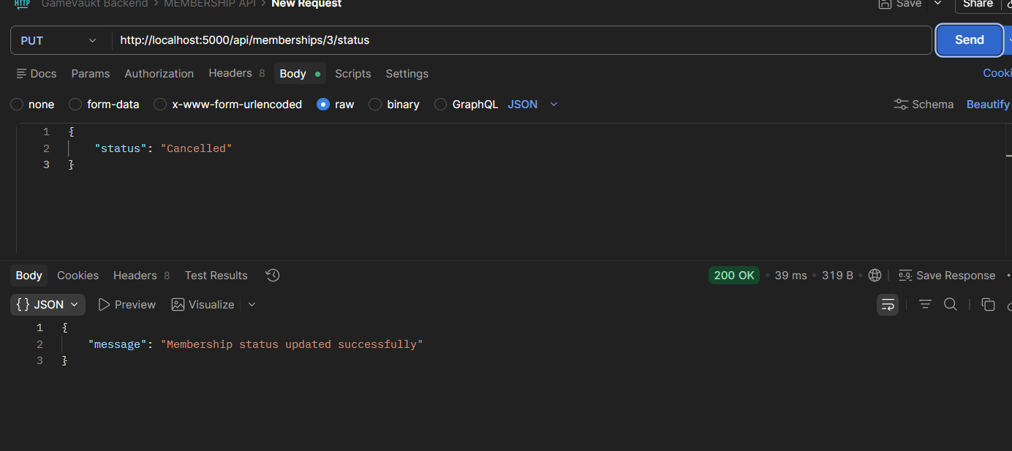

GAMES:
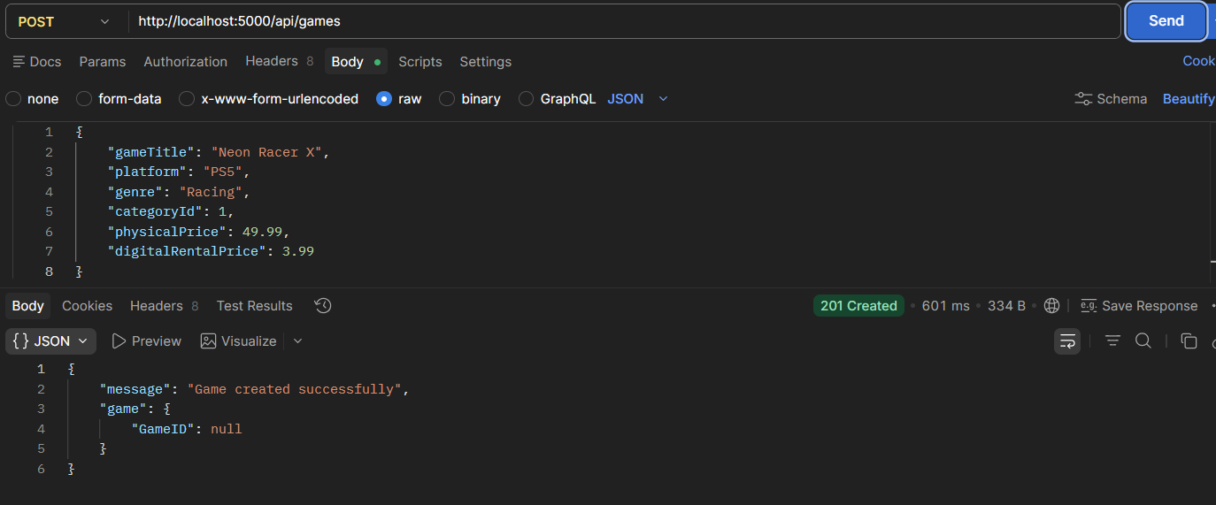
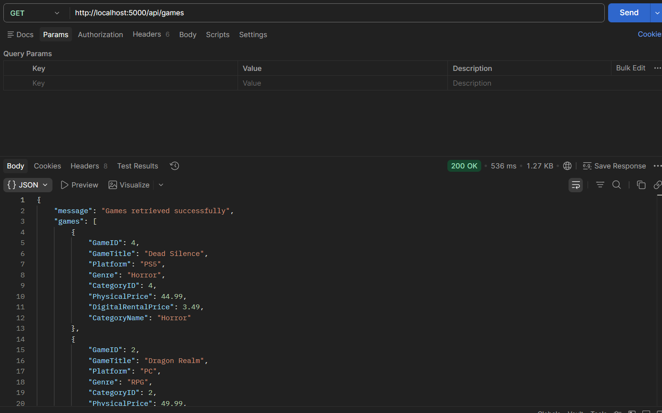
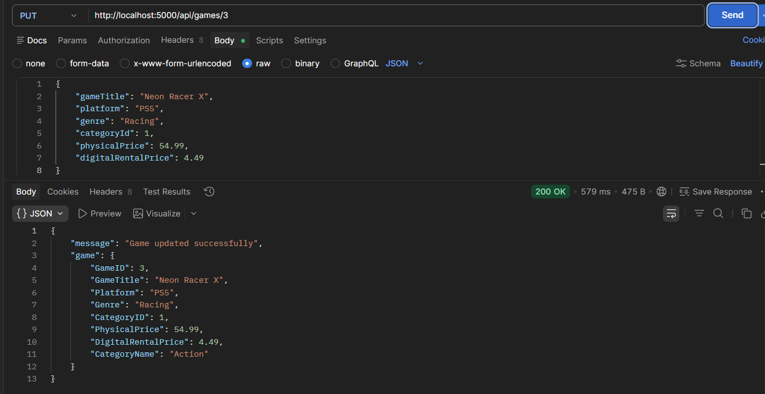

CATEGORY
