Laborator 7 - TCP

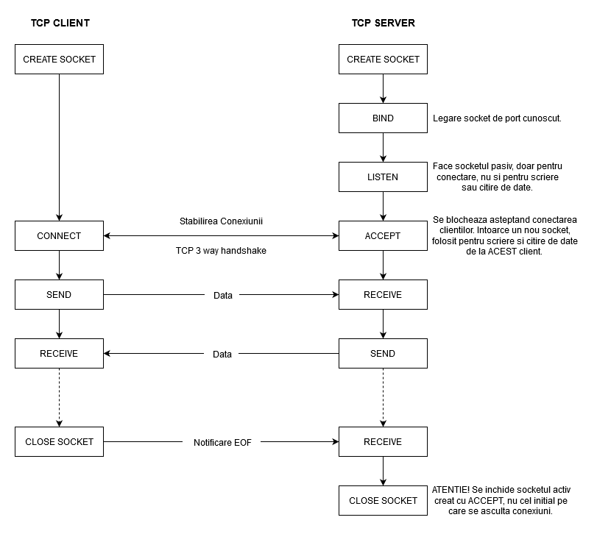

| **Server** | **Client** |
| --- | --- |
| */* int socket(int domain, int type, int protocol); */*  int sockfd = socket(AF_INET, SOCK_STREAM, 0)  if (sockfd < 0) { /* trateaza eroare */ } | |
| struct sockaddr_in serv_addr;  serv_addr.sin_family = AF_INET;  serv_addr.sin_port = htons(1234); | |
| serv_addr.sin_addr.s_addr = INADDR_ANY; | inet_aton(“127.0.0.1”, &serv_addr.sin_addr) |
| */*int bind(int sockfd,*  *struct sockaddr *my_addr,*  *int addrlen)*/*  int rs = bind(sockfd, (struct sockaddr *)&serv_addr, sizeof(serv_addr));  if (rs < 0) { /* trateaza eroare */ } |  |
| */* int listen(int sockfd, int backlog); */*  int rs = listen(sockfd, 1));  if (rs < 0) { /* trateaza eroare */ } |  |
| */* int accept(int sockfd, struct sockaddr *addr, socklen_t *addrlen); */*  rs < 0  struct sockaddr_in client_addr;  socklen_t socket_len = sizeof(struct sockaddr_in);  int connfd = accept(sockfd, (struct sockaddr *)&client_addr&client_addr, &socket_len);  if (connfd < 0) { /* trateaza eroare */ } | /* int connect(int sockfd, const struct sockaddr *addr, socklen_t addrlen); */  int rs = connect(sockfd, (struct sockaddr*)&serv_addr, sizeof(serv_addr));  if (rs < 0} { /* trateaza eroare */ } |
| */* ssize_t recv(int connfd, void *buf, size_t len, int flags); */*  recv(connfd, ...) | */* ssize_t send(int connfd, const void *buf, size_t len, int flags); */*  send(sockfd, ) |
| send(connfd, ...) | recv(sockfd, ) |
| /* int close(ind fd); *#include <unistd.h>* | |

La TCP, send/recv adauga sau citesc date intr-un flux.

Ce inseamna?

1. Cu un recv putem citi date de la mai multe send-uri (senderul poate face 5 senduri, iar recv sa citeasca tot dintr-odata)
2. Recv se deblocheaza cand “ceva date sunt disponibile”

Solutii:

1. incadrarea mesajelor
2. delimitare a mesajelor

Exercitii:

1. Echo server

- 2 terminale

- citim ceva in client, se trimite catre server, serverul trimite inapoi catre client

- fiecare afiseaza ce a trimis

- citim in client -> vedem in server ce s-a trimis -> vedem in client (echoul)

2.

SERVER

// Obtine un socket

int sockfd = socket(AF_INET, SOCK_STREAM, 0); // cer un socket pt stream-uri

// Legarea socketului la o adresa cunoscuta

struct sockaddr_in serv_addr;

serv_addr.sin_family = AF_INET;

serv_addr.sin_port = htons(1234);

serv_addr.sin_addr.s_addr = INADDR_ANY;

bind(listenfd, (struct sockaddr*)&serv_addr, sizeof(serv_addr))

listen(sockfd, 5);

// Acept conexiunea de la cei 2 clienti

connfd1 = accept(listenfd, (struct sockaddr *) &client_addr1, &socket_len);

DIE(connfd1 < 0, "Couldn't accept connection!\n");

printf("Got new connection from %s, port %d, socket %d!\n", inet_ntoa(client_addr1.sin_addr), ntohs(client_addr1.sin_port), connfd1);

connfd2 = accept(listenfd, (struct sockaddr *) &client_addr2, &socket_len);

DIE(connfd2 < 0, "Couldn't accept connection!\n");

printf("Got new connection from %s, port %d, socket %d!\n", inet_ntoa(client_addr2.sin_addr), ntohs(client_addr2.sin_port), connfd2);

// Trimite fiecarui client un numar pentru a sti care dintre el trebuie sa comunice primul

send(connfd1, "1", strlen("1") + 1, 0);

send(connfd2, "2", strlen("2") + 1, 0);

while (1) {

// primesc de la client1

// trimit catre client 2

// primesc de la client 2

// trimit catre client 1

}

CLIENT

// Obtine un socket

int sockfd = socket(AF_INET, SOCK_STREAM, 0); // cer un socket pt stream-uri

// Legarea socketului la o adresa cunoscuta

struct sockaddr_in serv_addr;

serv_addr.sin_family = AF_INET;

serv_addr.sin_port = htons(1234);

inet_aton("127.0.0.1", &serv_addr.sin_addr);

connect(sockfd, (struct sockaddr*)&serv_addr, sizeof(serv_addr))

char buff[BUFLEN], client_nr[BUFLEN];

recv(sockfd, client_nr, BUFLEN, 0); // ce client sunt: 1 - trimit sau 2 - primesc

if (client_nr[0] == '1') {

// citesc de la tastatura

// trimit catre server

client_nr[0] = ‘2’;

} else {

// ordine inversa

// primesc de la server

// afisez pe ecran

client_nr[0] = ‘1’;

}

close(sockfd);

Pentru exercitiul 2:

Relizati implementarea in client.c intr-o functie numita run_client2.

Apelati functia run_client2 in main in loc de apelul lui run_client.

void run_client2(int sockfd) {

char client_nr[2] = {0};

memset(client_nr, 0, 1);

recv(sockfd, client_nr, BUFLEN, 0);

printf("Client received number: %s\n", client_nr);

while (1) {

if (client_nr[0] == '1') {

if (read(STDIN_FILENO, buf, BUFLEN - 1) > 0 && !isspace(buf[0])) {

byte_count = strlen(buf) + 1;

bytes_remaining = byte_count;

// TODO a: Trimiteti lungimea mesajului

int rc = send(sockfd, &byte_count, sizeof(int), 0);

// TODO b: Trimiteti mesajul propriu-zis

while (bytes_remaining > 0) {

...

}

memset(buf, 0, BUFLEN);

}

client_nr[0] = '2';

} else if (client_nr[0] == '2') {

// TODO a: Receptionati lungimea mesajului

int rc = recv(sockfd, &byte_count, sizeof(int), 0);

// TODO b: Receptionati mesajul propriu-zis

while (bytes_remaining > 0) {

...

}

fprintf(stderr, "Received from the other client: %s\n", buf);

client_nr[0] = '1';

}

}

}

Structs:

*#include <netinet/net.h>*

struct sockaddr_in {

unsigned short sin_family; // familia de protocoale pe care le folosim

// ex: AF_INET (IPv4), AF_INET6 (IPv6)

unsigned short int sin_port; // portul (in network byte order)

struct in_addr sin_addr; // adresa ip pe care ascult dupa conexiuni

// (in network byte order)

}

struct in_addr {

uint32_t s_addr; // adresa IPv4 pe 32 de biti in network byte order

}

*#include <sys/socket.h>*

/* tip de date generic pentru a retine info despre adresa socketilor */

struct sockaddr {

unsigned char sa_family;

char sa_data[14];

}