Hey, I’ve gone through the new app and noted down a few things/questions.
Overall, I think the direction is good — just a few areas I’d like to clarify or adjust:
Overview page
Where is the Overview page now? I’d like to be able to see post performance there and save the top-performing posts for future reference/reuse.
Manual page
It looks like the Manual page no longer exists. Could we move this section back to the Manual page? I have some future plans for the Manual page, but for now I don’t need anything beyond this.
Padding / Text size
Padding doesn’t seem to be working anymore — changing the setting doesn’t seem to make any difference. It looks like the same might be happening with text size as well. Could you check?
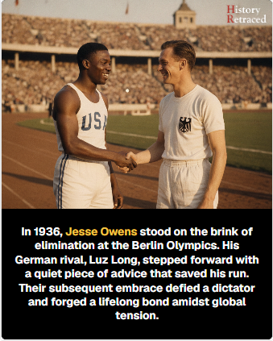
Hashtags
I don’t think we need hashtags anymore, so we can remove this.
Circular inset
Could we have the following options back? No border, Border colour, Border size, AI-generated image. Mixture of on the settings page and on the review page.
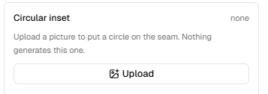
Generation & Templates
When generating a post, I don’t see an option to choose between the Card template and the Full Overlay template.
It would also be useful to have the same option during the review stage, so we can switch between the two templates before publishing.
When generating, we also need an option to: Generate without an image Use the image provided by the RSS feed
Additional
AI image sourcing It would be great if we could let the AI source a suitable real-life image from the internet when needed, for both the hero image and the circular inset image.
Hook / Caption / First Comment
I don’t see an option to regenerate these anymore. Could we bring that back?
Post + First Comment Scheduling
A few things I’d like to clarify/rework here: What exactly does the Approve button do? Does it simply remove the post from the queue? If so, I’m not sure we actually need an Approve button — perhaps we can just have the scheduling options directly.
I think we should have:
Publish Now, Schedule, Schedule Next Available Time Slot.
For Schedule Next Available Time Slot, this should be based on the time slots configured in Page Settings.
In Page Settings, we should be able to create as many time slots as needed and modify the time of each slot.
First comment delay I don’t want the first comment to be published at exactly the same time as the post. Could we add a First Comment Delay setting in Page Settings?
It could have: No delay Delay by X minutes
So the post gets published first, then the first comment is posted after the selected delay.
Automation thoughts — optional
I think full automation makes more sense for time-sensitive content, such as news/politics, where the RSS feed can act as the source. For this type of content, a fully automated flow — where AI determines whether something is time-sensitive and can then publish it automatically.
For other content, I’d probably keep the review/scheduling flow more manual for now.
Server
One other thing: if we decide to continue using Vercel as the server, I’ll also need your help moving the YouTube automation tool away from my VPS so it no longer depends on it. In that case, I’ll need to create my own Vercel account, and you would need to move everything over there as well.
Let me know what you think — happy to discuss any of these if there’s a better way to structure the flow.

