Republic of the Philippines
CAVITE STATE UNIVERSITY
College of Engineering and Information Technology
Don Severino delas Alas Campus, Indang, Cavite
Software Requirements Specification
for
RouteX: A Truck Profitability and Delivery Operations
Management System
Version 1.3 - Priority Revision
Prepared for:
Redeemed Route Logistics Inc.
3rd Floor, Glass Door, AGDC Commercial Bldg, Trece Martires - Indang Rd,
Inocencio, Trece Martires City, 4109 Cavite
Prepared by: RouteX Project Team
Louiza Joy C. Beñares
Jelene C. Punongbayan
Marc Rancel R. Bongalos
Date: October 17, 2026

Table of Contents
Table of Contents 2
Revision History 2
1. Introduction 3
1.1. Document Conventions 3
1.2. Purpose 3
1.3. Project Scope 3
1.4. Product Perspective 4
1.5. Product Functions 4
1.6. Design and Implementation Constraints 5
1.7. User Documentation 5
1.8. Assumptions and Dependencies 5
2. Data Requirements 6
2.1. Data Validation Rules 6
2.2. Data Security and Privacy Requirements 6
2.3. Data Retention and Backup Requirements 6
3. System Features 7
3.1. Functional Requirements 7
3.2. Nonfunctional Requirements 9
4. System Model and Diagrams 11
4.1. Use Case Diagrams 11
4.2. Entity Relationship Diagrams 11
4.3. Activity Diagrams 12
5. Other Requirements 12
Appendix A: Glossary 13
Appendix B: To Be Determined List 13
Appendix C: References 14
Requirements Validation / Consistency Review 14

Revision History
Name | Date | Reason for Changes | Version
RouteX | September 26, 2026 | Initial SRS draft (source PDF) | 1.0
RouteX | October 12, 2026 | Working revision reflecting clarified workflow and requirements | 1.1
RouteX | October 17, 2026 | Cross-checked against Project Plan, Technical Documentation, LOA and prototype evidence; restored original PDF section structure; reconciled outdated or unsupported statements | 1.2 working draft
RouteX | October 17, 2026 | Rebalanced functional requirement priorities; other requirement content retained | 1.3 priority revision

1. Introduction

1.1. Document Conventions
This Software Requirements Specification (SRS) organizes the intended requirements for RouteX using the section order of the original RouteX_SRS.pdf. Statements distinguish required behavior from recommendations and unresolved decisions. Requirements describe the intended scope; they do not by themselves prove that a feature is already implemented.
Convention | Description
RouteX | The proposed internal web application for Redeemed Route Logistics Inc. described in this SRS.
SRS | Software Requirements Specification.
POD | Proof of Delivery document associated with a delivery record.
RBAC | Role-Based Access Control; access is granted according to approved roles and permissions.
Shall | Required system behavior.
Should | Recommended behavior that remains subject to project prioritization.
May | Optional behavior.
REQ | Functional requirement identifier.
NFR | Nonfunctional requirement identifier.
TBD | To be determined; the point requires confirmation or an approved rule.

Requirement IDs are intended to remain unique and traceable to tests. “Approved” means explicitly confirmed by the client or authorized project decision-maker, not simply present in an earlier draft or prototype.

1.2. Purpose
This SRS defines the current proposed functional and nonfunctional requirements for RouteX: A Truck Profitability and Delivery Operations Management System. RouteX is intended to centralize completed-delivery records and related financial information so authorized personnel can retrieve records and review delivery-, truck-, and company-level performance.
The source documents describe a partially automated internal system. Staff enter operational and financial source information; the application validates, stores, retrieves, aggregates, and calculates from the recorded data. RouteX is not intended to be a live dispatch or GPS-tracking platform.

1.3. Project Scope

1.3.1. Scope
The reconciled target scope described by the October 2026 Project Plan, Technical Documentation, SRS working revision, and LOA includes the following capabilities. They remain requirements, not claims of completed implementation.
- Completed delivery transactions recorded by Operations after the real-world delivery has been completed, including the client, truck, driver/helper assignments, route or delivery locations, date and relevant timestamps, revenue/approved charges, delivery-attributable expenses, remarks, and POD linkage.
- Fleet and reference records needed for delivery operations, including owned/subcontracted trucks, plate number, truck type, status, clients, employees/crew, and relationships among those records.
- Delivery financial entries and derived delivery-level results using a client-approved formula. Derived results must not be directly editable as source amounts.
- POD upload, retrieval, and viewing linked to the correct delivery record and protected by permissions.
- Finance-managed company operating expenses that are not directly attributable to a specific delivery, kept distinct from delivery expenses.
- HR-maintained compensation amounts payable or period summaries for staff, drivers, and helpers. This is not an assumption of a complete payroll-processing engine.
- Search and date-range filtering across supported delivery, truck, client, employee/crew, and transaction records. The selected reporting period should remain visible in relevant views and exports.
- Truck profiles/history and delivery-, truck-, and company-level financial review under explicitly approved inclusion rules.
- Operational and financial reports, supported print/export functions, dashboards, authentication, role-based authorization, account administration, activity logs, and audit history.
The intended differentiator is traceability from a company-level result to a truck, then to the deliveries and underlying financial records that contribute to that result. This must not cause an expense to be counted more than once.

1.3.2. Limitations
- No automatic real-time GPS tracking, live-location maps, telematics, or tracking-device integration.
- No automatic dispatching, route optimization, customer portal, customer-facing booking, or customer-facing delivery tracking.
- No full accounting replacement, BIR filing, statutory-reporting automation, end-to-end payroll engine, attendance management, payslips, or automatic bank payments unless separately approved in writing.
- No automatic import from third-party platforms or other external business integrations under the current documented scope.
- No automatic allocation of company overhead to individual truck margins unless the client approves an allocation method.
- Accuracy and completeness of results depend on data entered and on financial classifications/formulas approved by the client.
- Only features in the approved requirements and change record are included. Proposed improvements, including a missing-POD/data-completeness cue, require scope confirmation if not already accepted.

1.4. Product Perspective
The project documents describe current work as spread across spreadsheets, paper records, basic bookkeeping, and communication channels. RouteX is intended to provide a centralized, browser-based tool for post-delivery recordkeeping, retrieval, documentation, and profitability review. It does not resolve dispatch coordination, delayed collections, or vehicle breakdowns on its own.
The latest available product prototype, RtX_-prototype-z(4).html, is a static interactive UI prototype. Its navigation includes Dashboard, Deliveries, Fleet, Transactions, Reports, and Administration, with Settings controls and shared search/date filters. It displays mock records and sample calculations. It does not establish production database, authentication, permissions, HR compensation, or deployment status. Therefore, the broader HR and company-level profitability scope in the October project documents is retained as target scope but flagged for confirmation against the current build.

1.5. Product Functions
Function area | Expected function
Dashboard | Summarize operational and financial records for the selected period; exact cards and metrics require validation against the implemented dashboard.
Delivery Management | Maintain completed delivery records, assignments, timestamps, revenue/charges, delivery costs, remarks, and POD.
Fleet Management | Maintain owned/subcontracted truck records and retrieve truck history for a selected period.
Transactions / Company Expenses | Maintain company operating expenses not assigned to a specific delivery.
HR Compensation Summaries | Record or summarize approved compensation amounts for staff, drivers, and helpers; detailed rules remain TBD.
Search and Record Retrieval | Search records by supported identifiers/text and filter by date range.
Profitability Analysis | Review delivery-, truck-, and company-level results distinctly, with source-record traceability and expense de-duplication.
Reports | Provide agreed operational/financial reports and available print/export formats.
Security and Administration | Authenticate users, enforce approved role permissions, manage accounts and record activity/audit events.

1.6. Design and Implementation Constraints

1.6.1. Technical Constraints
- The current project documents specify a single web application using Next.js 15 App Router, React, TypeScript, Tailwind CSS, shadcn/ui, and Lucide React.
- Server-side processing is specified through Next.js Server Actions and Route Handlers; no separate backend application is in scope.
- The database baseline is PostgreSQL through Supabase; file storage is Supabase Storage; authentication is specified as Auth.js; deployment is proposed on Vercel; npm is the package manager.
- The documented architecture says not to use Prisma or create a separate backend application.
- Authorization must be enforced server-side for protected reads, mutations, exports, and file access. Secrets and service-role credentials must not be exposed to browser code.
- POD and supporting documents must be protected by appropriate access checks and not be unrestricted public files by default.
- The current technical stack is a documented design baseline, not proof of completed integration or production deployment. In particular, the Auth.js/Supabase integration and production authorization model require technical validation.

1.6.2. Operational and Scope Constraints
- Access is restricted to authorized internal users under an approved role-permission matrix.
- Operations records delivery transactions after completion; users enter the source information and remain responsible for corrections according to approved permissions.
- The system relies on stable internet access and a modern desktop browser; minimum supported browsers and mobile behavior remain TBD.
- Proposed hosting provider ownership, production tier, recurring-cost payer, backup setup, and day-to-day operational owner are not established by the prototype.
- The project timeline in the current Project Plan/LOA is August 10 to December 4, 2026. The Project Plan says active development is planned to start October 19; this SRS does not assume earlier work is complete.

1.7. User Documentation
- Digital user manual explaining role-specific use of delivery records, fleet/reference data, POD, search, financial records, profitability views, reports, and administration.
- User orientation/training material for client turnover.
- Technical documentation describing the delivered architecture, data model, configuration, security, deployment, backup/restore arrangement, and known limitations.
- Documents must match the accepted implemented version rather than merely repeat this requirements draft.

1.8. Assumptions and Dependencies

1.8.1. Assumptions
- The client will provide or approve workflows, required fields, expense classifications, calculation examples, role permissions, and UAT scenarios needed to resolve TBD items.
- Users will enter accurate source data and protect their credentials; only authorized personnel will receive system accounts.
- Financial outputs remain provisional until the client approves formulas and inclusion rules in writing.
- The reviewed project documents are working documents. Where they conflict, the discrepancy is recorded in Requirements Validation / Consistency Review rather than silently resolved.

1.8.2. Dependencies
- The app depends on the selected hosting, database, authentication, and file-storage services remaining available and being configured securely.
- A stable internet connection and a supported modern browser are required; the exact browser/device support matrix is TBD.
- Hosting ownership and costs, retention, backups, file limits, and deployment controls require decisions before production use.
- Client feedback and approval are needed to finalize unresolved business rules and acceptance criteria.

2. Data Requirements

2.1. Data Validation Rules
- Delivery records shall reference valid client, truck, and crew/employee records as applicable.
- Delivery IDs and truck plate numbers shall be unique according to an approved uniqueness rule; the treatment of historical plate reuse or duplicate source IDs requires confirmation.
- Dates and timestamps must parse as valid values. The exact definitions, timezone conventions, and mandatory status of Call Time, ETA/arrival at store, Start Loading, End Loading, and Departure remain TBD.
- Money shall be stored using exact decimal/numeric values or integer minor units, not floating-point types.
- Amounts shall be numeric. Negative values, refunds, credits, corrections, reversals, and adjustments must follow an explicit approved business rule rather than being universally rejected.
- Base delivery revenue, approved additional revenue charges, delivery-attributable expenses, company expenses, and compensation summaries shall be represented distinctly enough to support reconciliation and avoid double counting.
- Derived delivery/truck/company totals and margins shall be calculated from approved source entries; derived values shall not be editable as if they were source transactions.
- Historical delivery values must not silently change when current rates or reference data are edited.
- POD uploads shall be associated with an existing delivery and validated against client-approved file-type and size limits. These limits remain TBD.
- Record states including cancelled, incomplete, disputed, adjusted, refunded, and duplicate deliveries require approved handling rules before calculations/reports are finalized.
- A missing-data or missing-POD indicator, if approved, must be based on explicitly defined required fields and must not substitute for validating the underlying record.

2.2. Data Security and Privacy Requirements
- The system shall authenticate users before granting access to protected records and shall enforce role-based permissions on the server, not only by hiding interface controls.
- Passwords and authentication secrets shall be handled using secure authentication mechanisms; secret configuration and service-role credentials shall not be exposed to browser code.
- Production communications shall use HTTPS/TLS.
- Access to POD files, financial records, employee/compensation information, exports, and audit logs shall be restricted according to approved permissions.
- Important record creation, modification, upload, and account-related events shall be logged. Before/after values should be retained for important financial/operational changes where technically supported and approved.
- Audit logs must not store passwords or unnecessary sensitive data.
- Personal and business records shall be handled for authorized operational purposes and consistently with applicable Philippine data-protection requirements. The SRS does not itself certify legal compliance; the implementation and procedures require review.
- Administrative rights must be separated from permission to edit financial records unless the approved permission matrix explicitly combines them.

2.3. Data Retention and Backup Requirements
- Delivery, truck, client, crew/employee, expense, compensation-summary, user, POD, and audit records shall be retained as required for agreed operational use and historical review.
- A backup and recovery arrangement shall be defined before production use. Backup frequency, retention length, recovery expectations, and responsibility for restore tests are TBD.
- POD file retention, attachment limits, deletion/archive behavior, and backup coverage require agreement with the client and hosting provider.
- Data export and handling on project termination shall follow the governing agreement and the approved turnover process.
- The currently available LOA-aligned file still contains conflicting maintenance/support wording and other editorial notes; this is a contract-document issue that must be corrected separately and is not treated here as an approved system function.

3. System Features

3.1. Functional Requirements
Priority: High = essential for the first release and core business outcomes; Medium = useful supporting capability that can follow once the core workflow is reliable; Low = optional enhancement that may be deferred. Priority measures business importance, not implementation readiness. Unresolved business rules remain listed as TBD and must not be guessed. The requirements below describe the target system. The UI prototype is not proof of implementation.
ID | Area | Requirement | Priority | Acceptance / Validation
REQ-001 | Authentication | The system shall require an authorized user to authenticate before accessing protected records. | High | Protected data cannot be viewed without authentication.
REQ-002 | Authorization | The system shall enforce role-based permissions server-side for protected pages, queries, mutations, exports, and file access. | High | Unauthorized direct requests are rejected.
REQ-003 | Fleet records | Authorized users shall maintain truck records including plate number, ownership category (owned/subcontracted), truck type, and status. Four-wheeler and six-wheeler types are identified in project documents. | Medium | Record creation/update and ownership/type retrieval are testable.
REQ-004 | Reference records | The system shall maintain clients and employee/crew records needed to associate a delivery with a client, driver, and one or two helpers where applicable. | Medium | Delivery relationships resolve to valid records; detailed employee fields TBD.
REQ-005 | Completed delivery entry | Operations shall be able to create a delivery transaction record after the actual delivery is completed. | High | User can create and retrieve a post-delivery record.
REQ-006 | Delivery details | A delivery record shall support a unique delivery identifier, client, truck, driver/helper assignments, route or delivery locations, delivery date, relevant timestamps, revenue, delivery-attributable expenses, remarks, and POD linkage. | High | Required fields follow the client-approved validation matrix.
REQ-007 | Timing details | The system shall support Call Time, ETA/arrival at store, Start Loading, End Loading, and Departure. Definitions and which timestamps are mandatory remain TBD. | Medium | Fields and validations match the approved timing definitions.
REQ-008 | Revenue and charges | The system shall store base delivery revenue and approved additional revenue charges as separately identifiable entries when required by the confirmed business rule. | Medium | Base revenue and additional charges remain distinguishable in reports.
REQ-009 | Delivery expenses | The system shall support delivery-attributable expense entries. Candidate labels in the documents include Fuel, Labor, Toll, Other, Permits, Entry Fees, Overtime, Demurrage, and Additional Drops; each label’s classification must be approved. | High | Each entry uses an approved category and treatment.
REQ-010 | Delivery calculation | The system shall calculate delivery-level financial metrics from recorded values using a client-approved formula and shall not allow derived margin values to be directly edited. | High | Test examples reconcile with an approved formula, including zero/reversal edge cases.
REQ-011 | POD documents | Authorized users shall be able to upload, associate, retrieve, and view supported POD files for a delivery, subject to access permissions. | Medium | A POD is linked to the correct delivery and unauthorized access is denied.
REQ-012 | Company expenses | Finance shall maintain expenses not directly attributable to a specific delivery, including date, category, description, amount, and supporting attachment/notes where applicable. | High | Company expenses remain separately identifiable from delivery costs.
REQ-013 | Compensation summaries | HR shall record or summarize amounts payable to staff, drivers, and helpers for an approved period. The requirement does not assume an end-to-end payroll calculation. | Medium | Approved summary fields and rules are implemented; unresolved payroll computations stay excluded.
REQ-014 | Global search | Authorized users shall search relevant delivery, truck, client, employee, and transaction records using identifiers/text such as plate number, delivery ID, driver, client, and date. | High | Search returns matching permitted records and respects authorization.
REQ-015 | Date filters | The system shall provide date-range filtering for relevant dashboard, truck profile, delivery, and report views. The selected period shall be visible in results and exports where applicable. | Medium | Records and totals correspond to the selected period.
REQ-016 | Truck history | The system shall provide a truck profile with delivery history and financial summaries for a selected period, subject to available recorded data and approved calculation rules. | High | Truck history matches filters; empty state does not imply no activity outside the period.
REQ-017 | Reports | The system shall provide operational and financial reports covering delivery activity, revenue, expenses, POD records, and approved profitability metrics. | High | Report figures reconcile with the selected underlying records.
REQ-018 | Company-level review | The system shall provide a company-level summary that accounts for delivery results, HR compensation summaries, and non-delivery operating expenses according to the approved financial model. | High | Reconciled company totals count each underlying expense once.
REQ-019 | Export and print | Authorized users shall be able to export or print supported reports with the selected filters and reporting period shown. Exact formats and limits are TBD. | Medium | Export preserves required columns, filters, totals, and reporting period.
REQ-020 | Activity logs | The system shall record relevant user actions such as login, record creation, modification, and document upload. | Medium | Audit/activity records identify actor, action, target, and timestamp where appropriate.
REQ-021 | Audit trail | The system should preserve before/after values for important operational and financial changes where technically supported and approved. | Low | Sample changes can be traced; sensitive content is not unnecessarily captured.
REQ-022 | User administration | Authorized administrators shall manage accounts and assign only approved roles. | Medium | Only authorized admins can update account/role records.
REQ-023 | Empty states | When no records match a selected period or filter, the system shall state that no records were found and shall not imply there was no activity outside that period. | Low | Empty-state message reflects active filters.
REQ-024 | Data validation | The system shall validate required fields, date/time formats, numeric values, valid relationships, supported file types, and file-size limits before accepting data. Detailed limits and required fields remain TBD where not approved. | High | Invalid records/files are rejected with actionable messages.
REQ-025 | Historical values | Changes to current rates or reference data shall not silently rewrite historical delivery financial values. | High | Historical calculation inputs and changes remain traceable.

3.2. Nonfunctional Requirements
ID | Quality area | Requirement | Validation
NFR-001 | Security | Passwords and authentication secrets shall be handled using secure mechanisms; sensitive configuration values shall not be exposed to the browser. | Verify configuration and client bundle.
NFR-002 | Transport security | Production traffic shall use HTTPS/TLS. | Verify production deployment settings.
NFR-003 | Privacy | Personal and business records shall be accessible only for authorized operational purposes and handled consistently with applicable Philippine data-protection requirements. | Review permissions, processing, retention, and privacy notices/practices.
NFR-004 | Data integrity | Money shall use exact decimal/numeric values or integer minor units, not floating-point types. Derived totals shall be calculated consistently from approved source entries. | Check schema/types and reconcile calculations.
NFR-005 | Reliability | Database and file-storage backup/recovery arrangements shall be defined before production use; schedule and retention remain TBD. | Document backup, restore owner, frequency, and test process.
NFR-006 | Usability | The interface should prioritize searchable tables, consistent filters, clear labels, useful empty states, and compact workflows suitable for internal users with basic computer skills. | Conduct user acceptance/usability checks.
NFR-007 | Compatibility | The system shall be usable in modern desktop web browsers; minimum supported browsers and mobile requirements are TBD. | Agree and test supported environment.
NFR-008 | Maintainability | The system shall use a single Next.js application with TypeScript, reusable UI components, documented environment configuration, and validation on server-side mutations. | Review structure, types, configuration, and documentation.
NFR-009 | Auditability | Important changes to operational and financial records shall be traceable to an authenticated user and timestamp. | Test audit events for representative actions.
NFR-010 | Performance | Search, common record views, and report generation should meet response-time targets agreed after expected data volume and deployment constraints are known. No numeric SLA is approved in the source documents. | Agree workload and thresholds; measure against them.

3.2.1. Performance Requirements
NFR-010 covers response time for search, common record views, and report generation. The source documents do not establish a numeric service-level target. Expected data volume, concurrent use, deployment constraints, and response-time targets must be agreed before performance can be objectively accepted. No arbitrary fixed 3-second screen or 10-second report threshold is imposed in this SRS.

3.2.2. Safety Requirements
RouteX does not control vehicles, perform dispatch, or provide safety-critical driving instructions. To reduce operational risk, the interface should confirm irreversible deletion/deactivation, and production use depends on an agreed backup/recovery arrangement. Data validation and financial reconciliation are addressed by NFR-004, NFR-005, and REQ-024.

3.2.3. Security Requirements
NFR-001 through NFR-003 and REQ-001/REQ-002 cover secure authentication, production transport security, privacy, server-side authorization, and restricted access to sensitive records and POD files. NFR-009 covers traceability of important changes. Exact per-role permissions remain TBD.

3.2.4. Software Quality Attributes
The primary quality attributes are data integrity (NFR-004), reliability and recovery planning (NFR-005), usability for internal users (NFR-006), desktop-browser compatibility (NFR-007), maintainability (NFR-008), and auditability (NFR-009). Acceptance checks are defined in the NFR table above; exact browser support and recovery targets remain TBD.

3.2.5. Business Rules
- BR-01: A RouteX delivery transaction represents a delivery completed in the real world; RouteX is not a live GPS or live dispatch system.
- BR-02: Provisional only: delivery-level result equals delivery revenue minus the expenses approved as attributable to that delivery. The exact formula and margin denominator require client approval before use as an official result.
- BR-03: Truck-level results are based on the deliveries associated with that truck plus truck-specific costs only if the client explicitly defines them as part of the metric.
- BR-04: Company-level result is distinct from delivery and truck margins. Each applicable economic expense must be counted once, even if referenced in multiple reports or summaries.
- BR-05: Company overhead shall not be allocated to truck-level margins unless the client approves a specific allocation policy.
- BR-06: HR compensation summaries must not duplicate labor/allowance amounts already represented in delivery costs unless the approved reporting model explicitly reconciles the two.
- BR-07: The ₱500/hour charge after three hours is mentioned in client context, but its trigger, timer start/stop, partial-hour rounding, approval, and revenue/expense classification remain TBD.
- BR-08: The five-included-drops / additional-drop fee reference is not defined sufficiently for calculation and remains TBD.
- BR-09: Fuel, labor, toll, overtime, demurrage, permits, entry fees, additional drops, subcontractor payments, salaries, allowances, cash advances, maintenance, insurance, and registration require approved classifications and treatment.
- BR-10: Driver/helper rate and allowance examples, payroll cutoff, and pay date are examples from discussion, not universal approved rules.
- BR-11: No target margin such as 20% or 30% shall be hard-coded without written client approval.
- BR-12: An administrator’s account does not automatically grant permission to edit financial records; the approved role-permission matrix controls access.

4. System Model and Diagrams

4.1. Use Case Diagrams
The diagram represents target user responsibilities from the October project documents. The role-permission matrix remains TBD; the diagram does not imply every actor has all actions enabled.
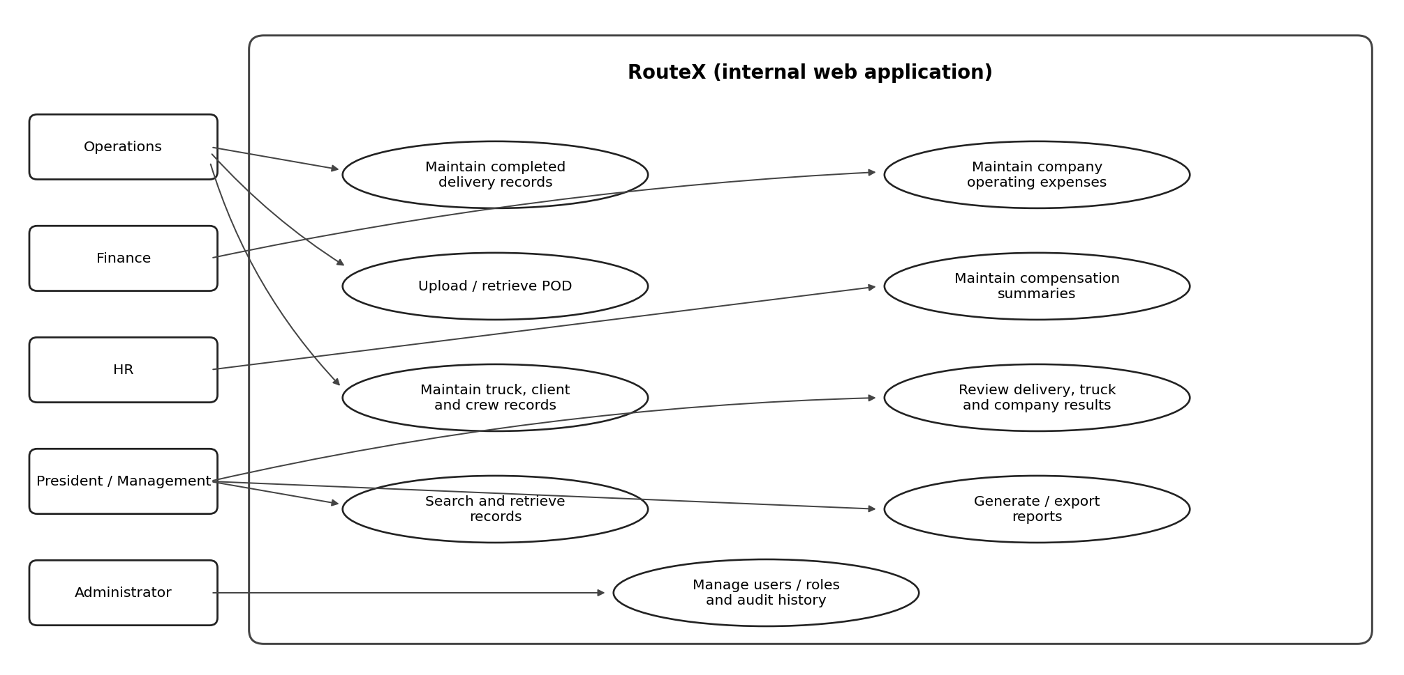
Operations maintains completed delivery records and POD; Finance maintains non-delivery company expenses; HR maintains compensation summaries; President/Management searches and reviews profitability/reports; Administrator manages approved accounts/roles and reviews authorized audit history.

4.2. Entity Relationship Diagrams
This is a conceptual ERD candidate, not a finalized implementation schema. Field selection, cardinality, optionality, expense attribution, and compensation allocation depend on client-approved rules.
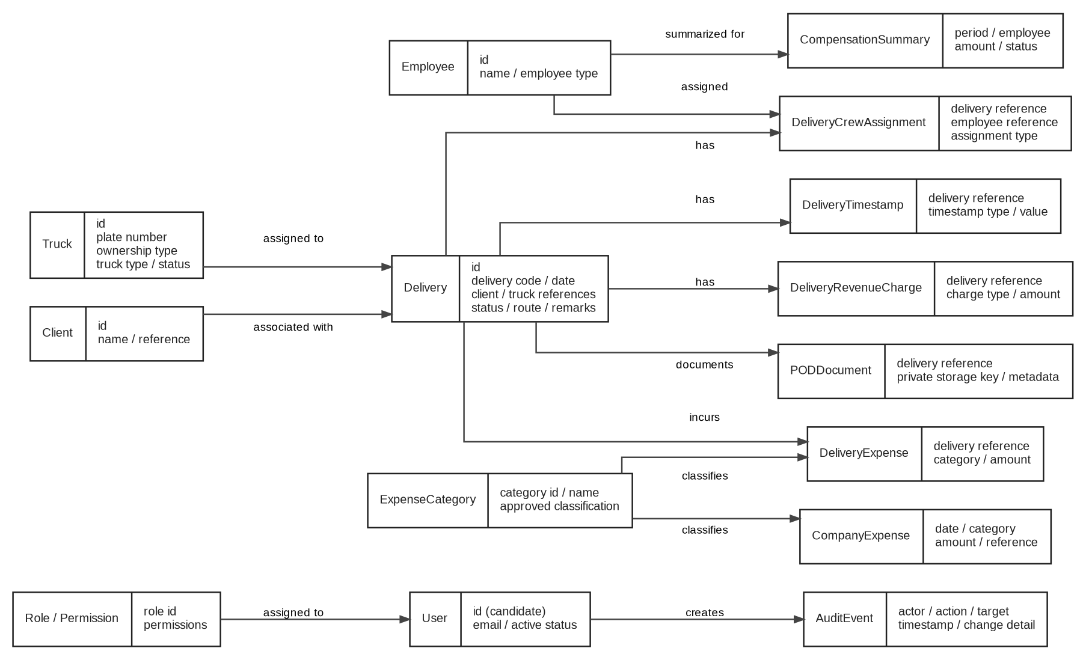
Candidate entities are based on the October SRS/Technical Documentation: User, Role/Permission, Truck, Client, Employee, Delivery, DeliveryCrewAssignment, DeliveryTimestamp, DeliveryRevenueCharge, DeliveryExpense, ExpenseCategory, CompanyExpense, CompensationSummary, PODDocument, and AuditEvent. Confirm whether separate subcontractor/reference entities or further relationships are needed before database implementation.

4.3. Activity Diagrams
The activity flow describes the intended end-to-end process. Delivery activity and company/HR financial inputs remain separately identifiable and join at approved profitability reporting.
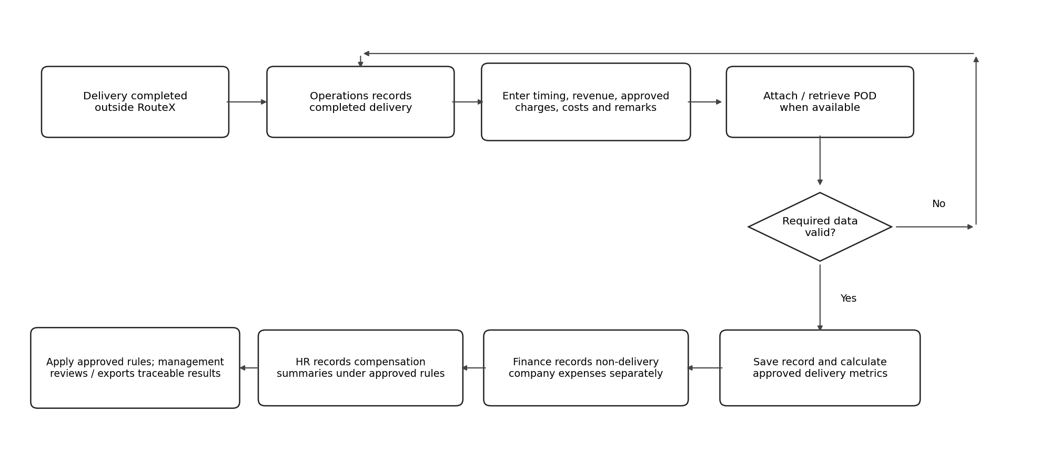

5. Other Requirements
- The database shall preserve relationships among delivery records, trucks, clients, crew, revenues/charges, delivery expenses, company expenses, compensation summaries, POD files, users, roles, and audit events as finalized in the approved data model.
- The system should support printing/exporting reports and a client-agreed data export for turnover. Exact export formats, fields, and delivery method remain TBD.
- Production deployment must have named account/operational ownership for application hosting, database, and file storage. Ownership, recurring-cost payer, and operational contacts remain TBD.
- Critical financial calculation and access-control paths require testing before UAT; the formal acceptance criteria and UAT sign-off flow must be agreed with the client.
- Changes outside the approved system scope must be handled through the written change process in the governing agreement.
- The SRS does not replace the project plan, technical documentation, UI specification, privacy review, or signed agreement; requirements must be consistent across the approved deliverables.

Appendix A: Glossary
Term | Meaning in RouteX
POD | Proof of Delivery document associated with a delivery record.
Delivery-level result | Revenue less the expenses approved as attributable to one delivery; final formula requires approval.
Truck-level profitability | Financial summary of deliveries associated with a truck over a selected period using approved inclusion rules.
Company-level result | Company-wide financial view for a selected period, accounting for applicable revenue and expenses with each underlying expense counted once.
Company operating expense | Expense not directly attributable to a specific delivery and recorded separately by Finance.
Compensation summary | Amounts payable to staff, drivers, and helpers recorded or summarized by HR; not necessarily a complete payroll calculation.
RBAC | Role-Based Access Control.
TBD | To Be Determined; requires client/team confirmation before final implementation.
UAT | User Acceptance Testing conducted against agreed requirements before acceptance/turnover.

Appendix B: To Be Determined List
ID | Question / unresolved rule | Why it matters
TBD-01 | Final role-permission matrix, including whether any Customer Service/Monitoring role is active. | Determines allowed pages, records, edits, exports, and admin actions.
TBD-02 | Required delivery fields and edit/delete rules after submission. | Validation, permissions, and audit requirements.
TBD-03 | Definitions and mandatory status for Call Time, ETA/arrival, Start Loading, End Loading, and Departure. | Correct record capture and time-based charges.
TBD-04 | Three-hour threshold and ₱500/hour charge: start/stop points, rounding, approval, and revenue/expense treatment. | Prevents unsupported charge calculations.
TBD-05 | Meaning of the five included drops and charge per additional drop. | Correct additional revenue/expense treatment.
TBD-06 | Whether overtime, demurrage, permits, entry fees, and additional drops are revenue, expenses, or context-dependent. | Expense classification and report accuracy.
TBD-07 | ₱700 daily rate, minimum ₱350 allowance, recipients, trip/payroll split, and reconciliation. | Compensation accuracy and no duplicate labor cost.
TBD-08 | Payroll cutoff/payout rules, employee-specific rates, and whether the app summarizes or calculates any payroll values. | Defines HR module boundary.
TBD-09 | How compensation is attributed where an employee works across multiple deliveries/trucks. | Prevents distorted truck/company results.
TBD-10 | Treatment of owned versus subcontracted trucks and subcontractor payments in delivery/truck margin. | Defines profitability results.
TBD-11 | Handling of cancelled, incomplete, disputed, adjusted, refunded, or duplicate deliveries. | Data lifecycle and reporting consistency.
TBD-12 | Company-level profit formula and whether any overhead allocation is required. | Prevents double counting and unsupported allocations.
TBD-13 | Retention, backup schedule, restore expectations, file limits, supported types, deletion/archive policy, and exports. | Production readiness and data protection.
TBD-14 | Hosting/account ownership, production plan, recurring-cost payer, and operational owner. | Deployment responsibility and cost clarity.
TBD-15 | Auth.js/Supabase integration and final authorization/database-policy design. | Technical feasibility and server-side data protection.
TBD-16 | Response-time targets, expected record volumes, concurrent users, and supported browser/device scope. | Measurable nonfunctional acceptance criteria.
TBD-17 | Which prototype features currently exist in the actual codebase versus design mockup, especially HR summaries, company-level drill-down, and audit behavior. | Prevents requirements from being mistaken for implemented features.
TBD-18 | Confirm missing-POD/data-completeness cue, report output formats, and dashboard metrics as approved MVP scope. | Controls scope and acceptance.
TBD-19 | Formal acceptance criteria, UAT participants, defect severity rules, and sign-off process. | Determines when the system is accepted.
TBD-20 | Resolve the LOA maintenance/support-period and date inconsistencies in the actual signed contract version. | Contractual consistency; kept separate from product functionality.

Appendix C: References
- RouteX_SRS.pdf, Version 1.0 source PDF, dated September 26, 2026. Used as the structural/TOC baseline and an earlier statement of scope; not assumed to reflect every current decision.
- RouteX_SRS_Updated_v1.1.docx, October 2026 working revision. Used as one source for clarified requirements; cross-checked rather than automatically treated as authoritative.
- RouteX_Project_Plan.docx and RouteX_updated_documents/RouteX_Project_Plan_Updated.docx, October 2026. Used for documented scope, responsibilities, proposed schedule, project limits, and pending decisions.
- RouteX_ PROJECT TECHNICAL DOCUMENTATION.docx.pdf and RouteX_updated_documents/RouteX_Technical_Documentation_Updated.docx. Used for module descriptions, platform constraints, candidate entities, and financial/data-integrity notes.
- RouteX_LETTER OF AGREEMENT.docx.pdf and RouteX_LOA_Aligned_Updated.docx. Used to cross-check objectives, out-of-scope items, acceptance/UAT, turnover, and contractual constraints. The available aligned file still contains inconsistent maintenance/support wording and requires correction.
- RouteX_ SWOT Analysis.docx.pdf and RouteX_updated_documents/RouteX_SWOT_Updated.docx. Used for problem context, user/team context, and supporting rationale.
- RtX_-prototype-z(4).html, current available UI prototype artifact. Used only as evidence of a design snapshot and visible navigation; mock data/UI logic is not treated as proof of production implementation or approved business rules.

Requirements Validation / Consistency Review
The following checks record where the current documents agree and where evidence is insufficient. “Consistent” means supported across the reviewed project documents, not necessarily implemented in code.
Review item | Status | Evidence / action
TOC and section structure | [x] Updated | Uses the section sequence of RouteX_SRS.pdf. The outdated SRS-Template (1).docx structure was not used.
Post-delivery workflow | [x] Consistent | LOA, October Project Plan, Technical Documentation, and SRS v1.1 describe entry after actual delivery completion; no live GPS/dispatch.
Operations / Finance / HR responsibilities | [x] Scope documented; [~] permissions | Operations records completed deliveries/POD; Finance records non-delivery company expenses; HR maintains compensation summaries; detailed edit/export permissions remain TBD.
Delivery / truck / company profitability | [x] Intended scope; [~] formula | LOA and Project Plan name all three levels. Calculation details and overhead handling remain unapproved.
Expense de-duplication | [x] Principle consistent | Expenses must be counted once in company results; precise treatment of payroll/allowances/subcontractor costs is still TBD.
Additional-hour / additional-drop charges | [~] Unresolved | ₱500/hour after three hours and a five-drop reference exist, but triggers, rounding, classification, and fee rule are not approved.
HR compensation scope | [~] Scope documented; implementation unverified | October docs include summaries; the HTML prototype’s primary navigation does not show an HR module. Do not treat as implemented until current code is checked.
Prototype navigation | [~] Design snapshot only | Prototype shows Dashboard, Deliveries, Fleet, Transactions, Reports and Administration, with Settings and global search/date filters. Its sample logic is not an approved financial model.
Technical stack | [x] Documents broadly agree; integration unverified | Next.js 15, TypeScript/React, Tailwind/shadcn/ui/Lucide, Server Actions/Route Handlers, Supabase PostgreSQL/Storage, Auth.js, Vercel, npm. Auth/data access design still requires a spike/review.
Company-level drill-down | [x] Proposed differentiator; [~] current build | Project Plan describes company → truck → delivery → source expense traceability. Prototype artifact alone does not prove this end-to-end behavior is built.
Performance targets | [~] Not specified numerically | v1.1 says targets to be agreed. No arbitrary 3-second/10-second requirement has been imposed.
Diagram readiness | [~] Provisional models supplied | Use case, ERD, and activity diagrams are included; ERD is conceptual and requires validation against final schema.
Project implementation status | [ ] Not established from reviewed files | Project Plan says active development is planned to begin October 19, 2026; no source reviewed proves which features are completed/tested.
LOA consistency | [ ] Requires separate correction | Available LOA-aligned file still contains conflict between six-month support language and unresolved two-to-three-week wording, plus date/signature notes. User previously clarified a one-month support intent, but available document does not consistently reflect it.
Team implementation ownership | [~] Needs confirmation | Project Plan/ SWOT list PM, Analyst, and QA; the dedicated developer assignment and actual implementation responsibility are not explicitly established.
Client approval | [ ] Pending | This is a cross-checked working SRS, not client-approved final requirements.

Cross-check conclusion: The intended RouteX scope can be updated with confidence at the requirements level for completed-delivery entry, separate company expenses and HR compensation summaries, search/date filters, POD, reporting, access controls, and distinct profitability views. However, the actual implementation status, final financial calculation model, detailed permissions, hosting/backup operations, and several UI acceptance details cannot be confirmed from the available documents alone. These points remain explicitly open rather than being guessed.

