VENDING MACHINE
WAVEFORM
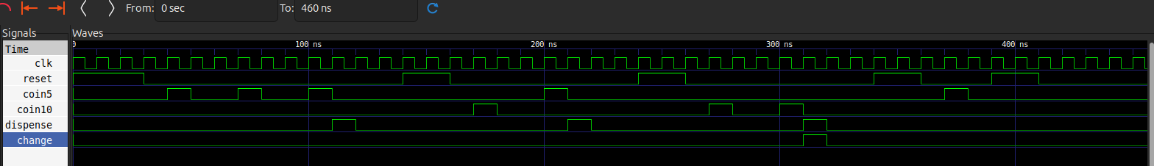
RTL
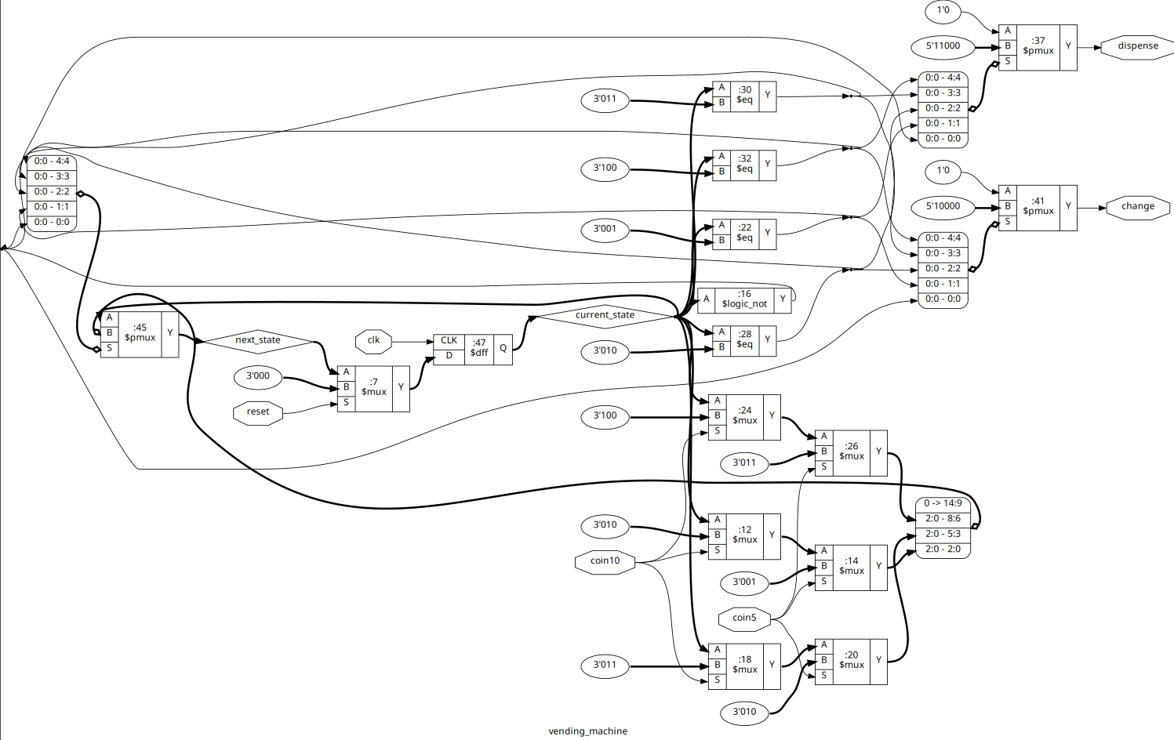

SEQ_DET_101_NONOVERLAP
WAVEFORM
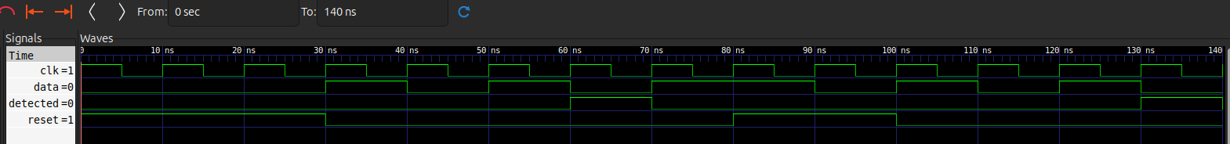
RTL
