Waveform:
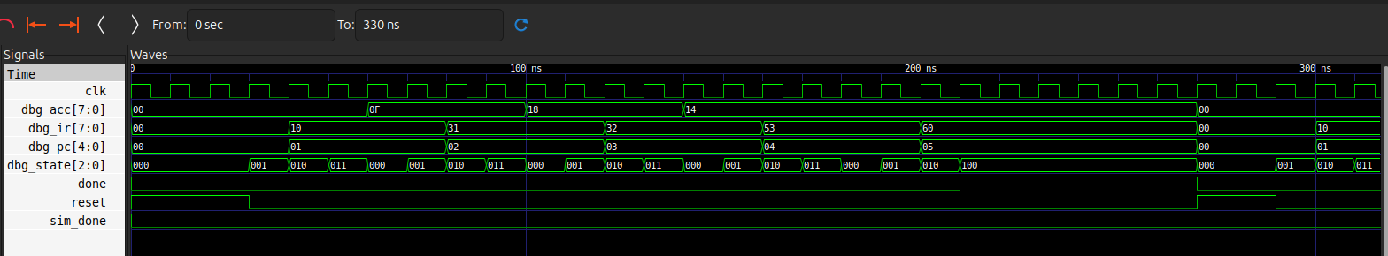
RTL:
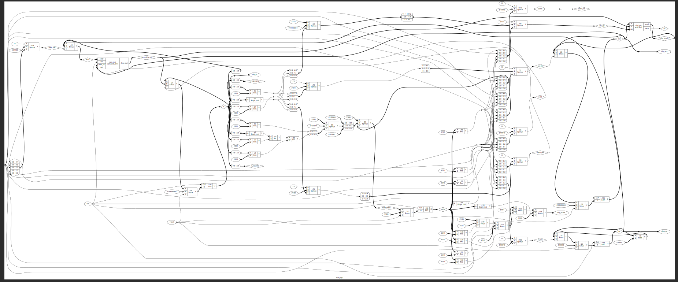
The mini_cpu rtl view is not clear in the screenshot. Please find the png file in the exercise1 directory.
BUGS:
In the tb, it was mentioned that S_FETCH1 was expected after last reset. This would hold if we didn’t wait for another cycle. Since we do, S_FETCH2 is found. Changed tb for the same.

