Week 7:
Error:
washu2_ram.vhd:76:27:error: no declaration for "ram_mem"
attribute ramstyle of ram_mem : signal is "block";
^
Fix: put the line later after declaration

Error:
washu2_cpu.vhd:105:14:error: choice subtype is not locally static
with std_logic_vector'(bus_pc &
^
Fix: need to declare a new signal; error is because std_l… isn’t constrained by size.

Error:
fetch2: mbr reads from bus, mar not updated yet.
Fix: The ram_addr signal was missing. Made changes accordingly.
This fixes the error because now we don’t need to wait an extra cycle for mar to update, ram_addr gets the info from the_bus and doesn’t have to wait for clock rising edge.

Waveform
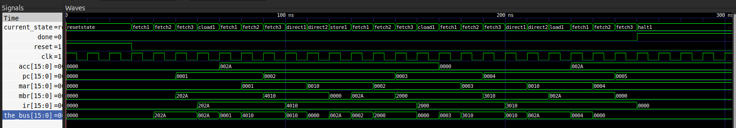
2nd part of waveform:
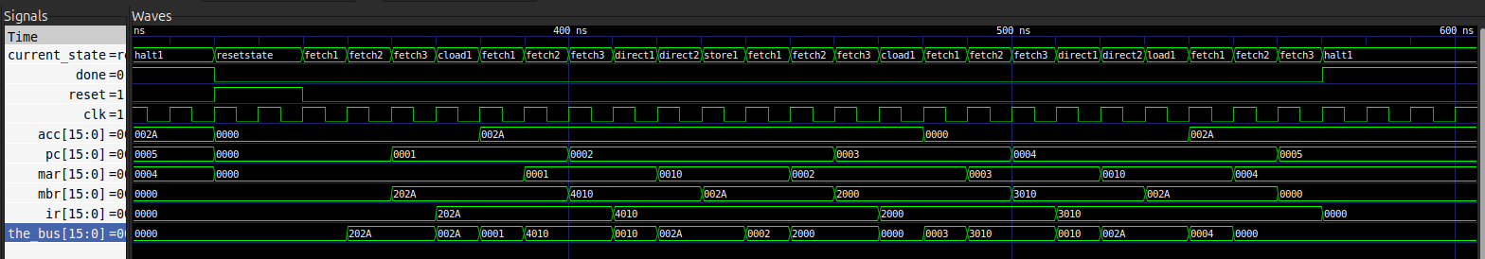
RTL:
Screenshot doesn’t make sense, too finely detailed image. Please find the ghd file in cpu/

