Week 8 Report
Architecture Summary
The WashU-2 is a simplistic cpu, introduced by Prof. Jon Turner (Washington University in St. Louis) as a teaching architecture.
It uses 16-bit registers and signals (wires)

The registers are:
Accumulator (ACC): holds the working data
Program Counter (PC): holds the memory address of the next instruction
Instruction Register (IR): using PC, instruction is loaded in this. (Instructions are 16 bit in this cpu)
Memory Address Register (MAR): stores the address in memory which we want to access at any time
Memory buffer register (MBR): contains data just read from memory, or data which is about to be written to memory

We also have 3 flags: zero_flag, pos_flag and neg_flag, which are assigned a value based on the sign of the quantity in ACC

Format of 16-bit instructions:
first 4 bits → the operation code; next 12 bits → the parameter for the operation
if the operator is binary, the parameter is the one not presently in ACC

To execute the instructions, we use an FSM (Finite State Machine) with 22 states:
3 for fetching instruction from memory
2 for direct access of memory
2 for indirect access of memory (for instructions like pointers in cpp)
and others specific to specific operations

The various registers and the ALU are connected by a multiplexed bus.
RTL netlist
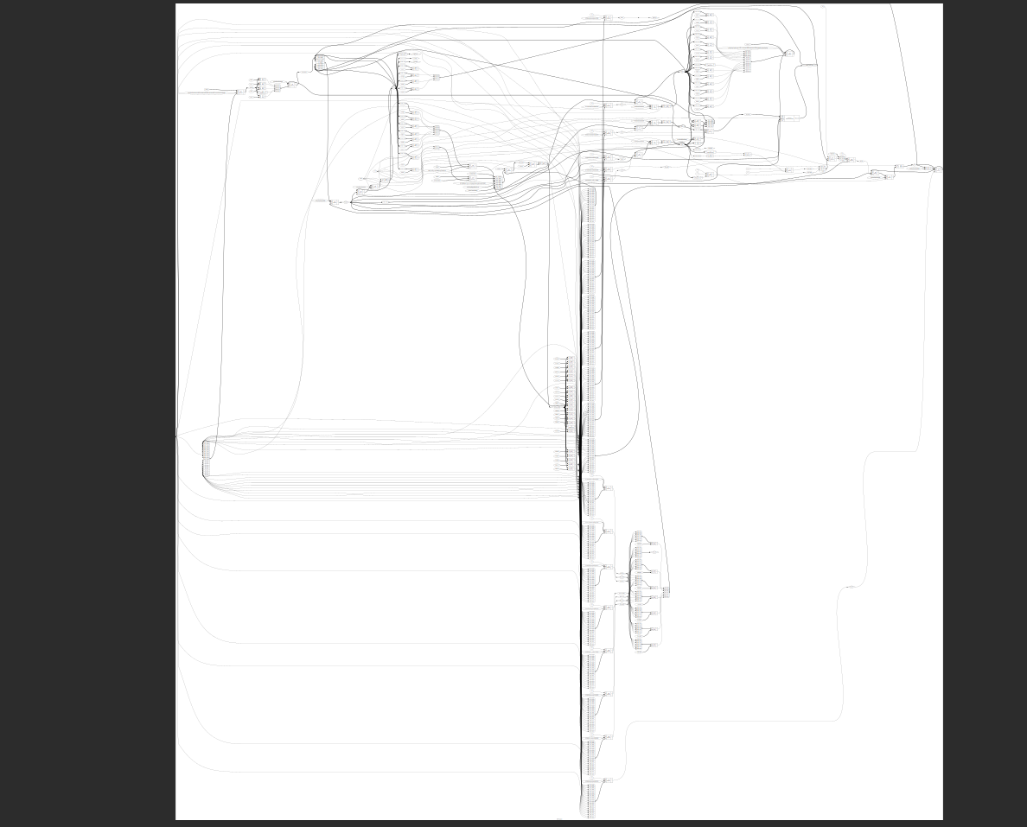
Since things are not very visible, please find week8.yosys_show.png in the cpu directory
Waveform Evidence
Direct Arithmetic
ADD
I
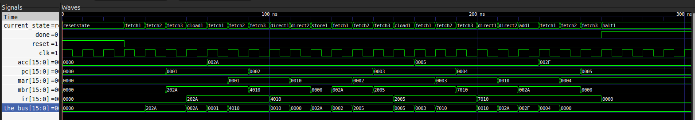
II
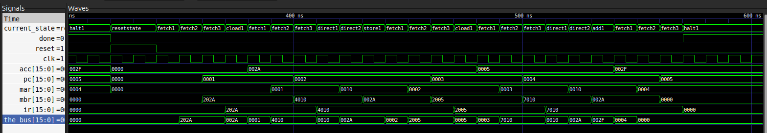

AND
I
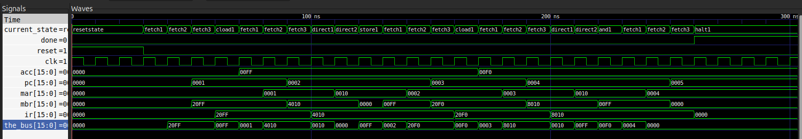
II
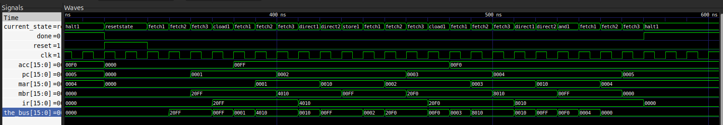

Conditional branch
BRANCH
I
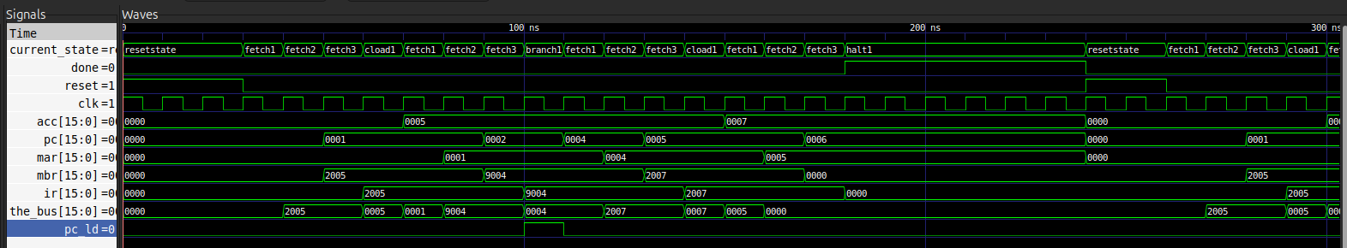
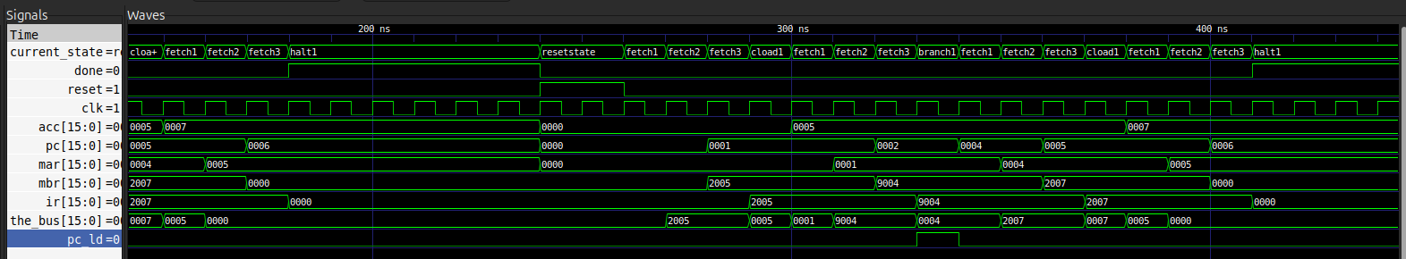
II

BRZERO: taken
I
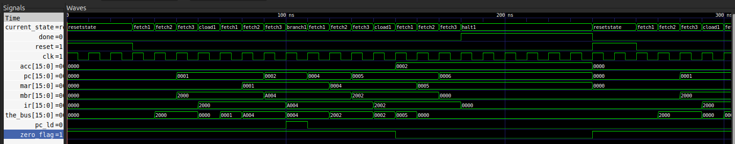
II
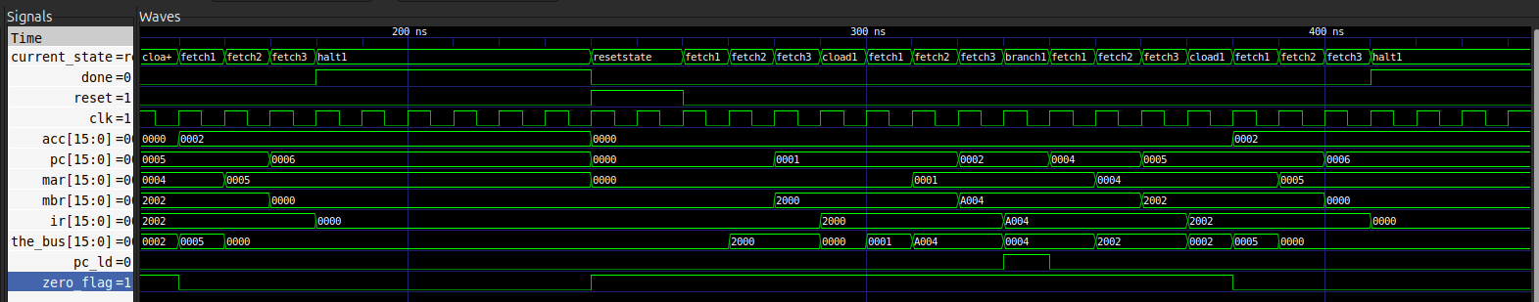

BRZERO: not taken
I
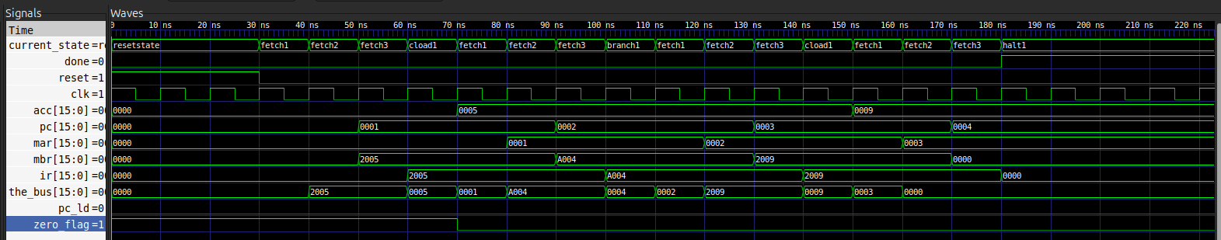
II
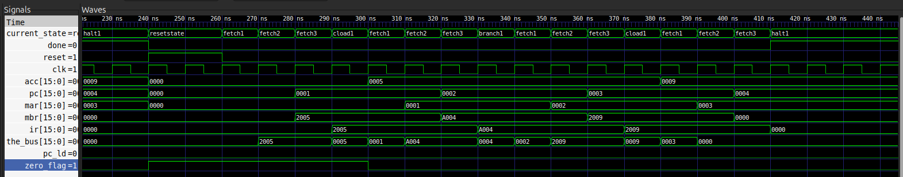

BRPOS (taken)
I
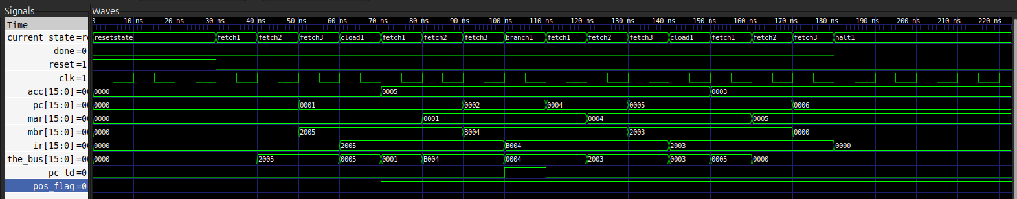
II
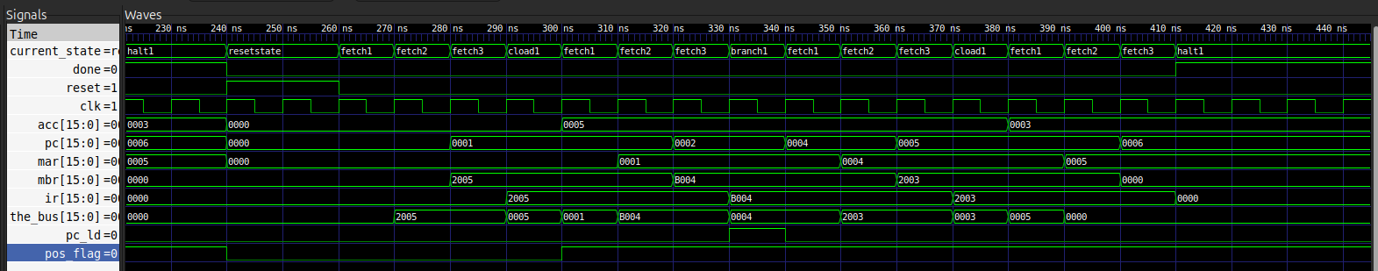

BRNEG
I
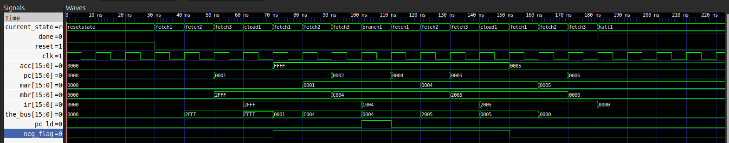
II
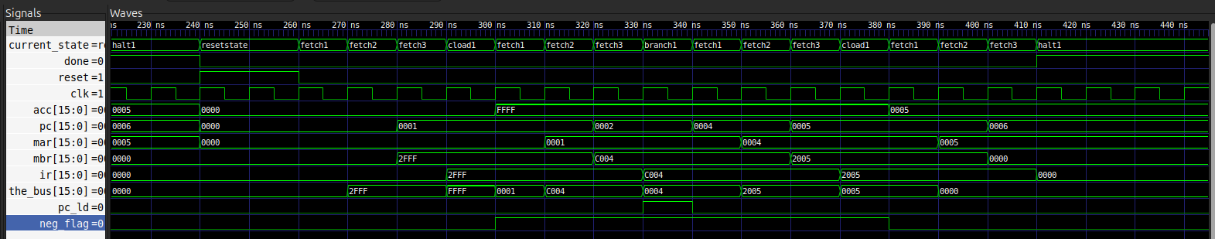

Indirect branch
BRIND
I
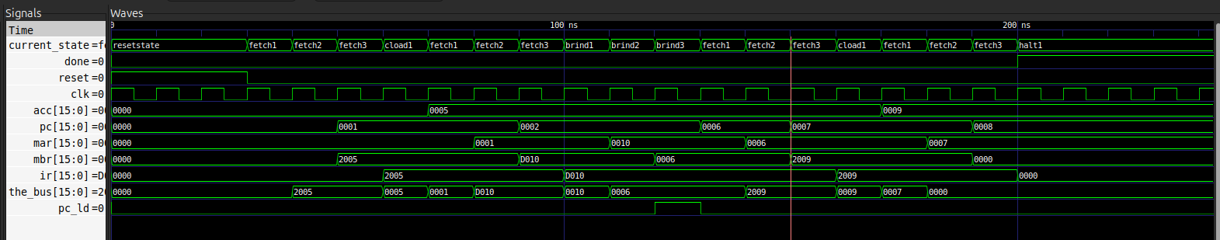
II
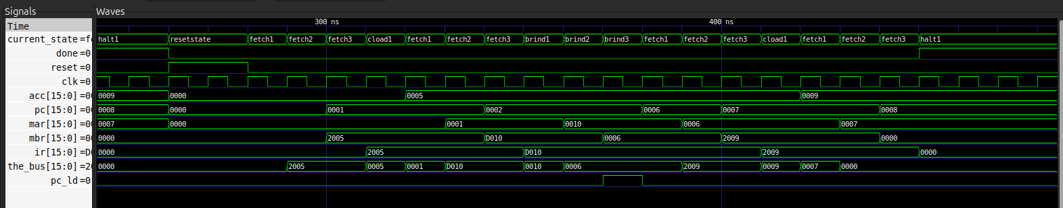

Double-indirect
ILOAD
I
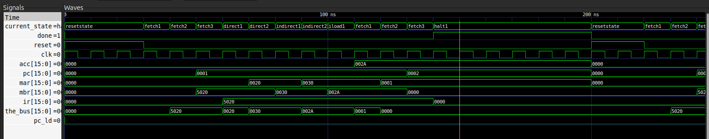
II
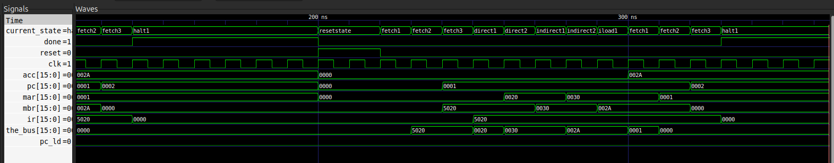

ISTORE
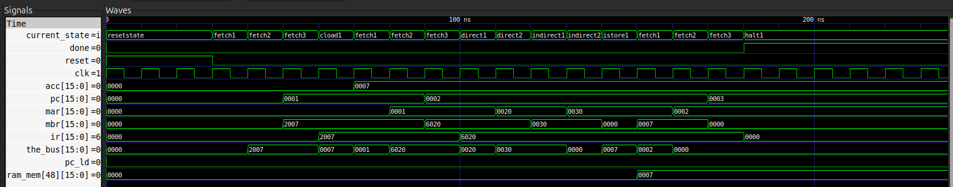

Integration
I
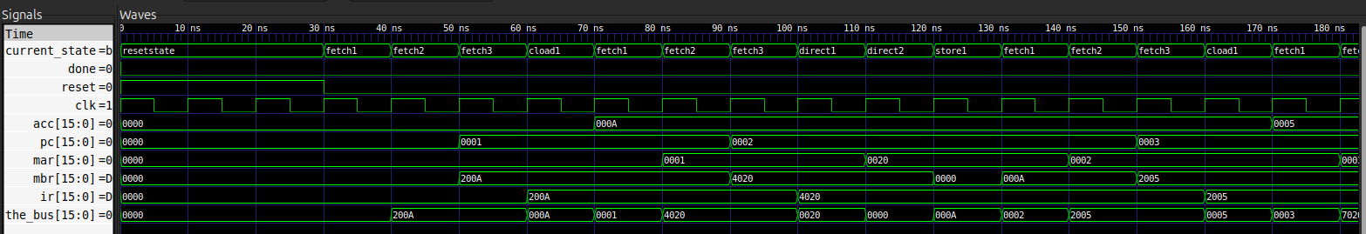
II
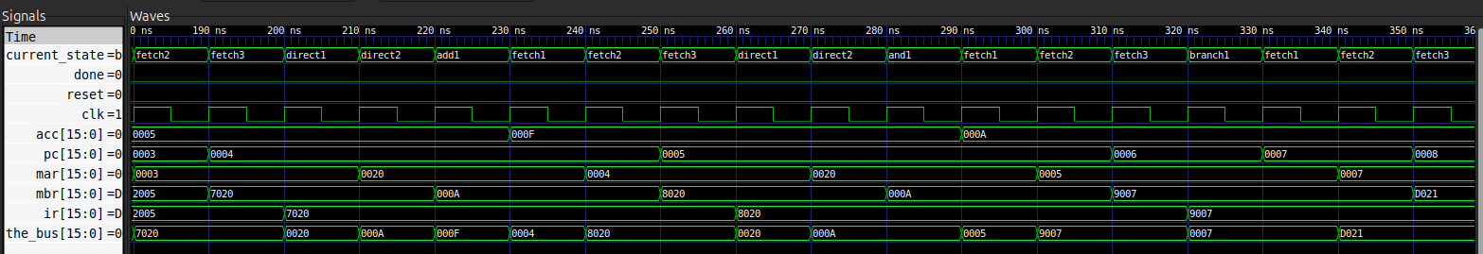
III
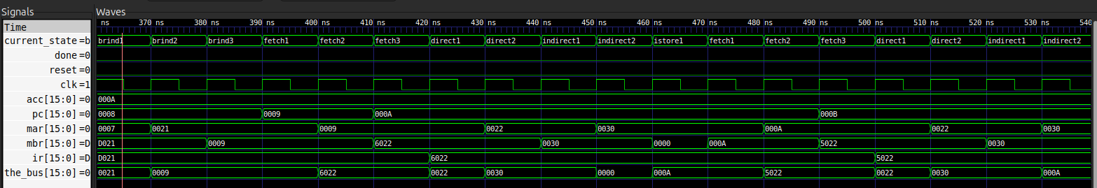
IV
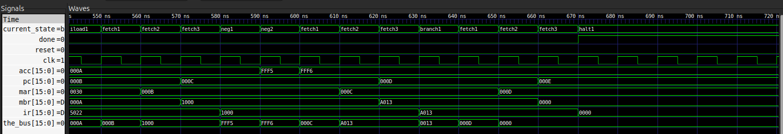
V
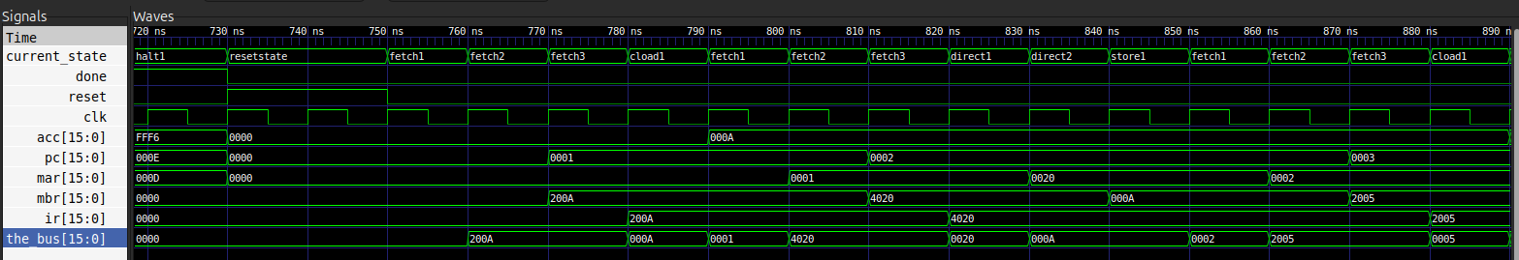
VI
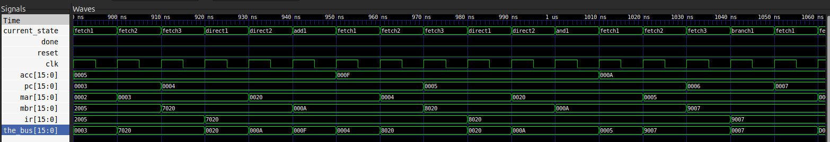

VII
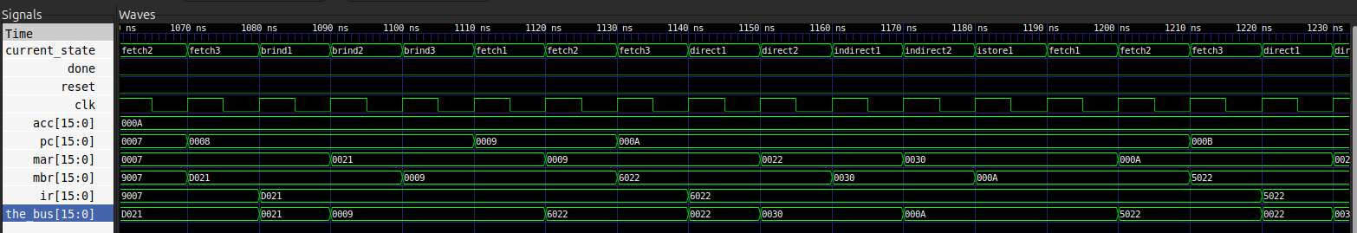
VIII
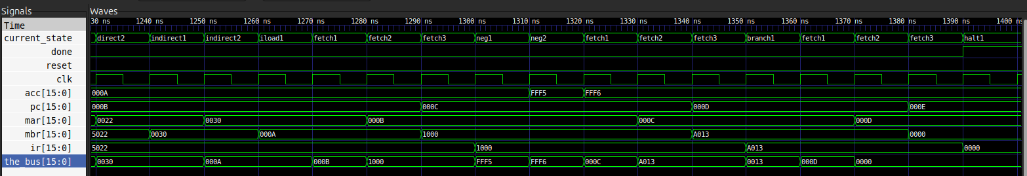

Bugs encountered:
Error:
washu2_ram.vhd:76:27:error: no declaration for "ram_mem"
attribute ramstyle of ram_mem : signal is "block";
^
Fix: put the line later after declaration

Error:
washu2_cpu.vhd:105:14:error: choice subtype is not locally static
with std_logic_vector'(bus_pc &
^
Fix: need to declare a new signal; error is because std_l… isn’t constrained by size.

Error:
fetch2: mbr reads from bus, mar not updated yet.
Fix: The ram_addr signal was missing. Made changes accordingly.
This fixes the error because now we don’t need to wait an extra cycle for mar to update, ram_addr gets the info from the_bus and doesn’t have to wait for clock rising edge.

Cycle Count Table
Instruction | Cycle Count
HALT | 4
NEGATE | 5
CLOAD | 4
DLOAD | 6
DSTORE | 6
ADD | 6
AND | 6
BRANCH | 4
BRZERO | 4
BRPOS | 4
BRNEG | 4
BRIND | 6
ILOAD | 8
ISTORE | 8

Self-assessment
The hardest part of the project was managing the latencies since signals in a clocked process would update on the next clock cycle. These latencies were mainly an issue in reading from memory, namely the latency in the update of the MAR register. The ram_addr signal was a work-around which allows the cpu to work properly without needing an extra cycle. Instead of waiting for the rising clock edge, whenever MAR is supposed to read from the bus, we also let ram_addr directly read from the bus and carry the address to the ram, which takes care of the latency.

