COUNTER
WAVEFORM
RTL
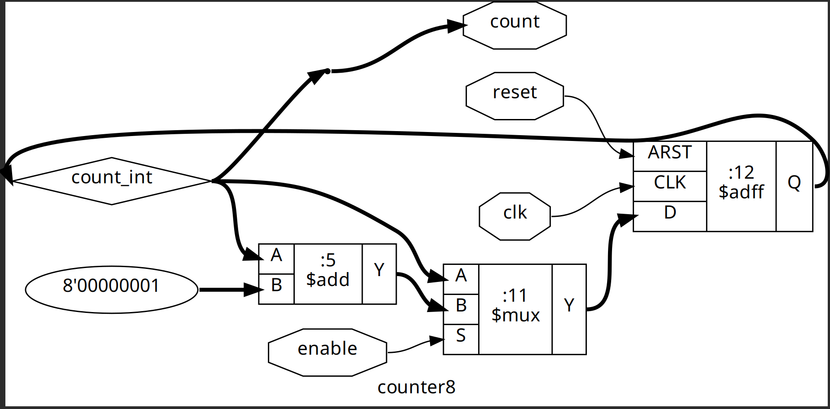

MOD_COUNTER
WAVEFORM
PS: I did multiple tests, it is too long to visibly fit in one prtsc. Please find the 4 screenshots
1.
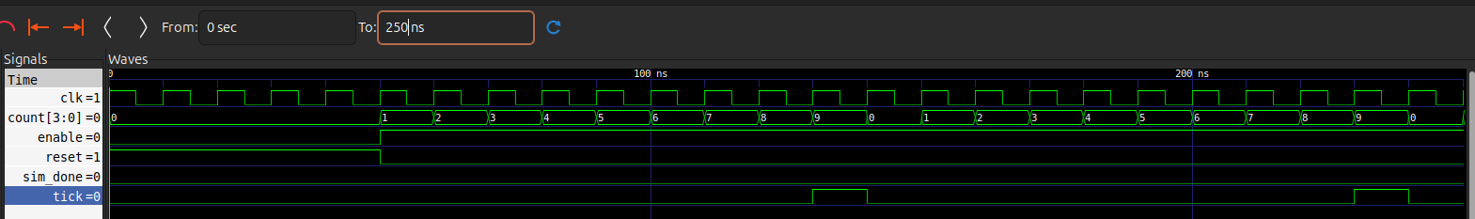
2.
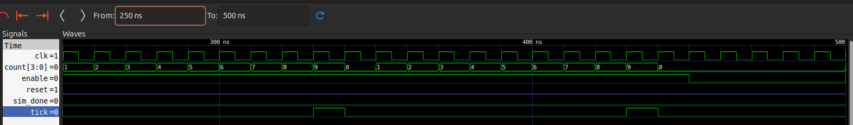
3.
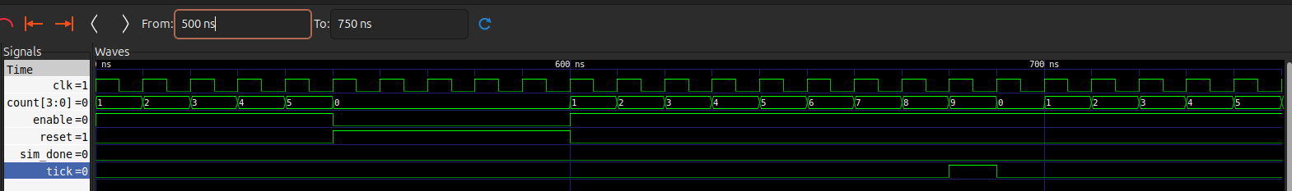
4.
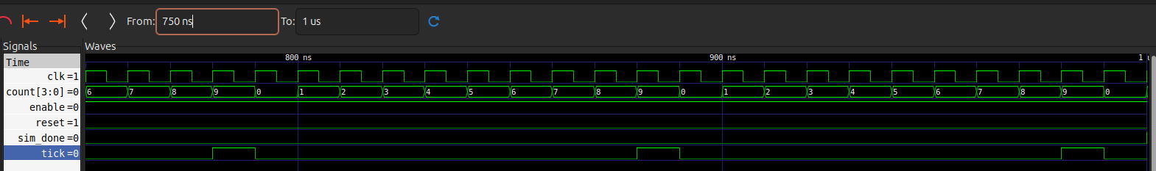
PS: on RHS of = in the time column are values at t=0fs, not those at start of current range

RTL
