Wireframe

# HR ANALYTICS

|  |  |
| --- | --- |
| **Written By** | NAUSHABA FARHEEN |

# Contents

1.Associate Degree...............................................................................03

2.Bachelor’s Degree..............................................................................05

3.Doctoral Degree.................................................................................06

3.High School.........................................................................................07

4.Master’s Degree.................................................................................08

# Associate Degree

# 

Title: A prominent title reflects the purpose of your dashboard, such as "HR ANALYTICS."

As per the requirement of the project, I have divided the analysis into five sections

1.Associate Degree

2.Bachelor’s Degree

3.Doctoral Degree

4.High School

5.Master’s Degree

* **Pie Chart**: Create pie chart to visually represent the department wise attrition. Display the different department such as R&D, Sales, HR .
* **Stack Column Chart**: Add stack column chart to represent number of employee by age group category such as under 25, 25-34, 35-44, 45-54 and over 55 slicers to allow users to filter the data shown in the bar graphs.
* **Table** : For representing the job satisfaction technique.
* **Stack Bar Chart**: for representing education field wise attrition

# Bachelor’s Degree

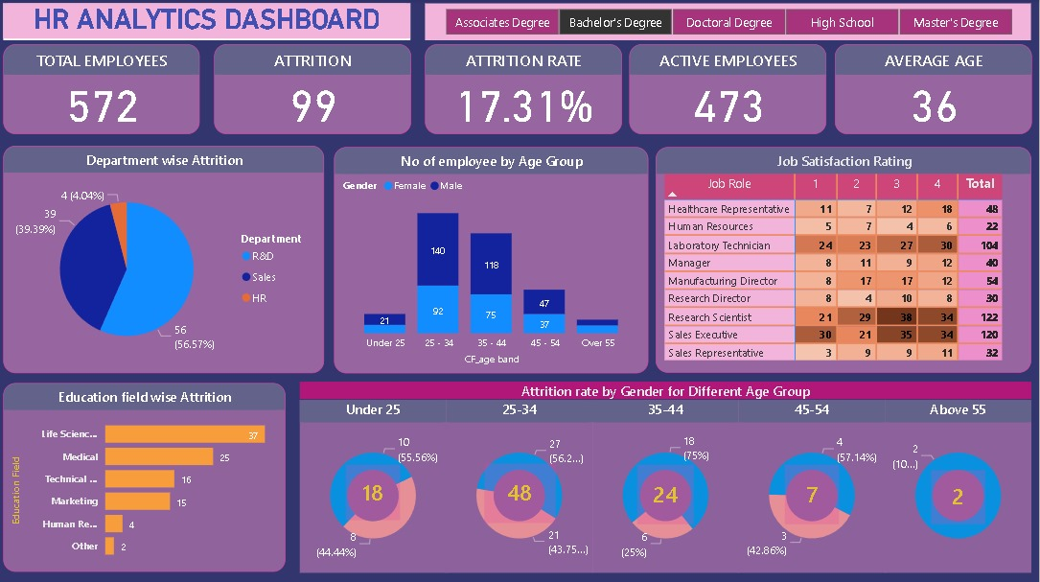

* **Pie Chart**: Create pie chart to visually represent the department wise attrition. Display the different department such as R&D, Sales, HR .
* **Stack Column Chart**: Add stack column chart to represent number of employee by age group category such as under 25, 25-34, 35-44, 45-54 and over 55 slicers to allow users to filter the data shown in the bar graphs.
* **Table** : For representing the job satisfaction technique.
* **Stack Bar Chart**: for representing education field wise attrition

# Doctoral Degree

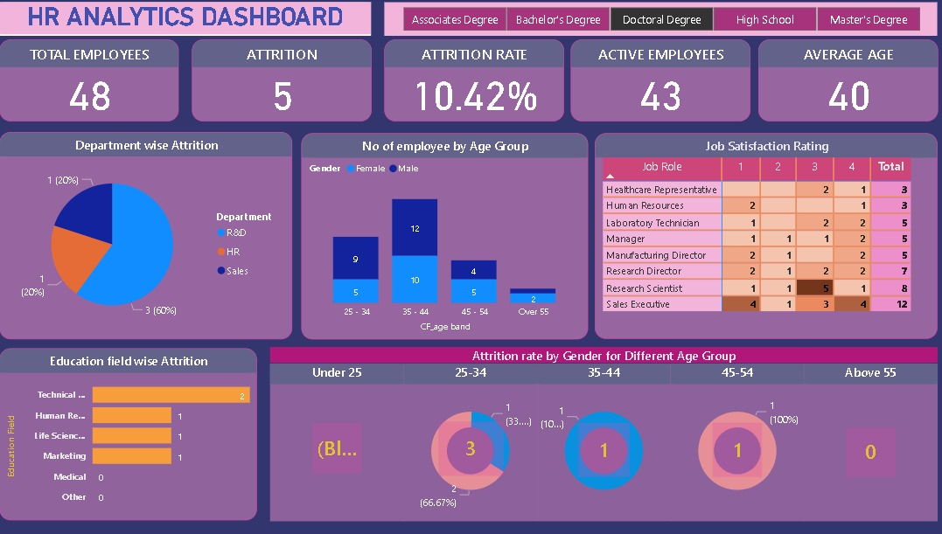

* **Pie Chart**: Create pie chart to visually represent the department wise attrition. Display the different department such as R&D, Sales, HR .
* **Stack Column Chart**: Add stack column chart to represent number of employee by age group category such as under 25, 25-34, 35-44, 45-54 and over 55 slicers to allow users to filter the data shown in the bar graphs.
* **Table** : For representing the job satisfaction technique.
* **Stack Bar Chart**: for representing education field wise attrition

# 4.High School

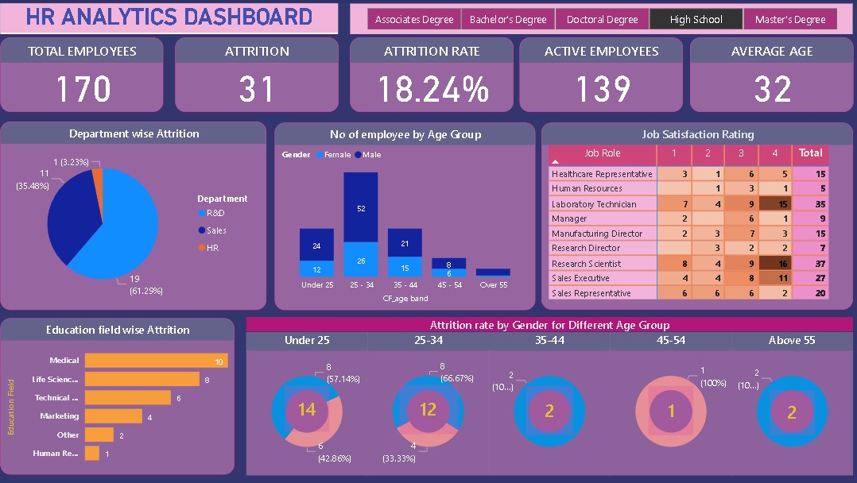

* **Pie Chart**: Create pie chart to visually represent the department wise attrition. Display the different department such as R&D, Sales, HR .
* **Stack Column Chart**: Add stack column chart to represent number of employee by age group category such as under 25, 25-34, 35-44, 45-54 and over 55 slicers to allow users to filter the data shown in the bar graphs.
* **Table** : For representing the job satisfaction technique.
* **Stack Bar Chart**: for representing education field wise attrition

# 5.Master’s Degree

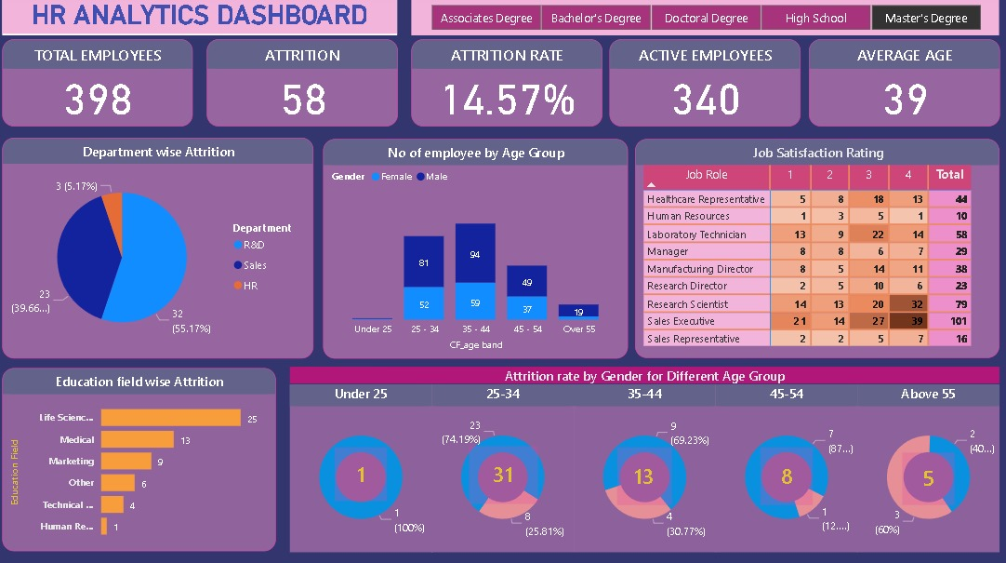

* **Pie Chart**: Create pie chart to visually represent the department wise attrition. Display the different department such as R&D, Sales, HR .
* **Stack Column Chart**: Add stack column chart to represent number of employee by age group category such as under 25, 25-34, 35-44, 45-54 and over 55 slicers to allow users to filter the data shown in the bar graphs.
* **Table** : For representing the job satisfaction technique.
* **Stack Bar Chart**: for representing education field wise attrition