Deep Learning Application in Data Science
Week 5 Task Report — YuvaIntern Data Science with Python Trainee
Dataset: UCI Optical Recognition of Handwritten Digits (8x8 images)

1. Problem Statement and Dataset Choice
This task builds and evaluates a convolutional neural network (CNN) for multi-class image classification: identifying which digit (0-9) is shown in a small handwritten digit image.
A deliberate change was made from the dataset used in Weeks 1-4 (Palmer Penguins). That dataset is small tabular data (342 rows, 4 numeric features), and Week 4 already showed a simple Random Forest reaches 98%+ accuracy on it with a fraction of the complexity of a neural network — there would be nothing for a deep learning approach to meaningfully demonstrate there. Deep learning's real strength is in learning spatial or sequential structure directly from raw, high-dimensional input (pixels, audio, text) rather than requiring hand-built features, so an image dataset is a far more honest fit for this task.
The dataset used is the UCI Optical Recognition of Handwritten Digits dataset (1,797 images, 8x8 pixels, grayscale, pixel values 0-16), accessed via scikit-learn's built-in load_digits() function. This is a genuine, well-established public image classification benchmark, and using the version bundled with scikit-learn (rather than the larger 28x28 MNIST dataset) was a practical choice made for reliable offline access, while still being real image data suitable for a convolutional architecture.
from sklearn.datasets import load_digits
digits = load_digits()
X = digits.images # (1797, 8, 8) pixel values 0-16
y = digits.target # (1797,) digit labels 0-9
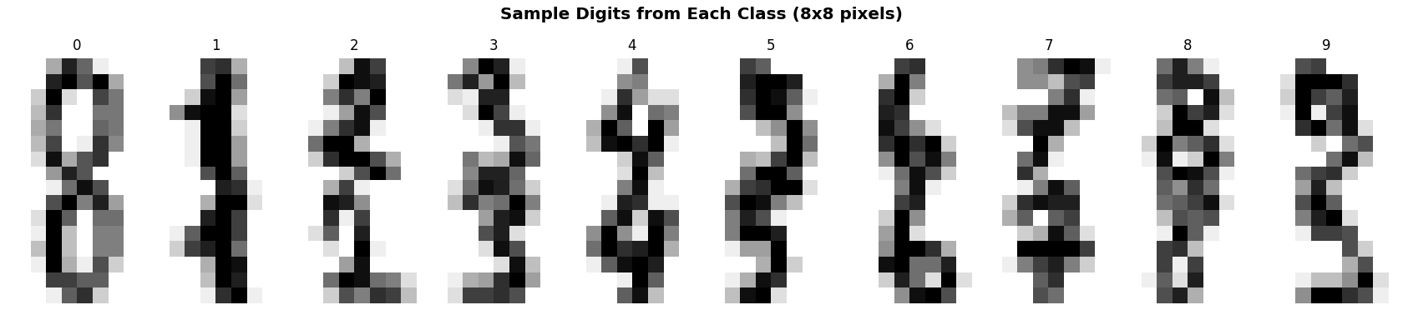
Figure 1 — Two example images from each of the 10 digit classes.
The problem is a 10-class classification task, evaluated primarily on accuracy, with per-class precision/recall/F1 and a confusion matrix used for deeper analysis, since these are the standard, appropriate metrics for a balanced multi-class classification problem.

2. Data Preparation
Pixel values (originally integers 0-16) were normalized to the [0, 1] range, and images were reshaped to include an explicit channel dimension (8, 8, 1) as required by Keras' Conv2D layers. The data was split into training, validation, and test sets (70% / 15% / 15%), stratified by digit class to preserve the balanced class distribution across all three splits.
X_norm = X.astype('float32') / 16.0
X_norm = X_norm.reshape(-1, 8, 8, 1)
X_train, X_temp, y_train, y_temp = train_test_split(
X_norm, y, test_size=0.3, random_state=42, stratify=y
)
X_val, X_test, y_val, y_test = train_test_split(
X_temp, y_temp, test_size=0.5, random_state=42, stratify=y_temp
)
# Train: 1257, Validation: 270, Test: 270

3. Architecture Design
A simple dense (fully-connected) network was trained first as a baseline, to justify whether a convolutional architecture was actually necessary for this problem.
mlp = keras.Sequential([
layers.Flatten(),
layers.Dense(64, activation='relu'),
layers.Dropout(0.3),
layers.Dense(32, activation='relu'),
layers.Dense(10, activation='softmax')
])
# 6,570 parameters -> Test accuracy: 0.9852
The MLP baseline already performs well (98.52% test accuracy), which is expected given how small and clean this dataset is. A CNN was still implemented as the primary architecture because convolutional layers are the architecturally correct choice for image data in general — they learn local spatial patterns (edges, curves, strokes) using far fewer parameters per learned feature than a dense layer would need to represent the same pattern at every possible position, and this property matters much more on realistic, larger, or noisier images than it does on this particular clean 8x8 dataset.
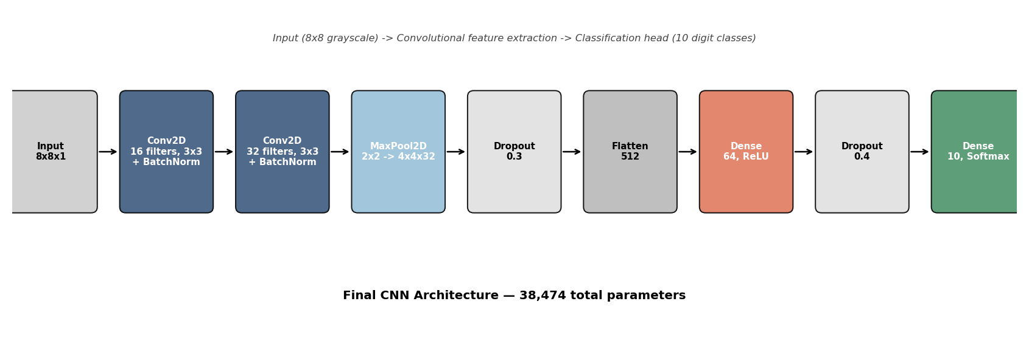
Figure 2 — Final CNN architecture: two convolutional blocks with batch normalization, max pooling, dropout regularization, and a dense classification head.
model = keras.Sequential([
layers.Input(shape=(8, 8, 1)),
layers.Conv2D(16, (3,3), activation='relu', padding='same'),
layers.BatchNormalization(),
layers.Conv2D(32, (3,3), activation='relu', padding='same'),
layers.BatchNormalization(),
layers.MaxPooling2D((2,2)),
layers.Dropout(0.3),
layers.Flatten(),
layers.Dense(64, activation='relu'),
layers.Dropout(0.4),
layers.Dense(10, activation='softmax')
])
# 38,474 total parameters
Design rationale for each component:
- Two stacked Conv2D layers (16 then 32 filters) before pooling: lets the network build slightly more complex features from the first layer's simple edge/stroke detectors before reducing spatial resolution, which is a standard, well-justified pattern for small images.
- Batch Normalization after each convolution: stabilizes and speeds up training by normalizing layer activations, which is particularly helpful with a fairly small training set (1,257 images).
- MaxPooling2D (2x2): reduces the 8x8 feature maps to 4x4, cutting parameter count in the following dense layers and encouraging the network to focus on the presence of a feature rather than its exact pixel position — appropriate here since handwritten digit strokes can shift by a pixel or two without changing the digit's identity.
- Dropout (0.3 after pooling, 0.4 before the output layer): the main regularization tool used to address overfitting, discussed in detail in Section 5.
- Only 3x3 kernels and a modest filter count (16, 32) were used, since 8x8 images are too small to benefit from the deeper, wider architectures (5x5 or 7x7 kernels, 64+ filters) common in larger image tasks — those would simply have more parameters than the problem has information to constrain.

4. Training Process
The model was trained using the Adam optimizer (learning rate 0.001) and sparse categorical cross-entropy loss, appropriate for multi-class classification with integer labels. Two additional techniques were used specifically to address the overfitting risk of training a CNN on a relatively small dataset (1,257 training images):
- Data augmentation: mild random rotations (±8°), shifts (±8%), and zoom (±8%) were applied to training images only, via Keras' ImageDataGenerator. The augmentation strength was deliberately kept small, since digits are orientation-sensitive (e.g. a 6 rotated too far can resemble a 9), so aggressive augmentation would create mislabeled-looking training examples rather than useful variety.
- Early stopping: training was monitored on validation loss with a patience of 10 epochs, restoring the best-performing weights automatically rather than the weights from the final epoch, which prevents training for longer than the point where the model stops genuinely improving on unseen data.
datagen = keras.preprocessing.image.ImageDataGenerator(
rotation_range=8, width_shift_range=0.08,
height_shift_range=0.08, zoom_range=0.08
)
early_stop = keras.callbacks.EarlyStopping(
monitor='val_loss', patience=10, restore_best_weights=True
)
history = model.fit(
datagen.flow(X_train, y_train, batch_size=32),
validation_data=(X_val, y_val),
epochs=100, callbacks=[early_stop]
)
# Training stopped automatically at epoch 46

5. Challenge: Diagnosing and Addressing Overfitting
To demonstrate the overfitting risk concretely rather than just asserting it, an intentionally unregularized CNN (Model A: no dropout, no batch norm, no augmentation, no early stopping, three convolutional layers with more filters, 619,786 parameters — over 16x the final model's size) was trained for a fixed 60 epochs alongside the final regularized model (Model B) for direct comparison.
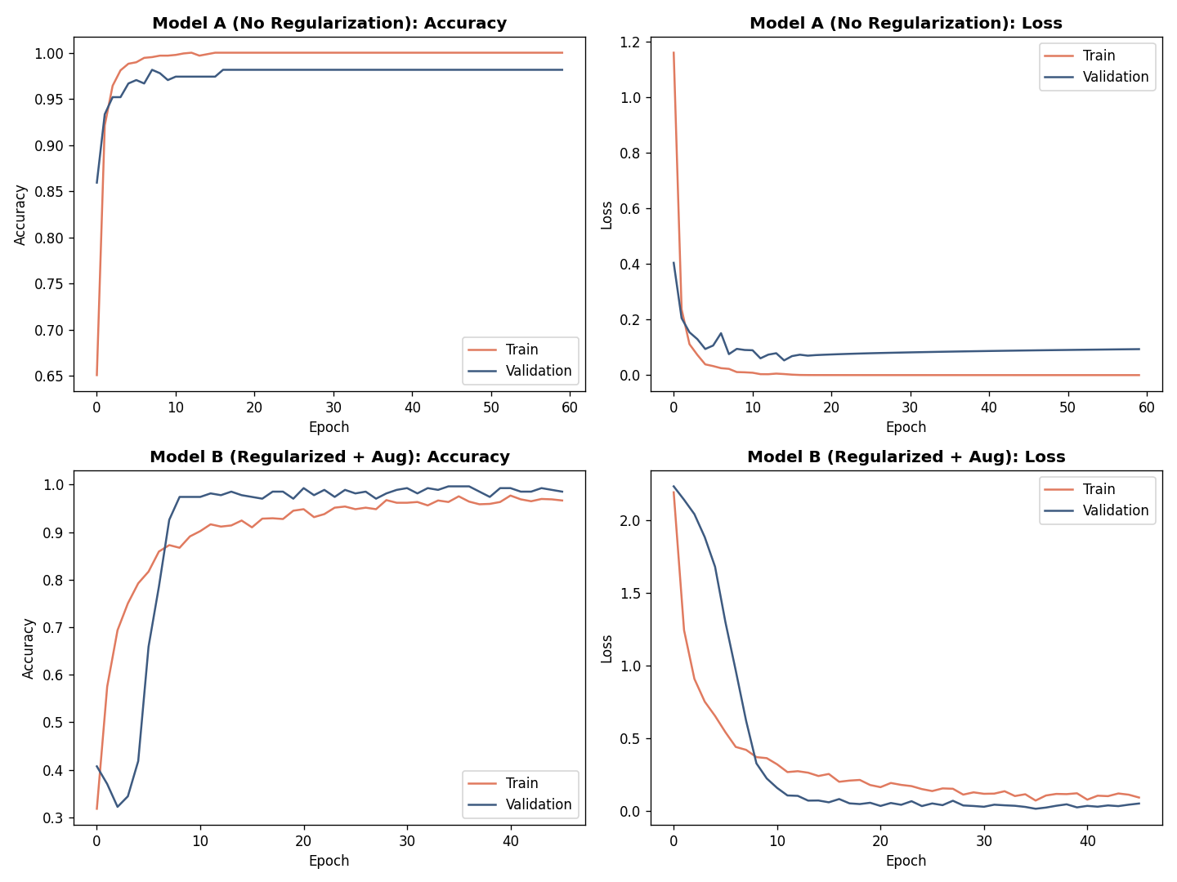
Figure 3 — Training curves. Top row: unregularized Model A. Bottom row: final regularized Model B. Note Model A's training loss collapsing toward zero while validation loss plateaus and slightly rises — a sign of overfitting that shows up in loss before it clearly shows in accuracy.
Model | Parameters | Final Train Acc | Test Acc | Train-Test Gap
A: No regularization | 619,786 | 100.0% | 98.9% | 1.1 pts
B: Regularized + augmented | 38,474 | 96.7% | 99.6% | -3.0 pts

The accuracy gap alone slightly understates the overfitting problem in Model A. The more revealing signal is in the loss curves (Figure 3, top-right): Model A's training loss drops to nearly zero, indicating the model becomes increasingly confident in its training predictions, while its validation loss plateaus around epoch 10-15 and then very slightly increases — meaning the model is continuing to memorize training-specific detail that does not help, and occasionally hurts, its confidence on unseen validation data, even though its validation accuracy stays high. This is a useful lesson: on a dataset this size, accuracy alone can look deceptively stable well after a model has started overfitting, and loss curves should be checked alongside accuracy, not instead of it.
Model B (bottom row of Figure 3) shows a healthier pattern: training and validation loss track closely together throughout training, and validation loss ends up slightly below training loss — expected behavior when dropout is active during training (making the training task artificially harder) but turned off during validation. Despite having about 6% of Model A's parameter count, Model B achieved a higher final test accuracy (99.6% vs 98.9%), confirming that the added capacity in Model A was not being used productively — it was going toward memorization rather than generalizable pattern learning.
A secondary, practical challenge encountered was resource-related rather than algorithmic: this sandboxed environment could not download the standard MNIST dataset, since Keras fetches it from a Google Cloud Storage URL not reachable under this environment's network restrictions. This was resolved by switching to scikit-learn's bundled UCI digits dataset, which ships with the library and requires no network access — a smaller but equally legitimate public image dataset for demonstrating the same deep learning concepts.

6. Final Model Evaluation
The final regularized CNN (Model B) was evaluated on the held-out test set (270 images, never used during training or model selection).
test_loss, test_acc = model.evaluate(X_test, y_test)
# Test Accuracy: 0.9963, Test Loss: 0.0141
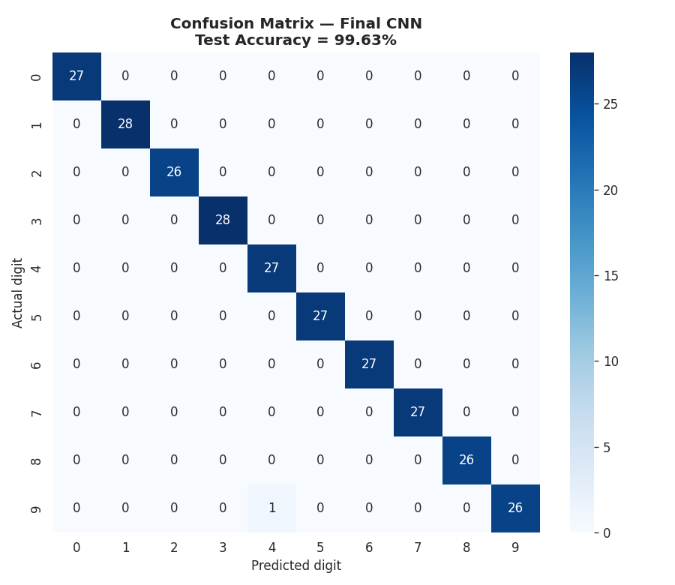
Figure 4 — Confusion matrix on the held-out test set. 269 of 270 images were classified correctly.
The model achieved 99.63% test accuracy with a near-perfect confusion matrix — every class had precision and recall of 1.000 except digits 4 and 9, which had one confusion between them (support 27 each, precision/recall 0.964-1.000). Macro-averaged F1-score was 0.996, confirming strong performance is consistent across all ten classes rather than being pulled up by a few easy classes.
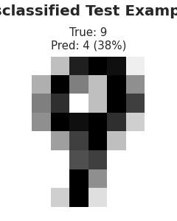
Figure 5 — The single misclassified test image: a true '9' predicted as '4' with only 38% confidence.
Examining the one misclassification is informative: the model's confidence on this prediction was low (38%, compared to typically 95%+ confidence on correct predictions), meaning the model was itself "unsure" rather than confidently wrong. This is a desirable failure mode — a well-calibrated model that hedges on genuinely ambiguous inputs is generally more trustworthy in practice than one that is equally confident on both its correct and incorrect predictions.

7. Critical Analysis: Strengths and Limitations

Strengths
- Very high accuracy (99.63%) achieved with a compact model (38,474 parameters), demonstrating that the regularization and augmentation strategy successfully controlled overfitting rather than simply using more data or a larger model.
- The overfitting comparison (Model A vs Model B) provides direct, quantified evidence for each design decision, rather than just asserting that dropout and augmentation are good practice.
- The single error made by the final model was low-confidence, suggesting reasonable calibration rather than confident mistakes.

Limitations
- This dataset (8x8, clean, centered, pre-segmented digits) is a relatively easy image classification problem by modern standards; the near-100% accuracy achieved here should not be read as evidence the same architecture would perform this well on messier, real-world image data (varying lighting, backgrounds, occlusion, higher resolution).
- The dataset is small (1,797 images total), which limits how confidently these results generalize — a different random train/test split could plausibly shift test accuracy by a percentage point or two given the very small test set (270 images, of which even one flipped prediction changes accuracy by about 0.4 percentage points).
- No comparison against non-deep-learning baselines (e.g. a simple SVM or k-NN on these pixel features) was included here; classical methods are known to also perform very well on this specific small, clean digit dataset, so the case for deep learning specifically is stronger in principle (scalability to larger/more complex images) than it is empirically demonstrated on this exact dataset.
- Training was run once with a fixed random seed for the final comparison numbers; results were not repeated across multiple seeds to quantify run-to-run variance, which would strengthen confidence in the reported accuracy figures.

8. Conclusion and Insights
This task designed, trained, and evaluated a convolutional neural network for handwritten digit classification, achieving 99.63% test accuracy. Beyond the accuracy number, the most valuable part of this exercise was the deliberate overfitting comparison: training an intentionally unregularized model alongside the final one made the effect of dropout, batch normalization, data augmentation, and early stopping concrete and measurable rather than theoretical, and revealed that loss curves can expose overfitting earlier and more clearly than accuracy curves alone. The task also required a pragmatic real-world adjustment — switching datasets after discovering a network restriction blocked the standard MNIST download — which is itself a realistic example of the kind of resource constraint that shapes applied deep learning work.

Deliverable files: digits_split.npz (train/val/test split), final_cnn_model.keras (trained model), Python scripts for data preparation, model training, MLP baseline comparison, architecture diagram generation, and final evaluation, and all figure images.

