Data Acquisition, Cleaning, and Preprocessing
Week 1 Task Report — YuvaIntern Data Analytics Virtual Internship
Dataset: Palmer Archipelago (Antarctica) Penguin Data — raw version

1. Objective
The objective of this task is to acquire a publicly available dataset, explore its structure and quality, and apply systematic cleaning and preprocessing techniques using Python. This report documents the full workflow — from raw data to an analysis-ready dataset — including the reasoning behind each decision, the code used, and the challenges encountered along the way.

2. Dataset and Data Collection Method
The dataset used is the Palmer Archipelago Penguins dataset, originally collected by Dr. Kristen Gorman and the Palmer Station Long Term Ecological Research (LTER) Program, and distributed publicly through the palmerpenguins GitHub repository maintained by Allison Horst. The raw CSV file was downloaded directly from the repository's public data folder.
The dataset contains 344 records of penguins from three species (Adelie, Chinstrap, and Gentoo) observed across three islands in the Palmer Archipelago, Antarctica, between 2007 and 2009. Each record includes physical measurements (bill/culmen length and depth, flipper length, body mass), categorical fields (species, island, sex, clutch completion), isotope measurements, and free-text field comments — making it a realistic candidate for demonstrating real-world data cleaning.
Source:
https://github.com/allisonhorst/palmerpenguins

3. Initial Data Exploration
Before cleaning, the dataset was loaded with pandas and explored to understand its shape, data types, and quality issues.
import pandas as pd
df = pd.read_csv('penguins_raw.csv')
print(df.shape) # (344, 17)
print(df.dtypes)
print(df.isna().sum())
This initial pass revealed the following data quality issues:
- Missing values in 7 of the 17 columns, ranging from 2 missing entries (physical measurements) to 290 missing entries (the free-text Comments field).
- Inconsistent capitalization in the Species column — e.g. "Adelie Penguin" (capital P) versus "Gentoo penguin" and "Chinstrap penguin" (lowercase p).
- The Date Egg column was stored as plain text rather than a proper date type.
- 190 unique Individual IDs across 344 rows, meaning many penguins were re-measured in different breeding seasons — a legitimate feature of the longitudinal study design, not a duplication error (confirmed via df.duplicated().sum() == 0, i.e. no fully duplicated rows).
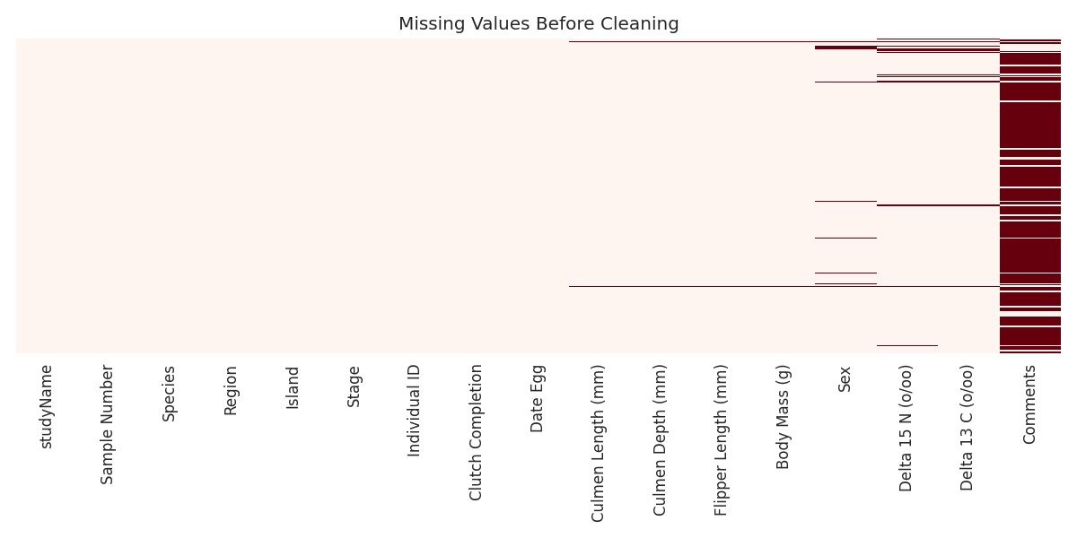
Figure 1 — Missing value map before cleaning. Each red mark is a missing cell; Comments and the isotope columns show the heaviest gaps.

4. Data Cleaning and Preprocessing

4.1 Standardizing categorical inconsistencies
The inconsistent casing in the Species field was standardized so that grouping and filtering operations later would not silently create duplicate categories.
df['Species'] = df['Species'].str.replace(
'Adelie Penguin', 'Adelie penguin', regex=False
)

4.2 Handling missing values
Rather than applying one blanket rule, each column's missing values were handled according to what the missingness meant for that specific field:
Column(s) | Missing | Strategy | Rationale
Culmen Length/Depth,  Flipper Length, Body Mass | 2 rows | Drop rows | Both rows were missing all four core measurements — nothing to impute from, and keeping them would add empty records with no analytical value.
Sex | 11 rows | Fill with "Unknown" | Guessing sex from body measurements would inject bias into a field that is itself often a variable of interest in later analysis.
Delta 15 N / Delta 13 C  (isotope ratios) | 14 / 13 rows | Median imputation,  per species | Isotope ratios differ systematically by species' diet, so a single global median would distort the values; per-species median preserves that structure.
Comments | 290 rows | Left as-is;  added has_comment flag | Free-text field not used in quantitative analysis; converting missingness into a boolean flag preserves the signal (was a note recorded?) without needing to fabricate text.

# Drop rows with no measurements at all
df = df.dropna(subset=numeric_cols, how='all')
# Explicit category instead of guessing
df['Sex'] = df['Sex'].fillna('Unknown')
# Per-species median imputation for isotopes
for col in ['Delta 15 N (o/oo)', 'Delta 13 C (o/oo)']:
df[col] = df.groupby('Species')[col]\
.transform(lambda x: x.fillna(x.median()))
df['has_comment'] = df['Comments'].notna()

4.3 Outlier detection
Outliers were first checked using the standard IQR method (values beyond 1.5×IQR from Q1/Q3) applied across the whole dataset. This pooled check flagged zero outliers in all four measurement columns.
That result was investigated further rather than accepted at face value: the three penguin species differ substantially in natural body size, so a pooled IQR calculated across all species can mask genuine outliers within a species (a large Gentoo penguin can look 'normal' next to an Adelie penguin). Repeating the check per species surfaced six values worth a closer look.
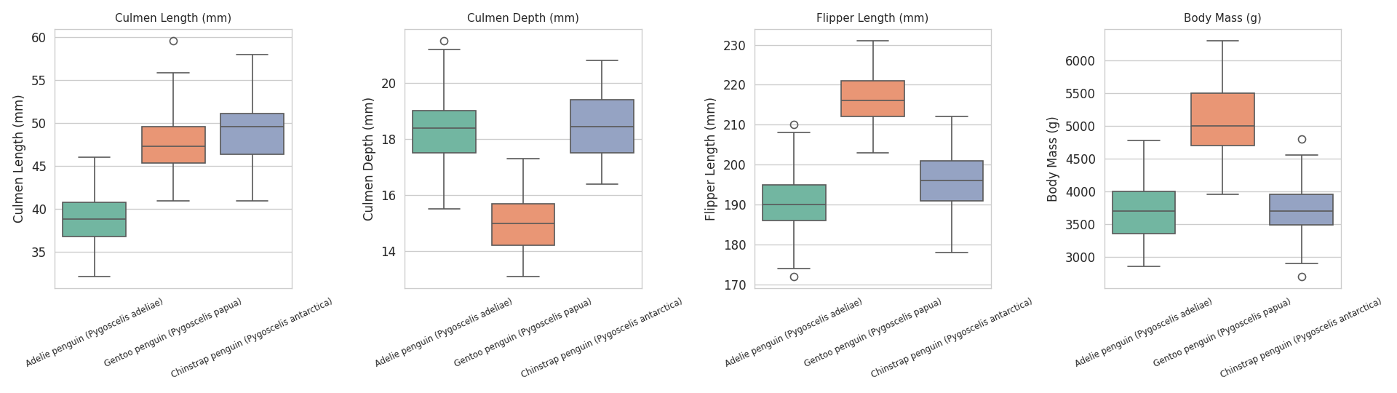
Figure 2 — Boxplots split by species. Each species has a visibly different distribution, which is why a single pooled IQR check underperforms here.
for species, group in df.groupby('Species'):
for col in numeric_cols:
Q1, Q3 = group[col].quantile([0.25, 0.75])
IQR = Q3 - Q1
lower, upper = Q1 - 1.5*IQR, Q3 + 1.5*IQR
flagged = group[(group[col] < lower) | (group[col] > upper)]
Species | Column | Value | Normal range
Adelie penguin | Culmen Depth (mm) | 21.5 | 15.2 – 21.2
Adelie penguin | Flipper Length (mm) | 172.0 | 172.5 – 208.5
Adelie penguin | Flipper Length (mm) | 210.0 | 172.5 – 208.5
Chinstrap penguin | Body Mass (g) | 4800.0 | 2793.8 – 4643.8
Chinstrap penguin | Body Mass (g) | 2700.0 | 2793.8 – 4643.8
Gentoo penguin | Culmen Length (mm) | 59.6 | 38.9 – 55.9

These six values were flagged rather than deleted. None of them are physically impossible for a penguin, and with only 342 records, removing biologically plausible variation would shrink an already modest dataset and could bias downstream analysis more than the outliers themselves. They were retained with a boolean is_outlier flag so later analysis can choose to include or exclude them explicitly.

4.4 Parsing dates
The Date Egg column was converted from plain text to a proper datetime type, which enables chronological sorting and time-based analysis (e.g. comparing egg-laying dates across seasons).
df['Date Egg'] = pd.to_datetime(df['Date Egg'], errors='coerce')
All 342 remaining values parsed successfully with no coercion failures.

5. Dataset After Cleaning
After cleaning, the dataset was reduced from 344 to 342 rows (2 fully-empty measurement rows dropped) and gained two derived columns (has_comment, and the per-species outlier flag). Missing values in the retained columns were fully resolved.
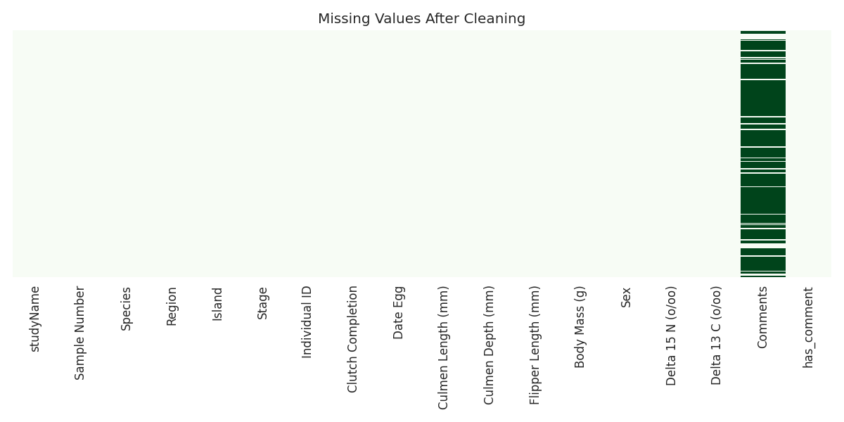
Figure 3 — Missing value map after cleaning. No gaps remain in the columns used for analysis.
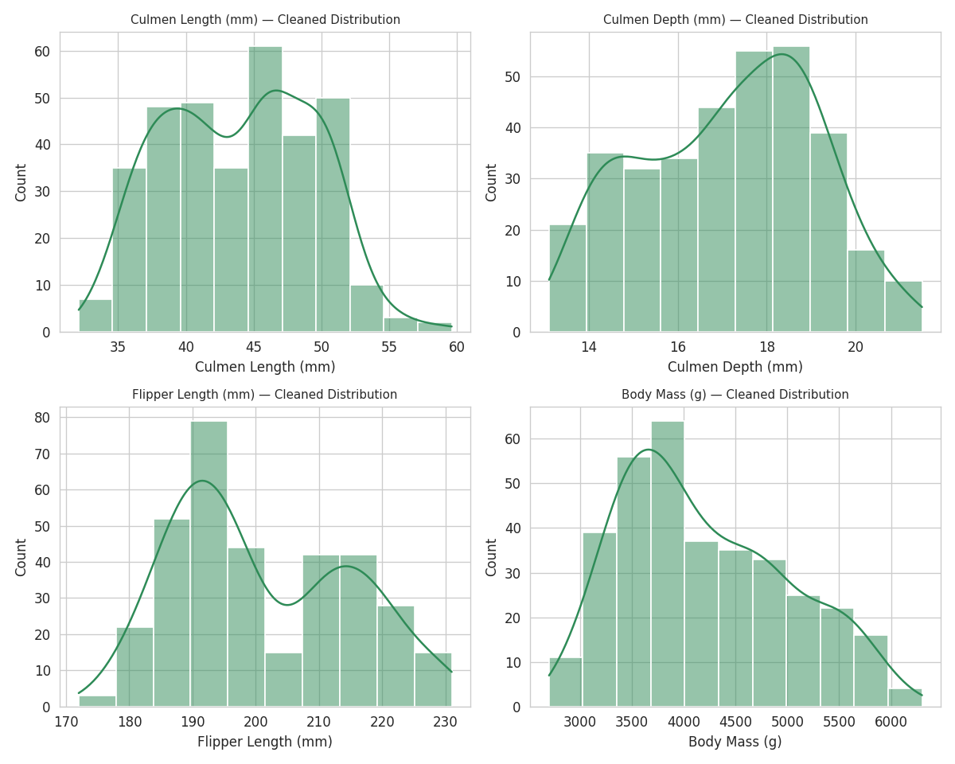
Figure 4 — Distributions of the four core physical measurements after cleaning.
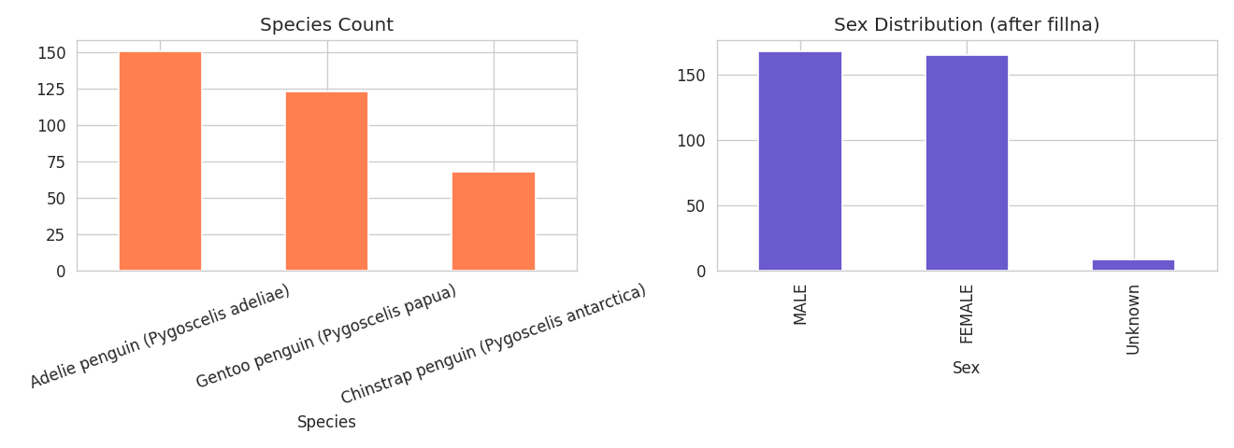
Figure 5 — Species counts and sex distribution after cleaning (11 unresolved sex values retained as "Unknown" rather than guessed).

6. Challenges Faced and How They Were Overcome
- Silent categorical inconsistency: The species-name casing issue ("Adelie Penguin" vs "Gentoo penguin") does not raise any error or missing-value warning — it simply causes value_counts() and groupby() to appear correct while silently splitting what should be one category if left unnoticed. It was only caught by explicitly printing df['Species'].unique() rather than trusting a summary count. Lesson: always inspect raw unique values of categorical fields, not just aggregate counts.
- Pooled outlier detection gave a false sense of cleanliness: The first IQR pass across the whole dataset reported zero outliers, which was tempting to accept and move on. Splitting the same check by species instead of taking the global result at face value uncovered six genuine edge cases. Lesson: outlier detection needs to respect known subgroups in the data rather than being applied blindly.
- Deciding what "missing" means per column: A single imputation strategy (e.g. fill everything with the mean) would have been faster but wrong in different ways for different columns — guessing Sex would fabricate a categorical label, while dropping every row with a missing isotope value would have discarded usable measurement data. Each column was handled based on what the missingness actually represented.
- Distinguishing repeated measurements from duplicate rows: With 190 unique IDs across 344 rows, an early assumption that this was duplicated data would have been wrong. Checking df.duplicated().sum() (which returned 0) confirmed that repeat IDs reflect the same penguins being measured across different breeding seasons, a real feature of the study design that had to be preserved.

7. Potential Impact of Preprocessing on Subsequent Analysis
Every cleaning decision made here has downstream consequences for any analysis built on this dataset:
- Standardizing species names is essential before any groupby, visualization, or model that uses Species as a categorical feature — leaving the casing inconsistent would silently fragment the Adelie group into two categories.
- Filling Sex with "Unknown" rather than imputing a guess keeps that field honest for any classification task that tries to predict sex from measurements; a guessed value would leak fabricated signal into the target variable.
- Per-species median imputation for isotope ratios preserves the real biological differences between species' diets. A global-mean imputation would have pulled Gentoo penguins' isotope values toward Adelie/Chinstrap norms, understating between-species variation in any later ecological analysis.
- Retaining rather than deleting the six flagged outliers keeps the dataset's natural variance intact for descriptive statistics and visualization, but any model sensitive to extreme values (e.g. linear regression, k-means) should explicitly decide whether to use the is_outlier flag to include or exclude them, rather than being silently affected either way.
- Converting Date Egg to a real datetime type is a prerequisite for any time-based analysis, such as comparing clutch timing across seasons or islands.

8. Conclusion
This task involved acquiring the Palmer Penguins raw dataset, systematically exploring its structure, and applying targeted cleaning strategies rather than one-size-fits-all rules. Missing values were resolved based on what each column's missingness meant, categorical inconsistencies were standardized, and outlier detection was corrected to account for species-level differences after an initial pooled check proved misleading. The resulting dataset (342 rows, 18 columns, zero missing values in analysis-relevant fields) is ready for exploratory analysis or modeling, with outliers flagged rather than silently removed so that later analytical choices remain transparent and reversible.

Deliverable files: penguins_raw.csv (source), penguins_cleaned.csv (cleaned output), and the Python scripts used for exploration and cleaning.

