Exploratory Data Analysis and Visualization
Week 2 Task Report — YuvaIntern Data Science with Python Trainee
Dataset: Palmer Archipelago (Antarctica) Penguin Data — cleaned in Week 1

1. Objective
This task performs exploratory data analysis (EDA) on a public dataset to extract meaningful insights using Pandas, Matplotlib, and Seaborn. The goal is to move beyond surface-level statistics and use visualization to uncover patterns, relationships, and anomalies, then interpret what those patterns suggest about the underlying data.

2. Dataset
This analysis continues directly from the Week 1 task, using the cleaned Palmer Archipelago Penguins dataset (342 records, three species: Adelie, Chinstrap, and Gentoo, collected across three islands in Antarctica). Building on an already-cleaned dataset keeps this task focused on analysis and interpretation rather than repeating data-quality work, and mirrors a realistic workflow where cleaning and EDA are separate, sequential stages of a project.
import pandas as pd
df = pd.read_csv('penguins_cleaned.csv')
print(df.shape) # (342, 18)

3. Initial Analysis: Summary Statistics
Before visualizing, basic descriptive statistics were computed for the four core physical measurements to establish a baseline understanding of scale and spread.
num_cols = ['Culmen Length (mm)', 'Culmen Depth (mm)',
'Flipper Length (mm)', 'Body Mass (g)']
print(df[num_cols].describe().round(2))
Metric | Culmen Length (mm) | Culmen Depth (mm) | Flipper Length (mm) | Body Mass (g)
Mean | 43.92 | 17.15 | 200.92 | 4201.75
Std Dev | 5.46 | 1.97 | 14.06 | 801.95
Min | 32.10 | 13.10 | 172.00 | 2700.00
Max | 59.60 | 21.50 | 231.00 | 6300.00

Species counts were also checked, since an imbalanced dataset changes how later visual patterns should be interpreted: Adelie penguins make up the largest group (151 records), followed by Gentoo (123) and Chinstrap (68).
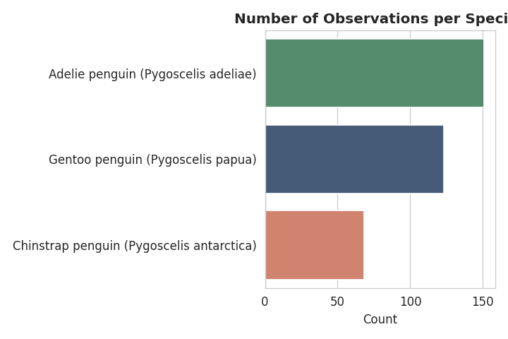
Figure 1 — Observation count per species. The dataset is moderately imbalanced, which is kept in mind when comparing group patterns later.

4. Visualizations and Patterns

4.1 Univariate distributions
Each of the four physical measurements was plotted as a histogram with a density curve, split by species, to see both the overall shape of each variable and whether species drive that shape.
fig, axes = plt.subplots(2, 2, figsize=(11, 8))
for ax, col in zip(axes.flat, num_cols):
sns.histplot(data=df, x=col, hue='Species', kde=True,
ax=ax, palette=PALETTE, alpha=0.6)
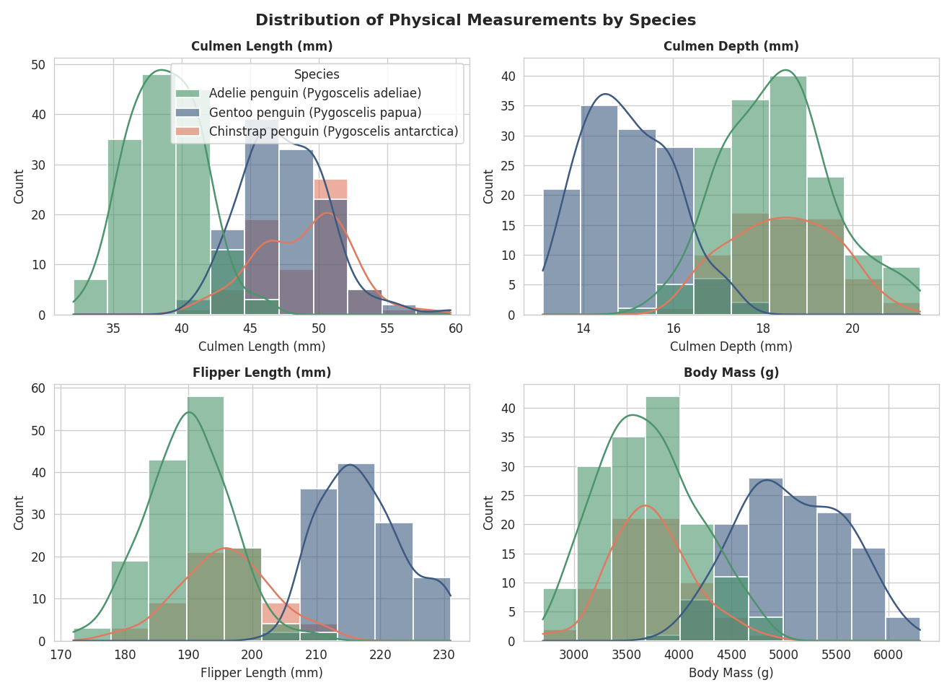
Figure 2 — Distribution of each measurement, split by species. Culmen length and flipper length show clear multi-modal shapes once split by species, showing the pooled distribution is really a mixture of three distinct species-level distributions.
Interpretation: none of the four measurements are unimodal by species — each species occupies a fairly narrow, separate range. This is an early signal that species is a strong driver of variation in this dataset and should be treated as a grouping variable in almost every subsequent analysis, not averaged over.

4.2 Correlation structure
A correlation matrix was computed across the four measurements, pooling all species together.
sns.heatmap(df[num_cols].corr(), annot=True, cmap='RdBu_r', center=0)
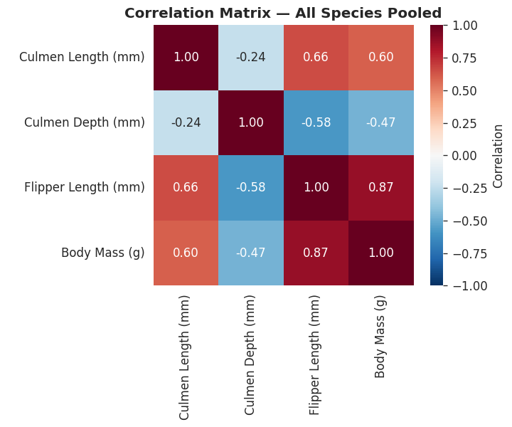
Figure 3 — Pooled correlation matrix. Flipper length and body mass are strongly positively correlated (r = 0.87), but culmen depth is negatively correlated with both body mass (r = -0.47) and flipper length (r = -0.58).
The negative correlation between culmen depth and body mass was unexpected — deeper bills would not obviously be expected to associate with lower body mass. This was investigated further rather than taken at face value.

4.3 Investigating the negative correlation: Simpson's Paradox
The relationship between culmen depth and body mass was re-examined by species rather than pooled.
for species, group in df.groupby('Species'):
r = group['Culmen Depth (mm)'].corr(group['Body Mass (g)'])
print(species, round(r, 2))
# Adelie: 0.58
# Chinstrap: 0.60
# Gentoo: 0.72
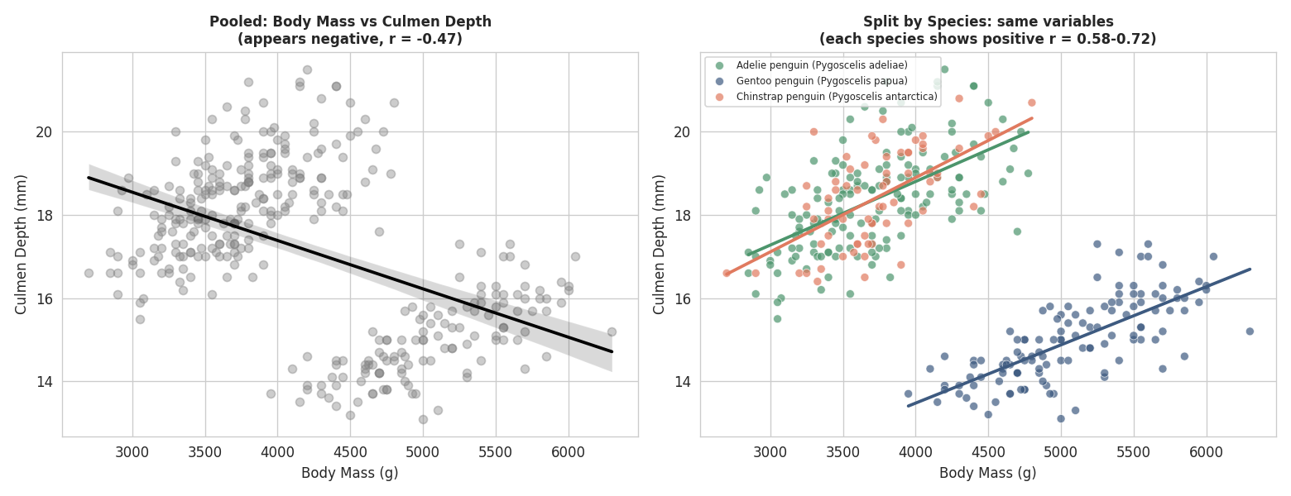
Figure 4 — Left: pooled data shows a misleading negative trend. Right: split by species, every species shows a clear positive relationship between culmen depth and body mass.
This is a textbook case of Simpson's Paradox: within every individual species, deeper bills genuinely associate with higher body mass (r = 0.58 to 0.72, all positive). The pooled negative correlation is an artifact of species acting as a confounding variable — Gentoo penguins are both the heaviest species and have proportionally shallower bills than Adelie or Chinstrap penguins, so mixing all three species together reverses the sign of the relationship entirely.
Why this matters: it demonstrates that correlation coefficients computed on pooled multi-group data can actively mislead rather than merely lack detail. Any later analysis (e.g. a regression model predicting body mass) that does not account for species as a variable would learn a relationship between culmen depth and mass that is the opposite of the true biological relationship.

4.4 Strongest relationship: flipper length vs body mass
Flipper length showed the strongest correlation with body mass in the pooled matrix (r = 0.87), so this relationship was visualized directly, split by both species and sex.
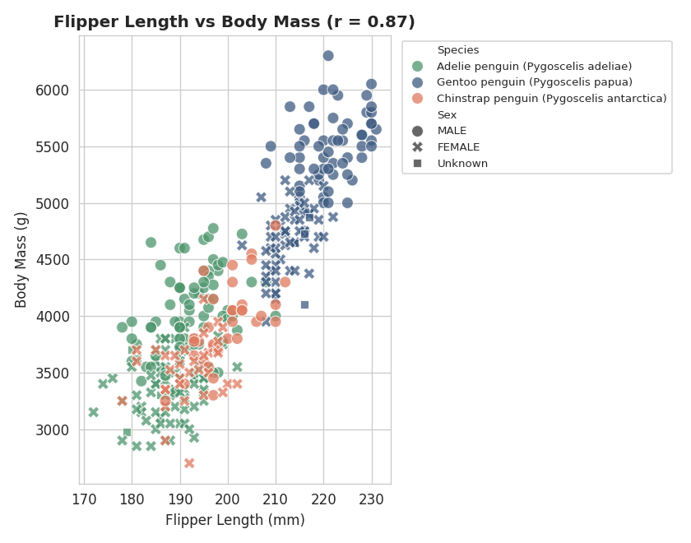
Figure 5 — Flipper length vs body mass. The relationship is strongly linear and, unlike culmen depth, holds in the same direction whether pooled or split by species — Gentoo penguins simply extend the same trend line to larger values.
Interpretation: flipper length is a reliable, direction-consistent predictor of body mass across all three species, making it a good candidate feature if this dataset were later used for a predictive model. Male penguins (marked with a different point style) tend to sit at the higher end of both flipper length and body mass within each species, consistent with sexual size dimorphism.

4.5 Species separation in bill shape
Plotting culmen length against culmen depth directly shows how cleanly the three species separate using just these two measurements.
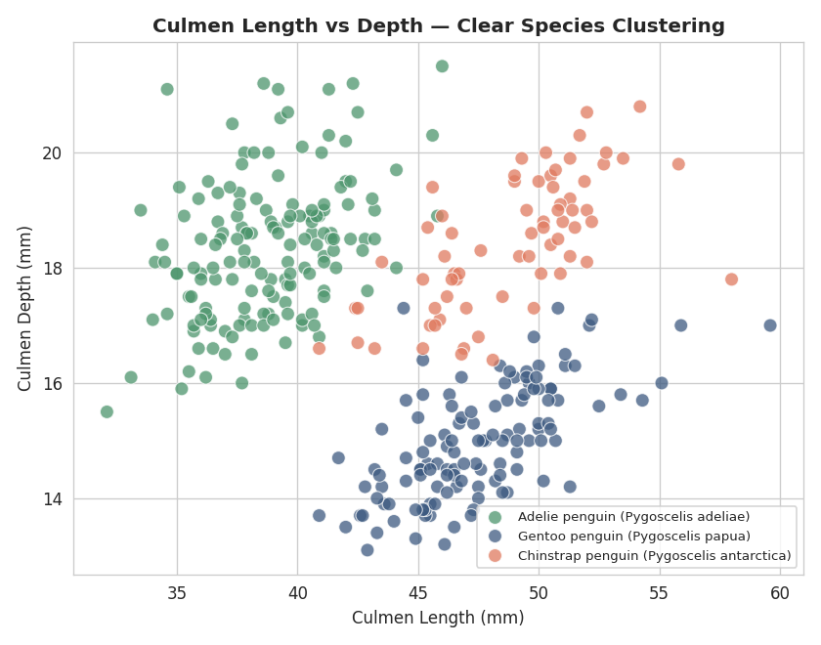
Figure 6 — Culmen length vs depth. Gentoo penguins are clearly separated from Adelie and Chinstrap by depth alone; Adelie and Chinstrap separate mainly by length.
Interpretation: this pair of measurements alone would likely be sufficient to classify species with high accuracy, which is a useful finding if this dataset were later used for a classification task — not all four measurements would be strictly necessary.

4.6 Species distribution across islands
Cross-tabulating species against island revealed a pattern worth visualizing: species and island are not independent.
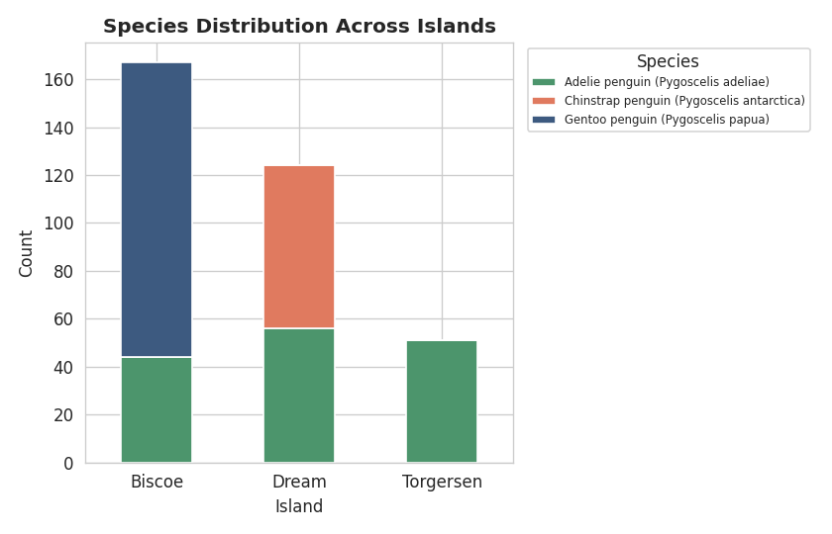
Figure 7 — Species counts by island. Gentoo and Chinstrap penguins each appear on only one island in this dataset (Biscoe and Dream respectively), while Adelie penguins are the only species present on all three.
Interpretation: island is almost a proxy for species in this dataset (perfect separation for two of the three species). This is an important caveat for any analysis: a model using 'island' as a predictor could achieve artificially high accuracy on this dataset by essentially learning species from location, which may not generalize to other penguin populations or islands outside this study.

4.7 Body mass by species and sex
To check for sexual dimorphism (size differences between males and females) within each species, body mass was compared using boxplots grouped by species and sex.
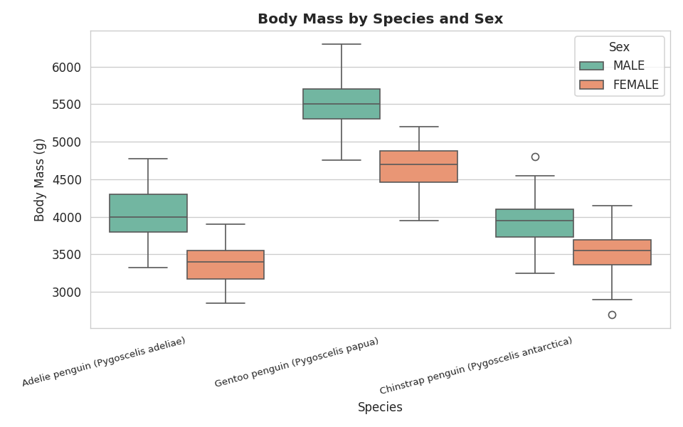
Figure 8 — Body mass by species and sex (rows with unknown sex excluded). Males are consistently heavier than females within every species.
Interpretation: the male-heavier pattern holds across all three species with little overlap in Gentoo, and more overlap in Adelie and Chinstrap. This confirms sexual dimorphism is a real, consistent effect in this population rather than being driven by one species.

4.8 Pairwise overview
Finally, a pairplot was generated to view all pairwise relationships between the four measurements at once, as a summary check for any pattern not already covered individually above.
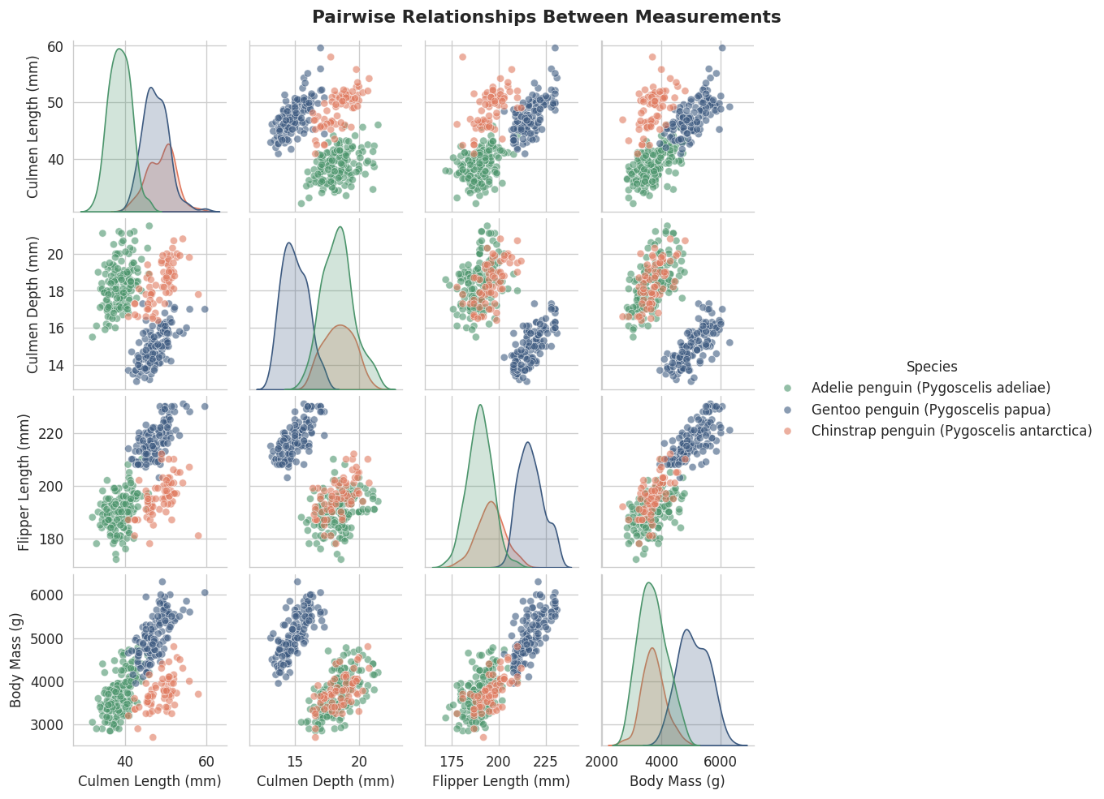
Figure 9 — Full pairwise grid of the four core measurements, colored by species. Diagonal panels show each variable's distribution by species.
This confirms the patterns found individually above: species form visually distinct clusters in almost every pairwise combination, with the most overlap between Adelie and Chinstrap (which share similar flipper length and body mass) and the cleanest separation involving Gentoo (driven by its shallower culmen depth and longer flippers).

5. Data Transformations and Aggregations Used
- Grouped aggregation (groupby + mean): used to compute mean measurements per species and per species-sex combination, summarized in Section 3 and used to interpret Figures 5 and 8.
- Per-group correlation: correlation coefficients were recomputed within each species subgroup (Section 4.3) rather than relying on the single pooled value, which is what surfaced Simpson's Paradox.
- Cross-tabulation (pd.crosstab): used to count species occurrences per island (Figure 7), turning two categorical columns into a matrix suitable for a stacked bar chart.
- Filtering: rows with Sex == 'Unknown' (11 rows, carried over from Week 1's cleaning) were excluded specifically for the sex-comparison boxplot (Figure 8), since an 'Unknown' category would distort a two-group male/female comparison without adding information.

6. Key Findings and Conclusion
- Species is the dominant source of variation in this dataset — nearly every measurement's distribution is really a mixture of three separate species-level distributions rather than one smooth population.
- The pooled correlation between culmen depth and body mass (r = -0.47) is misleading; the true within-species relationship is positive (r = 0.58-0.72) in all three species. This is a clear example of why correlations should be checked within relevant subgroups before being interpreted.
- Flipper length is the strongest and most consistent predictor of body mass (r = 0.87), holding in the same direction whether pooled or split by species.
- Island is nearly a proxy for species (Gentoo only on Biscoe, Chinstrap only on Dream), an important caveat for any future model that might use island as a feature.
- Male penguins are consistently heavier than females within every species, confirming genuine sexual dimorphism rather than a sampling artifact.
Together, these findings show the value of EDA beyond summary statistics: the single most important insight in this analysis (Simpson's Paradox in the culmen depth relationship) was invisible in the pooled correlation matrix and only became apparent through visualization split by a relevant categorical variable.

Deliverable files: penguins_cleaned.csv (input, from Week 1), Python scripts for summary statistics and visualization, and all figure images.

