Unsupervised Learning and Clustering Analysis
Week 3 Task Report — YuvaIntern Data Science with Python Trainee
Dataset: Palmer Archipelago (Antarctica) Penguin Data — cleaned in Week 1, explored in Week 2

1. Objective
This task applies unsupervised learning to segment a dataset into meaningful clusters without using any target labels, then interprets what each cluster represents. Two clustering algorithms — K-Means and Agglomerative (Hierarchical) Clustering — are applied and compared, with cluster quality evaluated both internally (silhouette score) and, since this dataset happens to include known species labels, externally against the ground truth as a way of sanity-checking the clustering's real-world meaning.

2. Dataset and Rationale
This task continues using the Palmer Archipelago Penguins dataset (342 records, cleaned in Week 1, explored in Week 2). It is a strong fit for a clustering exercise for a specific reason: the true species label exists in the data but is deliberately excluded from the clustering algorithm. This allows the clustering results to be validated against a known ground truth after the fact — something not possible with most real unsupervised learning problems, where no ground truth exists at all. Framed this way, the task becomes: can clustering recover the three known penguin species using only physical measurements, with no species information provided?
Only the four continuous physical measurements were used as clustering features: Culmen Length, Culmen Depth, Flipper Length, and Body Mass. Categorical columns (Island, Sex) and the Species column itself were excluded from the feature set — Species because it is the label being validated against, and Island/Sex because the goal was to test whether morphology alone is enough to separate the groups.

3. Preprocessing for Clustering
K-Means and hierarchical clustering both rely on Euclidean distance between points, which means features on larger numeric scales dominate the distance calculation regardless of their actual importance. Body Mass (g) ranges into the thousands while the bill and flipper measurements are in the tens to low hundreds, so without scaling, clustering would essentially become clustering on body mass alone.
from sklearn.preprocessing import StandardScaler
feature_cols = ['Culmen Length (mm)', 'Culmen Depth (mm)',
'Flipper Length (mm)', 'Body Mass (g)']
X = df[feature_cols]
scaler = StandardScaler()
X_scaled = scaler.fit_transform(X)
# Each feature now has mean 0, std 1
All four features were standardized to zero mean and unit variance before clustering. No missing values remained at this stage (resolved in Week 1), so no further imputation was needed.

4. Choosing the Number of Clusters (K-Means)
Two standard methods were used to choose k for K-Means: the elbow method (looking for a bend in within-cluster sum of squares) and the silhouette score (measuring how well-separated clusters are, independent of any ground truth).
from sklearn.cluster import KMeans
from sklearn.metrics import silhouette_score
for k in range(2, 9):
km = KMeans(n_clusters=k, random_state=42, n_init=10)
labels = km.fit_predict(X_scaled)
print(k, km.inertia_, silhouette_score(X_scaled, labels))
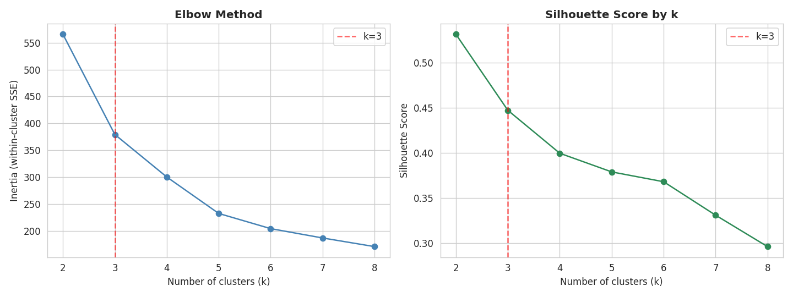
Figure 1 — Elbow method (left) and silhouette score (right) across k=2 to 8.
These two methods disagreed. The elbow plot shows a visible bend around k=3, consistent with prior domain knowledge that this dataset contains three species. The silhouette score, however, is actually highest at k=2 (0.532) and decreases at every k after that, including k=3 (0.447). Rather than picking whichever number looked more convenient, both k=2 and k=3 were carried forward and compared directly against the known species labels, which is discussed in detail in Section 6.

5. Applying K-Means
K-Means was fit at both k=2 and k=3 using scikit-learn, with n_init=10 to reduce sensitivity to centroid initialization and a fixed random_state for reproducibility. Results were visualized in 2D using PCA (Principal Component Analysis) to project the four-dimensional feature space down to its two most informative components.
from sklearn.decomposition import PCA
pca = PCA(n_components=2, random_state=42)
X_pca = pca.fit_transform(X_scaled)
# PC1 explains 68.8% of variance, PC2 explains 19.3% (88.2% total)
km2 = KMeans(n_clusters=2, random_state=42, n_init=10).fit(X_scaled)
km3 = KMeans(n_clusters=3, random_state=42, n_init=10).fit(X_scaled)
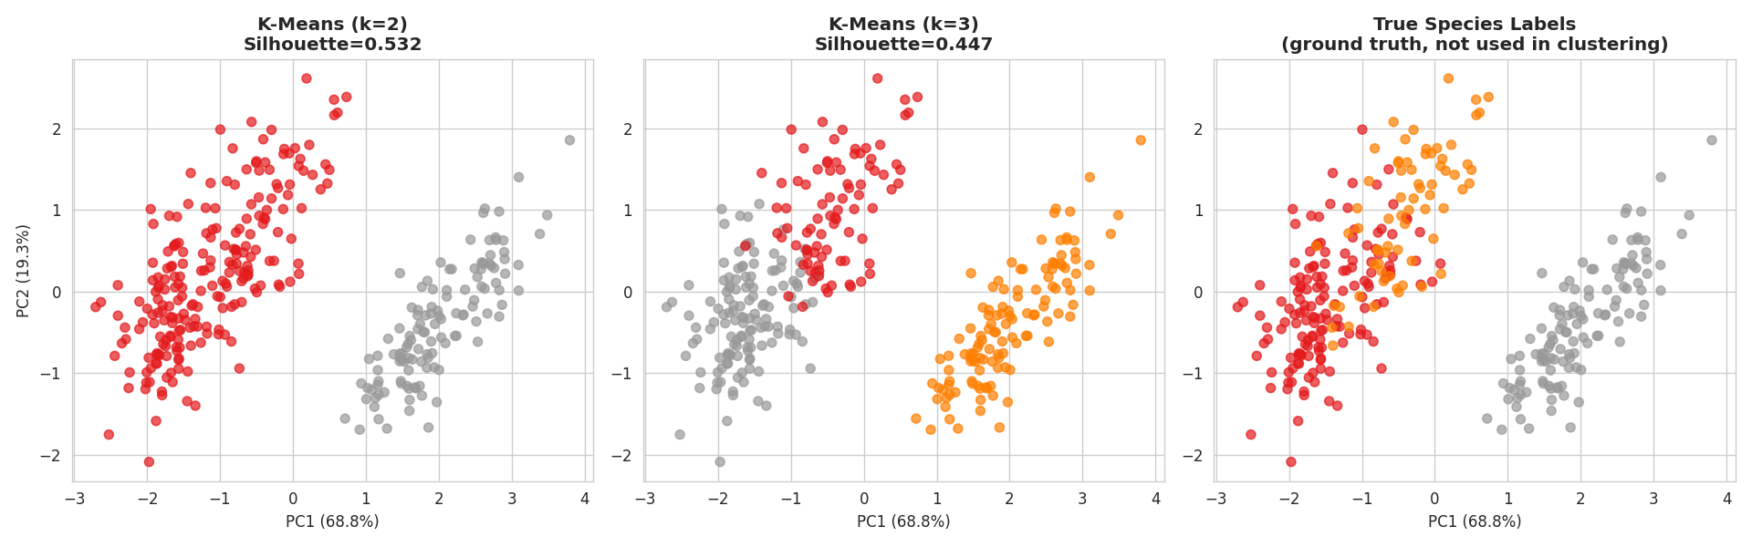
Figure 2 — PCA projection (88.2% of variance captured in 2 components) colored by: K-Means k=2 (left), K-Means k=3 (middle), and true species labels (right, for comparison only — not used in clustering).
Visually, K-Means at k=2 places a clean boundary between one large, elongated group and one tighter, separate group. At k=3, that larger group is further split. Comparing all three panels against the true species panel shows the k=2 split isolates Gentoo penguins almost perfectly, while grouping Adelie and Chinstrap together into a single cluster.

6. Validating Cluster Quality Against Ground Truth
Since this dataset's true species labels are available, the Adjusted Rand Index (ARI) was used to measure how closely each clustering matched biological reality. ARI ranges from -1 to 1, where 1 means perfect agreement and 0 means agreement no better than random chance. This step is only possible because the labels happen to be known here — in a genuine unlabeled problem this validation step would not be available, which is exactly why internal metrics like silhouette score matter in the first place.
from sklearn.metrics import adjusted_rand_score
ari_k2 = adjusted_rand_score(df['Species'], labels_k2) # 0.655
ari_k3 = adjusted_rand_score(df['Species'], labels_k3) # 0.793
Model | Silhouette Score | ARI vs true species | What it found
K-Means, k=2 | 0.532 (highest) | 0.655 | Gentoo isolated perfectly; Adelie + Chinstrap merged into one cluster
K-Means, k=3 | 0.447 | 0.793 | Gentoo isolated perfectly; Adelie/Chinstrap mostly but imperfectly separated

This is the central finding of the internal-vs-external comparison: the statistically "best" clustering by silhouette score (k=2) is not the most biologically meaningful one. k=2 achieves a higher silhouette purely because Adelie and Chinstrap penguins overlap heavily in overall body size and flipper length, making them look like a single natural group in Euclidean space — even though they are genuinely different species. k=3, despite a lower silhouette score, achieves a substantially higher ARI (0.793 vs 0.655) because it recovers a species boundary that silhouette score alone cannot see. The lesson: an internal validation metric like silhouette score measures how geometrically compact and separated clusters are, not whether they are meaningful — when any domain knowledge is available, it should be used alongside, not instead of, internal metrics.

7. Hierarchical Clustering as a Second Method
To test whether a different clustering approach would resolve the Adelie/Chinstrap overlap better than K-Means, Agglomerative Hierarchical Clustering was applied using Ward linkage, which — like K-Means — minimizes within-cluster variance, making the two methods reasonably comparable.
from scipy.cluster.hierarchy import linkage, fcluster, dendrogram
Z = linkage(X_scaled, method='ward')
hc_labels = fcluster(Z, t=3, criterion='maxclust')
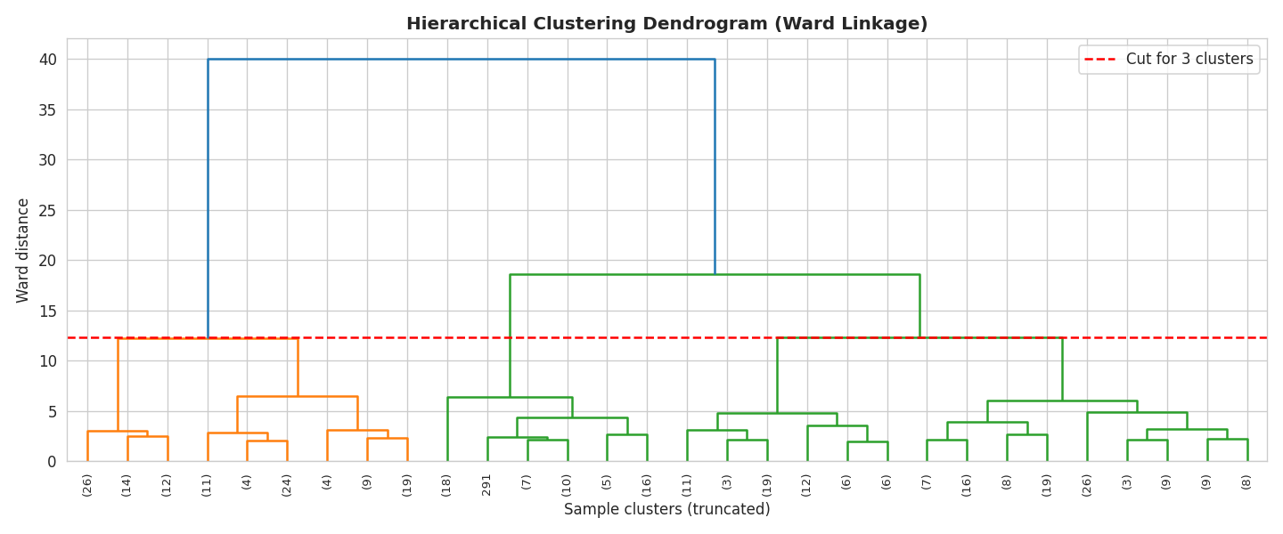
Figure 3 — Ward-linkage dendrogram (truncated for readability). The red line marks the cut used to produce 3 clusters; the tallest merge (leftmost, joining Gentoo to the rest) confirms Gentoo is the most distinct group, consistent with the K-Means results.
Model | Silhouette Score | ARI vs true species
K-Means, k=3 | 0.447 | 0.793
Hierarchical (Ward), k=3 | 0.454 | 0.916

Hierarchical clustering outperformed K-Means at the same k on both metrics, and substantially so on ARI (0.916 vs 0.793) — a meaningfully closer match to the true species structure. This suggests Ward linkage's approach of building clusters bottom-up by merging the closest pairs first handles the more subtle Adelie/Chinstrap boundary better than K-Means' approach of iteratively updating centroids from random starting points. Given this result, hierarchical clustering was used as the final model for the cluster profiling in Section 8.

8. Cluster Characteristics and Interpretation
Using the hierarchical clustering result (3 clusters, the best-performing model), the mean of each feature was computed per cluster to characterize what distinguishes each group.
Cluster | n | Culmen Length | Culmen Depth | Flipper Length | Body Mass | Dominant species
1 | 123 | 47.5 mm | 15.0 mm | 217.2 mm | 5076.0 g | Gentoo (100% pure)
2 | 57 | 49.8 mm | 18.6 mm | 197.1 mm | 3810.1 g | Chinstrap (100% pure)
3 | 162 | 39.2 mm | 18.3 mm | 189.9 mm | 3675.8 g | Adelie (151) + Chinstrap (11)

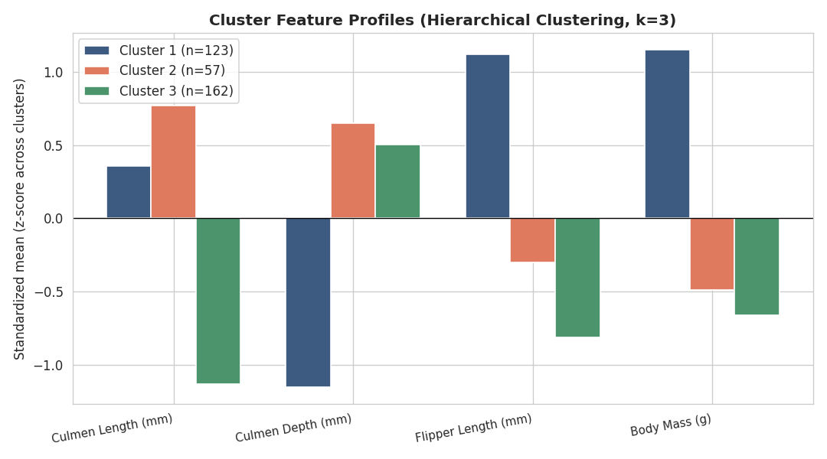
Figure 4 — Standardized feature profile per cluster. Cluster 1 stands out on Flipper Length and Body Mass; Clusters 2 and 3 are both smaller-bodied but separate mainly on Culmen Length.
Cluster 1 (Gentoo-dominant): the largest-bodied group by a wide margin — longest flippers and heaviest by nearly 1,300g on average compared to the other two clusters, but with the shallowest bills. This cluster was recovered essentially perfectly (123 of 123 members are Gentoo).
Cluster 2 (Chinstrap): smaller-bodied, but with the longest and deepest bills of the three clusters. This cluster was recovered perfectly pure (57 of 57 members are Chinstrap), indicating that once bill shape is weighted properly by the algorithm, Chinstrap penguins are in fact fully distinguishable from Adelie — the overlap identified earlier runs in one direction only.
Cluster 3 (Adelie-majority): smaller-bodied with the shortest culmen length by a clear margin, which is its main distinguishing feature from Cluster 2. This is the largest cluster (162 members) and is where all of the remaining confusion sits — 151 Adelie penguins plus 11 Chinstrap penguins that were pulled in here rather than into Cluster 2. In other words, the Adelie/Chinstrap boundary error found throughout this analysis is entirely a case of some Chinstrap penguins being mistaken for Adelie, not the reverse.

9. Research and Practical Implications
- Field identification support: since clustering recovers species groupings from four simple physical measurements alone, a similar model could support field researchers in tentatively classifying penguins from morphometric data when visual species identification is difficult or when working from historical measurement records without species tags.
- Feature importance for species distinction: the analysis shows body size (flipper length, body mass) primarily separates Gentoo from the other two species, while bill dimensions (especially culmen length) are what separate Adelie from Chinstrap. This has a direct practical implication — if only two measurements could be taken in the field, flipper length and culmen length would carry most of the species-discriminating power.
- Caution against relying on internal metrics alone: the silhouette-vs-ARI disagreement in Section 6 is a broader methodological lesson applicable beyond this dataset — internal clustering metrics answer 'are these clusters geometrically well-separated', not 'are these clusters meaningful', and the two questions can have different answers.
- Method selection matters: hierarchical clustering meaningfully outperformed K-Means here on the same features and same k. In applications where recovering a true underlying structure matters more than computational speed (K-Means scales better to large datasets, hierarchical clustering does not), this result suggests hierarchical methods deserve serious consideration rather than defaulting to K-Means.

10. Conclusion
This task applied K-Means and Hierarchical clustering to the Palmer Penguins dataset using only physical measurements, with species labels withheld from the algorithms and used only for post-hoc validation. Both methods recovered a clear three-group structure that closely mirrors the three true penguin species, with hierarchical clustering (Ward linkage) achieving the strongest match (ARI = 0.916). The analysis also surfaced a methodological insight applicable beyond this dataset: the internally-preferred k (k=2, by silhouette score) was not the most biologically meaningful choice, which is only detectable when validated against outside knowledge — a reminder that unsupervised learning results should be interpreted critically rather than accepted purely on the basis of internal statistical metrics.

Deliverable files: penguins_clustered.csv (final dataset with cluster assignments), Python scripts for preprocessing, K-Means, hierarchical clustering, and cluster profiling, and all figure images.

