IOT Mining Tracking & Worker Safety Helmet

Mining is indispensable to the creation of goods, infrastructure and services which enhance the quality of their lives. As a society we’re blessed to enjoy the many advantages that industry manufactured products provide us by processing these raw materials.
Working in the earth presents many different security and health dangers. Frequently the underground environment is shaky or unpleasant. The mines that are deeper, the more dangerous it could be to be running jobs. There’s oxygen leak that is restricted, and there are challenges related to leaving a mine if a crisis happen.
So here we propose a mining tracking as well as safety system for the mining industry using microcontroller based circuit on the worker helmet. We use rf based circuitry to detect workers moving through the entire mining site. The helmet is integrated with an rf based tracking system which in coordination with the tracker rf systems help provide data over IOT. The system makes use of atmega microcontroller based rf tracker circuitry to receive the data transmitted by worker helmet nodes. This helps map the current location of workers through the entire mining site. Moreover each worker helmet circuit is integrated with a panic/emergency button. This button when pressed shows an emergency sign over the IOT web interface about the worker emergency. This can be used for any emergencies like – toxic gas inhalation, cave ins, physical injury etc. Thus the system ensures mining worker safety using IOT.

Block Diagram:

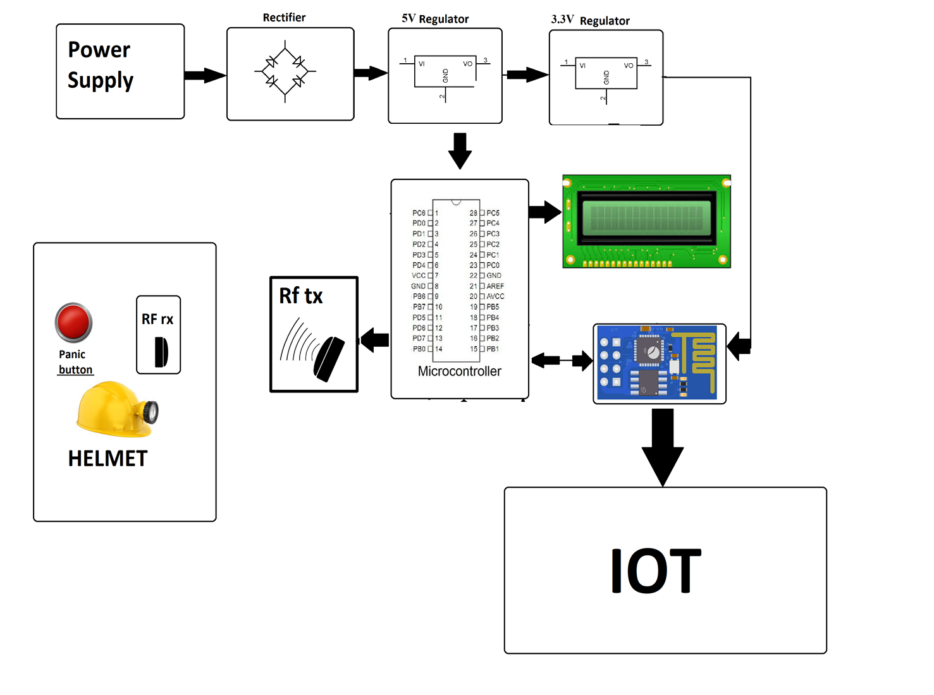

Hardware Specifications

- Atmega Microcontroller

- Wifi Module
- RF Tx Rx

- Buzzer

- LCD Display

- Crystal Oscillator

- Resistors
- Capacitors

- Transistors

- Cables and Connectors
- Diodes

- PCB and Breadboards

- LED
- Transformer/Adapter

- Push Buttons

- Switch
- IC

- IC Sockets

Software Specifications
- Programming Language: C

- IOT Gecko

