Overview cloud computing platform

Nowadays, with the development of digital technology, especially the development of 4G networks, companies from small to large have tended to use cloud computing platforms to deploy their servers. Some benefits of cloud computing platform are cost savings, stable speed, elasticity based on the number of users, easy to deploy the system, all data when used. such as the number of users at a time will be conveniently recorded for reporting and cloud computing to allow for easy server configuration upgrades as needed. The benefits of cloud computing platform are undeniable but besides that, there are risks in the process of deploying and using it. The following are challenges for cloud computing systems based on statistics of (RightScale 2018 State of the Cloud Report)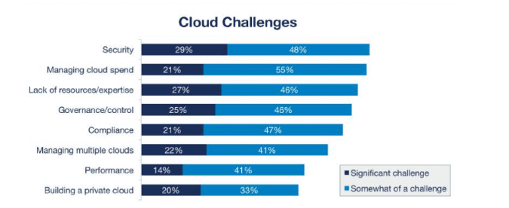

# Security

Based on the above statistics we can see that security is the most important issue. Based on the structure of the cloud computing platform, many users will use the same physical hardware of the server. This can lead to the fact that if a server tenant is attacked by a hacker, then the hacker may attack other users. Therefore, cloud computing system vendors take this issue seriously. For example, Amazon offers Data protection: AWS provides services that help you protect your data, accounts, and workloads from unauthorized access. AWS data protection services provide encryption and key management and threat detection that continuously monitors and protects your accounts and workloads. (<https://aws.amazon.com/en/products/security/>)

# Organizational Security Problem

The security team issue of the team is also one of the risks when using cloud computing or methods using local server. This problem may come from the human problem. Hackers can use this to infiltrate an organization to get information. Next, the company's security is also an important factor. For example, the company is not equipped with security equipment such as cameras, anti-theft locks, ...

Solution:

Equipped with security devices such as security cameras, barbed wire fence, ...

Human issues: we can select employees who have a clear background, and give them the appropriate rights to each role. For example: Salespeople can only enter places for employees. For employees involved in new data system can go into the data storage

Risk of project implementation process

During project implementation, the process of determining funding and timing is important. If the system implementation time is longer than initially expected, the project will not have enough funding for implementation

# Data integrity

During the process of transferring data from the client to the server, the data can be stolen and modified. This may cause the storage process in the database on the server to be corrupted. Next is the selection of data types on the back-end. Each data type has a certain limit to reach the limit where error will occur. For example, the int type is 2147483647 if the data is greater than 2147483647, it will change to -2147483648.

Solution:  
To avoid data theft during transmission we can encrypt the data before sending it. Some encryption methods can be applied such as hash, symmetric key encrytion, ...