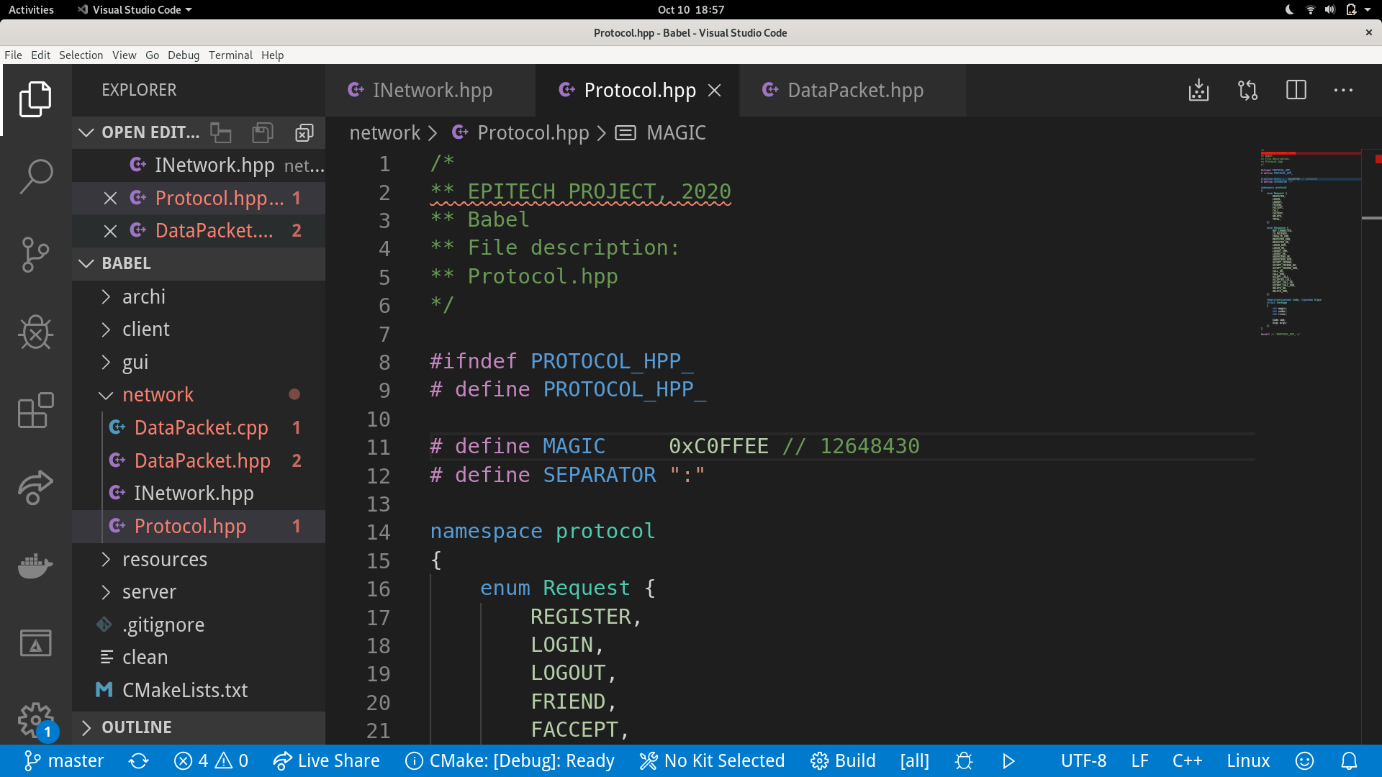**Babel** *protocol*

**Package**:

base package whose inherit client/server’ specific library packages

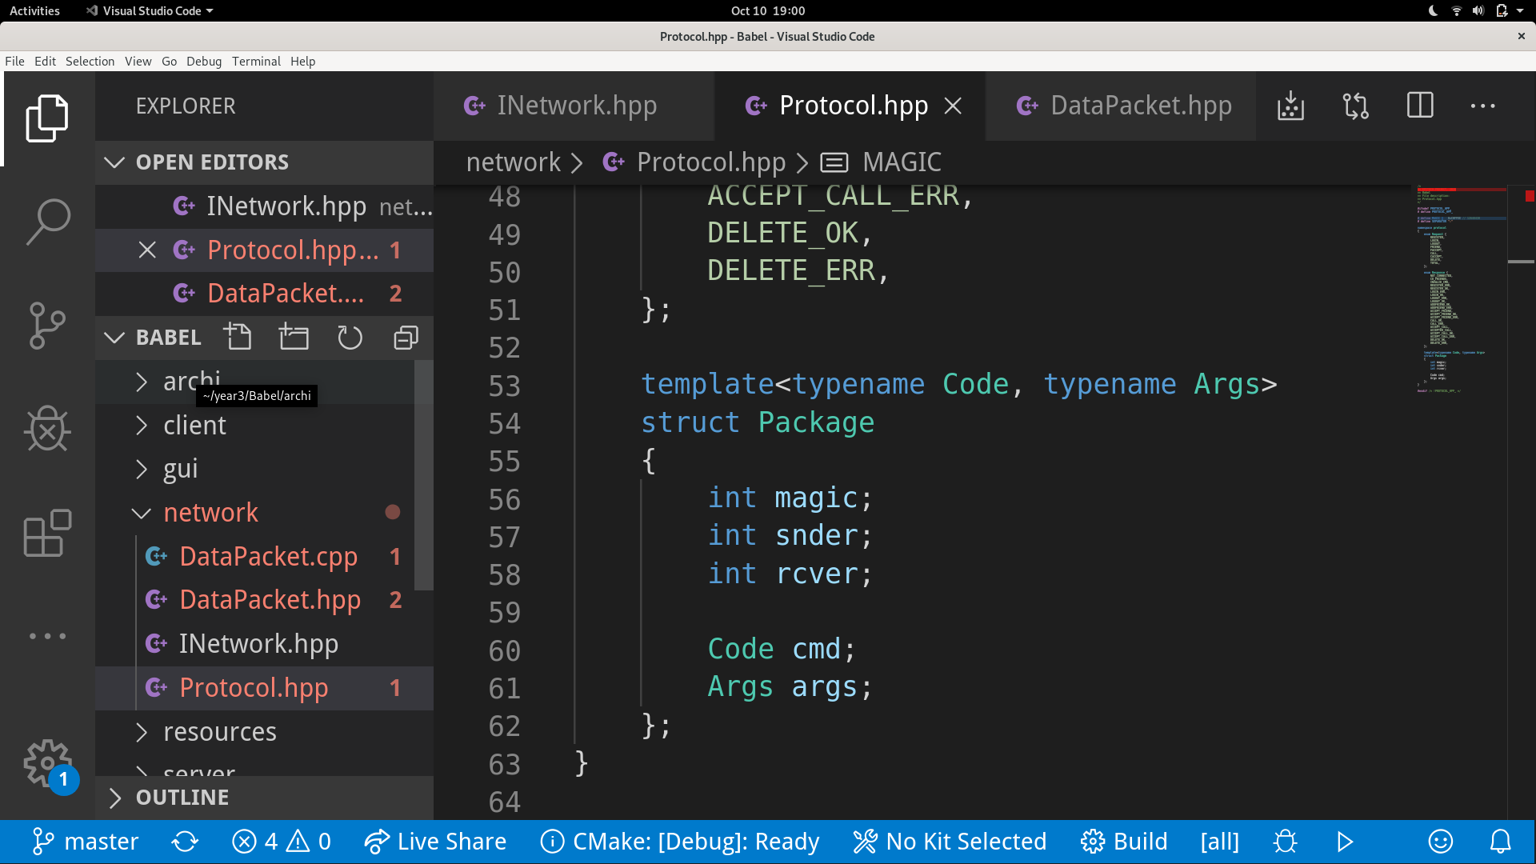

***magic*** *→ constant for verification of package format*

***snder*** *→ socket’s port which send package*

***rcver*** *→ socket’s port which receive package*

***cmd*** *→ request/response code sent by client/server*

***args*** *→ arguments needed by the command*

**Request/Response:**

enums containing requests/responses’ code to use

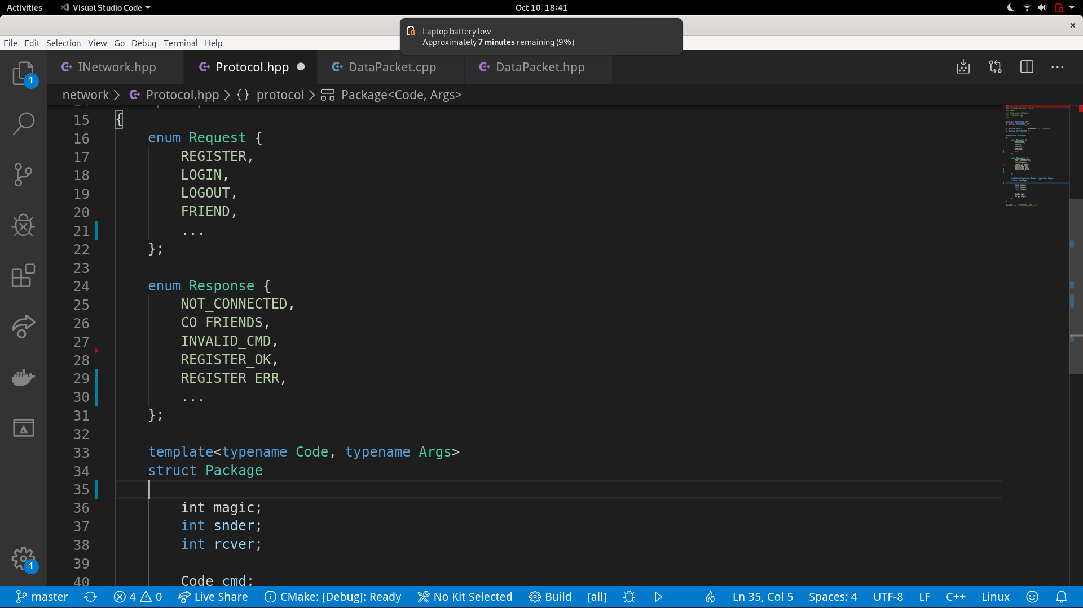

**Boost Asio Package: QtPackage:**

package sent by the server package sent by the client

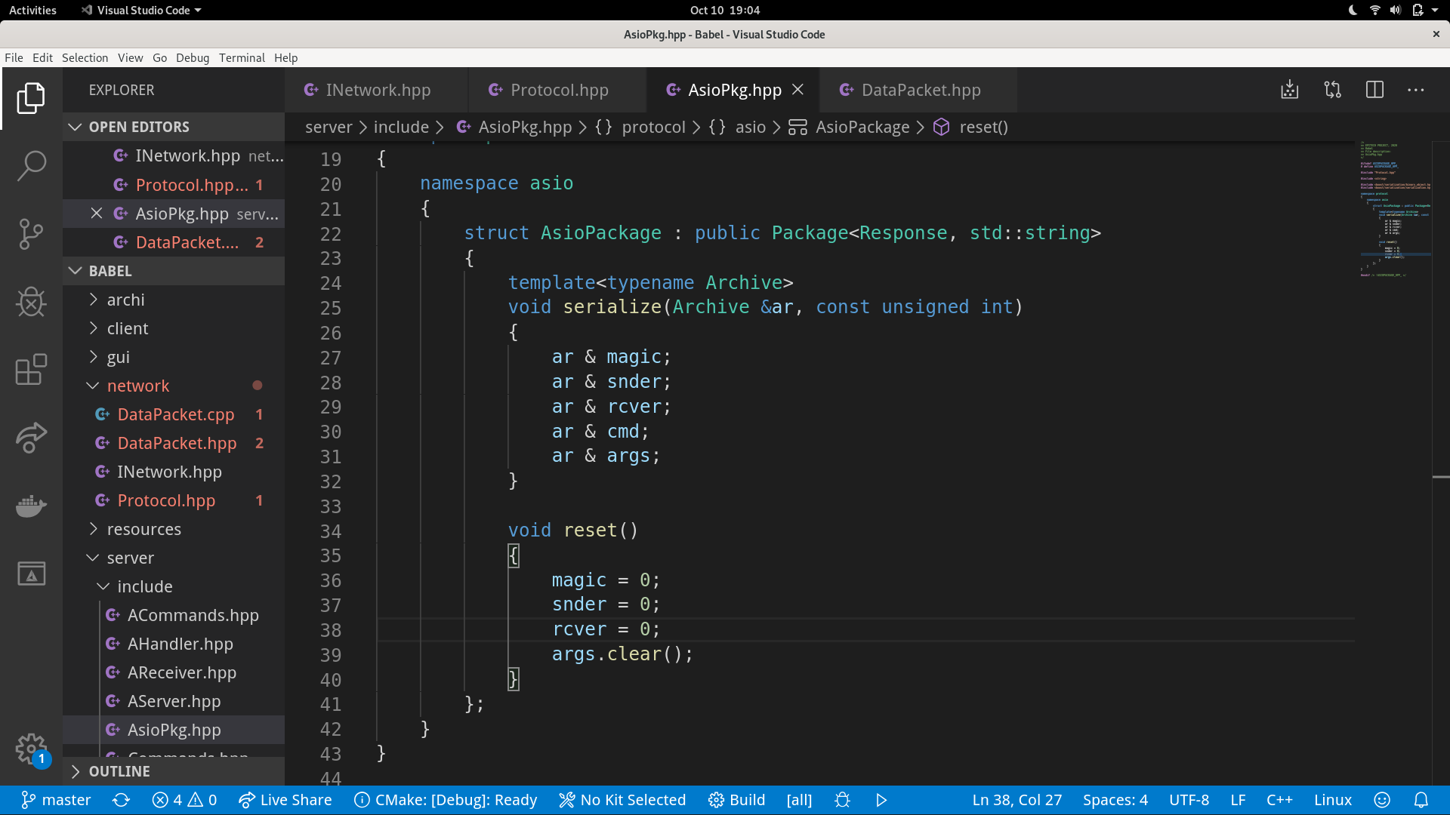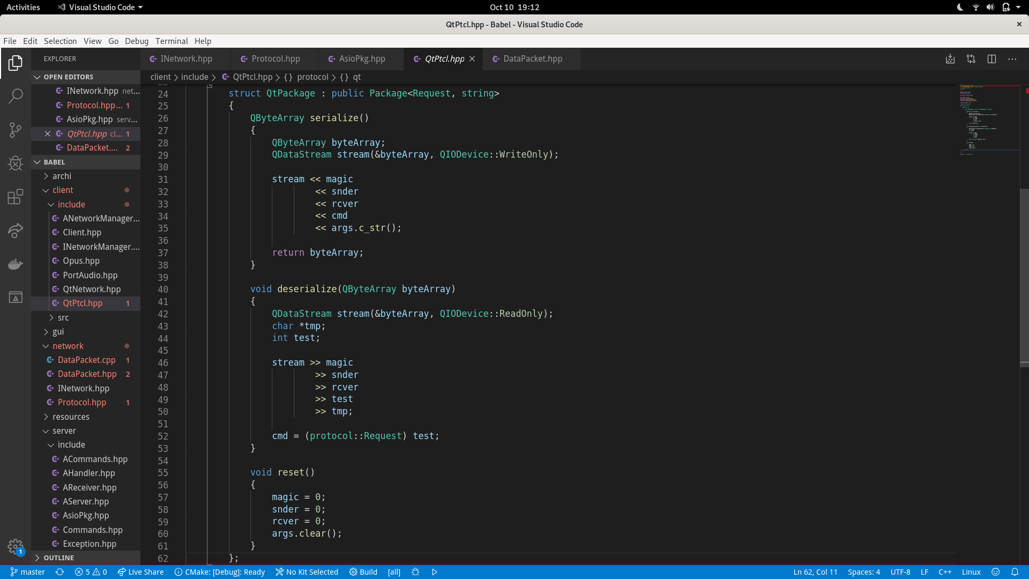

**serialize** *→ method used to compress package*

**deserialize** *→ method used to decompress package*

**reset**  *→ reinitialize package fields*

**Client Commands:**

**Command | Arguments | Description**

**REGISTER** (*username*, *password*) register with a set of *username/password*. If you are already register, use login to connect.

**LOGIN** (*username*, *password*) login with a set of *username/password*. You must first register before login.

**LOGOUT** (*username*) logout without delete *username* from server’s database. You must be login before logout.

**FRIEND** (*username*) send a friend request to *username* and wait for his answer.

**FACCEPT** (*username*, *response*) accept or refuse friend request from *username* according to *response*.

**CALL** (*username*, *port*) send a call request to *username* and wait for his answer. Then open *port* to host call.

**CACCEPT** (*username*, *response*) accept or refuse call request from *username* according to *response*.

**DELETE** (*username*) delete *username* from your friend list.

**Server Commands:**

**Command | Arguments | Description**

**NOT_CONNECTED** (*informative* *string*) client sent other command than login/ register without being connected.

**INVALID_CMD** (*command*) indicate that a wrong *command* was sent by the client.

**REGISTER_ERR** (*informative* *string*) indicate that the client has failed to register (info in *informative* *string*).

**REGISTER_OK**  (*informative* *string*) indicate that the client has succeeded to register (info in *informative* *string*).

**LOGIN_ERR** (*informative* *string*) indicate that the client has failed to login (info in *informative* *string*).

**LOGIN_OK** (*friend* *list*) indicate that the client has succeeded to login. Send *friend* *list* to client.

**LOGOUT_ERR** (*informative* *string*) indicate that the client failed to logout (info in *informative* *string*).

**LOGOUT_OK** (*informative* *string*) indicate that the client succeeded to logout (info in *informative* *string*).

**ADDFRIEND_OK** (*informative* *string*) indicate that the client succeeded to send friend request.

**ADDFRIEND_ERR** (*informative* *string*) indicate that the client failed to send friend request.

**ACCEPT_FRIEND**  (*username*) ask the client if he wants to accept/ refuse friend request from *username.*

**ACCEPTED_FRIEND** (*username*) indicate that your friend request has been accepted by*username*.

**ACCEPT_FRIEND_OK** (*informative* *string*) indicate that your response was well received by the server.

**ACCEPT_FRIEND_ERR** (*informative* *string*) indicate that your response packet contains some error fields.

**CALL_OK** (*informative* *string*) indicate that the client succeeded to send call request.

**CALL_ERR** (*informative* *string*) indicate that the client failed to send call request.

**ACCEPT_CALL** (*username*)ask the client if he wants to accept/ refuse call request from *username*.

**ACCEPTED_CALL** (*username*) indicate that your call request has been accepted by *username*.

**ACCEPT_CALL_OK** (*informative* *string*) indicate that your response was well received by the server.

**ACCEPT_CALL_ERR** (*informative* *string*) indicate that your response packet contains some error fields.

**DELETE_OK** (*username*) indicate that *username* was successfully deleted from your friends.

**DELETE_ERR** (*username*) indicate that *username* wasn’t successfully deleted from your friends.