Your Name
Lecturer’s Name
Module Code and Title
Date

Title: Subtitle (if any)
Research papers that use MLA format do not include a cover page unless requested by your instructor. Instead, start with the information shown at the top of this page. Do not bold the title or use all capital letters. Capitalize the first and last words of the title, and all principal words. If your paper includes a subtitle, separate it from the title by a colon and space, as shown. For more specific guidance on capitalization, see the MLA Handbook for Writers of Research Papers, 7th Edition (MLA 7th Edition).
All text—including titles, quotations, notes, and list of works cited—uses double line spacing. Body text and note text use a half-inch first-line indent. The list of works cited uses a half-inch hanging indent. Table titles and source text use a quarter-inch indent.
MLA format discourages extensive use of content notes. But, when you need to add notes, you can use either endnotes or footnotes. MLA 7th Edition indicates that you should use a superscript, Arabic numeral at an appropriate place in the text for the note reference. To begin the note text, use the same numeral, not superscript, and followed by a period.
For quotations of more than four lines, indent the quote one inch from the left margin and do not use quotation marks: this is the format of a block quotation. For shorter quotations, you can put them in quotation marks, and incorporate them directly into text. All quotations, inline or block quotations, should include a reference to a source listed in your bibliography in the form: (Smith 101–02).
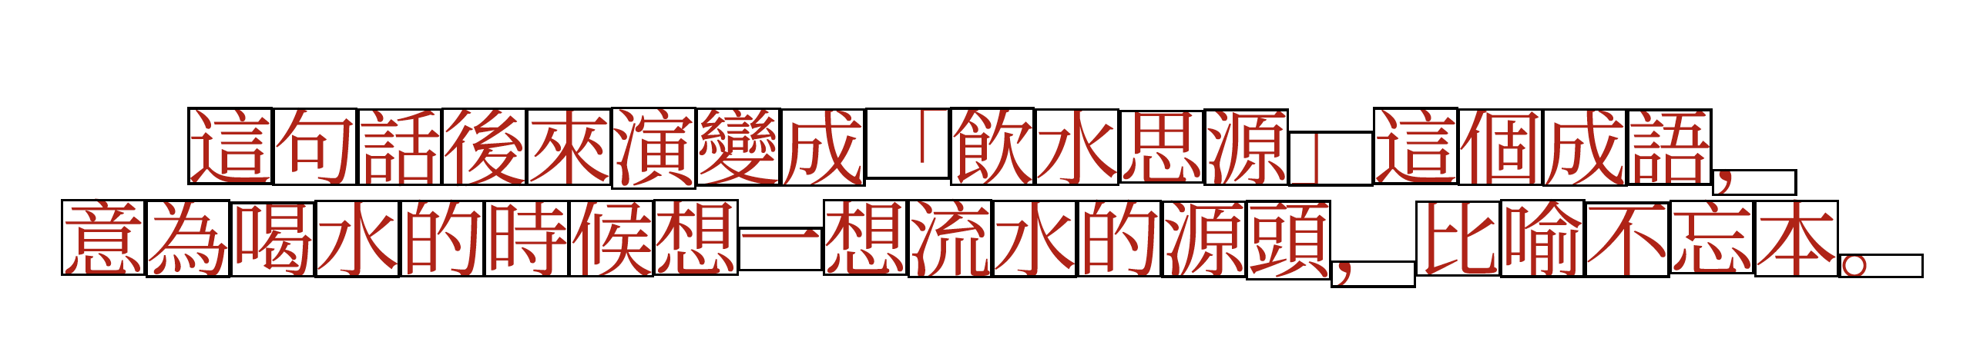
Fig. 1. Label figures with the abbreviated “Fig.” and a figure number.
The sample Works Cited list that follows MLA style. Note that MLA rules for citations and references are extensive. So it’s a good idea to refer to MLA 7th Edition for further information.

Works Cited
AuthorLastName, FirstName. Title of the Book Being Referenced in italics. City Name: Name of Publisher, Year. Type of Medium (e.g. Print).
LastName, FirstName. “Article Title.” Journal Title in italics (Year): 000 – 000. Print.

