8-2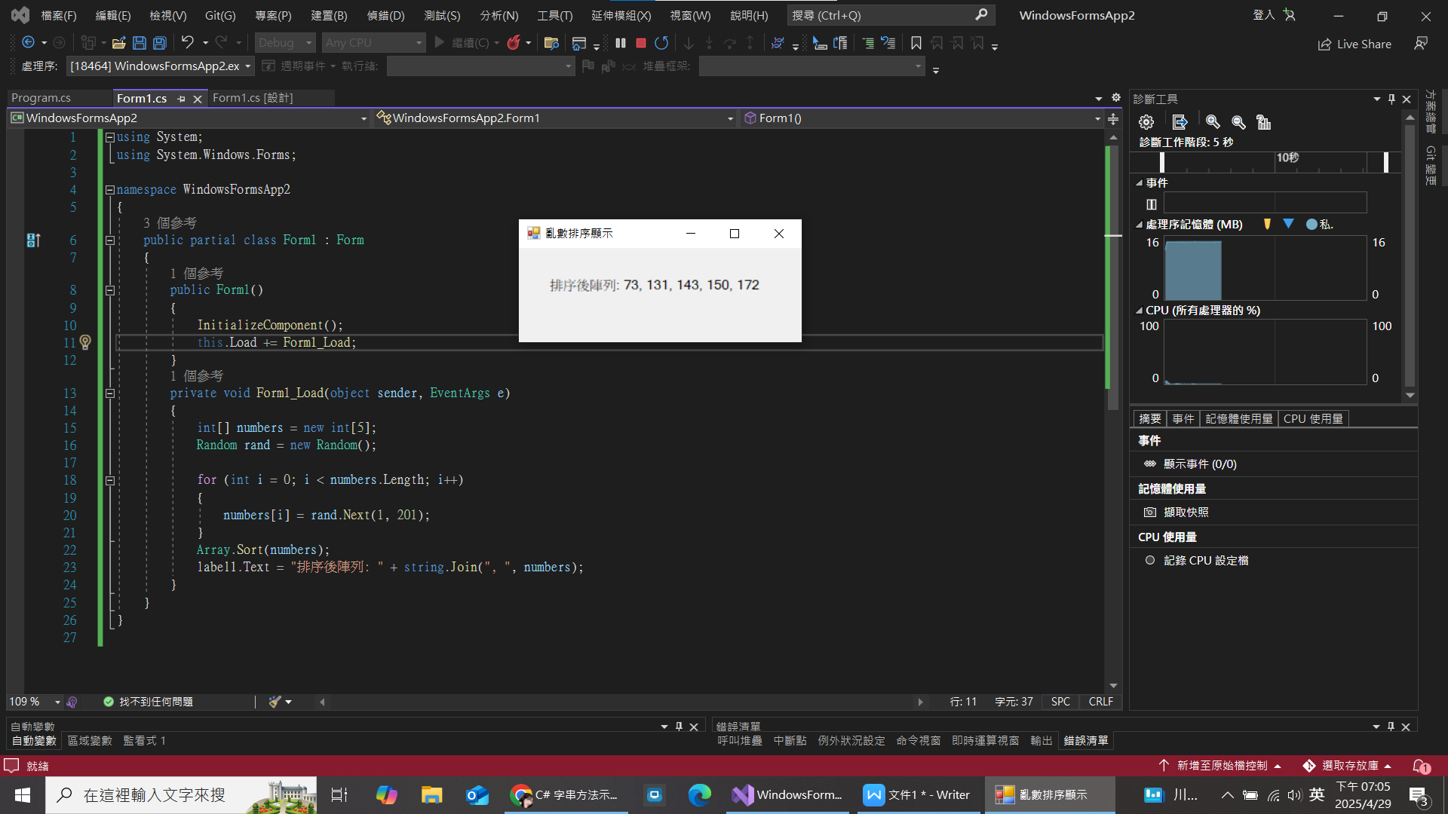

8-4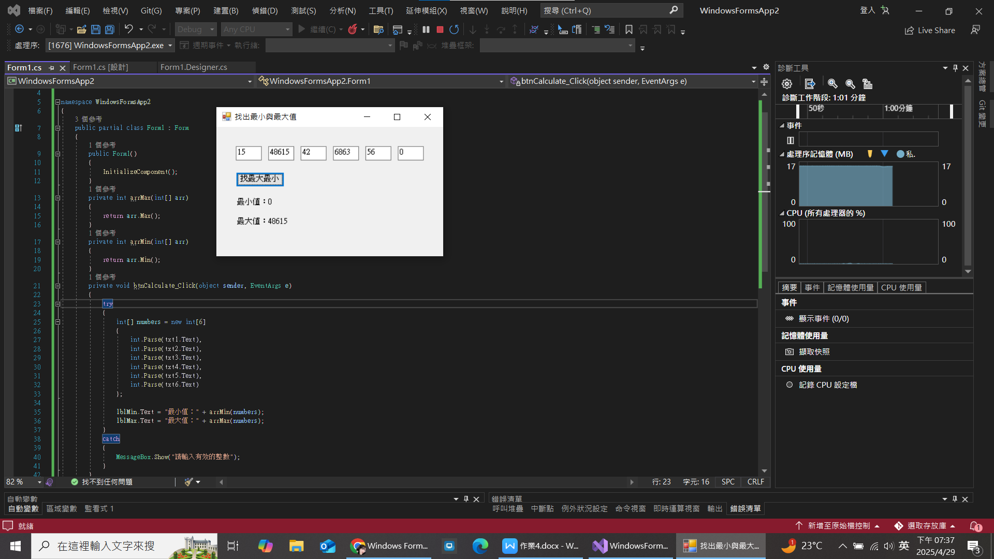

9-2

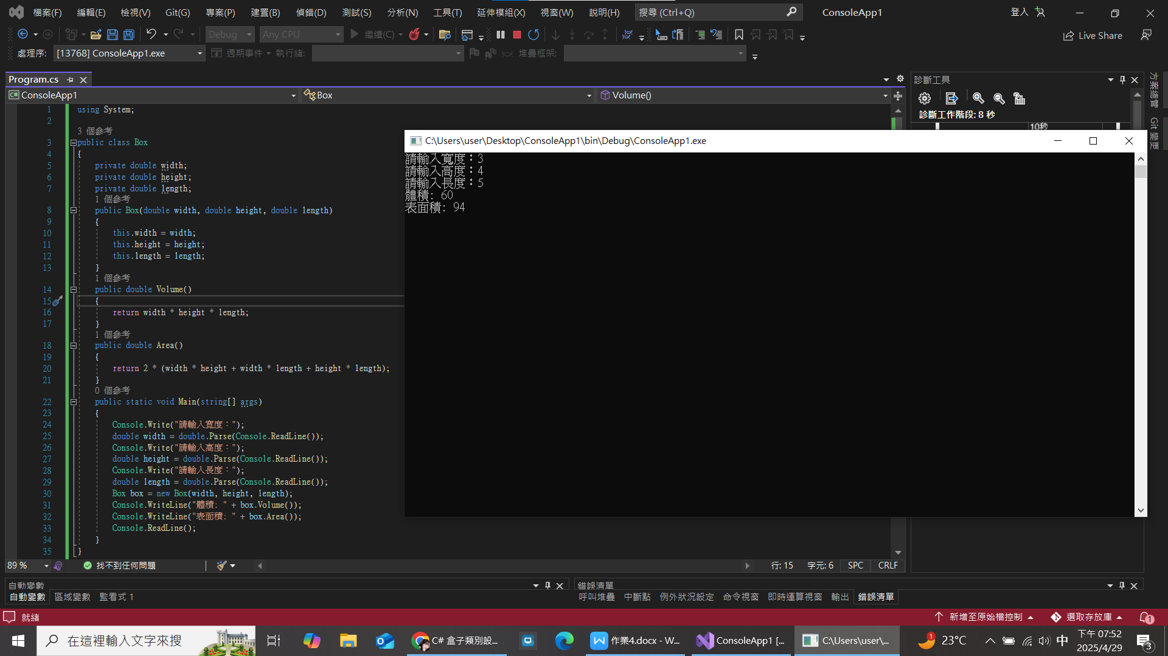

9-4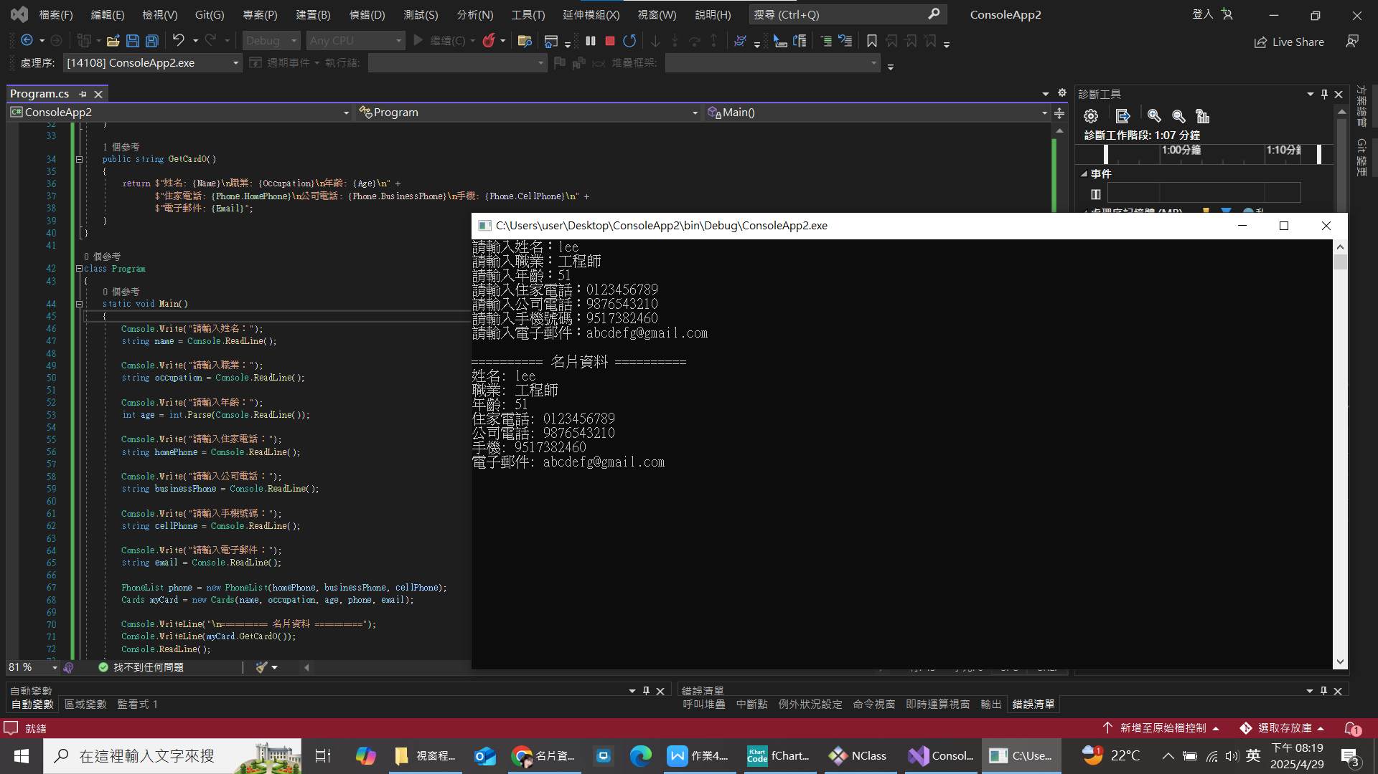

完整程式碼

using System;

public class PhoneList

{

public string HomePhone { get; set; }

public string BusinessPhone { get; set; }

public string CellPhone { get; set; }

public PhoneList(string homePhone, string businessPhone, string cellPhone)

{

HomePhone = homePhone;

BusinessPhone = businessPhone;

CellPhone = cellPhone;

}

}

public class Cards

{

public string Name { get; set; }

public string Occupation { get; set; }

public int Age { get; set; }

public PhoneList Phone { get; set; }

public string Email { get; set; }

public Cards(string name, string occupation, int age, PhoneList phone, string email)

{

Name = name;

Occupation = occupation;

Age = age;

Phone = phone;

Email = email;

}

public string GetCardO()

{

return $"姓名: {Name}\n職業: {Occupation}\n年齡: {Age}\n" +

$"住家電話: {Phone.HomePhone}\n公司電話: {Phone.BusinessPhone}\n手機: {Phone.CellPhone}\n" +

$"電子郵件: {Email}";

}

}

class Program

{

static void Main()

{

Console.Write("請輸入姓名：");

string name = Console.ReadLine();

Console.Write("請輸入職業：");

string occupation = Console.ReadLine();

Console.Write("請輸入年齡：");

int age = int.Parse(Console.ReadLine());

Console.Write("請輸入住家電話：");

string homePhone = Console.ReadLine();

Console.Write("請輸入公司電話：");

string businessPhone = Console.ReadLine();

Console.Write("請輸入手機號碼：");

string cellPhone = Console.ReadLine();

Console.Write("請輸入電子郵件：");

string email = Console.ReadLine();

PhoneList phone = new PhoneList(homePhone, businessPhone, cellPhone);

Cards myCard = new Cards(name, occupation, age, phone, email);

Console.WriteLine("\n========== 名片資料 ==========");

Console.WriteLine(myCard.GetCardO());

Console.ReadLine();

}

}