Team Member

au312821106019: Rajeswari V

Phase2: Document Submission

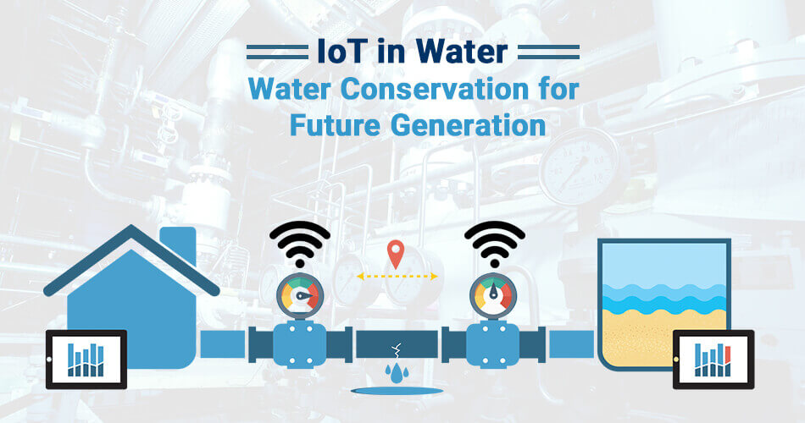

INTRODUCTION:

The goal of this project is to develop a smart water management system that leverages machine learning to analyze water consumption data and offer personalized conservation suggestions to users. The system will collect water usage data from various sources and apply machine learning algorithms to identify trends and anomalies, ultimately helping users reduce water waste.

1. Data Collection:

- Collect historical water consumption data from relevant sources, such as water meters, sensors, or utility bills.

- Gather additional data like weather conditions, household size, and demographics, which can impact water usage.

2. Data Preprocessing:

- Clean and preprocess the data to handle missing values, outliers, and inconsistencies.

- Feature engineering: Extract relevant features like daily usage patterns, seasonal variations, and more.

3. Machine Learning Models:

- Choose appropriate machine learning models for the task. Time series forecasting models like ARIMA or machine learning algorithms like decision trees, random forests, or neural networks can be useful.

- Train the models on the historical data to learn consumption patterns.

4. Predictions and Suggestions:

- Use the trained models to make predictions about future water consumption.

- Implement a recommendation system to suggest water conservation strategies based on the predictions. For example, if the model predicts high water usage during a certain time, suggest reducing irrigation during that period.

5. Feedback Loop:

- Continuously update the model with new data to improve accuracy and adapt to changing consumption patterns.

- Encourage user feedback to refine suggestions and make them more personalized.

6. User Interface:

- Develop a user-friendly interface, such as a mobile app or web portal, to present consumption insights and conservation suggestions to users.

7. Education and Awareness:

- Include educational content to help users understand the importance of water conservation and the impact of their actions.

8. Data Privacy and Security:

- Ensure that user data is handled securely and with respect to privacy regulations.

By incorporating machine learning into water consumption analysis, you can provide valuable insights and encourage more responsible water usage, contributing to sustainability efforts and resource conservation.

Data Security and Privacy:

Ensure that data collection and storage comply with privacy regulations. Anonymize and secure user data to protect their privacy.

Scalability:

Design the system to be scalable so that it can handle data from a growing number of users and devices.

Testing and Evaluation:

Test the system rigorously using historical data and simulate real-world scenarios. Evaluate its effectiveness in reducing water consumption and providing accurate suggestions.

Deployment:

Deploy the system to real users and gather feedback to make further improvements.

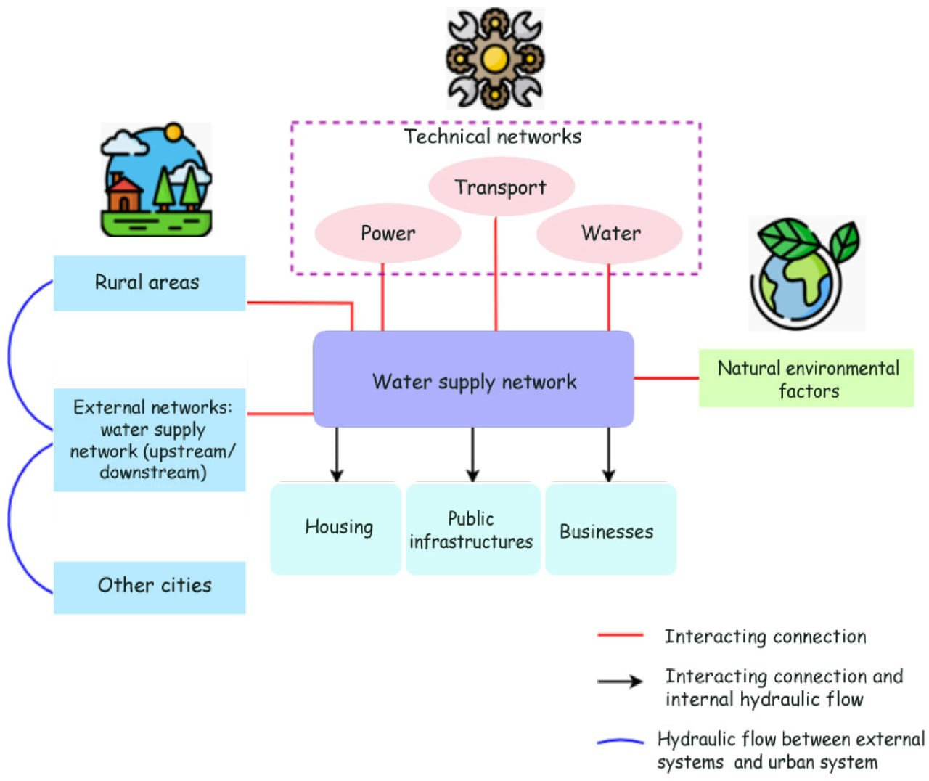BLOCK DIAGRAM:

FLOW CHART:

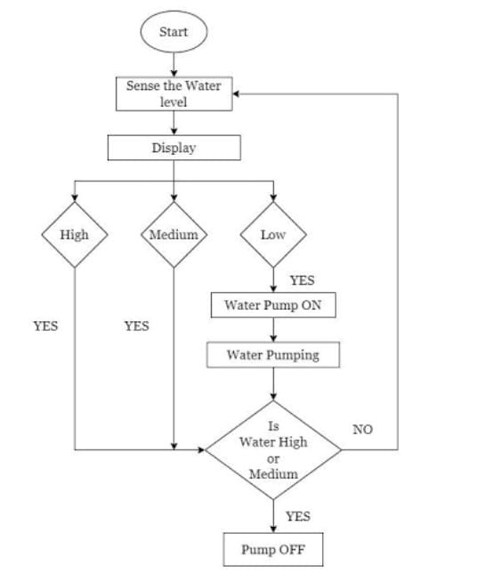

SUGGESTIONS:

1. Leak Detection and Alerts: Install IoT sensors at key points in your water distribution system to detect leaks in real-time. Receive instant alerts when leaks are detected, allowing for swift repairs and water conservation.

2. Smart Irrigation:

Use IoT-connected soil moisture sensors and weather data to optimize irrigation systems. Water plants only when necessary, based on soil moisture levels and weather forecasts.

3. Water Usage Monitoring:

Equip homes and businesses with IoT water meters that provide real-time data on water consumption. Empower users to track their usage and make informed decisions to reduce water waste.

4. Automated Shut-Off Valves:

Install IoT-controlled shut-off valves that can be remotely controlled or set on schedules. This prevents water wastage in case of leaks or during non-peak hours.

5. Rainwater Harvesting Control:

IoT sensors can monitor rainwater storage tanks and control their usage. When rainwater is available, switch to it for non-potable water needs like irrigation or flushing toilets.

6. Behavioral Feedback:

Use IoT devices to provide users with feedback on their water consumption habits. Smart displays or mobile apps can show real-time usage and offer tips for conservation.

7. Pressure Optimization:

Implement IoT systems that dynamically adjust water pressure in the distribution network based on demand. This reduces excess water flow and leakage.

8. Distributed Water Quality Monitoring:

Deploy sensors for monitoring water quality in real-time. Identify contamination issues promptly, preventing the need to flush entire systems.

9. Public Awareness Campaigns:

Utilize IoT-connected billboards or community platforms to share water conservation tips, real-time usage data, and success stories to encourage responsible water usage.

10. Predictive Maintenance:

Implement IoT for predictive maintenance of water infrastructure. This helps prevent unexpected breakdowns, reducing water loss during repairs.

11. Greywater Recycling:

IoT systems can control greywater recycling units, which treat and reuse wastewater for non-potable purposes like flushing toilets or landscape irrigation.

12. Demand-Responsive Water Heaters:

Use IoT-connected water heaters that adjust heating cycles based on usage patterns, reducing energy and water waste.

Conclusion:

This project combines data science, machine learning, and water conservation principles to create a valuable tool for individuals and communities to manage and reduce their water usage. It addresses real-world environmental challenges while providing actionable insights to users.