Storage Lab
- Amazon Linux AMI- EC2 instance in N.Varginia
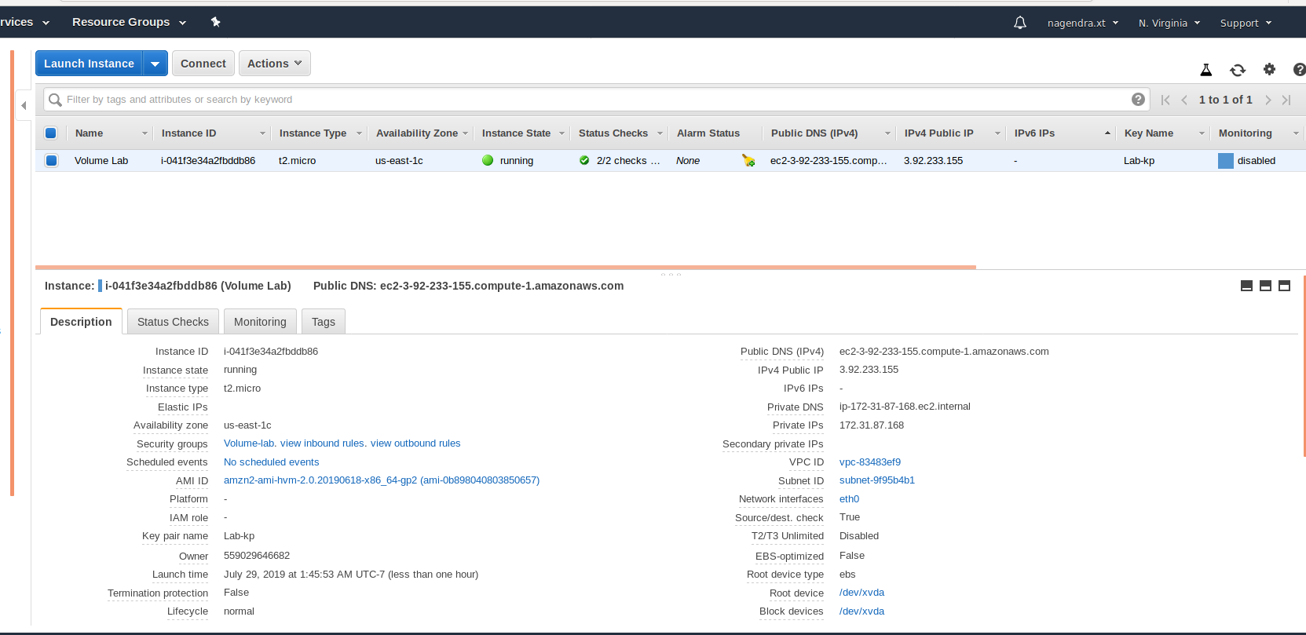

- SSH EC2
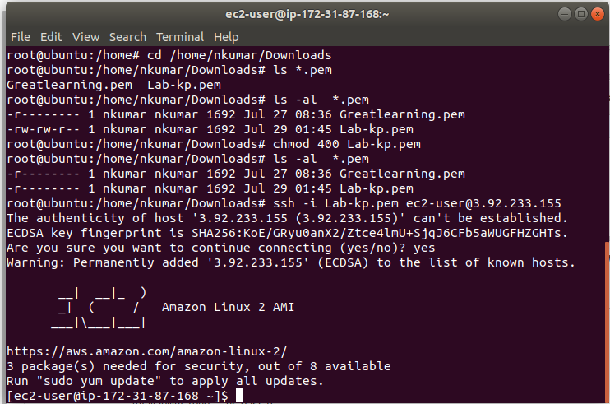

- Volume associated to EC2
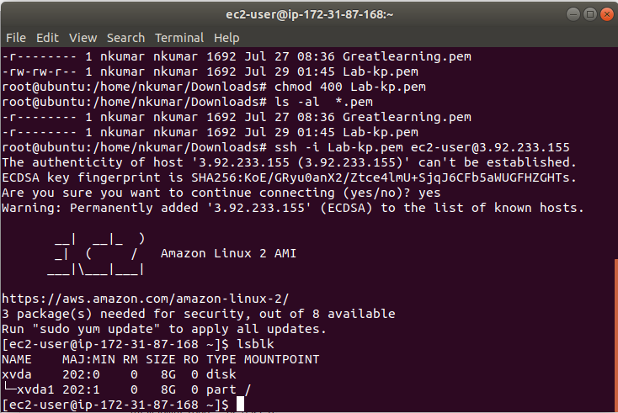
- Additional Volume creation
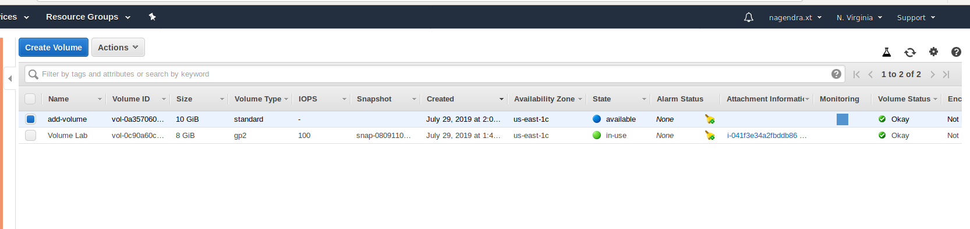

- In use of additional volume
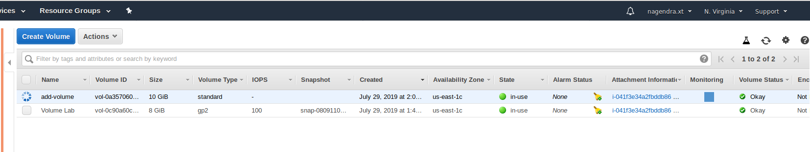
- LSBLK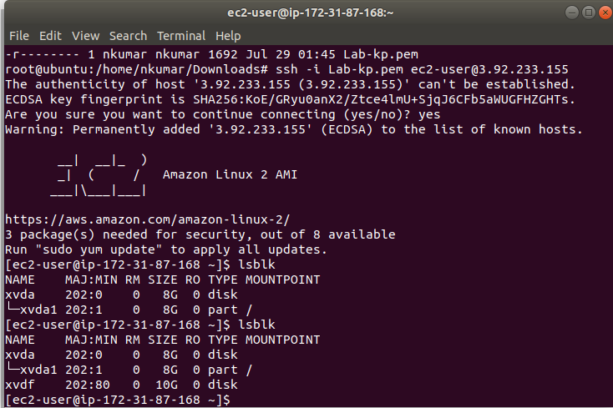
- Disk fragmentation
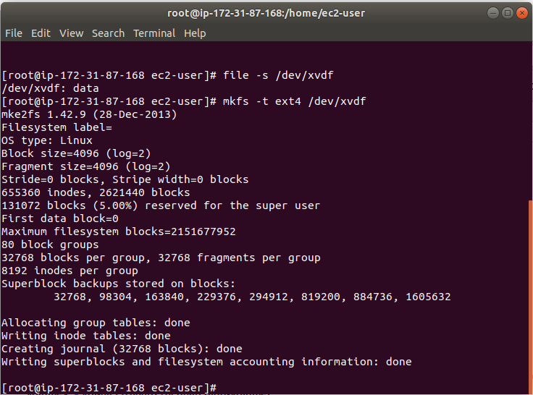

- Create new directory and mount the disk
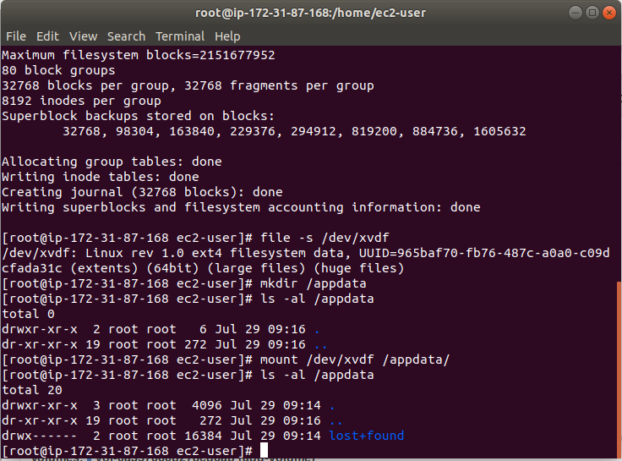

- File creation and umount the disk
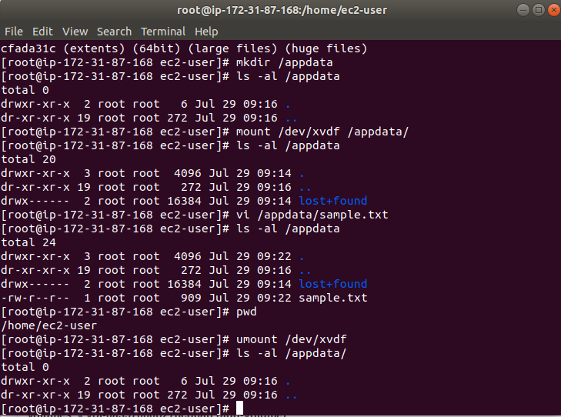
- Snapshot creation
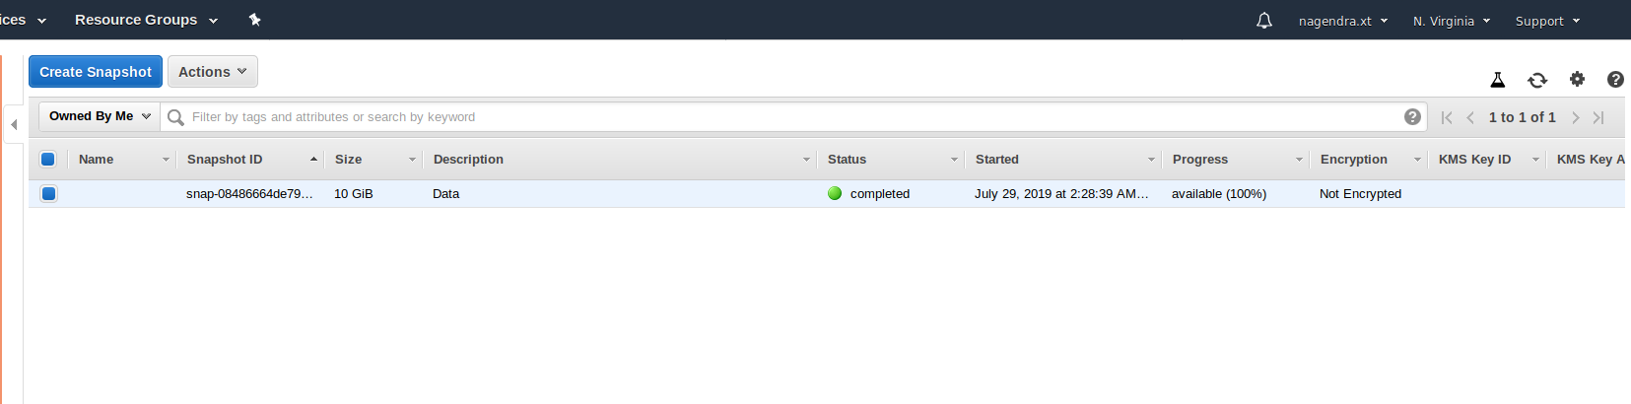

- Additional 15 GIB volume
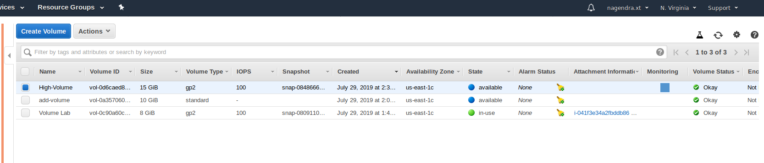

- New volume mount
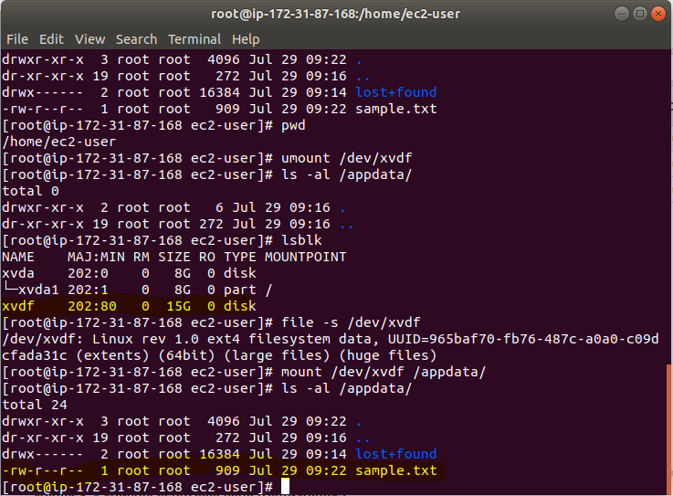
- Disk partition
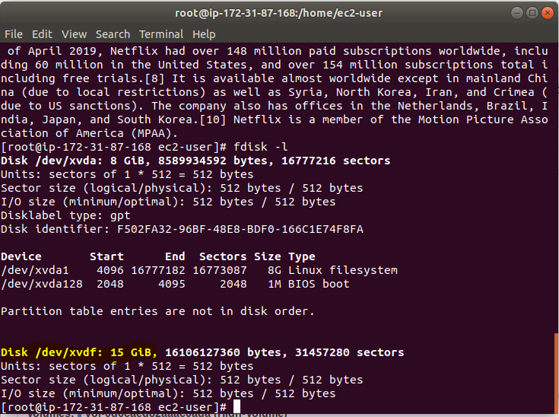

S3 CLI Lab
- Create user from IAM with CLI access
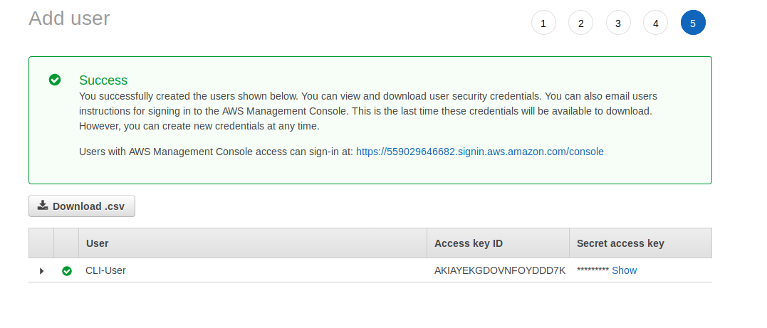
- Create Bucket
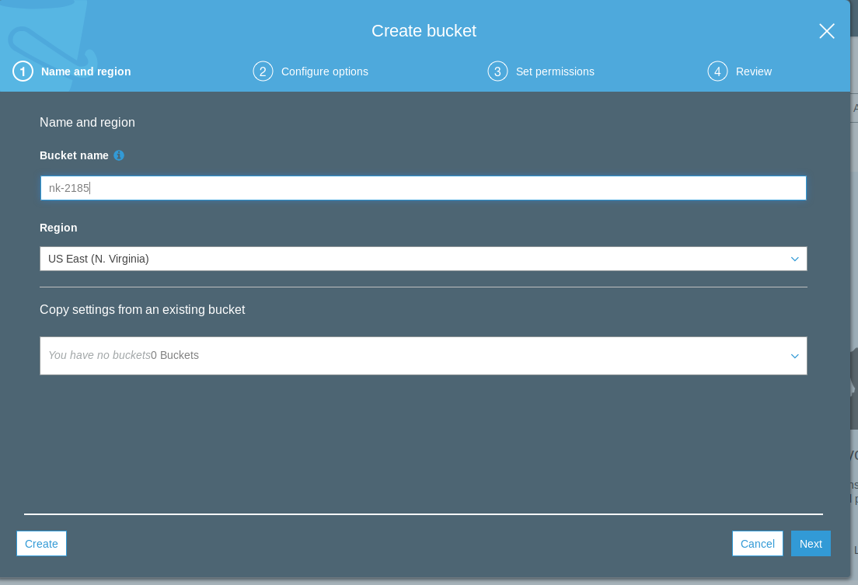

- Upload file to S3
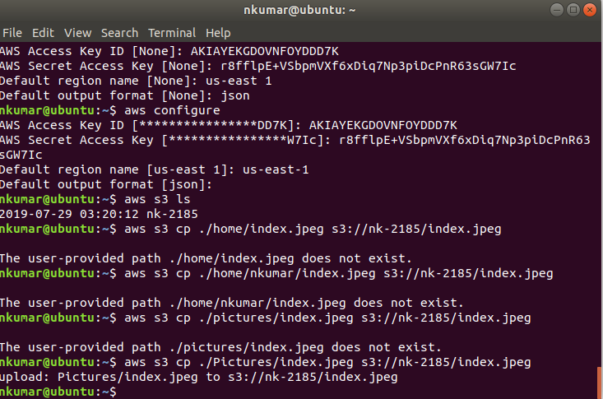

- Index.jpeg under bucket
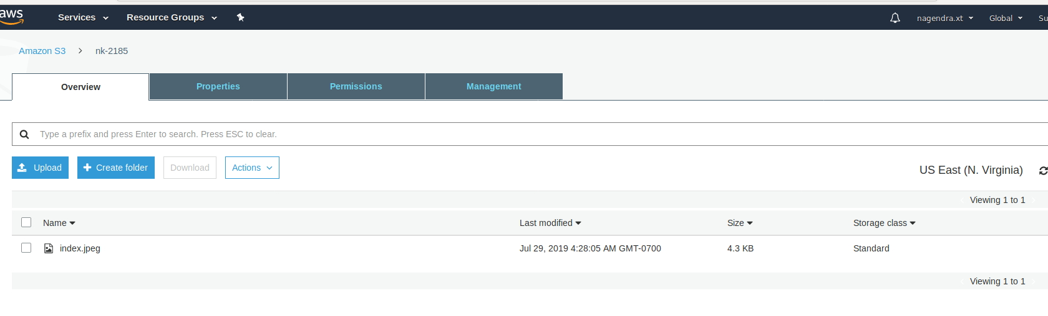

- Delete file from s3 bucket
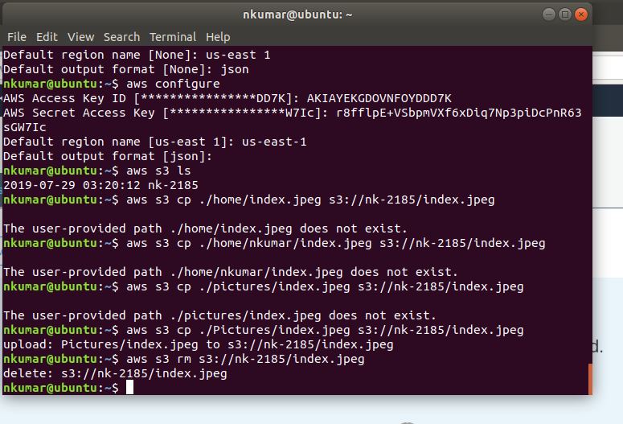

- Replication- Enabling versioning

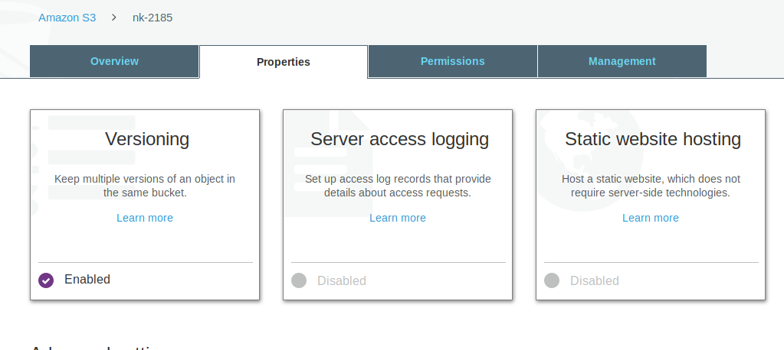
- Replication rule
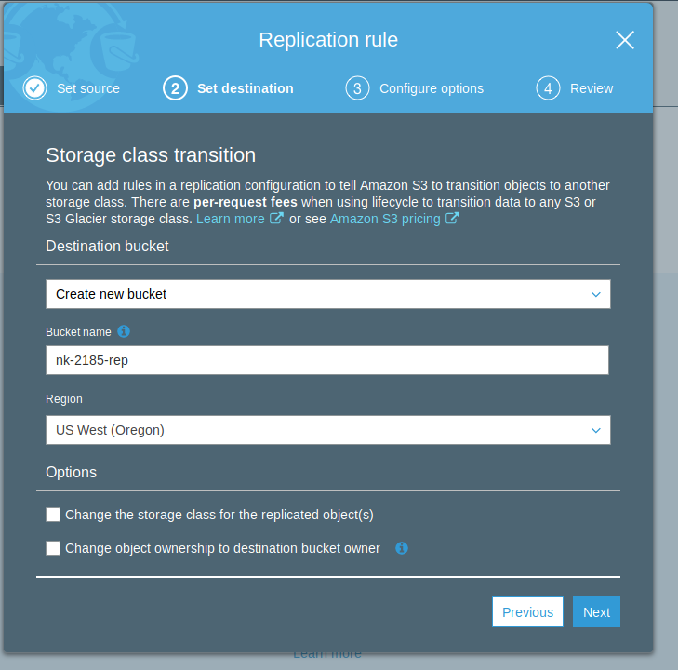

- Rule summary
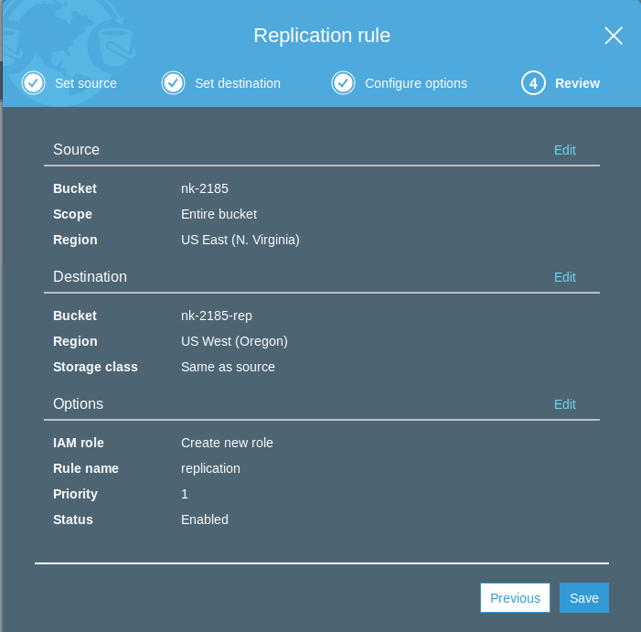
- Bucket in replication bucket in Oregon
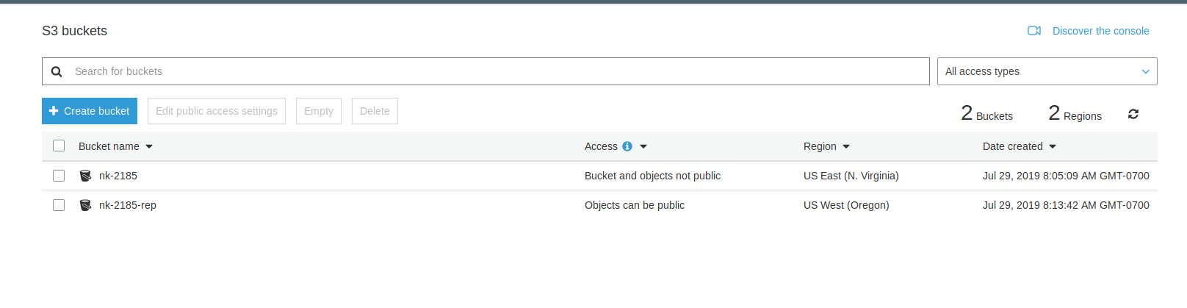

- File upload for replication in Oregon
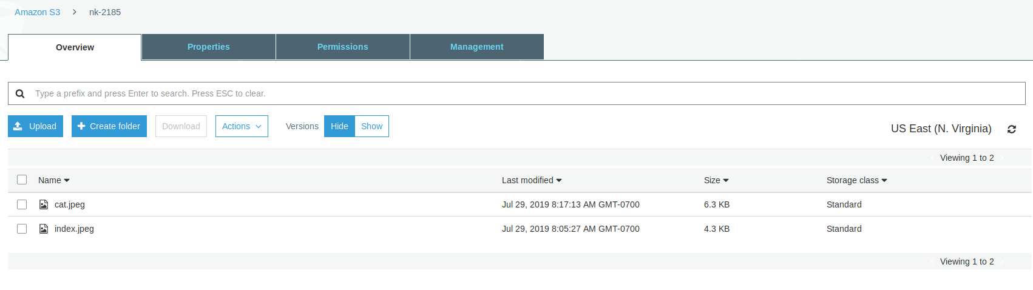
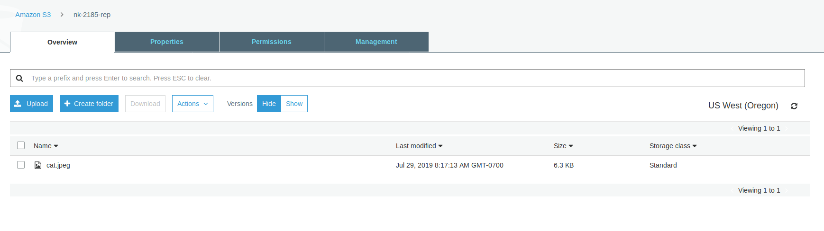
11.Versioning
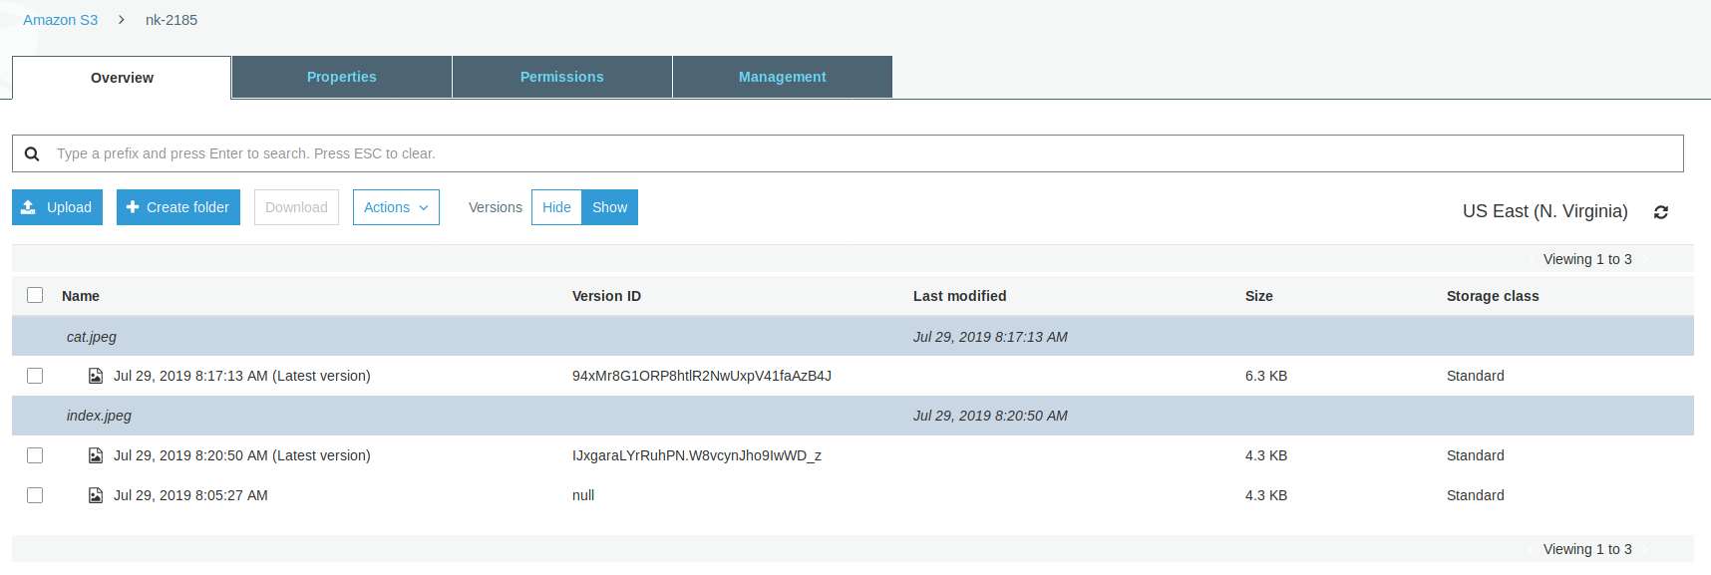

- Deleting the original file from N.varginia, replica still exists in Oregon
